Module 1: Introduction to MIS & IT Careers

Q1: Why is MIS the most important class in business school?

- The ultimate reason lies in a principle known as “Moore’s Law”.
- “ The number of transistors per square inch on an integrated chip doubles every 18 months. ” This famous quote is usually misunderstood. The point is that; because of Moore’s law, the cost of data processing, communications, and storage is essentially zero.
- This leads to the creation of many apps such as YouTube, Tumblr, Facebook, etc.
- In addition to these new apps, Moore’s law is also driving other trends;
- Access to the Internet is growing rapidly worldwide.
- It is also leading to an explosion of data; more data is being produced each year than in all the years in human history before 2007 combined.
- The most significant impact of Moore’s Law is in mobile platforms; due to the improved computing performance
- Future business professionals need to be able to assess, evaluate, and apply emerging information technology to business as Moore’s law has created several opportunities; you need this course to attain these skills.

Q2: How can I attain job security?

- According to RAND Corporation, rapid technological change and rapid international competition place the spotlight on the ability to adapt to changing technology and shifting demand the market nowadays favours strong NONroutine cognitive skills.
- In other words, you cant expect job security if you don’t have these skills, no matter what your major is.
- Nonroutine cognitive skills (according to Robert Reich):
- Abstract reasoning
- Systems thinking
- Collaboration
- Ability to experiment

Q3: How can Intro to MIS help you learn nonroutine skills?
This course helps you learn and practice these four key skills;

- Abstract Reasoning: this is the ability to make and manipulate models. An abstraction is a simplification of an object; it is an idea, model, or concept that can then be manipulated with a logical or reasonable though process.
e.g. : Construct a model or representation to solve a specific problem, such as; confusion about life cycle for new clients.
- System thinking: this is the ability to model the components of the system show how components inputs and outputs relate to one another, one that explains the phenomenon observed.
e.g. : Model system components and show how components inputs and outputs elate to one another; How do all the items get on the shelves at Wal-Mart?
- Collaboration: Effective collaboration is not about being nice to others; it’s about giving and receiving critical feedback. Develop ideas and plans with others.
How do you advance your idea in the face of the VP’s resistance? And without losing your job?
- Ability to experiment: Experimentation is making a careful and reasoned analysis of an opportunity, envisioning potential products or solutions or applications of technology, and then developing those ideas that seem to have the most promise, consistent with the resources you have. It also means learning from experience; why it worked, or why not?

What is the bottom line?
- This course will give you the background you need to assess, evaluate and apply emerging information systems technology to business.
- It can also give you the ultimate in job security – marketable skills—by helping you learn the four key skills.

Q4: What is MIS?

- This stands for “management information systems” and is defined as the management and use of processes, information systems, and information to help organizations their strategies. This definition has three key components:
- Processes, information systems, and information
- Management and use
- Achieve strategies
- Process is a way of doing things
- Information system is a collection of components, including but not limited to a computer, that stores and retrieves data and produces information.
- Information: is meaningful insight that helps employees do their jobs
- Management (of MIS) is defined as the creating, monitoring, and adapting of processes, information systems, and information. Look at table page 10*
- Achieve strategies: an organization alone doesn’t do anything, it the people inside who sell buy design ect. do not start using twitter because your competitor does, you need to only construct systems for the purpose of achieving the organizations strategy
- The whole purpose of this is to learn to look at information systems and technologies only through the lens of business need. Learn to ask: what will it do for us?

Q5: How does MIS relate to organizational strategy?

- According to the definition of MIS, information systems exist to help organizations achieve their strategies;
- the company’s goals and objectives are determined by its competitive strategy.
- In other words, competitive strategy determines the structure, features, and functions of every information system.
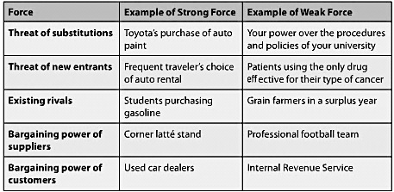
- To understand organizational strategy, you need to understand Porter’s five forces model which help determine industry profitability:

- The intensity of each of the five forces determines the characteristics of the industry, how profitable it is, and how sustainable that profitability will be.
- Substitute: performs the same or similar function as an industry’s product by another means. the threat of a substitute is stronger if its price is lower, benefits of substitute are similar, and if it easy for customers to switch products what email is to post office
- The threat from new entrants is based on industry barriers to entry and the reaction new entrants can expect from established companies in the industry. e.g. high customer switching costs (penalty fee if you switch comp.), large financial investments to get started, sales/distribution channels that are not available to new companies, and government policies.
- The competition from industry rivals (a.k.a copycats), is high when rivals compete with each other using price discounting, new products, and service improvements.
  - Also particularly high when competitors are numerous, industry growth is slow, and when exit barriers are high
- The strength of the two last powers depends on the number of suppliers and buyers available, switching costs, the differentiation of the product, and the relative size of the firm compared to the size of its suppliers and customers.

Q6: What is competitive strategy?

- A firm responds to the structure of their industry by choosing a competitive strategy
- A firm can either be the cost leader and provide products at the lowest prices in the industry, or it can focus on adding value to its products to differentiate them from those of the competition. It can also employ the cost or differentiation strategy across an industry, or it can focus its strategy on a particular industry segment. (Model of 4 competitive strategies)
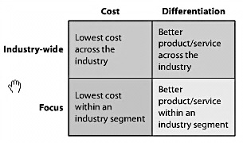
- The key is for companies to commit to one of the four competitive strategies.

Firms should choose to commit to one, because choosing to reduce costs and to differentiate usually results in none of them happening.
Second principle of the strategy: competitive strategy chosen must be distinctive and maintainable, this is because if your rivals are doing the exact same thing and better you can be in danger.

Q7: How does competitive strategy determine value chain structure?

- First you analyze your industry, then you choose your competitive strategy based on that analysis next step is to organize and structure the organization to implement that strategy
- Cost leaders: business activities should be developed to provide essential functions at the lowest possible cost
- Differentiation strategy: not necessarily structuring itself around least-cost activities, but they may choose a more costly process if the benefits outweigh the risks it will add cost to an activity as long as the activity has a positive margin

- A value chain is a network of value-creating activities. According to Porter, that generic chain consists of 5 primary activities and 4 support activities.
- The difference between the value (price customer pays) that an activity generates and the cost of the activity is called the margin.
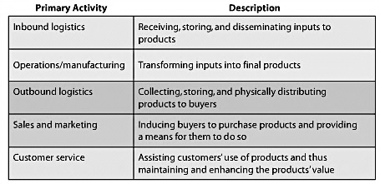
- Each stage of this generic chain of primary activities adds value and costs to the product. The net result is the total margin of the chain.

- The support activities in the value chain contribute indirectly to all of the primary value chain activities:
- Procurement: the process of finding vendors, setting up contractual arrangements, and negotiating prices. Ex. Manage supplier relationships
- Technology: includes R&D, and other activities within the firm for developing new technologies, methods, and procedures. Ex. Investigate new designs
- Human resources: recruiting, compensation, evaluation, and training of employees. Ex. Hire employees
- Firm infrastructure: general management, finance, accounting, legal, and government affairs. Ex. Manage company’s resources
- Porter’s model of business activities includes linkages; interactions across value activities. e.g. system uses sales forecasts to plan production; it then uses the production plan to determine raw material needs and then uses the materials needs to schedule purchases. (a.k.a. economies of scope)

Q8: How does competitive strategy determine business processes and information systems?

- Organizations analyze their industry and choose a competitive strategy. Given that strategy, they examine their value chain and design business processes that span value-generating activities. Those processes determine the scope and requirements of each organization’s information systems.

Module 2: Information Technology Components

Q1: What do business professionals need to know about computer hardware?
- Harware: consists of electrical components and related gadgetry that input, process, output, and store data according to instructions encoded in computer programs or software.

- Components of hardware:
- Central Processing Unit (CPU): selects instructions, processes them, performs arithmetic and logical comparisons, and stores results of operations in memory.
- Some computers may have 2 CPUs (dual-processor) or more (quad-processor).
- It also works in conjunction with main memory. It reads data and instructions from memory, and it stores results of computations in main memory. (RAM)
- Random Access Memory (RAM): main memory and it is volatile (content is lost when power is off)
- Storage hardware: used to save data and programs.
  - magnetic disk, thumb drives, magnetic tape (large data centers).
- Types of hardware:
- Personal Computers (PC): classic computing devices that are used by individuals.
- Tablets (a.k.a slates)
- Smartphones: cellphones with processing capability
- Server: computer that is designed to support processing from many remote computers and users. e.g. Dell PowerEdge
- Server Farm: is a collection of thousands of server – PCs smartphones ect that access these servers are called clients

Computer Data:
- Computers represent data using binary digits, called bits.
- It is either 1 or 0
- The data can be numbers, characters, currency amounts, photos, recordings, or whatever.
- 8 bits = 1 byte and 1 byte represents 1 character
- Computer disk capacities are specified according to the amount of data they can contain.
- Byte kilobyte megabyte gigabyte terabyte Petabyte Exabyte (1024 PB)

Q2: What do business professionals need to know about software?

Operating System (OS):
- Every computer has an OS - a program that controls that computer’s resources.
- Functions:
- Read and write data
- Allocate main memory (RAM)
- Perform memory swapping
- Start and stop programs
- Respond to error conditions
- Facilitate backup and recovery
- Creates and manages the user interface (includes keyboard, mouse, and other devices)
- Major Operating Systems:
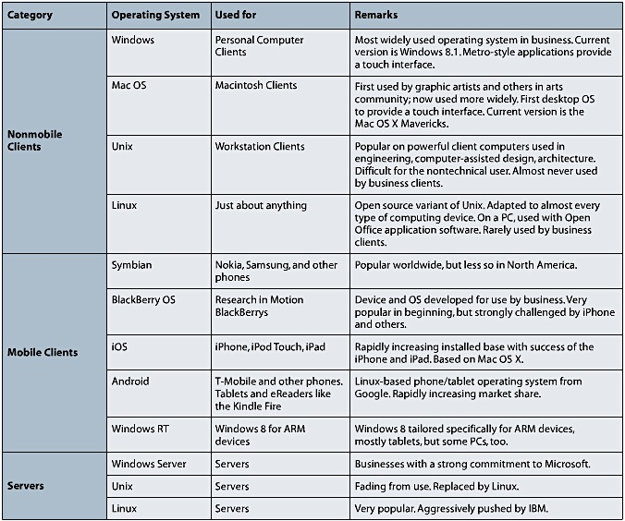

Non-mobile client operating systems: used on personal computers (page 54 for deets)

Virtualization:
- Process by which one computer hosts the appearance of many computers
- One operating system, called the host operating system, runs one or more operating systems as applications.
- These hosted operating systems are called virtual machines (vm).
- Each virtual machine has disk space and other resource allocated to it, but the host operating system controls it.
- There are 3 types of virtualization:
- PC Virtualization: a personal computer, such as desktop or portable computers, hosts several different operating systems.
- Server Virtualization: a server computer hosts one or more other server computers.
- Desktop Virtualization: a server hosts many versions of desktop operating systems. you can access your desktop on any computer.

Own Versus License

- When you buy a computer program, you are not actually buying that program. Instead, you are buying a license to use that program.
- For large organizations, they do not buy Microsoft for example for each of there computers in the office they get a site licence which is a flat fee and they are aloud to download the program on all computers at a specific site
- However, Linux has no license fee; it’s an open source program.

Types of applications and how organizations obtain them:

- Application software: performs a service or a function. Some application programs are general purpose, such as Excel or Word. Other application programs provide specific functions; Quickbooks (accounting).
- Horizontal-market Application software: provides capabilities common across all organizations and industries. e.g: word processors, graphics programs, spreadsheets, and presentation programs. You can find these programs in software such as Word, Excel, PowerPoint, or Adobe’s Acrobat, Photoshop, and PageMaker. (off-the-shelf)
- Vertical-market Application software: serves the needs of a specific industry. e.g. those used by dental offices to schedule appointments and bill patients, those used by auto mechanics to keep track of customer data and repairs, or those used by parts warehouses to track inventory, purchases, and sales. (off-the-shelf & then customized)
- One-of-a-Kind Application software: is developed for a specific and unique reason. e.g: IRS develops such software (custom-developed)

- Just like suits, you can buy computer software in the same ways (Software Sources 3); off-the-shelf software, off-the-shelf with alterations software, or custom-developed software. (page 57 see diagram)

What is Firmware?

- A computer software that is installed into devices such as printers, print servers, and various types of communication devices.
- The software is coded just like other software, but it is installed into special, read-only memory of the printer or other device.
- This way, the program becomes part of the device’s memory; it is as if the program’s logic is designed into the device’s circuitry.

Is open source a viable alternative?

- Source code is computer code that is written and understood by humans.
- Source code is compiled into machine code that is processed by a computer
- Open source means that the source code of the program is available to the public and can be changed – the key is everyone collaborates to make it better.
  - Examples of open source: Open Office, Firefox, MySQL, Apache, Hadoop, Android.
- In a closed source project, the source code is highly protected and only available to trusted employees and carefully vetted contractors. (Ex. Microsoft Office)
- To answer the question; it depends on the requirements and constraints of any situation. Open source lets you be creative and work on your own projects, but if a job does not require that, there’s no point of using open source.

Q3: What are the differences between Native and Thin-Client applications?

Native Applications: those that can run on just one operating system.
- They are developed using serious, heavy-duty, professional programming languages.
- MAC OS and iOS are constructed using Objective-C
- Linux (Android) is constructed using Java
- Windows applications are constructed using CH, VB, Net, and C++, and others.
- All these languages are object-oriented; which means they can used to create difficult, complex applications and, if used properly, will result in high performance code that is easy to alter when requirements change.
- Cost of native applications is high – so limits on native applications are usually budgetary not technological
- Problem: you need to create a new code for each operating system

Thin-Client Applications: those that run in browsers on many different operating systems.
- Developing thin-client applications involve languages such as html5, CSS3, and JavaScript much easier to learn
- These applications run inside a browser such as Firefox, Chrome, Safari, or Internet Explorer, but are limited by the capabilities of the browser less limited than creating a new code for each operating system however
- Examples: Seafood Website: www.brownfamilyseafood.com or Picozu editor: www.picozu.com/editor.
- The major advantage of thin-client server is that they will run on any operating system and hardware. Also, they can be created more easily than native applications, which reduces the price of developing them (cheaper than native).
- Problem: hard to make revenue

Which one is better? It depends on your strategy, your particular goals, the requirements for your application, your budget, your schedule, your tolerance for managing technical projects, your need for application revenue, and other factors.

Q4: What characterizes quality mobile experiences?

- User Interface (UI): is the presentation format of an application.
  - It consists of windows, menus, icons, dialog boxes, toolbars, and more.

- User Experience (UX): is a newer term that refers not only to the UI, but also to the way that the user responds to the application.
  - Effective UX includes enjoyment, desire to use the application again, and a positive emotional experience within that application

Characteristics of quality mobile UX (5) :

- Feature Content and Support Direct Interaction:
- Feature Content: the content should be shown cleanly and in center stage.
  - Chrome is a term that refers to the visual overhead in a computer display. It is the windows, the menus, and other apparatus that drive the application
  - GOAL: REDUCE IT OUR SCREENS ARE TOO SMALL
- Direct interaction: when you use content to drive application behaviour.
  - E.g. Light blue underlined writing = click on it to navigate to it
- Use Context-Sensitive Chrome
  - Mobile applications should use context-sensitive chrome, meaning it pops up in the display when appropriate.
    - Ideally, no button or command name is ever shown in a displayed (grayed-out) state.
    - Leaves more space for the display of the users’ content.

- Provide Animation and Lively Behaviour:
  - Great mobile application captures your attention with motion and sound.
- Example: an icon to play a movie has the movie’s preview playing inside it.

- Design to Scale and Share:
  - Applications must be designed so that they can scale up and down without appearing awkward or taking over the device because they can be on various screen sizes
- Modern operating systems (for native applications) and browsers (for thin-client applications) are designed to support such scaling; applications come in different sizes, and will adapt quickly depending on the device being used.
- Example; an application will be smaller on an iPhone than on a Laptop.
- Mobile applications also need to be designed to share data.
- Example: Charms (icons that slide in from the right of the display).

- Use the Cloud: Quality applications utilize data and computing resources that are remote from the user and are likely not known by the user.
- Roaming: occurs when users move their activities, especially long-running transactions (reading a book), across devices.
- The best applications do it for you; Kindle will track customers’ reading within a book across devices.
- How does this work? Amazon.com stores data about your reading progress out in the “cloud” somewhere.
- Push Data: is data that the server sends to or pushes onto the device. (most “impressive” because users don’t need to do anything to receive data)
- Pull data: is data that the device requests from the server.

Q5: What do business professionals need to know about data communications?

Network: is a collection of computers that communicate with one another over transmission lines or wireless connections. There are 3 basic types of networks:
- Local Area Network (LAN): connects computers that reside in a single geographic location on the premises of the company that operates the LAN. Keyword: a single location.
- Example: the computers for a college located on a single campus can be connected using a LAN.
- An organization can place communication lines wherever it wants because all lines reside on its premises.
- Wide Area Networks (WANs): connects computers at different geographic locations.
- Example: the computers for a college located on multiple campuses must be connected through a WAN.
- To connect computers in different cities, you need to contact a communication vendor that is licensed by the government and that already has lines.
- Internet: is a network of networks.
- It connects LANs, WANS, and other Internets.
- Protocol: set of rules that two communicating devices follow.
- The Internet: is the “Famous” collection of networks that you use when you send e-mails or access websites.

Components of a LAN:
- The computers and devices (e.g. printers) communicate via a mixture of wired and wireless connections.
- Switch: special connection between computer and printer. It receives and transmits wired traffic on the LAN.
- The IEEE 802.3 Protocol: is used for wired LAN connections. This protocol standard, a.k.a Ethernet, specifies hardware characteristics, such as which wire carries which signals. It also describes how messages are to be packaged and processed for wired transmission over the LAN.
- The network interface controllers (NCIs) is most computers support 10/100/1000 Ethernet.
- NIC can be wireless or wired.
- The IEEE 802.11 Protocol: is used for wireless LAN connections.

Connecting LAN to the Internet:
- When you connect to the Internet, you are actually connecting to an Internet Service Provider (ISP). It has 3 functions:
- Provides you with a legitimate Internet address.
- Serves as your gateway to the Internet
- ISPs pay for the Internet. They collect money from their customers and pay access fees and other charges on your behalf.
- Digital Subscriber Line (DSL) operates on the same lines as voice telephones, but it does not interfere with the phone’s service.
- Cable Line: provides high-speed data transmission using cable television lines.
- You can also connect to the Internet using a WAN wireless connection.

Communication over the Internet:
- A lot of protocols are used on the Internet and they are organized according to the TCP/IP Protocol Architecture, which is a scheme of 5 protocol types arranged in layers.
- Hypertext Transport Protocol (http): is the protocol used between browsers and Web servers. When you see “https”, this means you have a secure transmission.
- Web Servers are programs that run on a server tier computer and manage HTTP traffic by sending and receiving web pages to and from clients.
- Simple Mail Transfer Protocol (smtp) is used for email transmission, along with other protocols.
- File Transfer Protocol (ftp) is used to move files over the Internet.
- You are using the Internet when you use any of these protocols.
- You are using the Web only when you use http/https.

Web: is the Internet-based network of browsers and servers that processes http or https. When you send an e-mail, you are using the Internet, but not the Web.

URL: Uniform Resource Locator: is an address on the Internet.
- It consists of a protocol (http:// or ftp://), followed by a domain name.

Q6: What happens on a typical web server?

Almost all e-commerce applications use the Three-Tier Architecture, which is an arrangement of user computers and servers into three tiers/categories.
- The User Tier consists of computers, phones, and other devices that have browsers that request and process Web pages.
- The Server Tier consists of computers that run Web servers and process application programs.
- The Database tier consists of computers that run a DBMS that processes requests to retrieve and store data.

Web page: is a document that is coded in one of the standard page mark-up languages.

Web servers: are programs that run on a server-tier computer and that manage http traffic by sending and receiving Web pages to and from clients.

Commerce server: is an application program that runs on a server-tier computer.
- Receives requests from users via the Web server, takes some action, and returns a response to the users via the Web server.
- Functions:
- To obtain product data from a database
- Manage the items in a shopping cart
- Coordinate the checkout process

Web farm: To ensure acceptable performance, commercial Web sites usually are supported by several or even many Web server computers in a facility called a Web farmer.

Hypertext Mark-up Language (html): is the most common language for defining the structure and layout of Web pages.
- An html tag is a notation used to define a data element for display or other purposes.
- For example: <h2>Price of Item</h2>
- Tags are enclosed in <>

Hyperlink: pointers to other Web pages and contain the URL of the Web page to find when the user clicks the hyperlink.

Q7: Why is the Cloud the future for most organizations?

The Cloud: is defined as the elastic leasing of pooled computer resources over the Internet.
- The term cloud is used because most early diagrams of three-tier and other Internet-based systems a cloud symbol to represent the Internet.
- Elastic: the amount of resource leased can be increased/decreased anytime.
- The resources are pooled because many different organizations use the same physical hardware: share it through virtualization.
- The resources are accessed via Internet Protocols and Standards, which are additions to TCP/IP that enable cloud-hosting vendors to provide processing capabilities in flexible yet standardized ways.
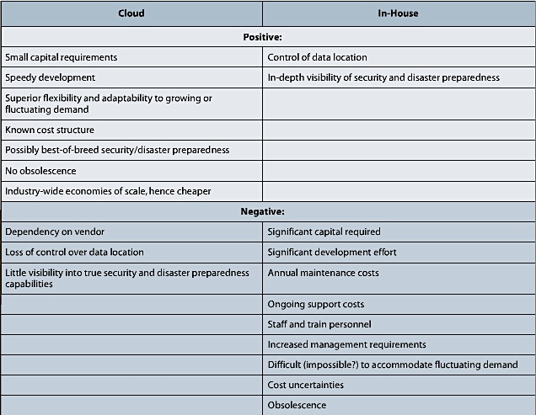
In-house hosting involves acquiring and training the personal to run the data center, and then manage them and your facility.

Three reasons that have made cloud-based hosting advantageous today:
- First, processors, data communication, and data storage are so cheap as to be nearly free.
- Virtualization technology enables the near instantaneous creation of a new virtual machine. The customer provides a disk image of the data and programs of the machine it wants to provision.
- New Internet-based protocols and standards have enabled cloud-hosting vendors to provide processing capabilities in flexible yet standardized ways. service-oriented architecture (SOA)

Cloud-based service offerings can be organized into 3 categories:
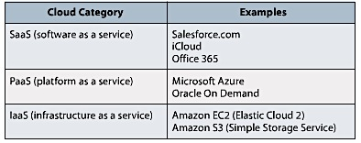

- SaaS provides hardware infrastructure and also an operating system and application programs.
- PaaS: vendors provide hosted computers, an operating system, and possibly a DBMS. Organizations add their own applications to the host.
- IaaS: is the most basic cloud offering, which is the cloud hosting of a bare server computer or disk drive.

Module 3: Business Processes, Information Systems, and Information

Q1: What is a business process?

Business Process: is a sequence of activities for accomplishing a function.
- For example, your university has business processes to: add a class to the business curriculum, add a new section to a class schedule, etc.
- Activity is a task within a business process.
- Business processes also involve resources, such as people, computers, and data and document collections.

Business Process Model and Notation (BPMN) Standard: one of the techniques for documenting business processes.
- We use this one because it is a global standard and is popular in the industry.
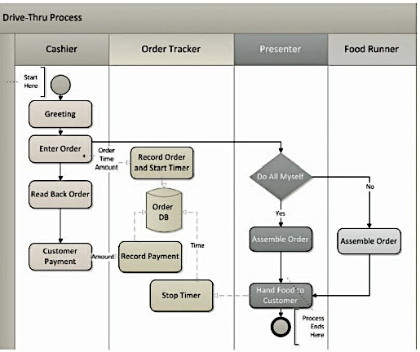
- Example of BPMN:

- The BPMN standard defines dozens of symbols;
- Activities are in rectangles with rounded corners.
- Decisions are in “diamonds”
- Solid arrow shows the flow of the action
- Dotted arrow shows that the flow of the data
- Repository: collection of something, usually a collection of records. It’s often a database.

Why do organization standardize business processes?
- Benefits:
- Policies can be enforced.
- Results are most consistent
- Processes can be copied and reused; they are scalable. Same process, same results.
- Risks from errors and mistakes are reduced: If every employee follows the same process, the chances of committing an error reduce.

Q2: What is an information system?

System: is a group of components that interact to achieve some purpose.
- So an information system is a group of components that interact to produce information.
- There are 5 components to an IS:
- Computer Hardware: “do things”
- Software: “tells hardware what to do”
- Data: bridge between the machine side, and the human side.
- Procedures: “tell people what to do”
- People: “do things”
- Also referred to as computer-based information system.
- How to apply the 5 component model:
- Recognize that you are the key: You are part of every information system you use. The quality of your thinking determines in large part the quality of the information system.
- Make each component work.
- Estimate the scope of new information systems: understanding the limits of the information system. e.g. Which jobs will change? Who will need training?
- Order components by difficulty and disruption.

Q3: How do business processes and information systems relate?

The role of procedures:
- A procedure is a set of instructions for a person to follow when operating an IS.
- Different procedure for every process and a process will have a different procedure for every IS that supports it.
- When the IS or process change, the procedure will also change.
- ** Difference between process and procedure**

Q4: How do structured and dynamic processes vary?

Structured Processes: are formally defined, standardized processes.
- Examples: scheduling work shifts, calculating daily tax totals; anything day-to-day operations.

Dynamic Processes: are less specific, more adaptive, and even intuitive.
- Examples: deciding whether to open a new store location and how best to solve a problem or poor employee.

Characteristics of these two processes:
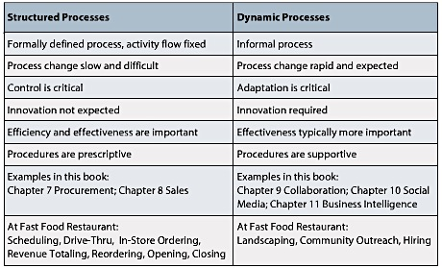
Why are dynamic processes evaluated on effectiveness more than efficiency? Because they change so fast that it is not possible to measure efficiency over time.

Q5: What is Information?

Information: is knowledge derived from data.
- Example: Jack earns $11.50 per hour at the restaurant and that Sally earns $10.00 per hour are data. The statement that the average wage of all hourly wage employees is $10.37/hour is information.
- Another definition: information is data presented in a meaningful context.
- Third definition: information is data processed by sorting, filtering, grouping, comparing, summing, averaging, and other similar operations.
- Common elements in the definitions:
- It’s not data, it is more
- Varies from person to person
- Is located inside of you
- Benefits of understanding information:
- Assume it’s hard to communicate: Having the same data does not guarantee that the people dealing with the data will interpret it the same.
- Recognize that all new IS are frustrating at first.
- Understand how to be effective on a team. To help your teammates, provide data that is different from what they already know so they can create information for themselves. Take that information and see how different it is from your point of view; understanding these differences can help you see different sides of the data.
- Stay curious.

Q6: What are necessary data characteristics?

Characteristics:
- Accurate: Good information is conceived from accurate, correct, and complete data that has been processed correctly. Accuracy is crucial; business professionals must be able to rely on the results of their information systems.
- Timely: Good information requires that data is available in time for its intended use.
- Relevant: Data should be relevant both to the context and to the subject.
- Just sufficient.
- Worth its cost: Data is not free. For data to be worth its cost, an appropriate relationship must exist between the cost of the data and its value.

Module 4: Using IS to Improve Processes

Q1: What are the important characteristics of processes in organizations?

Review from Module 3:
- Actors: are resources who are either humans or computer hardware.
- Role: is a subset of the activities in a business process that are performed by a particular actor.

Scope of Processes:
- Operational: commonplace, routine, everyday business processes.
- The procedures/instructions are changed very infrequently.
- There are more computerized actors in an operational process than in other types of processes.
- Due to the fact that there are many actors that contribute to this process, changing operational processes is more difficult than changing other types of processes.
- IS that facilitate these processes are sometimes called “ Transaction Processing Systems” (TPS).
- For example: order supplies, pay bills, check out customers.
- Managerial: concern resource use.
- These processes occur less frequently and with fewer computerized actors than operational processes
- IS that facilitate managerial processes are sometimes called “Management Information Systems” (MIS)
- For example, planning, assessing, and analyzing the resources used by the company in pursuit of its objectives.
- Strategic: seek to resolve issues that have long-range impact on the organization.
- These processes have broad scope and affect most of the firm.
- Because judgment and a tolerance for ambiguity are important, there are typically more human actors than in operational or managerial processes.
- IS that support strategic processes called “ Executive Support Systems” (ESS)
- For example, decide on new restaurant location, corporate budgeting.

Objective of Processes:
- Objective: desired goal an organization has decided to pursue. There are 2 types of objectives:
- Efficiency: means that a process creates more output with the same inputs or the same output with fewer inputs. In other words, it’s a ratio of process of outputs to inputs.
- An efficiency objective aims to conserve resources.
- Effectiveness: An effective objective helps achieve an organizational strategy.
- An effectiveness objective helps achieve a company strategy.

In summary, the characteristics of processes are:
- Stability of Flow: either Structured or Dynamic (covered in mod 3)
- Scope: operational, managerial, or strategic
- Objectives: effectiveness, efficiency.
- Location in value chain: inbound logistics, operations, outbound logistics, sales and marketing, service, technology development, and infrastructure.

Q2: What are Examples of Common Business Processes

The fourth characteristic of processes is their place within the value chain.
** Value Chain: Module 1**

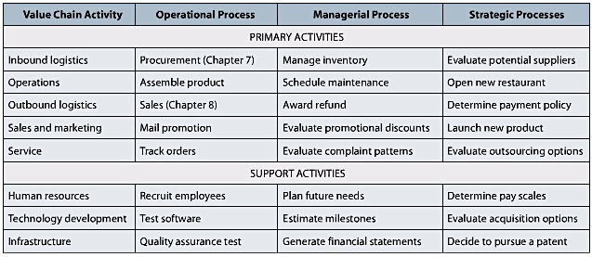
Value Chain Activities and Process Examples:

Inbound Logistics Processes:
- These processes receive, store and disseminate product input.
- This includes Procurement, Manage Inventory, and Evaluate Potential Suppliers.
- Procurement: is an operational process that acquires goods and services. For example, ordering ingredients and boxes as well as receiving and paying for those items. Will be discussed in Chapter 7
- Inventory Management: basically uses past data to compute stocking levels, reorder levels, and reorder quantities in accordance with inventory policy.
- Choosing suppliers that were previously approved by the strategic process called “ Supplier Selection”.

Operations Processes:
- This process transforms inputs into outputs, and in some industries, it is called the production process.
- Operations processes schedule the equipment, people and facilities necessary to build or assemble a product/service. For example, assembling and baking a pizza is considered as 2 different operational processes.
- An example of a management operations process is scheduling maintenance on the ovens.
- Strategic processes evaluate if the pizza company should open another restaurant or change its menu.

Outbound Logistics Processes:
- These processes collect, store and distribute products to buyers. It concerns the management of finished-goods inventory, and the movement of goods from that inventory to the customer.
- Sales process: records the sales order, ships the product, and bills the customer.
- A managerial outbound logistics process is Award a Refund.
- A strategic outbound logistics process is Determine Payment Policy; if the shop will accept personal checks.

Sales and Marketing Processes
- This process provides the means and incentives for customers to purchase a product or service.
- Its primary objective is to find prospects and transform them into customers by selling them something.
- Mail promotion (O.P), Evaluate promotional discounts (M.P), and Launch new product (S.P).

Service Processes:
- Providing after-sales support to enhance or maintain the value of a product is called service.
- An example of management service process evaluates customer complaints to determine if there are patterns to the complaints such as day of the week or a particular delivery person.
- Evaluating Outsourcing Service Options is a strategic service process.

Human Resources Processes:
- These processes assess the motivations and skills of employees; create job positions; investigate employee complaints; and staff, train, and evaluate personnel.
- Operational HR: recruit, compensate, and assess employee performance for the organization.
- Management HR: address the development and training of the organization’s workforce and planning for future needs.
- Strategic HR: determine pay scales, authorize types of incentives, and decide organizational structure.

Technology Development Processes:
- These processes include designing, developing, and testing technology in support of the primary activities.
- Operational T.D. : tests whether newly developed software can handle ten of thousands of possible keystrokes entries.
- Managerial T.D.: estimates time required for each step in a software development process.
- Strategic T.D: decides if a particular technology will be purchased or developed by the company.

Infrastructure Processes:
- These processes are essential supporting processes in the organization that enable day-to-day operations.
- Processes in accounting, administration, quality assurance, and legal and financial areas.
- Operational: executing the quality assurance evaluation
- Managerial: the production of financial statements.
- Strategic: determining if a patent should be obtained for a new product.

Applying Process Characteristics:
- Ask good questions about objectives
- Standardize structured processes; keep dynamic processes fluid.
- Don’t confuse process and IS.
- Ensure processes work together.

Q3: How can Management Improve Processes?

Process improvement: means that a process better achieves its objectives based on its measures.

Process Objectives:
- It the job of the managers responsible for the process to make sure that the objectives are specified and clearly communicated, so process participants can better understand how the process can be improved.
- Objectives can either be efficient or effective. For example, “reduce time needed to place an order by phone” is an efficiency objective, where as “sell to freshmen” is an effectiveness objective. It is important to clarify the type of objective you are dealing with.
- It is also important for managers to make unstated objectives explicit.
- Managers have to ensure that objectives are appropriate for the strategy.

Process Measures:
- Measures: a.k.a metrics, are quantities assigned to attributes. Measures are also called key performance indicators (KPIs) by process improvement experts.
- For example, a measure for the Deliver process is the time in minutes between leaving the store and arrival at the customer’s location.
- Just as there are many possible objectives for each process, there are many possible ways to measure each objective. It’s the manager’s job to specify the measure.
- When considering measures, recognize they all have limitations and that the key business challenge is to select the best ones available and know their limits.
- Managers should be able to recognize when a measure is no longer appropriate for a process; changing it is okay.

Q4: How Can Information Systems Be Used

Options for improving a process with an IS:
- Improve an Activity. For example, at the pizza shop, the delivery process driving activity can be improved by adding a GPS to each delivery vehicle that displays traffic updates. As a result, the measure of delivery objective – delivery time – is improved.
- Improve Data Flow Among Activities. For example, display order process data on GPS in delivery process you’ll know when to put gas.
- Improve Control of Activities. In general, control limits behaviour. So by limiting the behaviour of the activities, control helps the process provide consistent results.
- Use Automation. Automation means that a computer does an activity or a part of an activity that was once done by a person. For example, ATM replaced some of the activities performed by tellers.
- Improve Procedures. Procedures in business need to be constantly refined as technology changes and processes change.

Q5: How can Process Management Principles Improve Processes?

There are a number of process principles that can improve processes, as shown in the figure below. Process management experts call these process improvement principles a number of name; systems engineering, workflow/WfMc, Business process modeling, business process reengineering, continuous improvement, xMatrix, kaizen and six sigma.
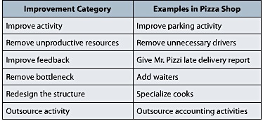

- You can improve an activity without necessarily improving the IS. One way of improving it is by adding more resources.
- You can also remove unproductive resources from a process; also known as cutting slack.
- You can also improve the feedback generated by the process. With better feedback, process managers and participants can identify problems, suggest process improvements and test potential solutions.
- You can also remove a process bottleneck; it occurs when one activity reduces the performance of the overall process.
- Changing the structure of a process can also improve it; changing structures means to change the arrangement or roles of the activities.
- Outsource an activity: have a supplier, customer, or business partner do one of the activities in the process.

The most common approach to process improvement, particularly in the manufacturing industry, is called Six Sigma.
- Six Sigma seeks to improve process outputs by removing causes of defects and minimizing variability in the process.
- Each Six Sigma project follows a very structured sequence of steps with quantified financial measures.
- Its goal: that 99.99966% of process outputs will be free from defects.
Q6: How Do Process Teams Diagram Process Improvement

Process improvement at medium to large organizations always involves a team. The team typically includes the users who are the actors in the process, general managers responsible for the process, IT analysts, and business analysts.

“As-is” Diagrams: diagrams of the current process.
“Ought-to-be” Diagrams: diagrams of suggested improvements.

Q7: How Can an IS Hinder A Process?

Information systems usually support and improve processes. However, sometimes they are the goat. If an IS prevents or restricts the data flow, this can hinder a process.
- This is called an information silo – the data needed for a process activity is unavailable because it is stored in an isolated, separated information system.
- For example, your smartphone: You may have music, email, chat, contact and other data on your smartphone that is not easily synced with similar programs on your laptop.
- One way to fix the information silo problem is by duplicating the data – make it available to any other process that needs it. The problem with that is that the data can become inconsistent with the actual data.
- The best solution is: store a single copy of data in a shared database and connect the business processes to that database.

Why do information silos still exist?
- Some companies decide to store data in separate databases for several reasons.
- Each department in an organization may have different objectives.

Module 5 Part 1: Supporting the Procurement Process with SAP

Q1: What are the Fundamentals of Procurement?

Procurement: process of obtaining goods and services.
- The three main activities include:
- Order
- Receive
- Pay
- It is the most common organizational process
- Example of this process: inbound logistics
- It is an important process because it is the only one that spans the entire organization
- Purchase order: written document requesting delivery of a specified quantity of a product/service.
- Tires are received
- CBI (business name example) updates raw material inventories
- Bills arrives from supplier
- Supplier is paid
- CBI maintains 2 types of inventory:
- Raw materials: produced from the suppliers
- Finished goods: completed products waiting to be delivered to the customers

Q2: How Did the Procurement Process at CBI Work Before SAP?

The procurement process at CBI before SAP had 6 roles:
- Recognize that item is below reorder point
- Look over previous purchases to discover a good supplier
- Determine the order quantity
- Create purchase order
- Order goods
- When item is received, unpacked and counted; the inventory is updated

Lead-time: time required for a supplier to deliver an order.

Invoice: also called an itemized bill, shows the amount due and the purchase order number for that invoice. The data on the invoice is entered into the Accounting database.
- To make sure that the data on the invoice matches the data in the purchase order and the goods receipt; accountants do a three-way match between the three things listed above and match specific data, such as supplier name, PO number, shipped items, ship quantity, and price.

Q3: What Were the Problems with the Procurement Process before SAP?

- Warehouse Problems:
- The key problem is that the warehouse manager does not have data on sales process discounts.
- In order words, the warehouse manager could see the items that were sold the previous day, but the data didn’t include any discounts; that data only appears in the sales information silo.
- For example: running out of raw materials because finished goods inventory and raw material inventory shared the same warehouse.
- Accounting Problems:
- When there is a discrepancy in a three-way match, the accountants have to do a costly and labour intensive process to send e-mails to warehouses/suppliers to solve the problem.
- Reports always lagged: never up-to-the-minute or up-to-the-day. This was a result of not sharing real-time accounting data.
- Reports were produced at the end of the month; it takes several days to “roll up” (compile and summarize) the accounting transactions into balance sheets and income statements.
- Current data allows firms to detect problems sooner and solve them right away.
- Purchasing Problems:
- Purchasing agents were scattered throughout the firm. They all had different training, experience, and motivation.
- As a result, they produced a variety of mistakes on the purchase orders.
- It is also harder to train them because they were scattered all over the organization.
- Internal Control: could be a possible solution; internal controls can systematically limit the actions and behaviours of employees, processes, and systems within the organization to safeguard assets and achieve objectives.

Q4: How does CBI Implement SAP?

Implementation Process: the steps required for CBI (company) to install an ERP system.
- These steps include:
- Re-examine Strategy: This step can be done by assessing industry structure, picking competitive strategy, and selecting an ERP vendor. (TOP MANAGEMENT)
- Construct Gap Analysis (TOP MANAGEMENT)
- Develop Processes: This step can be completed by determining objectives and measures, and by choosing inherent processes. (ERP TEAM)
- Configure the ERP Software (ERP TEAM)
- Install: write procedures, train users, and test the system. (IT STAFF)
All SAP implementations start with an SAP industry-specific platform

ERP Vendor examples: SAP, Oracle, and Microsoft.

Q5: How Does the Procurement Process Work at CBI After SAP?

Purchase Requisition (PR): is an internal company document that issues a request for a purchase.
- e.g. When raw material inventory goes below the reorder point, PR is automatically generated.

Examples of Steps in a Procurement Process:
- Purchasing: If the purchasing manager approves the purchase, well he converts the PR into a purchase order (PO). Whereas the automatically generated PR is a CBI document, the PO is a document that CBI shares with its suppliers, and if accepted, is a legally binding contract.
- To execute this activity, the manager follows the Create Purchase procedure. To do so, the manager needs to log into SAP. Once the PO is found and saved, SAP accomplishes several other tasks. SAP creates a unique PO number and this number is displayed on the screen; SAP notifies the supplier.
- Warehouse: Once the PO is saved and transmitted to the supplier, the next activity at CBI is Receive Goods when the shipment arrives.
- On the computer screen, you will see “ Good Receipt Purchase Order” on SAP.
- The header also includes a date.
- Once the receipt is saved, SAP creates a document number for this particular goods receipt. It also updates records in the Raw Material Inventory table in the database to reflect the addition of these new bottles and cages.
- Accounting: The next activity, Receive Invoice, occurs when the supplier company sends CBI an invoice for the material. The accountant of the company receives the invoice the day after the material arrives.
- To record the arrival of the invoice, the accountant executes the Enter Incoming Invoice procedure. On that page (on SAP), you will have to enter the date of invoice, the Amount, and the PO number.
- The system then finds other data about the PO and displays it on the screen. This data includes the vendor name, and address and the items that were ordered. Each item has its own row.
- The accountant then saves the data, SAP records the invoice, displays a new document number for this invoice, and updates the accounting data records to reflect the arrival of the invoice.
- The final activity is Pay Supplier. – Post Outgoing Payment page. On the computer screen, the accountant enters the date of payment, the bank account, and the amount.
- Then she clicks on “ Process Open Items” icon and then saves the transaction.
- A document number is again created, and an accounting update is made to reflect the outgoing payment.

The benefits of SAP for the CBI Procurement Process:
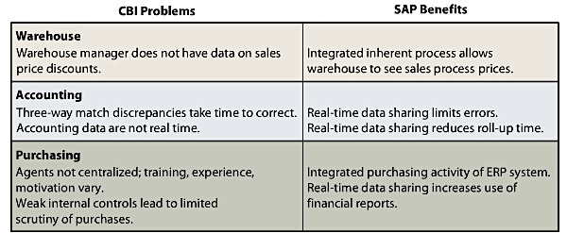

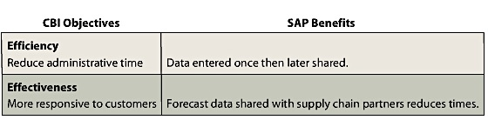
The use of SAP also allows the company to reach their objectives:

Q6: How Can SAP Improve Supply Chain Processes at CBI?

Several Processes in a given company’s Supply Chain:
- The Supplier Relationship Management (SRM) process: automates, simplifies, and accelerates a variety of supply chain processes.
- Broader than the single Procurement process, SRM is a management process helps companies reduce procurement costs, build collaborative supplier relationships, better manage supplier options, and improve time to market.
- The Returns Management Process: manages returns of faulty products for business.
- It is also a managerial process.
- Efficiently getting the defect to the right supplier and charging the right cost to each company in the supply chain are the goals of the Returns Management process.
- The Supplier Evaluation process: determines the criteria for supplier selection and adds and removes suppliers from the list of approved suppliers.

Supply Chain Management (SCM): the administration of supply chain processes.
- It is the design, planning, execution, and integration of all supply chain processes.
- It uses a collection of tools, techniques, and management activities to help businesses develop integrated supply chains that support organizational strategy.
- SAP offers SCM capabilities and can help CBI improve this set of processes.
- Inventory Management

Improving Supply Chain Processes by Sharing Data:
- For example, data from the Returns Management process about defective bicycle parts should be shared with the Supplier Evaluation process to ensure that suppliers with high defect rates are removed the list of approved suppliers.
- Sharing sales data with suppliers in real means that suppliers can anticipate the company’s orders and make raw materials in anticipation of orders, reducing lead time.
- Sharing data not only reduces raw material inventory at CBI, it helps reduce the bullwhip effect in the supply chain.
- Bullwhip effect occurs when companies order more supplies than are needed due to a sudden change in demand.

Improving Supply Chain Processes with Integration:
- The second characteristic of ERP, process integration, can improve the set of supply chain processes at CBI.
- Integration: occurs when processes are mutually supportive; that is, when one process is done well, the objectives of another process are also achieved.
- For example: you integrate your dating and studying processes when you study with your boyfriend.
- Example in the CBI company: The Returns Management process collects data on defective returns from retailers of CBI bikes and accessories. The final step of the Returns Management process is to analyze how to improve the Production process to create fewer defects and thus fewer returns. When the Returns Management process is done well, an objective of the Production process is supported.

Examples of Process Integration Among Supply Chain Processes:
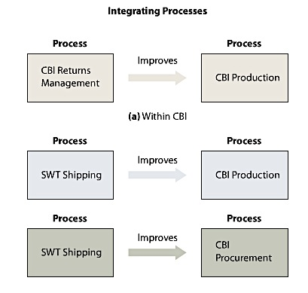

Improving CBI Processes Beyond the Supply Chain:
- The most common enterprise-wide approach is to use SAP in Accounting, Procurement, Production and Sales.
- Other major categories: R&D Processes, IS processes, HR, Quality, BI.

Q7: How Does the Use of SAP Change CBI?

Changes seen in a company:
- New Skills Needed: this type of change is more subtle and less expected.
- For example, with more data being produced and saved, CBI will hire more people with abstract reasoning and analytical skills to look for patterns in the data that will lead to new ways to improve processes.
- Process Focus: this means being more focused on the inputs and outputs of its processes to connect with other partner firms.
- More Data Sharing: pressures from suppliers and customers to share more and more data will lead CBI to be more open with company data than in the past.
- Using more Outsourcing: Many firms outsource parts of their production to take advantage of other firms that can produce a subassembly or service cheaper than they can.

- Another major change is that the system automatically tracks raw material inventory and generates purchase requisitions when reorder levels are reached.

Q8: What New IS Will Affect the Procurement Process in 2024?

SAP is just one IS that has an impact on procurement processes.

Other IS Technologies:
- Augmented Reality (AR): Computer data or graphics are overlaid onto the physical environment.
- For example, Google Glass, which superimposes computer data on eyeglasses to augment what the user sees when looking through the glasses. Using these glasses, workers at CBI can look at the warehouse and see overlaid on top data about the location of a product they are looking for, the arrival date of the next shipment of an item or the weight of a container.
- Radio-Frequency Identification (RFID): technology can be used to identify and track items in the supply chain.
- For example, in the supply chain domain, suppliers put RFID chips on the outside of boxes and shipping pallets so that when those boxes get to their destination, the receiving company can know the contents of the box without opening it. This makes tracking inventory faster and cheaper for all collaborating companies in a supply chain.
- Companies can also put sensors/tracking devices in their trucks.
- The forklifts rely on RFID chips on pallets to locate the pallet in the warehouse and to know where to deliver the pallet.
- 3D Printing: also affects procurement processes.
- It is also called additive manufacturing
- 3D printing creates objects that are manufactured through the deposition of successive layers of materials.
- Rather than relying on suppliers for all its raw materials, CBI may choose to “print” some raw material in house.

Module 5: Part 2: Supporting Processes with ERP Systems

ERP systems are wonderful tools to help reduce costs and achieve strategic goals, but as university will find, successfully installing an ERP system is exceptionally challenging.

Q1: What Problem Does an ERP System Solve?

Before ERP, departments of companies, such as Central Colorado State, ran their own processes using their own information systems and databases. This created information silos everywhere.
- Because information silos exist in isolation from one another, they create islands of automation that can reduce the performance of processes and make process integration difficult.
- Information silo problem is solved by ERP systems.
- For now, keep in mind that ERP systems are very large enterprise IS that bring data together in a big database and help a company improve its processes.

Solutions:
- Enterprise Application Integration (EAI): system tackles the silo problem by providing layers of software that connect information systems together.
- Enables information silos to communicate with each other and to share data.
- Layers of EAI include: Accounting, HR, Sales, and Operations. So basically, the EAI server communicates with the EAI Metadata, but the EAI server is the one connecting with the EAI interfaces of each of the layers.
- Functions of EAI:
- It connects information silos via a new layer of software
- It enables existing applications to communicate and share data
- It provides integrated data
- It leverages existing systems, leaving departmental information systems as is, but providing an integration layer over the top.
- It enables a gradual move to ERP.
- The major benefit of the EAI connect-the-silos approach is that it enables organizations to use existing application while alleviating many of the problems of information silos.
- Converting to an EAI system is not nearly as disruptive as converting to an ERP system, it can be less expensive and it provides many of the benefits of ERP.

- Enterprise Resource Planning (ERP)
- ERP system solve the silo problem, but with a centralized approach.
- ERP have 2 key characteristics:
- It creates a single database. By consolidating data, a company can avoid the problem of having multiple versions of the same thing.
- Provides a set of industry-leading processes that are well integrated with each other. In other words, takes all the processes of a company and integrates them all into 1 big database.
- For example, the data from a new sale is immediately sent to the database and that new data updates the pace of production and the procurement of supplies.

ERP Implementation: Before and After Examples:

Example 1: Single Process – University Purchasing
- Before, each university department works with its own purchasing agent to buy goods and services from 3 different suppliers.
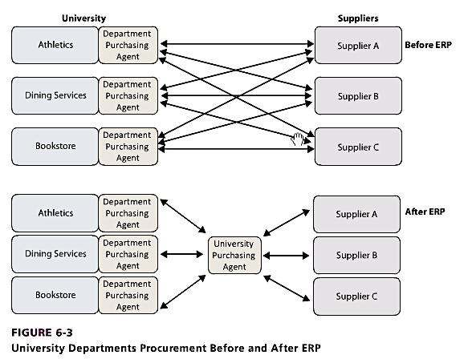
- After installing ERP, each department-purchasing agent works through a centralized university purchasing agent who in turns buys from the three suppliers. By integrating all the purchasing activity in one central office, the school is better able to standardize its purchasing process, manage it more effectively, and gain bargaining power over suppliers.

- Rather than storing data in department information silos, the new ERP process consolidates all the procurement data for the different departments in a central database.
- In the language of business processes, measures are often called key performance indicators (KPIs).

Example 2: Many Processes- Chuck’s bikes:
- Before implementing the ERP system, CBI had 5 databases; vendor, raw material, manufacturing, finished goods, and customer relationship management.
- These 5 databases are information silos, isolated from each other as they support different processes.
- CBI faces difficulty when data need to be shared in real time.
- With ERP, all of CBI’s data is consolidated into a centralized ERP database, which makes it easier to share data.

Q2: What Are the Elements of an ERP System?

History:
- By the 1970s, businesses began to buy their own mainframe computers and manufacturing companies began to use software called Material Requirements Planning (MRP) to efficiently manage inventory, production, and labour.
- When computing became cheaper, Manufacturing Resource Planning (MRPII) was developed that added financial tracking capabilities as well as the opportunity to schedule equipment and facilities.
- The business environment continued to evolve with the advent of Just In Time (JIT) delivery. JIT integrates manufacturing and supply. To execute JIT, tight supplier relationships were needed. These relationships depended on unimpeded flows of data between partners.
- Couple years later, new federal laws such as the Sarbanes-Oxley Act (SOX) required companies to exercise greater control over their financial processes, and ERP systems addressed that new requirement.

For a product to be considered a true ERP product, it must include applications in the following business functions:
- Supply Chain Management: procurement, sales order processing, inventory management, supplier management, and related activities.
- Manufacturing: manufacturing scheduling, capacity planning, quality control, bill of materials, and related activities
- Customer Relationship Management: sales prospecting, customer management, marketing, customer support, call center support.
- Human Resources: payroll, time and attendance, HR management, commission calculations, benefits administrations, and related activities.
- Accounting: general ledger, accounts receivable, accounts payable, cash management, fixed-asset accounting.

Components:
- Software: ERP software typically resides on servers and on client machines in the company.
- The software can be customized to meet customer requirements without changing program code: called configuration.
- A company will make more than 8,000 configuration decisions to customize the ERP system to its needs.
- If a new ERP customer has requirements that cannot be met via configuration, then the customer either needs to adapt its business to what the software can do or write application code to meet its requirements: called customization.
- Data: An ERP solution includes a gigantic but largely unpopulated database, database design, and initial configuration data.
- Operational data are entered during development and use of the system.
- ERP systems rely on a DBMS to process and administer the ERP database.
- Different types of data:
- Transactional Data are data related to events such as a purchase or a student enrolment. For the university; purchases at the bookstore, student tuition payments, deliveries, and payroll expenditures.
- Master Data, also called reference data, are data used in the organization that don’t change with every transaction. This includes supplier names and addresses, item names, and units of measures, and employee data.
- Organizational Data are data about the university/company, such as the location of its warehouses, the mailing addresses of the buildings, and the names of its financial accounts.
- Hardware: Each ERP implementation requires a wide variety of hardware, including disk storage, servers, clients, printers, scanners, network devices, and cables.
- To determine the necessary levels of each of these hardware devices, an organization first estimates the number of users, the processes supported, and the volume of data for intended system.
- Cloud Computing is a new hardware opportunity that emerged and that affects ERP systems.
- With the cloud, ERP systems may be rented with a much lower upfront cost, stored on cloud vendor hardware, and paid for by use.
- Most ERP vendors are offering cloud-based solutions, and this segment of the ERP market is growing 3 times faster than on-premises ERP.
- Procedures: a procedure is a set of instructions for a person to follow when operating an IS.
- Every ERP installation requires a firm to select ERP processes and then specify how those processes will be executed on the ERP software.
- These specifications and procedures are unique to the firm.
- Procedures are also an important opportunity for organizations to improve control of a process.
- A well-written procedure for a process can limit the behaviour of people executing the process. By limiting behaviour, procedures help processes provide consistent results – less errors.
- Crafting the procedure is the first step; training employees to use the procedure is the second step.
- Training employees can be time-consuming and costly. This is why ERP vendors have developed extensive training classes and training curricula to enable users to learn the ERP system.
- ERP vendors typically conduct classes on site prior to, during, and after implementation.
- People: the people involved with an ERP into 3 general categories:
- Users: are the employees of the firm implementing the system
- IT analysts, also called systems analysts, are also employees. They have specialized training or education that enables them to support, maintain and adapt the system after it has been implemented. They usually have background in MIS or IT.
- Consultant: works for the ERP vendor or a different company, called a third party, and helps budget, plan, train, configure, and implement the system.

Inherent Business Processes: ERP specify processes called inherent processes or process blueprints.
- To transform an existing process to an inherent process, changes must be made.
- Companies must either adapt to the predefined inherent processes of design new ones.
- Designing a new one is expensive. It also involves changes to software and database structures.

How does a firm put all these components together?
- First, the top managers of the company revisit their strategy so that the ERP system has clear goals.
- Next, they conduct a gap analysis, a study that highlights the differences between the business requirements that emerge from strategic planning and the capabilities of the ERP system.
- Then, the implementation team develops processes it will use and configures the software.
- Lastly, the company’s IT staff writes procedures, trains the users, and tests the system.

Q3: What Are the Benefits of an ERP System?
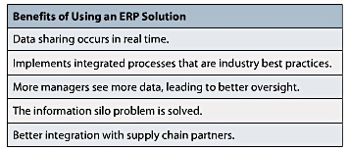

- Real-Time data sharing allows managers to see trends as they occur and respond appropriately.
- Leads to better management. To help managers spot trends and changes, ERP systems can provide managers with dashboards, which are easy to read, concise, up-to-the-minute displays of KPIs. A process dashboard will show sales for today, output of a production machine, or a summary of expenditures for the current month.

Q4: What Are the Challenges of Implementing an ERP System?
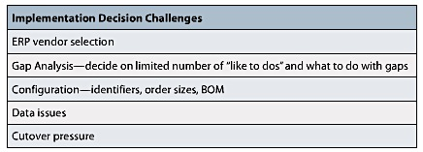
1) Decision-Making Challenges:

- Client firms have unique needs, and ERP vendors have a variety of strengths and weaknesses. Picking the right vendor is an important challenge because it creates a long-term relationship between the firms; this relationship will have an impact on the effectiveness of the ERP system for the length of the contract.
- Deciding what the company would like the ERP system to do leads to a long list of “likes” and that eventually leads to a long list of gaps and a difficult implementation.
- The top leadership team should make sure that a focused, well-understood, short list of “likes” is adopted. THEN, the company can write custom codes, look for a solution outside ERP to solve the gap issue or just live with the gap for now.
- Many of the decisions require a wide understanding of both the business and the ERP system.
- BOM: bill of material is a decision that needs to be made about raw materials, quantities, and subassemblies needed to create a final product.
- Cutover is like deciding which option to use to overcome an addiction.

2) People Challenges: In addition to the challenge of making good decisions, the actions and attitudes of the people of the client organization can make implementation even more challenging.
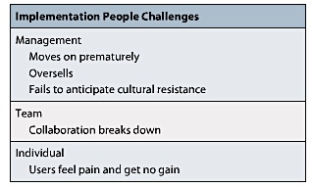

- Managers believe that once the decision to implement is made, they move on. Instead, they need to stay involved and ensure implementation is monitored, resources are committed, good procedures are written, and thorough training is conducted.
- Often management can be blinded by the benefits of the promised system and not look carefully at the assumptions behind the promises – managers buy more features than it needs.
- An ERP implementation can change the culture of an organization – day-to-day work habits and practices that workers take for granted and is hard to see and change. Changing the culture can lead to employee resistance.
- Implementing an ERP system requires extensive and effective collaboration; when collaboration breaks down, implementation suffers.
- The people, whose work has changed, often receive no benefit from the change; they get the pain but no gain.

ERP Upgrades Challenges:
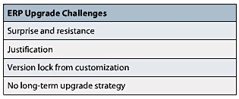

- Aggressive client firms upgrade their ERP systems every 2-3 years, whereas as less aggressive firms update it every 5-6 years.
- Resistance can be strong if people believe that the upgrade will be as disruptive as the original implementation.
- It might be more challenging to justify upgrades than an original implementation
- Version lock: when the ERP vendors upgrade their system to a new version, the new software may not be compatible with the customization done by client firms. Upgrading is harder for clients who customized a lot.

Q5: What Types of Organizations Use ERP?

ERP by Industry Type: Manufacturing, Distribution, Mining, Material Extraction, Petroleum, Medical Care, Government & Public Service, Utilities, Retail, and Education.

ERP by Organization Size: ERP was originally just used by large manufacturing organizations that had complex problems than needed ERP solutions.
- Companies of different sizes have one very important difference that has a major impact on ERP; the availability of skilled business and IT analysts.

International Firms and ERP:
- Some organizations operate in different countries: ERP must be available in many languages and currencies.
- International ERP solutions are designed to work with multiple currencies, manage international transfers of goods in inventories, and work effectively with international supply chains.
- ERP also provides a worldwide consolidation of financial statements on a timely basis.
- Single instance: when international firms consolidate all their operations within one large ERP implementation.
- Multiple instances: ERP per country/region/business unit.

Q6: Who Are the Major ERP Vendors:

SAP has the largest market share and longest history, while Oracle and Microsoft have trailed in that order for most of the previous decade.

ERP Products:
- Microsoft Dynamics: is composed of 4 ERP products, all obtained via acquisition: AX, Nav, GP, and SL.
- AX and Nav have the most capabilities.
- GP is smaller and easier to use.
- The future of SL is particularly cloudy; Microsoft outsources the maintenance of the code to provide continuing support to existing customers.
- A Dynamic implementation is typically smaller in scale and functionality and, as a result, a bit less expensive and time consuming to implement.
- None of these products are well integrated with Microsoft Office, and none of them are integrated with Microsoft’s development languages.
- Each product is heading in a different direction, and none of them are attached to the primary Microsoft coach.
- Oracle: is an intensely competitive company with a deep base of technology and high-quality technical staff.
- Developed some of its ERP products in-house and has complemented those products with others obtained through its acquisition of PeopleSoft (high-quality HR products) and Siebel (high-quality CRM products).
- Oracle is not known for producing easy-to-use products, instead, it is known for producing fully-featured products with super performance.
- Expensive products
- Also interested in the cloud-ERP sector; owns 70% of NetSuite (cloud-based solution for integrated financial reporting for large, international organizations).
- SAP: is the gold standard of ERP products.
- Used by midsized and large companies and offers the most extensive line of ERP products.
- For small to midsized companies: Business ByDesign and Business One.
- It is expanding its cloud offerings with Cloud for Financials and Cloud for Customers.
- Outside of Tier 1: While the titans of Tier 1 duke it out trying to be everything to everybody, smaller firms are establishing a strong niche by offering industry-specific systems, solutions for particular business functions, or pay-as-you-go cloud services.
- Tier 1 vendors: SAP, Oracle, Microsoft Dynamics
- Midsize to small firms find smaller, more nimble, or cloud-based solutions less disruptive and lower risk.
- Popular choice: salesforce.com

Q7: What Makes SAP Different from Other ERP Products?

SAP is a product of SAP AG; a German firm.
- Systems, Applications, Products.
- Founded in 1972 by 5 former IBM employees
- Third-largest software company in the world
- The core business of SAP AG is selling licenses for software solutions and related services.
- It also offers consulting, training and other services for its software solutions.
- SAP’s goal is to help companies make their business processes more efficient and agile.
- To speed up the configuration process, SAP produces and sells industry-specific platforms – is like a suit before it is tailored; it is a preconfiguration platform that is appropriate for a particular industry as retail, manufacturing, or health care.
- A common way to view SAP is as a collection of interconnected and interdependent modules -- distinct and logical grouping of processes.
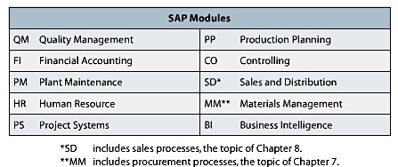

SAP Inputs and Outputs:
- Following the company’s procedures, you can enter data into a SAP display screen.
- Once something is saved onto SAP, you can’t delete it; SAP is designed to preclude deleting saved records. This control makes auditing and supervision of the transactions more complete and reduces the risks of fraud.
- Other controls limit the data the salesperson can enter; e.g. you can only enter an item that is in the inventory, ZIP codes much match cities, delivery locations must be specified.

SAP Software:
- First ERP software designed to work at different companies.
- Known version of SAP: R/3; program was the first truly integrated system that was able to support most of an organization’s major operational processes.
- Uses classic, native client, client-server architecture rather than browser-based approach that would be easier to use on a wide range of devices.
- SAP rebranded its R/3 Software as the SAP Business Suite.
- Runs a program called an application platform – for SAP, it is NetWeaver.
- NetWeaver is like the OS in your computer.
- It connects SAP to hardware, third-party software, and output devices.
- NetWeaver also has SOA capabilities that help it integrate SAP with non-SAP applications. – more adaptive

From the quiz:

- System Analyst: understands the technical aspects of enterprise resource planning (ERP) and helps plan, configure, and implement an ERP system for company use.
- ABAP: is SAP’s high-level application language that is used to enhance the functionality of an SAP implementation.
- SAP provides industry-specific platforms that are configured to a particular company.

Module 7: Business Intelligence

Q1: What Challenges do Managers Face When Making Decisions?

For most people:
- Decision-making is a rational act in which individuals or groups consider the possible choices and the likely consequences and choose what they think is the best alternative.
- However, human beings are not “economic automatons” or “ lighting-fast calculators” who can compute the “perfect choice”; instead, we tend to settle, or satisfice, with an alternative that is generally good enough across a range of criteria.
- Because computers deal with large amounts of information, it should be no surprise that applying computers to improve decision-making is popular.

Who is Ackoff? Russell Ackoff wrote “Management Misinformation Systems” and suggested that designers of management information systems (MIS) make several erroneous assumptions about managerial decision-making and that computers might not necessarily provide good solutions.

Ackoff’s assumptions:
- The first assumption is that managers will have no problem making decisions if they get the data they need.
- Poor decisions are made because managers lack relevant information.
- He also argued that managers suffer from an overabundance of irrelevant data – Information Overload.
- Managers know what data they need.
- However, managers do not know what data they do NOT need (goes along with assumption #2).

Information overload:
- According to International Data Corporation (IDC), the digital universe is doubling in size every 2 years, and by 2020, the data copied and created annually will reach 44 trillion gigabytes (44 zettabytes).
- IDC also found that data is growing at the rate of 40% a year.
- The challenge for managers in a world overloaded with information is to find the appropriate data and incorporate them into their decision-making processes.
- So, at the end of the day, information systems can help the managers make the decisions but can also hinder the decision-making process due to the information overload problem.

Data quality:
- It’s already hard enough to make decisions when you have good-quality data, so imagine now if the quality of the data was poor.
- Problems with using raw/operational data for business intelligence systems:
- Dirty data: the data might be problematic. For example, using values such as B for customer gender
- Missing values; For example, a non-profit organization can process a donation without knowing the donor’s gender or age, but a data-mining application will be considered “impaired” if many such values are missing”
- Inconsistent data: particularly common in data that have been gathered over time.
- Data not integrated: can occur if the data reside in different sources or are incompatible with the intended purpose.
- The data’s granularity is also a problem

Data can also be too fine or too coarse:
- Data granularity refers to the degree of summarization or detail.
- Coarse data are highly summarized
- Fine data express details that are too precise. For example: clickstream data is the customer’s clicking behaviour data and is very fine.
- It is better to have fine data because you can sum it up or combine it – just Google Analytics does.
- If data is too coarse, you cannot “separate” the data into constituent parts.

A number of factors, such as complexity, uncertainty, information overload, and data quality make decision-making challenging.

Q2: What is OLTP, and How Does it Support Decision Making?

As discussed in Module 6, functional systems (general ledger systems, HR systems, and operational systems) are used to capture details about business transactions and then create uploaded information by processing these transaction details.
- Information systems are important for capturing and processing details about these transactions.
- Using computers to capture information electronically is often referred to as “being online”. For example, when a teller accepts your deposit, she puts it in the computer right away instead of writing it on a paper and submitting it electronically later.
- Most web-based applications are examples of online systems.

Online Transaction Processing (OLTP): When you are collecting data electronically and processing the transactions online.
- There are 2 basic ways that transactions can be processed:
- If transactions are entered and processed immediately on entry, then the system is operating in real-time because there is little or no delay in updating the system with new data.
- The other option is to wait for many transactions to pile up before you process them on the computer. (Also referred to “batch processing”)
- Choosing between real-time processing or bath processing really depends on the nature of the transactions, the cost of the system, and the needs of the organization.
- Real-time processing tends to cost more and is more complex, but provide the most up-to-date information. For example: selling tickets online – real-time processing makes more sense than bath processing.
- OLTP systems are the backbone of all functional, cross-functional, and interorganizational systems in a company.
- OLTP systems are designed to efficiently, enter, process, and store data. They also combine large databases with efficient input devices to process transactions quickly and accurately.

Q3: What are OLAP and the Data Resource Challenge?

Information is a competitive weapon and can be a source of competitive advantage for a company.
- However, it is can only be used as an advantage if the company uses the data they have collected to make better decisions.
- Data resource challenge: it’s basically when data is collected through OLTP, but is not used to improve decision-making.
- Quickest way to explain the data resource challenge is to consider whether a company views its data as an asset.
- The question you should ask yourself is “Who’s controlling this asset?”
- Systems that focus on making OLTP-collected data useful for decision-making are referred to as “decision support systems DSSs) or online analytic processing (OLAP systems)

Online Analytic Processing (OLAP):
- Provides the ability to sum, count, average, and perform other simple arithmetic operations on groups of data.
- Their format is dynamic
- The viewer of the report can change the report’s structure.
- An OLAP report has measures, or facts, and dimensions.
- Measure: is the data item of interest. It is the item that is be summed or averaged or otherwise processed in the OLAP report. For example: total sales, average sales, and average costs.
- Dimension: is a characteristic of a measure. For example: purchase data, customer type, customer location, and sales regions.
- The presentation of a measure with associated dimensions is often called an “OLAP cube” or just “cube”.
- With an OLAP report, it is also possible to “drill down” into the data – to further divide the data into more detail.
- Drilling down stores located in California; the report will show the four cities in California that have stores.
- OLAP reports can provide the manager with different perspectives; see store locations first then product data OR product families first then store location data. They can change it anytime.
- This flexibility comes at a cost.
- OLAP tools have become the primary tools used in the area of business intelligence.

Q4: What are BI Systems, and How Do They Provide Competitive Advantage?

Business Intelligence (BI) systems:
- System that provides information for improving decision-making.
- BI systems vary in their characteristics and capabilities, and in the way they foster competitive advantage.
- Characteristics and Competitive advantages of BI systems:

Business Intelligence System | Characteristics | Competitive Advantage
Group Decision Systems (GDSS) | Allow multiple decision makers to collaborate, often anonymously, and at different times and locations. | Improve decision outcomes by reducing many of the biases inherent in group discussion and option evaluation.
Reporting Systems | Integrate and process data by sorting, grouping, summing, and formatting.  Produce, administer, and deliver reports. | Improve decisions by providing relevant, accurate, and timely information to the right person.
Data-Mining Systems | Use sophisticated statistical techniques to find patterns and relationships. | Improve decisions by discovering patterns and relationships in data to predict future outcomes.
Knowledge Management Systems | Share knowledge of products, product uses, best practices etc, among employees, managers, customers and others. | Improve decisions by publishing employee and others’ knowledge. Create value from existing intellectual capital. Foster innovation, improve customer service, increase organizational responsiveness, and reduce costs.
Expert Systems | Encode human knowledge in the form “if/then” rules and process those rules to make a diagnosis or recommendation. | Improve decision making by non-experts by encoding, saving, and processing expert knowledge.

As with all information systems, it is important to distinguish between BI tools and BI systems.
- Business Objects licenses the reporting tool Crystal Reports, SPSS licenses the data-mining suite Clementine and Microsoft offers SharePoint Server as, in part, a KM system.
- All these products (^) are just software.

RFM Analysis: is a way of analyzing and ranking customers according to their purchasing patterns.
- Considers how recently (R) a customer has ordered.
- Considers how frequently (F) a customer orders.
- Considers how much money (M) the customer spends per order.
- It’s a useful analysis that can be readily implemented.
- To produce a RFM score:
- The application first sorts customer purchase records by the date of the most recent (R) purchase. The program then divides the customers into 5 groups and gives customers in each group a score of 1 – 5 (20% most recent = 1, […] the last 20% least recent = 5).
- Then the program re-sorts the customers on the basis of how frequently they order. The 20% of customers who order most frequently get a F = 1 […] the least frequently F=5.
- Finally, the program sorts the customers again according to the amount spent on their orders. The 20% who have ordered the most expensive items are given an M=1, […] the last 20% who spent the least M=5.

Q5: What are the Purpose and Components of a Data Warehouse?

Purpose of a data warehouse: is to extract and clean data from operational systems and other sources and to store and catalogue that data for processing by BI tools.

Components of data warehouse:

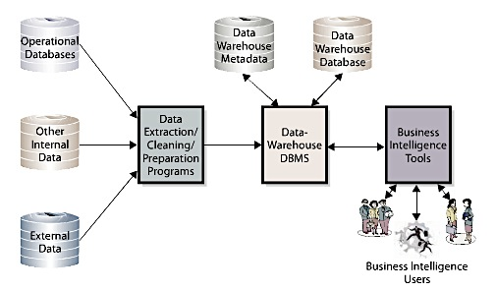

- Programs read operational data and extract, clean and prepare that data for BI processing.
- The prepared data are stored in a data warehouse database using a data warehouse DBMS, which can be different from the organization’s operational DBMS.
- For example, an organization might use Oracle for its operational processing, but SQL Server for its data warehouse. Other use SQL server for operational processing, but DBMSs from statistical package vendors, such as SAS or SPSS, in the data warehouse.
- Data warehouses include data that are purchased from outside sources. A typical example is customer credit data.
- List of consumer data that can be purchased from commercial vendors: Name, address, phone, age, gender, ethnicity, religion, income, education, voter registration, home ownership, vehicles, magazine subscriptions, hobbies, catalogue orders, marital status, life stage, height, weight, hair and eye colour, spouse name, birthdate, children’s name and birth dates.
- A lot of data available, but from a privacy standpoint; scary and creepy.
Metadata: are data about data.
- For example, a database might store not only data but also data from the source of the data, the format of the data, and other facts the data.
- This type of data is stored as metadata in the data warehouse.

A small department consisting of both technical personnel and business analysts staffs data warehouses.
- Technical personnel works on developing the best ways of storing and cataloguing the data warehouse’s contents.
- Business analysts work to ensure that the contents are relevant and sufficient for the business needs of BI system users.

Q6: What is a Data Mart and How Does It Differ from a Data Warehouse?

Data mart: is a data collection that is created to address the needs of a particular business function, problem, or opportunity.
- For example, an e-commerce company might create a data mart storing clickstream data that are pre-sampled and summarized so as to enable the analysis of webpage design features.
- You can have multiple data marts within an organization.

What’s the difference between data mart and data warehouse?
- Data warehouse is like a distributor in a supply chain; it takes data from the data manufacturers (operational systems and purchased data), cleans and processes the data and locates the data on its “shelves” (disks of the data warehouse computers).
- People working at the data warehouse are experts at data management, data cleaning and transformation.
- Data mart is a collection; smaller than the data warehouse, that address a particular area of the business.
- Data mart is like the retail store in a supply chain. Users in the data mart get their data from the data warehouse.

(Picture)

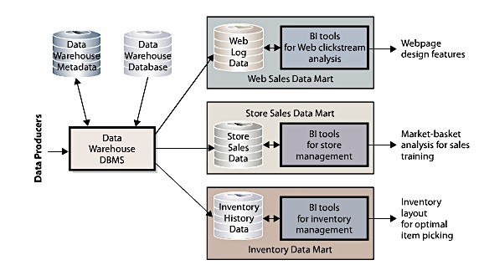
Q7: What Are Typical Data-Mining Applications?

Data mining: is the application of statistical techniques to find patterns and relationships among data and to make classifications and predictions.
- Represents a convergence of disciplines.
- Data-mining techniques emerged from statistics and mathematics and from artificial intelligence and machine-learning fields in computer science.
- These techniques take advantage of developments in data management for processing the enormous databases that have emerged in the last decade.
- Most of them are difficult to use.
- Data-mining techniques fall into 2 categories:
- Unsupervised: with unsupervised data mining, analysts do not create a model or hypothesis before running the analysis. Instead, they apply the data-mining technique to the data and observe the results. With this method, analysts create hypotheses after the analysis to explain the patterns found.
- Common unsupervised technique: cluster analysis: in which statistical techniques identify groups of similar customers from customer order and demographic data.
- Supervised: with supervised data mining, data miners develop a model prior to the analysis and apply statistical techniques to data to estimate the parameters of the model.
- For example, suppose marketing experts in a communications company believe that cellphone usage on weekends is determined by the age of the customer and the number months he or she has had the cellphone account. A data-mining analyst would then run an analysis that estimates the impact of customer and account age.
- Regression analysis: measures the impact of a set of variables on another variable.
- Neural networks: another popular supervised data-mining technique used to predict values and make classifications such as good prospect or poor prospect customers.
- Market-basket analysis is another example. (Think of contingency table in statistics.)

Market-basket definitions:
- Confidence: conditional probability estimate.
- Lift: the ratio of confidence to the base probability of buying an item.

Big Data:
- New but poorly defined term.
- Almost all definitions and uses involve or reference the core concept that large amounts of varied data from a variety of sources over a period of time could be used to make better decisions.
- For example: during USA elections, Obama’s team create more “personalized” e-mails to voters by considering their ZIP codes and a variety of other data.
- Big data is criticized because the lack of precision in its definition, but also because it adds to excessive data collection, is expensive, and occasionally results in predictions that do stand the test of time.

Module 8: E-commerce, Social Networking, and Web 2.0

Q1: What is E-Commerce, and How is it Used?

E-Commerce:
- Defined as the buying and selling of goods and services over public and private computer networks.
- But using a service online does not necessarily mean e-commerce. For example, using the weather network service to check the weather doesn’t count as e-commerce. But buying a subscription for the weather magazine online counts as an e-commerce transactions.
- E-commerce is a subset of the broader definition of electronic business.
- Electronic business: is described as everything having to do with the application of information and communication technologies to the conduct of business between organizations (B2B), B2C, and C2C.

Implications of e-commerce:
- Technology perspective: additional infrastructure (more technology) for organizations will be required. This is not an issue for big organizations, because they have the funds to keep up with these technological advances and competitions. This is more of an issue for small organizations. Solutions for small companies:
- To keep up with these technological chances, one option is to purchase the technologies as business services. Goods and services offered by a smaller company may be listed on larger sites such as EBay, Amazon, and Craigslist. PayPal or local banks can handle payment processing, and hosting may be done by Internet service providers (ISPs), such as GoDaddy or Amazon. In order words, small companies don’t have to build their e-business from scratch, they can use the services already provided online.
- There is an increased coordination between organizations and systems.
- For large organizations, the linkages required by ecommerce could be extensive, especially when partners are involved. For example, you will need SCM system, CRM system, and an accounting system to manage everything.
- Large implications for management and governments.
- Before the enterprise management systems are securely connected, organizations need to ensure that all aspects of the business operate smoothly and do not operate at cross-purposes.
- Externally, companies need to ensure that end-to-end customer security is enabled and that the information is only shared appropriately and with customer permission.

Categories of e-commerce:
- Merchant companies: defined as those that take title to the goods they sell – buy goods and resell them.
- Business-to-consumer (B2C): concerns sales between a supplier and a retail customer (consumer). Typical information for B2C: web storefront (web-based application) where customers manage their own orders.
- Business-to-business (B2B): refers to sales between companies. For example, raw material suppliers use B2B systems.
- Business-to-government (B2G): refers to sales between companies and governmental organizations. For example, a manufacturer that uses an ecommerce site to sell computer hardware to a government ministry is engaging in B2G ecommerce.
- There is more B2G and B2G happening now than B2C.
- Nonmerchant companies: are those that arrange for the purchase and sale of goods without ever owning or taking title to those goods.
- Ecommerce auctions: match buyers and sellers by using an ecommerce version of a standard auction. It supports a competitive-bidding process used to offer goods for sales. Example: Ritchie Bros; one of the biggest auction site.
- Clearinghouses provide goods and services at a stated price and arrange for the delivery of the goods, but they never take title. For example, one division of Amazon.ca operates as a nonmerchant clearinghouse; when they sell a good, they take the money and give it back to the seller (less a commission obviously).
- Electronic exchanges: that match buyers and sellers; the business process is similar to that of a stock exchange. Sellers offer goods at a given price through the electronic exchange, and buyers make offers to purchase over the same exchange. For example: priceline.com

Benefits of ecommerce:
- Disintermediation: the removal of intermediaries between parties. It is believed that some of the agents (such as wholesaler, distributor, retailer) in the distribution process will be eliminated.
- The good thing about that is that consumers will pay less for a specific good and there will be higher revenues for manufacturers.
- The bad thing is that most of Canadian companies revolve around distribution. If everybody starts buying online, the economy of Canada will be affected negatively.
- Ecommerce also improves the flow of price information.
- As a consumer, you can go to any number of websites that offer product price comparisons.
- From the seller’s side, ecommerce produces information about price elasticity that has not been available before.
- Price elasticity measures how much demand rises/falls with changes in price. For example, when companies use auction ecommerce, they can see how price affects the demand of a given product.
- Managing prices by direct interaction with the customer (online) yields better information compared with managing prices by watching competitors’ pricing.

Challenges of ecommerce:
(These economic factors listed below need to be considered by the companies)
- Channel conflict
- Suppose you work for a manufacturer that sells directly to government agencies. Before engaging in the B2G ecommerce, the manufacturer must consider the economic factors. Channel conflict is one of the economic factors.
- When the manufacturer begins to sell goods B2G that employees of the government agency had previously purchased from a computer retailer down the street, that retailer will resent the competition and may drop the manufacturer. This creates channel conflict – WTF?
- Price conflict: when a business engages in ecommerce, it may also cause price conflict with its traditional channels.
- Because of disintermediation, the manufacturer may be able to offer a lower price and still make profit. However, as soon as the manufacturer offers the lower price, existing channels will object.
- Logistic expense
- Customer service expenses
- Higher for manufacturers using B2C ecommerce.
- Showrooming: occurs when a customer learns or tries a product in the high cost bricks-and-mortar retail store when completing the sales transaction at the low-cost Internet sales channel of another retailer.
- For example, Future Shop allows customers to see and “feel” the product in their stores, but they can also purchase the products online.
- Taxation.
- For government, the problem is determining how to tax ecommerce.
- For example: if a Canadian buys anti-virus software from USA in a state where the sales tax is not applicable, this can be a problem for the Canadian government; who is collecting the tax?

Due to all the information available online, ecommerce makes it harder for retailers to increase their prices. If they do, people will research online other shops to see if the price increase “is normal”, and if it is not, they’ll just buy it from another company.

Q2: What is Social Networking, and how is it Enabled and Affected by IS/IT?

Social network: structure of individuals and organizations that are related to each other in some way.

Social networking: is the process by which individuals use relationships to communicate with others in a social network.

Business literature defines 3 types of capital:
- Physical capital:
- Karl Marx defined physical capital as the investment of resources for future profit.
- Physical resources include factories, machines, manufacturing equipment.
- Human Capital:
- It’s the investment in human knowledge and skills for future profit.
- For example, by taking 226, you are investing in your own human capital.
- Social Capital:
- According to Nan Lin, social capital is investment in social relations with the expectation of returns in the marketplace.
- When you attend a business function for the purpose of meeting people and reinforcing relationships, you are investing in your social capital. Joining LinkedIn or contribute to Facebook is considered as investing in your social capital.
- Social capital adds value in 4 ways:
- Information:
- Relationships in social networks can provide information about opportunities, alternatives, problems, and other important factors to business professionals.
- Influence
- Relationships can provide an opportunity to influence decision makers in one’s employer or in other organizations who are critical to your success.
- Social credentials
- Being linked to a network of highly regarded contacts is a form of social credential.
- Personal reinforcement
- Being linked to social networks reinforces the way you define yourself to the world.
According to Henk Flap, the value of social capital is determined by the number of relationships in a social network, by the strength of those relationships, and by the resources controlled by those related.
- Strong relationships create the most social capital in a social network, but, ironically, it is weak relationships that contribute the most to the growth of social networks.

To understand why that is true, consider the following diagram:
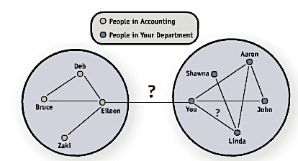

- Clearly, people in accounting know each other, and some have stronger relationships with each other. Same applies for people in your department.
- If you’re at a party, and want to introduce yourself to other people, your best choice should be to introduce yourself to people from the accounting department. Building connections to people who are NOT part of your current circle opens up many more possibilities.
- The connection from you to Eileen (from accounting department) is called a weak tie in the social network theory, and this kind of links is crucial in increasing the number of relationships in your network.
- In other words, the people you know the least contribute the most to your network.

How do social networks add value to businesses?
- Organizations have social capital too.
- They create social capital via salespeople, customer support, public relationships, and endorsements by high-profile people.
- Today, progressive organizations maintain a presence on social networks.
- They can create strong customer relationships by answering questions/comments online.

How is social networking enabled by IS/IT?
- Improved search capabilities
- Search capabilities (so the technological advancements) are important to social networking because they enable us to quickly sort through large amounts of data and find the specific person or relationship that we are interested in.
- The second advantage of technology is the ability to keep track of many more people and enhance personalization.
- The more people that we connect with, the lower the level of interaction that can exist with each connection.
- The final technological consideration is that of network effects.
- As a network grows, the benefit or utility that each person adds tends to increase.
- This can accelerate the speed at which networks grow and how useful they become.

Q3: What is Web 2.0?

Web 2.0:
- First popularized in 2005 by Tim O’Reilly to refer to the integration and interaction of products and services, such as smartphones, user-created content, social networking, location, and context-based services, and dynamic marketplaces, not as a specific technology.
- Comparison of Web 2.0 with Traditional Processing:
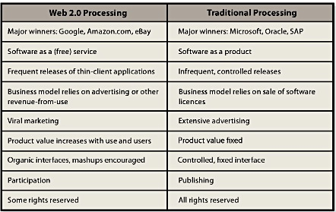

- Examples of web 2.0: Google, Amazon, and eBay. These examples don’t sell software licenses; instead, they provide software as a service (SAAS).
- Web 2.0 applications are thin clients. In other words, they do not require installation on users’ computers. Software as a service goes against traditional processing: software as a product.
- In the Web 2.0 world, little such marketing is done; new features are released, and vendors wait for users to spread the news to one another – called viral marketing.
- With Web 2.0, the value of the site increases with number of users and their use of the site.
- User-generated content (UGC) refers to website content that is contributed by users.
- Crowdsourcing: when users can provide customer support to one another or even participate in the creation of product specifications, designs, and complete products in a process.

Advertising on Web 2.0:
- Advertising can be specific to user interests. For example, if you search “cars”, you will find paid advertisement on cars.
- Google uses “AdWords software”; vendors pay Google a certain amount for a particular search words.
- Another alternative is Google AdSense; where Google searches an organization’s website and inserts ads that match the content on that side. When users click on those ads, Google pays the organization a fee.
- The cost of advertising online is cheaper compared to traditional processing.
- Mashups: Suppose you’re watching a movie and you want to buy the dress that the actress is wearing.
- With 2.0 technology, the movie’s producer and Target (where you can find the dress) can mash up their contents together so that you can click on an item you want while watching the movie.

Q4: Is There a Web 3.0?

Nothing much to say about this; when the book was published, they didn’t have much info on it.

Module 9: Acquiring IS Through Projects

Q1: How Can Information Systems Be Acquired?

Five basic ways of acquiring a software application:
- Buy it and use it as it is
- Buy it and customize it – which is the most common way
- Rent or lease it
- Build it yourself
- Outsource it

Recall from Module 1: acquiring software applications is NOT the same as acquiring information systems.
- IS combine hardware, software, data, procedures, and people.
- In other words, IS involves incorporating the software into the current technological infrastructure and integration the software into the data and procedures people use to make things happen in an organization.

Even if you get a free software (open source software), the costs of integrating it can be more than expected and even more expensive that the software itself.

Q2: What are IT Projects, and What Does PMBOK Mean?

Project Management Body of Knowledge (PMBOK):
- The project in which the organization embarks into once it has purchased an information system.
- This project guide was developed by the Project Management Institute, and the first guide to the PMBOK was published in 1996, and the most recent (4th edition) was published in 2008.
- This guide states that “ a project consists of a temporary endeavour undertaken to create a unique product, service, or result”
- Projects begin with a set of goals or objectives. Then the scope for the project is developed, and project managers are given resources, such as people, money, and working space, to complete the project.
- Projects often represent change within an organization – Why? Because the objective of projects is to accomplish something new and unique.

IT Projects:
- Projects that have a large IT component (in terms of budget or personnel).
- These projects include: installation of a new e-mail application, a CRM system, or an enterprise resource planning (ERP) system.
- Projects that require some fundamental changes to business processes are also referred to as IT projects, because the new IT supports the change in business processes.
- IT projects affect data, people, processes, and obviously technology.

Information technology project management (ITPM):
- Collection of techniques and methods that project managers use to plan, coordinate, and complete IT projects.
- The tools include work breakdown structures; budgeting methods, graphical scheduling methods, such as PERT (program evaluation review technique), and Gantt charts, risk management techniques, communication planning, and high-tech team development.
- ITPM is central to the skills needed for organizations to adapt appropriately to an increasingly complex business environment.

The guide to the PMBOK suggests 5 process groups in any project:
- Initiating
- Planning
- Executing
- Controlling and monitoring
- Closing
- These process groups should not be viewed as independent entities, but rather as a collection of activities that often overlap and occur throughout the project.

These process groups are related to the notion of a systems development life cycle (SDLC) which is often used to describe IT projects. Each of these process groups can be related to one of the 9 project knowledge areas:
- Integration management
- Scope management
- Time management
- Cost management
- Quality management
- Human resources management
- Communications management
- Risk management
- Procurement management

Q3: What Should You know About IT Operations and IT Projects?

IT department is responsible for providing IT services to an organization. The 2 main activities required to provide these services:
- Maintaining the current IT infrastructure
- The maintenance, delivery of service, protection and management of IT infrastructure are often done as part of IT Operations or IT Services.
- These services require a lot of money; major part of budget.
- Renewing and adapting the infrastructure to keep IT working effectively in the future.
- This is usually accomplished through projects.

Distinctions between operations and projects is important for several reasons:
- Operational work and project work tend to attract 2 different types of IT professionals.
- Example of people who prefer to work in IT operations: networking specialists, operating systems specialists, database administrators, and hardware technicians.
- These workers continually seek ways to improve the efficiency and security of the entire set of systems that support operations – production systems.
- It’s all about stability, predictability, accountability, reliability, and security.
- IT projects are temporary and often change existing infrastructures, and they generally require broad skills, and they challenge project team members to learn new technologies.
- Within IT operations, Information Technology Infrastructure Library (ITIL) is a well-recognized collection of books that provide a framework of best-practice approaches to IT operations.
- ITIL offers a large set of management procedures that are designed to help businesses achieve value from IT operations.
- It basically supports IT operations.
- At the end of the day, operations and IT projects are separate fields but they rely on each other for success.
- How do they rely on each other? Well projects come to and end and must be maintained (so project operation) and infrastructure must eventually be replaced (operation project).

IT services are needed for both internal and external employees.
- New employee needs access to computer, software, ID and password, and as well as an e-mail account.
- They also need access cards to get into the building, or have access to certain rooms of the organization; no matter what the size of the organization is.

Internet:
- IT Services also need to take care of any “internet activity” – updating the website, making sure the applications are working properly, FAQ section of website, etc.

Q4: Why Are IT Projects So Risky?

Factors that make projects risky:
- When you need to build a bridge, you can ask the architect to build a small model of the bridge, so people can have an idea of what the final product will look like.
- BUT with an IT project, you can’t really build a physical model of it. The lack of a good model makes it difficult for people to understand what the system will look like, and how it will behave when it is finished. This is an important risk to consider.
- Estimating costs for certain projects can be pretty straightforward. For example; building a bridge requires components (labour, steels, concrete) that are stable, well known, and have been used for hundreds of years.
- BUT in an IT project, the tools for building the project are constantly changing. Computers get cheaper and faster, programing languages, operating systems, and databases get more complex.
- This makes precise estimates for IT projects difficult.
- Monitoring a project is harder for IT Projects. If you’re building a bridge, you can tell when the bridge is halfway done or completely done.
- It’s hard to tell what an IT project looks like halfway through its completion.
- Also, systems development often means aiming at a moving target; systems requirements change as the system is developed.
- It is difficult to tell how far an IT project has come and how far it needs to go.
- Lack of experience in the team
- Unclear and uncertain project requirements
- High level of technical complexity
- Changes in the project environment

Q5: What is an SDLC?

Systems development life cycle (SDLC):
- The classic process used to acquire/develop information systems.
- The number of phases in the SDLC varies by organization and author. But for now, we’ll look at a 5-phase process:
- System definition
- Requirement analysis
- Component design
- Implementation
- System maintenance

Diagram showing the relation between them:
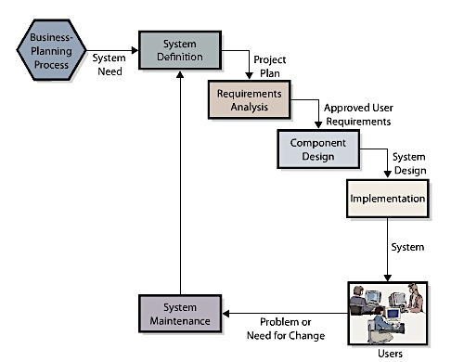

Phase 1: Defining Systems
- Define system goals and scope
- Assess feasibility
- “Does this project make sense?”
- This step is usually referred to as “creating the business case for the project”
- Feasibility has 4 dimensions:
- Cost feasibility: whether you have the $$ for it
- Schedule feasibility: whether the company has the time to do it
- Technical feasibility: whether existing information technology is likely to be able to meet the needs of the new system
- Organizational feasibility: whether the new system fits within the organization’s customs, culture, charter, or legal requirements.
Phase 2: Requirement Analysis
- This step includes the formation of the project team and the development of the requirements.
- The development of project requirements is basically the management of scope in an IT project.
- When developing requirements, the team normally consists of both IT personnel (internal personnel or outside contractors) and user representatives (managers, systems analysts, programmers, software testers, and users).
- The team composition changes over time.
- During requirements definition, the team will mainly consist of business analysts and systems analysts.
- During design and implementation, the emphasis will shift to programmers, testers, and database designers.
- During integrated testing and conversion, the team will be augmented with testers and business users.
- The important point of this phase is for users to have active involvement and to take ownership of the project through the entire development process.

(The rest of phases are in Q6)

Q6: How are IS Designed, Implemented, and Maintained?

Factors to be considering before acquiring an IS:
(this is called matching organizational needs and COTS software capabilities)
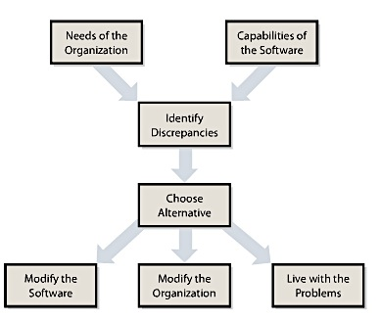

- When an organization works through the matching process, it will almost always find discrepancies between the requirements of the business and the capabilities of the software application. When they do find the discrepancies, they’re faced with 3 options: modify the Software, modify the organizational procedures and data, or live with the problems.
- COTS: commercial-off-the-shelf software will never fit your organizational requirement exactly.

Phase 3: Component Design
- Determine hardware specification: the team needs to specify the computers, operating systems, networks, and network connections that will process the data.
- The software design depends on the source of the programs.
- For off-the-shelf software, the team must determine candidate products and evaluate them against the requirements.
- For off-the-shelf-with-alterations software, the team identifies products to be acquired off the shelf and then alterations required.
- For custom-developed programs, the team produces design documentation for writing program code.
- Design the database.
- Design procedures
Procedures to be designed:
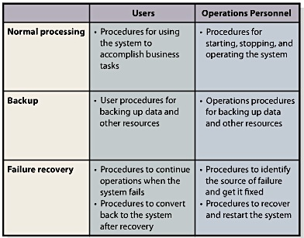

- Create job definitions.
- Developing job descriptions for both users and operations personnel.
Phase 4: Implementation
- Tasks in this phase include building, testing, and converting the users to the system.
- System testing: Developers need to design and develop test plans and record the results of tests.
- Test plan: consists of sequences of actions that users take when using the new system. It includes both the correct and wrong actions.
- Testing is also called: product quality assurance (PQA).
- Beta testing: is the process of allowing future system users to try out the new system on their own. These users then report problems back to the vendor. This is the last stage of testing.
- System conversion: this term is often used to refer to this activity because it implies the process of converting business activity from the old system to the new. Organizations can implement a system conversion in one of 4 ways:
- Pilot installation: the company implements the entire system in a limited portion of the business. The advantage: if the system fails, it only affects one section of the organization.
- Phased installation: the new system is installed in phases across the organization.
- Parallel installation: the new system runs in parallel with the old one until the new system is tested and fully operational. It’s very expensive.
- Plunge installation: basically the organization shuts down the old one and starts the new system.

Phase 5: Maintenance
- The work done during this phase is either to fix the system so that it works correctly or to adapt it to changes in requirements.
- You need a way to track both failures and requests for enhancements to meet new requirements.
- For small systems, organizations can track failures and enhancements using word-processing documents. But the bigger it gets, the need to develop a failure tracking database increases.
- IS personnel prioritize system problems according to their severity
- Fix failures:
- Group high-priority failures into a patch that can be applied to all copies of a given product.
- Group low-priority failures into larger groups called service packs

Problems with the SDLC:
- One of the reasons for SDLC problems is the waterfall method of the SDLC:
- Like a series of waterfalls, the process is often described as a sequence of nonrepetitive phases.
- The team completes the requirements phase and goes over the waterfall into the design phase, and on through the process (phase 1 phase 2 phase 3 phase 4 phase 5).
- BUT sometimes, you need to go back into the previous phase to fix/improve a problem.
- Another problem, especially with complicated systems, is the difficulty of documenting requirements in a usable way.
- Analysis paralysis: when projects in which people spend so much time documenting requirements.

Q7: What is Outsourcing, and What Are Application Service Providers?

Outsourcing: is the process of hiring another organization to perform a service.
- When the vendor is overseas; outsourcing = offshoring.
- Why do companies choose outsourcing for portions of their information systems activities?
- Outsourcing can be an easy way to gain expertise without having to spend a lot of time and money in creating the specialized software.
- Cost reductions: skilled programmers in China, India, and Russia are way cheaper than American programmers.
- To reduce development risk. Outsourcing can reduce risk by ensuring a certain level of quality or voiding the risk of having substandard quality.
- To reduce implementation risk
- Risks of outsourcing:
- First risk is the ensuing loss of control over the service. Outsourcing puts the vendor in the driver’s seat. Once the vendor is in charge, the organization’s employees must conform to the vendor’s procedures.
- The outsource vendor may change its pricing strategy over time. At first, they get a “competitive” price so the vendor can win the company over. And because the chosen vendor will get to build a relationship with the organization and know their processes in and out, it makes it harder to switch vendors or have other vendors for other purposes; so the company will accept the increase in prices.
- Another problem is that an organization can find itself paying for another organization’s mismanagement with little recourse.
- No easy exit: it’s expensive and risky to switch vendors.

Application Service Providers (ASPs):
- Particular form of outsourcing.
- In an ASP agreement, an organization contracts with a vendor to “rent” applications from the vendor company on a fee-for-service basis – fees depend on the number of users/employees of the software and it’s paid monthly/yearly.
- In an ASP, the vendor maintains the system at its own web location, and the client organization accesses the application on the vendor’s website.
- The application software, therefore, does not have to be located with the client.
- Risks:
- The client company loses physical control over some corporate data that are stored in the vendor’s machines – the applications are not located with the clients.
- If there’s a failure of Internet, the company can’t access the software application = cannot operate.
- Corporate data can be easily ported to competing vendor’s sites – because of the potential lock in of the ASP.

Module 10: Structure, Ethics, and IT Governance

Q1: How Is the IT Department Organized?

IT Services/Information Systems Services:
- Department of people who provide support for: email systems, accounting applications, desktop computers, and mobile devices of a company.
- This group needs to be organized and managed like any other business department.
- This figure shoes the typical top-level reporting relationships in an organization that has IT Services:

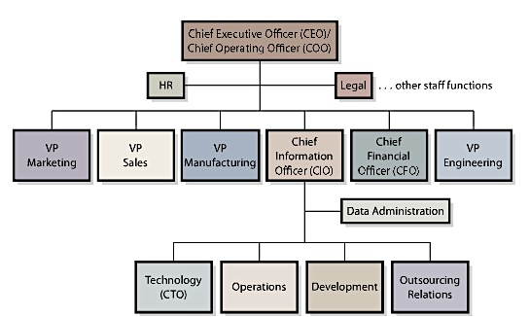

- Chief Information Officer: CIO is a common title used to name the principal manger of the IT department
- Most IT departments include a technology office that investigates new information systems technologies and determines how the organization can benefit from them.
- The CTO (chief technology officer) sorts through new ideas and products to identify those that are most relevant to the organization. This requires deep knowledge of information technology and the ability to envision how new IT will affect the organization over time.
- Operations: manages the computing infrastructure, including individual computers, computer centres, networks and communications media.
- This group includes system and network administrators.
- An important function of this group is to monitor user experience and respond to user concerns or problems.
- Development: this group manages projects that acquire new information systems and maintains existing information systems.
- The size and structure of the development group depends on whether programs are developed in-house. If they are not, this department will be primarily staffed by business analysts and/or systems analysts who work with users, operations, and vendors to acquire and install licenced software and to set up the system components
- Business analysts are usually involved in developing the business case for a newly proposed system as well as the requirements for that system.
- System analysts are usually involved in designing and implementing the new system.
- Outsourcing relations: this group exists in organizations that have negotiated outsourcing agreements with other companies to provide equipment, applications, or other services.
- These relationships require constant attention, so this department monitors service levels and focuses on developing good relations with outsourcing vendors.
- Data administration staff function: the purpose of this group is to protect data and information assets by establishing data standards and data management practices and policies.

Creating a well-designed company website requires knowledge of branding and marketing, but also of these factors:
- TCP/IP networks (Transmission Control Protocol/Internet Protocol)
- HTML (Hypertext markup language)
- XML (Extensible markup language)
- Content management systems
- Web-design applications (e.g. Adobe Flash)

Web design industry:
- Radius is one the largest Canadian web design firms, with clients like Nike, BMW, Converse etc.
- Types of employees needed to create a web design:
- Project manager: responsible for interacting the client and moving the project successfully toward completion
- Lead designer/analyst: responsible for understanding client needs and developing the overall look and feel of the site and all the design elements (colours, navigation, graphics, buttons, animation etc.)
- Developer: responsible for taking the design and creating the functioning site; usually specializes in static content
- Technical architect: responsible for making decisions about technical issues related to the site, including server/browser support, database integration, administrator access, and any scripting issues.

Q2: What Jobs Exist in IT Services?

Major Job Positions in the IS Industry:
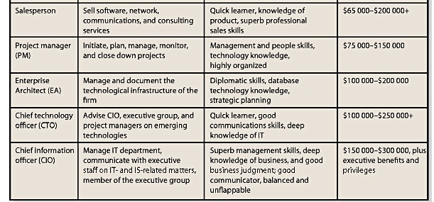
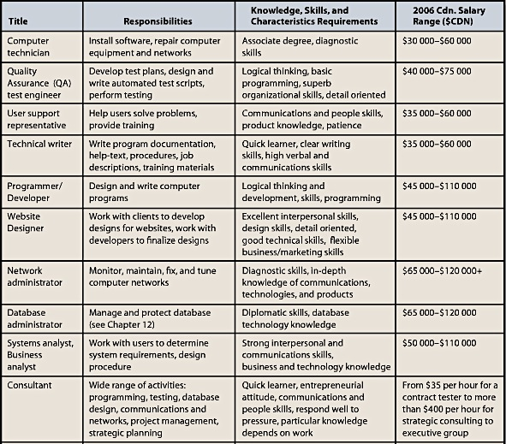

Q3: What is IT Architecture

The challenge in developing these plans is that it requires an understanding of both organizational strategy and the technological architecture underlying information systems.

IT Architecture:
- It is the basic framework for all the computers, systems, and information management that support organizational services.
- It is complex, and its complexity increases as more services are supported and different technologies are used.
- Job: enterprise architect:
- His/her job is to create a blueprint of an organization’s information systems and the management of these systems.
- The blueprint should provide an overview that helps people in the organization better understand current investments in technology and plan for changes.
- The enterprise architect needs to consider organizational objectives, business processes, databases, information flows, operating systems, applications and software, and supporting technology.
- An architecture is usually a long document with many sections that include quite complicated diagrams as well as management policies (such as privacy, sourcing, and security) and discussion of future changes to the architecture.

Zachman Framework:
- Method that helps organize the development of an architecture.
- This framework decides the system into 2 dimensions: one is based on 6 reasons for communication (what-data, how-function, where-network, who-people, when-time, why-motivation) and the other is based on stakeholder groups (planner, owner, designer, builder, implementer, and worker).
- The intersection of these 2 dimensions helps provide a relatively holistic view of the enterprise.

Example:

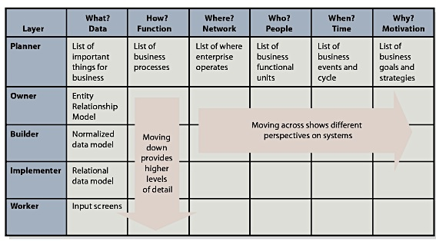

Q4: What is Alignment, Why Is It Important, and Why is It Difficult?

Alignment: the process of matching organizational objectives with IT architecture.
- However some MIS researchers have suggested that alignment should be viewed as an ongoing process – that fitting IT architecture to business objectives is continually evolving.
- The alignment process takes advantage of IT capabilities as they develop, at the same time maintaining a balance between business objectives and IT architecture.
- It’s a very important part of businesses, but difficult to achieve
- Communication between business and IT executives is the most important indicator of alignment.
- Only successful companies find ways to help share knowledge and frustrations between the IT department and the business functions.

Q5: What is Information Systems Governance?

Governance: is the development of consistent, cohesive management policies and verifiable internal processes for information technology and related services.
- Managing at a corporate level often involves establishing the way in which governing boards oversee a corporation and developing the rules that apply to such issues as sourcing, privacy, security, and internal investments.
- The goal of system governance is to improve the benefits of an organization’s IT investment over time.
- This picture shows the benefits from IT governance (how stakeholder value can increase):

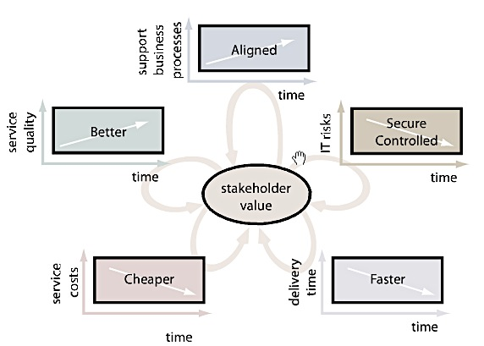

- Information systems governance is a piece of organizational governance that is associated with IT architecture.
- The increasing interest in IS governance is the result of laws, such as the Sarbanes-Oxley Act (SOX) in the USA and Bill 198, commonly known as the Budget Measures Act. These laws force companies to comply with governance standards for collecting, reporting, and disclosing information.
- Both pieces of legislation require management to create internal controls sufficient to produce reliable financial statements and to protect the organization’s assets.
- The organization’s external auditor must also issue an opinion on the quality of the internal controls and the credibility of management’s statement.
- An example of internal control: separation of duties and authorities.
- Information systems governance in the future will require that all stakeholders, including corporate board members, have input into important information systems decisions.

Q6: What is an Information Systems Audit, and Why Should You Care about It?

Financial audit: can be defined as an examination and verification of a company’s financial and accounting records and supporting documents by an accredited professional.

Information Systems Audit:
- It is analogous to a financial audit
- The focus is placed on information resources that are used to collect, store, process, and retrieve information.
- The recent increase in attention on information systems governance has meant a higher focus on the IS audit and the establishment of methods for examining and verifying organizations’ information systems policies and procedures.
- For example: ISACA (Information systems audit and control association) and CISA (Certified information systems auditor) certification.

In Canada, the Canadian Institute of Chartered Accountants (CICA) has an agreement with ISACA that recognizes the CISA designation developed by ISACA as the only designation that leads to recognition as a CA-designed specialist in information systems audit, control, and security.

One of the developments provided by ISACA along with the IT Governance Institute (ITGI) is:
- Control Objectives for Information and Related Technology (COBIT)
- Framework of best practices designed for IT management
- This framework provides board members, managers, auditors, and IT users with a set of generally accepted measures, indicators, processes, and best practices to assist them in getting the best from their organizational IT investments.
- Establishes links between objectives and business requirements, organizes IT activities into a generally accepted process model, identifies the major IT resources in the organization, and defines the management control objectives to be considered.
- In establishing these foundations, COBIT can help link business goals to IT goals, providing metrics and maturity models to measure their achievement and identifying the associated responsibilities of business and IT process owners.
Why should we care about governance and IS audits?
- The increased need to report and disclose information systems operational information will require employees at all levels of an organization to become more familiar with the issues facing IT management.
- Even though it’s more expensive for organizations, the increased exposure to IT issues should improve the ability of organizations to IT more effectively and efficiently.

Q7: What is Information Systems Ethics?

Information systems ethics:
- It is not about hardware or software but, rather, about the people involved in the system.
- Advances in IT bring new opportunities as well as new risks to individuals and organizations.
- It’s about understanding our own behaviour—the way we think and act in situations in which our choices affect others.
- We face choices in situations and these choices should be guided by principles. For example: The Canadian Charter of Rights and Freedom, Association for Computing Machinery’s code of ethics.

Q8: What is Green IT, and Why Should You Care About It?

Green IT – also known as green computing:
- This means using IT resources to better, support the triple bottom line for organizations.
- Triple bottom line: includes measures of traditional profit along with ecological and social performance.
- Primary goals of Green IT are to improve energy efficiency, promote recyclability, and reduce the use of materials that are hazardous to the environment.
- It represents a choice to consider not only the financial implications of adopting and using IT but also the effects of those choices on people and on the environment.
- For example: ENERGY STAR program, which is an international government-industry partnership that is intended to produce equipment that meets high-energy efficiency specifications or promotes the use of such equipment.
- Issues in Green IT:
- E-cycling: recycling of electronic computing devices
- E-waste guidelines

Module 11: IS Security Management and Privacy

Q1: What is Identify Theft?

Identity theft:
- They use your name, address, date of birth, social insurance number, and social insurance number.
- With this information, they can take over your financial accounts (open accounts, transfer funds, loans, credit card etc).
- One of fastest-growing crimes in Canada.
- Public Safety Canada provides useful information about what this is and who to contact if it happens to you.

Q2: What is PIPEDA?

PIPEDA:
- Personal Information Protection and Electronic Documents Act
- This act is intended to balance an individual’s right to the privacy of his/her personal information with an organization’s need to collect, use and share that personal information for business purposes.
- To oversee this Act, the Privacy Commissioner of Canada was created as the ombudsman for privacy complaints in Canada.
- Every Canadian business professional needs to be aware of PIPEDA because it governs how data are collected and used.
- Examples of what this Act says:
- Individuals have the right to know what type of information an organization collects about them and also how that it will be used.
- Organizations are not allowed to use the information collected for any purpose other than what the organization agreed to use it for.
- Organizations have a duty to protect the information it collects, and individuals have the right to know who in the organization is responsible for securing the information.
- PIPEDA also requires that this information be complete, up to date, and accurate.
- PIPEDA does NOT facilitate individuals suing organizations.
- If issues arise that cannot be resolved between an individual and an organization, they should file a complaint with the Office of the Privacy Commissioner of Canada. It then reviews the case and produces a report stating its conclusions. This report can be used in federal court, if the lawsuit is filed.

Q3: What Types of Security Threats Do Organizations Face?

There are 3 sources of security threats:

- Human errors and mistakes: include accidental problems caused by both employees and others outside the organization.
- For example, when an employee misunderstands the operating procedures and deleted customer records by accident.

- Malicious human activity: includes employees and other who intentionally destroy data or other system components.
- Also includes hackers, virus and worm writers, and people who send out spam mail.

- Natural events and disasters: include fires, floods, hurricanes, earthquakes, tsunamis, avalanches and other acts of nature or accidents.

There are 5 types of security problems:

- Unauthorized data disclosure: can occur by human error when someone inadvertently releases data in violation of policy.
- For example: An university department administrator who posts student names, numbers, and grade in a public place – this goes against provincial laws. This type of disclosure is covered by PIPEDA.
- Search engines have created another source of inadvertent disclosure: employees who place restricted data on websites that can be uncovered by search engines may mistakenly publish proprietary or restricted data over the web.
- Pretexting: occurs when someone deceives by pretending to be someone else. For example: someone pretending to be your credit card provider and getting personal information over the phone.
- Phishing: uses pretexting via email. The “phisher” pretends to be a legitimate company and sends an e-mail requesting confidential data, such as account numbers, SIN, passwords etc.
- Spoofing: someone pretending to be someone or somewhere else (using an American IP when you’re in Canada – Netflix USA)
- E-mail spoofing = phishing
- Sniffing: is a technique for intercepting computer communications.
- Drive-by-sniffers basically take computers with wireless connections through an area and search for unprotected wireless networks.

- Incorrect data modification:
- Examples include incorrectly increasing a customer’s discount or incorrectly modifying an employee’s salary, earned days of vacation, or annual bonus.
- It also includes placing incorrect information on the company’s website or portal.
- This can happen through human error when employees don’t follow properly the procedures or when procedures have been incorrectly designed.
- System errors – discussed in Module 6
- Hacking: occurs when a person gains unauthorized access to a computer system.

- Faulty Service:
- Includes problems that result because of incorrect system operation.
- In other words, it could include incorrect data modification, but also systems that work incorrectly by sending the wrong goods to the customer or ordered goods to the wrong customer, incorrectly billing customers, or sending the wrong information to employees.
- Humans can also be blamed for faulty service: system developers can write programs incorrectly or make errors during the installation of hardware, software programs, and data.

- Denial of service:
- Human error in following procedures or lack of procedures can lack in denial of service (DOS)
- For example, employees can inadvertently shut down a web server or corporate gateway router by starting a computationally intensive application.
- DOS attacks: often launched maliciously – e.g. millions of fraudulent or bogus service requests so it can occupy the server and not let the server process legitimate requests.

- Loss of infrastructure:
- Human accidents can cause loss of infrastructure: For example, a bulldozer cutting fibre-optic cables or maintenance crew unplugging an important device in order to plug the vacuum.
- Theft and terrorist events can also destroy an infrastructure.

Summary of the 5 security problems AND the security threats:

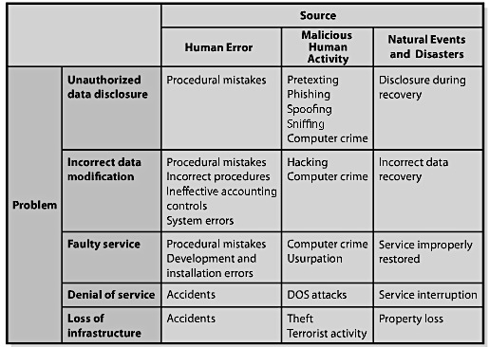

A security program has 3 components:

- Senior management: has 2 critical security functions:
- They must establish the security policy. This policy sets the stage for the organization’s response to security threats.
- They must manage risk by balancing the costs and benefits of the security program.

- Safeguards of various kinds:
- There should be security safeguards for each component:
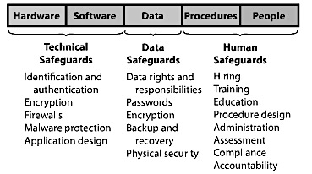

- Incident report
- Consists of the organization’s planned response to security incidents.

Q4: How Can Technical Safeguards Protect Against Security Threats?

Technical safeguards: involve the hardware and software components of an information system.
- Primary technical safeguards include:

- Identification and authentication: Every non-trivial information system should have a username (identifies user) and password (authenticates user).
- Passwords have many weaknesses; users tend to share their passwords and use the same password for many different types of systems. These deficiencies can be reduced by using smart cards and biometric authentication;
- Smart card: is a plastic card that is similar to a credit card and contains microchip. Users are required to enter a PIN (personal identification number) to be authenticated or use a challenge-response (only people with the card will know that if the number 9 appears, you enter the double + 1 of it)
- Biometric authentication: uses personal physical characteristics (fingerprints, facial features and retinal scans).
- Single Sign-on for multiple system: to open computer; put password, to log onto system; put password, to connect to database; put password etc.

- Encryption and Firewalls:
- Encryption is referred to as cipher text.
- Firewall: security system that controls incoming and outgoing network traffic based on a set of rules.

- Malware Protection: Malware includes viruses, worms, Trojan horses, spyware, and adware.

- Malware safeguards:
- Install antivirus and anti-spyware programs.
- Set up your anti-malware programs to scan your computer frequently
- Update malware definitions – patterns that exist in malware code.
- Open email attachments only from known sources
- Promptly install software updates from legitimate sources.
- Browse only in reputable Internet neighbourhoods.

Recall from BTM:

- Worms:
    - Slightly different from a virus in that a worm attempts to travel between systems through network connections to spread an infection
    - Works independently of host file execution and is much more active in spreading itself
- Trojan Horse:
  - A program that appears to be something useful or desirable, but while it runs does something malicious in the background without your knowledge
  - Trojan horses stall backdoor programs that allows hackers to take almost complete control of your computer without your knowledge
- Spyware:
    - An unwanted piggyback program that usually downloads with other software you want to install from the Internet
    - Without you knowing, it transmits information about you to the owner of the program so that the information can be used for marketing purposes
- Adware:
    - Software that displays sponsored advertisements in a section of your browser window as a pop-up ad box

Q5: How Can Data Safeguards Protect Against Security Threats?

Data safeguards: protect databases and other organizational data and 2 organizational units are responsible for data safeguards:
- Data administration: refers to an organization-wide function that is in charge of developing data policies and enforcing data standards.
- Database administration: refers to a function that pertains to a particular database.
- ERP, CRM, and SCM each have a database administration.

Working together:
- Data administration should first define data policies e.g. we will not share customer information with competitors.
- Then database and data administration work together to specify user data rights and responsibilities.
- Those rights should be enforced by user accounts that are authenticated by, at the minimum, passwords.

An organization should protect sensitive data by storing them in encrypted form. These encryptions use one or more keys in ways similar to that described for data communication encryption.
- One potential problem, however, is that the key might be lost or that disgruntled or terminated employees might destroy it.
- This is why, when data are encrypted, a trusted party should have a copy of the encryption key – this safety procedure is sometimes called key escrow.

Another data safeguard is to periodically create backup copies of database contents.
- IT personnel should then periodically practice recovery, to make sure those backups are valid and that effective recovery procedures exist.

Physical security is another data safeguard.
- The computers that run the DBMS and all devices that store database data should reside in secure, controlled-access facilities – reduce chances of theft and damage.

Q6: How Can Human Safeguards Protect Against Security Threats?

Human safeguards: involve the people and procedures components of information systems.
- Human safeguards result when authorized users follow appropriate procedures for system use and recovery.

- Human safeguards for employees:
- Position definitions: effective human safeguards begin with creating definitions of job tasks and responsibilities.
- Job descriptions should provide a separation of duties and authorities.
- User accounts should be defined to give users the least possible privilege needed to perform their jobs; users whose job does not require modifying data should only be given accounts with read-only privileges.
- The security sensitivity should also be documented for each position.

- Hiring and screening: There should be security considerations during the hiring process, both for new employees and for employees who are promoted to sensitive positions.

- Dissemination and enforcement: Employees need to be made aware of the security policies and procedures and of their responsibilities.
- Employee security training begins during new-employee orientation.
- Enforcement consists of 3 interdependent factors:
- Responsibility: the company must clearly define the security responsibilities of each position.
- Accountability: the design of the security program should be such that employees can be help accountable for security violations.
- Compliance: employee activities should be regularly monitored for compliance, and management should specify action to be taken in the event of noncompliance.

- Termination: Companies must establish security policies and procedures for the termination of employees
- HR policies: remove accounts and passwords of the terminated employee.
- When the termination is unfriendly; let’s say someone is doing a horrible job but you don’t know how to fire them because of their temper or other reasons: System administrators must remove account and passwords BEFORE notifying the employee.
- BYOD: bring your own device has made it harder for data protection

- Human safeguards for non-employees (opening information systems to temporary personnel, vendors. Partner personnel, volunteers and the public):
- The best safeguard from threat from public users is to harden the website or other facility against as much as possible:
- Hardening a site means to take extraordinary measures to reduce a system’s vulnerability. This means locking or eliminating some OS functions so the user cannot have access to those functions.
- It’s actually a technical safeguard but it is the most important safeguard against non-employees.

- Account Administration: The administration of user accounts, passwords, and help-desk policies and procedures is an important component of the security system.
- Account management: this includes the creation of new user accounts, the modification of existing account permissions, and the removal of unneeded accounts – need to inform IS personnel to avoid security threats.

- Password management: passwords are the primary means of authentication.
- Strong password according to National Institute of Standards and Technology (NIST):
- 7 or more characters
- Does not contain your name, user name, or company name
- Dos not contain a complete dictionary word in any language
- Is different from your other passwords
- Contains upper and lower cases, and special characters
- Can contain numbers
- Change password frequently
- Users must not keep the password given by the IS personnel: change it.
- Help-desk policies:
- Help-desk is the personnel you call when you forget your password.
- The problem with that is that the person on the phone cannot guarantee the authentication of the caller;
- Use questions like: birthplace, mother’s name, or last 4 digits of an important account the user has access to.
- An e-mail is sent to the user once the password is changed

- System procedures:

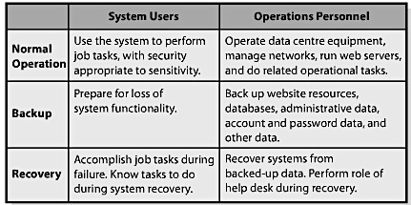

- Security monitoring:
- Important monitoring functions are analysis of activity logs, security testing, and investigating and learning from security incidents.

Q7: What is Disaster Preparedness?

The best safeguard against a disaster is appropriate location:
- If possible, place computing centres, web farms, and other computer facilities in locations not prone to natural disasters.
- And even in those locations, place infrastructure in unobtrusive buildings, basements, back rooms, and similar locations well within the physical perimeter of the organization.

Disaster preparedness guidelines:
- Locate infrastructure in safe location
- Identify mission-critical systems: these are the systems without which the organization cannot carry on and which, if lost of any period, could cause the organization’s failure.
- Identify resources needed to run those systems: computers, operating systems, application programs, databases, administrative data, procedure documentation, and trained personnel.
- Prepare remote back-up facilities:
- Hot sites: remote processing centres and may be run by commercial disaster-recovery services.
- Cold sites: provide space and limited technology and customers provide and install the equipment needed to continue operations following a disaster.
- Warm sites: are somewhere in the middle of the two extremes
- Train and rehearse

Q7: How Should Organizations Respond to Security Incidents?

Major factors of an incident-response plan:
- Have a plan in place.
- The plan should provide centralized reporting of all security incidents.
- Such reporting will enable an organization to determine whether it is under systemic attack or whether an incident is isolated.
- It also allows the organization to learn about security threats, take consistent actions in response, and apply specialized expertise to all security problems.
- Specific responses
- Speed – being prepared and trained comes in handy.
- Practice: organizations should periodically practise their incident-response plan

Module 6: Database Management
Q1: What is Content?

Content:
- Something of value and can be considered an asset
- Closely related to intellectual property a form of creative endeavor that can be protected through a trademark, patent, copyright, industrial design, or integrated circuit topography
- Content varies by industry
- The challenge is to present it appropriately for various stakeholders inside and outside of organizations
- Word-processing .doc, .txt, .pdf
- Spreadsheets .xls
- Presentations .ppt

Q2: How can Content be Organized?

The challenge in content management is indexing or cataloguing the right information, processing and storing it, and then getting it to the right person in the right format at the right time
- Content presentation focuses on how best to present data to the person using the system
- The management of many types of content has traditionally been handed by: Database management systems (DBMS)
- DBMSs are central to the management of content data
- The presentation of content in organizations is increasingly handled through a series of steps supported by software content management systems (CMSs) have been developed to help companies organize the process
  - These systems actively seek out documents located across an organization and automatically manage access to this content
  - Media files, word-processing documents, html pages, and many other documents can all be categorized and searched by CMSs

Q3: What is the Purpose of a Database?

A database keeps track of things:
- The purpose of a database is to keep track of things that involve more than one theme.
- What differentiates database from a spreadsheet: the fact that lists presented in a database involve multiple themes (grades, emails, office visits etc) whereas on a spreadsheet, lists involve a single theme (grades)

Q4: What does a Database Contain?

A database is a self-describing collection of integrated records
  - A byte is a character of data (grouped into columns also called fields)
  - Columns are grouped into rows also called records
  - A group of similar rows or records is called a table or a file
- A database is a collection of tables plus relationships among the rows in those tables, plus special data (metadata), that describe the structure of the database

Relationships among Records:
- A key is a column or group of columns that identifies a unique row in a table
- Foreign keys are columns that are keys of a different (foreign) table from the one in which they reside
- Relational databases are databases that carry their data in the form of tables and that represent relationships using foreign keys

Metadata:
- Data that describe data
- The format depends on the software product that is processing the database
- Field name, Data type, Description
- Metadata are about data and that such metadata are always a part of the database
- Its presence makes databases much more useful than spreadsheets or data in other lists

Q5: What is a DBMS, and what does it do?

Database application systems make database data more accessible and useful
- Users employ a database application that consists of forms, formatted reports, queries, and application programs each of these in turn calls on the DBMS to process the database tables

Database management system (DBMS) is a program used to create, process, and administer a database.
- Examples of DBMS: Acess, SQL Server, DB2, Oracle
- DBMS and database are two different things*
- DMBSsoftware program
- Database a collection of tables, relationships and metadata
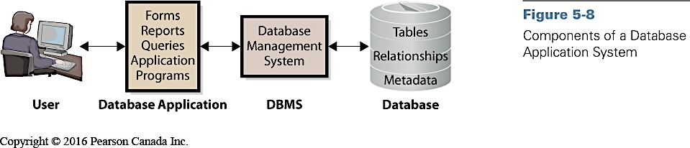

Creating the Database and its Structures
- DBMS is used to create tables, relationships and other structures in the database
- Used to define a new table or modify tables

Processing the Database
- DBMS processes database
- Application use DBMS to read, insert, modify, or delete data
- Structured Query Language (SQL): international standard for processing a database

Administering the Database
- DBMS provides tools to assist in administration of database
- Can be used to set up security system
- Used to back up data
- Add structure to improve performance
- Remove data

Q6: What is a database application?

Database application:
- Collection of forms, reports, queries, and application programs that process a database
- Databases can have more than one application
- Each application can have multiple users
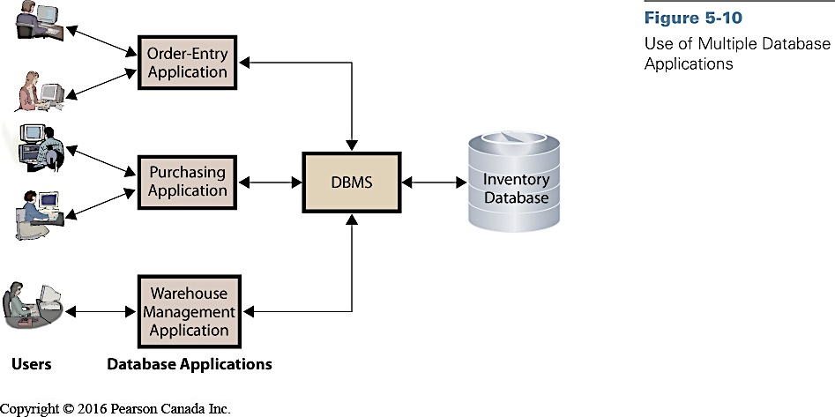

Forms, Reports, and Queries
- Forms: used to read, insert, modify, and delete data
- Reports: show data in structured context; may compute values
- Queries: means of getting answers from database data

Database Application Programs
- Forms, reports, and queries work for standard functions
- Application programs
  - Process logic specific to business need
  - Enables database processing over Internet
    - Serves as intermediary between Web server and database
    - Responds to events
    - Reads, inserts, modifies, deletes data

Multi-user Processing
- Multi-user processing is common
- Unique problems
  - Lost-update problem
  - Locking used to coordinate activities of multiple users
    - Creates new set of problems
  - Data conflicts produce inaccurate results

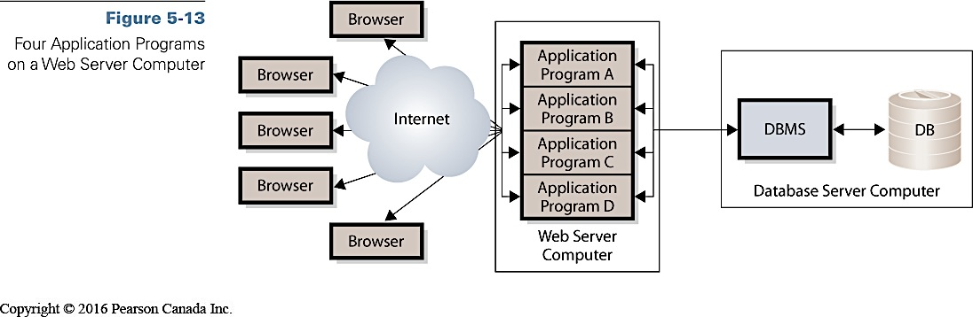

MIS in Use
- The many names of one customer
  - Customers can have multiple products, and multiple instances of individual products
  - Challenge was to ensure that the data in the customer information file (CIF), the database that held all customer data, was accurate and identified customers uniquely and completely
  - Problems with incomplete customer information or misidentification of financial records

Q7: What is the difference between an enterprise DBMS and a personal DBMS?

- Enterprise DBMS
  - Process large organizational and workgroup databases
  - Support many users and many different database applications
    - i.e. IBM’s DB2, Microsoft’s SQL Server, and Oracle’s Oracle
- Personal DBMS
  - Designed for smaller, simpler database applications
  - Supports fewer than 100 users
    - I.e. Microsoft Access

Chapter Extension 5a

How are database application systems developed?
- Database application systems consists of:
  - Database
  - DBMS
  - One or more database applications
- Database applications consist of:
  - Forms
  - Reports
  - Queries
  - Application programs
Database Development Process
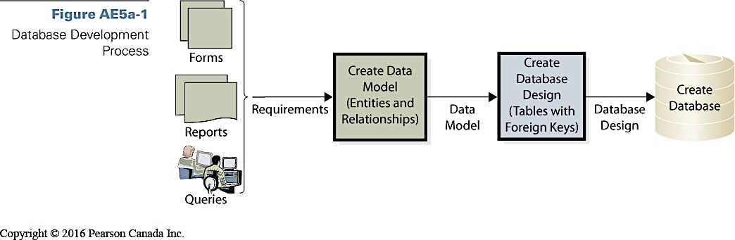

Database Application System Development process
- Developers interview users
- Develop requirements for new system
  - Analyze existing reports, forms, and user activities
- Requirements summarized in data model
  - Logical representation of structure of data
  - Contains description of data and relationships
- Users validate and approve the data model
- Design implemented in a database
  - Database filled with user data

Database
- Must include all data necessary for users to perform jobs
- Contains only that amount of data, and no more
- Developers rely on users to:
  - Tell them what to include
  - Check data model
  - Verify correctness and completeness

What are the components of the entity-relationship data model?
- Techniques for creating data model
  - Entity-relationship (E-R) data model
  - Unified modeling language (UML)
- E-R data model components
  - Entities (things) stored in the database
  - Relationships among those entities

Entities
- Some thing that users want to track
  - i.e. order, customer, salesperson, and item
- May be:
  - Physical object i.e. item, or salesperson
  - Logical construct or transactionorder, contract
- Entity names are always singular
- Entities have
  - Attributes: describe characteristics of the entity
  - Identifier: attribute (or group of attributes) whose value is associated with one and only one entity instance
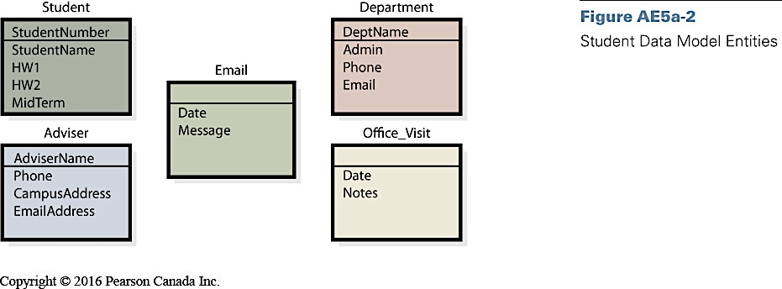

Relationships
- Entities have relationships to each other
- 1:1 relationship
  - Single entity to single entity
- 1:N relationship
  - One-to-many
  - Single entity to many entities
- N:M
  - Many-to-many

E-R Diagrams
- Rectangles represent entities
- Relationships shown by lines
- Crow’s foot
  - Forks at end of lines
  - Indicate more than one relationship
  - Read “many”
- Vertical line means at least one entity of that type
- Small oval means entity is optional

Cardinality
- Number of entities that can be involved in relationship
  - Maximum cardinality
    - Maximum number involved
  - Minimum cardinality
    - Constraints on minimum requirements
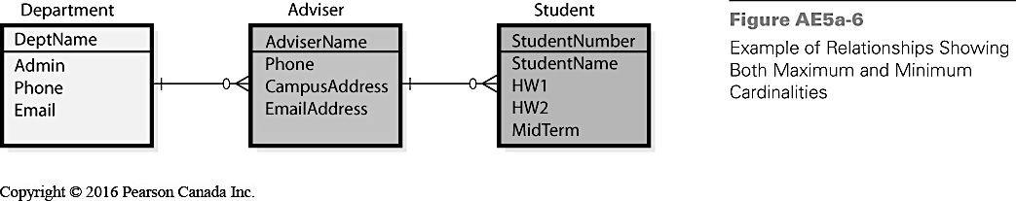

How is a data model transformed into a database design?
- Database design is the process of converting a data model into tables, relationships, and data constraints
  - Transforms entities into tables
  - Expresses relationships
    - Defines foreign keys
  - Shows data constraints

Normalization
- Normalization is the process of converting poorly structured tables into two or more well-structured tables
- Data integrity problems
  - Different names for the same entity
  - Produces incorrect and inconsistent information
  - Resolve by eliminating duplicated data
- Normalizing for data integrity
  - Eliminate data duplication
  - Slower to process
  - Construct such that every table has single topic

Representing a 1:N Relationship

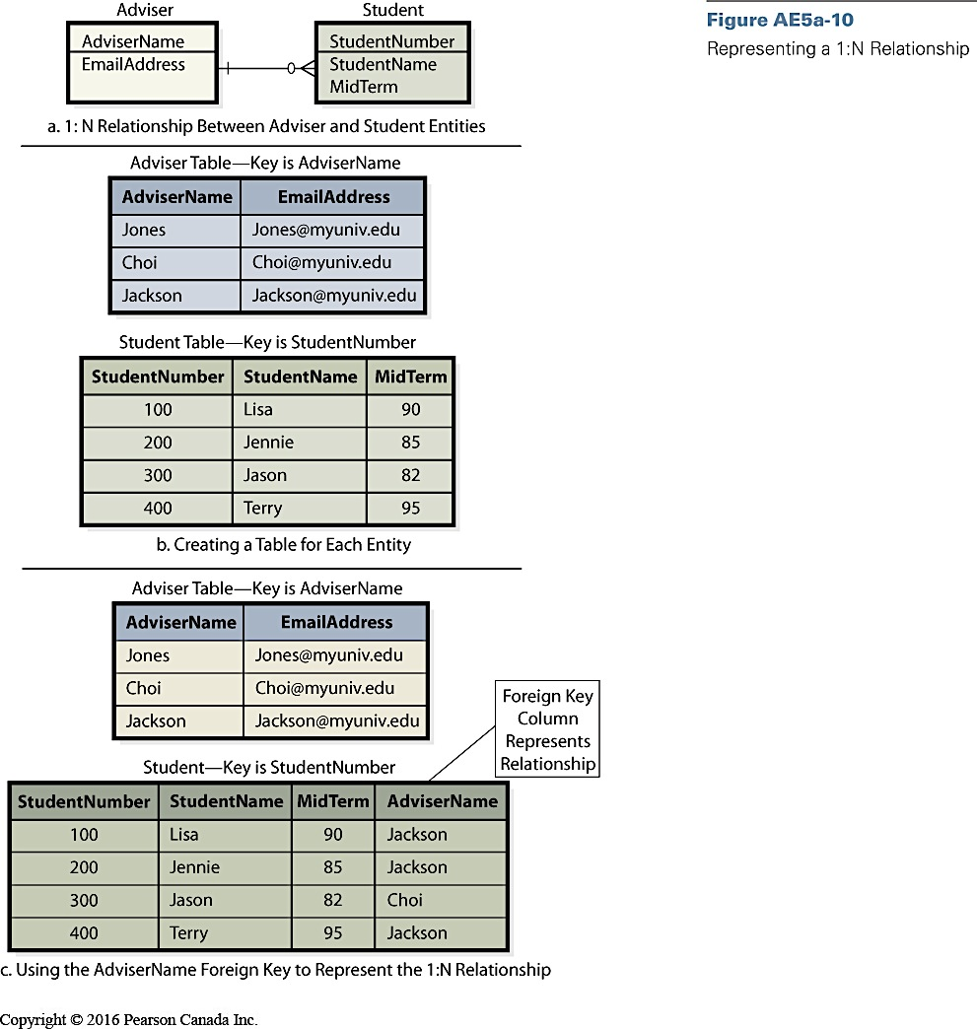

Relational Database Design
- Designer creates table for every entity
- Entity identifier becomes primary key of table
- Attributes of entity become columns
- Tables normalized to single theme
- Represent relationships between tables
- Add foreign key to one or more tables
What is the users’ role?
- Final judges as to what data should contain
- Determine how records are related to each other
- Need to review data model
- Must insure that model reflects an accurate view of business
Who will volunteer?
- Consultant creates data model
  - Based on interviews with users
- Data model reviewed and approved
- Database tables constructed
  - Primary and foreign keys selected
    - Based on interviews
- Microsoft Access database created
  - Relationships indicated
  - Forms and reports constructed

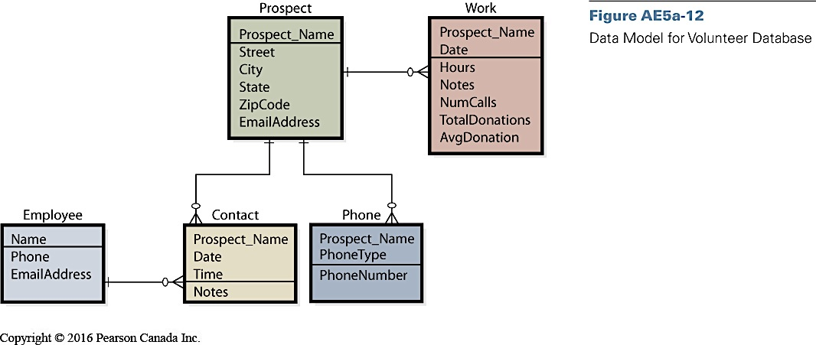

Chapter Extension 5b

How do you create tables?
- Create data model from users’ requirements
- Transform model into database design
  - Primary key
  - Foreign key
  - Rows
  - Columns

** Look at the extension: Assignment 2 Part A – B important **

