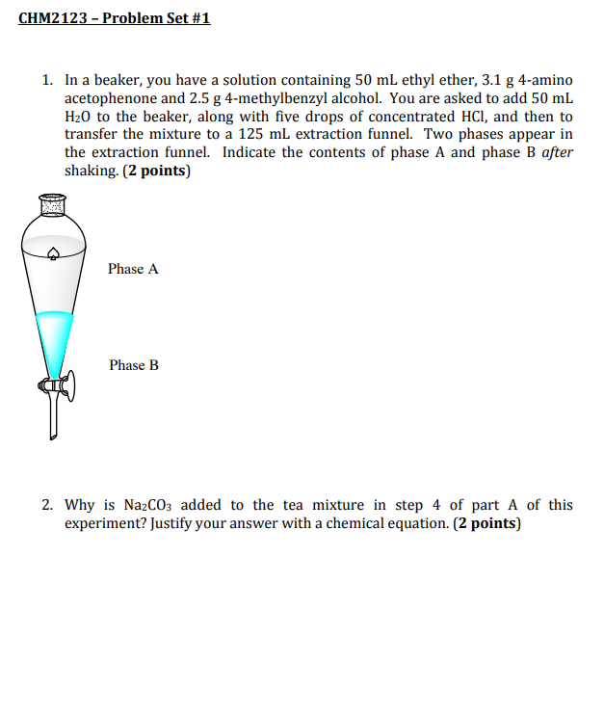

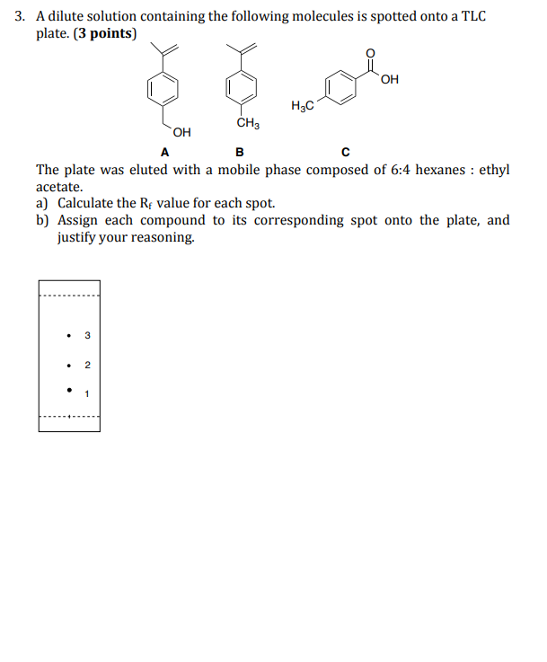

4. From a mixture containing para-dichlorobenzene and benzil, you have isolated both compounds via liquid-liquid extraction to yield 0.2 g of paradichlorobenzene and 1.9 g of benzil in the form of crude crystals. Between sublimation via a cold-finger and recrystallization with ethanol, select the best method for purification of each crude compound, and justify your answer. (4 points)
a) para-dichlorobenzene
b) benzil



