Lab 09
Registry

%1. Registry Manual Restore Point In System Protection dialog box
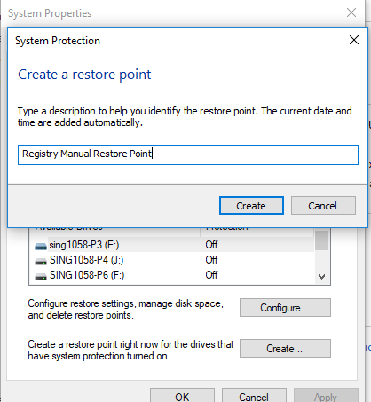

%2. Registry Backup 2018-04-04 in File Name
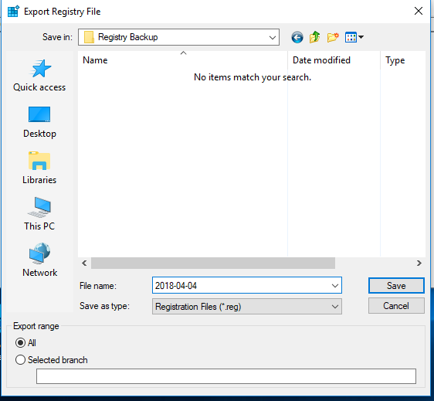

#3.

%4. HKEY_CLASSES_ROOT Expanded
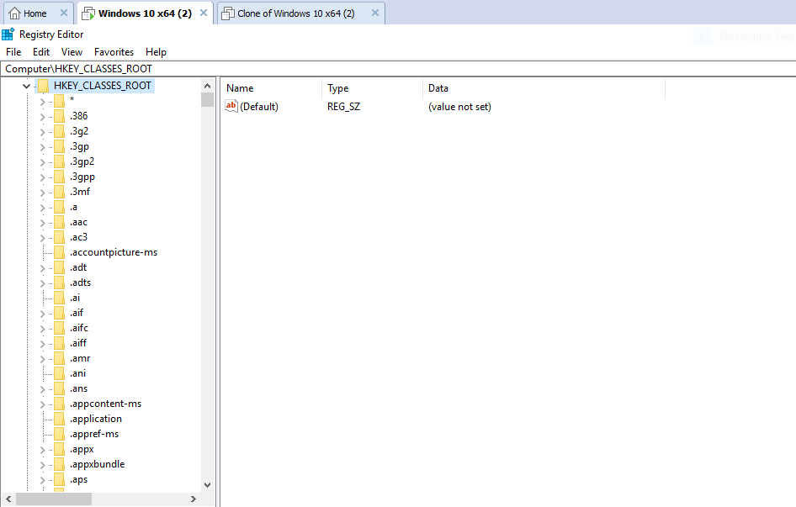

%5. HKEY_CURRENT_USER Expanded
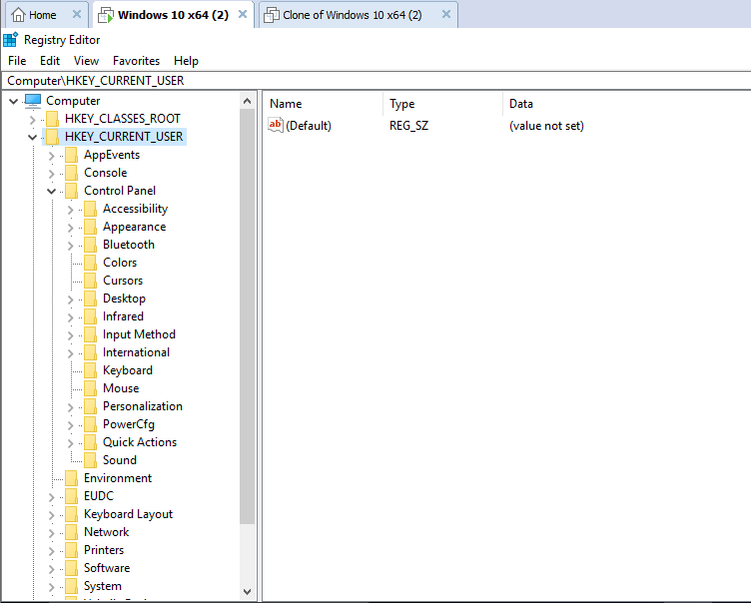

%6. HKEY_LOCAL_MACHINE Expanded
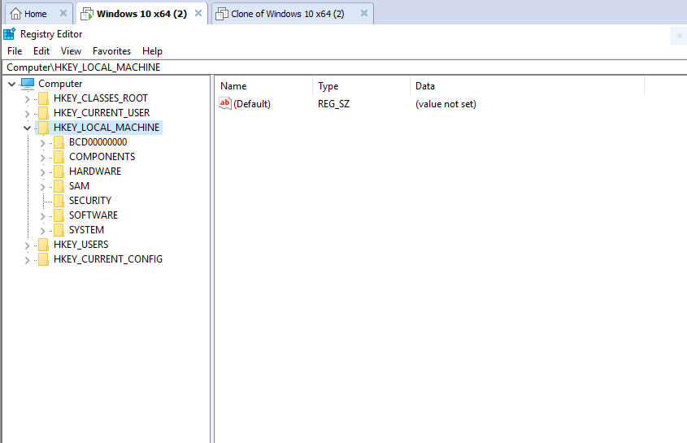

%7. In HKEY_CLASSES_ROOT .bmp key
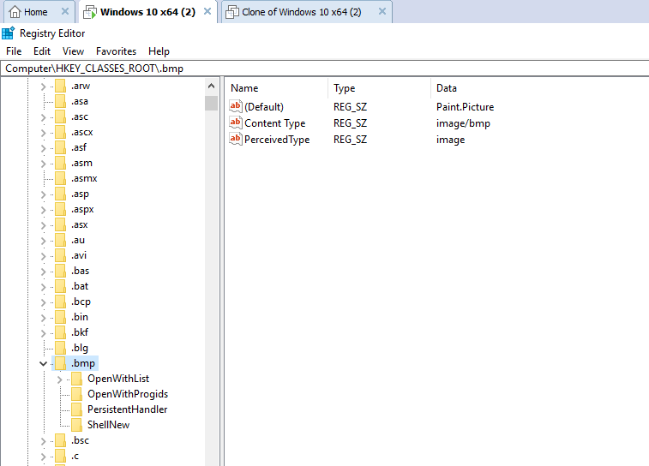

%8. ShellNew subkey in .bmp key
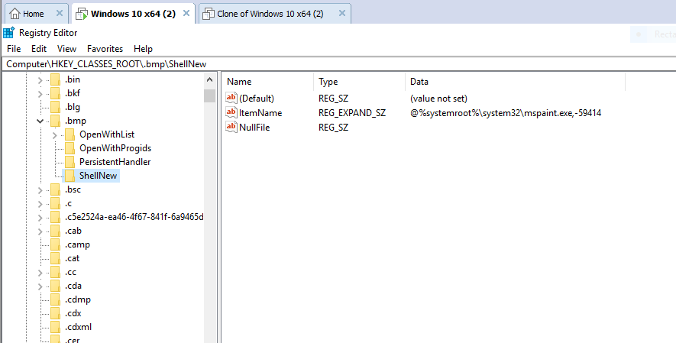

%9. Check mark on Keys and Match whole string only
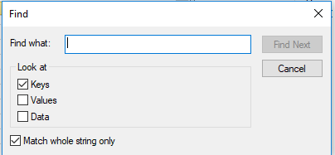

%10. Paint.Picture key
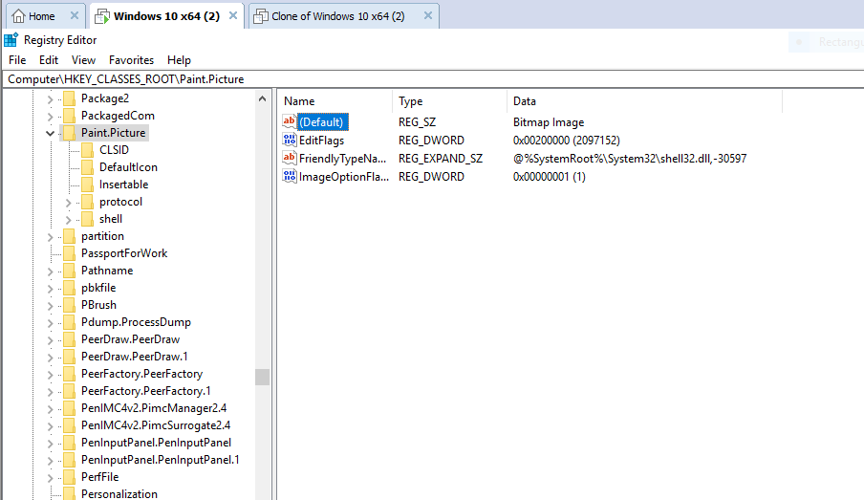

%11. Defaulticon subkey
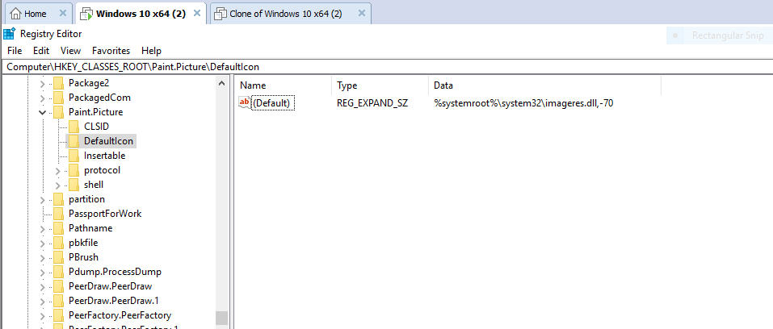

%12. Finding 654FF
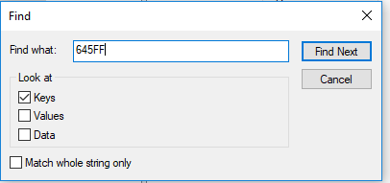

%13.
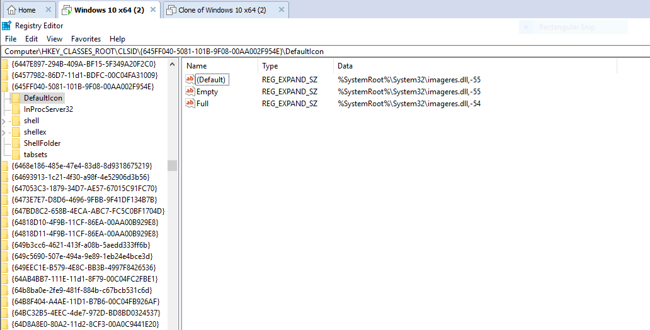

%14. MouseTrails indicating value 0
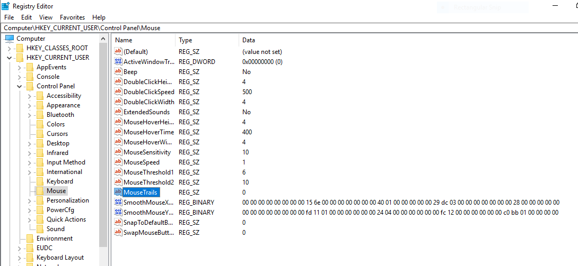

%15.
%16.

%17. Console
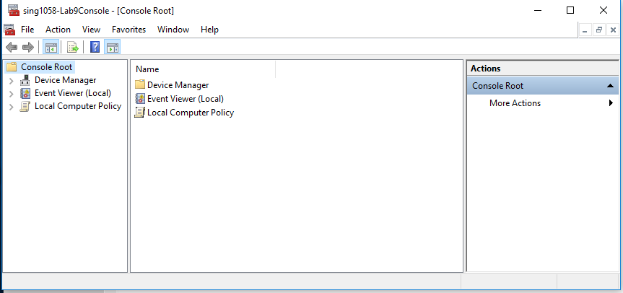

%18. Remove Recycle bin icon
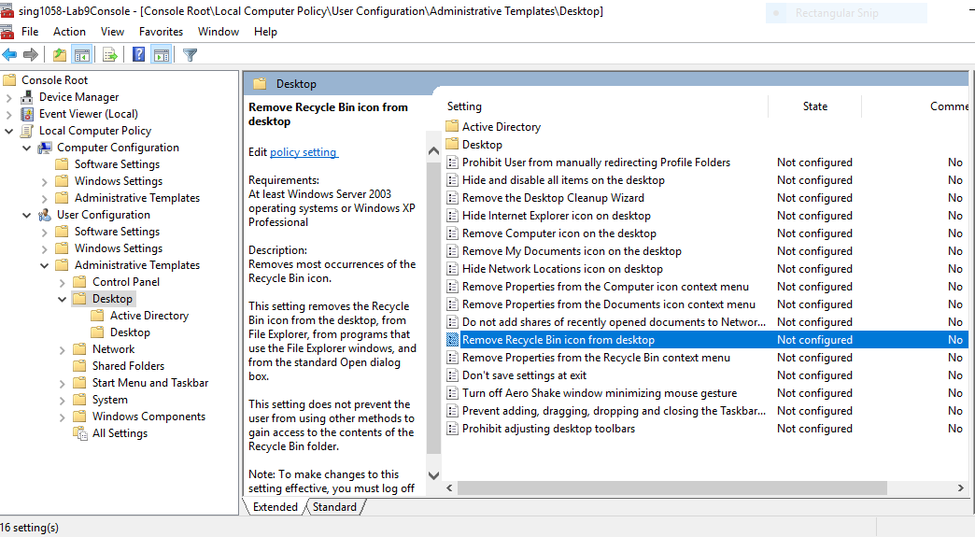

%19. Remove Security tab
#20. Recycle bin visible and usable because, at this stage under Group Policy Object Recycle bin is set to “Not Configured”, and Security tab is still not visible because it is still set to “Enable”

%21. In Regular Account Recycle bin is visible
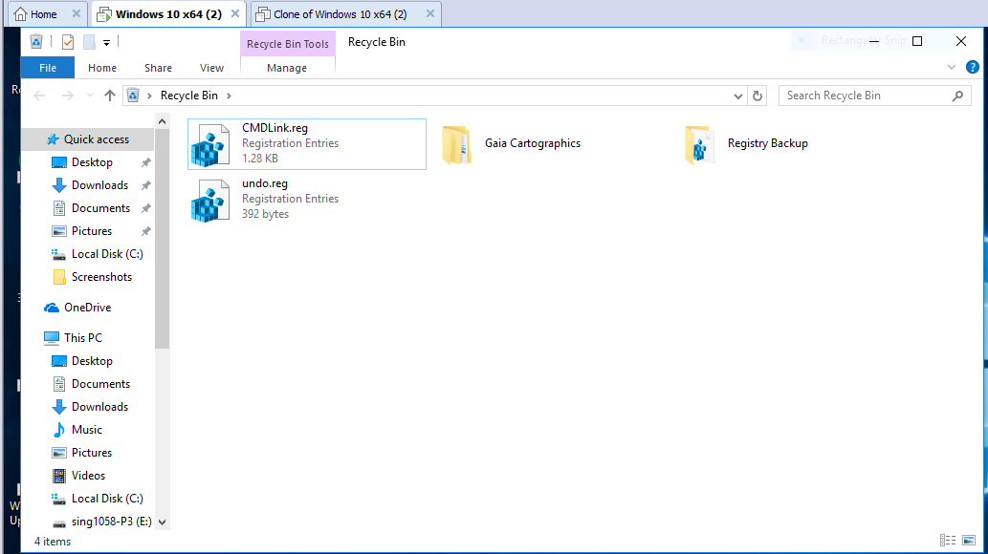

%22. New User sing1058-9B
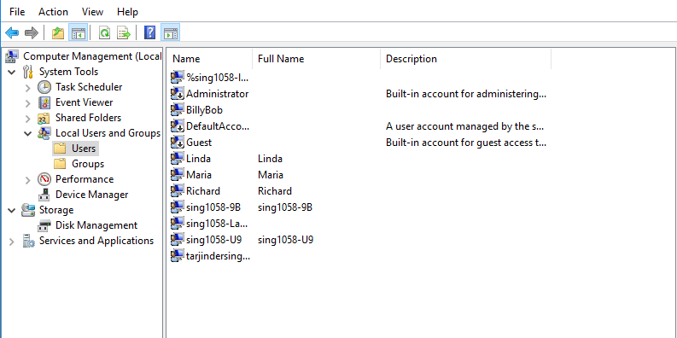

%23. User sing1058-9B for new Local Group Policy
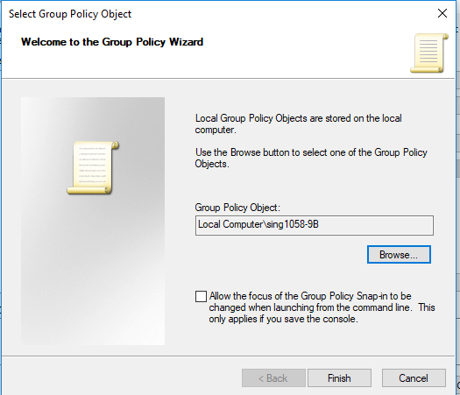

#24. Yes, Security tab is set to be as a “Not Configured”

#25. After setting Security tab for “Enable”, the tab is not visible in user sing1058-9B

%26. Enable Security tab user sing1058-9B
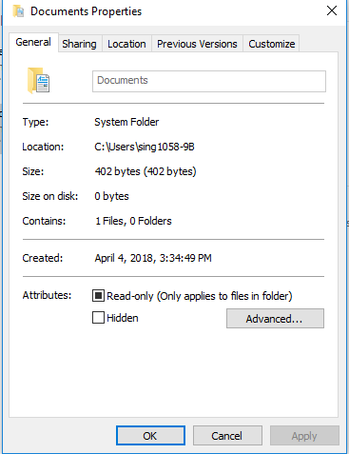

#27a). For Internet “Enable Protected Mode” has a checkmark, Custom Level and Reset all zones to default level options are available.

#27b). For Local Intranet “Enable Protected Mode” does not have a checkmark, Custom Level, Default level and, Reset all zones to default level options are available.

#27c). For Trusted Sites “Enable Protected Mode” does not have a checkmark, Custom Level and Reset all zones to default level options are available.

#27d). For Restricted Sites “Enable Protected Mode” has a checkmark, Custom Level and Reset all zones to default level options are available.
#28. Internet and Restricted Sites has “Enable Protected Mode” checkmark.

#29. All Devices under Hard Drive in correct order
VMware Virtual SCSI Hard Drive (0:0)
VMware Virtual SCSI Hard Drive (0:1)
VMware Virtual SCSI Hard Drive (0:2)
VMware Virtual SCSI Hard Drive (0:3)
VMware Virtual SCSI Hard Drive (0:4)
VMware Virtual SCSI Hard Drive (0:5)
VMware Virtual SCSI Hard Drive (0:6)

%30. SCSI 0:1 moved to the top of the list
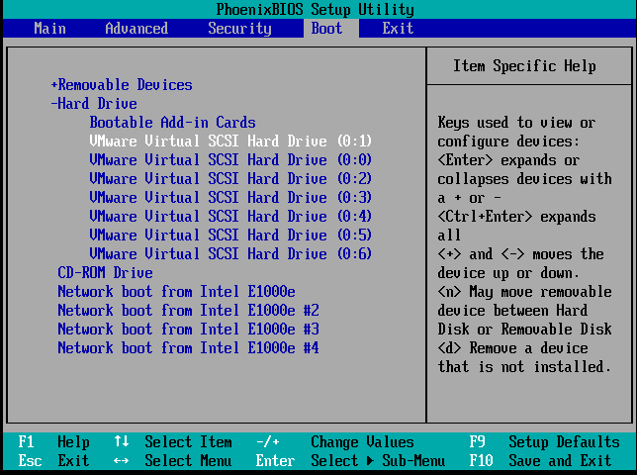

#31. PXE-E53: No Boot file name is received
And Operating system not found

#32. This happen because I shift the SCSI 0:1 to the top of the list and SCSI 0:0 is now at second number.

#33. An Operating system was not found. Try disconnecting any drives that don’t contain the operating system.
Press Ctrl+Alt+Del to restart

#34.

%35. Task Manager
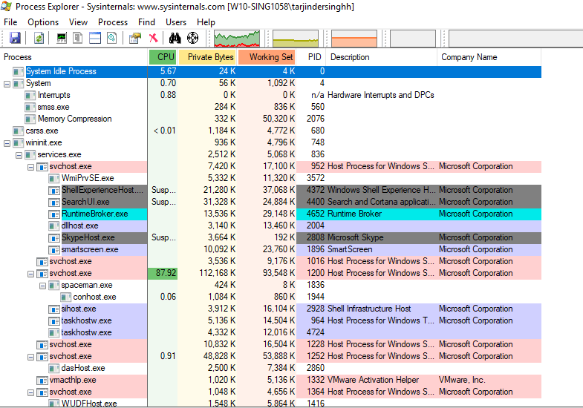

%36. Host Backup


