Chapter 3
3.1 ACCOUNTING TRANSACTIONS (ANALYZE)

Accounting Information System: The system of collecting and processing transaction data and communicating financial information to decision makers.

- Some factors that shape these systems are the type of business and its transactions:
The size of the company
The amount of data
The information that management and others need.

Example: BeaverTails did not need a formal accounting system when it first began. However, as the business and the number and type of transactions grew, an organized accounting information system became essential.

- An accounting information system begins with determining what relevant transaction data should be collected and processed. Not all events are recorded and reported as accounting transactions. Only those events that cause changes in assets, liabilities, or shareholders' equity should be recorded.

Example: Suppose a new employee is hired. Should this event be recorded in the company's accounting records? The answer is “no.” While the hiring of an employee will lead to a future accounting transaction (the payment of salary after the work has been completed), no accounting transaction has occurred at this point.

Accounting Transaction: Occurs when assets, liabilities, or shareholder's equity items change as result of an economic event.

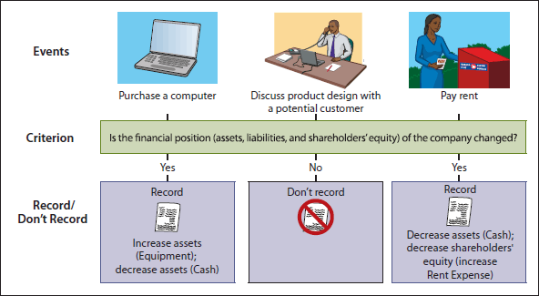

- _{ANALYZING TRANSACTIONS}

Accounting Equation: ASSETS = LIABILITIES + SHAREHOLDERS' EQUITY

- We will learn how to analyze transactions for their effect on each component of the accounting equation. Remember that the accounting equation must always balance, so each transaction will have a dual (double-sided) effect on the equation.

Example: If an individual asset is increased, there must be either a corresponding decrease in another asset, an increase in a specific liability, and/or an increase in shareholders' equity.

Example: Assume that services of $200 have been provided, for which $50 has been received in cash and the remainder is owed on account. An asset (cash) would increase by $50, a different asset (accounts receivable) would increase by $150, and shareholders' equity (service revenue) would increase by $200.

- Transaction 1: Investment by Shareholders
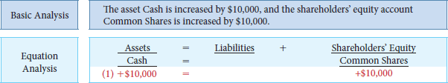

- On October 1, cash of $10,000 was invested in Sierra Corporation in exchange for 10,000 common shares.
- This transaction results in an equal increase in assets and shareholders' equity.
- There is an increase of $10,000 in the asset account Cash and an increase of $10,000 in the shareholders' equity account Common Shares.

- Transaction (2): Purchase of Equipment.
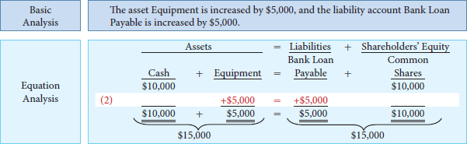

- Also on October 1, Sierra borrowed $5,000 from Scotiabank to purchase equipment. It promised to repay the bank loan, plus 6% interest per annum (year), in three months.

- This transaction results in an equal increase in assets and liabilities: Equipment (an asset) increases by $5,000 and the liability Bank Loan Payable increases by $5,000.

- The specific effect of this transaction and the cumulative effect of the first two transactions are: Total assets are now $15,000 and the new liability of $5,000 plus shareholders' equity of $10,000 is also $15,000.

- Transaction (3): Payment of Rent.

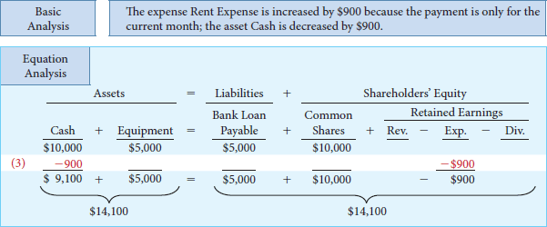

- On October 2, Sierra Corporation paid its office rent for the month of October in cash, $900.

- To record this transaction, Cash is decreased by $900 and Rent Expense is increased by $900.

- Rent is an expense incurred by Sierra in its effort to generate revenues. Expenses decrease retained earnings, which in turn decrease shareholders' equity.

- You will recall from earlier chapters that shareholders' equity consists of common shares (which is one type of share capital) and retained earnings. Retained earnings are increased by revenues and decreased by expenses and dividends.

- As there is not enough room to use specific account names for each individual revenue and expense account in the expanded accounting equation shown below, they will be summarized under the column headings Revenues (abbreviated as “Rev.”), Expenses (abbreviated as “Exp.”), and Dividends (abbreviated as “Div.”).
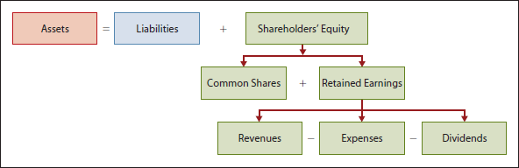

- Transaction (4): Purchase of Insurance

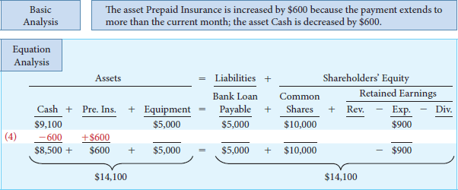

- The asset Cash is decreased by $600.

- On October 5, Sierra paid $600 for a one-year insurance policy effective October 1 that expires next year on September 30.

- The asset Prepaid Insurance (abbreviated as “Pre. Ins.”) is increased by $600 because the payment is for more than the current month.

Prepaid expenses (prepayments): Payments of expenses that will benefit more than one accounting period are assets.

- As shown, the balance in total assets did not change; one asset account decreased by the same amount by which another increased.

- Transaction (5): Hiring of New Employees.

- On October 7, Sierra hired four new employees to begin work on Monday, October 12.

- Each employee will receive a weekly salary of $500 for a five-day (Monday-Friday) workweek, payable every two weeks. Employees will receive their first pay-cheques on Friday, October 23.

- There is no effect on the accounting equation because the company's assets, liabilities, and shareholders' equity have not changed.

- An accounting transaction has not occurred because the employees have not yet worked; at this point, there is only an agreement that the employees will begin work on October 12. (See transaction 10 for the first payment of salaries.)

- Transaction (6): Purchase of Supplies on Account
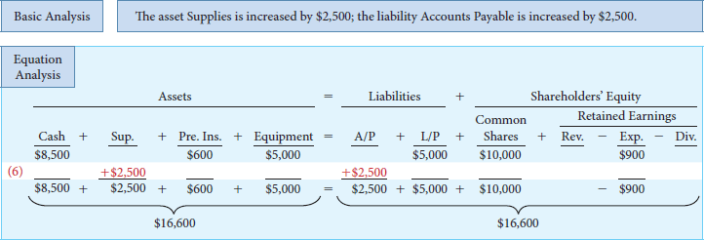

- On October 9, Sierra purchased advertising supplies on account from Aero Supply Corp. for $2,500.The account is due in 30 days.

- This transaction is referred to as a purchase “on account” or “on credit.” Instead of paying cash, the company incurs a liability, usually an account payable, by promising to pay cash in the future.

- Assets are increased by this transaction because supplies represent a resource that will be used in the future in the process of providing services to customers. Liabilities are increased by the amount due to Aero Supply.

- The asset Supplies (abbreviated as “Sup.”) is increased by $2,500, and the liability Accounts Payable (abbreviated as “A/P”) is increased by the same amount. The Bank Loan Payable account has also been abbreviated as “L/P” (indicating a Loan Payable) due to space limitations in the equation analysis below.

- Transaction (7): Services Performed on Account
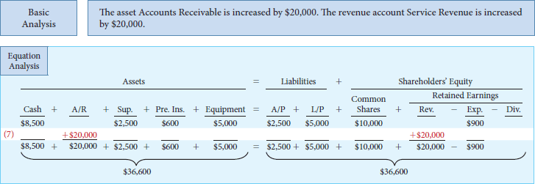

- On October 13, Sierra performed $20,000 of advertising services for Copa Ltd. Sierra sent Copa a bill for these services, asking for payment within 30 days.

- Companies often provide services “on account” or “on credit.” Instead of receiving cash, the company receives a different type of asset, an account receivable.

Accounts Receivable: The right to receive payment at a future date.

Revenue is recorded when services are performed, even though cash has not been received. Because revenue increases retained earnings—a shareholders' equity account—both assets and shareholders' equity are increased by this transaction.

In this transaction, Accounts Receivable (abbreviated as “A/R”) is increased by $20,000 and Service Revenue is increased by the same amount.

- Transaction (8): Receipt of Cash in Advance from Customer
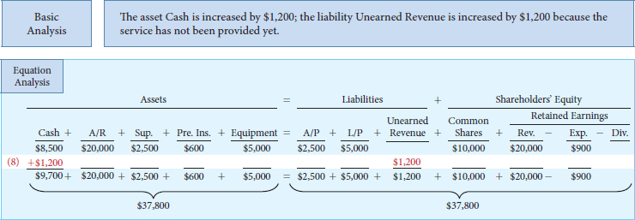

- On October 19, Sierra received a $1,200 cash advance from R. Knox, a client, for advertising services that are not expected to be completed until November.

- Revenue should not be recorded until the work has been performed. However, since cash was received before performing the advertising services, Sierra has a liability for the work due. We call this liability unearned revenue.

- Note that the word unearned indicates that this is a liability account rather than a revenue account. Although many liability accounts have the word payable in their title, not all do. Unearned Revenue is a liability account even though the word payable is not used.

- This transaction results in an increase to Cash (an asset) of $1,200 and an increase in Unearned Revenue (a liability).

- Transaction (9): Payment on Account
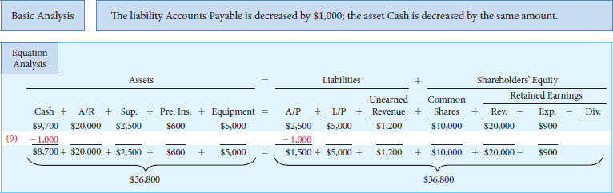

- On October 22, Sierra made a partial payment of $1,000 on the amount it owed for the supplies purchased from Aero Supply on October 9.

- Recall that the supplies and an account payable from this transaction were recorded earlier in transaction 6, when the supplies were purchased.

- Supplies should not be recorded again when the cash is paid. Rather, Accounts Payable is decreased by $1,000 and Cash is decreased by the same amount.

- Transaction (10): Payment of Salaries.
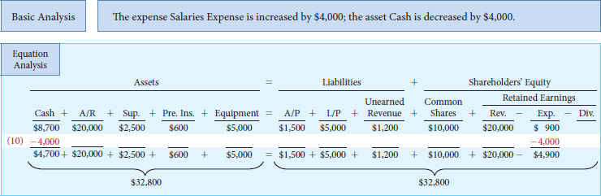

- Employees worked two weeks, earning $4,000 in salaries (4 employees * $500/ week * 2 weeks), and were paid on October 23.

- Salaries are an expense similar to rent because they are a cost of generating revenues.

- While the act of hiring the employees in transaction 5 did not result in an accounting transaction, the payment of the employees' salary is a transaction because assets and expenses are affected.

- Cash is decreased by $4,000 and Salaries Expense is increased by $4,000 (which reduces retained earnings, which in turn reduces shareholders' equity, by $4,000)

- Transaction (11): Payment of Dividend
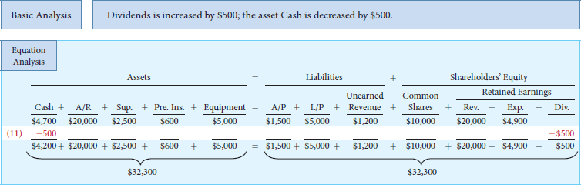

- On October 26, Sierra paid a $500 cash dividend.

- Dividends are a distribution of retained earnings rather than an expense—they are not incurred to generate revenue.

- Cash is decreased by $500 and Dividends is increased by $500, which reduces both retained earnings and shareholders' equity

- Transaction (12): Collection on Account
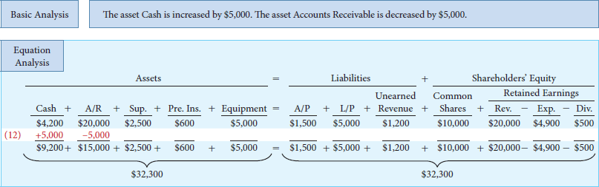

- On October 30, Copa paid Sierra $5,000 of the amount owing on its account.

- Recall that an account receivable and the revenue from this transaction were recorded earlier in transaction 7, when the service was provided.

- Revenue should not be recorded again when the cash is collected.

- Cash is increased by $5,000 and Accounts Receivable is decreased by $5,000, bringing the balance in this account to $15,000—the amount still owing from Copa. Total assets and total liabilities and shareholders' equity are unchanged.

- Transaction (13): Payment of Income Tax
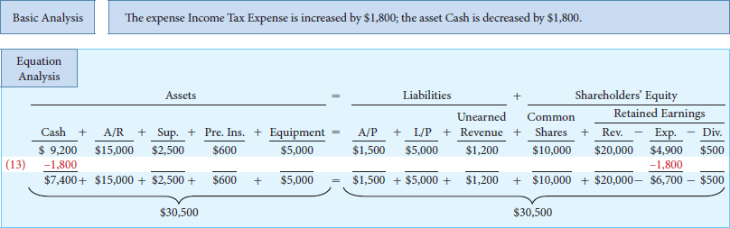

- On October 30, Sierra paid a monthly income tax instalment of $1,800.

- Cash is decreased by $1,800 and Income Tax Expense is increased by $1,800, which in turn decreases retained earnings and shareholders' equity by $1,800

- _{SUMMARY OF TRANSACTIONS}
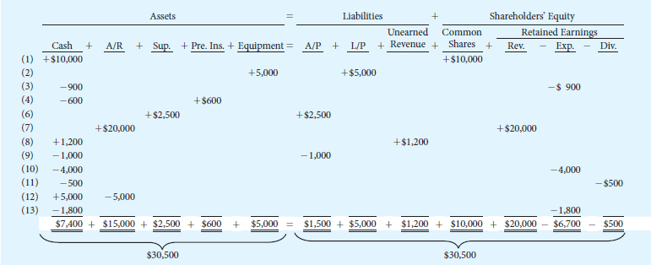

3.2 _{THE ACCOUNT}

Account: Is an individual accounting record of increasing and decreasing specific assets, liabilities or shareholders' equity items.

Types of Accounts
Cash
Inventory
Equipment
Note payable

Example: Sierra Corporation has separate accounts for cash, accounts receivable, accounts payable, service revenue, salaries expense, and so on.

- In its simplest form, an account consists of three parts: (1) the title of the account, (2) a left or debit side, and (3) a right or credit side.

T Account: The basic form of an account with debt on the (left side) and credit on the (right side) showing the effect of transactions on the account. (Increasing and Decreasing in a specific Asset, Liability, or Shareholders’ Equity item)


- _{DEBITS AND CREDITS}

Debit (Dr.): The left side of the account

Credit (Cr.): The right side of the account

- Debits and credits are merely directional signals used in the recording process to describe where entries are made in the accounts.

Debiting: The act of entering an amount on the left side of an account.

Crediting: Making an entry on the right side account.

- When the totals of the two sides are compared, an account will have a debit balance if the total of the debit amounts recorded exceeds the total of the credit amounts recorded. Conversely, an account will have a credit balance if the credit amounts exceed the debits.

- When we record transactions, two or more accounts are affected and their balances change. We use debits and credits to explain the effect of these changes.

- At all times, the debit movement in the accounts must equal the credit movement in the accounts.

Double-entry accounting system: A system that records the dual (two-sided) effect of each transaction in appropriate accounts.

- This system provides a logical method for recording transactions and ensuring that amounts are recorded accurately. If every transaction is recorded with equal debits and credits, then the sum of all the debits to the accounts must equal the sum of all the credits.

- The following diagram will help us understand how debit and credit effects apply to the accounting equation:



- Beginning on the left-hand side of the accounting equation (asset accounts), we can see that increases in asset accounts are recorded by debits. The converse is also true: decreases in asset accounts are recorded by credits.

- If we cross to the right-hand side of the equation, it must follow that increases and decreases in liabilities and shareholders' equity have to be recorded opposite from increases and decreases in assets. Thus, increases in liabilities and shareholders' equity are recorded by credits and decreases by debits.

*Debits and credits do not always mean “increases” and “decreases.” While debits do increase certain accounts (such as assets), they decrease other accounts (such as liabilities).

- _{ASSETS AND LIABILITIES}
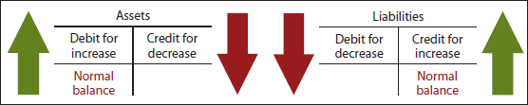

- Asset accounts normally show debit (left-side) balances. Increases in assets must be entered on the left or debit side of a T account while decreases in assets must be entered on the right or credit side.

- Debits to a specific asset account should exceed credits to that account, which results in a normal debit balance.

*The normal balance of an account is always on its increase side. (You can never spend more than you have)

- Knowing an account's normal balance may help when you are trying to identify errors.

- Liability accounts normally show credit (right-side) balances. Increases in liability accounts must be entered on the right or credit side of a T account while decreases in liability accounts must be entered on the left or debit side. Credits to a specific liability account should exceed debits to that account, which results in a normal credit balance.

- _{SHAREHOLDERS' EQUITY}

- All asset and liability accounts have the same debit/credit rule procedures. That is, all asset accounts are increased by debits and decreased by credits. All liability accounts are increased by credits and decreased by debits.

- However, shareholders' equity consists of different components, and they do not all move in the same direction. You will recall that shareholders' equity is usually composed of common shares (one type of share capital) and retained earnings.

- Retained earnings can be further subdivided into revenues and expenses (which make up profit) and dividends; these components are then added to (in the case of profit) or deducted from (in the case of dividends) any beginning balance in retained earnings.

- Increases in Shareholders' Equity.
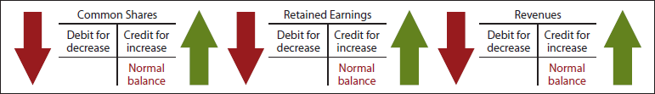

- Common shares and retained earnings both increase shareholders' equity.

- Common shares are issued in exchange for cash and other assets received from shareholders when they invest in the business.

- Retained earnings are the portion of shareholders' equity that has been accumulated through the profitable operation of the company.

- Retained earnings (and shareholders' equity in turn) are increased by revenues.

- Common shares, retained earnings, and revenue accounts are increased by credits and decreased by debits. The normal balance in these accounts is a credit balance.

- Decreases in Shareholders' Equity.
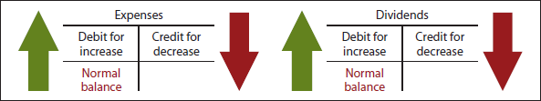

- Expenses and dividends both decrease retained earnings (which in turn decreases shareholders' equity).

- Expenses, along with revenues, combine to determine profit. Since expenses are the negative factor in the calculation of profit, and revenues are the positive factor, it is logical that the increase and decrease sides of expense accounts should be the reverse of revenue accounts. Thus, expense accounts are increased by debits and decreased by credits.

- Dividends are a distribution to shareholders of retained earnings, which reduces retained earnings.

- If retained earnings are decreased by debits, it follows that increases in the dividends account are recorded with debits. Credits to the dividends account are unusual, but might be used to correct a dividend recorded in error.

- Because expense and dividend accounts are increased by debits, the normal balance in these accounts is a debit balance

- SUMMARY OF DEBIT AND CREDIT EFFECTS
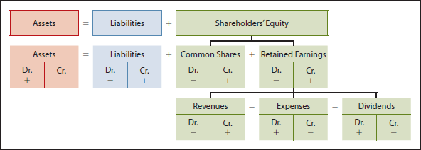

- Assets, on the left-hand side of the accounting equation, are increased by debits.

- Liabilities and shareholders' equity, on the right0hand side of the equation, are increased by credits.

- Shareholders' equity is further divided into at least two components: common shares and retained earnings. Since shareholders' equity is increased by credits, both of these accounts—common shares and retained earnings—are also increased by credits.

- Retained earnings can be further subdivided into revenues and expenses (revenues and expenses combine to determine profit) and dividends, which add to or reduce any beginning balance in retained earnings. Since revenues increase retained earnings and shareholders' equity, increases in revenue accounts are recorded by credits.

- Expenses and dividends decrease retained earnings, and thus shareholders' equity. Decreases in shareholders' equity are recorded by debits. Because expenses and dividends decrease shareholders' equity, increases in each of these accounts are recorded by debits.

3.3 _{THE JOURNAL (RECORD)}

- _{RECORDING PROCESS}
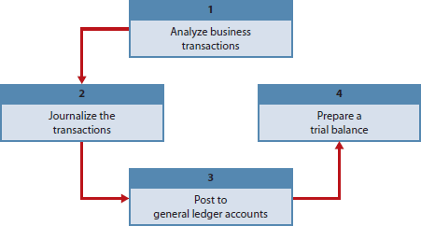

Accounting Cycle: A series of nine steps followed by accountants to record transactions and prepare financial statements. The first four steps were introduced in this chapter: analyzing transactions (step 1), journalizing transactions (step 2), posting transactions (step 3), and preparing a trial balance (step 4).

- Each transaction must be analyzed to determine if it has an effect on the accounts. Evidence of the transaction comes from a source document, such as a sales slip, cheque, bill, or cash register tape.

- In the beginning, as described in our feature story, Grant Hooker used cheques to begin the recording process for BeaverTails. This evidence of the transaction is analyzed to determine the effect on specific accounts. Deciding whether a transaction has occurred, and if so what to record, is the most critical point in the accounting process.

- _{GENERAL JOURNAL}

General Journal: The book of original entry in which transactions are recorded in chronological order by date.

- The general journal makes several contributions to the recording process:
  - It discloses the complete effect of a transaction in one place, including an explanation and, where applicable, identification of the source document.
  - It provides a chronological record of transactions.
  - It helps to prevent and locate errors, because the debit and credit amounts for each entry can be quickly compared.

Journalizing: Entering transaction data in the general journal.

*look at the first transaction of Sierra Corporation. On October 1, common shares were issued in exchange for $10,000 cash.


- This transaction would be recorded in the general journal as follows:
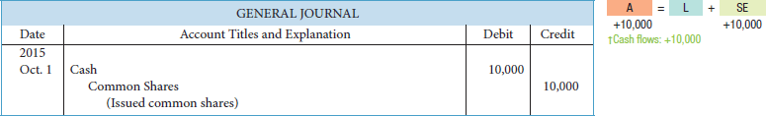

- Note the following features of the journal entry:
  - The date of the transaction is entered in the Date column.
  - The account to be debited is entered first at the left. The account to be credited is then entered on the next line, indented under the line above. The indentation differentiates debits from credits and decreasing the chance of switching the debit and credit amount by mistake.
  - The amounts for the debits are recorded in Debit (left) column, and the amounts for the credit are recorded in the Credit (right) column.
  - A brief explanation of the transaction is given.

If a journal entry affects only two accounts, one debit and one credit, it is considered to be a simple journal entry. When three or more accounts are required in one journal entry, the entry is called a compound entry. Regardless of the number of accounts used in the journal entry, the total debit and credit amounts must be equal.
In assignments when specific account titles are given, they should be used in journalizing. When account titles are not given, you should create account titles that identify the nature and content of each account. Ambiguous or multiple account titles with similar names can lead to incorrect financial reporting. For example, a company could use any one of these account titles for recording the cost of delivery trucks: Automobiles, Delivery Trucks, Trucks, or Vehicles. However, if it uses more than one of these account titles, it will not be able to easily determine the total cost of its delivery trucks.
Once the company chooses the specific account title to use (say, Vehicles), all future transactions related to that account should be recorded in the Vehicles account. Note that an account title itself should not contain explanations or descriptions (such as Vehicles Purchased).
Although explanations are an important part of each journal entry, you may omit them unless otherwise instructed in your homework assignments because including an explanation in an assignment simply involves copying the information from the problem to your assignment.

3.4 _{THE LEDGER}

- _{GENERAL LEDGER}

General ledger: The book of accounts that contains all the asset, liability, shareholders' equity, revenue, and expense accounts. Each account has a number so that it is easier to identify.

- A company can use a loose-leaf binder or card file for the ledger, with each account kept on a separate sheet or card.

- A column in spreadsheet software can also be used as a general ledger account, but most companies today use a computerized accounting system where the entries from the journal are automatically recorded in the ledger by the software.

- The ledger is often arranged in the order in which accounts are presented in the financial statements, beginning with the statement of financial position accounts. The asset accounts come first, followed by liability accounts, and then shareholders' equity accounts, including share capital, retained earnings, and dividend accounts, followed by revenue and expense accounts.

Chart of accounts: It lists the accounts and the account numbers that identify where the accounts are in the ledger.

- The numbering system that is used to identify the accounts can be quite sophisticated or pretty simple. Similar to the ledger, the chart of accounts usually starts with the statement of financial position accounts, followed by the income statement accounts.

*Accounts shown in red are used in this chapter; accounts shown in black are explained in later chapters. The four-digit numbering system allows room for new accounts to be created as needed during the life of the business.
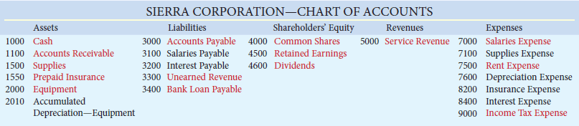

- _{POSTING}

Posting: The procedure of transferring journal entries from the general journal to the general ledger accounts.

- This phase of the recording process accumulates the effects of journalized transactions in the individual accounts. Posting involves transferring information from the general journal to the general ledger.

Example: The date and amount shown on the first line of a general journal entry is entered in the debit column of the appropriate account in the general ledger. The same is done for the credit side of the entry—the date and amount are entered in the credit column of the general ledger account.

- Posting should be done in chronological order. That is, all the debits and credits of one journal entry should be posted before going on to the next journal entry.

- Posting should also be done on a timely basis—at least monthly—to ensure that the general ledger is up to date. In a computerized accounting system, posting is usually performed by software simultaneously after each journal entry is prepared.

- The first three steps in the accounting cycle—analyze, journalize, and post transactions—occur repeatedly in every company, whether a manual or a computerized accounting system is used.

- However, the first two steps—the analysis and entering of each transaction—must be done by a person even when a computerized system is used.

- The basic difference between a manual and computerized system is in the last step (Step 3) in the recording process—posting the information (and in some of the subsequent steps in the accounting cycle that we will learn about later). In a computerized system, Step 3 is done automatically by the computer. In order to understand how this happens, we need to understand manual approaches to the recording process,

- THE RECORDING PROCESS ILLUSTRATED
  - _{LOOK AT ONLINE TEXTBOOK}

3.5 _{THE TRIAL BALANCE}

Trial balance: Is a list of general ledger accounts and their balances at a specific time. It is prepared at the end of an accounting period, which is usually monthly, but could also be quarterly or annually.

- In the trial balance, the accounts are listed in the order in which they appear in the ledger, with debit balances listed in the left column and credit balances in the right column. The totals of the two columns must be equal.

- The main purpose of a trial balance is to prove (check) that the debits equal the credits after posting. That is, the sum of the debit account balances must equal the sum of the credit account balances.

- If the debit and credit totals don't agree, the trial balance can help uncover errors in journalizing and posting.

Example: The trial balance will not balance if a debit or credit amount is unequal in a journal entry, or if the amount is transferred incorrectly to the general ledger from a journal entry. If the trial balance does not balance, then the error must be located and corrected before proceeding.

- A trial balance is also useful in the preparation of financial statements.

- The procedure for preparing a trial balance is as follows:
  - List the account titles and their balances in the same order as in the general ledger (which is usually in financial statement order). Debit balances should be entered in the debit column and credit balances in the credit column.
  - Total the debit column and the credit column.
  - Ensure that the debit and credit column totals are equal (agree).
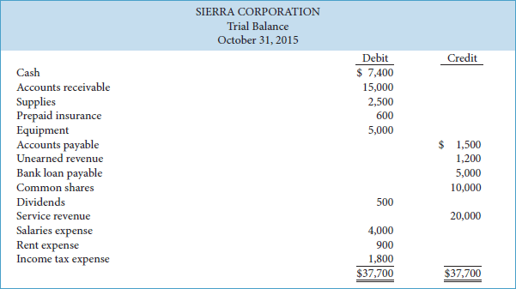

- You might wonder why there is no retained earnings account included in the above trial balance.

- When a trial balance is first prepared, it is important to understand that the retained earnings account balance that is listed on the trial balance is not the retained earnings balance at the end of the period; rather, it is the retained earnings balance at the beginning of the period.

- In Sierra's case, its beginning retained earnings balance is zero as this is its first month of operations; accounts with zero balances are not normally included in a trial balance.

- Recall that retained earnings at the beginning of a period plus revenues less expenses and dividends for the period gives us retained earnings at the end of the period. If a trial balance lists revenues, expenses, and dividend account balances, the retained earnings balance has not yet been updated for these items and must therefore represent the balance in retained earnings at the beginning of the period. We will learn how to update retained earnings at the end of the accounting period in the next chapter.

- _{LIMITATIONS OF A TRIAL BALANCE}

- Although a trial balance reveals many types of errors in the recording process, it does not prove that all transactions have been recorded or that the general ledger is correct. Errors may exist even though the trial balance column totals agree.

- The trial balance may balance even when:
  - A transaction is not journalized
  - A correct journal entry is not posted
  - A journal entry is posted twice
  - Incorrect accounts are used in journalizing or posting
  - Errors that cancel each other's effect are made in recording the amount of a transaction

- In other words, as long as equal debits and credits are posted, even to the wrong account or in the wrong amount, the total debits will equal the total credits. Nevertheless, despite its limitations, the trial balance is a useful screen for finding many errors.

Chapter 4
4.1 _{TIMING ISSUES}

- Accounting divides economic life of business into artificial time periods

- Accounting time periods are normally one month, one quarter (three months), or one year.

Fiscal year: The accounting time periods of one year.

Interim Period: Is know as a shorter time period.

- _{REVENUE RECOGNITION}

Revenue: Is considered to be earned when goods and services are exchanged for cash or claims of cash (such as account receivable), which results in an increase in future economic benefits.

- Revenues comes in the course of “ordinary” activities, such as the sale of merchandise in a merchandising company or providing services in a service company.

- Revenues can also come from other activities, such as:
Rent revenue,
Investment income (from sources such as interest or dividends)
Gains on sale.

- Cash doesn’t all way dictates when revenue is recognized. Revenue recognition occurs when three conditions are met:
  - The sale performance is substantially complete
  - The revenue amount is determinable
  - The collection of revenue is reasonably confident.

- In a merchandising company, revenue is recognized (recorded) when the merchandise is sold (normally at the point of sale). In a service company, revenue is recognized (recorded) at the time the service is performed. Regardless of whether cash is received at the point of sale or delivery of service or expected to be received at some point in future, the revenue is recognized when earned; that is, when the above three conditions have been met.

Example: A consulting company provided services to a client on account after doing a detailed credit check. The services were performed in September. In October, the company sent the client an invoice, and in November, the company received payment from the client. In what month should the revenue be recorded by the consulting company? The answer is September because that was when the service was performed and consequently the revenue was earned. An asset account, Accounts Receivable, would be increased, as would a revenue account, Service Revenue. At that time, the amount of the revenue could be measured because, even though an invoice had not been prepared, the price would have been known and agreed to by both parties. Furthermore, the revenue and any related accounts receivable are likely to be collected.

- _{EXPENSE RECOGNITION}

Expenses: Are the costs of assets that are consumed or services used in a company's ordinary business activities.

- Expenses are tied to changes in assets and liabilities. When an expense is incurred, an asset will decrease or a liability will increase. Consequently, just as revenues are related to increases in future economic benefits, expenses are related to decreases in future economic benefits.

Expense recognition: The process of recording an expense when there is a decrease in future economic benefits related to a decrease in an asset or an increase in a liability in the course of ordinary activities that can be measured reliably. When there is a direct association between the expenses incurred and the generation of revenue, expenses (effort) are matched with revenues (results).

Example: During the month of September, company employees provided services to a client. Because of this, the company owes these employees salaries. This obligation creates an increase in a liability, Salaries Payable (or a decrease in an asset, Cash), and a corresponding increase in an expense, Salaries Expense. In this case, the expenses were recognized in the same month as the revenues because the expenses were incurred at the same time and contributed to the earning of the revenue. This does not mean that revenues and expenses are always recognized at the same time.

- Sometimes, it is not possible to directly associate expenses with revenue.

Example: If a company rented office space, each month the rent would be due and this would increase a liability, Rent Payable (or decrease an asset, Cash) and increase an expense, Rent Expense, even if the company earned no revenue in a particular month.

- It is also difficult to match interest expense with the revenue this finance cost might help earn.

Example: Include costs that help generate revenue over multiple periods of time, such as the depreciation of long-lived assets such as equipment.

- ACCRUAL VERSUS CASH BASIS OF ACCOUNTING

- The combined application of revenue recognition and expense recognition results in accrual basis accounting.

Accrual basis accounting: Transactions affecting a company's financial statements are recorded in the periods in which the events occur, rather than when the company actually receives or pays cash.

Explanation: Recognizing revenues when they are earned rather than only when cash is received. Likewise, expenses are recognized in the period in which goods (such as supplies) are consumed or services (such as employees' labour) are used, rather than only when cash is paid.

Cash basis accounting: Revenue is recorded only when cash is received, and an expense is recorded only when cash is paid.

- Cash basis accounting seems appealing because of its simplicity, but it can result in misleading information for decision-making because it leaves a time gap between the matching of efforts (expenses) with results (revenues).

Example: Colours Paint Barn and you paint a building complex during year 1. In year 1, you incur and pay total expenses of $50,000, which includes the cost of the paint and your employees' salaries. You bill your customer $80,000 at the end of year 1, but you are not paid until year 2. On an accrual basis, you would report the revenue during the period when it is earned—year 1. The expenses would be recognized (recorded) in the period in which the revenues were earned. Thus, your profit for year 1 would be $30,000, and no revenue or expense from this project would be reported in year 2. The $30,000 of profit reported for year 1 provides a useful indication of the profitability of your efforts during that period.

Example: If, instead, you were reporting on a cash basis, you would report expenses of $50,000 in year 1 and revenues of $80,000 in year 2. In year 1 there would be a loss of $50,000, while profit for year 2 would be $80,000.
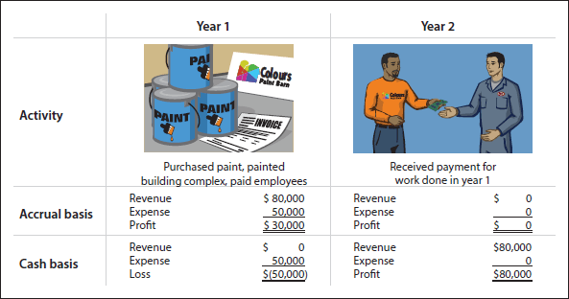

While total profits are the same over the two-year period ($30,000), cash basis measures are not very informative about the results of your efforts during year 1 or year 2. The total overall profit of $30,000 is the result of a loss of $50,000 in year one and a big swing in profit to $80,000 in year 2. As Carter Scott, the controller of Western University in our feature story, said, “Accrual accounting is considered the most appropriate method of financial reporting because revenues and expenses are recognized in the period to which they relate, regardless of whether there has been a receipt or payment of cash. A more meaningful picture of financial position and operations is provided under accrual accounting than on a cash flow basis.”

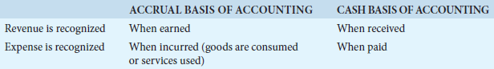

4.2 _{THE BASIC OF ADJUSTING ENTRIES}

Adjusting Entries: Journal entries made at the end of an accounting period to update the accounts to ensure the proper recognition of revenues and expenses. (revenues to be recorded in the period in which they are earned, and for expenses to be recorded when incurred)

- Adjusting entries form Step 5 of the accounting cycle

- Adjusting entries are necessary because the trial balance—the first pulling together of the transaction data—may not contain complete and up-to-date data. This is true for several reasons:
  - Some events are not recorded daily, because it would not be useful or efficient to do so.
Examples: The use of supplies and the earning of salaries by employees.

- Some costs are not recorded during the accounting period, because these costs expire with the passage of time rather than as a result of recurring daily transactions.
Examples: Include rent, insurance, and depreciation.

- Some items may be unrecorded.
Example: Utility service bill that will not be received until the next accounting period. The bill, however, covers services delivered in the current accounting period.

- Adjusting entries are required every time financial statements are prepared. For public corporations, this means at least quarterly as they are required to issue quarterly financial statements. For private corporations, this means at least annually although many companies may choose to record adjusting entries more frequently.

- Preparing adjusting entries requires an understanding of the company's operations and the interrelationship of accounts and can be a long and detailed process.

Example: To accumulate the adjustment data for supplies, a company may need to count its remaining supplies. It may also need to prepare supporting schedules of insurance policies, rental agreements, and other contractual commitments.

- Adjustment data are often not available until after the end of the period.

Example: Telephone and other bills will not be received until after the month end or year end. In such cases, the data are gathered as soon as possible after the end of the period and adjusting entries are made, but they are still dated at the period end (in other words, the statement of financial position date).

Unadjusted trial balance: Which simply means it was prepared before adjusting entries have been made.

- _{TYPES OF ADJUSTING ENTRIES}

- Adjusting entries can be classified as either prepayments or accruals. Each of these classes has two subcategories, as follows:
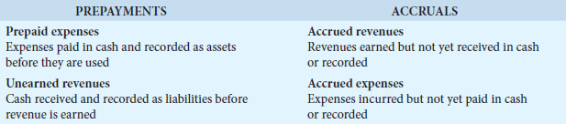

- Subsequent sections give examples and explanations of each type of adjustment. Each example is based on the October 31 trial balance of Sierra Corporation from Chapter 3, monthly adjusting entries will be made, dated October 31.
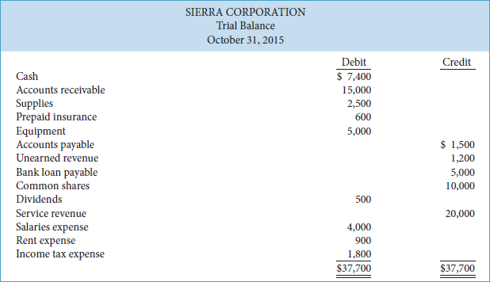

*Note that when a trial balance has no preceding adjective in its title, such as “adjusted” trial balance or “post-closing” trial balance, it is assumed to be an unadjusted trial balance.

- ADJUSTING ENTRIES FOR PAYYMENTS

Prepayments: Increase current assets such as prepaid expenses and certain types of non-current assets such as buildings and equipment.

- A prepayment can also be received rather than paid, in which case the prepayment increases current liabilities such as unearned revenue. We will look at each of these

- Types of prepayments:
Prepaid expenses
Unearned revenues

- Prepaid Expenses

Prepaid Expenses: Cost that are paid for in cash before they are used.

- Prepaid expenses are costs that expire either with the passage of time (such as insurance) or through use (such as supplies).

- Instead, we record these expired costs when financial statements are prepared. At each statement date, adjusting entries are made for two purposes:
  - Record the expenses (expired costs) applicable to the current accounting period
  - Show the remaining amounts (unexpired costs) in the asset accounts

- The original journal entry to record a prepaid expense normally involves a debit to an asset (prepaid expenses) account and a credit to the Cash account. It can also involve a credit to a payable account, instead of Cash.

- An adjusting entry for prepaid expenses is required to recognize the expense and reduction of the asset (prepaid expenses).

- Consequently, adjusting entries for prepaid expenses result in an increase (a debit) to an expense account and a decrease (a credit) to an asset (prepaid expenses)
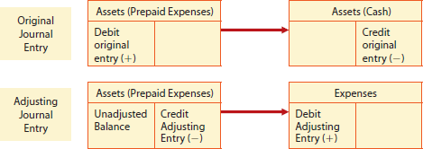

- Until prepaid expenses are adjusted, assets are overstated and expenses are understated. If expenses are understated, then profit and shareholders' equity will be overstated.

Example: Supplies

- The purchase of supplies, such as paper and envelopes, results in an increase (a debit) to an asset (Supplies) account.

- During the accounting period, supplies are used. Rather than record supplies expense as the supplies are used, supplies expense is recognized at the end of the accounting period.

- At that time, the company must count the remaining supplies. The difference between the balance in the supplies (asset) account and the actual cost of supplies on hand gives the supplies used (an expense) for that period.

- Sierra Corporation purchased supplies costing $2,500 on October 9. This is an example of a prepayment made on account, rather than by cash. The payment was recorded by increasing (debiting) the asset account Supplies and increasing (crediting) the liability account Accounts Payable.

- The Supplies account therefore shows a balance of $2,500 in the October 31 trial balance. A count at the close of business on October 31 reveals that $1,000 of supplies are still on hand. Thus, the cost of supplies used is $2,500-$1,000=$1,500
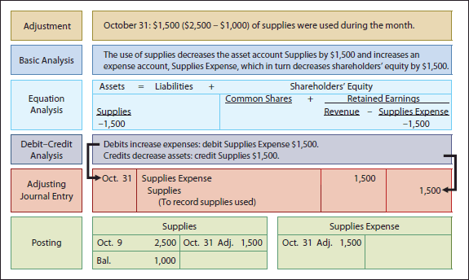

- After adjustment, the asset account Supplies shows a balance of $1,000, which is equal to the cost of supplies on hand at the statement date.

- Supplies Expense shows a balance of $1,500, which equals the cost of supplies used in October.

- If the adjusting entry (abbreviated in the T account above as “Adj.”) is not made, October expenses will be understated and profit overstated by $1,500. Moreover, as the accounting equation shows, both assets and shareholders' equity will be overstated by $1,500.

Example: Insurance

- Companies purchase insurance to protect themselves from losses caused by fire, theft, and unforeseen accidents. Insurance must be paid in advance, often for one year.

- Insurance payments (premiums) made in advance are normally recorded in the asset account Prepaid Insurance. At the financial statement date, it is necessary to make an adjustment to increase (debit) Insurance Expense and decrease (credit) Prepaid Insurance for the cost of insurance that has expired during the period.

- On October 5, Sierra Corporation paid $600 for a one-year insurance policy. Coverage began on October 1. The payment was recorded by increasing (debiting) Prepaid Insurance when it was paid. This account shows a balance of $600 in the October 31 trial balance. An analysis of the insurance policy reveals that $50 of insurance expires each month. $600/12 months= $50
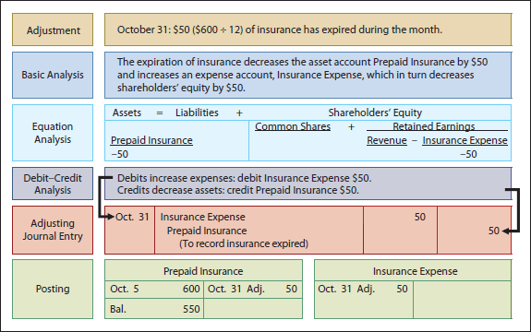

- After adjustment, the asset Prepaid Insurance shows a balance of $550, which represents the cost that supplies to the remaining 11 months of insurance coverage 11 months*$50=$550

- At the same time, the balance in Insurance Expense is equal to the insurance cost that was used in October. If this adjustment is not made, October expenses will be understated and profit overstated by $50. Moreover, both assets and shareholders' equity will be overstated by $50.

Example: Deprecation

Useful Life: The length of service of a depreciable asset.

Depreciation: The process of allocating the cost of a long-lived or non-current asset, such as buildings and equipment, to expense over its useful life.

Depreciable Assets: Only assets with specified useful lives are depreciated.

- When an asset, such as land, has an unlimited useful life, it is not depreciated.

- While the term depreciation is normally used in relation to property, plant, and equipment,

Amortization: Is used in relation to intangible assets.

- Deprecation and Amortization mean the same thing

- Some companies use the term amortization in place of depreciation, especially private companies reporting under ASPE.

Straight-line method of depreciation: COST/ USEFULL LIFE =ANNUAL DEPRECIATION EXPENSE

- Sierra Corporation purchased equipment that cost $5,000 on October 1. If its useful life is expected to be five years, annual depreciation is $5,000/5=$1,000


- If you are calculating depreciation for partial periods, the annual expense amount must be adjusted for the portion of the year that the asset was used.
Example: if we wish to determine the depreciation for one month, we would multiply the annual result by one-twelfth as there are 12 months in a year. For Sierra Corporation, depreciation on the equipment is estimated to be $83 per month 1,000*1/12 =$83
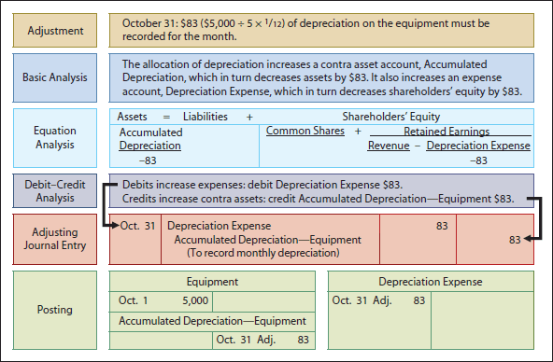

- The balance in the Accumulated Depreciation account will increase by $83 each month until the asset is fully depreciated in five years.

- Accumulated depreciation represents the cumulative total of the depreciation expense since the asset was purchased, less any reductions when assets are sold.

- As in the case of other prepaid expenses, if this adjusting entry is not made, depreciation expense will be understated and profit overstated by $83. Total assets and shareholders' equity will also be overstated by $83.

- Statement Presentation of Depreciation LOOK OVER

- A contra account is an account that is offset against (deducted from) a related account on the income statement or statement of financial position.

- Accumulated Depreciation—Equipment is a contra asset account. That means it is offset against an asset account, Equipment, on the statement of financial position. Its normal balance is a credit—the opposite of the normal debit balance of its related account, Equipment.

- There is a simple reason for using a separate contra account instead of decreasing (crediting) Equipment: using this account discloses both the original cost of the equipment and the total estimated cost that has expired to date. This also helps separate actual amounts (cost) from estimated amounts (accumulated depreciation).

In the statement of financial position, Accumulated Depreciation—Equipment is deducted from the related asset account as follows:

Carrying amount (book value): The difference between the cost of a depreciable asset and its accumulated depreciation.

Example: The equipment's carrying amount at the statement of financial position date is $4,917. Be sure to understand that, except at acquisition, the asset's carrying amount and its fair value (the price at which it could be sold) are two different amounts. As noted earlier, the purpose of depreciation is not to state an asset's value, but to allocate its cost over time.
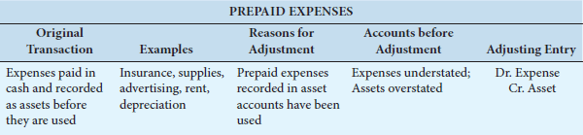

- Unearned Revenues

Unearned Revenues: When cash is received in advance for items like rent, magazine subscriptions, and customer deposits—received for services that will be provided in the future.

- Cash is increased (debited) and the liability account Unearned Revenue increased (credited) to recognize that the company has received cash in advance and has an obligation to provide a service in the future, or refund the cash.
Example: Airlines, such as Air Canada, treat cash received from the sale of tickets as unearned revenue until the flight service is provided. Similarly, tuition fees received by universities before the academic session begins are considered unearned revenue, as at Western University in our feature story.

- Unearned revenues are the opposite of prepaid expenses. Indeed, unearned revenue on the books of one company is likely to be a prepaid expense on the books of the company that has made the advance payment.
Example: If identical accounting periods are assumed, your landlord will have unearned rent revenue when you (the tenant) have prepaid rent.

- It is not practical to make daily journal entries as the revenue is earned. Instead, recognition of earned revenue is delayed until the adjustment process. At that time, an adjusting entry is then made to record the revenue that has been earned during the period and to show the liability that remains at the end of the accounting period.

- The original journal entry to record unearned revenues results in an increase (debit) to the asset (cash) and an increase (credit) to the liability (unearned revenue). The subsequent adjusting entry results in a decrease (debit) to the liability (unearned revenue) account and an increase (credit) to a revenue account.

- Typically, until the adjustment is made, liabilities are overstated and revenues are understated. If revenues are understated, then profit and shareholders' equity are also understated.

Example: We note that Sierra Corporation received $1,200 on October 19 from R. Knox for advertising services expected to be completed in the next month, November. The payment was credited to Unearned Revenue, and this liability account shows a balance of $1,200 in the October 31 trial balance. From a review of the work performed by Sierra for Knox during October, it is determined that $400 worth of work was done in October. After adjustment, the liability Unearned Revenue shows a balance of $800, which represents the remaining advertising services expected to be performed in the future. At the same time, Service Revenue shows total revenue earned in October of $20,400. If this adjustment is not made, revenues and profit will be understated by $400. Moreover, liabilities will be overstated by $400 and shareholders' equity will also be understated by that amount.

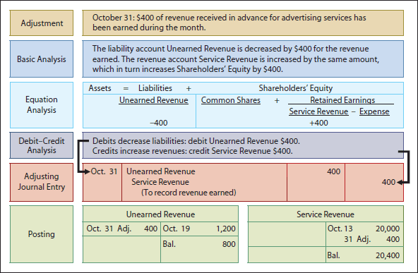

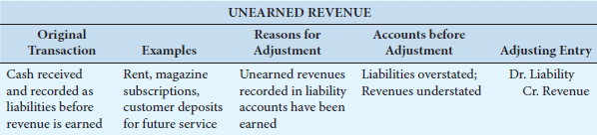

- _{ADJUSTING ENTRIES FOR ACCRUALS}

- Adjusting entries for accruals are required in order to record revenues earned, or expenses incurred, in the current accounting period.

- Unlike prepayments, accruals have not been recognized through daily entries and thus are not yet reflected in the accounts. Until an accrual adjustment is made, the revenue account (and the related asset account), or the expense account (and the related liability account), is understated.

- Thus, adjusting entries for accruals will increase both a statement of financial position account and an income statement account.

- There are two types of adjusting entries for accruals:
Accrued revenues
Accrued expenses

- Accrued Revenues

Accrued Revenues: Are revenues that have been earned but not yet received in cash or recorded.

- Accrued revenues may accumulate (accrue) with the passing of time, as in the case of interest revenue, or they may result from services that have been performed but not yet billed or collected, such as fees.

- Since accrued revenues have not previously been recorded, an adjusting entry is required for two purposes:
  - To show the receivable that exists at the end of the period
  - To record the revenue that has been earned during the period.

- Until the adjustment is made, both assets and revenues are understated. Consequently, profit and shareholders' equity will also be understated.

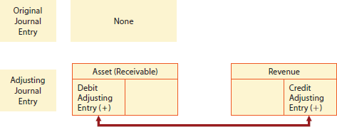

In October, Sierra Corporation earned $200 for advertising services that were not billed to clients before October 31. Because these services have not been billed, they have not yet been recorded.
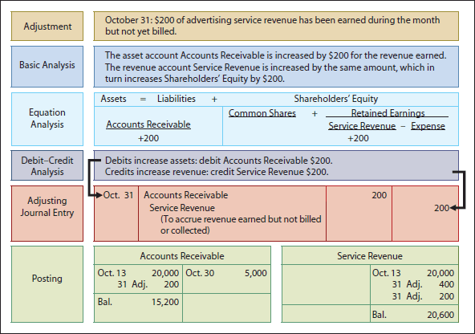
The asset Accounts Receivable shows that $15,200 is owed by clients at the statement of financial position date. The balance of $20,600 in Service Revenue represents the total revenue earned during the month. If the adjusting entry is not made, revenues and profit on the income statement, and assets and shareholders' equity on the statement of financial position, will be understated.

In the next accounting period, cash will be collected from clients for services provided in October, as well as for services provided in November. When this occurs, the entry to record the collection should recognize that $200 of the revenue was earned in October and has already been recorded in the October 31 adjusting entry and should not be re-recorded.

Example: Assume that $2,500 of revenue is collected from clients on November 6. Of this amount, $2,300 relates to services provided for cash in the first week of November, and $200 is for the services provided in October on account. The collection of cash from clients will be recorded as follows:
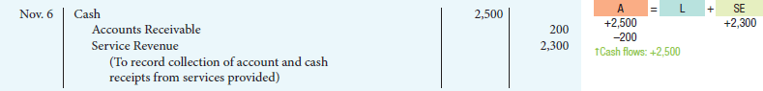

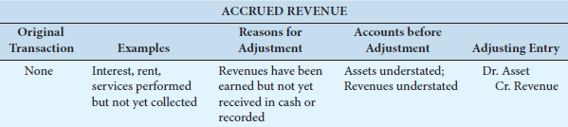

Accrued Expenses

Accrued expenses are expenses incurred but not yet paid or recorded.

Example: Interest, rent, salaries, property tax, and income tax are common examples of accrued expenses.

Accrued expenses result from the same factors as accrued revenues. In fact, an accrued expense on the books of one company is an accrued revenue to another company.

Example: the $200 accrual of service revenue for Sierra Corporation discussed above is an accrued expense for the client that received the service.

An adjusting entry for accrued expenses results in an increase (debit) to an expense account and an increase (credit) to a liability account, as shown below.
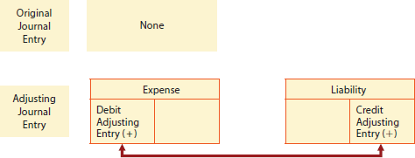

Interest.

Sierra Corporation signed a bank loan for $5,000 on October 1, repayable in three months. The bank loan accrues interest at an annual rate of 6%. Interest rates are always expressed in annual terms. The amount of the interest accumulation is determined by three factors: (1) the principal amount, or face value, of the loan ($5,000 for Sierra); (2) the interest rate, which is always expressed as an annual rate (6% for Sierra); and (3) the length of time that the loan is outstanding (unpaid) (three months for Sierra).

Interest is sometimes due monthly, and sometimes at maturity when the principal amount is due. In this instance, interest is due on the $5,000 bank loan at its due date, three months in the future. The total interest due at that time will be
, or $25 for one month. Note that the time period is expressed as a fraction of a year.
The formula for calculating interest, including how it applies to Sierra Corporation for the month of October, is shown in Illustration 4.5.
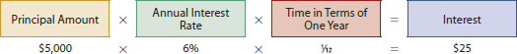
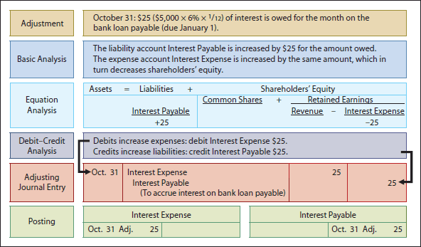
Interest Expense shows the interest charges for the month of October. The amount of interest owed at the statement date is shown in Interest Payable. It will not be paid until the bank loan comes due on January 1, 2016. The Interest Payable account is used, instead of crediting Bank Loan Payable, to disclose the two different types of obligations—interest and principal—in the accounts and statements. If this adjusting entry is not made, liabilities and expenses will be understated and profit and shareholders' equity will be overstated.
Since this is a three-month note, Sierra will also need to make identical adjustments at the end of November and December to accrue for interest expense incurred in each of these months. After the three adjusting entries have been posted, the balance in Interest Payable will be
. The following entry is made on January 1, 2016, when the loan and interest are paid:
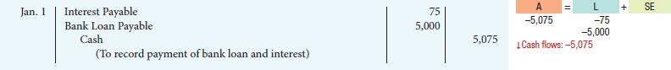
This entry does two things: (1) it eliminates the liability for Interest Payable that was recorded in the October 31, November 30, and December 31 adjusting entries; and (2) it eliminates the bank loan payable. Notice also that the account Interest Expense is not included in this entry, because the full amount of interest incurred was accrued in previous months.
Salaries.
Some types of expenses, such as employee salaries, are paid for after the services have been performed and require an accrual adjustment when financial statements are prepared. For example, at its year end, Western University, described in our feature story, accrues salary and vacation pay for approximately 3,500 faculty and staff.
At Sierra Corporation, salaries are paid every two weeks. Sierra's four employees were last paid on October 23 for the period October 12-23. The next payment of salaries will not occur until November 6. As shown on the calendar below, there are five working days that remain unpaid for October (October 26-30).
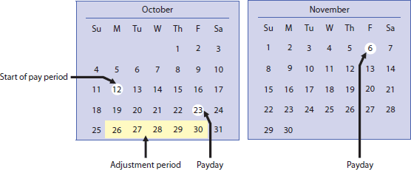
At October 31, the salaries for these five days (Monday, October 26 through Friday, October 30) represent an accrued expense and related liability for Sierra. As the four employees each receive a salary of $500 a week for a five-day workweek from Monday to Friday, or $100 a day, accrued salaries at October 31 are
.
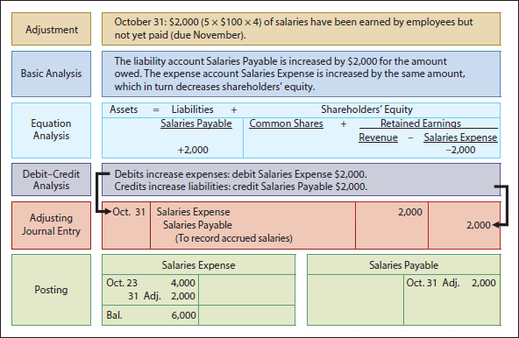
is the actual salary expense for October for the period October 12-31. The balance in Salaries Payable of $2,000 is the amount of the liability for salaries owed as at October 31. If the $2,000 adjustment for salaries is not recorded, Sierra's expenses and liabilities will be understated by $2,000. Profit and shareholders' equity will be overstated by $2,000.
At Sierra Corporation, salaries are payable every two weeks. Consequently, the next payday is November 6, when total salaries of $4,000 will again be paid. The payment consists of $2,000 of salaries payable at October 31 plus $2,000 of salaries expense for November 2-6
. Therefore, the following entry is made on November 6:
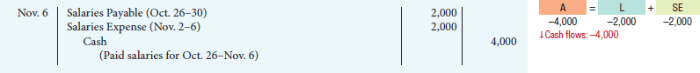
This entry eliminates the liability for salaries payable that was recorded in the October 31 adjusting entry and records the proper amount of salaries expense for Monday, November 2, through Friday, November 6, inclusive.
The following summarizes the accounting for accrued expenses.
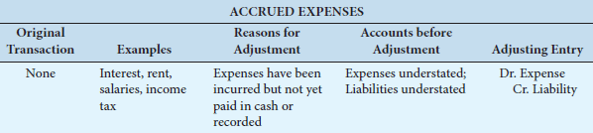
Note that each adjusting entry for accruals, whether an accrued revenue or an accrued expense, affects at least one statement of financial position account and at least one income statement account, similar to adjusting entries for prepayments.
It is also important to understand that adjusting entries never involve the Cash account. In the case of prepayments, cash has already been received or paid and recorded in the original journal entry. The adjusting entry simply reallocates, or adjusts, amounts between a statement of financial position account (such as prepaid expenses or unearned revenues) and an income statement account (such as expenses or revenues). In the case of accruals, cash will be received or paid in the future and recorded then. The adjusting entry simply records the receivable or payable and the related revenue or expense.

