1.1 _{USES & USERS OF ACCOUNTING}

Financial Accounting: The information system that identifies and records the economic events of an organization, and then communicates them to a wide variety of interested users.

- Financial Statement:
  - Income
  - Changes in shareholders' equity
  - Financial position
  - Cash Flow
  - Notes to Financial Statement

- INTERNAL USERS (Who uses Financial Statements)

Internal users: of accounting information plan, organize, and run companies. They work for the company.
These include:

(Board of Directors) Finance Directors (Is there enough cash to pay bills?)
(Management) Marketing Managers (What price should we sell products/services to maximize profit?)
Human Resource Personnel (How many employees can we afford to hire this year?)
Production Supervisors (Which product line is the most profitable?)
Company Officers

- For internal users, accounting provides a variety of internal reports, such as financial comparisons of operating alternatives, projections of profit from new sales campaigns, analyses of sales costs, and forecasts of cash needs. In addition, companies present summarized financial information in the form of financial statements for both internal and external use.

- EXTERNAL USERS (Who uses Financial Statements)

Shareholders/ Owners/ Investors: They care about profit and the stability of the company
(Potential) Investors: Use accounting information to make decisions to buy, hold, or sell their ownership interest. (Should I purchase shares of the company?)
Lenders (Bankers): Use accounting information to evaluate the risks of lending money. (Will the company be able to pay its debts as they come due?)
Other creditors (Suppliers): Use accounting information to decide whether or not to grant credit (sell on account) to a customer. (Will the company be able to pay its debts as they come due?)

- Investors, lenders, and other creditors are considered to be the primary users of accounting information.

- _{ETHICAL BEHAVIOUR BY USERS}

- Ethics in accounting is of the utmost importance to accountants and the decision makers who rely on the financial information they produce.
- Their actions are both legal and responsible. They consider the organization's interests when they make decisions.
- Accountants and other professionals have extensive rules of conduct to guide their behavior with each other and the public.

1.2 _{FORMS OF BUSINESS ORGANIZATION}

- There are three common forms of business organization: proprietorships, partnerships, and corporations.

- _{PROPRIETORSHIPS}

"Sole" Proprietorship: A business owned by one person.

- Proprietorship form of business organization is simple to set up and gives the owner control over the business.
- In some cases only a small amount of money (capital) is needed to start in business as a proprietorship.
- The owner (the proprietor) receives any profits, suffers any losses, and is personally liable (responsible) for all debts of the business. (unlimited liability)
- The life of the proprietorship is limited to the life of the owner.
- The business profits are reported as self-employment income and taxed on the owner's personal income tax return.
- However, for accounting purposes, the business records of the proprietorship must be kept separate from those related to the owner's personal activities.

- The separation of business and personal records is known in its simplest form as the reporting entity concept.

Reporting entity concept: Requires that the economic activity that can be identified with a particular company be kept separate and distinct from the activities of the owner and of all other economic entities.

- Small service businesses such as hair salons, plumbers, and mechanics are often proprietorships, as are many farms and small retail stores.

- _{PARTNERSHIPS}

_{Partnership:} A business owned by more than one person.

- Partnerships are often formed because one person does not have enough economic resources to start or expand the business, or because partners bring unique skills or other resources to the partnership.
- Formalized in a written partnership agreement that outlines the formation (Contract) of the partnership (contributions, how profits and losses are shared, provisions for withdrawals of assets and/or partners, dispute resolution, and partnership liquidation.)
- Disadvantages:
  - Each partner generally has unlimited liability for all debts of the partnership, even if one of the other partners created the debt. However, there are certain situations where partnerships can be formed with limited liability for selected partners.
- Similar to a proprietorship, the profits of the partnership are reported as self-employment income and taxed on each partner's personal income tax return.
- The reporting entity concept requires that partnership records be kept separate from each partner's personal activities.
- Partnerships are typically used to organize professional service businesses (lawyers, doctors, architects, engineers, and accountants)

- _{CORPORATIONS}

Corporation: A business organized as a separate legal entity owned by shareholders.

Explanation: Shoppers Drug Mart in our opening feature story is a corporation. As an investor in a corporation such as Shoppers Drug Mart, you receive shares to indicate your ownership claim. It is often possible for individuals to become owners of shares (shareholders) by investing relatively small amounts of money.

- Advantages:
Indefinite life (Continues on regardless (not affected by the withdrawal, death, or incapacity of an owner), of who owns its shares)
Ease of transferring ownership
Limited liability
- Make it easier for corporations, especially large corporations, to raise capital (cash) compared with proprietorships and partnerships.
- Corporations pay income tax as separate legal entities on any corporate profits.
- Corporations may receive a more favorable income tax treatment than other forms of business organization.

Public corporations: Distribute their financial statements to investors, lenders, other creditors, other interested parties, and the general public.

Private corporations: Also issue shares, but they do not make them available to the general public nor are they traded on public stock exchanges. (closely held)
- Consequently, many private corporations, especially small ones, do not have the same advantages of raising capital as do large corporations.

Example: A small, local incorporated business would likely have as much difficulty raising funds as would a proprietorship or partnership.

- GENERALLY ACCEPTED ACCOUNTING PRINCIPLES FOR BUSINESS ORGANIZATIONS (Page 8 On Slides)

(GAAP) Generally accepted accounting principles (rules & practices): Include broad policies and practices as well as rules and procedures that have substantive authoritative support and agreement about how to record and report economic events.

- Publicly traded corporations must use International Financial Reporting Standards (IFRS), a set of global accounting standards developed by the International Accounting Standards Board.
- Private corporations, whose users can have different needs than publicly traded corporations, have a choice between using IFRS or Accounting Standards for Private Enterprises (ASPE), developed by the Canadian Accounting Standards Board.
- Non-Profit Organizations can use IFRS, ASPE and Accounting Standards for Not-for-profit Organizations

1.3 _{BUSINESS ACTIVITIES}

- All businesses are involved in three types of activity: financing, investing, and operating

Example: Shoppers Drug Mart needed financing in 2012 to expand its operations, so it borrowed money from outside sources. It then invested the cash in new drugstores, as well as expanding and remodelling others. This helped Shoppers increase its operating activities and improve sales.

- FINANCING ACTIVITIES

- The two primary ways of raising outside funds for corporations are:
  - Borrowing money (debt financing)
  - Issuing (selling) shares (equity financing) in exchange for cash.

- Creditors and Lenders are people that money is owed to (one of the key user groups of accounting information)

Liabilities: Amounts owed to lenders and other creditors (in the form of debt and other obligation)

- Specific names are given to different types of liabilities, depending on their source.

Operating line of credit: A pre-arranged bank loan for a maximum amount that allows a company to draw more money than there is on hand in its bank account.

Bank indebtedness: When a company uses its operating line of credit to cover cash shortfalls and overdraws its bank account.

- Short-term loan payable (note payable) to a bank for the money borrowed to purchase racks and display cabinets.
- long-term debt, which is money borrowed for longer periods of time.

Example: mortgages payable, bonds payable, finance lease obligations, and other types of debt securities

Common shares (Share Capital): The term used to describe the amount paid by investors for shares of ownership in a company.

- Companies can also use cash for financing activities, such as repaying debt or repurchasing shares from investors.
- In loaning money, you specify a repayment schedule; for example, payment at the end of each month. In addition, interest is normally added to the amount due or overdue. As a lender or other creditor, you have a legal right to be paid at the agreed time. In the event of nonpayment, you may force the company to sell assets to pay its debts.
- If you buy a company's shares instead of loaning it money, you have no legal right to expect any payments until all of its lenders and other creditors are paid.
- Once shares are issued, the company has no obligation to buy them back, although it may choose to do so. On the other hand, debt obligations must be repaid.
- Many companies pay shareholders a return on their investment on a regular basis, as long as there is enough cash to cover required payments to lenders and other creditors.

Dividends: Payment to shareholders and are normally in the form of cash, although they can also take other forms.

- _{INVESTING ACTIVITIES}

- After a company raises money through financing activities, it then uses that money for investing activities.

Investing activities: The purchase (or sale) of long-lived assets that a company needs in order to operate.

Assets: Are resources that a company owns or controls.

- Every asset is capable of providing future economic benefits that can be short- or long-lived.

Example: Furniture, equipment, computers, vehicles, buildings, and land are all examples of long-lived assets that result from investing activities.

- Together, they are referred to as property, plant, and equipment, or “property and equipment,”(Fixed Assets)

Goodwill: Results from the purchase of another company when the price paid is higher than the value of the purchased company's net identifiable assets.

Intangible assets: Assets that do not have any physical substance themselves but represent a privilege or a right granted to, or held by, a company.
Examples: Intangible assets include patents, copyrights, and trademarks.

Cash: One of the more important assets owned by any other business.

Investments: If a company has excess cash that it does not need in the short term, it might choose to invest it in debt securities (such as bonds) or equity securities (such as shares) of other corporations or organizations

- Many students misunderstand the term investing activities, thinking the term means “investments” only. However, in the context of a business activity, investing activities means investing in the long-lived assets necessary to run the company and not just purchasing an investment on which to earn a return for the long term, such as interest or dividends.

- _{OPERATING ACTIVITIES}

- Once a business has the finances and has made the investments it needs to get started, it can begin its operations.
Example: Shoppers Drug Mart sells prescription and non-prescription drugs, as well as health and beauty aids and household products.

Revenue: We call the amounts earned from the sale of these goods at a specific period of time.

- Revenues are increases in economic benefits normally an increase in an asset but sometimes a decrease in a liability.
- Revenues come from different sources than cash and are identified by various names:
Principle Businesses:
Sales revenue
Service revenue
Other Businesses:
Interest revenue
Rent revenue

Account receivable (inflow of assets): Are assets because they will result in a future benefit—cash—when the amounts owed are eventually collected.(short-term)

Explanation: When Shoppers Drug Mart sells a prescription to a customer who has a drug plan, such as Blue Cross, it does not immediately receive all of the cash for the sale. Instead, it must send a bill to Blue Cross for the amount covered by the drug plan and then wait for Blue Cross to pay the amount owed. This right to receive money in the future is called an

- Companies also have other types of receivables, such as:
Interest receivable
Rent receivable
Income tax receivable (deferred tax assets) that is due from the federal government.

Supplies: A short-term asset used in day-to-day operations.

Before Shoppers Drug Mart can sell products to its customers, it must first buy prescription drugs, health-care aids, cosmetics, household items, and other goods. Items such as these that are held for future sale to customers result in an asset called inventory or merchandise inventory. When the goods (inventory) are sold, they are no longer an asset with future benefits but an expense. More specifically, the cost of the inventory sold is an expense called cost of goods sold. In accounting language,

Expenses: Are the costs of assets that are consumed or services that are used in the process of generating revenues.

- When an expense is incurred, an asset will decrease or a liability will increase.

- There are many kinds of expenses and they are identified by various names, depending on the type of asset consumed or service used:
Cost of goods sold
Operating and administrative expenses
Interest expense
Income tax expense

- Operating and administrative expenses item is a summary of individual expense accounts such as salaries, advertising, utilities, professional fees, rent, depreciation (the allocation of the cost of using property and equipment), amortization (the allocation of the cost of intangible assets), and other costs associated with running the business.

Short-term liabilities may result from some of these expenses. This occurs, for example, when Shoppers Drug Mart purchases drugs on credit (on account) from pharmaceutical companies (suppliers).

Payable: The amount owed by a company as of the balance sheet date

Accounts payable: The obligations to pay for these goods.

Interest payable: The outstanding (unpaid) liability amounts owed to various lenders and other creditors

Dividends payable: to shareholders

Salaries payable: To employees

Property tax payable: To the municipal and/or provincial governments

Sales tax payable: To the provincial and federal governments.

Income tax payable (deferred tax liabilities): Another liability that is payable to the government. (per-tax profit × corporate income tax rate)

To determine whether it earned a profit, Shoppers Drug Mart compares the revenues earned in a period with the expenses incurred in that same period.

- The goal of every business is to sell a good or service for a price that is greater than the cost of producing or purchasing the good or providing the service, plus the cost of operating the business.

- This means that revenues should, ideally, be greater than the expenses incurred to generate the revenue.

Profit (Net earnings or net income): When revenues are more than expenses.

Formula: REVENUE - EXPENSES = PROFIT (LOSS)

- _{SUMMARY OF BUSINESS ACTIVITIES}

- Financing activities include borrowing cash from lenders by issuing debt, or conversely, using cash to repay debt. Cash can also be raised from shareholders by issuing shares, or paid to shareholders by repurchasing shares or distributing dividends.
- Investing activities include purchasing and disposing of long-lived assets such as property, plant, and equipment and purchasing and selling long-term investments.
- Operating activities result from day-to-day operations and include revenues and expenses and related accounts such as receivables, supplies, inventory, and payables.

1.4 _{COMMUNICATING WITH USERS}

- External users, are interested in a company's assets, liabilities, and shareholders' equity, including revenues and expenses. For external reporting purposes, it is customary to arrange this information in four different financial statements that are the backbone of financial reporting.

- Income statement: Reports revenues and expenses to show how successfully a company performed during a period of time.

- Statement of changes in equity: Shows the changes in each component of shareholders' equity (usually common shares and retained earnings), as well as total equity, during a period of time.

- Statement of financial position: Presents a picture of what a company owns (its assets), what it owes (its liabilities), and the resulting difference (its shareholders' equity) at a specific point in time.

- Statement of cash flows: Shows where a company obtained cash during a period of time and how that cash was used.

- Additional information is reported in notes to the financial statements that are cross-referenced to the four statements. These explanatory notes clarify information presented in the financial statements and provide additional detail. They are essential to understanding a company's financial performance and position.
- Financial statements must be produced annually, as well as quarterly, by public corporations.

- Financial statements are often produced monthly as well for internal use.

Fiscal year: An accounting time period that is one year in length. Can start at Jan 1st - Dec 31st or Feb 1st - Jan 31st

- SIERRA'S FINANCIAL STATEMENTS (INCOME STATEMENT)

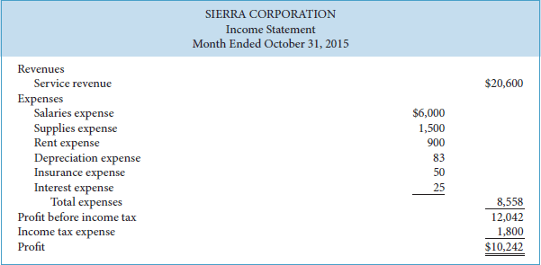
Income Statement: Reports the success or failure of the company's operations for a period of time (annually, quarterly, and/or monthly)

Example: Sierra Corporation formed the company on October 1. It has been in operation for one month only, the month ended October 31, 2015, and reports its results monthly. To indicate that Sierra's income statement reports the results of operations for a period of one month, its statement is dated “Month Ended October 31, 2015.”

- The income statement lists the company's revenues first and then its expenses.

- For now, we have simply listed expenses in order of magnitude—that is, from the largest to the smallest. Expenses are deducted from revenues to determine profit (or loss) before income tax.

- Income tax expense is usually shown separately, immediately following the profit (or loss) before income tax line. Finally, profit (or loss) is determined by deducting the income tax expense.

- Investors are interested in a company's past profit because these numbers provide information that may help predict future profits.

- Investors buy and sell shares based on their beliefs about the future performance of a company. If you believe that Sierra will be even more successful in the future, and that this success will translate into a higher share price, you should buy Sierra's shares.

- Lenders and other creditors also use the income statement to predict the future. When a bank loans money to a company, it does this because it believes it will be repaid in the future. If it thought it was not going to be repaid, it would not loan the money. Thus, before making the loan, the bank's loan officer must try to predict whether the company will stay in business long enough, and be profitable enough, to repay the loan and any interest charges. Thus, reporting recurring and increasing profits will make it easier for Sierra to raise additional cash either by borrowing or by issuing shares.

- SIERRA'S FINANCIAL STATEMENTS (CHANGES IN EQUITY)

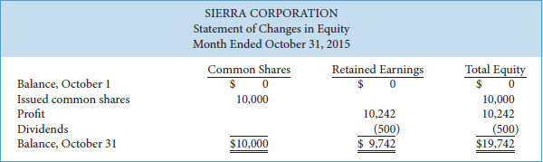

Statement of Changes in Equity: A financial statement that summarizes changes in total shareholders' equity, as well as each component of shareholders' equity for a specific period of time.

- It starts with the account balances at the beginning of the period and ends with the account balances at the end of the period. The time period is the same as for the income statement—for the year, quarter, or month.

Shareholders' Equity: The shareholders' claim on total assets, represented by the investments of shareholders (share capital) and undistributed earnings (Retained earnings) generated by the company.

- Total shareholders' equity includes (1) share capital and (2) retained earnings.

Share Capital: Amounts contributed by the shareholders in exchange of shares of ownership.

- If there is only one type of shares issued, it is called common shares

- Together, these two classes of shares—common and preferred—combine to form the company's share capital.

Example: The statement of changes in equity starts with the beginning balance of share capital—common shares, in Sierra's case. This is zero for Sierra Corporation because it just began operations at the beginning of the month, October 1. The statement then goes on to add any changes in share capital due to new shares issued (or to deduct any changes in share capital due to shares repurchased) during the period to arrive at the ending balance of share capital, as shown in equation format below.

Formula:
BEGINNING BALANCE OF CAPITAL STOCK + ISSUED OF CAPITAL STOCK DURING THE CURRENT FISCAL YEAR - PURCHASED OF CAPITAL STOCK DURING THE CURRENT FISCAL YEAR = ENDING BALANCE OF CAPITAL STOCK

Retained Earnings: Cumulative profit that has been retained in the corporation.

Deficit: If retained earnings are negative that is, there have been more losses than profits.

Example: Just as Sierra's beginning common shares balance was nil because it only began operations on October 1, so too is its beginning retained earnings balance. The profit for the period is added and dividends (if any) are deducted from the beginning balance to calculate the retained earnings at the end of the period.

Formula:
BEGINNING BALANCE OF RETAINED EARNINGS + PROFIT OF THE CURRENT FISCAL YEAR (EARNINGS OR LOSS) - DIVIDENS DISTRIBUTED DURING THE CURRENT FISCAL YEAR= ENDING BALANCE OF RETAINED EARNINGS

- If a company has a loss, it is deducted (rather than added) to arrive at the ending balance of retained earnings. It is important to understand that dividends are not reported as an expense in the income statement. They are not an expense incurred to generate revenue. Instead, dividends are a distribution of retained earnings to shareholders and reported in the statement of changes in equity.

- By monitoring the statement of changes in equity for a publicly traded corporation, financial statement users can evaluate the use of equity for financing purposes. From this statement, they can determine the amount of shares that were issued during the period,

Example: More importantly, the statement of changes in equity allows users to monitor a company's dividend payment practices. If Sierra is profitable, at the end of each period it must decide what portion of its profits to pay to shareholders through dividends. In theory, it could pay all of its current period profit, but few companies choose to do this. Why? Because they want to retain part of the profits in the business so the company can expand when it chooses to.

- SIERRA'S FINANCIAL STATEMENTS (FINANCIAL POSITION)
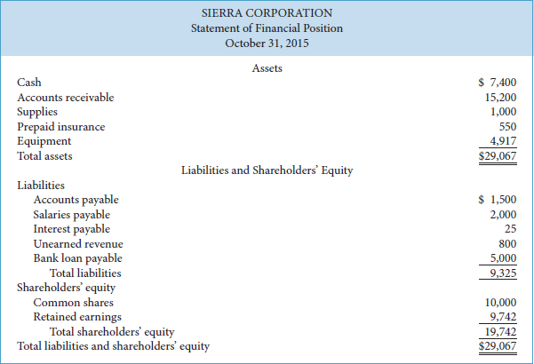

Statement of Financial positions (Balance sheet): Reports assets and claims to those assets at a specific point in time.

- Claims to assets are subdivided into two categories: claims of lenders and other creditors and claims of shareholders. As noted earlier, claims of lenders and other creditors are called liabilities. Claims of shareholders, the owners of the company, are called shareholders' equity.

Accounting Equation: ASSETS = LIABILITIES + SHAREHOLDERS' EQUITY

- Assets must be in balance with the claims to the assets. The right-hand side of the equation the liabilities and equities—also shows how the assets have been financed (through debt by borrowing from lenders or other creditors or through equity by investments from shareholders [share capital] or profits retained in the company [retained earnings]).

- As you can see in the above illustration, Sierra's assets are listed first, followed by liabilities and shareholders' equity.

Example: Sierra's assets total $29,067 and include cash, accounts receivable, supplies, prepaid insurance (insurance paid in advance but not yet used), and equipment. Of these assets, only the purchase of equipment would be presented as an investing activity in the statement of cash flows, as we will see in the next section. The other items (except for cash) are examples of assets that come from operating activities. Sierra's liabilities total $9,325 and consist of accounts payable, salaries payable, interest payable, unearned revenue (cash received in advance for which the service has not yet been provided and is therefore still owed), and a bank loan payable. Of these liabilities, only the bank loan payable is an example of a financing activity. The other items are examples of liabilities that arose from operating activities. Sierra's shareholders' equity consists of common shares of $10,000 and retained earnings of $9,742, for total shareholders' equity of $19,742. Note that Sierra's total liabilities and total shareholders' equity equal its total assets of $29,067.
The items listed in the statement of financial position can be ordered in different ways.

- Lenders and other creditors analyze a company's statement of financial position to determine the likelihood that they will be repaid. They carefully evaluate the nature of the company's assets and liabilities.

- Managers use the statement of financial position to determine whether inventory is adequate to support future sales and whether cash on hand is sufficient for immediate cash needs.

- Managers also look at the relationship between total liabilities and shareholders' equity to determine whether they have the best proportion of debt and equity financing.

Formulas:

TOTAL ASSETS: TOTAL LIABILITIES + SHAREHOLDERS' EQUITY

TOTAL ASSETS: TOTAL LIABILITIES + ( *RETAINED EARNINGS + SHARE CAPITAL)

TOTAL LIABILITIES: TOTAL ASSETS - ( *RETAINED EARNINGS + SHARE CAPITAL)

SHAREHOLDERS' EQUITY: TOTAL ASSETS - TOTAL LIABILITIES

*RETAINED EARNINGS + SHARE CAPITYAL = SHAREHOLDERS'S EQUITY

- RELATIONSHIPS BETWEEN THE STATEMENTS

- Because the results on some statements are used as data for other statements, the statements are said to be interrelated (related to each other). These interrelationships are evident in Sierra's financial statements.

- The statement changes in equity depends in part, on the result of the income statement.

Example: Sierra reported profit of $10,242 for the month. This amount is added to the beginning amount of retained earnings as part of the process of determining ending retained earnings—one of the components of total shareholders' equity shown in the statement of changes in equity.

- The statement of financial position and statement of changes in equity are interrelated.

Example: Note the ending balances of each component of shareholders' equity—common shares, $10,000, and retained earnings, $9,742—as well as total shareholders' equity of $19,742 at the end of the month reported on the statement of changes in equity. These are reported in the shareholders' equity section of the statement of financial position in.

- To prepare financial statements, you must understand the sequence in which these amounts are determined and how each statement affects the next. Because each financial statement depends on information contained in another statement, financial statements must be prepared in the following order: (1) income statement; (2) statement of changes in equity; (3) statement of financial position.
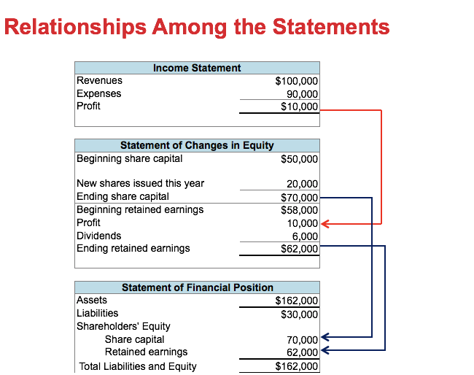

Chapter 2
2.1 THE CLASSIFIED STATEMENT OF FINANCIAL POSITION (Balance Sheet)

The statement of financial position (Balance Sheet): Presents a snapshot of a company's financial position, its assets, liabilities, and shareholders' equity at a point in time.

- To improve users' understanding of a company's financial position, companies group similar types of assets and similar types of liabilities together. A classified statement of financial position generally contains the standard classifications

- _{ASSETS}

Assets: Are the resources that a company owns or controls that will provide future economic benefits.

- Assets include:
Current Assets those resources whose benefits will be realized within one year (current assets) and those resources whose benefits will be realized over more than one year (non-current assets).

- Current Assets

Current assets: Assets that are expected to be converted into cash or will be sold or used up within one year of the company's financial statement date or its operating cycle, whichever is longer.

Operating cycle: Average period of time it takes for a business to pay cash to obtain products or services and then receive cash from customers for these products or services.

- In a merchandising business, this means the time it takes to purchase inventory, pay cash to suppliers, sell the inventory on account, and then collect cash from customers. In a service business, this is the time it takes to pay employees, provide services on account, and then collect the cash from customers. For most businesses, the operating cycle is less than a year but for some businesses, such as vineyards or airplane manufacturers, the operating cycle is longer than a year. For the purposes of this textbook, we will assume companies use one year to determine whether an asset is current or non-current.

- Common types of current assets include:
  - Cash
  - Trading Investment
  - Account Receivable
  - Note Receivable, including loans receivable
  - Merchandise inventory
  - Suppliers
  - Prepaid Expenses

You are already familiar with cash, which includes not only cash on hand but cash in banks or other financial institutions.

Cash equivalents: Short-term, highly liquid investments with very little risk that can be easily sold.

Trading investments: Investments in debt securities such as bonds of another company, or equity securities such as shares of another company, that are bought with the intention of selling the investments after a short period of time in order to earn a profit from their price fluctuations.

Accounts Receivable: Amounts owed to the company by customers who purchased products or services on credit (on account) and are normally supported with an invoice.

Accrued revenues: When payments for revenues earned by the company have not yet been received in cash.

Example: Other types of receivables can arise from amounts owed to the company for interest, sales tax, rent, and like items. Normally they are not supported by an invoice and must sometimes be estimated.

Notes receivable: Amounts owed to the company by customers or others that are supported by a written promise to repay. Loans receivable are a type of note receivable.

Merchandise Inventory: Goods held for sale to customers.

Supplies: Include consumable items like office supplies (such as paper, toner, pens) and cleaning supplies. They are a current asset because we expect that these will be used up by the business within the year.

Prepaid expenses: The cost of expenses like rent and insurance paid in advance of use. They are current assets because they reflect unused benefits such as office space and insurance coverage available for future use during the year.

- North American companies normally list current assets in the order in which they are expected to be converted into cash; that is, in their order of liquidity. Some international companies list current assets in the reverse order of liquidity.

- Non-Current Assets

Non-current assets: Are not expected to be converted into cash, sold, or used up by the business within one year of the financial statement date or its operating cycle. In other words, non-current assets consist of all assets that are not classified as current assets.

- Common types of Non-current assets include:
  - Investments
  - Property, plant, and equipment
  - Intangible assets and goodwill
  - Other assets

- Long-term investments include:
  - Multi-year investments in debt securities (for example, loans, notes, bonds, or mortgages) that management intends to hold to earn interest
  - Equity securities (for example, shares) of other companies that management plans to hold for many years to generate investment revenue or for strategic reasons.

- Long-term because they are not readily marketable or because management is not intending to sell the investment and convert it into cash within one year.
Often, long-term investments are referred to only as investments. If the word “investment” is used without any modifier (trading or long-term), it is assumed to be long-term.

Property, plant, and equipment (Fixed Assets): Tangible assets with relatively long useful lives that are currently being used in operating the business. (includes land, buildings, equipment, and furniture)

These items are normally listed in the statement of financial position in their order of permanency. That is, land is usually listed first as it has an indefinite life, and is followed by the asset with the next longest useful life, normally buildings, and so on.

Revaluation model: Most companies record their property, plant, and equipment at cost. However, some companies may choose to record these assets at fair value instead.

- Depreciation Accumulated (years after Book Value) & Depreciation Expense ( current year expense)

Depreciation: Property, plant, and equipment, except land, have estimated useful lives over which they are expected to generate revenues. (Original book value - Accumlated Depreciation = Net Book Value)

- Companies calculate depreciation by systematically assigning a portion of the asset's cost to depreciation expense each year (rather than expensing the full cost in the year the asset was purchased). Only assets with estimated useful lives are depreciated.

- Land also generates revenue, but its estimated useful life is considered to be infinite as land does not usually wear out or lose its value.

- Assets that are depreciated should be reported on the statement of financial position at cost less their accumulated depreciation.

Accumulated depreciation: Shows the amount of depreciation taken so far over the life of the asset.

Contra asset account: Its balance is subtracted from the balance of the asset that it relates to.

- The difference between cost and accumulated depreciation is referred to as the carrying amount, also commonly known as net book value or just simply book value.

Intangible assets: Are non-current assets that do not have physical substance and that represent a privilege or a right granted to, or held by, a company.

Examples: Patents, copyrights, franchises, trademarks, trade names, and licenses that give the company an exclusive right of use for a specified period of time.

- Intangible assets are normally divided into two groups for accounting purposes:
Definite useful lives
Indefinite useful lives

- Similar to buildings and equipment, the cost of intangible assets with definite useful lives is allocated over these future periods through the use of amortization.

- Amortization of intangible assets is the same as depreciation for property, plant, and equipment, even though a different term is used.

Goodwill: Results from the acquisition of another company when the price paid for the company is higher than the fair value of the purchased company's net identifiable assets (net means the value of the assets less the value of the liabilities as both are typically obtained and assumed when buying a company).

- Goodwill is a calculated amount—simply the difference between the price paid for the company and the fair value of the assets less liabilities acquired from the purchased company.

- The difference, which is goodwill, represents a value not attributable to any recorded asset or liability and relates to something intangible like the reputation of the company and the quality of its employees.

- Goodwill is similar to intangible assets in that it has no physical substance and will generate future value. It differs from intangible assets in that it cannot be separated from the company and sold—it is determined in relation to the acquired company as a whole. The only way it can be sold is to sell the acquired company. Goodwill is not amortized and is reported separately from other intangibles.

- _{LIABILITIES}

Liabilities: Are obligations that result from past transactions. Similar to assets, they are also classified as current (due within one year) and non-current (due after more than one year).

- Current Liabilities (order of urgency to pay off)

Current liabilities: Are obligations that are to be paid or settled within one year of the company's statement date or its operating cycle, whichever is longer.

- Common examples of current liabilities include:
  - Bank indebtedness
  - Accounts payable
  - Unearned revenue
  - Notes payable, including bank loans payable
  - Current maturities of long-term debt

Bank indebtedness: A short-term loan from a bank, typically occurring when a company uses an operating line of credit to cover cash shortfalls.

Accounts payable: Amounts owed by the company to suppliers for purchases made on credit (account).
- They are usually supported by an invoice.

Accrued payables: When expenses incurred by the company have not yet been paid in cash.

Explanation: Other types of payables can arise from amounts owed by the company for salaries, interest, sales tax, rent, income tax, and similar items. They are normally not supported by an invoice and may have to be estimated because of this.

Unearned revenue: Cash received in advance from a customer before revenue is earned.

Example: An airline would receive cash from passengers to purchase their tickets in advance of the flight. It is recorded as a current liability because the airline has an obligation to provide the flight in the future.

Notes payable: Amounts owed, often to banks but also to suppliers or others, that are supported by a written promise to repay.

- Amounts owed to banks are usually known as bank loans payable. It is common to refer to notes and loans interchangeably. Notes can be current or non-current. When a company has a non-current or long-term note or loan payable (such as a five-year bank loan), a portion of the loan is often repayable each year.

Current maturities of long-term debt: The portion of a non-current or long-term loan that is repayable in the current year.

- Similar to current assets, North American companies often list current liabilities in the order in which they are expected to be paid; that is, in their order of liquidity by due date.

- Users of financial statements look closely at the relationship between current assets and current liabilities. This relationship is important in evaluating a company's ability to pay its current liabilities.

- Non-Current Liabilities

Non-current (long-term) liabilities: Obligations that are expected to be paid or settled after one year

Examples of non-current liabilities include:
- Notes payable, including bank loans payable, mortgages payable, and bonds payable
- Lease obligations
- Pension and benefit obligations
- Deferred income tax liabilities

Mortgages payable: Are similar to long-term notes but have property (such as a house or a building) pledged as security for the loan.

Bonds payable: Are used by large corporations and governments to borrow large sums of money.

Lease obligations: Amounts to be paid in the future on long-term rental contracts used for equipment or other property.

Pension and benefit obligations: Amounts companies owe past and current employees for retirement benefits.

Deferred income tax liabilities: Income tax related to the current year's profit that is expected to be paid in a later year or years when a company prepares its future corporate income return.

- Non-current liabilities reported in the statement of financial position are normally accompanied by extensive notes to the financial statements that describe the nature and terms of the obligation and other relevant details.

Example: Disclosure for a long-term mortgage payable would include the maturity date, interest rate, and any security pledged to support it.

- _{SHAREHOLDERS' EQUITY}

- Shareholders' equity is divided into two parts:
Share capital & Retained earnings

- Some companies may include other parts in the shareholders' equity section, such as accumulated other comprehensive income.

- Share Capital

- Shareholders purchase shares in a company by investing cash (or other assets).
- When the company receives these assets, it issues ownership certificates to these investors in the form of common or preferred shares.

- If preferred shares are issued in addition to common shares, the total of all classes of shares issued is classified as, or titled, share capital. Quite often, companies have only one class of shares and the title is simply “common shares.” International companies often call these ordinary shares.

- Retained Earnings

Retained Earnings: The cumulative profits that have been retained for use in a company.

- Recall that the changes during the year (or period) to both share capital and retained earnings are detailed on the statement of changes in equity.

Example: I need $10mill (total assets) I only have $8mill that is invested by investors, shares, bonds etc.. (shareholders' equity) to the rest of the $2mill I will have to take a loan.

Additional contributed capital: represents amounts contributed by shareholders (in addition to share capital) as a result of certain types of equity transactions.

- _{COMPREHENSIVE ILLUSTRATION}
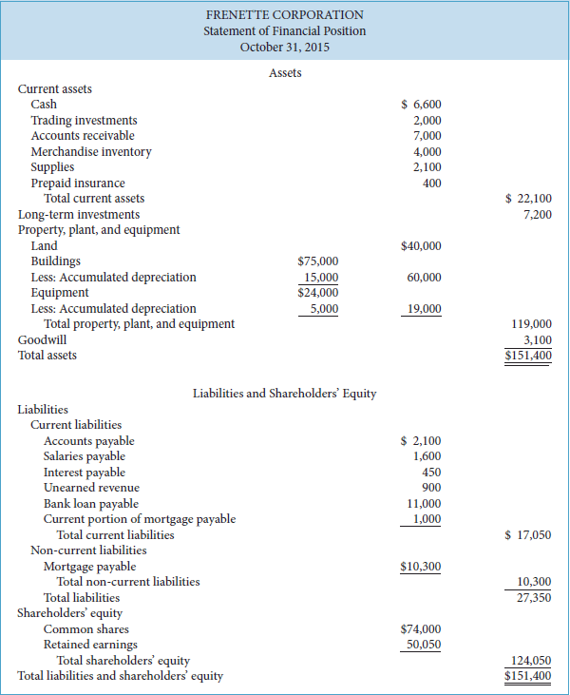

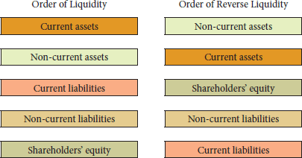

2.2 _{Using the Financial Statements}
_{Ratio analysis:} Expresses the relationships between selected items of financial statement data. Liquidity, solvency, and profitability ratios are the three general types of ratios that are used to analyze financial statements.

- Ratios can give clues about underlying conditions that may not be easy to see when the items of a particular ratio are examined separately. Since a single ratio by itself is not very meaningful, in this and later chapters we will use the following comparisons wherever possible:
Intracompany comparisons covering two or more periods for the same company
Intercompany comparisons based on comparisons with a competitor in the same industry
Industry average comparisons based on average ratios for particular industries with specific company ratios

- USING THE STATEMENT OF FINANCIAL POSITION (BALANCE SHEET)
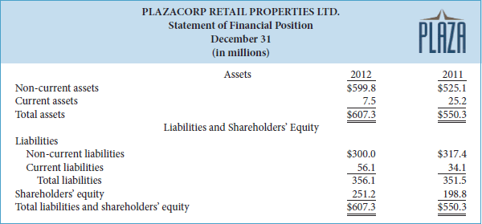
Reverse order

- Liquidity

Liquidity ratios: Measure a company's short-term ability to pay its maturing obligations (usually its current liabilities), and to meet unexpected needs for cash.

- We will look at two examples of liquidity measures: working capital and the current ratio

Example: Suppose you are a contractor entering into an arrangement to renovate some of the properties operated by Plazacorp. You would be concerned about Plazacorp's liquidity—its ability to pay obligations that are expected to become due within the next year. You would use liquidity ratios to look closely at the relationship of its current assets to its current liabilities.

- Working Capital

Working capital: The difference between current assets and current liabilities.

- When working capital is positive, there is a greater likelihood that the company will be able to pay its liabilities.
- When working capital is negative, a company may have to borrow money; otherwise, short-term creditors may not be paid.

Formula: CURRENT ASSETS — CURRENT LIABILITIES

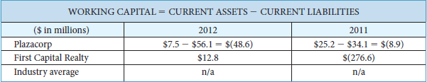

Explanation: Plazacorp reported negative working capital in both 2012 and 2011, which means that its current liabilities exceeded its current assets. Note, however, that the fact that its working capital is negative does not mean that this company is nearing bankruptcy. It obtains monthly cash flows from tenant rent payments that are sufficient to meet its current obligations and some of its current liabilities consist of unearned revenues from rent collected in advance. Unearned revenues are not liabilities that have to be settled with cash. First Capital Realty, on the other hand, improved its working capital because it obtained a higher amount of cash during the year when it sold off some of its properties.
When industry averages are not available for the ratios that we calculate in this text, such as working capital, this is indicated by “n/a” (not available).

- Current Ratio

Current ratio: Calculated by dividing current assets by current liabilities.

- The current ratio is a more dependable indicator of liquidity than working capital because it measures the relative relationship between current assets and current liabilities and therefore makes comparisons between smaller companies like Plazacorp and larger companies like First Capital Realty possible. Furthermore, two companies with the same amount of working capital may have significantly different current ratios.

Formula: CURRENT ASSETS / CURRENT LIABILITIES

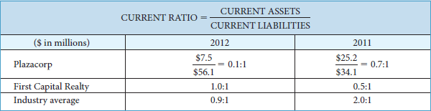

Explanation: The 2012 current ratio of 0.1:1 means that for every dollar of current liabilities, Plazacorp has 10 cents of current assets. It is interesting to note that some industries tend to have much lower current ratios than we would expect. Although a general belief regarding the current ratio is that it should exceed a value of at least 1 to 1, we have to understand that this ratio will be different for companies in different industries. It is therefore more worthwhile to compare the ratios of competitors within an industry than the ratios of companies operating in different industries. Compared with a company that produces and sells inventory, real estate companies will not have inventories and since most tenants pay rent on time, their accounts receivable will be very low. Furthermore, since cash flows from rent are very predictable, large cash reserves are not needed. Therefore, compared with companies that sell inventory, a real estate company will have much lower current assets and this is the major reason for the lower current ratios we see above.
The current ratio is only one measure of liquidity. It does not take into account the composition of the current assets. For example, a satisfactory current ratio may not reveal that a portion of the current assets can be tied up in uncollectible accounts receivable or slow-moving inventory. The composition of the assets matters because a dollar of cash is more easily available to pay current liabilities falling due than is a dollar of inventory. For example, suppose a company's cash balance declined while its inventory increased by an even greater amount. To finance this increase in inventory, the company obtained long-term bank loans. Consequently, current assets will rise. If inventory increased because the company was having difficulty selling it, then the current ratio, which is rising, would not fully reflect the reduction in the company's liquidity.

Quick Ratio

- Solvency

Example: Now suppose that, instead of being a short-term creditor, you are interested in either buying Plazacorp's shares or making a long-term loan to the company. Investors and long-term lenders are interested in a company's long-run solvency—its ability to pay interest as it comes due and to repay the face value of debt at maturity.

Solvency ratios: Measure a company's ability to survive over a long period of time by having enough assets to settle its liabilities as they fall due.

- Debt to Total Assets.

Debt to total assets: It measures the percentage of assets that are financed by lenders and other creditors rather than by shareholders.

- Financing provided by lenders and creditors (debt) is riskier than financing provided by shareholders (equity) because debt and the related interest must be repaid at specific points in time, whether the company is performing well or not. On the other hand, equity does not have to be repaid and there is no requirement for companies to pay dividends.

- The lower this “debt to equity” ratio, the better a company's solvency.

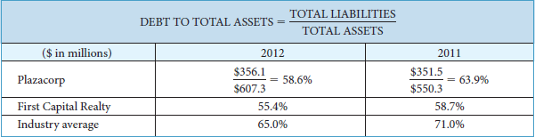

Explanation: The 2012 ratio for Plazacorp means that approximately 59 cents of every dollar that the company invested in assets was provided by its lenders and other creditors. Plazacorp's ratio improved (fell) in 2012. The same decrease occurred for First Capital Realty and the industry overall. During the recent recession, many real estate companies had debt levels that were too high and the decrease that we see above reflects the industry's desire to have lower levels of debt relative to assets. The higher the ratio, the higher the amount of interest expense that a company will incur. If liabilities are too high, there is a lower equity “cushion” available to lenders and other creditors if the company becomes insolvent (unable to pay its debts). Thus, from the lenders' and other creditors' point of view, a high ratio of debt to total assets is undesirable and they would view the ratios of the two companies above as favorable when compared with the industry average.

- USING THE INCOME STATEMENT (INCOMLPETE)

- The income statement reports how successful it is at generating profit from its rental operations.

- Profitability

Profitability ratios: Measure a company's operating success for a specific period of time. We will look at two examples of profitability ratios in this chapter: earnings per share and the price-earnings ratio.

- Earnings per Share

- Price-Earnings Ratio

