Mental Health in Post-Secondary Institutions:
Improving Mental Health Possibilities

Prepared
by

Department of English
University of Ottawa
ENG1112
Geraldine Arbach
April 13, 2018
Table of Contents
List of Figures and Tables iii
Executive Summary iv
1.0 Introduction 1
1.1 Purpose of the Report 1
1.2 Background of the Report 1
1.3 Scope of the Report 1
2.0 Mental Health Awareness 1
2.1 What is Mental Health? 1
2.2 The Stigma Surrounding Mental Health 2
2.3 Raising Awareness of Mental Health 2
3.0 Community Response 3
3.1 The Stepped Care Model 3
4.0 Self-Management 4
4.1 Coping Methods 4
5.0 Access to Services 5
5.1 The Current State of Mental Health 5
5.2 Mental Health Services on Campus 6
5.3 Peer-to-Peer counselling 6
6.0 Crisis Intervention 7
7.0 Summary and Conclusions 8
References 9

List of Figures
Figure 1. The Stepped Care Model 3
Figure 2. Coping Skills and Strategies 4

List of Tables
Table 1. Students’s Mental Health State 2
Table 2. Responding to a Mental Health Crisis 8

Executive Summary
The stigma surrounding mental health has led many students, who suffer from mental illnesses and issues, to deny their need for professional aid. There is a <7% increase in the total number of students who suffer from depression and anxiety in 2016 compared to the total number of students in 2013.
Staff and faculty members are in the best position to recognize symptoms of stress and anxiety that may lead to the development of mental health issues. The Stepped Care Model is a system that can be used to determine the appropriate resources a student will need at any given time when they are suffering from a mental illness or mental health challenges.
Students can manage their stress and anxiety better by adopting coping skills. The skills seek to navigate a student out of moments of weaknesses, in positive and beneficial ways.
The current access to services on campus communities is lacking in funds. Many students who have sought out help have had to wait long periods of time to consult a professional. Peer-to-peer counseling was introduced to provide students with another means of consulting a trained individual. Students can discuss their dilemmas with peers who understand the burdens that other students carry.
Crisis intervention is a critical aspect of the mental health issue. It is important that, in the event of a crisis, other students, staff and faculty members understand how to appropriately respond to a crisis.

Introduction
  - Purpose of the Report
This report highlights the current state of mental health in post-secondary institutions. It will also discuss the potential improvements that can be made to develop the response to demands of mental health services. The overall goal of this report is to provide a course of action that we can take to ensure that students receive the mental health support they need to achieve success in their post-secondary education.
  - Background of the Report
The demand for mental health has increased all over the country, especially in campus communities. The transition to post-secondary education from lower education is a big change and many students have difficulty adjusting. As a result, the number of students suffering from anxiety and stress has increased in recent years. Currently, the stigmatization of mental health and the lack of access to mental health services have caused student mental issues and illnesses to develop and worsen. As more students demand services, it has become apparent that the mental health dilemma will only continue to grow unless we improve the current state of responding to mental health.
  - Scope of the Report
The goal of the report is to complete the following:
- Address the stigma surrounding mental health.
- Develop a community that can respond to mental health needs.
- Provide students with methods of self-management and coping with stress.
- Improve mental health services to better support a student through periods of difficulty and recovery.
- Implement a coordinated and structured response in campus communities to effectively manage a crisis.

Mental Health Awareness

What is Mental Health?
A common misconception surrounding mental health is that it is simply the lack of mental disorders. The World Health Organization (WHO) highlights the positive elements of mental health in their definition of health: “Health is a state of complete physical, mental and social well-being and not merely the absence of disease or infirmity” (WHO, n.d.). Mental health should be a topic of concern for everyone, and not solely people who suffer from a mental disorder. No individual is immune to mental disorders. Unfortunately, all over the world, mental health and disorders are not given the same importance as physical health by society. Rather, society has largely ignored and neglected this issue, thus, allowing it to grow.

The Stigma Surrounding Mental Health
Despite improvements in mental health services, many people who would benefit from these services have chosen not to participate. Stigma is a major factor that causes an individual to make such decisions. It can be defined as “the threat of diminished self-esteem and of public identification when labeled ‘mentally ill’” (Corrigan, 2004, p.614). In a survey conducted by the Priory Group (n.d.), it was discovered that 25% of students are uncomfortable with sharing their mental health issues with their friends, for fear of being mistreated. The discussion of mental health has been known to negatively affect personal relationships, leaving a student isolated and unable to ask for support. These displays of discrimination lead to self-stigmatization: people with mental illnesses begin to believe the negative ideas expressed by others and thus, begin to think that they are unable to recover, are undeserving of aid and are responsible for their issues. This can lead to low self-esteem and the inability to achieve success in their pursuits.

Raising Awareness of Mental Health
Mental health is a growing issue on campuses today as students are at a critical period in their development, in addition to being in a period of transition. To effectively respond to the concerns of students who suffer from ongoing dilemmas, the negative reputation surrounding mental health must be eliminated. Mental health awareness initiatives seek to increase the knowledge and understanding of the nature, impacts, and reality of these issues. In the spring of 2016, the American College Health Association (ACHA) published a survey of around 16,000 students attending Ontario colleges and universities. Among the results, 44.4% reported feeling so depressed that it was difficult to function, 64.5% felt overwhelming anxiety and 13.0% seriously considered suicide (ACHA, 2016, p.13-14). The following table compares some of the data from the 2016 survey to the data from the 2013 survey of more than 40,000 students (ACHA, 2013, p.13-14).
Table 1
% of students who have reported experiencing the following within the last 12 months during 2013 and 2016.
Students: | 2013ª |  |  | 2016^{b}
Students: | Male | Female | Total | Male | Female | Total
Felt overwhelming anxiety | 46.5 | 63.2 | 57.9 | 51.4 | 69.6 | 64.5
Felt exhausted (not from physical activity) | 79.5 | 90.4 | 86.9 | 80.4 | 91.6 | 88.2
Felt so depressed that it was difficult to function | 35.2 | 42.3 | 40.1 | 37.9 | 46.4 | 44.4
Felt very lonely | 59.9 | 69.3 | 66.2 | 59.1 | 69.5 | 66.6
Seriously considered suicide | 10.3 | 11.0 | 10.9 | 11.5 | 12.9 | 13.0
Attempted suicide | 1.2 | 1.6 | 1.5 | 1.8 | 2.0 | 2.1
Intentionally harmed or otherwise injured themselves | 5.1 | 8.5 | 7.5 | 5.5 | 9.5 | 8.7
Notes: ª n=16,123. ^{b} n=43,780.
As shown in the figure, an overwhelming number of students have endured very negative emotions and thoughts. During the three-year gap between the surveys, there appears to be a <7% increase in the total percentage of students who have experienced the symptoms highlighted in the table. However, through community support in understanding signs of stress and coping mechanisms, symptoms of depression and anxiety have been observed to decrease. In promoting mental health, thus establishing an open community, students will be able to seek for and obtain the help they need to overcome their mental burdens.

Community Response
In recent years, efforts have been taken to ensure that post-secondary communities are aware of the barriers and difficulties that exist for people with mental health issues. As the number of students dealing with mental health issues continues to rise, it is vital that more is done to ensure that students, staff and faculty members are aware of the services and supports that are available on campus.
Faculty or academic advisors those who interact with students regularly, are in the best position to recognize signs of concern and should be aware of what resources are available to provide help. Thus, it is essential that such training is provided on campus.
  - The Stepped Care Model
The Stepped Care Model is a system determines the delivery and monitoring of treatments. The most effective yet least resource intensive treatments are delivered to a patient first. A patient only “steps up” to specialized services as medically required.
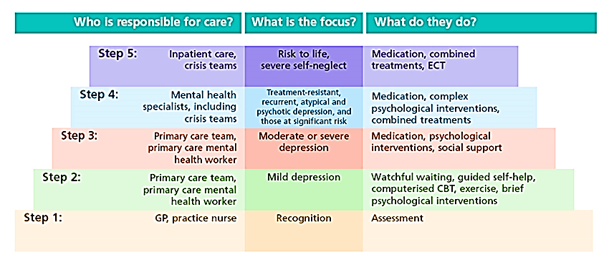
Figure 1. The Stepped Care Model (Washington Mind, n.d.)
Trained staff and faculty members can use this model as a safe guide to determine what kind of resources best suit a student who suffers from mental illness at any given time. This model ensures that a student who is diagnosed correctly will receive the right resources at the right place, by the right person. The implementation of this system in post-secondary institutions will help build a community and system that will reach out to students and direct them to the appropriate resources and support.

Self-Management
Starting a post-secondary education requires students to adapt to a new environment of living and learning inside and outside the classroom. Many students face new challenges of living independently, building relationships, determining their future direction while simultaneously managing the demands of their academic life. Learning to self-manage and developing their own methods of coping with stress, will strengthen a student’s endurance and ability to manage their workload. Often, this would also mean managing and preventing the progression of mental issues and illnesses that a student might develop over the course of their academic career.
  - Coping Methods
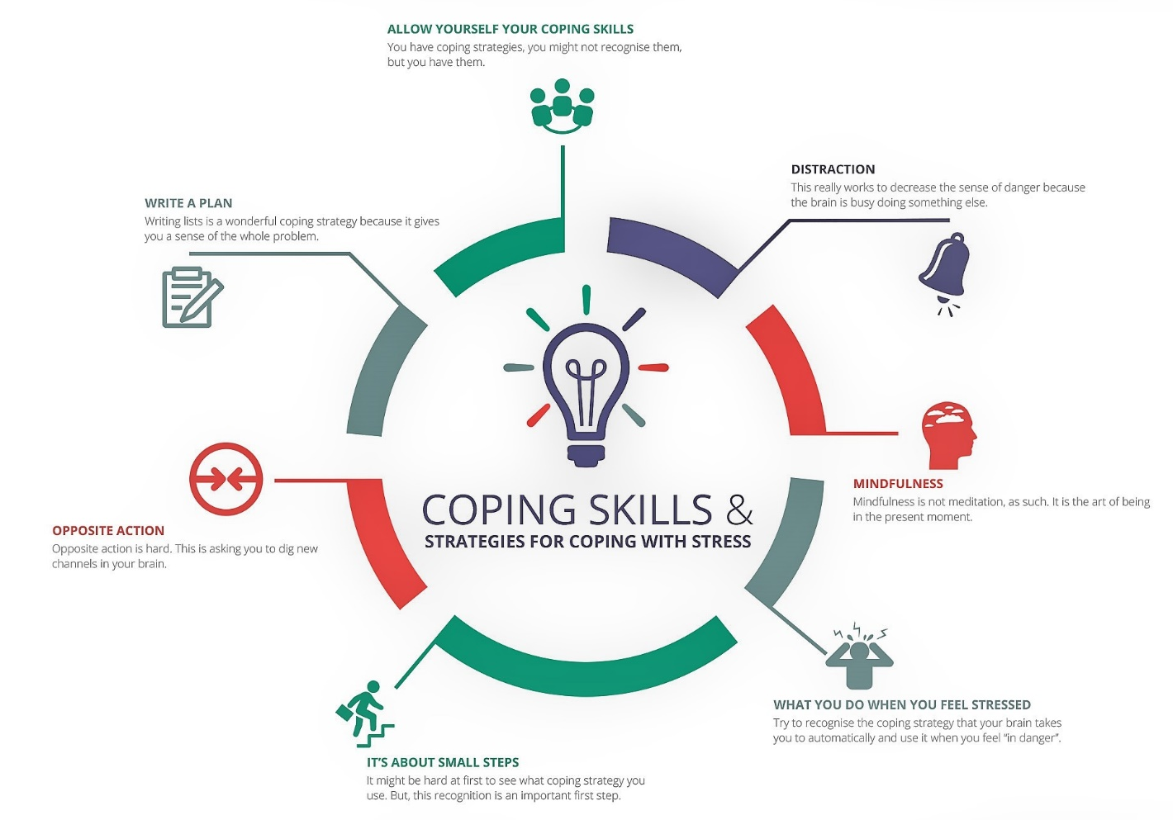
Figure 2. This figure illustrates various coping skills and strategies (Unstress Yourself, 2016).
There are many different methods a student can use to cope with stress and anxiety. Listed, are a few common coping skills that post-secondary institutions should work to promote, and students should practice during their everyday routine.

Distraction
The most common method of coping, distraction works to decrease the sense of danger as your brain is busy doing something else. Often, focusing on a strong emotion can will make intensify it and causes you to lose control of it. Temporarily distracting yourself allows your emotions the time to decrease in intensity, making it much easier to manage and maintain. However, distraction implies the eventual return of the strong emotion a student may be experiencing. Distraction can keep a student safe during a moment of weakness by preventing unhealthy behaviours (like deliberate self-harm) that occur as a response to the strong emotion.

Mindfulness
Mindfulness is the concept of being in the present moment. This coping skill consists of being aware of one’s thoughts, emotions, physical sensations and the environment that surround him/her. There are many benefits of practicing mindfulness, some of which include the following:
- Improved concentration and mental clarity
- Increased ability to manage emotions
- Decreased impulsivity
This coping mechanism allows a student to focus on themselves. A student is given the time to self-reflect and understand things about themselves like what makes them uneasy and what makes them feel happy and at ease. When a student becomes aware of themselves, they can be mindful of their reactions to others and situations, improving the insight into their own mental and emotional health.
The most important aspect of coping mechanisms is understanding that everyone has different methods of dealing with stress. It is important for students to practice different methods and understanding what works the best for them. Figure 2 highlights more common ways of coping with stress that students should try when developing their own coping methods.

Access to Services

The Current State of Mental Health
Healthcare in Canada is governed by the provisions of the Canada Health Act (CHA) established in 1984. The CHA aims to protect the mental and physical well-being of Canadians and ensure that Canadians have access to health services regardless of personal circumstances like financial income or education. The federal government provides the funding and the task of distributing the funds are left to each province and territory. Provinces and territories are required to provide coverage for healthcare services that are considered “medically necessary” to maintaining health, preventing diseases or treating injuries or disabilities. However, the scope of what is considered “medically necessary” has gone through a lot of debate. Many services remain unfunded or only partially funded, where only limited coverage, if any, is available. The most commonly overlooked health service, despite being essential in maintaining a person’s overall health, is mental health.
  - Mental Health Services on Campus
In recent years, there has been an unprecedented demand for mental health services from students all over Canada. Many students who have sought out help have repeatedly stated how difficult it is to book an appointment, with many having to wait up to 6 months to see a psychiatrist. Mental health services can have a profound impact on a student’s mental well-being by providing support and preventing issues from developing. Thus, the integration of health-care services and the addition of mental health providers, competent in a range of specializations, is vital. This action will relieve the demand for mental health services currently on campuses.
A large source of anxiety and stress that students face comes from the transition going into post-secondary education from lower education or the workplace. How a student enters this new phase of their life can impact their student career, both positively and negatively. To prepare a student for their transition and alleviate their potential concerns, the following acts can be implemented by each province:
- Funding psychological evaluations that can diagnose students with mental health concerns before the start of their studies.
- Allowing students to seek treatments on and off the campus without any cost barriers.
- Providing on-campus professionals with more freedom in (re)diagnosing and treating students with less complex issues without certain restrictions.
- Establishing mental health agencies offices on university and college campuses.
- Investing in an online referral system with a comprehensive and updated list of community mental health resources and their specializations.
With the necessary funding needed to implement these changes, more students will have access to the services they need in a relatively quick and easy manner.
  - Peer-to-Peer counselling
Limited funding, despite increases from provincial funding in recent years, is still a problem that universities have yet to overcome. With the number of students with mental health concerns rising, the need for more professional support is apparent. However, students have taken matters into their own hands. There is an increase in student-led mental health activities. One of these initiatives is peer support centers which are led by students and funded by student unions. Students can volunteer and are then put through hours of training. In an interview with W. Pang (2017) Danielle Stanford, the coordinator of peer-support organization UBC Speakeasy, voices that many students find speaking to a peer less intimidating than speaking to a professional authority (Pang, 2017).
In some instances, students dealing with mental health challenges struggle to discuss their issues with people who they see as strangers. Students are more likely to develop connections with peers who they see as having a better understanding of the barriers a student faces. These connections can lead to a stronger and more stable support system and allow students with mental health issues that ability to develop a greater resiliency. Similar programs should be made available across all post-secondary institutions, increasing support and reducing the sense of intimidation a student might face when consulting a professional. Further development of peer-to-peer counseling can consist of the following:
- Providing funds for initiatives that train students to provide counselling.
- Ensuring that peers have the necessary tools and skills to support others and address crisis situations.
- Involving people with experiences of living with mental health issues and illnesses to reduce stigma.
Further promoting peer support programs and expanding current mental health practices to include peer counsellors would help stabilize the mental health supports that are available to students.

Crisis Intervention
Students, staff and faculty may find themselves in a situation where a student is in crisis. Such situations often involve a traumatic event or accident that causes a great deal of stress and affects the coping skills of an individual or group. Critical events can include the following:
- A serious injury
- A sudden death of a student, staff or faculty member
- Physical violence/Threat of physical violence
Crisis intervention is necessary in the fight against mental health challenges. As previously mentioned, many students are not receiving the aid they need to prevent their mental health issues from growing. The consequences of allowing their concerns to grow can lead a student to become mentally and emotionally unstable as they encounter more obstacles. They become more susceptible to encountering a crisis. Thus, the response to a student in a mental health crisis is critical in its intervention. The following table consists of some ways a student, staff or faculty member respond to a student in crisis and de-escalate the situation, as suggested by Network, a magazine published bi-yearly by the Canadian Mental Health Association (CMHA) (Uppala, 2009).

Table 2
Suggestions of how to improve your response to a person in a mental health crisis
Suggestion | Description
Remain Calm | Set the tone you want (e.g., courteous, respectful, calm)
Communicate | Ask questions, listen, avoid interrupting, and speak one at a time. Don’t argue about what’s real, just respond to what you can relate to (e.g., “How are you coping with that?”)
Decrease other distractions | Reduce bright lights and loud noises.
Make a statement about the behaviour you are observing (e.g., “You seem to be afraid, angry, confused”). | Ask, “Is this right?” or “Please tell me what’s making you afraid.”
Be an ally | Use statements like: “I’m here to help. How can I help you?”
Avoid judgmental, authoritative statements | Do not use statements such as: “You’re acting like a child.”
The way we respond to a student’s mental health crisis is critical in how the student perceives the aid they can choose to seek and receive. It is important that a student who is suffering from a mental crisis feels comfortable in reaching out for help, knowing that they will get the support they wish to have. Creating a stable connection with a victim of mental health issues is an important aspect of crisis intervention and should be practiced to further strengthen and develop current mental health services.

Summary and Conclusions
This report highlights the many obstacles that post-secondary students who suffer from mental health issues or illnesses currently face in their communities. With the increase in the demand for mental health services for students, it has become apparent that more must be done to accommodate mental health needs. To ensure that students have access to a safe community and appropriate resources, communities must work to complete the following:
- Eliminate the stigmatization surrounding mental health.
- Train staff and faculty members to be aware of available mental health services that they could direct students towards.
- Teach students how to positively cope with stress and anxiety.
- Make mental health service off and on campus more accessible to students.
- Understand how to appropriately respond to a crisis.
Through implementing these changes, we would provide all students with the ability to seek support for their mental health needs without fear of judgment and with the knowledge that they are surrounded by a community that can help them.
Word Count (Introduction to Conclusion): 2889

References
American College Health Association. (2013). American College Health Association-National College Health Assessment II: Ontario Province Reference Group Executive Summary Spring 2013. Hanover, Maryland: American College Health Association.
American College Health Association. (2016). American College Health Association-National College Health Assessment II: Ontario Canada Reference Group Executive Summary Spring 2016. Hanover, Maryland: American College Health Association.
Corrigan, P. (2004). How stigma interferes with mental health care. American Psychologist, 59(7), 614-625. doi:10.1037/0003-066x.59.7.614
Pang, W. (2017, October 18). Peace of mind: universities see spike in students seeking mental-health help. The Globe and Mail. Retrieved March 10, 2018, from https://www.theglobeandmail.com/news/national/education/peace-of-mind-universities-see-spike-in-students-seeking-mental-health-help/article36637574/.
Priory Group. (n.d.). UK students suffer in silence when it comes to mental health. Retrieved Feb. 27, 2018, from http://www.priorygroup.com/blog/mental-health/student-mental-health-research
Unstress Yourself. (2016, October 19). Coping Skills and Strategies for Coping with Stress. Retrieved April 13, 2018, from http://www.unstressyourself.com/coping-skills-strategies/
Uppala, C. (2009). First Responders. Network, 25(2), 18-22. Retrieved from http://ontario.cmha.ca/wp-content/files/2013/04/fall_2009.pdf
Washington Mind. (n.d.). Stepped Care. Retrieved April 13, 2018, from http://wellbeinginfo.org/self-help/mental-health/stepped-care/
World Health Organization. (n.d.). Frequently asked questions. Retrieved Feb. 27, 2018, from http://www.who.int/suggestions/faq/en/

University of Ottawa
75 Laurier Ave E
Ottawa, ON K1N 6N5
April 13, 2018
Dr. Loren Glover
Mental Health Commission of Canada
350 Albert St #1210
Ottawa, ON K1R 1A4
Dear Dr. Loren Glover:
I am submitting the report Mental Health in Post-Secondary Institutions: Improving Mental Health Possibilities.
This report analyzes the current state of mental health on post-secondary campuses. Through the analysis, the report provides ways of improving the mental health crisis that has grown in recent years. The recommended improvements have been suggested to eliminate the stigmatization of mental health, create a campus community that supports students with mental health issues and concerns, introduce students to coping mechanisms, provide students with better access to mental health services and respond to mental health crises.
I hope that the report succeeds in providing appropriate methods of improving the mental health challenges students face in university and college communities. If you have any questions or concerns, please feel free to contact me at …@uottawa.ca.
Sincerely,

