THEO 206

Lesson 1: The earliest Christian writings

Introduction Video:
Historical figure from 2000 years a go
The writings that talk about Jesus known to be as the Bible
Bible compose of two parts: Old Testament and New Testament

***
Christianity is the faith based on Jesus Christ:
- Life
- Teachings
- Death
- Resurrection

Jesus lives some 2000 years ago

The Christian Bible contains:
- Old testament (OT) + Apocrypha/deuterocanonical books
- New Testament (NT): 27 books, including Gospels (good news)
- Gospels were written some 40-50 years after Jesus’s death

Methods of Bible Interpretation: Method of Biblical Interpretation: Understand the bible, who Jesus were, how Christianity came into existence, see how people interpreted the bible…
- Historical critical method
- Literal method
- Allegorical method
- Mystical method
- Moral method

The most widespread with scholars today is the historical method which looks at:
- Historical context: It looks at how the authors of the books have put their writing into the historical context, how exactly we today the scholars we understand it.
- Intended audience of the author: The audience that the author had in mind…
- Desired effect of the author: What did the author had exactly in mind when he wrote the particular the book? Was it to convert people? To convey a certain message of salvation? To provide a parabola that could be used to teach a lesson that could to bring more to a life

The first three Gospels are known as: The synoptic Gospels, from a Greek word that means “take together or seen together, these are the gospels of Matthew, Mark, and Luke

Using the historical critical method, scholars have been able to INSERT WORD a number of things about these Gospels
- They look very similar in contents, why? Why is that? Because it is based on the gospel of Mark
- Targets a Jewish Christian audience

The fourth Gospel: Established using the historical critical method that is different from the first three. It talks about the Jesus as the eternal son of God

WATCHED THE VIDEO

Bible interpretation
The Gospels
Synoptic (Greek for “seen together”)
- Matthew, Mark, Luke
- Matthew and Luke are based on Mark and Q (from the German word Quelle = sources)
The historical critical method established that:
- Matthew targets a Jewish-Christian audience, because Jesus is presented as the second Moses and Messiah.
- Luke targets a Gentile audience, because it speaks in universal terms.

The Gospel of John (Jn):
- Jesus is the eternal Son and Logos (or Word) of God, the incarnate God on Earth.
- There are also apocryphal (or secret) gospels attributed to Thomas, Peter, Mary Magdalene, Philip, and even Judas – most of them come from Gnostic circles and are later.

The evangelists, along with their symbols in iconography from the Book of Kells (image), are:
- Matthew the Evangelist, symbolized by a man, to represent the human nature of Christ.
- Mark the Evangelist, symbolized by a lion, to represent Christ as king.
- Luke the Evangelist, symbolized by a bull or a calf, to represent Christ as sacrifice and as priest.
- John the Evangelist, symbolized by an eagle, to represent the Christ as God

The life teaching of Jesus
Biblical Prophecies
- Jesus was born in the year 0 of the common Era (CE), this is the secular alternative to AD (Anno Domini)
- Jesus’s parents: Mary and Joseph
- There are Old Testament prophecies about the Messiah being born in Bethlehem
- The Gospels tells us about Jesus’s birth, then an episode at age, and his life around the age of 30
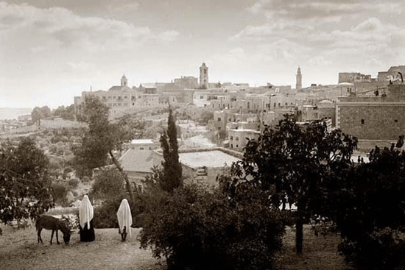

The picture shows a man and a woman approaching Bethlehem with a donkey. It was taken on Christmase Day, 1898. The photograph presents a scene reminiscent of Mary and Joseph, as they approached Bethlehem some 1900 years earlier.

John the Baptist: An important character, was Jesus’s forerunner and he baptized people for the forgiveness of their sins

Jesus’s baptism by John has been seen as:
- Consecration to God as the Messiah
- John publically announcing that the Messiah had arriver
- Jesus identifies himself with sinful humanity

After the baptism:
- Jesus undergoes a 40-day retreat in the desert before starting his ministry
- Jesus then begins to gather his first disciples: Simon, Peter, Andrew, James and John
- The emphasis of Jesus’s ministry is on a spiritual life

Jesus’s Ministry
WATCHED VIDEO

Miracles
Many stories of the miracles in the Bible of Jesus

Why are Miracle so important? How are they understood?
Jesus performed Miracles
Miracles are seen as signs of the presence of the God
A glimpse of the better world, less suffering, justice is being done, equality

Scholars have understood the message of Jesus for miracles: the kingdom of God is here, but not fully. On the other hand, these people will continue to die or perhaps sick again

We don’t have a full taste, tension between already here but not fully

People kept hoping for justice, the disappearance of suffering

Thy kingdom done: The kingdom is not here yet

A new reality is being presented when he heals people

Miracles are seen as signs of the presence of the Kingdom of God:
- Turning water into wine
- Healing the sick
- Restoring life to the dead
- Casting devils out of the possessed
- Multiplication of bread

The kingdom is already here, but not yet fully realised.

The Kingdom of Heaven
Given the fact that the New testament was written in Greek, the video show how Greek sounded back then, the famous prayer that the Jesus teaches his disciples known as our Father.

The New Testament was translated in Latin, the video shows again the famous prayer of the Father.

Jesus’s Radical Ethics
An important question: Is Jesus the Messiah?
- Jesus reluctantly applies this title to himself because of misunderstandings
- At the Transfiguration (witnessed by three disciples) Moses and Elijah appear to seal the fact that Jesus is the Messiah

Jesus’s Ethics and teachings:
- Touched lepers and a bleeding woman to heal them
- Welcomes women as disciples
- Extended the command against adultery to adultery in one’s heart
- Preached “turn the other cheek” (as oppose to “an eye for an eye”)
- Taught love your enemies
- Proposed love if for God and for one’s neighbor
- Offered forgiveness to those who repented
- Challenged the interpretation of the Mosaic law (generally NOT the law itself)
- Challenged the Jewish authorities

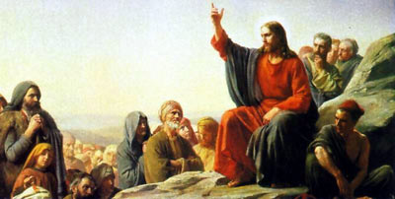
Picture above: The Sermon of the Mount, painting by Carl Heinrich Bloch (1890). Christians believe that Jesus is the mediator of the New covenant

Jesus’s Crucifixion, Death and Resurrection
Sequence of events:
- Jesus return to Jerusalem, Has last supper with his disciples
- Judas betrays Jesus for 30 pieces of silver, Jesus is arrested
- At the trail Caiaphas, the high priest, asks Jesus if he is Christ or the Messiah and Jesus answers: “You have said so”, thus answering in the affirmative
- Caiaphas and the other priests see this declaration as blasphemy against God
- Roman authorities are asked to crucify Jesus
- The crucifixion occurs sometime between 2-33 CE (apparent end of the story)
- Resurrection: women visit the tomb; Jesus’s appearances; women’s presence witnesses to the historical truth in claims of Jesus’s resurrection

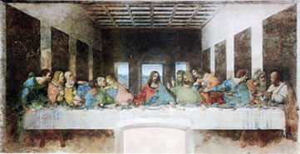
The last supper (1495-1498) by Leonard o da Vinci (1452-1519)

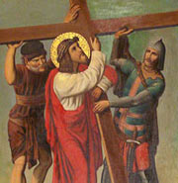
Jesus helped by Simon of Cyrene, 19th- century Brazilian depiction

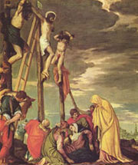
Calvary by Palo Veronese, 16th century
The Early Church
After Jesus’s Death and Resurrection:
- Acts of the Apostles (Author Luke), Paul’s letters, the other letters of the New Testament
- Jesus’s ascension to heaven is followed by the descent of the Holy Spirit at the Pentecost (Acts 2)
- Paul’s attempts to convert both Jews and Gentiles to Christianity
- Anti-Christian feelings among Jews which led to anti-Jewish feelings among the early Christians
- The new message Christianity proposes: salvation is by faith, not by circumcision, says Paul.

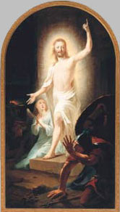 The Resurrection painted by Johann Heinrich Tischbein the Eider 1778

The Spread of Christianity (300 to 800 AD)

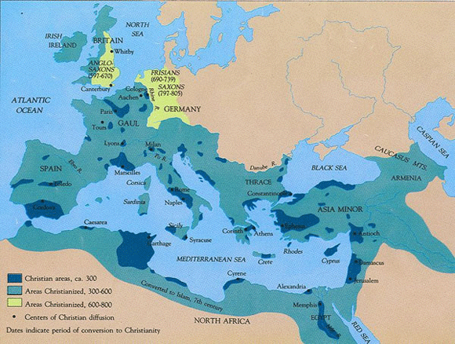

Lesson 2: Christianity in the roman world

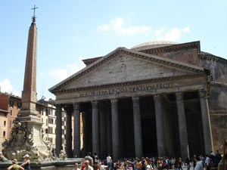
Pantheon, dedicated to all pagan gods, today a church, Rome

The Roman World
- Christianity was born in the Roman Empire
- Roman colonization was militaristic and administrative
- Culturally and religiously, the East colonized the Empire

Map animation of areas under Roman control from 510 BC to 1453 AD:
- Roman Republic: 510 BC – 27 BC
- Roman Empire: 27 BC – 476 AD/1453 AD
- Western Roman Empire: 286 – 476 AD
- Eastern Roman Empire: 330 – 1453 AD
- Byzantine Empire: 330 – 1453 AD

Roman Society
All of the following provided a certain security and relative prosperity knowns as pax Romana or Romani peace for the population around the Mediterranean basin

Administrative
- Roman citizenship was possessed by entire cities, but it was bestowed on others as recompense for services rendered to Rome
- Local administrative was quite effective

System of justice
- While respecting local customs, it applied the principles of Roman law and it enables citizens to take their case to the Emperor himself

Currency
- Unified throughout the Empire
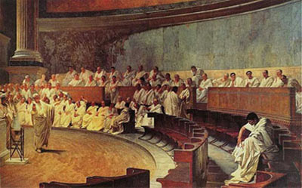
Cicero Denounces Catiline (Cicero, Author of the classic book the laws, attacks Catilina, a traitor to the Republic, in the Roman Senate) Fresco by Cesare Maccari (1840-1919)

Roman Religion
- Astrology – horoscopes were avidly compiled
- Not Zeus, but rather chance of fate or fortune (Greek, Tyche) was the most important to God
- Apostle Paul dismissed Roman religion (Known as paganism) when writing:
“Now that you have come to know God… How can you turn back again to the weak and beggarly elemental spirits? How can you want to be enslaved to them again? “(Gal 4:9)
- “Elemental spirits” are demonic beings or forces to whom Paul believed humans had been enslaved before their conversation to Christianity

Older view of the Roman Empire: An unprogressive society rules by impersonal forces whose nature was not understood and which was morally degenerate
Newer Scholarship: With some exceptions, this was not the case. Examples: Grave memorials testify to the affection of family life, and surviving papyrus letters testify to its decency and sobriety

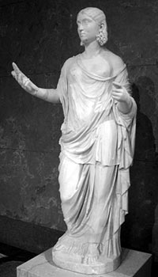
Statue depicting Ceres the Roman goddess of agriculture holding wheat, on display papyrus at the Louvre in Paris, France
The Role of Roman Religion in Society
- Religion ensured the existing world order and the prosperity of the roman people, while the emperor was the supreme priest (Pontifex Maximus in Latin)
- Fear of chaos if the empire fell was shared by all
- Roman religion was a series of religious acts performed by professionals (the priests) and there were no scriptures
- Religion was meant to achieve the right relationship between the gods and humans
- Roman citizens were expected to revere and severe the Roman gods and not to practice any alien religion. In practice, however, any religion was allowed as long as it did not offend the laws and practices of Roman life

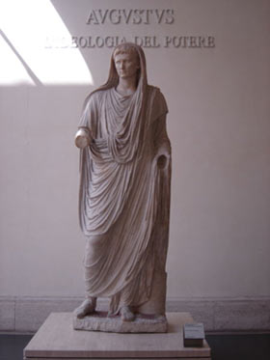
The Via Labicana Augustus – Emperor Augustus in the robes of Pontifex Maximum

Opposition to New Religious Movements
WATCHED VIDEO

2000 years ago, Christianity was a new religious movement

Cult (negative meaning): suicide, money, laundering, brainwashing, subjugation, mass suicide by the members of the cult

Neutral term: New religious movement

Why is there opposition to Christianity?
It perceived Christianity as a threat
Off shoot from, Meir, Judaism

Governments: They have been struggling to balance with the public safety and health, they are always concern that its citizen is not to be exposed to dangerous practice that could harm their health, practicing kidnapping people. But they make sure they have room for religion freedom, the practice of religion

State authorities are sometimes opposed to Christianity

Illegal businesses, money extornacist,

Some people think new religious movements can cause psychological problems: Parents of children, schools, governments (Newer practices)

Any new religious movement is like the new kid on the block

Cannibalism

Christians like Jews and Muslims, believe in only one God, and they believe its Jesus

Christians were prosecuted, because they were accused of damaging the balance between the gods and humans, they were scapegoated, seen as revolutionaries, they did not behave like the rest of the population, against the roman ideals, roman society.

Opposition from:
- Previously organized and established religions
- Government struggling to balance religious freedom with public safety

Examples from the Contemporary Era:
- Illegal businesses or money extortionists posing as religious groups
- Neo-fascists disguised as medieval cults but promoting white supremacy and hatred of immigrants
- Concern that NRMS may cause psychological damage, especially to vulnerable young people
- Loneliness and alienation from mainstream culture

Opposition to Christianity

The romans were open to enlarging the Pantheon of God

At what stage did “foreign worship” become “evil worship” abominable to the Roman gods?

In Rome in 186 BC, Livy (Roman historian) describes the case of Bacchanals (Dionysius’s feast) that degenerated into a conspiratorial orgy and had to be repressed.

The Christians in the time of Nero were another “foreign religion”, sometimes understood as a superstition
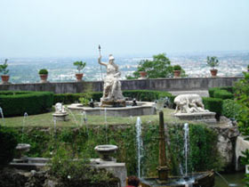 Statues of Pagan gods, Rome

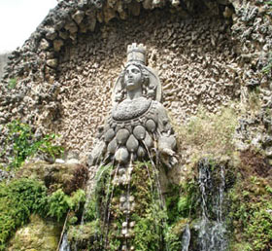 Goddess of fertility, Rome

- Christians (like Jews and Muslims) are monotheistic, that is, they believe in only one God – Christian claimed their God was Jesus Christ
- Christians refused to worship foreign gods, especially emperors who claimed divine descent. That refusal led to persecution and martyrdom
- Christians were also seen as revolutionary by the state (because they did not behave like the rest of the population)

The result was the scapegoating of Jews and Christians with false accusations

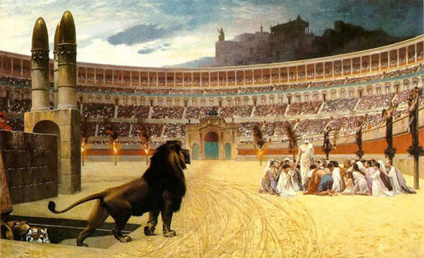
The Christian Martyrs” Last Prayer, by Jean-Leon Gerome (1883)
Lesson 3: The Jewish Legacy

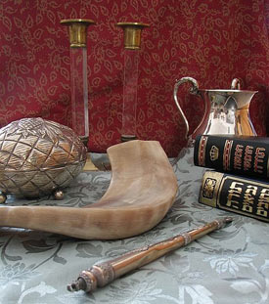
Judaica (clockwise from top): Shabbat candlesticks, handwashing cup, Chumash and Tanakh, Torah pointer, shofar, and Etrog box

History of the Jewish People

Judaism is the diverse tradition associated with the Jewish people

Jews – history experienced as a continuing dialogue with God

Meanings of “Israel”
- The semi-nomadic tribes who answered God’s call to use the divine law
- Those who answer the call and strive to obey the law through the Torah

Geographical location today: Israel, diaspora (i.e., outside of Israel)

Jewish history starts with the stories recounted in the Hebrew Bible (Tanakh in Hebrew, “Old Testament” for Christians)

Stories such as…
- Creation of the world by a supreme deity or God
- Patriarchs and matriarchs
- Moses, who spoke with God and led the people according to God’s commandments
- Prophets who heard God’s warning for sinners

Post-biblical evolving teaching and practices are collected in the Talmud a great compendium of Jewish law and love

Year 70 AD: Romans destroy the Jewish temple in Jerusalem and disperse the Jews throughout the world

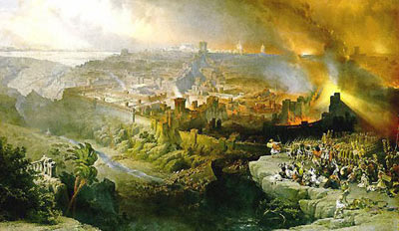
The Siege and Destruction of Jerusalem by the Romans under the Command of Titus, painting by D. Roberts (1850)

Biblical Stories

Problem of historicity: Scholars are uncertain about the historical accuracy of the early biblical stories because no other devices exists about certain events and people genealogies mentioned in the Bible

Tradition holds: Torah (Five books of Moses) were revealed by God directly to Moses, who wrote them down

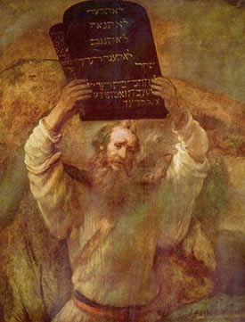
Moses with the Ten Commandments by Rembrandt (1659)
Scholars hold: Torah was an oral tradition reworked and redacted by later authors

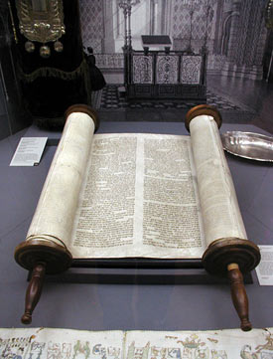
Sefer Torah at old Glockengasse Synagoge, Cologne

Final form of Torah around 430 BCE: Created by Ezra the Scribe and Priest and his editorial team

Intent of later authors: Interpreting the formation of Israel from a religion point of view as the results of God’s actions in human history

Similarities of biblical stories with Mesopotamian legends: Creation, the Garden of Eden, the great flood, the tower of Babel

Despite concerns about accuracy, biblical stories are religiously significant for both Christians and Muslims.

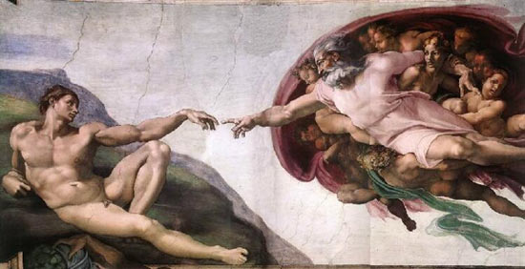
God created Adam by Michelangelo, Sistine Chapel, Vatican City, Rome
From Creation to the God of Abraham
Genesis 1.1-2.4 – “Priestly” source (God – referred to as Elohim) dates from after 586 BCE
- Creation of heaven and earth by God in six “days”
- Creation of material universe
- Creation of man and woman in the divine “image”
- Humans placed as masters of the earth

Genesis 2.4 – The “Yahwist” source (God – referred to as Yahweh) is thought to be an earlier account than genesis 1.1-2.4
- God is transcendent creator, without origin, gender, or form, a being utterly different from the created world

The Adam and Eve story
- The of exile from paradise is present throughout Jewish history
- Either punishment or straightening of the world through Jews

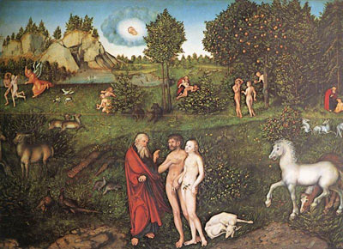
Adam and Eve painting by Lucas Cranach the Elder

Noah’s story and the flood
Ten generation after Noah:
- The “patriarchs” (Abraham, Isaac, Jacob)
- The “matriarchs” (their wives – Sarah, Rebecca, Leah and Rachel)

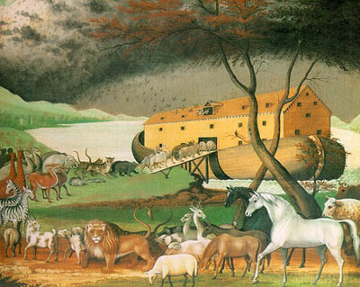
Painting by the American Edward Hicks (1780-1849) showing the animal boarding Noah’s Ark two by two

Abraham
- Born in Chaldean City of Ur, Mesopotamia, migrated to Haran, and then called by God to Canaan
- Shows an example of obedience to God’s commandments through:
- Circumcision – sign of the covenant with God
- Ready to sacrifice his son Isaac (from Sarah) upon request from God
- Abraham’s son Ishmael and his mother (slave Hagar) are driven into the desert – Ishmael is an ancestor of the Arabs
- Abraham is taught by God to be monotheistic

God was perceived as a ruler in relations to the people, like a parent to a child, or a sovereign to a vassal, like husband to a wife

Birth of Israel
- Jacob, Isaac’s second son, receives the new name “Israel” after wrestling for a whole night with an angel of God
- Israel – the one who struggled with God
- Names are indicative of the person’s character
- A new name means a new character, in this case of one reborn at a higher level of spirituality
- Jacob is given the promise that many nations will be born from him

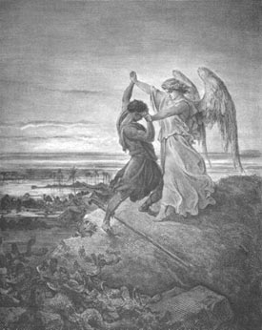
Jacob wrestling with the Angel, by Gustave Dore, 1855

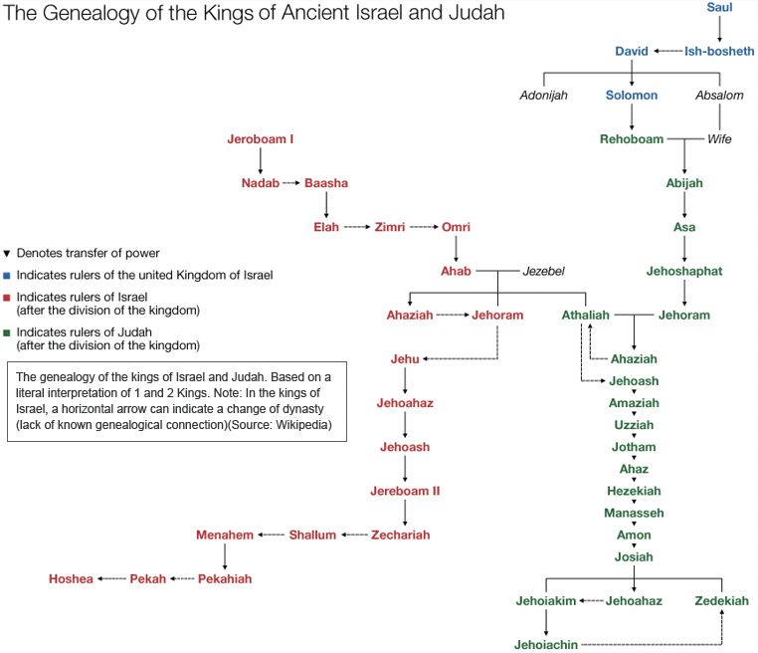

Egypt: Bondage and Exodus

The Twelve Tribes of Israel
Jacob/Israel had 12 sons and one daughter from his two wives
The 12 sons become heads of the twelve tribes of Israel

Biblical stories:
- Joseph and the Egyptian Pharaoh
- Moses and the burning bush
- Exit from Egypt: signs, plagues, Passover, redemption from bondage, crossing of the Red Sea
- God’s presence as a pillar of cloud/fire; then, Ark of the Covenant
- The Ten Commandments

The First Temple of Jerusalem
- 1010-970 BCE:
- King David establishes Jerusalem as the Capital
- 961-931 BCE:
- King Solomon builds a great Temple in Jerusalem
- Burnt offerings of animals, grain and oil were made to God in the Temple
- Solomon ended up an idol worshipper and womanizer
- Division of Israel follows into the northern and southern kingdom (Israel and Judah)
- 722 BCE:
- Israel is conquered by Assyria – most Jews are sent into exile in Assyria
- 586 BCE:
- Judah is conquered by Babylonian King Nebuchadnezzar and the Temple is destroyed
- The destruction of the Temple is interpreted as divine punishment for Israel’s infidelity toward God

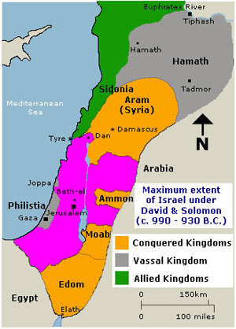
Map showing the extent of David and Solomon’s Kingdom of Israel

Return to Jerusalem

530 BCE: King Cyrus of Persia allows the Jews to return to the land of Israel
515 BCE: The Temple is rebuilt
430 BCE: Ezra, a priest and scribe, coordinates the redaction of the Torah

Judaism becomes contaminated with foreign influences (Persian, Greek, Parthian, Roman)

175-164 BCE: Antiochus IV Epiphanes, a Hellenistic ruler of Syria, forces Greek ways upon the Jews
164 BCE: The Maccabean revolt rejects Antiochus IV’s rule and manages to re-establish a Jewish independent kingdom
63 BCE: Roman general Pompey conquers Israel
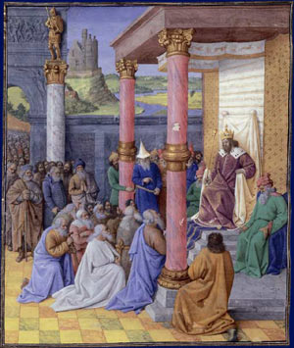
King Cyrus the Great allowed the Hebrew exiles to resettle and rebuild Jerusalem, earning him an honored place in Judaism, painting by Jean Fouquet (1470-1475)

Jewish groups around the Year 0
WATCHED VIDEO

Jewish group around the year 0

Sadducees: Important to know these people, it will help us to see that Judaism was not a unified religion

Pharisees: Encounter with Jesus, it was read in the churches till this day, known as hypocritical people but they weren’t, they were just interested in the Torah on how to apply in everyday life. They tended to be more liberal citizen of Jewish society. War between the first and them for many issues.

Essenes: Made of men, becoming monks, disgusted with the priest. They considered death. They were the chosen ones. They thought about the end of the world. The sons of Light

Zealots: Jewish militias. They started a major revolt against the Romans, it lasted about 4 years.

Sadducees:
- Priest and wealthy businessman
- Conservatives who provided a literal interpretation of the Bible
- Rejected oral law and traditions
- Denial of an afterlife and coming of a messiah
Pharisees:
- More liberal citizens of all classes
- Studied the applications of Torah to everyday life
- In 1st century. BCE – civil war between Sadducees and Pharisees
Essenes:
- Monastic community disgusted with what they considered a corrupted priesthood
- Apocalyptic group who wrote the Dead Sea Scrolls (discovered in 1947)
- Some retreated to Qumran on the shore of the Dead Sea
Zealots:
- Militias who in 66 CE revolted against the romans

Roman general (later emperor) Vespasian and his son Titus supressed the revolt and destroyed the Second Temple in the year 70 CE

Rabbinic Judaism
WATCHED VIDEO

Rabbinic Judaism: Movement that survived the distraction of the Hebrew temple in the Jerusalem in the year 70.

The year 70 was really a crucial year for the Jewish people, because it brought to an end to a life. Jewish life was centered around the temple. Jewish was expected to go to the temple at least once an year and bring offerings to God. The temple was destroyed for the second time, and for good.

It is hard to rebuild it. Where it was located, there is an important Islamic place of prayer, but in order to rebuild it, you have to remove the rock. And this can lead to major confrontation between Jewish and Islamic people. So, what happened after the destruction of the Temple

Synagogues are places of worship, like churches in Christianity or mosques in Islam. There are places where gods hang out, and people go there to show their devotions to god. But these places cannot be used to make animal sacrifices like the temple was used. It was brought by people and offered as a sacrifice to god. People were through those sacrifices their sins would be forgiven. More over synagogues were ran by rabbis. The rabbis are different from priest. They are not entitled to make sacrifices.

Rabbis replaced the priests

Third transformations were that prayers have replaced sacrifices.

The book was left to them, copies in various synagogues. In order to know the book, you had to read it.
Destruction of the Temple by the Romans brought some revisions
- Synagogues replaced temple
- Rabbis replaced priests
- Prayers replaced sacrifices

Emphases on the Book and Literacy (not for women, however)

Revelation was closed (with the completion of the Bible), but Interpretation (midrash) of the Bible has been encouraged in legal decisions (halakhah) non-legal decisions (haggadah) – folklore, historical knowledge, theological arguments, sermons and mystical teachings

Two messianic movements survived the destruction of the Temple:
- Rabbis – inheritors of the Pharisee tradition; rabbis are teachers, religious decision-makers, creators of liturgical prayer
- Jesus of Nazareth’s follower – Christianity

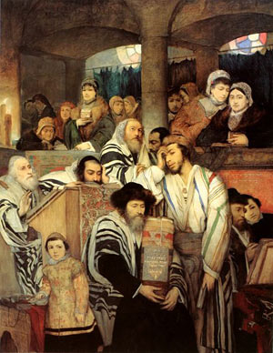
An 1878 painting by Maurycy Gottlieb depicting Ashkenazi Jews praying in the synagogue on Yom Kippur, the Jewish day of atonement

- Interpretation led to the Mishnah (oral Torah) – completed in about 200 CE
- Mishnah is divided into six sections: seeds, festivals, women, damages, holy things and purities
- Subordination of women to men, but also directions for responsibilities
- Mishna + rabbinic commentaries on it = The Talmud
- The Jerusalem Talmud (completed c. 400 CE) emphasizes continual study of the Torah as a spiritual practice
- The Babylonian Talmud (completed c. 500 CE) the dominant version in theology and law
- The Talmud continues to grow to this day

Perception of God
In early biblical narratives, God is perceived as a:
- Burning bush
- Pillar of cloud/fire
- Smoking mountain

In the prophets, God is present through:
- Visits by angelic messengers
- Inner voices

Rabbinical tradition:
- God’s presence in the world is called Shekinah
- Shekinah is a feminine quality representing God’s nurturing, motherly aspect
- This is a non-anthropomorphic, transcendent presence
- Sometimes Shekinah is depicted as a radiant, winged presence

Location of Israel Today



