Slack = LST-EST
Project Management
To find LST & LFT, we should start by the end
PERT
When we do the SD of completion, we must do ___, don’t do an addition of all SD as we do for the mean/variance.
a=Optimistic time
m=Most likely time
b=Pessimistic time
Once we found the SD and the mean, we can find the probability of project completion.
If we need to find the critical path with this method: Sum up all the possible option and take the longest.
Project Crashing
- Find the crash cost per period and the maximum reduction time for each activity.
- Draw a table (identify all possible paths)
- Total Crash Cost = Answer**You should not shorten the activity by its maximum reduction time**
Decision Analysis

Decision making under uncertainty (5 criteria):
- Maximax: Find the maximum of each row and take the maximum of your column.
- Maximin: Find the minimum of each row and take the maximum of your column.
- Equally Likely: Find the average of each row and take the maximum of your column
- Hurwicz Criterion: Find the largest (Mi) and smallest (mi) payoff for each decision.
  - Alpha will be given to find the expected value
  - Take the highest expected value in your column
- Minimax Regret Criterion: Redo the table. Take the highest amount for each states of nature (columns) and find the difference between the highest amount of each column and the value. *Must have a zero in each column*
Decision making under risk (3 criteria):
- The Maximum likelihood criterion: With the probabilities given, identify the States of Nature with the largest probability and take the decision with the largest payoff.
- Expected Payoff (EP) criterion (Bayes): Using another column, find the EP: (amount*prob)+(amount*prob) AND take the maximu of that column
- Expected Opportunity Loss (EOL): Using another column, find the EOL; sum of all (regrets*prob) AND take the minimum of that column
- Expected Value of Perfect Information (EVPI): Difference between Expected payoff under certainty (EPC) and the EP under risk
  - We must find EPC; Sum of the (highest amount in each column*its prob) AND the EP is explained above (the amount chosen)
  - It gives us the maximum amount that a company should be willing to pay for inside information.
Decision Tree
- To find the EP, we must start with the final payoff and work backward
- Posterior probabilities

Integer & Binary Programming
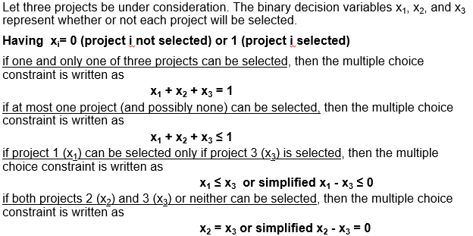

-An IP solution can never be better than the solution to the same LP problem. (think graphically)
On solver:
- Integer Optimality at 0.05%
- Simplex LP
- No sensitivity analysis
-Capacity constraint: Don’t forget to link the binary with the normal constraints (x1 + x2 + x3 ≤ 1000Y1)
-Fixed costs are usually linked with the binary variable (500y1 + 700y2 + 2x1 + 3x2)

Goal Programming

d+ : Overachieving level of the goal
d- : Underachieving level of the goal
- Objective function is ALWAYS minimizing Mind: the bad faces☹
We must include ALL d- and d+ in our constraints. When we put these deviations in it, we must use “=” sign. Then, we will solve the problem, the amount under d+ or d- will give us by how much the goal is not met. Ex.: 600x1 + 700x2 + d₁⁻ - d₁⁺ = 3000
If the time available is for all the steps in the production, we must define variable to determine the time used for each steps (assembly, finishing)

Simultaneous Changes in the Objective Function Coefficients 100% rule
Sensitivity Analysis
Objective function coefficients that are changed, sum the % of the allowable increases and the allowable decreases represented by the changes. If the sum of the % changes does not exceed 100%, the optimal solution will not change, if it exceeds, we need Excel. (Change / Allowable change)*100 ≤ 100

Graphically, Changes in the objective function coefficient values do not affect the size of the feasible region.
Changes in constraint quantity values = changes in resources = changes in the managerial policy decisions. Graphically, usually it affects the size of the feasible region and often the value of the optimal solution.
Simultaneous Changes in the RHS = if it respects the rule, the shadow price remains valid.
Shadow Prices (Definitions): **must be valid**
- It’s the marginal profit of additional unit of resource.
- The maximum price you are willing to pay for 1 unit of the resources.
- Amount by which profit will decrease if the availability of the resource associated with the constraint is reduced by 1 unit.
Ex.: if it asks to determine the allowable decrease of a constraint and it’s not bunding, the amount that should be in the allowable decrease will be the amount of slack (300). Because the shadow price is 0 and it will remain 0 as long as there’s a slack (300). There will remain slack so long as the RHS decreases no more than 300 minutes. The allowable increase is infinity since the shadow price will stay 0 no matter how much we add to the RHS (since this would merely add to the slack). allowable changes change the RHS constraints.
Ex.: If the objective coefficient is negative in the objective function, we must consider that a decrease in the objective coefficient represents an increase actually. (allowable increase).
Reduced Costs
- The amount by which the profit will decrease if 1 unit of this activity is forced into the solution.
- The amount by which the profit contribution of an activity (objective function coefficient) needs to be increased before producing this activity.
Multiple optimal solution – within variable cells
(Either, zero in the “final value” and reduced cost” column.) we need to have “0 in final value and reduced cost column and "0 in the allowable increase or decrease column. (Or, zero in the “allowable increase” or “allowable decrease” columns of the variable cells table.)
Pricing-out new variables
- Checking validity of the shadow price using 100% rule.
- Compute the opportunity cost: marginal worth (amount of the new constraint*shadow price) of the resources that would be diverted from existing product + cost of making the product
- Opportunity cost > profit contribution Do not produce the product.

Types of linear programming problem
- Resource allocation
- Cost-benefit-trade-off
- distribution-network problem (transportation & assignment)
Constraints must be = (fixed-requirement constraints) when supply = demand.
Constraints must be <= when demand < supply, excess in supply will appear as slack.
Constraints must be <= when demand > supply
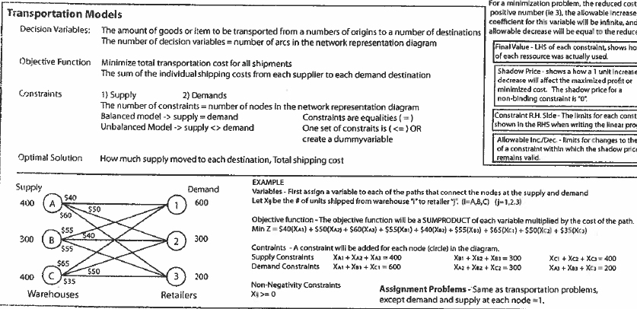
When a feasible region is unbounded, it does not mean the optimal solution will be unbounded.

