Chapter 1

What is marketing
- Set or practices aimed at:
  - Developing the product
  - Producing the product
  - Distributing the product
  - And building customer relationships

Core aspects of marketing
  - Helps create value
  - Occurs in many settings
  - About satisfying the customers wants and needs
  - Entails an exchange
  - Requires the 4 P’s decisions
  - Can be performed by individuals and organization
- Marketers try to create a “need” that really isn’t there

Marketing shaped by internal and external forces
- Macro-environment
  - Culture
  - Demographics
  - Social
  - Technology
  - Economics
  - Political/legal
- Microenvironment
  - Company
  - Competition
  - Cooperate partners

Value based marketing
- Trying to provide customer w/ value that exceeds the acquisition cost, while making reasonable returns
- Must also exceed what’s being offered by the competitors
- Firms need to now how their products create value for their customers
How firms compete on a value basis
- Changing customer perceptions
- Constantly monitor the marketplace to create value
Becoming value driven
- Understand key benefits
- Focus on key benefit
- Eliminate cost of less strategic benefits
- Take a long-term view of customer relationships
- Use data to assist in maintaining the relationship

Why is marketing important
- Expands global presence

Negative aspects of marketing
- Deception
- Objectifying

Marketing today
- Building relationships with customers
- Dialogue- conversations community
- Engagement
- Innovation
- Information mgmt: lots of info in real time
- Immediate gratification
- Customization and globalization
- Consumer cynicism
- Brand switching rather than brand loyalty
Marketing is complex and requires careful planning
Chapter 2
Strategy identifies:
- A firm’s target market(s)
- A related Marketing Mix (4 P’s)
- The bases upon which the firm plans to build a sustainable competitive advantage
Marketing strategies/S.C.A./Macro-strategies/Excellence strategies
- Product
  - Achieving effective branding and position
- Customer
  - Customer service
  - retaining loyal customers
- Operational
  - efficient operations
  - excellent supply chain mgmt.
- Location
  - putting your store in the right location

Developing a marketing plan (not sequential)
Step 1: mission and objectives
- objectives
- MS
  - activities it plans to undertake
  - answers: type of business? How it’ll accomplish its objectives
Step 2: situational analysis
- SWOT
- CDSTEP
Step 3: Identify and evaluate Ops. Using STP
- Segmentation
- Targeting
- Positioning
Step 4: Implement the Marketing mix
- Product value creation
- Price value for money
- Place and value delivery
- Promotion and value communication
Step 5: Evaluate performance metrics
- Financial metrics
- Marketing metrics
- Social responsibility metrics
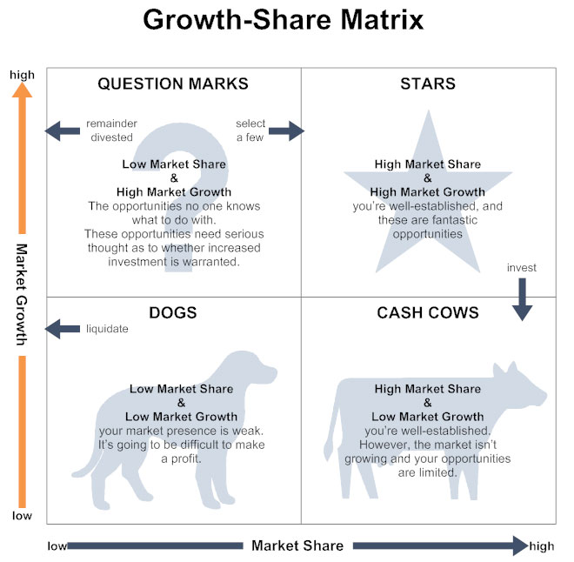
Product, Market Growth Matrix
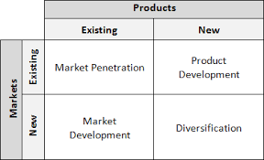
- Market penetration: selling the more products to the same people
- Market development: selling the same products to new customers
- Product development: selling new products to the same customers
- Diversification: entering new markets w/ new products

Chapter 3: Analyzing the marketing environment
Microenvironments
- Company (what they can do)
- Corporate partners (what their supplies/allies can do)
- Competition (what other firms can do)
  - Competitive intelligence: collets info so firm can anticipate changes
Culture
- Shared meanings, beliefs, morals of a group of people
- Country culture: easy to see visible nuances, dress, symbols, ceremonies, food preferences.
Social and demographic trends
- Connected: apps, mobile wallets, convenience in purchases
- Social consciousness- social environmental, sustainability efforts
- Preference for luxury
- Kids living longer at home
- Living home- trying out relationships more prevalent
- Waiting longer to start family
- Smaller space, bigger lifestyles
- More multi-cultural
- Age of access and sharing
Technological Changes
- Internet
- Smartphones
- Wearables
- Internet of things
- Other examples
Economic Factors
- Inflation rate
- Exchange rate
- Interest rate
- Growth
- Unemployment
- Recession
- Business and consumer confidence
Political/Regulatory Environment
- Competition Act
- Consumer packaging and labelling act
- Food and drugs act
- Access to information act
- Patent act
- North American free trade agreement
Chapter 4: consumer behaviour
Consumer decision process
Step 1: Need recognition
  - functional needs
  - psychological needs
Step 2: information search
  - internal search
  - external search

Step 3: Evaluation of alternatives
- Evoke set: first brand that come to you mind
- Consideration set: what consumer have tried/like
- Compensatory vs non-compensatory
  - Give and take vs. pre-sets (price based)
- Decision heuristics (mental shortcuts to narrow down choices)
  - Price
  - Quality perceptions
  - Product presentation
  - Brand
Step 4: Purchase decision
- Does the consumer follow through?
Step 5: Post purchase
- Customer satisfaction
- Post purchase dissonance (buyer’s remorse)
- Customer loyalty
Undesirable customer behaviour: negative word of mouth
Factors influencing buying decision
Situational factors
Purchase
- Occasion/person
  - Wedding
  - Baby shower
  - Self
Shopping
- Store atmosphere
- States people
- Crowding
- In-store Demo
- In-store Promotions
Temporal factors
- Time of day
- Season
- Weather
Social factors
- Family: immediate family
- Reference group: used as a basis for comparison about beliefs, feelings, and behaviours
- Culture: shared meanings, beliefs, and values of a group of people
Psychological factors
- Motives
  - Self-actualization
  - esteem
  - Love
  - Safety
  - Psychological
- Attitude
  - Cognitive (think)
  - Affective (emotions)
  - Behavioral
- Perception
  - Selective
    - Exposure
    - Attention
    - Comprehension
    - Retention
- Learning
  - Affects bother attitudes and perceptions
  - Affected by social experiences and
    - Stimulus generalization
    - Stimulus discrimination
- Lifestyle & Personality
  - Activities (work, shopping, sports)
  - Interest (family, fashion, food)
  - Views (about self, others, social issues)
  - Personality (sociability, dominance, autonomy)
  - Self-image ( true self, mirror self, aspirational (ideal) self)
Involvement and consumer buying decisions
- High involvement
  - Greater attention
  - Deeper processing
  - Generates strong loyalty
- Low involvement
  - Less attention
  - Peripheral processing
  - Generates weak loyalty
Types of buying decisions
- Extended problem solving
- seller
  - Give lots of info
  - After sale service: relieve fear
  - Price
  - Convenience
  - Payment options
  - Warranty & guarantee
- Limited problem solving
  - Impulse buying
  - Habitual decision making
  - Seller
    - Dominate shelf space
    - Lower prices
    - Sales promotions
    - Convert low purchase situation into high involvement
Chapter 5: B2B markets
Markets
- Institutions
- Government
- Resellers
- manufacturers
Benefits of B2B
- expand market reach
- result in lower price
- reduce operational cost
- higher potential profits
- lower inventory
- greater transparency
- efficient planning
- reduce bottlenecks
key challenges to B2B clients
- identify decision makers (who authorizes or influences purchases)
- understand the buying process if each potential client
- identify factors that influence the buying process of potential
Characteristics of business markets
- Market characteristics
  - Derived demand
  - Fewer customers, larger orders, geographically concentrated
  - Demand is more inelastic
- Product characteristics
  - Products technical in nature, purchase based on specs
  - Mainly raw and semi-finished goods
  - Heavy emphasis on delivery time, technical assistance, after sale service, financing
- Buying process characteristics
  - Buying decisions more complex
  - Biding, negotiated pricing, complex financial agreements
  - Qualified, professional buyers (formalised process)
  - Buying criteria and objective specified
  - Many people involved in purchase decisions
  - Close long-term relationships
  - Online buying common
- Marketing mix characteristics
  - Direct selling and physical distribution often essential
  - Advertising more technical, promotions emphasize personal selling
  - Price often negotiated, inelastic, affected by trade/quantity discounts
B2B classification system & segmentation
NAICS Code
- 51- information
  - 515 Broadcasting except internet
    - Radio & TV
      - Radio broadcasting
        - Radio Networks
B2B Buying process
- Need recognition
- Product specification
- RFP process
- Proposal analysis and suppliers section
- Order specification (purchase)
- Vendor performance assessment using metrics
Vendor performance assessment
- Customer Service
- Issue Resolution
- Delivery
- Quality
- Total
Factors affecting the buying process
- Buying centre
- Influencer
- Decider
- Buyer
- User
- Gatekeeper (most powerful)
- Initiator
- Organizational culture (4 types)
  - Democratic
  - Autocratic
  - Consensus
  - Consultative
- Buying situation
  - New buy
  - Straight rebuy
  - Modified rebuy
Chapter 6: Segmentation, Targeting, Position
- Segmentation: dividing up into smaller groups
- Targeting: deciding which segment to go after
- Position: how to portray your company
Step 1: establish overall strategy or objectives (segmentation)
Step 2: segmentation bases (segmentation)
- Geographic (where they live)
- Demographic (age/gender/income)
- Psychographic (lifestyle, personality, social class)
- Behavioural (usage rate, loyalty, and occasion)
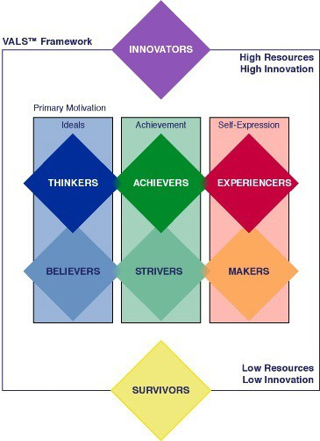
Step 3: evaluate segment attractiveness (targeting)
- Identifiable: who’s in the segment
- Reachable: can the market be accessible
- Responsive: similar responses, and positive ones
- Substantial and Profitable: measure their size and growth potential
Step 4: select target market (targeting)
- Undifferentiated targeting strategy/mass marketing: Many segments, with 1 offering
- Differentiated targeting strategy: targeting many seg+/8*ments with different offerings
- Concentrated (niche): prioritizes and produces for one segment
- Micro marketing one-to-one: tailoring product or service to individual wants or needs
Step 5: Identify and Develop positioning strategy (positioning)
- Position statement `
  - Target market
  - Offering name or brand3
  - Product/service
  - Point of difference/benefits
- Position methods
  - Value (not always “cheaper”)
  - Product attributes (about the product)
  - Benefits and symbolism (psychological)
  - Competition (head to head ex: wind)
  - Marketing leaderships (playing up your status)
- Positioning by using perceptual mapping
  - Find out what consumers think about your P&S compared to others
  - Identify the markets ideal points and size
  - Identify the markets competitor’s positions
  - Determine consumer preferences
  - Select the position
  - Monitor the positioning strategy
- Brand repositioning
  - Changing brand focus to new markets, or realign with changing preferences
Chapter 7: Marketing Research
Marketing research: techniques and principles for systematically collecting, recording, analyzing, and interpreting data that can aid decision makers involved in marketing goods, services or ideas
The marketing research process
- Define research problem and objectives
- Design the research plan
  - Type of data: primary (collected and used for Q. A), secondary (collected for Q. A used for Q. B), or both
  - Research method: qualitative, quantitative, or both
- Collect data
Recruit qualified researchers, prepare instruments, detailed description of the process, technologies, approvals
Types of data
- Secondary data
  - Info that was collected prior to a focal project
  - Can be internal or external (Currency, Reliable, Authority, Purpose)
- Primary data
  - Collected to address specific research needs
  - Focus groups, interviews, surveys
Research method
- Qualitative: Learn something new
  - Projective techniques: Metaphor, third party projections, RP, association
  - Observations, in depth interviews, social media, focus groups
- Quantitative: confirm something already known
  - experiments, survey, scanner, panel
- Analyze data and develop insight
- Data cleaning, screening
  - converting data into info to explain, predict, and/or evaluated a situation
- Data analysis (rigorous)
  - Basic analysis
    - Averages
    - Standard deviations
    - Frequencies
    - Cross-tabulation
  - Advanced
    - Regression analysis
    - Analysis of variance
    - Etc.
- Qualitative methods
  - Transcribe notes, coding data
  - Analysis
    - Text mining & Text analytics
    - Huge trend since social media
- Present action plan
- Generic structure
  - Executive Summary
  - Body
  - Conclusions
  - Limitations
  - Supplements
    - Tables
    - Figures
    - Appendixes

Chapter 8 & 9: Developing New Products, Branding & Packaging Decisions
Product: 1st of the four P’s
What is a product (product mgmt.)
Three layers of a product
- Core product: core customer benefit/value (inner)
- Actual products: brand names, quality, packaging, design (middle)
- Augmented product (associated services): financing, warranty support (outer)
Types of Goods
Convenience
- Low price
- Widespread loctions
- Mass promotion
- Ex. Tooth paste, magazines, laundry
Shopping
- Customers spend time comparing alternatives
- Ex: fragrances, apparel and, Appliance
Speciality
- Strong preferences
- Willing to spend a lot of time searching
- Ex: luxury cars, competitive road bike
Unsought
- Don’t not think/know about these goods
- Ex: coffins, fire extinguishers
Product mix and Product line
- Width: how many different types of products (columns)
- Products line Depth: how many products in each column (rows)
SKU’s” Stock keeping unit
What is a brand (brand mgmt.)?
- Brings value to the customer and to the market
  - impact market value
  - facilitate purchasing
  - establish loyalty
  - protect form competition
  - reduce marketing costs
  - are assets
- behavioural loyalty: repeat purchase
- attitudinal: hype it up, consideration set, good word of mouth

Brand equity
Brand value is determined by brand equity
BE= Brand Awareness + Brand Association + Brand Loyalty + Perceived Value
- Awareness: do you know about the brand
- Association: how do you associate the brand
  - Strong positive/negative, negative/positive, neutral
- Loyalty: how much are you committed
- Perceived Value: how much value to you get from your product
Branding strategy
- Types of brands
  - National brands
  - Private label brands
  - Generic brands
- Brand naming
  - Corporate
  - Individual
  - Corporate product lines
- Brand extension
  - Risk Brand Dilution (having your name on too many things)
  - Ex: FedEx office, FedEx trade networks, FedEx freight
- Co-branding
  - When multiple brand come together and share customer base, revenue, and cost
- Brand licensing
  - Using a brand name in/for your product
- merchandising
  - selling products using aspect of another brand
  - when buying a meal and get a toy
Packaging and labeling
Why develop new products (new products mgmt.)
- fashion cycles
- changing customer needs
- market saturation
- managing risk through diversity
- improving value
- competitive pressures
- improving business relationship
how firms develop new products
- idea generation: development of viable new product ideas
- concept testing: testing the new product idea with potential customers
- product development: development of prototypes and/or the product
  - prototype
  - alpha testing
  - beta testing
- market testing: testing the actual products in a few test markets
  - concept (pre-trial): consumer contacted
    - Exposure to concept stimulus
    - Evaluation of concept
  - after-use (post-trial): eligible consumers placed with product
    - consumer re-contacted (after usage period)
    - evaluation of product
- product launch: full-scale commercialization of the product
- evaluation of results: analyze performance of new product and make modifications
Chapter 10: Services
Unique dimension of services
- Intangible
  - Key: Cues, Images, and Atmosphere
- Can be Inventory
  - Key: understand demand trends and capacity management.
- Inconsistent
  - Service difference from branch to branch or employee to employee
  - Key: training, standardization, customized service, bundled packages, use technology
- Inseparable
  - Two types: consumer an provider/ or service and provider can’t be separated
  - Key: must lower risk through warranties, guarantees etc...
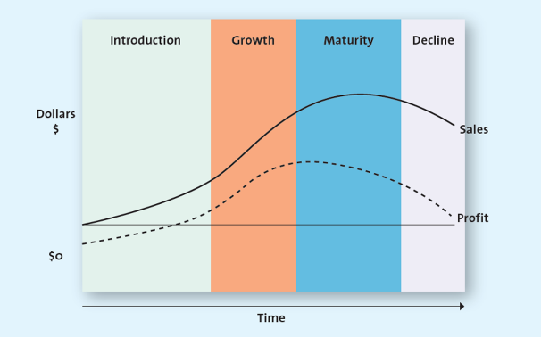
Product life cycle
- Introduction
  - Innovators are buying
- growth
  - gains acceptance and sales
- maturity
  - sales peak
  - repositioned, or new features added
- decline
  - exits the market
  - step 3 was unsuccessful
Consumer adoption cycle/ diffusion of innovation
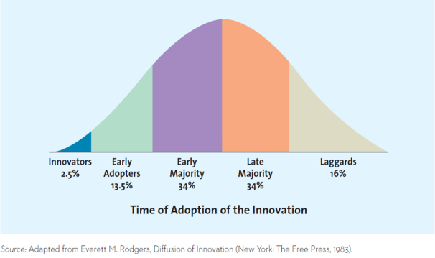
- innovators (2.5%)
  - venturesome
  - risk takers
  - accepts imperfect product
- early adopters (13.5%)
  - opinion leaders
  - take less risk than innovators
  - want improved products (no bugs)
- early majority (34%) (mainstream market)
- adopt before average consumers
- not risks takers
- price sensitive
- perfect products
- like offers and deals
- late majority (34%) (mainstream market)
  - avoid risks
  - price sensitive
  - perfect product
  - like offers and deals
- Laggards (16%)
  - Price sensitive
Strategies for extending the PLC:
- Develop new uses
- Modify the product
- Increase the frequency of use
- Increase the # of users
- Find new users
- Reposition product
- Tweak marketing strategy

Proving great service: The Gaps model
Knowledge Gap
- Customer expectations vs what mgmt. think customers want
Standards Gap
- What mgmt. think consumers want vs standards that specify the service to be delivered
Delivery Gap
- Standards that specify service vs the service that’s delivered
Communication Gap
- Actual service delivered vs retailer communications about service quality
Fixing the gaps
Market research, understand consumers, employees + org Culture
Ex 1: give the public everything you can give (Disney: not my fault but its my problem)
Ex 2: Zappos – its all WoW!
Ex 3: Ritz Carlton – Go to any lengths to make customer happy
Other tips:
- Provide emotional and other support, reward employees, and use consistent mgmt.
- Use technology, set standards, develop systems to ensure high quality service
- Manage customers expectation and promise only what you can deliver
Service recovery – what to do when you mess up
- Listen to customers
- Resolve problem quickly
- Provide fair solution
  - Procedural fairness/justice: process used was fair to the customers
  - Distributive fairness/justice: solution itself is fair to the customers
Evaluating service quality (5 dimensions)
Zone of tolerance: diff. b/w what you expect and how much longer you’ll wait (don’t mind: 3 minutes late, $2 overcharge,)
- Reliability: ability to perform service dependably and accurately
- Responsiveness: willing to help customers and provide prompt service
- Assurance: the knowledge of employees and their ability to convey and confidence
- Empathy: caring individualized attention provided to customers
- Tangibles: appearance of physical facilities, equipment’s, personnel and communication materials
Chapter 11: pricing concepts and strategies
Why is it important
- Major component of firm revenue
- Influence purchase decision
- Signals value
- Signals quality
- Signals a firm’s competitive position
- Used to establish value creation in the marketing mix
5 C’s pf pricing
- Company objectives: business objective or orientation
  - Profit orientation: focus on profit levels
    - Max profits, target return pricing, and target profit pricing
  - Sales orientation: focus on increasing sales and market share
  - Competitor orientation: focus on competitive position
  - Customer orientation: focus on matching customer expectations
- Customers: sensitivity to price changes
  - Demand and supply (key tool)
  - Price elasticity of demand
    - Effected by income
    - Close substitutes (substitution effect)
  - Elastic (price sensitive)
  - Inelastic (price insensitive)
  - Consumers less sensitive to price
- Cost: cost of inputs (factors of production)
  - Variable cost
  - Fixed cost
  - Total cost (FC+VC)
  - BEP (units)= FC/Contribution per unit
  - Contribution margin = Price - VC
- Competition: competitiveness of the industry
  - Monopoly: single sellers
  - Oligopoly: few sellers
  - Monopolistic competition: many sellers, intense price competition – differentiation is key
  - Pure competition: many sellers – commodities – usually price takers but try some differentiation
- Channel members: supplies, distributors and retailers
  - Manufacturer, wholesaler, and retailers can have different objectives on pricing strategies
  - Manufactures must protect against grey market transactions, why
Macro influences on prices:
- Technological factors (ex; internet)
  - Increased info, price comparisons, growth of online auctions, increased price sensitivity etc.
- Economic factors
  - Increased disposable income
  - Increased status consciousness
  - Increases globalization
  - Local economic conditions
  - Cross-shopping (different stores/ same stores different levels)
- Regulatory factors
  - Cost of complying with government regulations, pot sales?
  - Trade policies- tariffs, quotas, non-tariff restrictions etc
Pricing strategies:
- Cost based
  - Starts with cost
  - Cost calculates on per unit basis
  - Assumes cost don’t vary for different level of production
- Competitor bases
  - Set prices to signal how products compares with competitors
  - Premium pricing or discount pricing
- Value based
  - Focuses on consumer perceptions
  - Pricing that focus on overall value
New product pricing strategies
Price skimming
- Applies to new products (innovative or ones that provide new benefits)
- Customers: usually innovators and early adopter in the PLC
- Recoup R&D costs
- Signal quality
- Limit demand while ramping up production
- Test consumers price sensitivity
- Profits through margins
Market penetration pricing
- Set initial price low to encourage customer to buy early and discourage competitors
- Risk leaving money on the table
- Build sales, market shares and profits quickly
- Cost tend to fall as volume increases (experience curve effect)
- Profits through volume
Psychological factors affecting pricing strategies
- Reference pricing
  - Internal: the price we have in our mind
  - External: price they give (50% off, was X now is Y)
- Price quantity relationship
- Odd prices
- Everyday low pricing (EDLP) vs High-Low price
Consumer pricing tactics
- Price lining:
  - price floor and price ceiling – offer multiple version s of a product
  - Enable easy comparison
- Price bundling:
  - Encourage sales of slow moving items
  - Encourage stock up
  - Encourage trial of new brand
  - Incentive to purchase
- Leader pricing
  - Enticing consumers into the store with popular aggressively priced item
  - Hoping the will pick up other items while shopping
Consumer price reductions
- Mark downs:
  - Generate traffic
  - Get rid of slow moving items
  - High/low tactic
- Coupons and rebates
  - Coupons- retail handles
  - Rebate-manufacturer issues
B2B pricing tactics and discounts
- Seasonal discounts
  - Buying out of season
  - Buying in season
- Cash discounts
- Allowance
- Quantity discounts
- Uniform delivered vs geographic pricing
  - UD: same price to deliver a product
  - GP: changes based on were you are (urban/ rural, also where you’re sitting)
Legal and ethical aspects of pricing
- Deceptive pricing: differing price (other than what’s advertised)
  - Bait n’ switch
  - Lying about the “original” price
- Price fixing: collusion to charge consumers more
- Price discrimination: 2 consumer groups pay different pricing
- Predatory pricing: trying to price out your competition
Chapter 12: Distribution
Distribution components
Is a distribution channels: brokers, dealers, wholesalers, agents, resellers, retailer ()
Logistics: all activities involved in the flow of goods
Supply chain: network of firms involved in the flow of goods>
Suppliers (flow of inputs)producers (Outflow of Finished goods) consumers
Keys for this to work:
- information flows
- coordination mutual trust
- strategic relationships
- commitment
Distribution channel structure
Different level channels
- Direct: Manufacturer to consumer
- Indirect: Manufacturer to retailer to consumer
- Indirect: Manufacturer to wholesaler to retailer to consumer
- Multichannel marketing: manufacturer, distributors, Dealers/retailers, consumer segment
- Major influence
  - customer expectations
  - channel member characteristics

Distribution channels add values/ functions performed by intermediaries
- intermediaries reduced the number of transaction
transactional function:
- buying
- risk taking
- promotion
- selling
logistical function
- physical distribution
- risk taking
facilitating function
- gather information
- financing
Distribution intensity
- intensive: everywhere – Products/Companies
- selective: few locations – Products/Companies
- exclusive: even fewer locations – Products/Companies
- determined by Products, Company, and Consumers
Managing distribution channels
Independent or vertical marketing channel
Independent: each channel member tries to satisfy their own objectives
VMS
- Contractual VMS: independent firms join to make EOS through contracts
- Administered vertical marketing system: dominant channel member controls the relationships
- Corporate VMS: parent company dictates priorities and objectives of the channel
Working together to reduce cost

Logistics management: marking merchandise flow
- inbound transportation
- receiving and checking
  - receiving: arrival receipt
  - checking: undamaged, ordered # received
  - Radio frequency distribution: container computer chips
- storing and cross docking
  - put it away, or immediately prep. to ship out
- getting merchandise floor ready
- shipping merchandise to stores
- just-in-time systems (JIT)
supply chain benefits
- fulfill delivery promises
- meet customer expectations
- reduce number of transactions
- increase value for consumers
- more efficient and effective distribution system
Chapter 13: retailing
Retailing
- sits at the end of the supply chains
- marketing meets the consumer
- fulfilling customer expectations
- se of business activities that add value
- stores, catalogues, kiosks, internet
History of retailing in Canada
- mom & pops specialty store: central business districts
- department stores: Eaton’s in 1869 (one stop shop, low cost)
- chain stores: competed mainly on price
- Discount retailers (1960): cut out the middle man to lower cost Zellers, Woolco., K-Mart
- Strip malls indoor mall power centres
- Free trade: increase on cross boarder shopping, and influx of American retailers
- Power centres thrived (accessible to those outside of cities)
- Internet 1993: “changed the game” internet retailing
Types of retailers
- Food retailers
- General merchandise retailer
General merchandise retailers
- Department stores: broad variety deep assortment
- Full-line discount: broad variety low prices
- Specialty: limited merchandise with service in small stores
- Drugstores: specialty pharmaceuticals and health
- Category specialist: discount with narrow but deep assortment
- Extreme value: full line, limited, very ow prices
- Off price: inconsistent assortment of brand name at low prices
The wheel of retailing
- Entry phase: Outlet starts with low prices, margins, and status
- Entry phase: Outlet now has higher prices, margins, status
- Trading-up phase: Outlet now has still higher prices, margins, status
- Vulnerable phase: New form of outlet retailing enters retailing environment with characteristics of outlet box 1 (innovation)
Creating a retail strategy using the 4ps
Retailing strategy (over arching)
- Put customer at the centre of strategy
- Influence Customer to carry your dialogue
- Present products as customer solution
- Align channels to customer shopping journey
- Establish customer-focused, cost-effective operations
- Product/service strategy
- Pricing strategy
- Place strategy
- Promotions strategy
Benefits of buying in a store
- Browsing
- Touching and feeling
- Personal service
- Cash and credit
- Entertainment and social interaction
- Instant gratification
- Risk reduction
Benefits of online & multi channel retailing
- Deeper and broader selection
- Personalization
- Gain insights in to consumer shopping behavior
- Increased customer satisfaction an loyalty
- Expand market presence
Chapter 14: integrated marketing communications
Communicating with consumers: the communication process
Sender (firm)trnsmtr. encode msgcommunications channel (media)rcvr. (consumer) decodes it
7 steps to planning an ad campaign
Step 1: identify target audience (who your targeting)
Step 2: set campaign goals (what you want to achieve)
- Ex:
  - Attention/awareness/remind/persuade
  - Loyalty
  - Introduce a produced, increase trial, increase sales
  - Increase brand recall (aided & unaided)
Step 3: determine your budget
- Considerations
  - Role that advertising plays in meeting overall promotional objectives
  - Nature of the market and the products influence budget
  - Expenditures vary over the course of the product life cycle
- Budgeting methods
  - Objective-and-task method: set comms. objectives, then pick the best tools and media to reach target market
  - Competitive parity: match the budget of competitive
  - Percentage of sales: fixed percentage of forecast sales
  - Affordable budgeting: money available after accounting for operating cost and profits
Step 4: convey the message (value proposition)
- Unique selling proposition
  - Ex: “reveal the goddess in you”, “best a man can get”, “you decide what’s inside”
  - Message strategy and execution is key: speak to rational vs emotional and pre-set
    - Comparison
    - Image
    - Demonstration
    - Testimonials
    - Mood
    - Slice of life: relatable
    - Scientific
    - Humor
    - Fear
    - Puffery: exaggerated claims
Step 5: evaluate and select media: compare & select appropriate media
- Media planning: how much media will you use, what the right medium
- Media mix: what media will you use
- Media buy: pay for the media you want
  - Continuous: runs year round
  - Pulsing: year-round, but changing frequency/intensity at certain times
  - Flighting: only shown at a certain time of the year (Halloween, valentines, Christmas)
medium | advantages | disadvantages
TV
Radio
magazines
Internet

Step 6: create the message: appeal? Design element?
- Plays a big role
- Should not over shadow message
- Type of Medium determines the execution style
- Execution style must match medium and objectives
Step 7: Asses effectiveness: metrics
- Pretesting: assessment performed before the Ad campaign
- Tracking: monitoring key indicators
- Posttesting: evaluation of the campaign: what are the results, were the objectives achieved
Results: measuring IMC success:
- Understand desired outcome at outset
- Short-term or long-term

When and where to place ad
Ottawa target market: 1,000,000
6om news audience: 300,000
Reach (%)= 3000,000/1,000,000 = 30
Frequency: 5 times
GRP=150
Advertising
- Paid message
- Delivered through media
- Must have identifiable source
- Designed to inform, remind, persuade
Types of advertising
- Product Ad: Chevy Equinox
- Institutional Ad:
- Advocacy Ad: environmental protection
- Public Service Ad: Distracted driving
Lagged effect
- Advertising not always have immediate impact
- Multiple exposures are often necessary
- Difficult to determine which exposure led to purchase
Informative advertising
- Used early in the PLC to inform & educate consumers about product/service
Persuasive advertising
- Generally, occurs in the growth and early maturity stages of the PLC when competition

Regulatory and ethical issues
- Messages with economic purposes Must be fact based
- Messages with no economic purposes are protected under the charter of rights and freedoms
Chapter 15: PR, sales promotion, personal selling
Public relations
- Free media attention
- Importance of PR has grown
Elements of a PR toolkit
- Publications
- Video and audio programs
- Annual reports
- Media relations
- Sponsorships
Types of campaign
Advertising:
Digital media
Direct marketing: marketing that communicates directly with target market
Public relations: managing comms.to achieve objectives (ex: handling bad press, making a good image)
Sales promotion: special incentives or excitement building programs to encourage purchases
  - Can be targeted at either consumer of channel member
  - Pull: when customer wants it
  - Push: when company wants you to buy I
- Types of sales promotion
  - Coupons: stimulate demand
  - Deals: encourage trial
  - Premiums: build good will
  - Contests: increase consumer involvement
  - Sweepstakes: encourage higher corruption
  - POP displays
  - Rebate
- Types of B2B sales promotion
  - Discounts and allowance
  - Co-operative advertising
  - Salesforce training
- Evaluate sales promotion
  - Realized margins
  - Cost of additional inventory
  - Potential increasing sales
  - Long-term impact
  - Potential loss from switches from more profitable items
  - Additional sales by customers
Personal selling: two-way flow designed to influence buyer decision
- Internet
- Telephone
- Face-to-face
- Teleconference
7 benefits of personal selling
- Customized message for buyers
- Assists in creating strong supply chain relationships
- Increased customer loyalty through relationship selling
- Gather research input from customers
- Crucial to the success of CRM
- Educate & provide advice
- Save time & simplify buying
The personal selling processes
- Generate and qualify leads
  - Find some one to sell to
  - Make sure they are the right industry and the right person
- Pre-approach
  - How to get in the door
- Sales presentations and overcoming objections
  - How handle objections
    - Acknowledge and convert them
    - Postpone: get back to you
    - Agree and neutralize
    - Accept the objection
    - Denial
    - Ignore the objection
- Closing the sale
  - Last objection closing
    - Are you ready to order if we show you…?
  - Trial closing
    - How much would you like to order?
    - What colour, style, design, etc.
  - Standing room only closing
    - If you don’t buy now, we can’t guarantee it later
- Follow-up
  - Five service quality dimensions
    - Reliability
    - Assurance
Managing the sales force
- Setting sales force objectives
- Designing sales force strategy
- Recruitment & selection s
- Training
- supervision
- Motivation
- Compensation
- Monitoring
- Performance evaluation
Characteristics of best sales people
- Intrinsic motivation
- Disciplined workstyle
- Ability to close a scale
- Ability to build relationship

Chapter 17
- Environmental (PEST) analysis
- Market Entry Strategy
- Marketing strategy
Assessing global markets (PEST)

- GDP: signals economic growth of contraction
- Purchasing Power Parity: Cost of goods in different Countries
- Global Human Development Index:
  - Life expectancy
  - Education attainment
  - Average income enough for basic needs

Global entry strategy 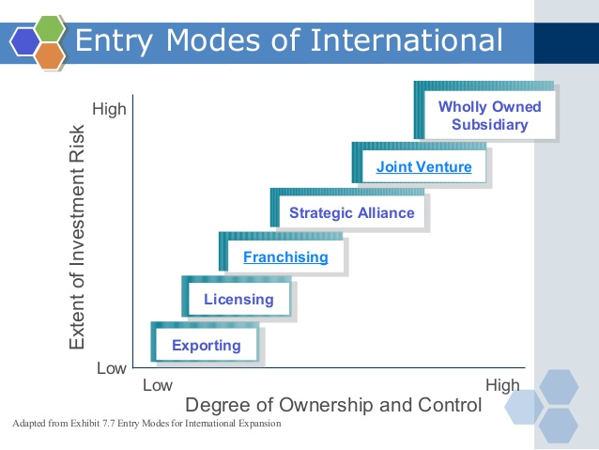
Risks
- Losing employee
- Brand reputation
How to choose global strategy
- Cultural nuances
- Subcultures
- View of product and consumer role
- Different positioning
- Adaptation vs. standardization
- Single positioning strategy

Mandatory
- Legal standards
- Economic conditions
- Education
- Climate and geography
Discretionary
- Cultural differences
- Customer needs/preference
- Competitors strategies
Global marketing mix:
Pricing strategies

Global distribution strategies
- Some channels are long and complex
- Consumer shop local small stores
- Supplies must be creative in delivering to the outlets
Global communication strategies
- Literacy levels vary by and country and w/in different regions
- Firms choose to/ to not adapt language differences
- Cultural and religious differences matter

Final exam
Chapter 7-15 and globalization
60 MC 1.5 marks each
However, much fits on the page (probably 10 out of the 30 he provides)
- Persuasive marketing:
- Projective techniques: understand the consumers motivation, attitudes, beliefs, and values.
- Coupons and rebates: get consumers to try, reward loyal consumers, encourage repurchases
- Push marketing strategy: getting channel members to carry their goods
- Premiums: build goodwill, reward; buying, sampling, and testing
- RFID Tags: eliminates individual item handling, reduces overall inventory, and processing time
- Cobranding: increase customers perception of quality, appeal to diverse markets, reduce costs
- Trade agreements: manage and promote trade between countries,
- Corporate VMS: dictate supply chain objectives, lessen conflict, manage inventory, info, and relationships w/in the supply chain
- Protectionist Policies: promote domestic business, reduce foreign competition, restrict trade
- Personal selling: influence buyers purchase decision, simplify the buying process for consumer, add value
- Efficient Supply Chains: minimize cost, reduce process times
- Joint-venture: enter new markets, reduce cost, gain outside expertise on markets or products
- Innovation: establish new markets and early and commanding lead, satisfy new needs, reinvent existing products
- Strategic alliance: expand market share, reduce expansion cost,
- Leader pricing: build in-store traffic, encourage consumers to buy other goods,
- Trade sanctions: get a country to discontinue something, put econ. Pressure on a countries gov. through it citizens
- Individual brands: allow a company to compete w/in one category, diversifies the assets, easier to establish a comp. advtg.
- Emotional appeals: satisfy cust. Emotional desire, create an emotional bond
- Pop- up stores: promote a new product, customers can interact with brand, get customers to buy products in-store
- Rational Appeals: help customers make decisions, get customer to favour your brand, convince customer you’re better
- Test Marketing: predict product success, decide to fold, or push the product, cage customers attitudes
- Competition Bureau of Canada: enforce laws to make sure firms are operating fairly, make sure no companies get to big
- Price Skimming: get the most revenue out of each segment, recoup some of the innovative costs
- The CRTC: regulates broadcasting, and telecom. Common carriers, and service providers
- Private label brands: creates a competitive advantage, capitalize on lower price points, increase stores revenue
- Advertising standards Canada: monitors voluntary industry codes
- Concept testing: estimate sales value of a product, determine weather or not to produce,
- Public service announcement: promote public welfare, spread awareness for social issues, educate the public.

