CHAPTER 8 MEMORY
Intro
- Our memory that accounts for time and defines our life
- Memory= our storehouse of accumulated learning
- Without memory we would instead live in an enduring present

Studying Memory
8.1- What is memory, and how is it measured?
- Memory: the persistence of learning over time through the encoding, storage, and retrieval of information.
- We remember countless faces, places, and happenings; tastes, smells, and textures; voices, sounds, and songs.
  - In one study, students listened to snippets—a mere four-tenths of a second—from popular songs; recognize the artist and song> 25 % of the time
  - We often recognize songs as quickly as someone’s voice.
  - Experiment: people exposed to 2800 images for only 10/3 seconds each spotted the repeats with 90/82 percent accuracy
Measuring Retention
- To a psychologist, evidence that learning persists includes these three measures of retention:
- Recall: a measure of memory in which the person must retrieve information learned earlier, EX: fill-in-the-blank test.
- Recognition: a measure of memory in which the person need only identify items previously learned, as on a multiple-choice test.
- Relearning: a measure of memory that assesses the amount of time saved when learning material again.
- Our recognition memory is impressively quick and vast.
- Our speed at relearning also reveals memory.
- Hermann Ebbinghaus (1850–1909)
  - Pioneering memory researcher; relearning memory
  - Randomly selected a sample of syllables, practiced them, and tested himself
  - The day after learning such a list, Ebbinghaus could recall few of the syllables; not entirely forgotten.
  - The more frequently he repeated the list aloud on Day 1, the less time he required to relearn the list on Day 2.
  - Additional rehearsal (overlearning) of verbal information increases retention
- Tests of recognition and of time spent relearning demonstrate that we remember more than we can recall.
Memory Models
8.2- How do psychologists describe the human memory system?
- An information-processing model likens human memory to computer operations. To remember any event, we must:
- Encoding: The processing of information into the memory system—for example, by extracting meaning; get info into brain
- Storage: The process of retaining encoded information over time; retain that info.
- Retrieval: The process of getting information out of memory storage; later get the info back out
- Computers process info sequentially; Our brain processes many things simultaneously (some of them unconsciously)parallel processing
- Connectionism: a multitrack info processing model that views memories as products of interconnected neural networks.
  - Specific memories arise from particular activation patterns within these networks.
  - Learn something new, your brain’s neural connections change, forming + strengthening pathways
- Richard Atkinson and Richard Shiffrin (1968) proposed a three-stage model (memory-forming):
- Sensory memory: the immediate, very brief (fleeting) recording of sensory information in the memory system.
- Process info as Short-term memory: activated memory that holds a few items briefly, such as the seven digits of a phone number while calling, before the information is stored or forgotten ; encode it through rehearsal.
- Long-term memory: the relatively permanent and limitless storehouse of the memory system. Includes knowledge, skills, and experiences.
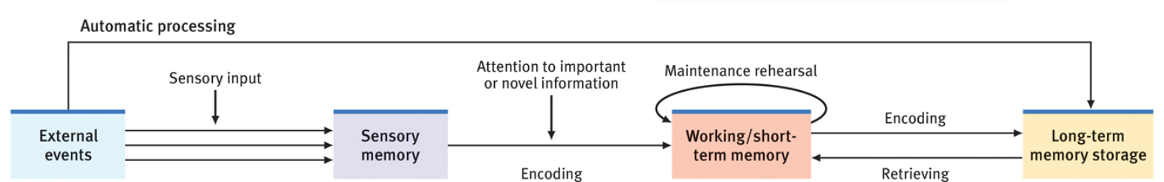
- Some info slips in long-term memory via a “back door,” without our consciously attending to it (automatic processing).
- More active processing = short-term memory/ working memory.
Working Memory
- Alan Baddeley extended Atkinson and Shiffrin’s view of short-term memory
  - Working memory is not a small, brief storage space for recent thoughts/experiences.
  - = active processing of info by making sense of new input and linking it with long-term memories.
  - EX: Whether we hear eye-screem as “ice cream” or “I scream” will depend on how context+ experience guide our interpreting + encoding the sounds.
- Working memory: a newer understanding of short-term memory that focuses on conscious, active processing of incoming auditory and visual-spatial information, and of information retrieved from long-term memory.
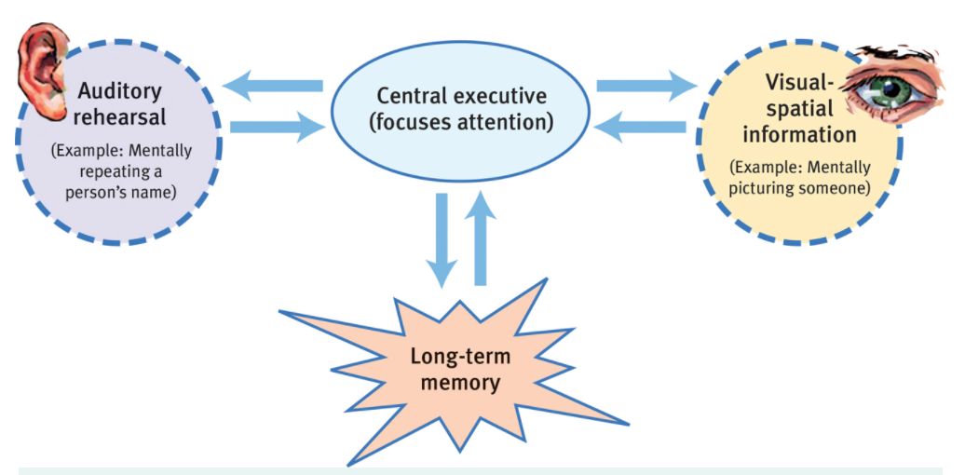
- Alan Baddeley’s (2002) model of working memory
- Includes visual and auditory rehearsal of new information
- A hypothetical central executive focuses attention and pulls info from long-term memory to give meaning to new info.

Encoding Memories
Dual-Track Memory: Effortful Versus Automatic Processing
8.3- How do explicit and implicit memories differ?
- Atkinson and Shiffrin’s focused on how we process explicit memories
- Explicit memory: memory of facts and experiences that one can consciously know and “declare.” (Also called declarative memory.)
- Mind = 2-track unconscious and conscious
- Effortful processing: encoding that requires attention and conscious effort.
- Automatic processing: unconscious encoding of incidental information, such as space, time, and frequency, and of well-learned information, such as word meanings.
- Implicit memory: retention of learned skills or classically conditioned associations independent of conscious recollection. (Also called nondeclarative memory.)
Automatic Processing and Implicit Memories
  - What information do we process automatically?
- Implicit memories include procedural memory for automatic skills and classically conditioned associations among stimuli.
- Automatically process info about space
  - Encoding where things appear on page
- Info about time
  - Unintentionally note the sequence of its events in a day
- Info about frequency
  - Tracking of how many times things happen
- Vision, thinking, and memory are not single abilities; split info into different components for separate and simultaneous parallel processing.
Effortful Processing and Explicit Memories
- Learning to read isn’t automatic.
- With experience and practice reading = automatic.
- Way in which skills= developed

Sensory Memory
  - How does sensory memory work?
- Sensory memory feeds active working memory, recording momentary images of scenes or echoes of sounds.
  - EX: George Sperling (1960) flashed a group of letters 1/20 sec, people could recall 1/2 of letters.
  - Signalled (with tone) to recall a row after the letters = disappeared= near-perfect accuracy.
  - George Sperling demonstrated people actually could see and recall all the letters, but only momentarily iconic memory
  - If Sperling delayed the tone signal > 1/2sec image faded =1/2 of letters.
- Iconic memory: a momentary sensory memory of visual stimuli; a photographic or picture-image memory lasting no more than a few tenths of a second.
- Our visual screen clears quickly and impeccable memory for auditory stimuli:
- Echoic memory: a momentary sensory memory of auditory stimuli; if attention is elsewhere, sounds and words can still be recalled within 3 or 4 seconds.

Capacity of Short-Term and Working Memory
  - What is the capacity of our short-term and working memory?
- George Miller (1956) proposed that we can store 7 bits of info in short-term memory.
- We can recall about 7 digits, 6 letters or 5 words
- Lloyd Peterson and Margaret Peterson (1959) wanted to know how quickly short term memories disappear
  - Ex: people remembered three-consonant groups
  - After 3 sec, people recalled letters ½ the time; after 12 sec= no recall
- Short-term memories have a limited life.
- Working memory capacity varies depending on age + factors
- Young adults = most working memory capacity; use their mental workspace more efficiently; greater ability to multitask
- Work more efficiently when focused, without distractions, on one task at a time.
- Unlike short-term memory capacity, working memory capacity reflects intelligence level
- Those with a large working memory capacity—whose minds can juggle multiple items while processing information—tend also to retain more information after sleep and to be creative problem solvers
Effortful Processing Strategies
  - What are some effortful processing strategies that can help us remember new information?
- Chunking: organizing items into familiar, manageable units; often occurs automatically.
- We all remember information best when we can organize it into personally meaningful arrangements. (Doug Hintzman)
- Mnemonics: memory aids, especially those techniques that use vivid imagery and organizational devices.
- We are good at remembering mental pictures; remember concrete words than we do abstract words.
  - EX: The peg-word system harnesses visual imagery skill; mnemonic requires memorizing a jingle
- When combined, chunking and mnemonic techniques can be great memory aids for unfamiliar material.
- Hierarchies: composed of a few broad concepts divided and subdivided into narrower concepts and facts.
- Organizing knowledge in hierarchies helps us retrieve information efficiently, as Gordon Bower demonstrated
  - Presented words randomly or grouped in categories.
  - Grouped words = 2 or 3 times better
Distributed Practice
- We retain info better when encoding is distributed over time.
- Spacing effect: the tendency for distributed study or practice to yield better long-term retention than is achieved through massed study or practice.
- Massed practice (cramming) = speedy short-term learning and a feeling of confidence.
- Distributed practice = better long-term recall
- Distributing learning over several months= life long retention
- The longer the space between practice sessions, the better retention (Bahrick)
- One effective way to distribute practice=
  - Testing effect: enhanced memory after retrieving, rather than simply rereading, information. Also sometimes referred to as a retrieval practice effect or test-enhanced learning.
  - Roediger and Jeffrey Karpicke (2006)
  - Highlighting text and rereading text= ineffective
- CONC: Spaced study and self-assessment > cramming and rereading; rehearsal with self-testing= lasting memories.
Levels of Processing
8.8- What are the levels of processing, and how do they affect encoding?
- Verbal info processed =@ different levels; depth of processing affects long-term retention.
- Shallow processing: encoding on a basic level based on the structure or appearance of words
- Deep processing: encoding semantically based on the meaning of the words; tends to yield the best retention.
  - EX: Fergus Craik and Endel Tulving (1975) flashed words at people.
  - Then they asked questions that would elicit different levels of processing
  - Deeper, semantic processing = better memory than shallow processing
Making Material Personally Meaningful
- If new information = not meaningful /related to experience= trouble processing it.
- (Brewer) (1977), You recall the sentence by the meaning you encoded when you read it
- We recall not the literal text but what we encoded.
- We can avoid mismatches by rephrasing information into meaningful terms
  - EX: Ebbinghaus estimated that, compared with learning nonsense material, learning meaningful material required 1/10 the effort.
- We have especially good recall for information we can meaningfully relate to ourselves.
  - Self-reference effect
  - Information deemed “relevant to me” = processed more deeply and = more accessible.
- The point to remember: The amount remembered depends both on the time spent learning and on your making it meaningful for deep processing.

8.2 Storing and Retrieving Memories

Memory Storage
8.9- What is the capacity of long-term memory? Are our long-term memories processed and stored in specific locations?
- Our capacity for storing long-term memories = essentially limitless
- Our brains are not like attics, which once filled can store more items only if we discard old ones.
Retaining Information in the Brain
- Memories do not reside in single, specific spots
  - EX: Karl Lashley (1950) trained rats to find their way out of a maze, then surgically removed cortex and retested memory
  - No matter which section he removed rats retained at least a partial memory of how to navigate the maze
- Memories are brain-based, but the brain distributes the components of a memory across a network of locations.
- These specific locations include some of the circuitry involved in the original experience: Some brain cells that fire when we experience something fire again when we recall it
- We do not store information as libraries store their books, in single, precise locations; Brain networks encode, store, and retrieve the information that forms our complex memories.
Explicit Memory System: The Frontal Lobes and Hippocampus
8.10- What are the roles of the frontal lobes and hippocampus in memory processing?
- The network that processes and stores your explicit memories for facts and episodes = frontal lobes and hippocampus
- Summon past experience brain regions send input to frontal lobes for working memory processing
- The left and right frontal lobes process different types of memories.
  - Left Frontal Lobe: Recalling a password
  - Right Frontal Lobe Calling up a visual party scene
- Hippocampus: a neural center located in the limbic system; helps process explicit memories for storage; “save” button for explicit memories
  - Damage to this structure therefore disrupts recall of explicit memories.
  - Left hippocampus damage, people = trouble remembering verbal information; no trouble recalling visual designs and locations.
  - Right-hippocampus damage problem is reversed
- Subregions of the hippocampus also serve different functions.
  - One part is active for face name association
  - Another part is active for spatial mnemonics
  - The rear area= spatial memory
- Memories = not permanently stored in hippocampus; brain registers + temporarily holds memories; older ones = shifted to storeroommemory consolidation
- Memory consolidation: the neural storage of a long-term memory.
- Sleep supports memory consolidation.
  - During deep sleep, the hippocampus processes memories for later retrieval.
  - The greater the hippocampus activity during sleep, the better the next day’s memory will be
  - Hippocampus and brain cortex simultaneous activity= brain is replaying the day’s experiences as it transfers them to the cortex for long-term storage.
Implicit Memory System: The Cerebellum and Basal Ganglia
8.11 What roles do the cerebellum and basal ganglia play in memory processing?
- Can lay down implicit memories for skills and newly conditioned associations without a hippocampus or frontal lobes
  - EX:LeDoux (1996) recounted a patient whose amnesia left her unable to recognize her physician as
  - One day, she yanked her hand back, due to tack in palm.
  - The next time he returned to introduce himself she refused to shake his hand but couldn’t explain why classically conditioned (implicit)
- Our implicit memory system= enabled by the cerebellum and basal ganglia
- Cerebellum: forms and stores the implicit memories created by classical conditioning.
  - Damaged cerebellum= inability to develop certain conditioned reflexes: associating a tone with an impending puff of air… no blink in anticipation
- Basal Ganglia: involved in motor movement, facilitate formation of our procedural memories for skills
  - Recives input from the cortex
- Our implicit memory system helps explain why the reactions and skills we learned during infancy reach far into our future.
- As adults, conscious memory of 1st 3 years = blank infantile amnesia
- Two influences contribute to infantile amnesia:
  - We index our explicit memory using words that nonspeaking children have not learned.
  - Hippocampus = one of the last brain structures to mature, and as it does, more gets retained
The Amygdala, Emotions, and Memory
8.12- How do emotions affect our memory processing?
- Our emotions trigger stress hormones that influence memory formation
- When we are excited or stressed, these hormones = more glucose energy available to fuel brain activity Stress hormones focus memory
- Amygdala two limbic system, emotion-processing clusters; emotion-related memory formation
- Stress provokes amygdala to initiate a memory trace in the frontal lobes and basal ganglia and to boost activity in the brain’s memory-forming areas
- Emotional arousal can sear certain events into the brain, but disrupt memory for neutral events.
- Emotions often persist without our conscious awareness of what caused them
- Significantly stressful events can form almost indelible memories
- After traumatic experiences vivid recollections of the horrific event may intrude again and again
  - adaptive sense
  - Memory predict the future and to alert potential dangers
  - Emotional events => tunnel vision memory; focus our attention and recall on high priority info, and reduce recall of irrelevant details
- Emotion-triggered hormonal changes = why we long remember exciting or shocking events
- Clarity of memories of surprising, significant events leads some psychologists to call them flashbulb memories
- Flashbulb memory: a clear memory of an emotionally significant moment or event.
  - noteworthy for their vividness and our confidence in them
  - But as we relive, rehearse, and discuss them errors creep in
- Dramatic experiences remain bright in our memory because we rehearse them; think about them and describe them to others.

Synaptic Changes
8.13- How do changes at the synapse level affect our memory processing?
- Increased activity in particular pathways, neural interconnections are forming and strengthening
- Experience and learning can increase—x2—# of synapses
  - EX: Eric Kandel and James Schwartz (1982) observed synaptic changes during learning in the neurons of the California sea slug
  - Had 20,000 or so unusually large and accessible nerve cells
  - When learning occurs, Kandel and Schwartz discovered, the slug releases more of the neurotransmitter serotonin into certain neurons synapses become more efficient at transmitting signals.
- Rapidly stimulating certain memory-circuit connections can increase their sensitivity
  - The sending neuron now needs less prompting to release its neurotransmitter due to more connections between neuronslong-term potentiation (LTP)
- Long-term potentiation (LTP): an increase in a cell’s firing potential after brief, rapid stimulation. Believed to be a neural basis for learning and memory.
- Several lines of evidence confirm that LTP is a physical basis for memory:
  - Drugs that block LTP interfere with learning
  - Mutant mice engineered to lack an enzyme needed for LTP couldn’t learn their way out of a maze
  - Rats given a drug that enhanced LTP learned a maze with half the usual number of mistakes
- Electroconvulsive therapy (ECT)= won’t disrupt old memories only very recent memories
  - Working memory =no time to consolidate info into long-term memory before lights went out.
- Ways to improve memory = drugs that boost LTP-enhance neurotransmitter glutamate or boost production of CREB, a protein that enhances the LTP
  - Boosting CREB production might trigger increased production of other proteins that help reshape synapses and transfer short-term memories into long-term memories.
- Others wish for memory-blocking drugs…propranolol; half the placebo group but none of the drug-treated group showed signs of stress disorder

Memory Retrieval
- After the magic of brain encoding and storage, retrieval of the info occurs.
Retrieval Cues
8.14-How do external cues, internal emotions, and order of appearance influence memory retrieval?
- Memories = held in storage by a web of associations; each piece of info = interconnected with others.
- When you encode into memory info (e.g name) you associate with it other bits of info in surroundings: mood, location (retrieval cues)
- More retrieval cues = better chance of finding a route to suspended memory
- The best retrieval cues come from associations we form at the time we encode a memory:smells, tastes, and sights
- Priming: the activation, often unconsciously, of certain associations, thus predisposing one’s perception, memory, or response. “wakening of associations.”
- Priming is often “memoryless memory”—invisible memory, without conscious awareness
- Priming can influence behaviors as well
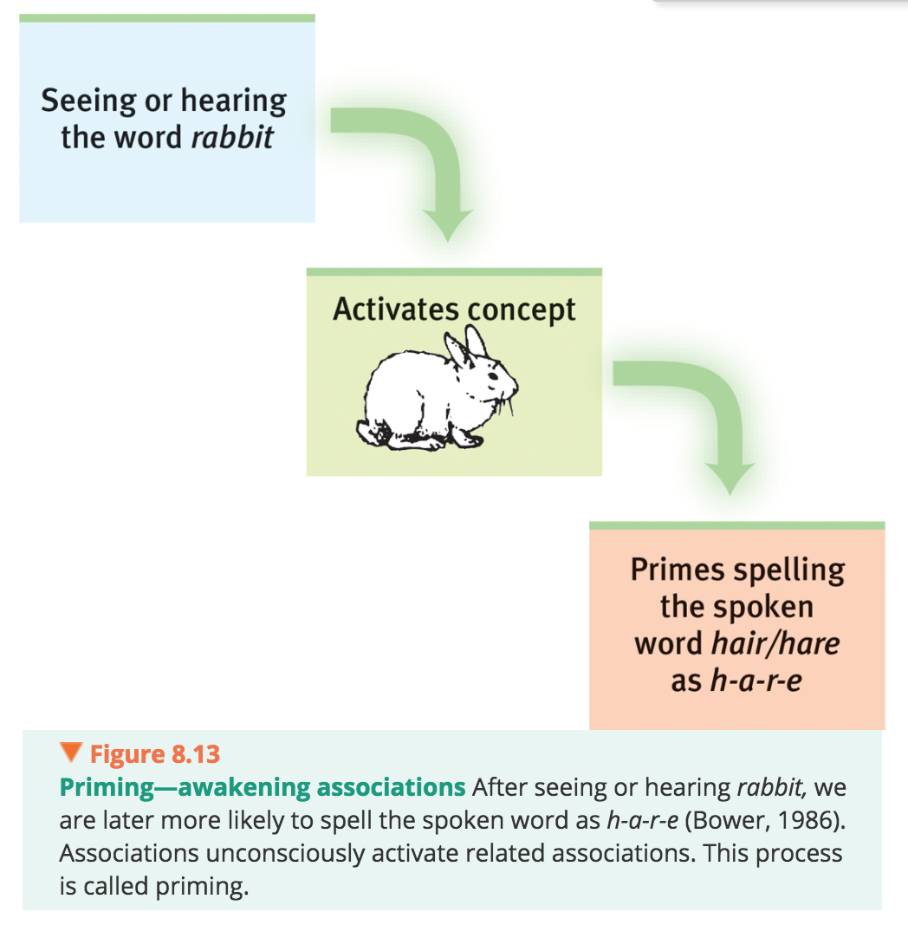
  - Ex: Participants primed with money-related words were less likely to help another person when asked
- Putting self back in the context where you experienced something can prime memory retrieval.
- By contrast, experiencing something outside the usual setting can be confusing.
- Encoding specificity principle: the idea that cues and contexts specific to a particular memory will be most effective in helping us recall it.
- In new settings, you may not have the memory cues needed Our memories depend on context, and on the cues we have associated with that context.
- Carolyn Rovee-Collier (1993) found that a familiar context could activate memories
- Infants learned that kicking would make a crib mobile move via a connecting ribbon from the ankle the infants kicked more in same crib than in a different context.
- State-dependent memory: related to context-dependent memory
  - What we learn in one state—be it drunk or sober—may be more easily recalled when we are again in that state.
  - Our mood states provide an example of memory’s state dependenceemotions that accompany good or bad events become retrieval cues
- Mood-congruent memory: the tendency to recall experiences that are consistent with one’s current good or bad mood.
- Mood effects on retrieval help explain why our moods persist; When happy, we recall happy events see the world as a happy place…prolong our good mood; depressed opposite
- Serial position effect: our tendency to recall best the last (a recency effect) and first (a primacy effect) items in a list.
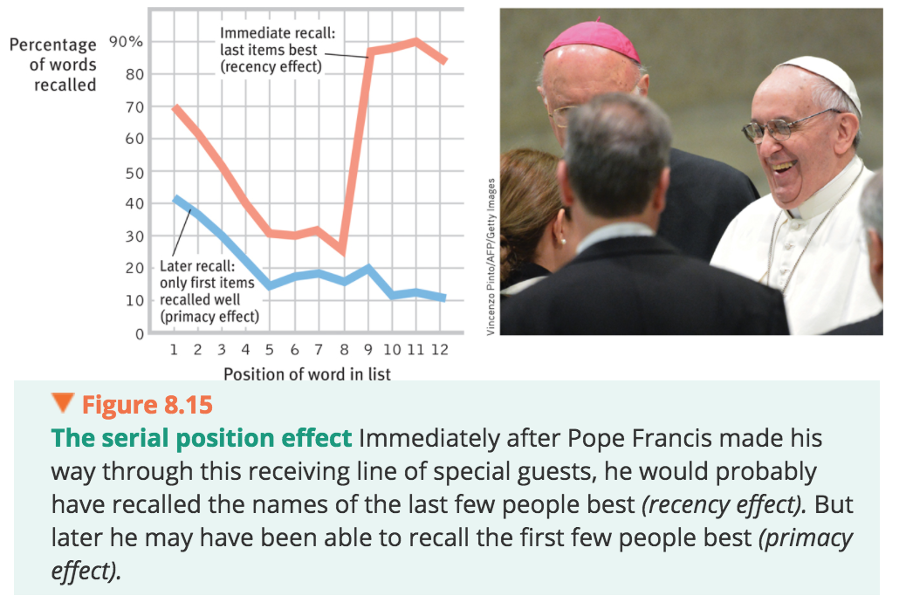

8.3 Forgetting, Memory Construction, and Improving Memory

Forgetting

8.15- Why do we forget?
- We have the ability to discard the clutter of useless or out-of-date information
- A good memory is helpful, but so is the ability to forget
- Out memory= unpredictable at times
Forgetting and the Two-Track Mind
- For some, memory loss is severe and permanent.
- “H. M.,” after removal of much of hippocampus to stop severe seizures = was unable to form new conscious memories.
- Anterograde amnesia: an inability to form new memories
  - Ability to recall past, inability to form new memories
  - Can learn nonverbal tasks Ex: finding Waldo time after time; find way to bathroom, without being able to tell you where it is classically conditioned
    - They do all these things with no awareness of having learned them
    - Confirm that we have two distinct memory systems, controlled by different parts of the brain.
  - Lose ability to form new explicit memories, but automatic processing abilities remain
    - Like Alzheimer’s patients= explicit memories are lost, but can form new implicit memories
- Retrograde amnesia: an inability to retrieve information from one’s past

REASONS WE FORGET:
Encoding Failure
- Much of what we sense we never notice, and what we fail to encode, we will never remember
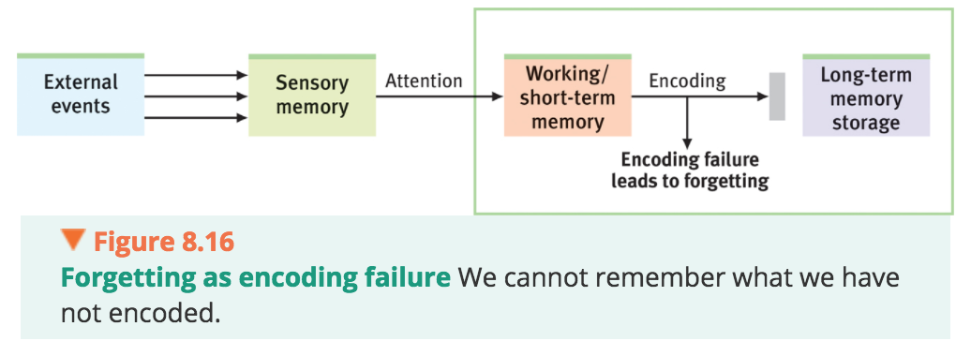
- Age can affect encoding efficiency
- The brain areas for encoding = less active in older adults
- This slower encoding helps explain age-related memory decline
- Without encoding effort, many potential memories never form; we selectively attend to few of the myriad sights and sounds continually bombarding us
Storage Decay
- Even after encoding something we later forget it.
- Ex: Harry Bahrick (1984) found people 3 years out of school had forgotten much of what they had learned; what = remembered then, still remembered forever forgetting = leveled off.
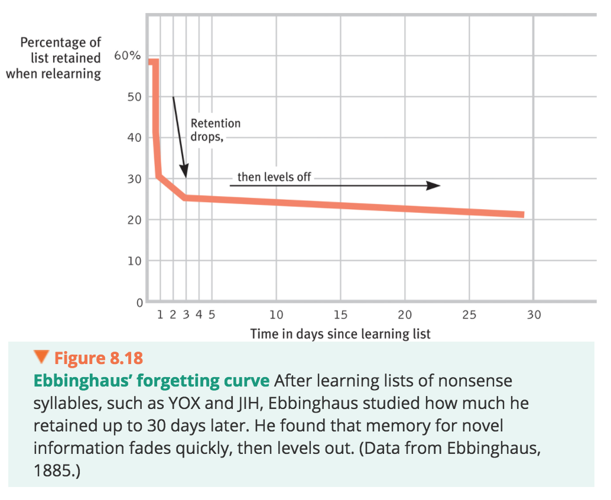
- Explanation for forgetting curves:
  - Some memories never acquired (not encoded)
  - Discarded (stored memories decay)
  - Others can’t be retrieved
Retrieval Failure
- Often, forgetting is not memories faded but memories unretrieved
- We store in long-term memory what’s important to us or what we’ve rehearsed
- But sometimes important events defy our attempts to access them
- Given retrieval cues (“It begins with an M”) helps retrieve memory
- Retrieval problems contribute to the occasional memory failures of older adults; tip-of-the-tongue forgetting
- Retrieval problems occasionally stem from interference and motivated forgetting.
Interference
- As you collect more info mental attic never fills but = cluttered.
- Ability to tune out clutter => focus=>recall information.
- Clutter winslearning and old collide:
- Proactive interference: the forward-acting disruptive effect of prior learning on the recall of new information.
- Retroactive interference: the backward-acting disruptive effect of new learning on the recall of old information.
- Information presented in the hour before sleep is protected from retroactive interference
  - John Jenkins and Karl Dallenbach (1924) discovered this forgetting occurred more rapidly after being awake and involved with other activities.
  - Forgetting is not so much a matter of the decay of old impressions and associations as it is a matter of interference, inhibition, or obliteration of the old by the new
- Old and new learning do not always compete with each other
- Previously learned information facilitates our learning of new information called positive transfer.
Motivated Forgetting
- To remember we revise it
- Why do our memories fail us memory =unreliable, self-serving historian
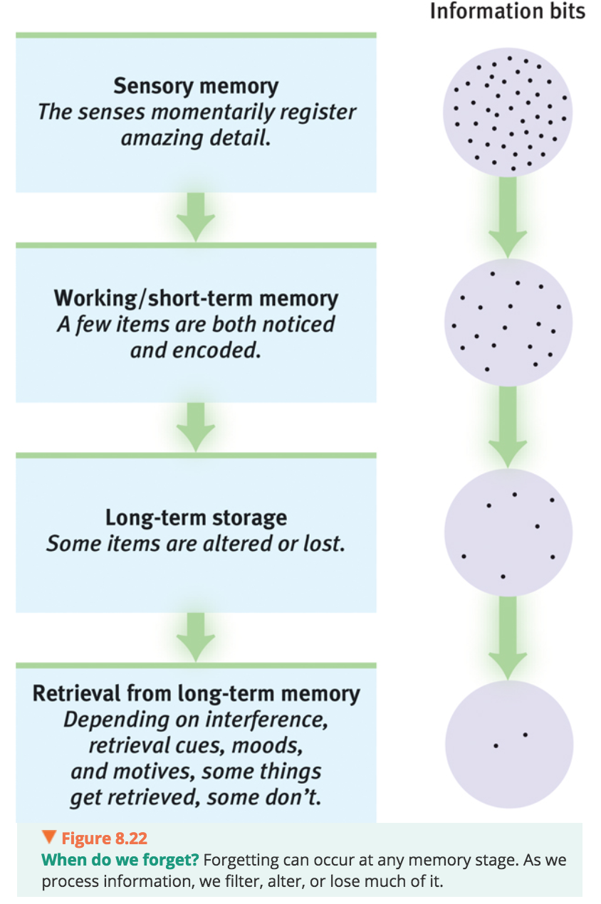
- Repression: in psychoanalytic theory, the basic defense mechanism that banishes from consciousness anxiety-arousing thoughts, feelings, and memories(Freudian)
- Believed repressed memory lingers, and can be retrieved by some later cue or during therapy.
- Repression = central to Freud’s psychoanalytic theory of personality
- People succeed in forgetting unwanted neutral information but it’s harder to forget emotional eventstraumatic experiences

Memory Construction Errors
8.16- How do misinformation, imagination, and source amnesia influence our memory construction? How do we decide whether a memory is real or false?
- Memory is not precise
- We infer past from stored information plus what we later imagined, expected, saw, and heard.
- We don’t just retrieve memories, we reweave them.
- When we “replay” a memory, we often replace the original with a slightly modified version reconsolidation
- Reconsolidation: a process in which previously stored memories, when retrieved, are potentially altered before being stored again
- LeDoux: “your memory is only as good as your last memory the fewer times you use it, the more pristine it is.”
- EX: Reconsolidation: people recall a traumatic or negative experience, then disrupt the reconsolidation of that memory with a drug or brief, painless electroconvulsive
Misinformation and Imagination Effects
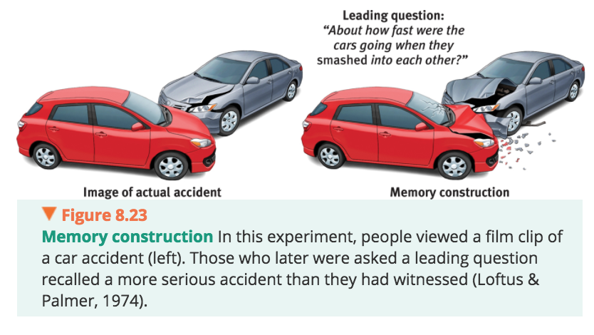
- Misinformation effect: when misleading information has corrupted one’s memory of an event.
- So powerful is the misinformation effect that it can influence later attitudes and behaviors
- Misinformation effect happens outside our awareness= impossible to sift the suggested ideas out of real memories
- Even repeatedly imagining nonexistent actions and events can create false memories
- Misinformation and imagination effects occur partly because visualizing something and actually perceiving it activate similar brain areas
- Imagined events also later seem more familiar, and familiar things seem more real. The more vividly we can imagine things, the more likely they are to become memories
Source Amnesia
- Among the frailest parts of a memory is its source.
- Source amnesia: attributing to the wrong source an event we have experienced, heard about, read about, or imagined. (Also called source misattribution.) Source amnesia, along with the misinformation effect, is at the heart of many false memories.
- Misattribution = at the heart of many false memories.
  - EX: authors think an idea came from their own creative imagination, when in fact they are unintentionally plagiarizing something they earlier read or heard.
- Source amnesia helps explain déjà vu
- Déjà vu: that eerie sense that “I’ve experienced this before.” Cues from the current situation may unconsciously trigger retrieval of an earlier experience.
  - Having familiarity with a stimulus
  - EX:Alan Brown and Elizabeth Marsh (2009) induced déjà vu in the laboratory
  - They invited participants to view symbols on a computer screen and to report whether they had ever seen them before.
  - Symbols had been subliminally flashed on the screen
  - ½ = experience déjà vu
- Feeling of familiarity temporal lobe processing, before consciously remember detailshippocampus and frontal lobe processing
  - When these functions + regions= out of sync= experience feeling of familiarity without conscious recall
Discerning True and False Memories
- Memory = reconstruction and reproduction can we tell real from unreal?
  - False memories can be persistent
- Memory construction helps explain why about 75 percent of 301 convicts exonerated by later DNA testing had been misjudged based on faulty eyewitness identification (Lilienfeld & Byron, 2013).
- How people feel today tends to be how they recall they have always felt
Children’s Eyewitness Recall
8.17-How reliable are young children’s eyewitness descriptions?
- Children often vividly make up scenarios
- Children can, however, be accurate eyewitnesses.
  - Children were especially accurate when they had not talked with involved adults prior to the interview and when their disclosure was made in a first interview with a neutral person who asked nonleading questions.

Improving Memory
8.19- How can you use memory research findings to do better in this and other courses?
Rehearse repeatedly.
- To master material, use distributed (spaced) practice.
- To learn a concept, give yourself many separate study sessions
- Take advantage little intervals
- New memories are weak; exercise them and they will strengthen
- To memorize specific facts or figures “rehearse the name or number you are trying to memorize, wait a few seconds rehearse again” The waits should be as long as possible without losing the information.”
- Reading complex material with minimal rehearsal yields little retention.
  - Rehearsal and critical reflection help more.
  - Taking lecture notes in longhand, which requires summarizing material leads to better retention than does verbatim laptop note taking
Make the material meaningful.
- Build a network of retrieval cues by taking text and class notes in your own words.
- Apply the concepts to your own life
- Form images
- Understand and organize information
- Relate the material to what you already know or have experienced.
- Mindlessly repeating someone else’s words won’t supply many retrieval cues.
Activate retrieval cues.
- Mentally re-create the situation and the mood in which your original learning occurred
Use mnemonic devices.
- Associate items with peg words to harness visual imagery skills to illustrate in your mind’s eye
- Make up a story that incorporates vivid images of the items.
- Chunk information into acronyms. Create rhythmic rhymes
Minimize interference.
- Study before sleep.
- Do not schedule back-to-back study times for topics that are likely to interfere with each other,
Sleep more.
- During sleep, the brain reorganizes and consolidates information for long-term memory.
- Sleep deprivation disrupts this process.
- Even 10 minutes of waking rest enhances memory of what we have read
- So, after a period of hard study, perhaps just sit or lie down for a few minutes before tackling the next subject.
Test your own knowledge, both to rehearse it and to find out what you don’t yet know
- Don’t be lulled into overconfidence by your ability to recognize information.
- Take practice tests

