- Linear functions are polynomials with a degree of 1.
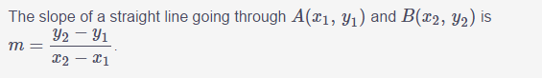
- When the slope of a line is positive, we say the line is increasing, which means it goes up from left to right.
- When the slope of a line is negative, we say the line is decreasing, which means it goes down from left to right.
- A horizontal line has a slope of 0.
- The slope of a vertical line is undefined.
- $y=m\left(x-x1\right)+y1$
- Quadratic functions are polynomials with a degree of 2. They form parabolas that open upwards or downwards.
- A parabola that opens upwards changes from decreasing to increasing. The change occurs at the vertex.
- A parabola that opens downwards changes from increasing to decreasing. Once again, the change occurs at the vertex.

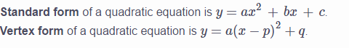
Change to vertex form
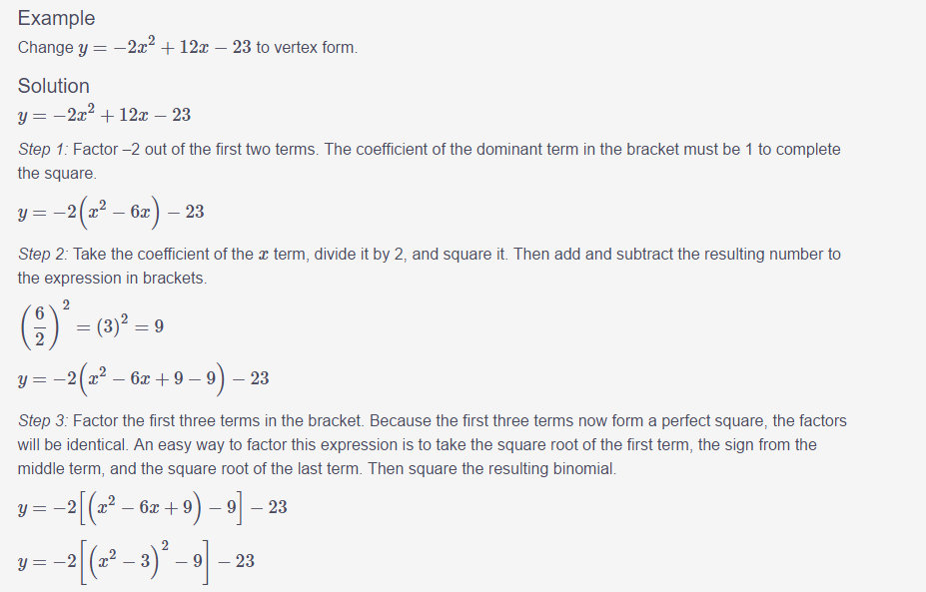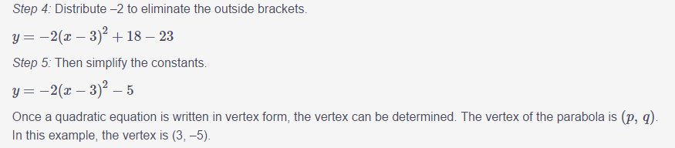
Factoring can be used to find the roots of a function.
These are the four most usual types of factoring:
- common factoring
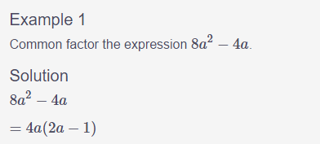
- difference of squares
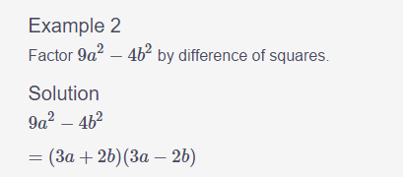
- simple trinomial factoring
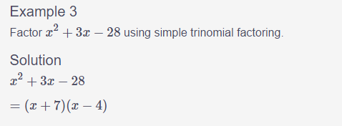
- complex trinomial factoring
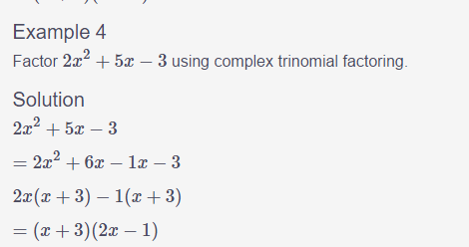
QUADRATIC FORMULA
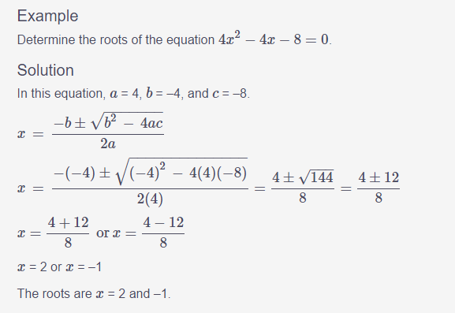

The factor theorem
The factor theorem is used to find the roots of polynomial functions with a degree of 3 or higher, such as cubic and quartic functions.
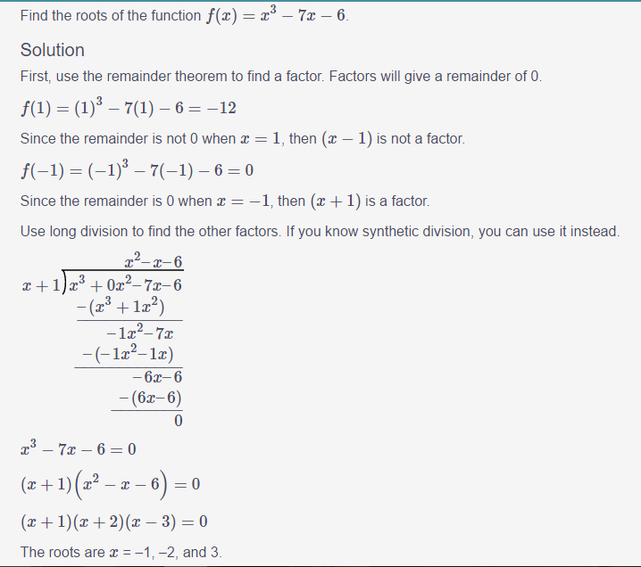

The method of substitution
The method of substitution can be used to find the point(s) where two graphs intersect.
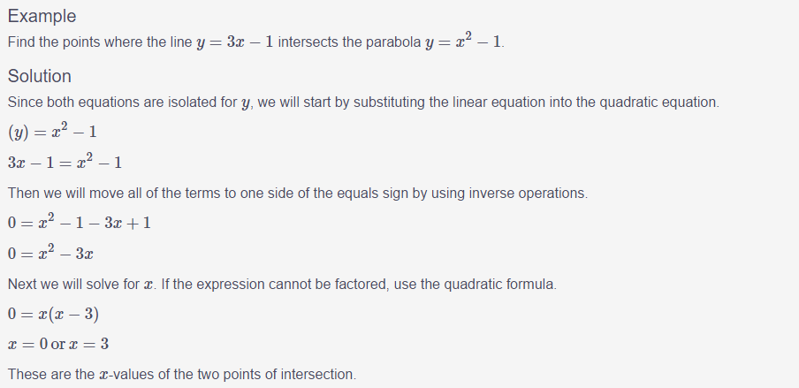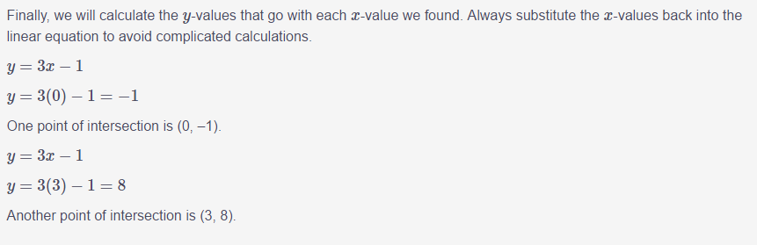
AVERAGE RATE OF CHANGE
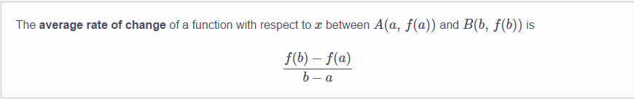
AVERAGE RATE OF CHANGE AND SECANT LINES
A secant line on a curve is a straight line that intersects the curve at two points.
- When does the stone hit the water? Round all non-terminating answers to two decimal places.
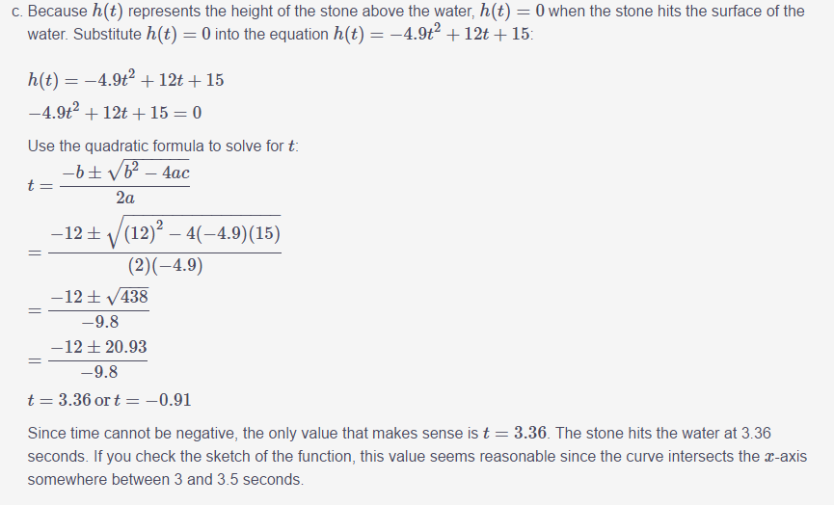
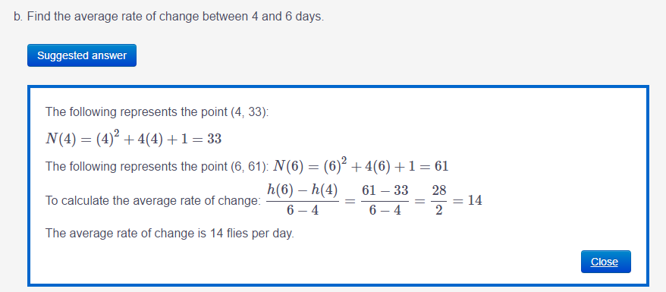
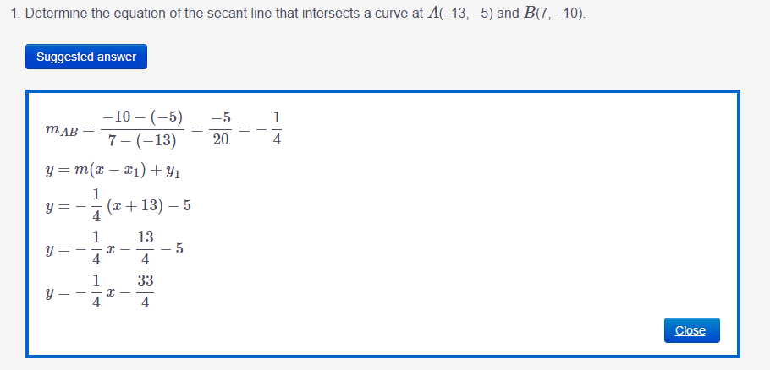
INSTANTANEOUS RATE OF CHANGE
The instantaneous rate of change is the rate of change on a continuous smooth function at a specific point on the function.
A tangent line to a curve is a straight line that touches the curve at one point.
SECANT METHOD:
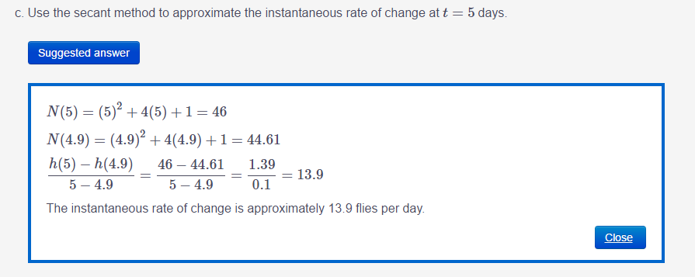
WHEN BALL HITS THE GROUND:
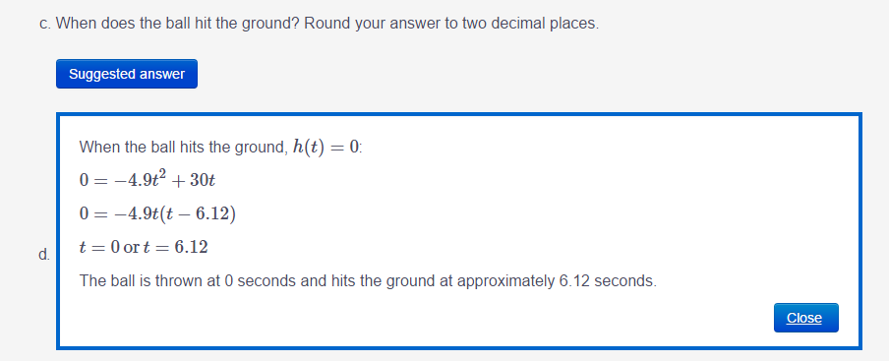
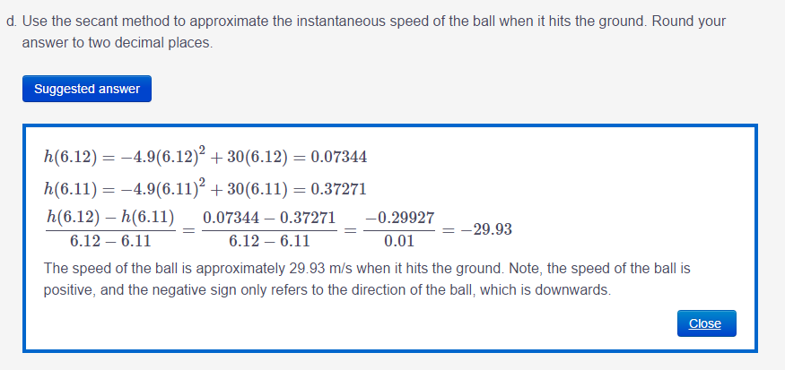
HORIZONTAL LIMITS
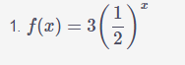
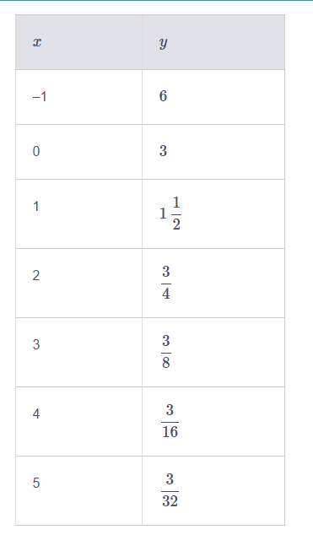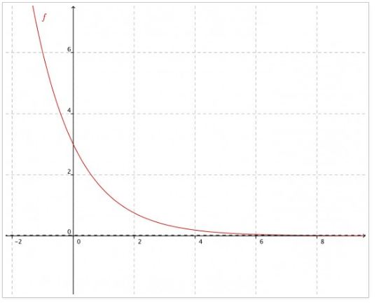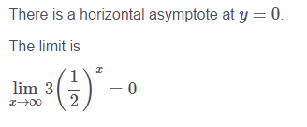
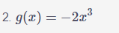
There is no limit for this function.
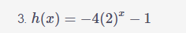
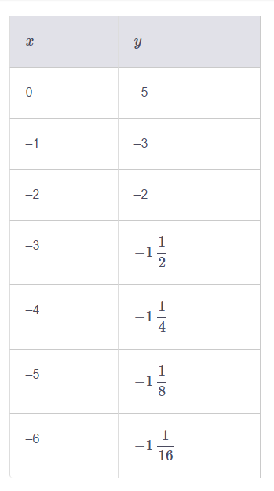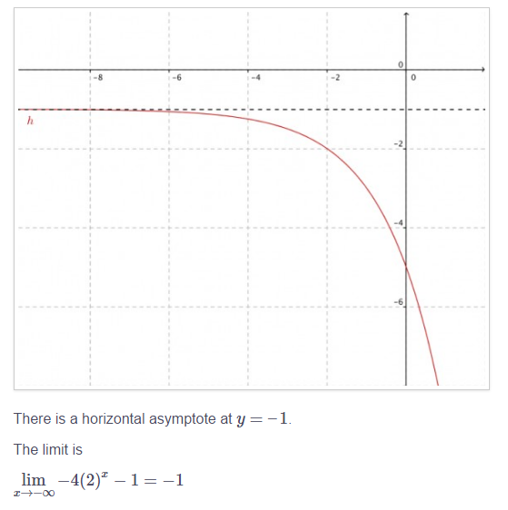
- VERTICAL ASYMPTOTE
- If a limit results in the same value when we approach it from the right-hand or left-hand side of the graph, the limit exists. If a limit results in a different value when we approach it from each side, the limit does not exist.
- For the rational function we just examined, the limit is positive infinity when we approach it from the right side and negative infinity when we approach it from the left side. For this function, the limit does not exist.
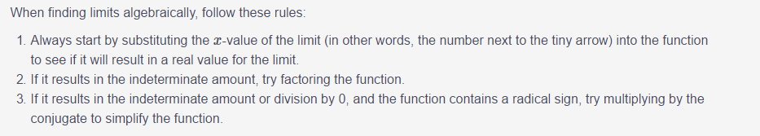
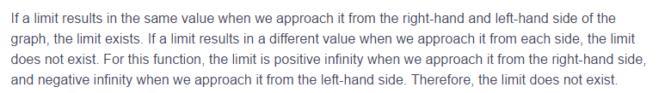
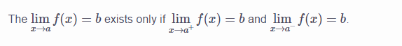

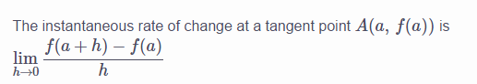

Maximum and minimum points
A local maximum is a point on a graph where the direction changes from increasing (going up from left to right) to decreasing (going down from left to right).
It is called a local maximum because it is not necessarily the highest point on the graph, but it is a point where the direction changes from increasing to decreasing.
On the other hand, a global maximum (also called an absolute maximum) is the highest point on a graph, and can occur as a local maximum point or as an end point on the graph.
A local minimum is a point on a graph where the direction changes from decreasing (going down from left to right) to increasing (going up from left to right).

Example 1 TANGENTS ALONG A CURVE

Let’s calculate the slopes of several tangents along the following curve.
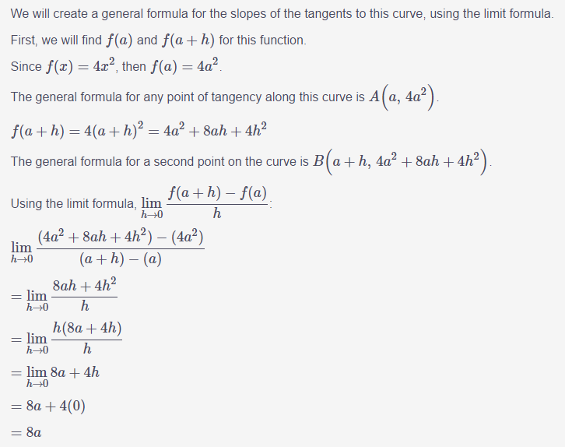

To find the inflection points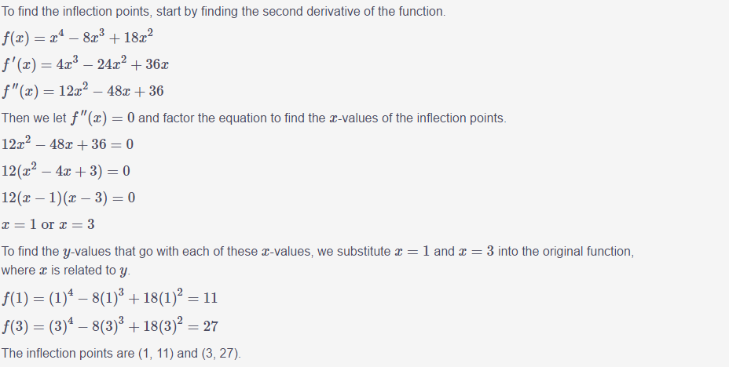
To find the intervals of concavity, we choose test points on each side of the inflection points and substitute them into the second derivative. When f′′(x) is positive, the function f(x) is concave up, and when f′′(x) is negative, f(x) is concave down.

To find x and y intercept for cubic fun
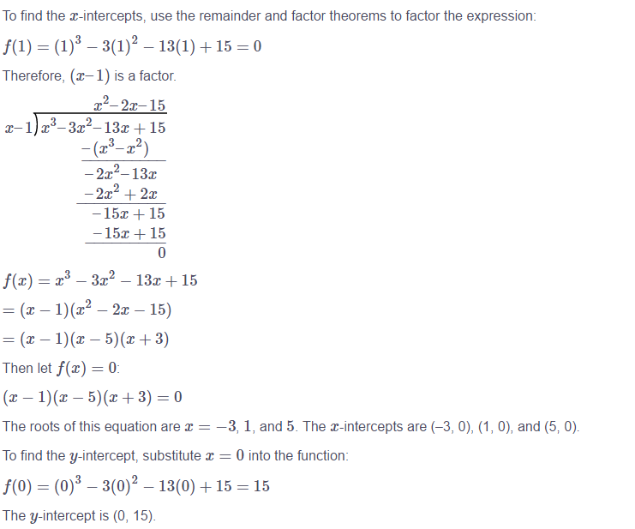
To find max and min points for cubic fun
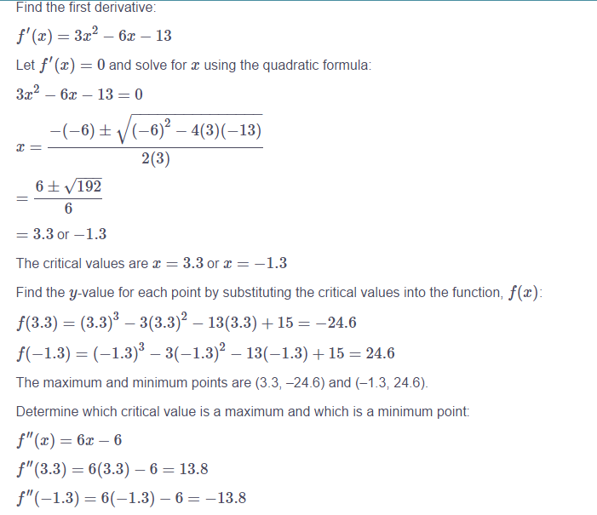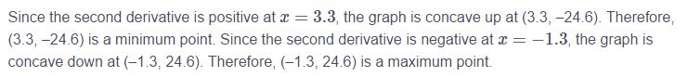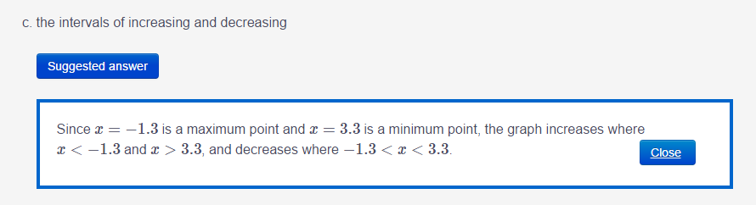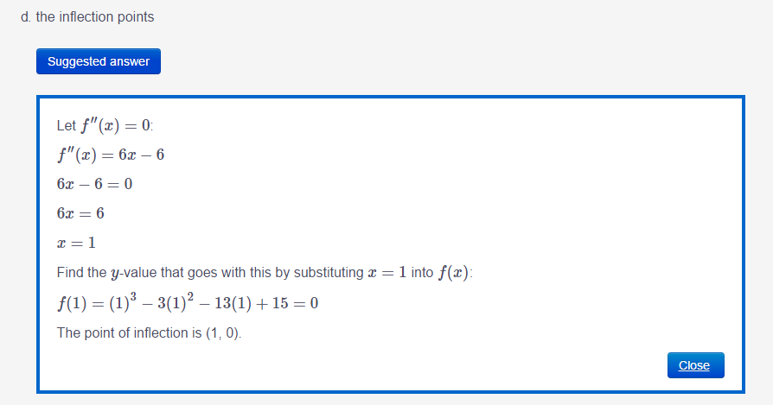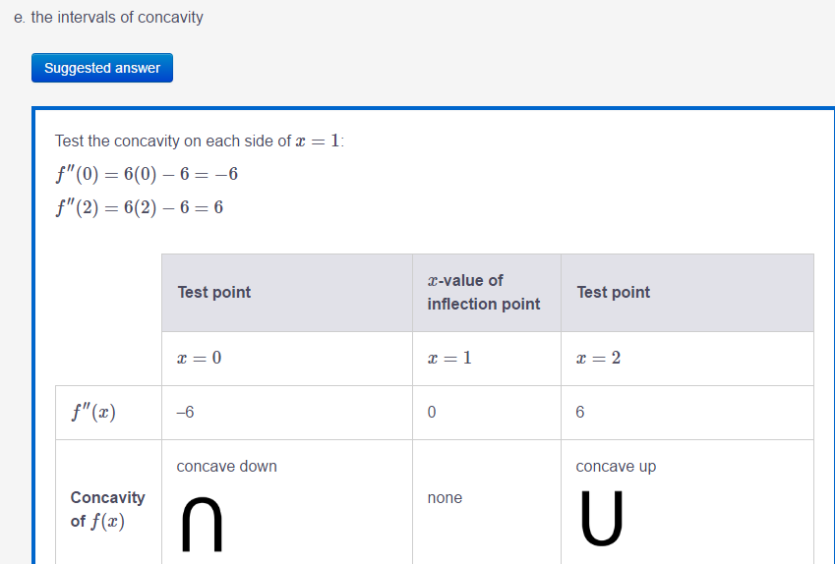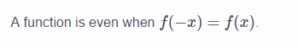

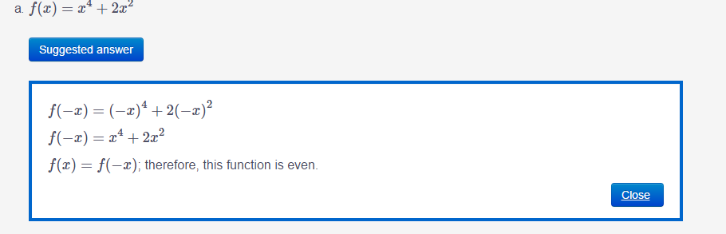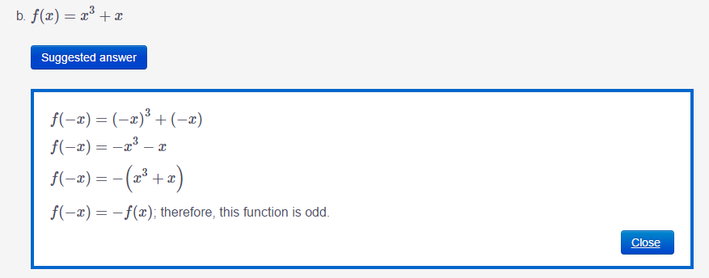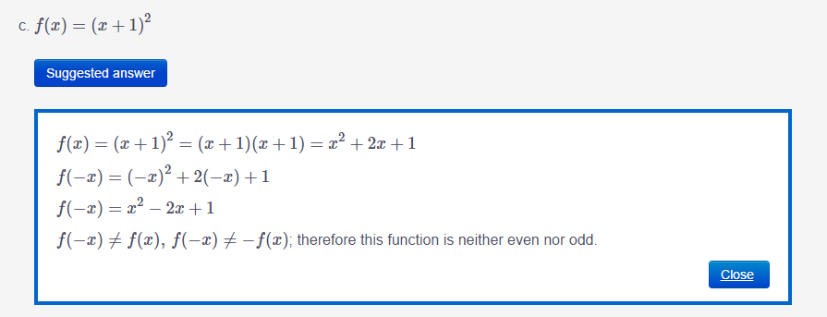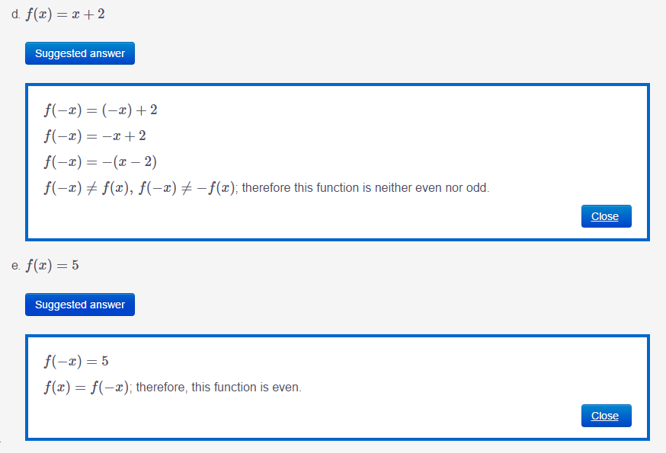

To find the equation of a polynomail fun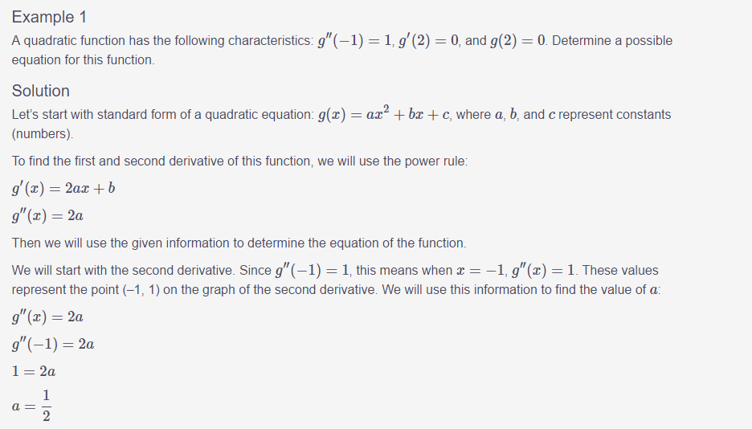 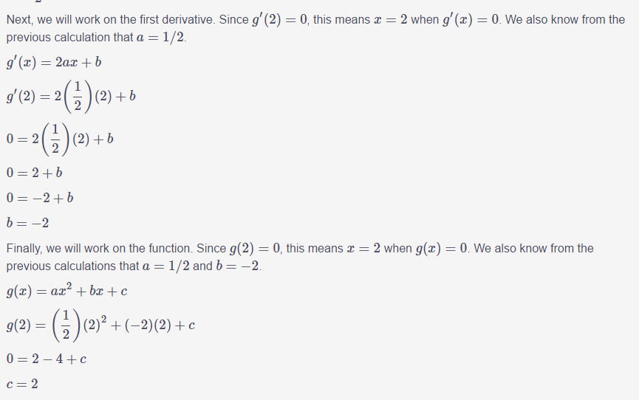 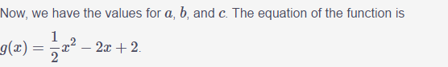
To find the equation of a polynomail fun using a graph
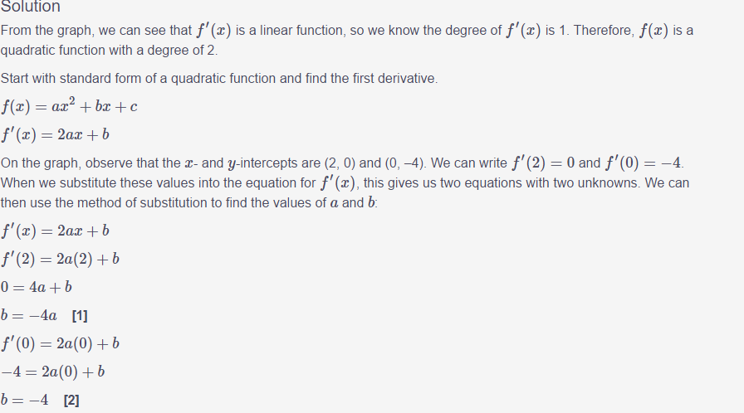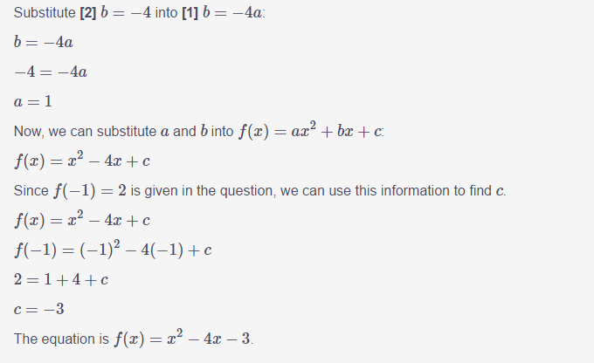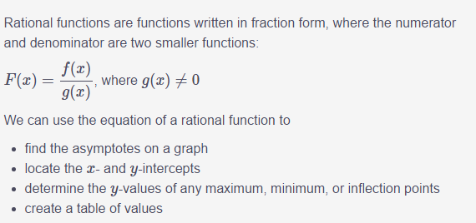

Horizontal asymptotes
 

