PSY3128 The Psychology of Aging May 2nd

What is aging?
Aging begins at birth while senescence is the final stages of the lifespan.
It's better to say “aged” and “older adult” rather than “coot, codger, elderly, senior”.

Definitions in aging:
- Chronological: No basis in biology, just the number. 65 is selected for retirement.
- Biological age: aging of different organ systems (affects people differently).
- Psychological: how I think, act and feel.
- Social: How/where do we fit in with other ppl. Social roles occupied. Age-related beginning (grandparenthood at 30) or cessation (athletic retirement at 30) of roles.
Functional age offers an advantages over chronological age
Biopsychosocial model → they all interplay. Functional aging. Gerontology
- Bio → functioning of organ systems. Physiological factors, genetics. Heart rate
- Psych → functioning of psychological tests. Reaction time, memory, intelligence, etc.
- Social → social context, history, culture. Parental status, work role, retirement status.

Four Principle Questions/Implications
(1) Changes are continuous over the lifespan. Individuals remain the “same” even though they change. Related across domains. Do ppl go through the same stages? In the same order? “Younger mind, older body” ← dynamic influences. Young-old = 65-74, old-old = 75-84, oldest-old = 85+. Centenarians (100-109). Supercentenarians (110+).
Continuity principle: changes that ppl experience in later adulthood build on the experiences they had in earlier years. Later years can’t be isolated from previous ones. If you’re hard on your body in your early years, you prob have negative changes as you get older (cumulative changes).

(2) Lifestyle choices -- Only survivors grow old. Survivors avoid these: LORDS.
L - being physically lazy. O - being overweight. R - risky behavior (drinking+driving),
D - dietary choices, such as high fat consumption. S - smoking.
Survivor principle: ppl who live to old age managed to outlive the many threats that could have caused their deaths at earlier ages (non-random death).

(3) Individuality matters. The volume of the hippocampus (memory) in ppl in their 70s may be the same as that of ppl in their 20s. Depends on the individual. Individuality states that as people age, they become more different from each other. This divergence occurs in physical functioning, psychological performance, relationships, interest in work, economic security, and personality.

(4) Primary aging → normal, age-related changes, which is diff than disease.
Secondary aging → disease related impairment.
Tertiary aging → rapid declining (psych+bio) before death
Optimal aging → improvements to functioning
Why Study Aging?
- The main reason we study aging are the numbers. There are way more older adults in the world than there used to be and will continue this pattern. Changes in life expectancy account for increases in 65+. Life expectancy vs lifespan.
Life expectancy: average length of life for ppl born in a particular time interval.
Lifespan: max age for a given species.

Health adjusted life expectancy: the number of years a person could expect to live in good health if current mortality and morbidity rates persist. We aim for higher life expectancy or compress morbidity.

- Money; economy, healthcare, immigration, education (check textbook)
- Value to society: quality of life; understanding psychological, social, biological changes that occur with age can lead to better outcomes in aging
Older adults have much to offer: Can continue to contribute to society through paid work • Play an important role in caregiving (e.g., grandchildren), etc.
We need to “re-engineer” the world so that older people can be participants, not dependants

PSY3128 Chapter 2 - Models and Theories May 7th
Models of Development: Nature vs Nurture in Adulthood

Lifespan perspective = emphasizes continuity of development from childhood to old age
Contextual influence = Life span change is a function of nature and nurture
Developmental science = Need to look at multiple factors in development

Nature vs Nurture → interactionist. Models of individual/environment interactions:
- Niche-picking; environment and interaction b/w you and your niche, which causes a reciprocity. Children literally pick their “niche”, area they develop their talents and abilities. Ppl choose the environment that compliment themselves. If genetically you’re a natural dancer, as a kid you’ll see a dancer and will want to enroll in ballet lessons. There, the kid found her niche “dance” and will find friends and environment that fits her niche. Genes → environment.
- Reciprocity principle: ppl influence + are influenced by events in their lives.
Psychological Models:
These theories are rare, not supported by the data, vague/imprecise, too difficult to falsify, too broad. So, we work piecemeal, domain-by-domain.
Erikson’s Psychosocial Theory of Development
At certain points in life, a person’s bio, psycho and social chanegs come together to influence our personality. Each stage is described as a “crisis” - turning point.
Epigenetic principle: Each stage unfolds from the previous stage in a predestined order, but people may experience a psych issue at an age other than the one shown where it crosses the diagonal → Erikson’s psychosocial theory graph on ppt. As you get older, you realize who you were in your life.
Criticism: not everyone goes through these stages, or shows that they have. 1950s perspective is hard to test (don’t think this stuff is real).

Terror Management Theory (TMT): we fear death so we distance ourselves of older adults who remind us of our mortality. In the back of our minds, it's something that always influences us and our behaviour. May be disrespectful to ppl who are close to death cause deep deep rooted fear of death itself. Do we get more or less anxious of death? TMT sees both responses so it sees how to measure it.

Biological Models:
Psychs turn to this to see what happens to old ppl’s behavior as they age.
Programmed Aging Theories: Propose that aging and death are built into the hard-wiring of all organisms and therefore are part of the genetic code. So ppl have “aging genes” that count the years off maturity.
- Species live to different maximum ages (life span) with diff species.
- “Good genes gone bad” theory: evolution has selected for species that are vigorous through the period of optimal sexual reproduction and then are less important once that period is passed.
- Replicative Senescence: the loss of the ability of cells to reproduce.
- Telomere theory: each cell replication reduces the length of telomeres until the chromosome’s tips are no longer protected.

Random error theories of aging: accumulation of errors in the process of info flow from genes to proteins. The errors create faulty proteins that do not function normally, resulting in impaired cell function and death.
Cross-linking: collagen molecules form cross-links. Free-radical: cause destructive changes in cells. Error catastrophe: mutations lead to deleterious changes.
Plasticity = course of development may be altered depending on nature of individual’s interactions with environment.
PSY3128 Chapter 3 - Research Methods May 9th
**WONT FOCUS TOO MUCH ON THIS**
Anecdotes and Folk Wisdom**
Experimental vs. Correlational Research
Experimental research: We manipulate a variable and measure its effect on another variable.
Correlational research: We attempt not to influence any variables, and simply measure the relationship between two things.

Experimental Designs
Experimental Method:
- Most direct way to test a hypothesis about a cause-effect relationship between variables
- Experimenter controls one variable: Independent – Hypothesized to cause effect on another variable
- The other is observed and measured: Dependent – Usually behaviour, hypothesized to be affected
- All other variables held constant: Control
- Make sure there is ONLY ONE THING DIFFERENT (your variable of interest) between experimental and control groups
- Confound: Another variable you didn’t notice or control that provides an alternative explanation for your findings

Random assignment
• Randomly assign treatments -Blinding
• Minimise expectancy by eliminating knowledge about experimental conditions
• Single vs double vs triple blind studies

Problem: Age is not a true independent variable
Studies on aging use quasi-experimental designs and compare groups on predetermined characteristics (age)
Simple correlational designs Correlation (“r”) Shows extent of relationship between two variables Can be negative or positive Strength is indicated by how close it is to 1 (or -1). No ability to detect causality.
As hostility increases so does blood pressure, but we can’t conclude one causes the other. There may also be a third, unmeasured variable, influence this relationship.
“Simpson’s paradox” -A certain pattern or trend looks different when you break the data down further. Suppose: X: Age Y: Happiness Z: Sex/gender (men vs. women)
Multiple correlational designs can make up for
shortcomings of simple correlational designs

Control for confounds other than age Other variables can be added into analysis that the research suspects may be linked with age
Allow investigations of “causality” Paths can actually be drawn from one variable to another, and their significance tested
Provide ways to examine change over time Can use statistical methods that model changes in growth
Cross-sectional research Cross-sectional research involves testing 2 or more groups of participants at the same point in time e.g., 20 older and 20 younger adults An attempt is made to match groups for all variables except age
Cohort vs. age effects Cohort = age group you belong to -Some differences between older and younger adults are due to changes with age. These are age effects. -Some are due to differences between birth cohorts. These are cohort effects.
Cohort effects – factors that affect people during a particular time period (e.g., war)
LONGITUDINAL DESIGNS Wiley Canada 29 Let’s follow a person across his/her life If you were born in 1930: -Great Depression (baby, child) -World War II (child) -1960s: beginning of social change (middle aged) -Computer/internet revolution (older) If you were born in 1960…
How long is a longitudinal study?
Selective attrition – when ceasing to participate in a longitudinal study indicates that these participants are not necessarily representative of the sample they were supposed to represent Terminal decline - individuals gradually lose cognitive abilities as they draw closer to death
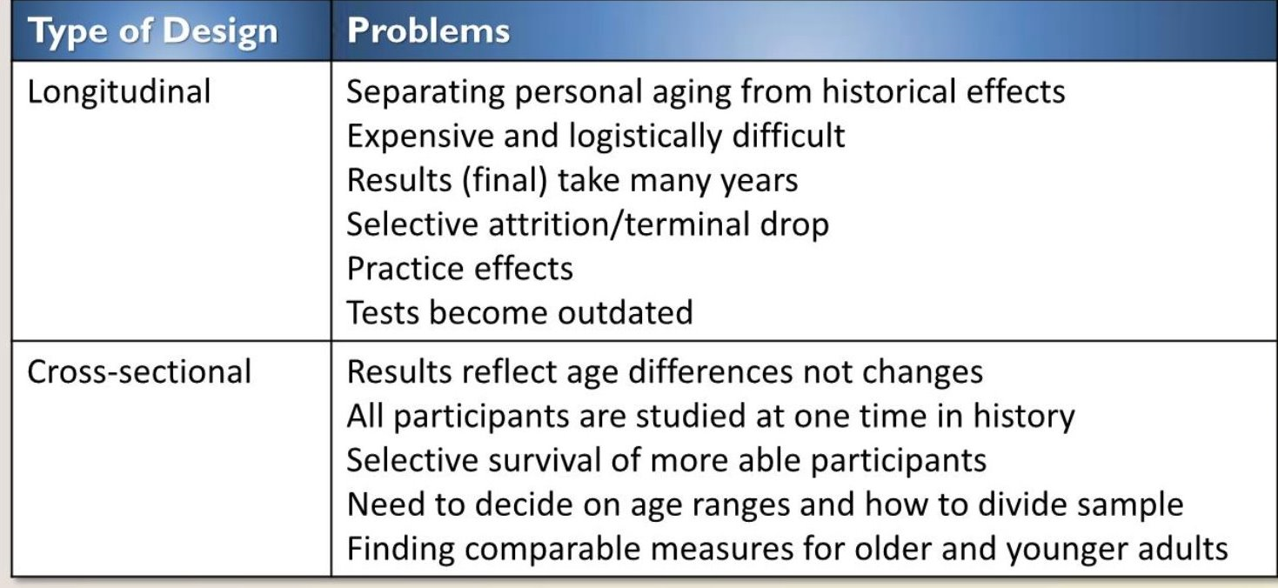

The most efficient design = cross-sectional + longitudinal. Combining data from all three provides estimates of the effects of age, cohort, and time of measurement

GENERAL CONSIDERATIONS
Sampling: Not just survivors -You are 80 years old -You see an ad inviting you to visit UO campus -2 hours of rigorous cognitive and physical testing -Electrodes on head -(Please come back every 6 months)
Psychometric criteria
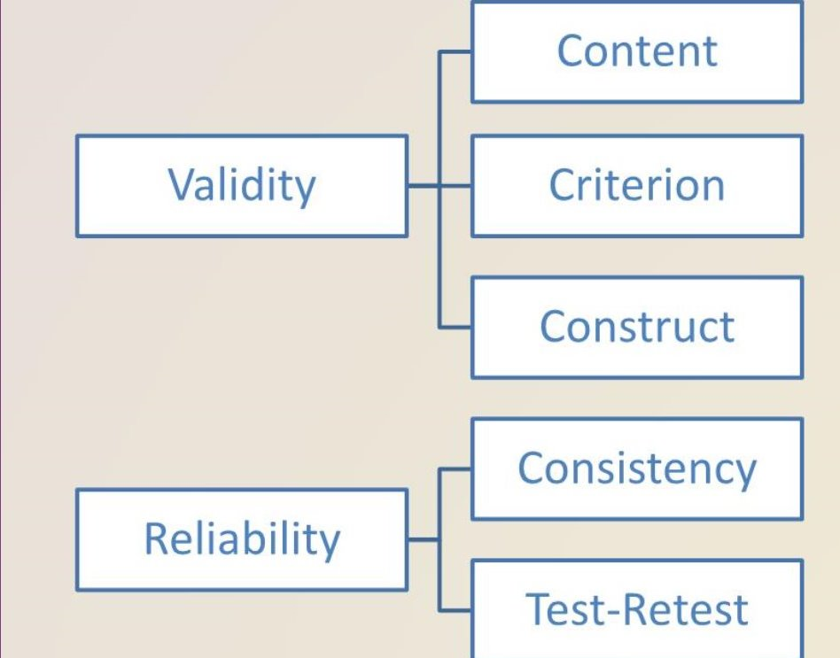
Age-ism -Might lead to: 1.Biased testing or scoring? 2. Stereotype Threat -Might the idea that aging is supposed to involve certain (usually negative) factors create a self-fulfilling prophecy? -Distraction? -Stress? -Threat to validity

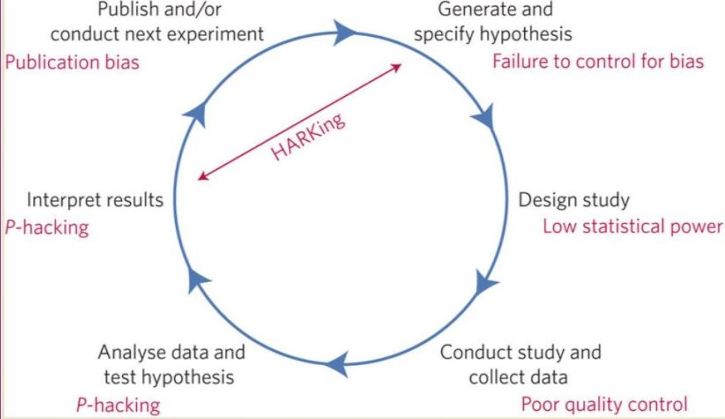

PSY3128 Chapter 4 - Physical Changes
Brain and heart interaction/link between the two. (first 12-pages of ch4 not needed)
Brain, heart, and sensation/perception
The Nervous System
- Basic Neuroanatomy - research based. Can look at brain with diff levels of analysis. LH-RH differences. Anterior (front), posterior (back), lateral (outer), medial (center).
- Neurons/Synapses: cellular/molecular level. Neurons fires action potential. Dendrites receive the messages, into the soma (body/nucleus), then axons send messages through the synapses.
- White/Grey Matter:
Grey matter - in the brain/spinal cord made up of cell bodies.
White matter - made up of nerve fibres forming tracts

Brain Imaging Techniques
EEG – scans electrical activity in brain
CAT or CT – scanning a cross-sectional slice of the brain from any angle
MRI – scanning brain using radio waves; based on water content of various tissues
fMRI – MRI provides a look at changes in the brain over the course of a mental activity
PET scan – provides a brain scan using radioactive compounds as they pass through the brain ← most versatile

Structural Changes with Age
Lower volumes of grey matter resulting from reduced synaptic densities
Some regions are more affected than others. e.g., prefrontal cortex, medial temporal structures.
MRIs → with longitudinal studies, not losing neurons but synapses are simplified, neurons themselves are not dying (normal aging brain)
Anterior vs Posterior: orbitofrontal not as affected in aging, but more apparent in dorsolateral (in prefrontal cortex)

Volume Changes by Region
Cross-sectional data from ages 20-85.
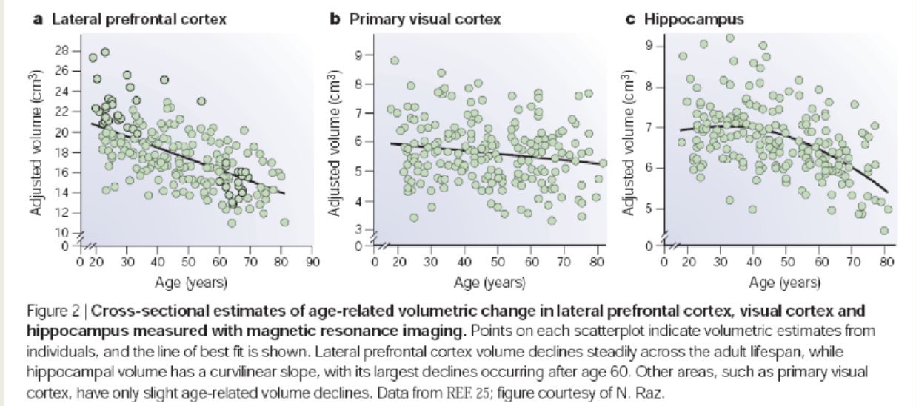
A- prefrontal cortex: ↓volume as we age (-ve r, slow and steady)
B- visual cortex: less affected by age
C- hippocampus: more clear change with age.
Frontostrial Circuitry
Neurotransmitters: decrease in neurotransmitters cause ↓connectivity b/w frontal regions and basal ganglia which = ↓dopamine (dopamine pathways blocked). So there’s a huge decline in cognition with age.

Correlations with Cognition
Prefrontal cortex volume correlates with:
- Measures of fluid intelligence.
- Perseverative errors on the Wisconsin Card Sorting Task (how much tissue → volume) WCST.

Intelligence
- Fluid Intelligence: think and reason abstractly/solve probs. Think on your feet (↓)
- Crystallized Intelligence: skills, knowledge, experience (↑)

Changes in White Matter
Older adults have less fluid intelligence but higher crystallized intelligence. Older adults tend to show decreased white matter integrity compared with younger adults, with the greatest age-related declines occurring in anterior cortex.
White matter abnormalities are associated with poor performance in speed, executive functioning, immediate/delayed memory.
Age-related decreases in frontal white matter coherence are correlated with decreases in processing speed and reasoning abilities.

Individuality Matters
Volume of the hippocampus in people in their 70s may be the same as those in 20s. Great memory. How do we define normal vs abnormal aging? We figure out the mean, SD and find where they fall in their age groups. Greater than 2SD we can say their behavior is abnormal (white matter). A disease is starting or picking up. Handful of brain predictors.

Normal Aging
All things that change, need to find question that involves all factors. Elephant thing: poem, each part of the elephant is described as something different, that’s how the brain is seen right now. The blind men thing.

Sensation and Perception
General effects of aging: a decline in acuity in all senses.
1. Visual Changes - Visual acuity declines because of:
- changes in the visual system that happen bc of normal aging,
- or disorders/cohort that increase prevalence with age; eg, cataract, macular degeneration
With Aging:
- Lens of the eye yellows, decreased ability to focus
- Pupil doesn’t dilate as well as changes in lighting
- Retina/cortex less able to process visual info
- Vision in dim light suffers, decrease in rods (peripheral vision) so driving becomes dangerous.

2. Auditory Changes - auditory acuity declines because of:
- Normal changes with age (less flexibility in parts of auditory system)
- Increased risk of disorders that result in hearing loss (eg tinnitus)
- Cochlea: decrease in cochlear cells triggered by HF stimuli located in front of cochlea, the area that receives the most stimulation by noise waves generally. Hearing loss is more severe at higher frequencies

3. Presbycusis and Speech Perception
- Decline in auditory acuity results in impaired language comprehension in many older adults
- Reduced high-frequency auditory acuity means some sounds are affected more than others.
- Spectrogram of “Sunday”: The ‘s’ sound has more energy at higher frequency than other sounds, so it’s harder to discriminate words with higher frequency.
“Discriminating”: uniquely selecting a single word as input. Can this be exploited?

4. Dementia
- Effected with even greater sensory/perceptual decline. Is the fact that hearing and vision are deteriorating contributing to dementia? ← less cognitive/social stimulation. Hearing test may prevent dementia.

At what levels do you think gradual reductions in sensory impact older adults?
Cognitive, Psychosocial

PSY3128 Sleep and Aging May 16th
*DOESN’T MATTER*
Stewart Fogel Lecture - Sleep and Aging *Review*
Sleep Stages ← defining features of sleep
Scalp recorded EEG in humans shows us waves; alpha, delta, theta. Sleep spindles + k-complex. We transition through all the stages of sleep. Diff sleep waves throughout each sleep stage.

Awake → Alpha waves.
NREM - Non-Rapid Eye Movement
- Stage 1 → Sleep onset, theta sleep. Some alpha, some theta, some slowing of EEG. < 50% of alpha, its stage 1.
- Stage 2 → Sleep spindles; short burst of activity that last about a second that oscillate 12-16 Hz. K-complex in this stage. These two mark the onset of stage 2.
- Stage 3 → Dreams. SWS. 0-4Hz waves, large, in amplitude, synchronized. Delta waves. Difficult to wake someone up in this stage. Massive SWS in adolescence.
- REM sleep → paradoxical sleep. EEG resembles wake EEG.
Hypnogram -- Sleep Cycles (sleep architecture graph). Sleep is measured using EEG. 10-20 system.

Ontogeny of sleep:
- Newborns and toddlers: conception until birth is mainly REM sleep for neuroplasticity to occur. REM imp for plasticity later on in life also. As a 1 year old, should get 13 hours of REM. 3 types of newborn sleep:
  - Quiet sleep (QS, like SWS)
  - Active sleep (AS, REM)
  - Intermediate sleep (IS)
QS&AS alternate in 50-60 mins cycle rather than 90 mins. Two types of wakes also
- Quiet wake
- Active wake
Sleep makes up to 16-18 hrs of a 24 hr day. Sleep-wake cycle is 3-4 hours (not 24hr).

1. Toddlers: AS becomes REMs after about 12 weeks. TST drops to 14-15 hrs by 16 weeks and 10-12 hrs between 3-5 yrs.
Fall into SWS (N3) quickly, within 10 mins. Quick sleep onset. Naps get shorter, disappear at 3 yrs.
2. Adolescents: need 8.5 to 9.25 hrs of sleep but they only get 6-7 hrs = chronic sleep debt. Chronically sleep deprived. Never catch up, messes up sleep rhythm if slept in.
Most teens are evening types but as you get older you tend to wake up earlier. Less SWS than children but a lot of huge delta waves. Difficulty falling asleep + naps reappear. Cycles are 90 to 110 mins. Not enough sleep is related to suicidal tendencies.
3. Adults: 90 to 110 mins. Light sleep 55%, SWS 20%. Short vs long sleepers.
4. Senors: need for sleep goes down. Weak bladder. Sleep is fragmented. 50% sensors nap. Longer SOL observed. More nocturnal awakenings + longer. Less TST. Shorter first NREM-REM cycle.
Increase in light sleep, less + degradation of sleep spindles. Drastic reduction in SWS. reduction and disorganization of REM sleep.

Ontogenesis of Sleep
Sleep goes from fragmentation to consolidation to fragmentation again. TST↓. Proper sleep hygiene maintains youth.

Sleep and Memory
Forming new memories:
Encoding = learning something new. Then that newly formed memory trace goes through the process of → consolidating. The memory is strengthened. Then you can → recall what you learned.
Procedural memory; the how of memory, motor skills. Sequences of movements. Acc to a study, your performance gets faster over time. Info is consolidated even if you just stayed awake. But if you sleep during the retention interval, your performance is a lot faster (offline gains through sleep).
Use MRI to test. Do the activity, sleep/don’t sleep/interrupt sleep, then retest, see the observation.
Younger subjects < older subjects in sleep fragmentation. Older subjects wake up more often in the latter part of the night. Older subs are able to learn memory tasks as fast as younger subjects, but doing it is slower than younger subjects. Older subs lose the consolidation.
Brain structure -- grey matter, allows brain activity to matter. As we get older we have less grey matter. Are the changes related to sleep spindles? Cerebellum and hippocampus. Procedural learning involves hippocampus bc it involves spatial matter. Sleep spindles = circuit to hippocampus. Relationship disintegrates over time.

Sleep and dementia; sleep can identify early markers in dementia. Sleep is the first signifier. Things won't be optimal with sleep deprivation.

PSY3128 Part II: Cognition

- What cognitive changes take place in normal aging?
- What are the cognitive changes that take place in dementia?
- Do ppl cross a line b/w normal changes and more serious ones?

Cognitive aging does not mean universal decline. Some cognitive processes appear to decline in aging. Others remain relatively intact/improve. Our challenges is to figure out what changes, in whom, where, when how, why. What age exactly do we start to decline and what’s the line between normal vs abnormal aging.

Does everything just get worse with age? When do you start to decline? Acc to a cross-sectional study, diff age groups were measured. Working memory separate from ST memory test separate from LT memory tests, etc…
Take digits 2197 and tell me then in descending order, thats working memory, hold onto them and work to say them backwards. Short term memory is just saying them again. LT memory is waiting a while and having interruptions to say them. Speed of processing is how long it takes you to do it.
Exception to the rule ⇒ verbal knowledge. Ppl in their 70s do better than 20s (scrabble).

PSY3128 Cognitive Aging Con’t May 23rd
1. What are the cognitive changes that take place in normal aging?
- What did Donald Hebb notice in himself?
2. What are the cognitive changes that take place in dementia?

What are the differences between older and younger adult.
Hebb (on himself, n = 1)
Aging does not lead to cognitive decline. Vocab is greater in older adult than younger people. Memory retrieval is worse. Cognitive aging can start in one’s 20s.
Memory retrieval; failing to remember that he made a little note in his journal.
Language; word finding/TOT in speaking and writing
Persistence of irrelevant thoughts; found it hard to purposely not think about something
Motivation; diminished drive for intellectual work, maybe bc of declined mental capacity?
24 is the inflection point, that’s where their response time decreased playing starcraft.

Slide 12 shows looking at stuff vs doing stuff in a video game; Looking-Doing Latency. So it’s seeing how fast we do stuff for ex, but aging just physically makes you slower. What if the older adult is just careful and that’s why they’re slower - they discriminate between the good aliens and bad aliens, so their cognitive behaviour may change.
Cognitive Methods
Two main dependent variable;
- Speed of response (reaction-time RT) - usually faster is better
  - How long it takes to push the button, to find waldo, to recognize a face, etc
- Accuracy (# of items recalled on list) - greater accuracy and fewer errors is better
  - How many words can you recall. Number of errors on test, etc
Speed-accuracy trade-off: If the score is based on accuracy, the highest number (subject 2 - 15) is best. But how about speed, the lowest number is better cause faster per item (subject 3 - 600ms). RT is usually slower in older adults but it may be for non-cognitive reasons (physical, like weak fingers, dry mouth, etc). So,
Solution 1 - have a baseline task to compare the RT (simple reaction time tasks)
Solution 2 - have tasks that focus on accuracy rather than RT (speed)
Note: choice reaction time tasks: 2 diff responses to 2 diff stimulus. Push f if you see red circle, push k if you see blue. Why are older people slower? According to the
General slowing hypothesis: decline of RT reflects decline in info processing speed in the nervous system of the aging individual.
Age-complexity hypothesis: through the slowing of the central processes in the nervous system, age differences increase as tasks become more complex and the older person’s processing resources are stretched more and more to their limit.

Attention Diff types of attention:
- Sustained/Vigilant: has little aging effects.
- Selective: selecting for relevant info while still somehow monitoring your environment for other potential info. Selective attention test, gorilla vid.
- Divided: dividing/alternating/switching attention from one task to another. Older ppl more impaired than young. Driving abilities in normal/abnormal aging is examined with a driving simulator (lab of cognitive aging)

Aging increases inattentional blindness to the gorilla in our midst. (selective attention)
When engaged in an attention-demanding task, people are surprisingly vulnerable to inattentional blindness—the failure to notice an unexpected event. … Using an inattentional blindness paradigm developed by Simons and Chabris (1999) we found that older adults were more likely to experience inattentional blindness than young adults.

Chapter 7: Higher-Order Cognitive Functions
Executive Functions: Complex planning, goal-setting, strategizing, switching, inhibiting
Dependent on frontal lobe. Sometimes impaired in aging
Wisconsin Card Sorting Test - Must sort deck of cards into piles. Cards can be sorted according to various rules. Only feedback given is “right” or “wrong”. Rules can change suddenly.
Executive function
Abstraction and strategizing; keep track of and use feedback to modify; performance; inhibition of old rule when switching; hallmark/canonical executive task. Milner (1963) based on previous work with monkeys, FL damaged patients could only shift rules two or three times… then began to perseverate (stay locked in to one rule). Damage to other areas of brain did not produce this effect

Memory
Sensory memory - extremely short term
STM - few seconds
LTM - diff types

Short-term Memory vs Working Memory
Short term Memory
Holding information in mind (and rehearsing it)
Relatively preserved in normal aging

Working Memory
Holding information in mind and manipulating it (e.g., remembering phone number backwards) declines in aging

Working Memory may be important for other cognitive domains
Because of WM decline, older adults have particular trouble understanding… Garden-path sentences:
Only at ending do we realize we’ve misunderstood/misinterpreted the beginning
The old man the boats.
The horse raced past the barn fell.

Other long sentences with many clauses:
The boy who came close to meeting that famous tall man in black at the small but busy record shop near downtown that day was full of surprises.
The boy… was full of surprises.
That day was full of surprises?

Working Memory predicts sophistication of production
Kemper (1990) from Baddeley (1999)
Diary study over lifespan of Kansas settlers
With aging sentences became shorter and simpler
Substitution of pronouns for nouns decreased, and ambiguous cases increased
“Uncle Joe will visit this week. He will take a train.”
“Uncle Archie and Uncle George emigrated to America. He worked in the car industry in Detroit.” Attributable to WM failures

But production improves with aging in some ways
Kemper diary study: When English writing teachers rated excerpts of diaries (previous slide) without knowing age of writer, they rated older adults’ entries as having more creative style and being more interesting
When older and young adults are asked to recount a story to an audience, the older people’s retellings are rated as more interesting

Long Term Memory
Types of Long-Term Memory (LTM)
Implicit/non-declarative: unconscious memory (does not decline)
- Procedural
- Priming: previous experience changes response without conscious awareness. Relatively intact in aging
Explicit/declarative: conscious memory (declines)
- Episodic: personal events/episodes; Relatively impaired in aging
- Semantic: facts, knowledge; Relatively intact in aging

Long-term memory can be divided into declarative memory and implicit memory. We can also distinguish between two types of declarative memory, episodic and semantic. There are a number of different types of implicit memory. Two of the main types are repetition priming and procedural memory

LTM Episodic
Explicit vs. implicit WSC
“Study these words..”: Harm, Termite, Master, Direct, etc.
Har___ Ter___ Mas___ Dir ___ Etc…
Direct (explicit) instructions: Use these stems to help cue/remind yourself of what was on the list
Indirect (implicit) instructions: Just fill in the blank with the first word that comes to mind
- Hard, termination, master, direct. Completing with study list (without awareness) shows priming?
Older adults do poorly compared to young on a direct test, but fine on an indirect test
Memory for episodic details
Laboratory studies consistently show age effects in memory, especially for source of information/context in which information was learned:
Did I read this in the New York Times or the National Enquirer?
Where have I seen this face before?
Last week, did I tell you I’d pay you $100 today, or did you suggest it?

The nature of what must be remembered is important
Castel (2005) Associative memory task for exact prices of grocery items
When prices were unrealistically high or low, young outperformed old
Yet when prices were within realistic range, no age impairment
When information is meaningful and realistic, older adults can use prior knowledge to help support memory

LTM Semantic
Crossword puzzles
Despite problems with retrieval of semantic information (TOTs, slower RT overall), older adults outperform young on crossword puzzles
Motivation? (both age groups seem highly motivated)
Larger semantic store?
Better at problem-solving, more experienced at deciphering clues and searching store?

Positive side of Semantic Memory
Older adults superior at crossword puzzles (relies on knowledge base, little emphasis on speed) Most societies recognize that accumulated knowledge = wisdom

Negative side of Semantic Memory
Retrieval failure (Bowls & Poon, 1985):
Define: A mythical animal with one straight horn on its head (unicorn)
Cue: Related to dragon >>> old impaired
Cue: Uni_____ >>> old equivalent to young

Slower access: speed with which we can access any particular bit of information declines with age. Check next 2 PPT slides

TOT → Tip of the tongue Strong feeling
Temporary retrieval failure → can recognize correct answer (Is it Laureen Harper?) Can often recognize if given cue (“Has a famous brother”). Can often recall information later Some information may be accessible (i.e., first letter vowel or consonant).
Hebb (1973): “It’s embarrassing when you have trouble finding the word you want, particularly when you are lecturing to an undergraduate class, and must ask them to tell you the word you can’t remember. It is also puzzling as an effect of age, since it’s new learning that’s supposed to be fragile and easily lost, not old learning. I never used a thesaurus in my writing until… my mid 60s. I have also learned that it’s better to write out a public lecture…instead of speaking from notes.”

SOMETIMES THE LAB AND REAL WORLD DATA MATCH UP NICELY. OTHER TIMES…

Prospective Memory
Remembering to do something. Stop at grocery store tonight. Email Kylee tomorrow
Event based: When certain event occurs, perform task. When you see Amber, tell her about the exam
Time based: after certain amount of time, perform specific task. In 20 minutes, take casserole out of oven
Time based more difficult, but you can make it event-based (e.g., set timer)

Age differences in Prospective Memory: A paradox?
Most studies show clear age differences on laboratory tasks of prospective memory However, when asked to call/mail something back the next day, older people often do better than young people! Healthy OAs often have little difficulty taking their medication

Problem Solving
Another paradox. Problem-solving, judgement and decision making: Not so bad in healthy aging (esp. in real world). Despite age-related reductions in: WM capacity “Executive functioning”. Why?

Why is there often a difference between the laboratory and the real world?
Why are cognitive aging effects often not noticeable in real life?
Cognitive ability is only one factor contributing to success:
Motivation/focus
Persistence
Conscientiousness and other personality factors
Aides and environmental supports
Few situations require performance at maximum levels
- Lab studies often “push” people with difficult tasks
  - Gist vs. detail in memory
In real life, we can often rely on habit (e.g., same pill every day at breakfast…)
Many people adapt to age related changes by altering nature and pattern of activities We modify our env’t to reduce physical and cognitive demands (NB even young people do this). Shuffleboard instead of rugby, driving outside of rush hour, only during daylight, calendar and pill organizer
Greater experience and knowledge in aging reduces need for type of novel problem solving. Working smarter instead of harder, drawing on experience to know answer, what to expect, what to do (next), etc…

Donald Hebb on Aging
Adjustments/consequences Quit worrying after 5pm Read selectively Focus on tasks that can be achieved, rather than ones that are too difficult (e.g., puzzles) Diminished self-confidence. Question: Meta-cognition?

How do we explain Cognitive Aging? Four (non mutually-exclusive) Models
Cognitive theories
Processing speed Salthouse general slowing of cognitive (and neural) systems may account for age-related memory loss simple reaction time correlated with memory, reasoning slower mind (decreased rate of mental operations) can’t do as much
Cognitive resources Craik smaller pool of cognitive resources leads older adults to process information less efficiently, deeply mental energy (tired after long day)

Neuro/bio theories
Frontal lobe function Decline of FL greater than other lobes older adults look similar in character, although not necessarily in magnitude, to FL pts
Common cause/“dedifferentiation” Baltes reduction in sensory, perceptual, cognitive linked to increased correlations among these tasks general aging mechanism?

Important factors to keep in mind when doing (and consuming) Cognitive Aging research
Can everyone see and hear what they’re supposed to? Sensory-perceptual decline can masquerade as, or drive, cognitive difficulties

Sensory decline I
Please remember this letter: o (super tiny font)
High-frequency hearing loss (esp. for woman examiner’s voice)

Sensory decline II
Straining and monitoring to make sure you’re hearing or seeing properly takes mental energy… …which can no longer be devoted to other cognitive operations (such as memory encoding). Older people, who have a smaller pool of cognitive resources to begin with, are especially penalized

What kinds of study are you doing (and on whom)?
Cross-sectional and longitudinal both useful
Vast majority of cognitive and neuroscience studies are cross-sectional
Longitudinal studies don’t need to span long time (1 year or 5 years vs. lifespan) W-WEIRD
“White,” Western, Industrialized, Educated, Rich, Democratic. Is aging the same in Asia? Eastern sub-Saharan Africa? Are differences due to genes or environment (or interaction)?

Stereotype threat: Even reminding someone subtly about stereotypes about the group to which they belong can affect their performance

(How) can we attenuate or reverse age-related cognitive problems?
Compensation
Aids to substitute for declining function -Calendar
Cognitive strategies to accommodate lost cognitive functions “Repeat the name of a new acquaintance out loud as soon as you meet her”
Restoration/ maintenance* Rejuvenation or preservation of brain and cognitive processes *It may be easier to maintain than restore

Maintenance/restoration of cognitive and brain processes
Exercise. Good diet (or specific compounds). Cognitive stimulation/education. Social stimulation. Gardening?!
Often we see correlations with healthy cognitive aging, but it’s difficult to prove a causal relationship. People who eat organic spinach can afford it, along with good healthcare, lead paint abatement, etc

Even if everyone appears “normal” and healthy, are some close(r) to dementia?
Alzheimer’s disease
New learning (encoding? new doctor’s appointment, when and where)
Word and name finding (retrieval?)
Conversation becomes difficult
- Word and name finding (semantic memory)
- Repetition (working and/or episodic memory)
- Distraction/losing track (attention)

Making the right call: “normal” vs. MCI vs. dementia
Can be worth a billion dollars. “Donald Sterling’s attorneys acknowledge he has mild cognitive decline but say he is competent. His estranged wife points to the evaluations of two doctors who examined Donald Sterling. They concluded he has symptoms of Alzheimer’s disease and lacks the mental capacity to serve as a trustee. Donald Sterling is fighting his wife’s decision to remove him as co-trustee, a step that subsequently allowed her to act alone in agreeing to sell the Clippers”

...can alleviate untold anguish for the patient and family members: You have been worried about a serious medical problem and have already had to wait a year to see a specialist. After several examinations (some of them painful, invasive, and embarrassing) you are told that you may have reason to worry. A debilitating, fatal, incurable and (essentially) untreatable disease is somewhat likely to attack your brain in the next few years. Or, it may not.

PSY3128 The Psychology of Aging Part II
Chapter 5 Health and Prevention May 30th

Health is not merely the absence of disease but the state of complete physical, mental and social well-being, fits with biopsychosocial model, emphasizes individual functioning
Researchers assess older people's ability to perform activities of daily living (ADL) = everyday activities like bathing, dressing, transferring, using the toilet, and eating. Elevated measure evaluates the instrumental activities of daily living (IADL), measures using the phone, shopping, do housework, prepare meals, laundry, transportation, take meds and handle finances. Its a functional assessment of health status bc it sees the level of independence person can maintain.

Cardiovascular System Diseases
Cardiovascular Disease
Can cause chronic disabilities cause blood pumping affects all parts of the body. Fat and other substances accumulate in the walls of the arteries throughout the body as a part of normal aging. Arteriosclerosis is a term for thickening and hardening of the arteries. In the heart muscle, called coronary heart disease; there’s myocardial infarction (blood supply to part of the heart muscle is severely blocked/reduced).

Hypertension
Chronically abnormal elevation of blood pressure. Based on two measures of hypertension; Systolic - pressure exerted by the blood as it is pushed out of the heart during contraction. Diastolic - pressure when the blood is relaxed between beats. Atherosclerosis contributes to hypertension cause the accumulation of plaque forces the blood to be pushed through narrower and narrower arteries and so the pressure on the blood in the heart gets greater, results in the risk of hypertension = damages artery.

Congestive Heart Failure
Heart is unable to pump enough blood to meet the needs of body’s other organs. Blood returning to the heart backs up since blood pumps out slower and slower. Tissues become congested with fluid
Cerebrovascular disease: disorders of circulation to the brain.
Cerebrovascular Accident
A stroke or brain attack, artery leading to the brain bursts or gets clogged.

Transient Ischemic Attack (TIA)
→ Mini-stroke, diff from above bc the blockage is only temporary. Tissues recover but the chances are another TIA will follow.
Cancer
Cancer is the leading cause of death in Canada. ⅖ canadians develop cancer and ¼ die from it. Lung cancer most lethal, mortality has decreased over the last 25 years tho.
Cancer is genetically caused → damage to the genes that control gene replication. Some of it is hereditary. Mutation. Best way is to prevent it by avoiding carcinogens.

Disorders of the Musculoskeletal System
Conditions that develop in the bones and joints. Not fatal but can be crippling and may lead to injury or bodily harm which may lead to death.

Osteoarthritis ← know diff bw 1-2
Arthritis → condition affecting the joints and surrounding tissues which can cause pain, stiffness, and swelling in joints + other connective tissues.
Osteoarthritis = most common form of arthritis. Affects joints in the hips, knees, neck, lower back, and small joints of the hands. Obesity is a risk factor (knee osteoarthritis). Thinning or wearing away the cartilage that cushions the ends of the bones in the joints.

Osteoporosis
When the bone mineral density reaches a point that is more than -2.5 SD
⅓ women and ⅕ men will suffer from this in their lifetime .
Women are have a higher risk because lower bone mass in general. Women with small bone structures and underweight + alcohol + cigarette smoking = increased risk
A deficiency in sex hormones in both men and women may be the cause.

Diabetes - Unable to metabolize glucose.
Adult Onset Diabetes (Type 2 diabetes) Develops over time gradually reducing the inability to convert glucose. Glucose in the blood make the pancreas release insulin. Glucose stored in the liver or in the body (muscle+fat) til its level in the blood is normal.
In Type-2 Diabetes, there’s insulin resistance bc the insulin can’t bind to the cell’s insulin receptors and so the glucose cannot be transported throughout the body. So the body loses a big source of energy while large amounts of glucose stay in the blood. Type2 is associated with long term complications and damages lots of organs + NS.
From biopsychosocial perspective (bio= glucose metabolism/obesity, psycho= sedentary lifestyle + depression/stress, social= eating patterns, ↓education, ↓economic resources).
“Thrifty Gene Effect” -- in aboriginals, protective mechanism from when food was scarce. Control glucose intake, blood pressure, and blood lipids. ↓alcohol consumptions also.
Respiratory Diseases
Chronic Obstructive Pulmonary Disease (COPD) Diseases obstruct the air flow into the respiratory system. Ppl with COPD experience coughing, excessive sputum and difficulty breathing. The prevalence increases with age. By age 75, 25% has COPD.
Neurocognitive Disorders
Cognitive malfunction severe enough to interfere w/ normal daily activities & social relationships. There are major & mild neurocognitive disorders. Mild → amnesia (retrograde, old info or anterograde, new info). Even normal looking ppl can be closer to dementia. Causes of dementia on recording.

Dementia → POSSIBLE SA. CHECK PPT FOR DETAILS.
Significant loss of cognitive functioning (w/ or w/o memory). Progressive; a diagnosis is more confident if it’s linked to a progressive change in the brain. The only possible cause left if other causes are ruled out → we diagnosed as dementia. Not blow to the head, not tumor, etc. Leading to cognitive problems and confusion, delirium, may take the wrong meds or several at the same time.
Vascular dementia: results from a small infarcts (dead tissue bc of a failure of blood supply) and is the second leading cause of dementia in Canada. Someone who has a series of small strokes and as a result gets cognitive declines will be labeled as having vascular dementia.

Alzheimer’s Disease *MEMORIZE*
Neurocognitive disorder where the person suffers progressive and irreversible neuronal death. Alzheimer’s original patient Auguste D. 52, suffered from progressive mental deterioration bc of increased confusion + memory loss. Found odd disorganization of nerve cells in her brain and concluded that those were responsible for her dementia (demented brain). The same thing was found in other ppl w/ same symptomes.

Prevalence figures
5% of Canadians 65+ had alzheimers/dementia. At 85+ it rises to 25%. If we look at alzheimer’s disease, there's a lot of value into looking a big numbers with close experience (case study). The drawing (on slide) is from a Canadian artist who paints self-portraits and we see his decline year after year. Visual perception, sense of self and ability to express himself artistically.

(1) Clinical: “probably Alzheimer’s Disease” Category 1 and 2 know it. Know the diff between the phases. Late stage is quite evident. Intervening and early-stage (borderline middle stage) is way better than the other two. Crossing over the line bw not alzheimer's and early stage depends on the reports. (next page).
Psychological Symptoms; changes in cognitive functions are the core of this disease, also there are changes in personality + behaviour. At the final stage, the person lost the ability to perform the simplest/most basic everyday functions. Ppl in their 60s/70s have a survival time of 7-10 years. In 80s, time is 3 years.
Biological Changes; most pervasive change is the formation of abnormal deposits of protein fragments amyloid plaques, in alzheimer's’ it’s referred to as beta-amyloid-42. Protein found in normal brain called amyloid precursor protein (APP). in normal aging, APP remains outside neuron and is trimmed by enzymes called secretases so it’s flush with the neuron’s outer membrane.
In Alzheimer's’, APP is snipped at the wrong place which causes beta-amyloid-42 to form. The fragments that have been cut off just clump together and the amyloid plaques are not disposable or recyclable in the body. They can also potentially kill neurons. Capase theory proposes that beta-amyloid stimulates caspases which are enzymes lethal to neurons. Apoptosis (destruction of neurons) = loss of cognitive function.
The second major change to occur in the brain is a profusion of abnormally twisted fibres within the neurons themselves → neurofibrillary tangles, tangled nerve fibres. They are made up of a protein called tau protein which maintains the stability of the microtubules that form the internal support structure of the axons.The microtubules are like train tracks that guide nutrients from the cell body down to the ends of the axon. The tau proteins are like railroad ties of the train tracks.
In Alzheimer’s, the tau is changed chemically, so loses its ability to separate and support the microtubules. Without the tau, the tubules wind around each other and don’t perform their function, may lead to death of neuron. This occurs early in the disease process and progress before person shows any behavioural symptoms → earliest changes of the disease are apparent if it happens in the hippocampus/entorhinal region of the cortex, which controls memory and learned info.
Possible causes: Normal neurons are hard, insoluble plaques formed by protein fragments whereas in alzheimer's ppl there are Neurofibrillary tangles which are insoluble, twisted fibres inside neurons (tau protein)
Proposed Causes
Alzheimer’s = formation of plaques and tangles, esp. areas of brain controlling memory + other vital cognitive functions. But what causes these changes? Having tangles & plaques doesn’t mean this person will have cogn symptomes, so this disorder is affected by bio + enviro factors.
The genetic theory emerged after the discovery that certain families are more prone to get the disease than others. The ppl in families prone to getting it at 40-50 is known as early-onset familial Alzheimer’s disease (linked to excessive amounts of beta-amyloid protein). Those who are prone to getting it at a later age 60-65 yrs is called late-onset familial Alzheimer’s disease. → only 5% of all cases of Alzheimer's are familial.
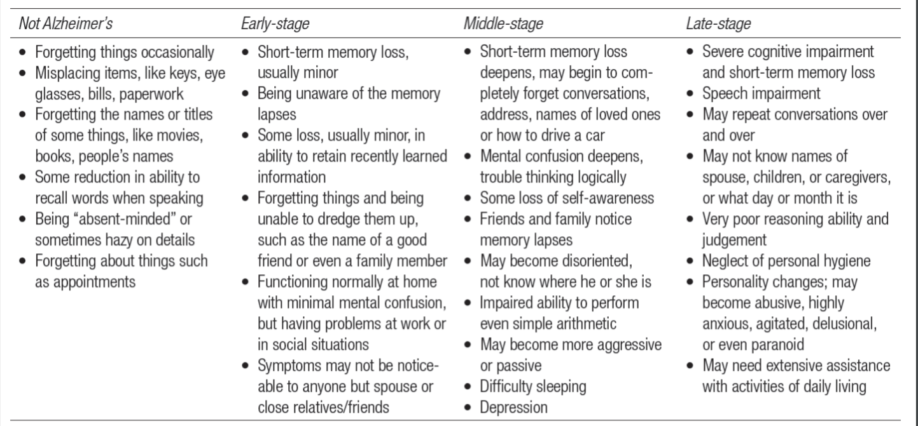
Know the late-stage exactly. Know diff bw early stage and not Alzheimers.
Individual diffs in AD is cognitive reserve the ability of the brain to cope with damage by using compensation or diff brain processes to continue to function well. Those with ↑cognitive reserve can tolerate more pathology before symptoms begin to appear. Those with ↑educations, ↑job position, ↑leisure activities = ↓dementia. ↑social life best.

Diagnosis
Made by psychiatrists + clinical psychs when person meets certain behavioural criteria. ↓complex attention, executive function, learning and memory, language, perceptual-motor, and social cognition. DSM-5 includes major & mild neurocognitive disorders(mild most controversial in DSM-5), cognitive deficits due to AD, vascular disease, brain injury, Lewy body disease, and other etiologies. Diagnosis is process of exclusion - rule everything else out bc there’s no way to test it. Only way is autopsy, which is after they’re dead.

MAY BE SA!!!!!!
What can we see in the living AD brain (to help us diagnose and predict)?
Imaging: Amyloid, Tangles, Cell loss; Volume of brain (grey vs. white matter), Cortical thinning, Synaptic loss?, Where (first)? ← hard to measure
ACh levels: PET tracers, Physiology (TMS)
- Neuropsychology Behaviour: Sudden weight loss? ← easier to measure
Cell loss in general + bran volume (grey, white matter) more concrete. So the tangles/plaques are hard to measure are not necessarily the cause of the AD.
Acetylcholine is getting lots of interest in this field because ACh is distributed widely throughout the brain. Now there’s experimental imaging, sees plaques and tau lvls to see the diff between normal brain levels and alzheimer's. The more tau, the stronger the signal will be. Moderate-severe phase, there isn't much tissue and so it doesn't give off as strong of a signal. Method is super expensive and dangerous. Basal forebrain degeneration precedes and predicts the cortical spread of Alzheimer’s pathology. Ppl debate whether AD originates in basal forebrain or entorhinal cortex. Damage to basal forebrain can ↓ACh and impairs memory/learning

Alzheimer’s Disease* late-onset.
What causes alzheimer's, many that interact with one another
Genetic Risk Factors: won't ask to regurgitate the list. Put together a genetic risk score, which genes do you have and you can know your score and see likelihood getting it.
Enviro Risk Factors: Head injury, stroke, heart probs, diabetes, ↓education, and lack of mental/social stimulation. Those who have an education and richer social/mental life than you are less likely to have alzheimer’s disease.
Effects more than additive – multiplicative/synergistic Some disorders may be caused by different genes or gene-env’t interactions leading to same outcome • E.g., multiple routes to Alzheimer’s disease?
Medical Treatments
Current meds temporarily alleviate memory loss but don’t slow the progression of the disease. First categories of AD meds target acetylcholinesterase, the enzyme that destroys ACh after its release into the synaptic cleft, which results in memory loss. So the meds inhibits this enzyme. Side effects; nausea, diarrhea, insomnia, vomiting, muscle cramps, fatigue, and loss of appetite, rare one is fainting, behavioural aggression. Two approaches to treatment research; (1) targets beta-amyloid (2) protect neurons from death.
Psychosocial Treatments
Caregivers also suffer. The term caregiver burden refers to the stress caregivers experience daily. As the disease progresses, caregivers must provide physical assistance (feeding them, carrying them, bathing them).

Treatments (PPT)
We understand the causes but also protective factors. May reduce alzheimer’s risk:
Mental activity, social support, physical exercise, mediterranean diet, limited alcohol.
There's a lot of noise/variability in these findings: Exercise doesn't halt dementia decline, it may increase the damage. Can we cure/prevent/slow/reduce effects of AD? Drugs; some ppl died during trials, etc. Dementia villages: ratio of res to staff is what slows down this project. May reduce med need.
Other Forms of Neurocognitive Disorder
Vascular Neurocognitive Disorder → progressively lose cognitive func bc of arteries supplying the brain.

Multi-infarct Dementia (MID) → caused by transient ischemic attacks. Leads to losing cognitive abilities. Most common form of vascular neurocognitive disorder.
Diff between AD and MID. (1) Development of MID is faster than AD. (2) ↑infarcts = ↑decline of cog func. (3) MID hippocampus smaller bc of infarcts and poor memory.
Risk factors similar to cardiovascular disease. Diabetes mellitus = ↑cognitive disorder. Metabolic syndrome = ↑risk of vascular neurocognitive disorder .

Frontotemporal Neurocognitive Disorder (FTD) → neurocog disorder in frontal lobe. FTD experiences personality changes like apathy, ↓inhibition, obsessiveness, addictive beh, & loss of judgment. Eventually become neglectful & lose communication abilities.

Parkinson’s Disease: motor disturbances like tremors, speech impediments, slower movement, muscular rigidity, shuffling gait, and no balance/posture. Neurocognitive disorder can develop in the later stages of PD. survive 10-15 years after symptoms appear. No cure but there’s meds to treat symptoms. Levadopa is a med but loses effect after a few years and may become toxic.

Neurocognitive Disorder with Lewy Bodies: similar to AD, accounts for 10-15% of all neurocognitive disorders. Fluctuates with severity, in early stages. Includes episodes of confusion and hallucinations, not found in AD. Lewy bodies are spherical structures with protein found in dying nerve cells in damaged regions of the brain of ppl with PD.

Pick’s Disease: severe atrophy of the frontal and temporal lobes. It’s diff from FTD bc the brain accumulates unusual protein deposits. Eventually mute, immobile, incontinent.
Reversible Neurocognitive Disorders: affects but does not destroy brain tissue. If condition is left untreated, permanent damage can be done to CNS, and opportunity for intervention is lost. If misdiagnosed as AD, person will be seen as untreatable
Normal-Pressure Hydrocephalus: rare, can cause cog impairment, dementia, urinary incontinence, and diff walking. There’s an obstruction in the flow of cerebrospinal fluid and it accumulates in the brain. Early treatment diverts fluid before damage occurs.

Subdural Haematoma: bc of head injury. Blood clot, creates pressure on brain tissue. Surgery can prevent further brain damage. Presence of brain tumor can cause cog deficits, can be prevented from developing into a more severe condition through diagnosis and intervention.
*Delirium: acute cognitive disorder causes temporary confusion. Caused by heart/lung disease, infection, or malnutrition. Unlike neurocog disorder, delirium has a sudden onset. reflects a serious disturbance elsewhere in the body, like infection, it requires immediate med attention. May be misdiagnosed also with dementia.

Polypharmacy: person takes multiple drugs or too strong can be lethal or cause neurocognitive disorder. Excretion of meds is slower in older adults bc of kidneys, so OA are more vulnerable to toxic effects of meds.

Wernicke’s disease: acute condition bc of chronic alcohol abuse, involves delirium, eye movement disturbances, balance probs, deterioration of the nerves to the hands + feet. Vitamin B1 can reverse this, but if it’s untreated it can progress to the chronic form of alcohol-induced neurocog disorder known as Korsakoff syndrome.

Pseudodementia: cognitive symptomes of OA with depression is similar to AD, symptoms; confusion, distraction, irritable outbursts, which may be mistaken for AD.

Social Determinants of Health
↓socioeconomic status (SES) = ↓ health. Chronic stress = ↑illness. Bias to OA thinking why treat them since theyre already old. More in textbook.

How do we define Normal vs Abnormal Cognitive Aging
Within 1SD of the average, you’re normal - sent home.
1 or 2SD < the average, you may begin to show symptoms.
2SD+ below the mean you’re prob really bad. Guy from vid usually had 3 or 4 SD above the mean (genius) and became average or -1SD at old age. That’s why it’s very imp to understand background. If someone’s average their whole life and stays average, its normal but this guy was way way below his normal and has abnormal cognitive aging.
Cause? Plaques, cause or effect? Or just happening by chance, doing nothing to AD.
The enviro risk factors may increase the plaque stuff in your brain.

Chapter 8, 9, 11, 14 combo (9 tho- relationships) June 5th
Video - 56 and Up - Movie summary
PSY 3128 Connection between what’s in the book, and what’s in the film
Paul
- Prefer to be alone when young, didn’t want to get married, at 28 was getting married, then was happily married until later in life
- Wanted to be a police man, than teacher, but worked in building, factory work, and now is a maintenance man in a retirement village
- Active role as grandparents to fill traditional role of female caregiver to children
Still feels the same, don’t feel differences of getting old, only physical limitations
Neil (Erikson's identity vs despair - did not resolve issue, stayed in despair for life, issues with substance abuse)
- Dreams of going to oxford but didn’t get in, dropped out of other school, and ended up working in building/construction
- Homeless at 28
- Always wanted to be involved in politics
- Worked with some politics, and began working in church as a minister
- Said sometimes acts in erratic way
- Didnt want children and pass down his genes to someone else, even in later life not successful in relationships
Peter
- Good intentions band
- Friends with Neil
- Wanted to be an astronaut, or police officer, became a teacher, then studied law and joined civil service

Jackie
- wants to get married when grown up, married at 21, divorced at 35 no kids had a kid separately
- married Ian, had two more sons, then split up at 42.
Nick (Observation that follows with Niche picking- early childhood passion, reciprocity, lead into prospective future)
- interested in physics, and chemistry, bright student
- married Jackie at 28, divorced later, remarried Chris
- nuclear fusion research in US
- then professor for electrical engineering
Suzie (According to freud personality develops and is stagnant at age 5, however with Suzie see a large transition, very different later in life)
- 21 chain smoking, agitated
- More calm once married Rupert
- Didn’t want kids as teenager, had three later in life

56 & up and Erikson’s psychodynamic theory (Page 199)

Similarities:
- Identity vs despair: seen in Neil, lost sense of identity after dropping out of college, couldn’t come to terms with what he wanted and what his decisions were, ended up cycling downward and being homeless, substance abuse assumed and struggles with mental health related issues, was then able to resolve conflict and in the end have a role in politics as he had originally intended.
- Neil- Theory of Possible Selves, theory proposes that the individual’s view of the self, guides the choice and pursuit of future endeavours. Possible self just means; what are you now, and what could you be in the future? These thoughts can motivate you to act in certain ways to achieve your hoped-for possible self. A dreaded possible self is opposite of the hoped for.
  - See that those Neil has possible self in mind, his life choices do not guide him to this possible self, and instead of revising his idea of a possible self he lives with a negative reflection of self until the day that he finally becomes involved in politics.

Similarities:
- Relationship matters a lot – importance of family and friends; divorces doesn’t necessarily mean end of family
- Life goes on – people gradually return to happiness (mid level) after a triumph or tragedy. (idk if this should be on differences) U-shape thing
- Diff background but same cohort but similar personality in regards to money (great depression).
- Interaction bw enviro (social context) and their bio personality; similarity bc it’s personal traits. Nature is something, ppl in similar context have the same effects.
- Agrees with niche-picking bc of the guy who wanted to do aerospace thing and bc he was smart his teacher put him in an advanced program and it leads to his (predisposed) success.
- Emergent dynamics pathway
Differences: Idk what I should put on this.. I didn’t think there were any?
- In the vid they show +ve examples in happiness and stability rather than individual diffs.
- PAGE 199; Diff between psychodynamic theory that involves erikson - lawyer,oxford thing, and the longitudinal study
- Nature vs nurture diff results in diff in personality in individual differences.
- Freud’s perspective believes that child has personality at 5. (Don’t want kids or be married at age 5 but later in life they got married/had kids).
- Women who score ↓intimacy in college were more likely to be divorced in later life and no affect on men but in the vid the men who scored ↓ also got divorced.

Ch11 - Mental health + Treatment
Major Depressive Disorder: extreme sadness lasts > 2 weeks and not typical of the person’s usual mood. Also, appetite+sleep disturbances, feeling guilty, low sense of self-worth and difficulty concentrating. women>men to get MDD, the prevalence is lower in OA than YA. Men ages 60-80 have higher rates of symptoms than women.

Bipolar Disorders; one or manic episode with depression.

Anxiety Disorders main thing is feeling anxiety, sense of dread about the future. Ppl with anxiety disorder try to avoid anxiety-provoking situations. OA < YA to be diagnosed. Women 5x more likely than men to have anxiety disorder. Profess are not good at recognizing symptoms of anxiety disorders in OA.
Generalized Anxiety Disorder (GAD): sense of uneasiness+concern w/out specific cause.

Trauma and Stress-Related Disorders
Exposure to trauma can lead ppl to experience symptoms that may last for prolonged periods of time, even after the trauma subsides.
- Acute-stress disorder - experience symptoms for up to a month after the trauma
- Post-traumatic stress disorder (PTSD): symptoms persist for over a month. Men who have ↑lvls of PTSD = ↑ risk of heart attack or coronary heart disease.
- Late-onset stress symptomalogy (LOSS): veterans that were exposed to trauma in younger years emerge in later life. Symptoms of LOSS similar to PTSD, but develops later in life.

Schizophrenia and Other Psychotic Disorders
Ppl who experience distorted perception of reality and impairment in thinking, behaviour, affect and motivation is known as schizophrenia. Display symptoms for over a month. Clinicians use rating scales to evaluate severity of symptoms. YA>OA (65+); survivor principle. OA with schiz have ↑rate of suicide. Late-onset schizophrenia condition is not thought to be schiz anymore, but a phenotype of psychotic disorder (so what is it?).

Treatment Issues in Mental Health Care
The CCSMH established assessment + treatment guidelines for delirium, depression, and suicide, and mood/behavioural symptoms. This brought on professional geropsychology, the application of gerontology to the psychological treatment of older adults. Psychs trained to apply the guidlelines known as Pikes Peak Model of Geropsych set of competencies psychs are expected to have to deal with OA with MI. Clinicians should also take into accound chronic med conditions + normal age-related changes in physical, cognitive and social functioning + consider ethnicity/culture.

Assessment
A psych assessment: formal evaluation of person’s cognitive, personality and psychosocial functioning. The clinical interview approach involves a series of questions face-to-face w/ client. Mental status exam assesses client’s state of mind. Outcome is description of how client feels, thinks, beh, etc. + it measure orientation where it examins if person whos where they are, time it is, who they are. Mini-Mental State Exam (MMSE) is a screening tool clinicians use to identify dementia.

Treatment
Neuroleptics → treatment for schiz and antipsychotic meds, alter dopamine lvls.
Many OA dont recieve proper psychosocial interventions.
Mental Health Literacy: knowledge/beliefs abt mental disorders which aid in their recognition, management, and pervention
Evidece-based psych practice: clinicians integrade best research evidence + clinical expertise w/ cutlural, background and characteristics of client.
Psychs know that we need to establish a relationship w/ clients, so psychodynamic therapy focuses on clients underlying conflicts. But traditional models are changing and therapists are working from this framework may focus on other issues like attachment styles. In this method psychs use life review or reminscence therapy, which helps OA rework past experiences (good+bad) w/ goal of gaining greater acceptance of the past.
Behavioral therapy - changing reinforcements associated with ppl’s behaviour
Cognitive therapy - disorders develop bc of maladaptive thought processes
CBT - develop adaptive behaviours and better ways of thinking abt their experiences
Interpersonal therapy (IPT) - understand and change their relationships.

Suicide - from Ch11 !!!!!!!!!
The two patterns of the rate of death by suicide:
- Rate of men way higher than women
- Midlife, 35-59 is way higher than we would have expected. 40-59 highest
Mental health illness a risk factor in suicide. Other risk factors: marital breakdown, financial hardship, deteriorating physical health, a major loss, or a lack of social support. Suicides among men ↑ up to 45-49, ↓ up to age 65-69, then ↑ again. 85 highest for men. Suicide is understand from the biopsychosocial perspective (chronic pain, cognitive changes/depression and stress/isolations can lead to suicide). But most OA are just severely depressed but super hard to identify, even to a mental health professional. Rational suicide is a sane, well-thought out decision by someone mentally competent. Ex, person’s been suffering from chronic illness and chooses suicide as best option.
2 underappreciated factors:
(1) (Un)happiness (2) Social networks: support, prevention
(Un)happiness
Measuring happiness, we ask how your day was and how intense your feelings are (joy, sadness, etc) and are you doing something meaningful.
Top of the ladder is the best possible life and bottom is the worst possible life and indicate on the ladder where you stand. (1-10 step ladder). Survey: “All things considered, how satisfied are you with your life as a whole these days?” 0 = lowest, 10= highest. Think of 3 people’s answers: Sibling, parent (same sex as sibling), grandparent (same sex as sibling). Genetically related. If you don’t have a sibling, substitute yourself
My sister: __/10 -My mom: __/10 -Her mom (i.e., your grandmother): __/10
Check slide 14
The U-bend is the happiness scale that shows the younger generation is happier, than the adults dip and the older adults are happier. When the older person is not happier it’s bc of an abnormality in them (neurological or something else).

Cohort Effects -- survivor effects. Group of ppl who’ve witnessed the same trauma, in this case born in the same era.
Ppl born during great depression and WWII, they say life satisfaction is high. Reported higher than baby boomers. Diff cohorts and circumstances may contribute.

Other factors to consider
Time of measurement/history effects:
Economic fluctuations, social networking (facebook). This has a major effect on how we’re doing bc we compare ourselves to seemingly-perfect lives.
Individual Diff in:
Physical health (if we’re in chronic pain, how different would your answer be in answering life satisfaction), sleep, marital status, income/employment, etc.

Three samples of apes had the same results. Older apes had the highest wellbeing.

Social Networks
How many ppl could you talk to about a serious problem? How many ppl can talk to you? Survey thing again. The older you get, the more friends you lose. So there are things that expand your social network or trim your social network. “Friendships follow a trajectory from formation to dissolution.”
Historical changes; fb is now for older ppl than younger ones
Men have less friends, leading cause of death is loneliness
How we get social networking data?
Mostly self-report (interviews, questionnaires), Informant report, In younger samples, social networking sites like Facebook
Problems with this approach cont. Individuals’ ability to report all relevant data: • People are not aware of the “big picture” (where they are situated within the network) • Would the people you’ve nominated list you? Maybe not as often as you’d think • Memory problems lead to under-reporting?
Links to well-being People with supportive family and friends have a stronger sense of meaning in life, Strong social networks predict greater emotional wellbeing (both everyday and during stressful events) Strong social networks predict better cognitive function
Question on the exam about 56 Up. enough detail to back your argument to be convincing. Textbook says “x” but I didn’t see it in the movie because blablabla. Or I did see it because x,y,z. Analyze and synthesize.

Continuation June 7th
Recap: how to measure happiness; the ladder thing. U-shape.

Social networks: structural and functional aspects Structural = number and type of social partners in the network Functional = the perceived or actual receipt of support -both aspects are important

Impact of structural aspects: cognition
Older men who live alone at any point during a five-year period have double the risk of cognitive decline -Larger social context: SES of urban neighbourhoods predicts cognitive status of older adults living there independent of individual SES (study in UK)

Impact of structural aspects: physical health
Strong social networks linked to reduced morbidity and mortality -Effect sizes similar to traditional medical indicators (e.g., smoking, high cholesterol)

Impact of functional aspects: cognition
People who report lower satisfaction with their networks show greater declines in cognitive functioning over time -Better emotional support has been linked to better cognitive performance eight years later

Impact of functional aspects: physical health
Negative social exchanges are related to poorer health, depressive symptoms -Women who report low levels of emotional support are twice as likely to die as older women with high levels

Origins of healthy relationships
-Relationships you have when younger predict those you will have when you are older -Early relationships affect social, emotional, and physical functioning in adulthood
-Many of these relationships last and continue to be important (e.g., with parent)

What to do?
Public health really worried about… so in the UK there's an effort to decrease loneliness. Some ppl call radio call-in shows

Know the table on Perspectives on Long-Term Relationships
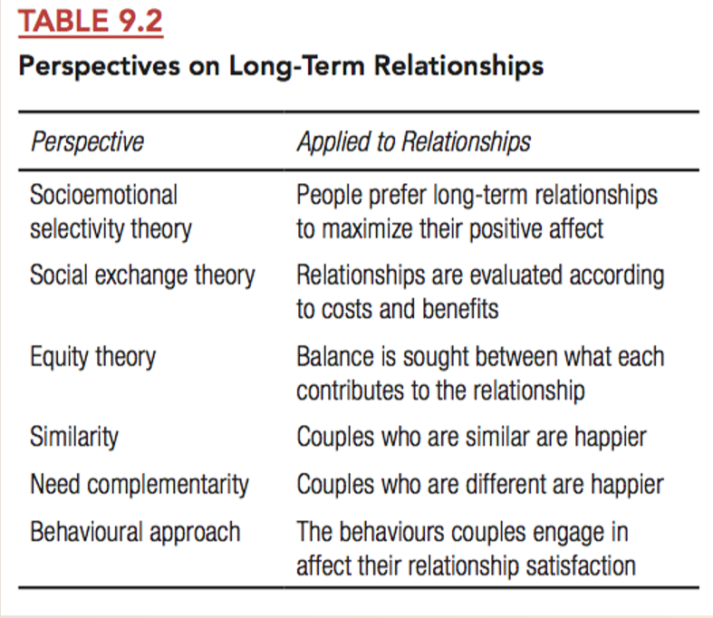

Socioeconomical Selective Theory (SES)
Sense that time is running out (sense of mortality), they would feel like they lived experiences and knowledge and because there isn’t much time left, and so they want to focus on the positive only. “I don’t have time to get upset over this or to get angry”, so they dampen -ve emotions and maximize their positive emotions. Older adults may show advantages in ability to control, and express, negative emotions.

“Dying Is Unexpectedly Positive” ← when faced with mortality (young or old)
In people’s imagination, dying seems dreadful; however, these perceptions may not reflect reality. In two studies, we compared the affective experience of people facing imminent death with that of people imagining imminent death. Study 1 revealed that blog posts of near-death patients with cancer and amyotrophic lateral sclerosis were more positive and less negative than the simulated blog posts of nonpatients—and also that the patients’ blog posts became more positive as death neared. Study 2 revealed that the last words of death-row inmates were more positive and less negative than the simulated last words of non inmates—and also that these last words were less negative than poetry written by death-row inmates. Together, these results suggest that the experience of dying—even because of terminal illness or execution—may be more pleasant than one imagines.

You May Want to Marry My Husband
Piece by a woman who is dying, saying that her hubs is a great guy, etc. +ve > -ve

Age Diff in Processing, Remembering and Actions on Emotions
What kinds of things happen when your perspective changes?
Change in Perspective:
- Increased desire to maintain high levels of well-being
- Increased importance of emotionally meaningful experiences
Which leads to altered thoughts & behaviours related to social & emotional experiences
- preservation of important social partners
- discarding of peripheral social ties
- reduction in levels of anger and distress

Appraisals
How we appraise events or situations determines how we experience them emotionally.
- Can you think of some examples of this?
Older adults perceive and remember events more positively and less negatively. Older adults attend less to negative stimuli and describe negative situations less negatively.

Memory
Younger adults show a “negativity bias” in recalling events in their life
Older adults do not show this bias
Possible theoretical account (SST):
- These effects are a result of adaptation
- Early in life, we must maximally absorb information
- Negative stimuli generally hold more information than positive stimuli
- In older adults, motivation focuses on preserving emotional balance

Behavioural responses
Negative interactions are associated with poorer health, greater levels of depression,...
Older adults engage in behaviours that prevent escalation of tense situations
- e.g., more passive responses (do nothing, let situation pass)
- e.g., “infusing negative comments with positive ones” in discussions with spouse about conflict

Figure 9.4 - Widowhood
Widowhood effect mediated by conditions such as depression, stress, economic hardship, and loss of social support. • Changes in lifestyle may occur as well.

Most ppl show resilient grief. Even the closest person dies after 40-50 years together, they are resilient and being +ve may be a part of that as a coping mechanism.
Widowhood effect mediated by conditions such as depression, stress, economic hardship, and loss of social support. Changes in lifestyle may occur as well.

People vary in their reactions to widowhood.
Prospective study of 200 widows
Some showed depression before and after the loss
Majority showed “resilient grief”
Widowhood is not a unitary process

Chapter 14 Successful Aging June 6th
What is Successful Aging?
→ Diff definitions across diff studies/models/context. Maintaining wellbeing? Good social lifes. Diff perspectives; lonely and SST.

Rowe and Kahn definition of successful aging; it’s the absence of disease and disability, high cognitive and physical functioning and engagement with life.

World Health Org (WHO) def: process of optimizing opportunities for health participation and security order to enhance quality of life as ppl age.

Successful Cognitive Aging (pg 321).
- Cognitive performance that is above average for an individual’s age group “Superagers” – individuals 80 and older with superior episodic memory had thicker volume of cortex
- Greater ability to take advantage of brain plasticity
- Maintain relative superiority compared to age peers not against performance of younger adults
- Higher, not lower, C-reactive protein?!
- Remaining engaged with life, including being involved with family

Individuality Matters → keep in mind.
Volume of hippocampus can be the same as that of ppl in their 20s. May be a general trend but there are lots of ppl that don’t fit in with that trend. In the case of hippo, cognition, etc.
How do we know we are aging optimally?

Factors that Promote Successful Aging
Positive psych: provide a greater understanding of the strengths and virtues that enable ppl and communities to thrive, within that, life statisfaction: overall assessment of an ind feelings and attitudes abt his/her life at a particular point in time.
Subjective well-being: person’s overall sense of happiness
Paradox of well-being: well-established finding that OA maintain high subjective well-being despite facing challenges from their objctve cirumstances.
Set point perspective: ppl’s personalities influence their lvl of well-being throughout life
Social comparison: when ppl rate themselves relative to their primary reference group
Life story: narrative view of the past wherethey express their identity over course of time

Creativity and Aging
Lehman’s Age and Achievement; identify age trends in productive accomplishments. Lehman concluded that the peak of productivity in adult yrs occure prior to 40.
Planck hypothesis; earlier peaks are reached in the sciences and in the fields in which success is dependent on intellectual imagination and physical ability
Career age; age person embarks on his/her career.
Creative potential; # of works a person can hypothetically do in a life span w/out limits
Equal-odds rule: creative ppl who produce more works more likely to produce higher quality than those who produce fewer works.

Characteristics of Last Works
- Old-age style; eliminates the fine details and presence the essence of work’s meaning. Swan song; creative work produced at the end of an artist’s life
- Lastingness; they persist over time
- Integration and synthesis; incorporates complex and multiple features
- Willingness to criticize; ability to see own work objectively

What should you do?
1. Don’t worry
Younger ppl worry about a lot of things in aging, they expect it to be worse than what it actually is. Most feared thing is memory loss (57% of young adults), which is only true for 25% of older adults.

2. Save money
Starting when you’re young to invest like when you’re 20-25 is diff from investing starting at age 30-35. Save it and forget it; interest.
If you take a selfie and enhance it to make yourself look older, just by doing that you’re more interested to save money than if you don’t.

3. Follow your grandmother’s advice
May reduce AD
- Mental activity
- Social Support
- Physical exercise
- Meditarranian diet
- Limited alcohol

4. Get (or stay) creative
Older artists coping with physical limitations alter their medium or mode of creating

NOVA SCOTIA + NEW BRONSWICK = HIGHEST PERCENTAGE OF PPL 65+
There are regional diff cause, city vs rural?
Percentage in less developed regions show a precipitous rise in the next decade and will continue to exceed the rate of growth in developed countries.

