Final Notes
  - Chapter 9-Psychosexual development
- Infancy (0 to 2 Years)
  - Attachment - psychological bond that forms between an infant and the mother, father, or other caregiver
  - Gender identification : Gender Awareness stage (knowing about boy-girl differences)
  - Nongenital sensual experiences
  - Exploratory genital manipulation
  - Language
- Early Childhood (3 to 7 Years)
  - Gender Identification : Gender Stability and Gender Constancy stages
  - Gender role socialization
  - Exhibitionist stage
  - Self-stimulation
  - Child sex play
- Preadolescence (8 to 12 Years)
  - “Latency” or modesty?
  - Masturbation
  - Other-sex sexual games and sexual contact
  - Gender segregation (homosociality) and same-sex sexual contact
  - Sibling sex
- Adolescence (13 to 19 Years)
  - Increased sexual interest
    - Bodily changes
    - Sex hormones
    - Cultural expectations
  - Masturbation and sexual fantasies
  - Same-sex sexual behavior
  - Other-sex sexual behaviour among gay and lesbian youth
  - Other-sex sexual behavior
  - Dating and sexual exploration
  - Sexual intercourse
    - Motives for engaging in intercourse
      - love
      - physical arousal and pleasure
    - peer pressure vs perception of what other’s are doing
  - Chapter 14-Diversity in adult romantic and sexual relationships
- Dating
  - Variable age of onset (preadolescences; X: 16yrs; later for LGBTQ+)
- Internet dating
  - More information gathering vs traditional dating
  - More socially accepted
- Cohabitation and marriage
  - Rates of hetero marriage on decline; same-sex increased; cohabitation popular but more unstable
  - Sex more frequent in committed relationships
  - Divorce rates for 1st marriages in Canada 33%
- Consensual non monogamy:
  - In Western societies, consensually nonmonogamous relationships (those in which all partner agree that each may have romantic or sexual relationships with others) are widely viewed as illegitimate and objectionable (Conley et al., 2013)
  - Evolutinary perspective: Individuals engage in multiple mating strategies because different strategies are effective in different situations = adaptive (Jonason et al., 2012)
- Non-monogamous relationships
  - Friends with benefits (casual sexual relationships also includes: hook up, one night stands, booty calls, fuck buddies, exs)
  - Swinging
  - Open relationships
  - Polyamory (vs Polygamy)
  - Extradyadic Behaviour (infidelity- non consensual)
  - The majority of reasearch does not find a significant difference between consensual non-monogamists and monogamists on the following
    - Psychological well-being
    - Overall relationship adjustment
    - Jealousy
    - Sexual satisfaction
    - Relationship stability
  - Chapter 1-Dominant discourses on sexuality and the influence of mass media
- How media influences our sexuality:
  - Agenda-setting theory
  - Cultivation theory
  - Social learning theory
- Age of intercourse
- Unrealistic sexual expectations
- Sexually irresponsible behaviours
- Stereotypes about sex and gender
- Education and awareness
- Reliable information sources
- Vicarious learning
- Forum for sexual expression
- Online Sexual Activity:
  - Establishing and maintaining relationships
  - Obtaining sexuality information
  - Obtaining sexual gratification
- Positive and negative effects on relationships and intimacy
- Sexually explicit material
  - Chapter 14-Dominant discourses on sexuality and the influence of mass media
  - Chapter 11-Variations of sexual orientation and gender identity
- Conceptual Models
  - Pre-Kinsey dichotomous model
  - Kinsey Sexual Orientation Scale (1948)
  - Ranking behaviour and “psychologic reactions”
    - 0- Exclusively heterosexual with no homosexual
    - 1- Predominantly heterosexual, only incidentally homosexual
    - 2- Predominantly heterosexual, but more than incidentally homosexual
    - 3- Equally heterosexual and homosexual
    - 4- Predominantly homosexual, but more than incidentally heterosexual
    - 5- Predominantly homosexual, only incidentally heterosexual
    - 6- Exclusively homosexual
  - Storms Two Dimensional Scheme (1980)
    - 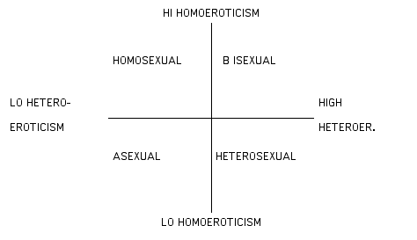
  - Klein’s Sexual Orientation Grid
    - 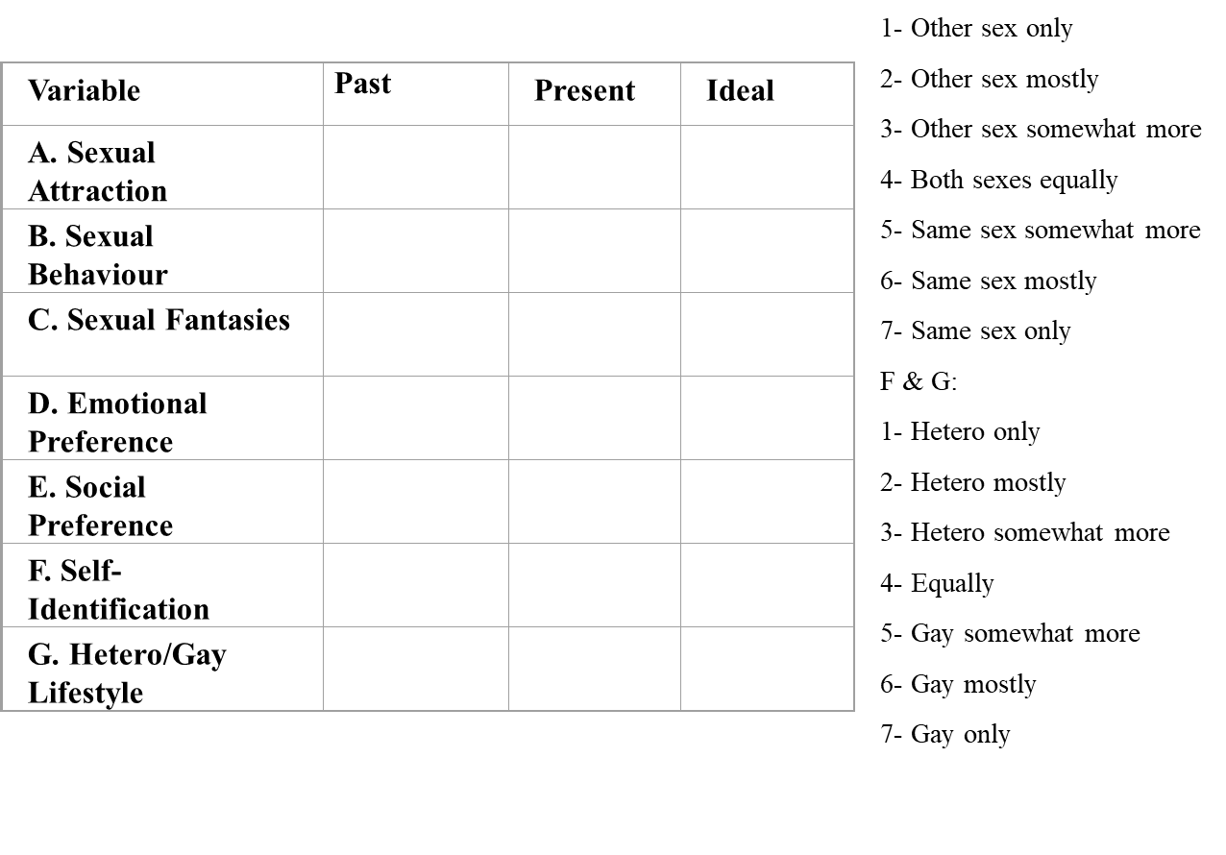
  - Chapter 17-Sexual coercion, assault and consent
  - Chapter 15-Diversity of sexual behaviour and the concept of “normal”
- Paraphilia
  - Definition: Medical term that refers to statistically uncommon patterns of sexual arousal or behaviour.
  - Also referred to by (non-medical) terms such as: unconventional sexual behaviour, atypical or unusual sexual behaviour, non-normative sexual behaviour, kink.
  - Terms such as deviant, abnormal, perversions, etc. imply a social, moral or medical judgment (i.e. good or bad).
  - Disorders
    - A diagnostic category used by the American Psychiatric Association to describe atypical patterns of sexual arousal or behaviour that becomes problematic for the individual or in the eyes of society and are considered to be mental disorders.
    - According to the APA’s DSM-5 (2013):
      - A paraphilic disorder is a paraphilic behaviour that is currently causing distress or impairment to the individual or whose satisfaction has entailed personal harm, or risk of harm, to others. A paraphilia (behaviour) by itself does not necessarily justify or require clinical intervention and is not considered a psychopathology/mental illness.
      - * Principal argument: there is no definition of healthy sexuality/behaviours. Non coercive unusual sexual interests may be healthy expression of sexuality for some individuals . Many are labeled « paraphilia » due to sociopolitical and historical factors.
    - Paraphilia disorders listed in the DSM-5:
      - Voyeuristic Disorder
      - Exhibitionistic Disorder
      - Frotteurism Disorder
      - Sexual Masochism Disorder
      - Sexual Sadism Disorder
      - Pedophilic Disorder
      - Fetishistic Disorder
      - Transvestic Disorder (w fetishism; autogynephilia)
  - The difference between a paraphilia disorder and paraphilia behaviour?
    - Paraphilia disorders tend to be:
      - Psychologically and/or physically harmful
      - Obsessive or compulsive (ritualistic, insistent, demanding or impulsive)
      - Chronic
      - The psychiatric diagnosis of paraphilia disorder requires that the person has acted on the urges or is distinctly distressed by them.
  - Chapter 12-Love and Attachment
- Triangular Theory of Love (1986) Robert Sternberg
  - Three components of love:
    - Passion
      - Motivational component
      - Physical attraction and sexual desire
      - Physiological arousal
      - Is quick to grow in romantic relationship but also first to fade
    - Intimacy
      - Emotional component
      - Feelings of closeness, connectedness and bonding
      - Emotional investment and support, mutual understanding and self-disclosure
      - Part of many kinds of relationships
    - Decision or commitment
      - Cognitive component
      - Short-term: decision to love someone
      - Long-term: decision to maintain the love
      - Can sustain a relationship without passion or intimacy
  - 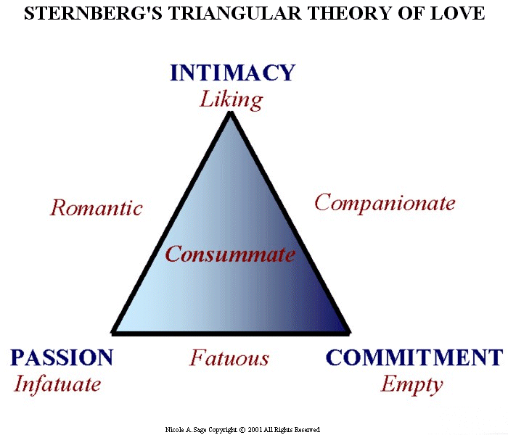
  - Sexual abuse and people with disabilities
- What is an intellectual disability (ID)?
  - Definition: is characterized by significant limitations to intellectual and adaptative functioning with an onset before the age of 18
  - Conceptualization: level of disability (ex.: IQ) level of support
- Historical context
  - 1876: Opening of the first government operated in Ontario, the Orillia Asylum for Idiots (Brown & Percy, 2003)
  - 1970: Approximately 30 institutions for people with ID in Ontario (Brown & Percy, 2003)
  - 2006: United Nations enacts the Convention on the rights of persons with disabilities (3 articles)
  - A total of 3,873 people with ID remain in institutions in Canada (Institution Watch, 2006)
  - 2009: Closure of the last government operated institution in Ontario (Ontario Ministry of Community and Social Services, 2012)
- Sexual abuse and people with intellectual disabilities
  - Studies show that up to 90% of people with ID are victims of sexual abuse (Matich-Maroney, 2003)
  - Among them, approximately 80% are victims of multiple abuse (Sobsey & Doe, 1991)
  - Estimate that roughly 3% of people with ID victims of sexual abuse denounce the abuse (Sexual Assault Support Centre of Ottawa)
- Possible explanations of increased vulnerability specific to ID
  - Greater social isolation and dependence (Plummer & Findley, 2012)
    - Social network limited to family and professionals
    - Daily role of professionals
    - Notion de control
  - Learn to always say yes
    - To avoid punishment
    - To please others/make friends
  - Attitudes towards sexuality
    - Asexual, childlike, and needing protection (Abbott & Howarth, 2007; Milligan & Neufeldt, 2001; Swango-Wilson, 2010; Wilkenfeld & Ballan, 2011)
    - Hypersexual and unable to control their urges (Abbott & Howarth, 2007; Ailey et al., 2003; McCarthy, 1999; Wilkenfeld & Ballan, 2011)
    - Issues within the family
  - Do not recognize abuse (Plummer & Findley, 2012)
  - Lower sexual knowledge (Galea, Butler, Iacono, & Leighton, 2004; McCabe, 1999)
    - Institution vs community living
    - Difficulties learning and retaining information
  - Fewer sexual experiences than those without an ID (Ailey, Marks, Crisp, & Hahn, 2003)
  - Problems with sexual education programs
    - Focus on negative aspects of sexuality
    - Promotion of sexuality as non-reproductive, solitary, and heterosexual
    - Lack of emotional and psychological aspects
- Consent
  - Free and informed consent
    - What does it mean?
    - How is it used in research?
    - How does this transfer to daily living?
  - Obtaining consent is a process
  - Challenges:
    - Obtaining consent
    - Having a proxy
- Next steps
  - Need for clear policies for the sexuality of people with ID to reinforce their rights to live a fulfilling sexuality, especially in service agencies
  - Need for accessible sexual education programs for people with ID that don’t limit sexuality to the negative aspects
  - Need for attitude shift in the community regarding the rights of people with ID and their rights to have a sexuality

