Expected value e(x) = u = sum xP(x)
Pop var (av sq devia) v(x)=o^2=sum(x-u)^2 *P(x) => (calculate u which is exp val and plug in) SD = o (sqrt of variance)
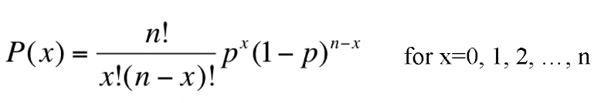
E© = c, e(X+c) = e(X)+C, e(cX) = cE(X)
V©=0, v(X+c)=v(X), v(cX)= c^2 *V(X)
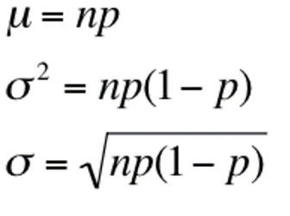
Binomial experiment – fixed # of trial, two outcome, p(s) = 1-p(f), independent
Simple,stratified random, cluster sampling
Nonsample arror-data acquisition, nonresponse, selection bias
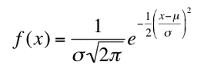
Uniform dist function (eq prob at every value.. rectangle) – f(x) = 1/(b-a) , a<=x<=b
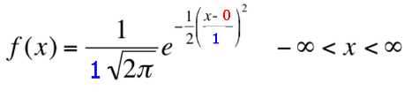
Norm dist - standard norm dist –
(o = SD, u=mean)
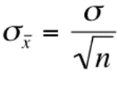
Convert to norm standard dist -> z= (X-u)/o -> shift x by mean to make centre 0, divide by sd to make sd=1
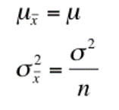
Sampling distribution (eg 2 or more dice) n=# of dice
SD of sample dist is standard error

If x normal, x also normal. If x nonnormal, x only normal if sample size large enough
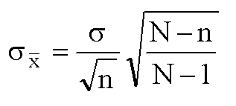
(if pop is infinity).. if finite ->
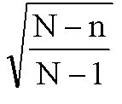
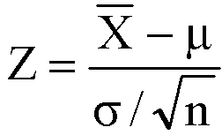

N is pop size ^ is finite pop correction factor…. If population > 20* sample, it’s large enough to ignore finite pop correction factor

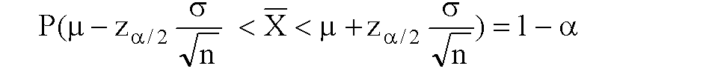
95% chance.. z between +-1.96 90% chance.. z between +- 1.645
a= probability not fall into interval
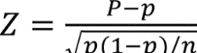
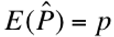
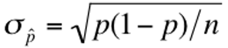
sample proportion
(eg chance > 50 (P hat) of 300 (n) sample getting vote when last time 52% (p) voted for him)
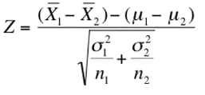
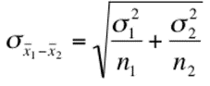
Difference between 2 means is normally distributed (if they are not both normal, sample size has to be >30 for difference to be normal).. u = u1 – u2..

2 types of inference.. estimatation (determine approx. value of pop param from sample param.. sample mean -> pop mean u) point estimator and interval estimator. Point estimator not useful cuz param closer if increase sample size, but then point doesn’t reflect that. X = 400 (point estimate) .. x between 380 and 420 (interval estimate)
Important qualities of estimators – unbiased(exp val = param) consistent (larger samp = smaller difference).. if 2 unbiased estimators, smaller variance = relatively efficient
E(x) = u (unbiased) V(X) = (o^2)/n (consistent n big = v small).. sample median vs sample mean are both unbiased, but sample mean has smaller var -> relatively efficient
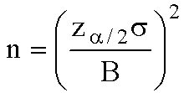
Sample size to estimate mean: B = bound on error of estimation

