CHAPTER 1 Module 1: What Is Marketing?
What is marketing-is the organizational function and set of processes that subject to constraints, attempts to establish mutually satisfying product exchange relationships between any two interested parties.
THE 4 PS THE MARKETING MIX (covers chapters 8-16 basis of final exam)
The 4ps Are Changing
- Product
-content, context, infrastructure, branding
- Pricing
-perceived value, dynamic, auctions
- Promotion
-dialogue, buzz marketing, viral marketing, placements, PR, Co-Promotion
- Place
-networks, alliances, organic structures
Needs vs. Wants
Needs: difference between a customers actual and some ideal or desire
Wants: desire to satisfy needs in ways that are influenced by culture ad society
Marketing’s Core Aspects
- Information gathering
- Profit
- Cresting value
Marketing shaped by internal and external forces
- Companies have control of internal factors within company but not outside
- CDSTEP (AKA : PEST OR STEPC) chapter 3-the environment of marketing
- Culture, demographic, social, technology, economics, political/ legal
Value Driven and Value based Marketing
- Understand key benefits offered and what consumers want
- Must understand key benefits and focus of product
- Eliminate cost of less strategic benefits
- Take long term view of customer relationship
- Use marketing research and data to understand customer
- Must understand how product if of value to customer
- Distribution location and convenience to best reach consumer
MARKET RESEARCH
- Info should be distributed through out company
- Creating strong relationships as marketer with barriers that stop the consumer from leaving
- Social media used to create relationships with the customers
Negatives of Marketing
Can be viewed as being
- Deceptive (example designer burgers)
- Objectifying(example hooters)
- Stereotyping(ex. barbie and ken)
Marketing today/How to combat negatives(note ths is not in slides)
- Building relationships with customer, suppliers, etc.
- Dialogue- conversations, community
- Engagement
- Innovation
- Info management: lots of info, real-time
- Immediate gratification
- Customization and globalization
- Consumer cynicism
- Brand switching rather than brand loyalty
Marketing’s Two Interest Parties
- -places
- -properties
Organization-Information
- -ideas
- -goods
- -services
- -experiences
- -events
- -persons
Product Exchange Relationships
- -Augmented Product
- -Actual Product
- -Core product
Kotler On Marketing-it is no longer enough to satisfy customers. You must delight them.
Evolution In Marketing Thought
-production concept> product concept > selling concept > marketing concept
Evolution Of Business:Pre-1945 To Today
Production (Pre-1945)[demand >supply] > sales (1945 to mid 1960s )[supply > demand] > marketing orientation (mid 1960s to early 1970s)[supply demand] > marketing concept (1970 to 1990s)
The Marketing Concept:identify and satisfy customer needs while making a profit
CURRENT STATE OF MARKETING
Marketing realities of today
- Information clutter
- Declining brand loyalty
- Consumer cynicism
- Need for knowledge
- Internet base customization
- Globalization
ATTRACTING AND RETAINING CUSTOMERS
Relationship Marketing
-what is driving RM
- Technology
- Need for real time MR(?)
- Need for integrating design and manufacturing
- Need for knowledge
- Need for dialogue and integrated communications
Marketing view of a product
- Core product (core benefit of service)
-key unique benefits you get from buying the product
-eg. furniture, book/the knowledge you get from it
- Actual Product
-packaging
-quality
-brand name
-features
- Augmented product
-installation
-delivery and credit
-after-sale service
-warranty

MODULE 2: MARKETING STRATEGIES AND MARKETING ETHICS AND SOCIAL RESPONSIBILITY
Strategic Marketing
Excellence strategies
-locational excellence
Marketing strategy
- Note:
-Cutting edge Companies focus on knowledge based rather than -information and they creat knowledge based product
-They have do not communicate with customers they have dialog with their customer
Two key aspects of Strategic Marketing
- Corporate marketing strategy
- Industrial outlook
- Corporate goals and values
- Corporate vision and mission
- Corporate positioning/image/branding
- Corporate growth strategies
- Portfolio analysis

- Industrial outlook
-what it is: where is the industry headed the big picture
-key factors:
recent trends,
development,
forces
(read article on virtual lib on 5 trends of industry outlook)
Experience
Gut feeling
Inspiration and role
Presence of champions

- Corporate goals and values
-define:a corporation’s institutional standards of behaviour
-importance
-building corporate brand image
-reputation and credibility
-leadership
-public relations
-corporate
- Corporate vision and mission

-wat is it-within industry outlook, where are we going eg. “to be number one company in the world of office automation”

-the importants of a mission statement?
-marketing Myopia article by Ted Levitt popular article that talks about having a limited vision or “Myopia” eg. Companies that when down when music became available online

-Define the corporate mission
1. what is our business/perspective?(global, environmental saftley)
2.what is of value to the customer, (consumer value focused)
3. What do we aspire to become (vision component)

- Corporate positioning/image/branding

-corporate positioning: how a company wants to be seen by stakeholders in terms of what they do

-corporate image: how they want to be seen I terms of what kind, eg. Are they premium, value, or economy player, or cutting edge or trailing edge or ethical

-corporate banding: an active campaign to establish awareness of the corporation, its name, its desired position, and image, and to create positive affect for the corporation

-Common corporate positioning- trustworthy, popular, caring, innovative, traditional, environmental, efficient

- Corporate growth strategies
-4 approches to market extension
-

- Portfolio analysis or General Electic’s strategic Planning Grid

-strategic business unit:is a single business entity that has its own collection of competing businesses, own top management, plans own operations independently, has own management that is responsible for strategic planning an profit making but it is part of a larger umbrella corporation. eg. Telfer (strategic business unit) and uOttawa (umbrella corporation) or PepsiCo(umbrella corporation) and Pepsi/Gatorade/Tropicana(strategic business unit)

- strategic business unit analysis- 2 APPROCHES idea of looking at different business units and deciding how recourses should be allocated
2 approaches-marketing growth rate, relative market share
4 sections (
Dogs-business units with very low market share and low growth rate (urban and regional planning, or black and white film)
Question marks-low market share but high growth rate(unpredictable) close eye must be kept on these businesses as they could be dogs or cash cows
Stars- high groth rate, high growth rate must tern into cash cows are they burn through cash
Cash cow- high market share, market growth rate has stabilized (usually leader or second, third top company in field)
General Electic’s strategic Planning Grid
Industry attractiveness-not attractive but lucrative business could be regulated, new technology could take over, environmentally unfriendly. As organization you are lacking strength controlee in his industry growth could be fluctuating
Business strengths-profitable at the moment
- Levels of Planning
-strategic planning: value oriented
Provide value and communicate value to customer
-Tactical panning: How your going to provide tis value product

- PRODUCT LEVEL MARKETING PLAN
- Executive summary
- Table of content
- Situational analysis
- Marking strategy
- Financial projections
- Implementation controls
-critical aspects of product level marketing plan: situation analysis and marketing strategy
- Elements of a product level marketing plan
-target market/ Marketing mix > marketing strategy /time related details and control procedures >marking plan/other marketing plans

- The marketing mix(traditional)
- Product
- Price
- Promotion
- Place
- Marketimg strategy questions-
Who are the customers- Activities, interests, opinions, lifestyle, expectations, size
What does your target market want- needs, benefits sought, preferences
Can yu provide what they want- define USP, constraints and limitations
Scan the environment -threats, opportunities and limitations
The right marketing mix-the 4Ps, packaging and positioning
Have you considered various risks/contingencies

- Stakeholder Analysis: A common tool in public sector(gov)
-this would be different view points from differing stake holders

- SWOT analysis: A common Tool
-Strengths
-Weaknesses
-Opportunities
-Threats
Note: swot can be used as a conclusion of yur detailed environmental analysis

MODULE #3 Environmental Scanning

key take away from madule 2
1.startigic marketing-
product placement,
price, promotions
segment targeting and positioning
a product is not just a product but a conglomeration of products
planning is a complicate thing
when a company mission is clearly myopic companies tend to disappear, the brodder the
Environmental Scan
Environmental Analysis
External Environment
macro influences that effect all firms
-demographic
-cultural forces
-legal and regulatory
-technology
-economic conditions
-competition
MACROENVIRONMENTAL FACTORS
- SWAT ANALYSIS
- CDSTEP(ACRONYM)
  - Culture
  - Demographic
  - Social
  - Technology
  - economic
  - Political legal
- Culture and demographics
  - factors create and remove opportunities
  - Baby boomer increasing creating demand for health workers
  - Fewer children being born decreasing need for teachers
  - Immigration creating more job opportunities
  - Demographic changes create new marketing opportunities
- Social demographic trends
  - Connected-apps, mobile wallets, convenience in purchasing drive-thru, curb side pick up, delivery
  - Waiting longer to start family
  - More multi-cultural
  - Living in smaller spaces and enjoying bigger lifestyles/ in turn furniture companies creating products to accommodate smaller homes
- Technology changes
  - Internet, smartphones, wearables, internet of things
  - Online reviews and ability to be informed on products
  - Wearables-
  - Bid data analytics-traffic data all information gathered via technology to mine consumer buying habits and patterns
- Economic Factors
  - Inflation ex. Rate, interest rates, recessions, growth, unemployment,
  - business and consumer confidence-effected by job security and income, if buyers have money and are confident in there financial situation they spend more and invest more
  - Politica rules and regulation on taxation and interest rates overall effect things like housing costs and importation
  - Discussion Q: Regulations on NAFTA protection that governs sectors of Canadian economy are now open to US firms
- Political/ regulatory environment
  - Competition act
  - Consumer packaginf ad labelling act
  - Food drug act
  - Access to info act
  - Patent act
  - North American free trade agreement NAFTA
CHAPTER 16 ISSUES
- ENVIRONMENTAL (PEST) ANALYSIS
  - ECONOMIC ANALYSIS
    - GROSS DEMESTIC PRODUCT (GDP)
READ PURCHASING POWERS PAGE 234 QUESTION WILL BE POSSSED ON EXAM/MIDTERM
- evaluting real income-Firm can evaluate icome needs of target area and adjust products to fit the income needs
- sociocultural factors how different marking sceems are targeted to certain cultures
  - masculinity-south American culture targeted
  - individualism-canadian market target
  - power distance-cultures that are restrained eg middle east

1.Demographic
- -Of great importance to marketers
- -Includes trends
Demographic changes include
- -World wide population explosion
- -Canadian birthrate slowdown
- -aging of population
- -changing canadian family(rise in smaller families, single families, gay families, large group families)
- -rise in non-family households
- -ethnic makeup of canada
- -population explostion provides great opportunities for countries like Canada and canaian firms looking for opportunities else where. With decline in birth rates in Canada means baby food companies would have to change based on demographic changes
2.Cultural Forces
- The characteristics of society
- Changing demographics
- Consumers values and beliefs
- Culture is the personality of a society
Culture
- Adaptive
- Value laden
- Cumulative (always changing)
- Learned
Cultural dimensions
- Space
- Colour
- Values
- Symbols
- Time
- Norms
- Customs
- Concept of social distance is different dependent on the country
Module 4: Market Research
Traditional market research methods
Descriptive research
-surveys(most common)
-weakness :surveys lie and misrepresent, limited questions
Causal research
Would use independent variables and dependent variable to answer marketing research questions
Example would be to plot graph with dependant and independent variables and survey people based on this.
Independent variables could be
-Climate. Age . culture
-Multi variables that are interdepedent
False causalty
-fallacy in which an incorrect cause is assumed to be the reason for an outcome
Statistics analysis
-factor, cluster, regression analysis(all the same as statistics)
cluster-the larger the cluster the larger the market and competition
inter-group-discriminate analysis
Sample Issues in surveys
-whats a random sample: means that everyone in the population has an equal chance of being selected.
-Most survey claim to be random but in reality they tend to not be very random
-random sampling
-Stratified sampling-
-block sampling
-convenient sampling
-are findings of surveys generalizable/external validity
-is there bias, non-response bias, sampling error
-sample error: means wrong people where surveyed(example survey ment for women is answered by men)
-internal validity:measurement error(ex. Questions that cause confusion, do you go to church often? What type of church a temple, what is considered often)
Tremore panel:online panels used to spread or advertise new products through conversation. Method was used in the past no longer used as it was over priced
Data Mining
-looking for random patterns in data
Video and photography
-proxemics and kinesics: proxemics the space in a stores, kinesics is body language eg when people enter a store do they go clockwise or counter clockwise. How do children react when entering a store (these methods are used in marketing research)
Watch invirolsale
Projective techniques
-using life style advertising, first used by general foods in 1954. Sales of instant coffee went off the roof
Comprehensive model
Decision making model
Marketing myopia will be an exam question
MODULE 5: Consumer Behavior
Why is price important?
- Its not just the product it’s consumer psychology
-Great slogans help push marketing. Ex. Raid “killes bugs dead” slogan is grammatically incorrect but slogan helps to push consumer desire and thnking
ALTERNATIVE EXPLANATION FOR CONSUMER BEHAVIOUR
- Economic
-explanation of human behaviour (Simplestic explanation)
This model 3 critical assumptions
1.People have complete knowledge
2.Develop preferences independent of others
3.Consumers always maximize the benefit to cost ratio
Note: this explanation of consumer behaviour is not irrelevant it is just limited a very few products
- Social Explanation
- -movie stars
- -friends

- Psychoanalytic
- -fraudian theory the id, ego, super ego
- -needs can be at the sub conscious level as such consumers may not know why they purchace item
- -some advertising is implicit and not clear
- Behavioural
-
COMPREHENSIVE BEHAVIOURAL MODELS
Note you don’t have to have these names memorized
Engel-Blackwell-Kollart
Model (1995)
• Nicosia Model (1966)
• Howard-Sheth Model
(1969)
These highlighted model are the more well known models
• Kindra-Laroche-Muller
Model
  - External Variables
  - Internal Variables
  - Decision-Making Process
1) INTERNAL VARIABLES THAT INFLUENCE ARE BEHAVIOUR
- Motivation
- Drives to satisfy needs-activate goes oriented behavior
- MASLOW’S Hierarchy of Needs
MASLOW’s Hierarchy of Needs
Self Actualization (self-fulfillment)
Personal (prestige, status, ego)
Social (love, friendship, belonging)
Safety (security, shelter)
Physiological (water, food, sleep, sex)
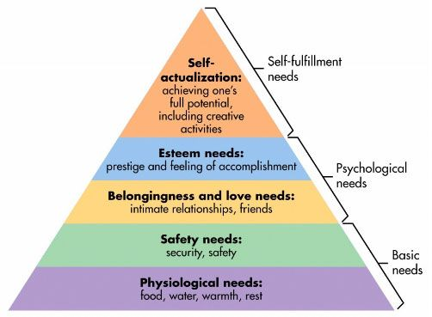

- personality
- perception
- selective exposure
-hve you seen/heard it
- selective perception
- selective comprehensive/distortion
-what does it mean to you
- selective retention
-do you remember it
- learning
- -repetition
- -reinforcment
- Values, beliefs, attitudes
  - Patterns and tastes, activities, interests and opinions
  - May show differences between consumers with identical demographic characteristics
- Lifestyle
2) EXTERNAL INFLUENCES-SOCIAL CULTURAL
• Personal Influence
- Opinion leadership
- Word of mouth
• Reference Groups
• Family Influence
• Social Class
• Subcultures
- Cultural differences: are taken into account when marketing
3) DECISION MAKING PROCESS
1. Activation
2. Search & Evaluation
3. Intention
4. Decision
5. Consumption
6. Outcome
LEVEL OF INVOLVEMENT
Key consideration:
- Financial risk (expensive)
- Personal risk (health)
- Social risk (image)
Consequences:
cognitive dissonance sort of like byers regret
- Brand examined
- Seller considered
- Attributes evaluated
- Use of eternal info
- Time & effort spent
Important for advertisers so that consumer will stay engaged when it come to advertisement instead of just ignoring of leaving room during promotion
DECISION MAKING PROCESS
• Extensive Problem Solving
- Can be high risk:not always money could be risky like bright hair dye
- High involvement
- Much info needed infrequently purchased
• Limited Problem Solving
- Involves knowing key attributes to product
- Example would be repurchase of products like laptops, microwaves
- Levels of involvemnt is there but not as great as the involvement for purchasing new product
- Ex. Buying second third laptop familiarity with product so not much time spent making the decision
- There could be development in new products such as technology updates as such requiring more research for repurchase
• Routine Response Behaviour
- Low envelopment, low risk, inexpensive, little info needed, frequently purchased
MODULE 6:…..
SEGMENTATION -TARGETING- POSITIONING
-Promotion seeks to shift demand curve
Product differentiation: To differentiate a product through marketing to make it more appealing than rivaling products in same market -ex salt can to differentiated if packaging is right
-comodity products like salt eggs are marketed through life style advertising
Market secializstion-3 ways to differentiate a product
- 3 procucts for 3 different markets
- 3 products for one vertical(market)so one market ex soft for hospitals or all kinds cosmetic products
- Concentrated marketing when one market and product is targeted
Segmentation Variables
Demographic -peoples activities, habits, likes
Psychographic -this segmentation reveals a lot about peoples buying habits
-study in 40,50s found that peoples income had little to do with the purchase of high end expensive product
-purchases where made based on personality vs. income
-most used method for understanding
Positioning and competition
Communicating and delivering chosen position
-all marketing mix efforts should support positioning statement
Brokerage Industry
-example of segmentation, positioning and communication
-Perceptual Map
-
CHAPTER 8: Developing New Products
Product life cycle
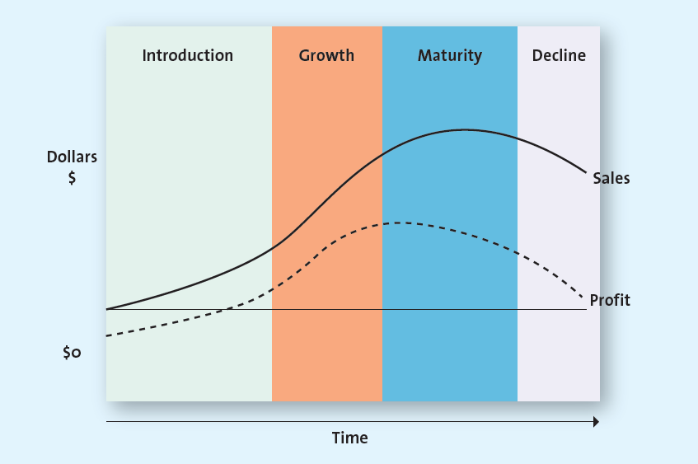
- Theory that can be applied in
- Product life cycle (PLC) NOTE In exam prof will use acronym PLC
  - Product lunches can fail
  - First stage of product launch
    - 4 stages
  - introduction
    - Introduction-if many people buy the produc them product moves to becoming a mature product example. iPhone are mature products
    - Products can decline after maturity
    - money is made after launching but most often brand cannot breakeven and make true profit until later stage
  - growth
    - growth stage is when profit is gained but at this point profit can also begin

- diffusion of innovation or consumer adoption cycle
- 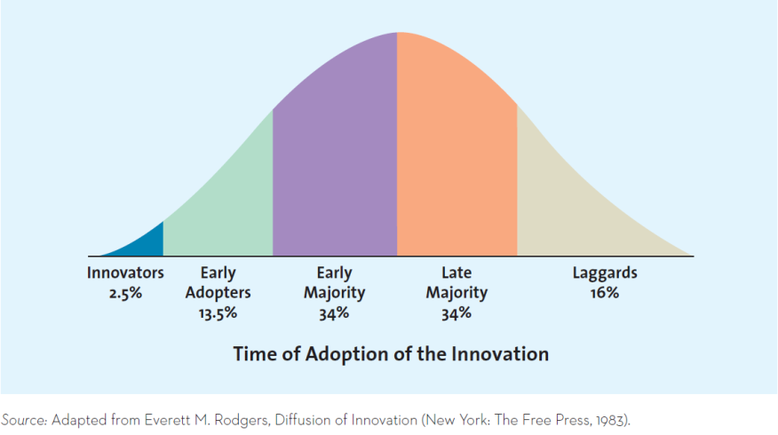
  - Adoption of innovation is the process by which the use of an innovation whether a product or service, spreads throughout a market group, over time & over various categories of adopters.
  - This is referred to a diffusion of innovation or adoption of innovation.
  - This theory helps marketers to understand the rate at which consumers are likely to adopt a new product or service.
  - As Exhibit 8.2 shows, the number of users of an innovative product or service spreads throughout the population over time & generally follows a bell-shaped curve.
  - Purchasers are divided into five groups according to how soon they buy the product after it has been introduced as shown in the exhibit.
  - diffusion how many people purchase product in the market and how quickly the product is diffused/spreed in the market
  - every consumer can be classified in these categories
  - what factors determine if product reaches main stream
    - example the microwave took 20 years to hit mainstream market
    - example the cell phone 80% of market got it after 10 years
    - example internet started 1993 hot major market 5 years
    - example washing machine took 80 years to hit mainstream market

- Innovators
  - Innovators are those buyers who want to be the first on the block to have the new
product or se r vice. These buyers enjoy taking risks and are regarded as highly

- Early Adopters
  - The second subgroup that begins to use a product or service innovation is early
adopters . They generally don’t like to take as much risk as innovators do but instead
wait and purchase the product after careful review. Thus, this market waits
for the first reviews of the latest movie b e fore purchasing a ticket, though they
likely still go a week or two after it opens. They do not stand in line to grab the
first Samsung LED Thin 3D televisions; only after reading the innov a tors’ complaints
and praises do they decide whether the new technology is worth the
cost. 30 Most of them go ahead and purchase though, because early adopters tend
to enjoy novelty and often are regarded as the opinion leaders for particular
product categories

- Early Majority
  - The early majority , which represents approximately 34 percent of the population,
is crucial b e cause few new products and services can be profitable until this large
group buys them. If the group never becomes large enough, the product or service
typically fails.
The early majority group differs in many ways from buyers in the first two
stages. Its me m bers don’t like to take as much risk and therefore tend to wait until
“the bugs” are worked out of a particular product or
service.

- Late Majority
  - At 34 percent of the market, the late majority is the last
group of buyers to enter a new product market. When
they do, the product has achieved its full market potential.

- Laggards
  - Laggards make up roughly 16 percent of the market.
These consumers like to avoid change and rely on traditional
products until they are no longer available. In
some cases, laggards may never adopt a certain product
or service.
- Using the Diffusion of Innovation Theory
  - Relative advantage(RA)- meaning that a product offers huge benefit, this prompts purchases because it is compatible with your life style
  - Compatibility- A diffusion process may be faster or slower, depending on various consumer features, including international cultural differences.
  - Observability-When products are easily observed, their benefits or uses are easily communicated to others, which enhances the diffusion process.
  - TP technical complexity-product has to be easy to use

- NOTE THIS WILL BE GIVEN BLANK IN THE EXAM, YOU WILL HAVE TO FILL IN AL BLANKS SO MAKE SURE TO MEMORIZE
- 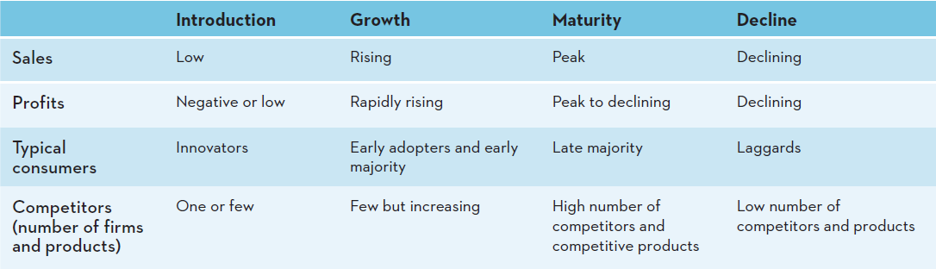

- Learn this chart Ajax said it said it important(memorize process so that it can be implemented with different products) NOTE image is only available in class
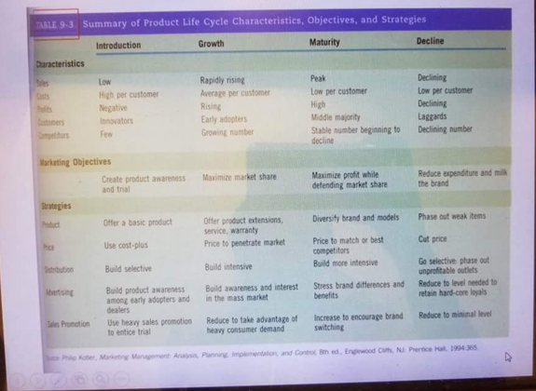

- Strategies for extending the PTC life
Note this is not in text or slides only class image

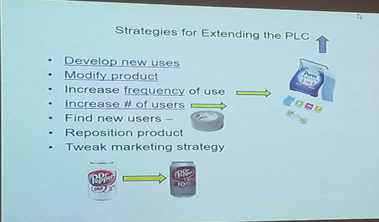
Chapter 8 continued….
Unique dimensions of service
- 4 points to service
  - intangible
    - Cues to good service
    - Cues, images, atmosphere
    - Physical cues can hint towards quality
  - inseparability
    - Two levels of inseparability
      - Level one: Service provider and consumer cannot be separated
      - Level two: you can’t separate service provider from the service received
    - Service excess cannot be stowed away like products example plain that’s not full cannot refuse to fly
    - Lower risk warranties ad guarantees
  - Inventory
    - Understand demand trends capacity management
  - Inconsistent
    - Lack of knowledge can lead to inconsistency
    - Training standardization, customized services, bundled packages, use technology

- Providing great service: the gaps model
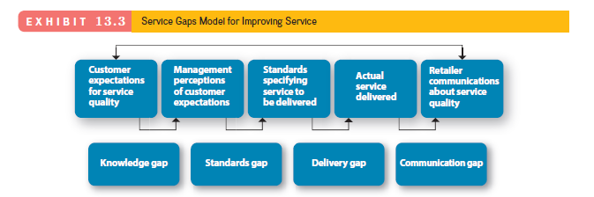
- Evaluating service quality
  - Reliability
  - Responsiveness
  - Assurance
  - Empathy
  - Tangibles
  - 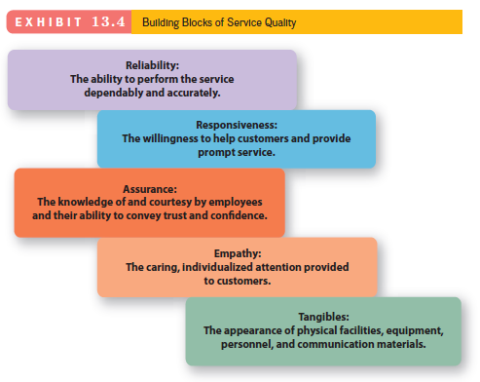
- Fixing the gaps
  - Market research, understanding consumers, employees + org cultures
  - Supporting incentives
  - Give public everything you like
    - Disney as an example all Disney employees even janitors are educated on Disney
    - Example 2 zappos its all about wow!
    - Example 3 ritz carlton go to any lengths to make customer happy
- Service recovery
  - Listen to customer
  - Resolve problem quickly
  - Provide a fair solution

Chapter 11: Pricing

- Why pricing is important
  - Major component of firm revenue
  - Influence purchase decision
  - Signals value
  - Signals quality
  - Signals a firms competitive position
  - Use to create value in creation of marketing mix
- The 5cs of pricing-firm level
  - Company objective-business objectives or orientation
    - Profit orientation- maxamize profit, target return pricing, target profit pricing
    - Sales orientation -focus on increasing sales and market share
    - Competitor orientation- focus on competitive position
    - Customer orientation focus on matching customer expectations
  - Customers-sensitivity to price changes
  - Costs- costs of inputs (factors of production)
  - Competitive-competitiveness of the industry
  - Channel members suppliers, distributers and retailers
- 2nd C: customers
  - Demand and supply -key tool
  - Price elasticity of demand
  - Elastic price sensitive
  - Inelastic (price insensitive)

CHAPTER 13

The importance of pricing
- Pricing and its importance in marketing mix
- Pricing creats value
- Signals quality or lack of it
- Consumers judge the benefits a product delivers against the sacrifice necessary to obtain it, & then make a purchase decision based on this overall judgment of value.
- Consumers recognize price as a signal. If a marketer sets a price too high or too low, the wrong message gets sent to the market.
- Remind students that price refers not just to money but also other costs such as time.
- Price is the only element of the marketing mix that generates revenue. Every other element in the marketing mix may be perfect but, with the wrong price, sales simply will not occur.
Break even analysis
- Concept of breaking eve will be on exam
If given fixed cost calculate fixed cost
The Five C’s of pricing
1st C company objectives
2nd C: Customers

4thc:competition
- Monopoly:single seller
- Oligopoly:few sellers
- Monopolistic competition-many sellers, intense price
- Competition-differentiation is key(example is apple vs. Samsung)
5th c:channel members
- Manufacturers, wholesales and retailers can have different objectives on pricing strategies
- Manufactures must protect against grey market transactions! Why?
- Msrp
- Grey market concept-not illegal, they are unauthorized-when a company like Samsung sells their and tech through best buy this is called authorized transaction. But if best buy buys over 500 tvs and Is left with 50 tvs they will look for another channel unauthorized dealer to cell the product
Macro influences on pricing
- Technological factors eg. The internet
  - Increasing info, price comparisons; growth of online auctions; increased price sensitivity; ect
- Economic factors
  - Increased disposable income
  - Increased status consciousness
  - Increased globalization
  - Local economic conditions
  - Cross-shopping
- Regular factors
  - Cost of company with gov. regulations-eg. weed sales?
  - Trade policies-tariffs, quotes, non-tariff restrictions, etc

Pricing strategies
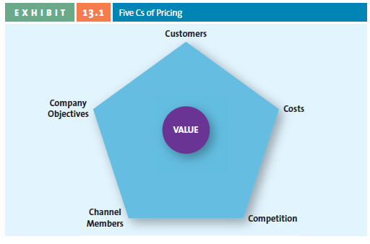
- Cost based
  - Cost-base pricing methods start with cost
  - All costs calculated on a per unit basis
  - Assumes costs don’t vary for different levels of production
  - These simple methods add a percentage amount to the unit cost to derive the price of the good.
  - Ask students: Its simplicity is the major benefit of this method; what are some of the potential problems associated with it?
  - It does not consider what the value the customer places on the product or service.

- Value based
  - setting prices that focus on the overall value of the product
  - comsumer perception
  - Sellers need to determine consumer value perceptions.
  - 1. Improvement value method – Determine the price that could be charged for a new laptop. Suppose the key features were – weight of the laptop, processing speed, hard drive capacity and battery life. The improvement value of the new laptop on these four features can be calculated and the benefits weighted to determine a price.
  - 2. Cost of ownership method - Installing solar panels on a home is costly, but the savings over the life of the panels make the cost much lower than traditional electric power. Governments offer incentives that lower the initial investment, in hopes that more homeowners will switch to using solar power. Ask students: What incentive would you need to do so? What method could you use to determine it?

- Competition-based
  - Set pricing information of how product compares with competitors
  - Premium pricing
  - An approach that attempts to reflect how the firm wants consumers to interpret its products relative to the competitors offerings

New product pricing strategies(image only available in class)
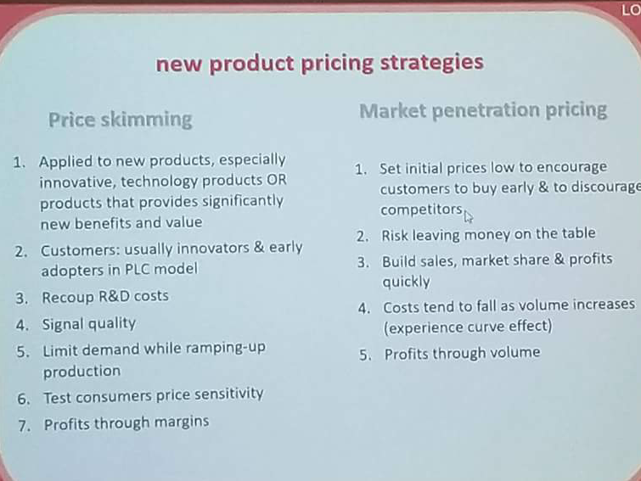

Psychological factory affecting pricing strategies

- Understanding the psychology underlying the way consumers arrive at their perceptions, make judgments, & finally invoke a choice is critical to effective pricing strategies, so marketers must examine some of the more important psychological processes that influence consumers’ reactions to & use of price.
- This slide introduces the subsequent series of slides or can be used as a basis for a shortened lecture.
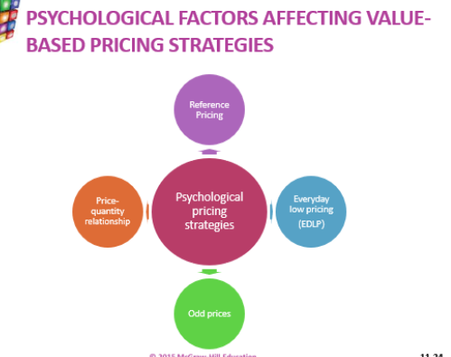
- Reference pricing
  - Internal
  - External
- Everyday low price(EDLP)
  - VS. High-Low Pricing
- Odd prices

Consumers’ use of reference prices
- The price against which buyers compare the actual selling price of the produt and that facilitates their evaluation process
- The reference price is usually regular or original price
Consumer pricing tatctics
- Price lining
  - Price floor and price celling-offer multiple versions of producst enable easy comparison
- Price bundling-
  - encourages stock up
  - Encourages sales slow moving items
  - Encourages trial of new brands
- Leader pricing
  - Leader pricing is a tactic that attempts to build store traffi c by aggressively pricing and advertising a regularly purchased item, often priced at or just above the store’s cost.

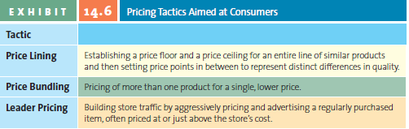
B2B Pricing tactics and discounts
- Seasonal discounts
- Cash discounts
- Allowences
- Quantity discounts
- Uniform delivered vs. Geographic pricing
Legal and ethical aspects of pricing
- Deceptive pricing
- Fixed pricing
- Predatory pricing
- Price discrimination
Retailing
General merchandise retailers
Note make sure you know the slide image provided as it may be used in multiples choice questions for exams
- Discount stores
- Specialty stores
- Category specialists
- Department stores
- Drugstores
- Off-price retailers
- Extreme-value retailers
- Many general merchandice retailers sell through multiple channels, such as internet and catalogues
The wheel of retailing
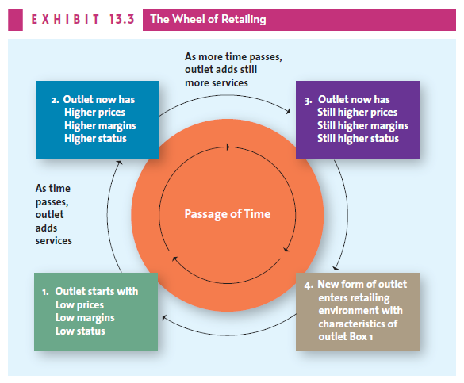
Overreaching retail strategies
- Put customer and centre of strategies
- Influence customer to carry your dialogue
- Present product as customer solution
- Align channels to customer shopping journey
- Established customer-focused, cost-effective operations
Benefits of the internet and multichannel retailing
- Deeper and broader selection
- Personizing(eg. Stitch fix-site that send you a box of clothes and you pick the ones you like)
IMC channels and tools
- Imc is the promotion dimension of the four P’s
- Uses a variety of communication methods
  - General advertising
  - Personal selling
  - Sales promo
  - Public relations
  - Direct marketing
  - Digital media
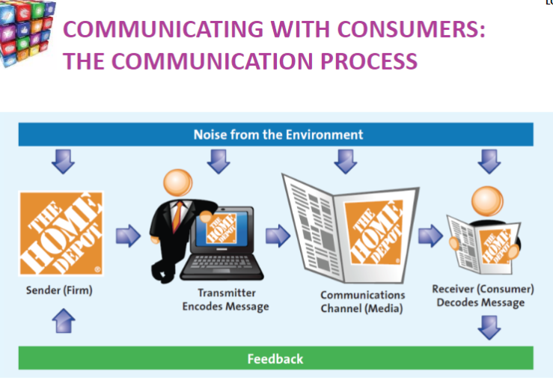
7 steps in planning an imc aor ad campaign
Step 1 identify target
Step 2 set goal-what you want to achieve
Step 3 determine ur budget how much money to spend
Step 4 determine the message value position, moral, emotional, thinking
Step 5 choose media -compare and select appropriate media

- Identify target audience
  - Campaign success depends on how well the advertisers can identify the target audience
  - Research is condicted
  - Info gathered sets tone of the ad and media selected
- Goals of campaign
  - Examples-trails, increase sails
  - Increase brand recall
  - Introduce products, increase trials, increase sales

Group project 2 in class notes
Implementation plan-
Table showing activities that are needed to start business,
- Activity
  - finding location, and dates for doing this, who is responsible for this (write names), money resources needed for this activity
  - launch day-flyers to be sent out, food for launch, money for launch day, who is responsible list names
Financial
- revenue-year one to year five-how much money you expect to make-eg. First year open this many hours, this many people working, we will charge this amount per client (place details in appendix)
- estimate costs for items needed for the centre (note ajax said making up these prices would equal a D) so try to get accurate numbers by checking fitness websites for machine prices
Customer analysis
- why clients will come to our location customer analysis-do they come because of insurance
- data from other sources eg. Tables make sure you add citation under the table you may end up creating
Segment
Place
- Describing location, place (lots of parking, central area, nice bright store, spacious, relaxing , area for kids), is it in urban area?
Promotions –
- Completive analysis- cant be for of Ottawa, 90% of customers will be from within a certain radius of our store location
Positioning
- -how we are perceived relative to competition, how we differentiate and compare from our competition
Charts
Small and readable, add some as they will make project more interesting, make sure to add citations under graphs or in appendix

