If uottawa email does not work use email: lstinson@bell.net

Canada was first country to illegalize environmental harm. Criminal legislation.
50s-70s did not see extreme poverty and homelessness as acceptable. 80s shift from unacceptable to who cares (an individual failing). 1982 first homeless shelter opened. Ideology change- moved from public good to individual good of people who were more capable able to compete and contribute.

http://laws-lois.justice.gc.ca/eng/acts/c-15.31/

Final exam is not cumulative except article from this week (Cohen)

Social and Criminal Policy

Media is a cultural conduit, a funnel from where we receive things.
Good news sources: The guardian, New York Times, Al jazeera, John Oliver

Crime Politics, Ideology and the Allocation of Value

***Cohen’s article sets up the class, the relationship between crime and politics because of big scale ideologies, what we see is important problematic and how we allocate value. What we think of as crime.
Tools: policy, response ( criminalization etc..)

Policy
Expression of purpose or desired state:

Homelessness now: respond to everything the homeless do as it’s a criminal problem, assumption is they are dangerous. We do not respond to homelessness, we see it as inevitable.
Mental health and drug and alcohol issues are common in homelessness due to coping/an escape/self medicating. Becomes a municipal problem where we give the problem to the police.

Majority of people who vote in Canada think we have a generally good society. (Age group who votes Elderly) See certain people as problematic, and areas as more problematic.

- Specific proposals: talking about a specific act.

- A field or area of government activity:
Policy spaces economic policy criminal policy
growing polarization of the social classes (bigger gap).

- Decisions of Government- Exceptional moments do result in real change: 9/11 policy shifted radically, who we saw as citizens, rights and liberty to be decimated.

Formal Authorization: cabinet and only cabinet makes changes bring bills to parliament and is passed. A Lot of decisions are made before it makes it to be seen. Lacks legitimization

Policy Program:
Policy Output:

Policy Outcome: Disconnect between goals, or promise and the actual practice. Takes time for a cultural shift.

Policy Process: the political process it is actually going through. In which our entire government runs.

Policy Analysis: Can be just talked about, does not need to be acted on. Poverty is not a political issue at the policy level but can still be talked about and analyzed.

Policy is whatever government decides to do or not to do (which is more common, decided not to do something).

John Oliver “Prison” example of Cohen’s article

When Obama was president, The United states was trying to move away from privatization of prisons. There's only so much the tax system could bear. Privatization is paid by taxpayers.

Crime, Culture, Justice, Politics and Policy

- Crime as social phenomenon
- Recognizing and seeing someone as criminal is inherently a social process.
  - Who and what is defined as criminal
    - How society responds
  - The place of crime in popular culture
- Fundamental responsibility of government
  - The reason d’etre for the modern state
- Criminal policy or social policy?
  - Spot the difference
  - How does what we define as crime relate to how we practice and organize our politics?
    - Political participation & democracy
    - The economy & societal priorities
    - Harm, danger, rightful response

Crime is inherently political. A social identification.
Reason the state is here we all agree to have the authority of the state to keep us safe and secure. In any society the gov’t is there for law and order.

First Nations population is over policed than African American’s in the united states

Negligent manslaughter
- Workplace deaths are considered crimes; however, the only ones that are counted are in which the employers are criminally negligent
- DUI
The way we see danger is how we respond.

Causing death by criminal negligence
220 Every person who by criminal negligence causes death to another person is guilty of an indictable offence and liable
- (a) where a firearm is used in the commission of the offence, to imprisonment for life and to a minimum punishment of imprisonment for a term of four years; and
- (b) in any other case, to imprisonment for life.
- R.S., 1985, c. C-46, s. 220;
- 1995, c. 39, s. 141.

Domestic assault is not considered a crime in Canada; it is considered common assault
Domestic violence and sexual assault rates are rising, especially for this age group. University is not the most dangerous place for sexual assault; in fact, women in university are less likely to be assaulted than women who are not

Domestic violence protection laws in ontario
https://www.ontario.ca/laws/statute/S00033

Crime & Politics

- Why crime and politics?
  - Politics and criminology intimately and inevitably connected
- Cohen suggests a number of ways that politics influences criminology
1. Hidden politics of criminology:
  - Development of the field and key theoretical assumptions were influenced by political realities, although these were often not explicitly acknowledged
2. Politics of law and social control:
  - Criminalization and enforcement are functions of the state, and social control institutions were established by the state; thus, these have an explicitly political nature, which criminological theories must account for
  - https://www.youtube.com/watch?v=0V5ckcTSYu8
John oliver (the Canadian Election) October 18, 2015

Increase of economic stressors = increase in domestic violence
90% is perpetrated by men, but men are not inherently violent, how can someone get away with corporate harm.

Social control= political control

Influence of Politics in Criminology
3. Political nature of crime:
  - Certain criminology theories expressed crime as a feature of capitalism – either the criminal as political actor/class revolutionary/Robin Hood; or more commonly via the notion that capitalism is criminogenic
4. Defining crime to include crimes of the powerful:
  - Extension of the definition of crime beyond a narrow legal base, to include social harms
5. Politics of personal life:
  - Making the personal political – this idea influenced social movements such as the women’s movement, that led to new ways of conceptualizing power, linking masculinity with violence, and deconstructing the boundaries between public and private space
7% vs 6% is the difference between women and men in domestic violence

Conflict tactic scale measures all violence as equal and the same.

***Capitalism as an economic system produces crime.***

It is believed that if capitalism was taken away, crime would disappear.

Cohen Highlights the Reverse: The Influence of Crime in Politics

1. Crime as a political issue:
  - The political discourse has made great use of crime in recent decades, and distinct political approaches have evolved to crime as a political issue (e.g. conservative and liberal)
  - Political issues include the actual incidence of crime, the public perception of the seriousness of crime, and the rhetorical manipulation of the crime problem and public anxiety
  - John Oliver on Ferguson & militarization http://www.youtube.com/watch?v=KUdHIatS36A&index=3&list=PLmKbqjSZR8TZa7wyVoVq2XMHxxWREyiFc

Relationship between crime and crime as a political issue. Politics in Criminology as a discipline vs crime in politics

Crime statistics since 1978 on a steady decline in Canada.

***Public perception about crime is usually based on the media (What drives crime?)

Crack was smoked by poor african americans. Snorting cocaine were rich white men. Class issue about how charges are carried out by the law and are discriminating.

Harper's crime deals in Canada; mandatory criminal sentences.

2. Corruption and legitimacy:
  - Political corruption and the abuse of political power for greed, etc. have long histories; they all lead to problems of legitimacy for governments.

We expect our political leaders to be corrupt, we respond that is it is normal.
Marxist or a Political economist

3. International criminal organization
  - International criminal networks (drug cartels, illegal arms dealers, etc.) move large amounts of resources around the world that is uncontrollable by sovereign states, and can influence national economies and the internal affairs of states (esp. poor states)
  - this can subvert legitimate politics by rackets immune to conventional crime control; and force states to re-deploy resources towards combating these activities.
Influence of Relationships between legal and illegal organizations (drug and alcohol industry, weapons industry, financial industry, sex trade industry) in the political system. Highly profitable

4. Crimes of the state – revisited
  - “Human rights violations” – genocide, other atrocities – by states against their own citizens (or by rebel political groups) can be portrayed using the language of crime
  - Is the punitive criminal law model a useful or effective response to these actions?
- We see crime as individual instead of systemic, state taks about it like it's a one off.

5. The new victimization
  - In rich countries, citizens discover ways they suffer human rights violations by state policies (or lack thereof), and claim victim status seeking criminal/legal redress, organized social movements; the personal has become political, in ways never originally intended by that phrase
  - https://www.youtube.com/watch?v=Q9gZ5mtVmD4 (2.5 mins)
  - https://www.youtube.com/watch?v=EDl7-JpoQ7Y (15 mins)
Tom Perkins Leave the Rich Alone!!! Why Do Billionaires Feel Threatened?
  - http://www.youtube.com/watch?v=Apuvlg8nYVo
6. Criminalization of political conflict
  - Political revolt since the end of the Cold War has often not been based on ideology, but rather has responded to the collapse of social structure with crime and lawlessness; criminological explanations of these conflicts can be relevant

The chances of being a victim of terrorism was higher in 1972 than it is now

The new victimization split
- Warren Buffett (argued that the rich should pay tax)
- Stan Cohen
- George Orwell

Political language is used to make lies sound truthful and murder respectable
Orwell: Seeing through the “defense of the indefensible”

Structure of Canadian ‘Democracy’ (Need to know for exam)

- Structure: array of organizations by which and through which policy is made and influenced
- Westminster Parliamentary System
  - Responsible government and party discipline
  - Majoritarian vs consensus parliamentary systems
  - Majority, minority & coalition governments
  - Elected chamber (House of Commons) & appointed chamber (Senate)
  - Constitutional Monarchy
    - Head of state (Hon. David Johnston) vs head of government
  - Executive Dominance
    - Focus on Government Political Executive
      - Prime Minister and Cabinet
      - Collective role of Cabinet
      - Central agencies
- https://www.youtube.com/watch?v=EGOfP_XvJPM (Rick Mercer)
- https://www.youtube.com/watch?v=b16IssAxJfA&list=PL664B572494CF4D29 (Russell)

***Prime Minister and Cabinet ON FINAL EXAM***

- ***the centre of the policy process***
- responsible to the elected Parliament for new and on-going policies and programs
- Prime Minister (PM):
  - elected head of the political party with majority support in the House of Commons
  - power to dissolve Parliament; hire and fire Ministers; appoint Deputy Ministers and heads of agencies and boards (review boards, mental health boards, energy review board)
  - doesn’t have complete control - instead must be shrewd in exercising power to push forward strategically important items

- http://www.youtube.com/watch?v=0BifNYKsLlE
(parliamentary democracy for dummies)

***Fill in the blank QUESTION ON EXAM: The Prime MInister and Cabinet are the centre of the policy process.*** Matching quest for role of cabinet etc
Absolutely everything goes through cabinet.

Cabinet

- Comprised of Ministers, appointed by the PM centre of the process, has his own office
- Responsibilities:
  - provide leadership on government’s overall direction
  - authority to take decisions on all major policy issues and government commitments
  - accountable to the PM and the public, through parliament PM has the ability to fire and hire, party discipline
  - solidarity with Cabinet colleagues cabinet solidarity, public disagreement

Collective Role of Cabinet

- a collective, political decision-making body:
  - collectively responsible to Parliament for overall government policy
  - individual Ministers responsible for their own portfolio
  - rough formal equality of all Ministers, but some in reality carry more weight (PM foremost, then central agency Ministers)
- also serves as legitimating institution:
  - must appear to represent Canadian diversity (regional, ethnic, gender)
- linked to operations of government
  - draws together politics, policies and administrative consequences
- most work done in Cabinet committees
- operates on important norms and traditions:
  - Cabinet solidarity, confidentiality
  - Ministers debate policy behind closed doors; but once Cabinet decides, all Ministers must publicly support the Government
- responsibility for particular legislation and programs assigned to individual Ministers and departments
- formal organization of Cabinet (machinery) changes on a periodic basis – often after elections
- key policy spaces grouped by theme in Cabinet committees, but some policy issues cross boundaries
  - Ministers are usually members of more than one Cabinet committee
  - aside from Cabinet committees there are also similar committees among DMs or other senior bureaucrats
CABINET = MOST POWERFUL INSTITUTION IN CANADA

The prime minister and the cabinet are the centre of the policy making process (EXAM QUESTION)

All policy decisions go through cabinet
Historically most important minister (next time PM) is finance minister; however, under Stephen Harper, that changed to head of the treasury board
Canada now has gender parity. Trudeau doing this is not that great it's supposed to always happen 52% of pop is female.
Cabinet is supposed to represent Canada. Canadian diversity; regional ethnic gender
Many immigrants (including white people from Ireland and other European countries) were not considered citizens in Canada for a very long time
Omnibus bills (covered everything) in the Harper gov’t

Cabinet Committees June 2014

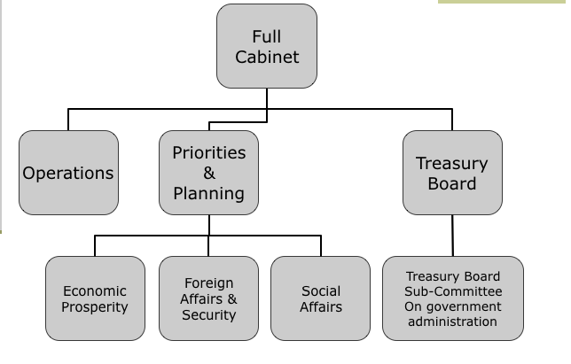

Cabinet committees reflected priorities

Cabinet Committees August 2017 deletion from 2016 in white box

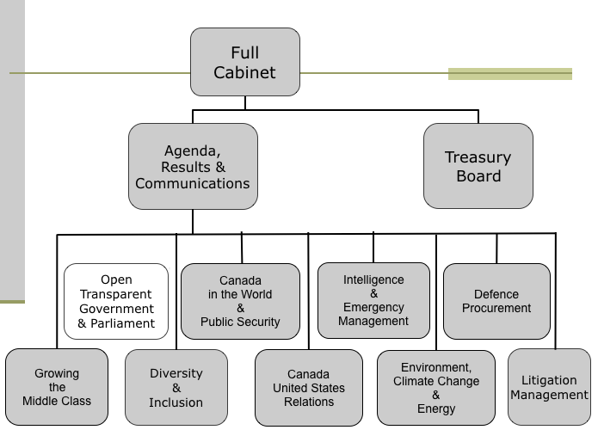

Ministerial Skills & Relationships

- relationships between Ministers and their senior bureaucrats, and in particular with central agency Ministers, will have an important influence on whose priorities move forward, and are funded in the Budget
- a Minister’s reputation determines their standing in Cabinet: their effectiveness, what they get done, how well they fight for and argue their case, intellectual prowess, popularity, ability to be a team player, etc.
- relationship between Prime Minister and Finance Minister is particularly important:
  - Finance Minister designs the Budget - the primary policy statement of the government each year
- regional concerns and ideological alliances also come into play

Central Agencies

- Three central agencies (central to the policy-making process):
  - Privy Council Office (PCO)
  - Department of Finance
  - Treasury Board Secretariat (TBS)
  - Prime Minister’s Office (PMO) is a quasi-central agency, but not a department - just political
- Key roles:
  - custody over central cross-cutting activities of government
  - cooperation with each other due to overlapping roles
  - offer great influence in government policy to their bureaucratic heads
- Power of these central agencies is sometimes cause for concern, but must be viewed as part of the overall balance of forces and groups in policy-making

All policies go through the three agencies PCO, DoF, TBS

****Privacy Council Office (PCO)
Current clerk: Michael Wernick
- Dual role:
  - Prime Minister’s department
  - Cabinet Secretariat, responsible for absolutely everything, in charge of administering everything, making sure all papers get to cabinet. High level secrecy.
- Provides strategic policy advice, policy coordination
- Management of Cabinet:
  - protects integrity of decision-making
  - Cabinet and Cabinet committee meetings
  - briefs Cabinet/committee chairpersons
  - records decisions and informs the government
- Ensure coherence with government’s broad agenda
- Challenging and enabling departments to achieve their policy and program goals within the government’s broad policy framework

Department of Finance
Current minister: Bill Morneau
- Government’s primary source of advice on economic and financial affairs
- Responsibilities:
  - prepares federal Budget
  - develops tax and tariff policy
  - manages federal borrowing
  - administers major federal transfers to provinces and territories
  - develops financial regulatory policy
  - represents Canada at international financial institutions such as IMF, World Bank, etc.

Prime Minister’s Office

- Political staff
- Supports the PM’s:
  - Political strategy and tactics
  - Proirites
  - Political dimensions of policy initiatives, problems, etc,
  - Coordination of PM’s agenda and travel
  - Communications
  - National political liaison

Treasury Board Secretariat
Current president (and chair): Scott Brison
- Oversees the implementation of public policy, ensures accountability, “guardian of the public purse”
- Responsibilities:
  - comptrollership
  - financial management
  - ensures that departments meet all requirements for expenditure planning, control and oversight
  - assesses policy proposals for due diligence and value for money
  - on-going monitoring of expenditures and reallocation of spending from low to high priorities

On the increasing centralization of Power and Authority

In August, 2007 Harper responded to criticism that too much power is concentrated in his hands, at the expense of Cabinet. "On very, very rare occasions would I make a decision on a policy matter—as opposed to just routine, machinery of government issues—would I make a decision on a policy matter unilaterally," he told reporters. "On all but a very small number of issues, there's been a very, very broad consensus in our Cabinet. I don't think I've ever been in a position where I've had to really force a decision through on one group of people or another." www.thecanadianencyclopedia.ca

Government Departments

- many departments (30+), regularly reorganized
  - 30 ministers
- exert continuous “bottom-up” and horizontal pressure on the policy process …
  - demanding new policies, resources, legislation
  - opposing other departments from scooping too many resources, or acting against its particular interests
- legally responsible for their mandate
  - enforce legislation in their area, sometimes alone, sometimes jointly with other departments
- bundles of programs, possess unique cultures and traditions
  - tendency to preserve the status quo with respect to their legislation, and their own existence and independence

Public Safety and Emergency Preparedness
Current minister: Ralph Goodale (not needed to know for midterm)

- Brings together several previous groups, for the purpose of “securing the public health and safety of all Canadians, while ensuring that all Canadians continue to enjoy the benefits of an open society”
- Rationale for structural change: “integrate federal activities under strong leadership, maximize the effectiveness of interagency cooperation, and increase accountability to all Canadians”
- ****Partial fill in the blank on midterm: Organization overview: the portfolio includes the Department, and five agencies:
  - RCMP
  - Canadian Security Intelligence Service (CSIS)
  - Correctional Service of Canada (CSC)
  - National Parole Board (NPB)
  - Canada Border Services Agency
  - Also 3 independent review bodies
- role: supporting the Minister in giving effective direction to the above agencies

Criminalizing social policy, crime is things we make illegal or what we see as a violation of law and order

Public Safety Canada (PSC)

- *Mandate is to keep Canadians safe from a range of risks such as natural disasters, crime and terrorism
  - Coordinates and supports the efforts of federal organizations ensuring national security and the safety of Canadians
  - Works with other levels of government, first responders, community groups, the private sector and other nations
- Delivers a range of programs designed to protect national security, improve Canadians’ collective capacity to handle emergencies, combat crime and promote community safety
- Policy areas include:
  - Corrections
  - Emergency management
  - Law enforcement
  - National security
  - Crime prevention (see presentation on National Crime Prevention Strategy)

2001 crime statistics in Canada have not been growing been on a steadying decline but since 1978 gap between rich and poor.
Break and enters since 1978 most steady decline category
Domestic assault and sexual violence is on the climb
4% of population indigenous

Department of Justice
see course pack for key reading
Current minister: Jody Wilson-Rabould
- Key roles:
  - works to ensure Canada’s justice system is fair, accessible, and efficient as possible
  - helps the federal government to develop policy, and make and reform laws as needed
  - also acts as the Government’s lawyer - providing legal advice, prosecuting cases under federal law, and representing the fed gov't in court
  - Minister thus responsible both for policy issues, and also serves as the Attorney General (Chief law officer of the Crown)

Key Functions and Policy Areas (Department of Justice)

- Providing legal advice, and drafting laws:
  - prepares bills to enact new laws approved by Cabinet
  - examines all new legislation in detail for consistency with the Charter of Rights and Freedoms
  - examines draft regulations to ensure they are legally valid, and take into account both of Canada’s legal systems (rule-based civil law in QC, precedent-based common law elsewhere)
- Making policy:
  - active in developing justice-related policies
  - incorporates Canadian values into policy proposals, such as fairness, and access to the justice system for all

Civil law is in Quebec

Provincial Governments

- Many similarities to federal structures, but important differences as well
- Constitution confers different powers to different levels of government
  - Some common policy spaces; some different
  - Criminal and social justice policies can be formulated at each level of government
  - The federal government is explicitly responsible for criminal justice, and penitentiaries
  - The provinces’ powers include the administration of justice, prisons, and social services
    - Provinces administer social services, provincial correctional facilities for adults and youth, etc.
- Head of provincial government – Premier
- Cabinet - similar to federal Cabinet
  - Cabinet solidarity, Deputy Ministers
- Certain core agencies/ministries exist, varies by province
  - Finance & provincial budget

Priorities and Mandates

- government regularly sets and announces priorities:
  - Speech from the Throne (SFT)
(Key policy statement of Government’s intentions in a new Parliament)
  - annual Budget is main statement of government policy every year (where the money is…)
  - other opportunities such as international meetings, special ‘ad hoc’ speeches on timely issues
- setting priorities is intricately tied to the government’s mandate
  - this includes relegating issues it doesn’t want to deal with to the backburner
  - e.g. the Liberal ‘Red Books’ (vols. 1, 2, and 3 in ‘93, ‘97, ‘00)
  - Tories’ five initial priorities
    - child care; lower taxes; accountability; crime; health care
- Political approval translates an idea into a political mandate, an internal notion into an external action
- political planning cycle normally lasts at most 3 years (then government begins gearing up for election)

Budget will lay out what they are going to do

Cabinet Papers

- Two basic types of Cabinet papers:
  - Cabinet documents: memorandum to Cabinet (MC), draft bills, agendas and minutes of Cabinet and Cabinet committee meetings, committee reports, Records of Decision (RD)
  - other Cabinet papers - including discussion papers
- Cabinet documents are secret
  - debate kept behind closed doors, to ensure Cabinet solidarity
- main Cabinet doc is the Memorandum to Cabinet (MC)
typical path by which a Minister brings a policy issue to Cabinet
  - Once MC approved, Dept. of Justice drafts a bill
  - Finance drafts Budget and tax bills
  - Then bill introduced to the House of Commons
    - Political process to confirm the policy
  - Once approved by Senate with no amendments, bill is passed
  - Royal Assent

Abortion is legal in canada because senate refused to let it go through it would be a violation of women's fundamental rights under the charter

Legislative Process

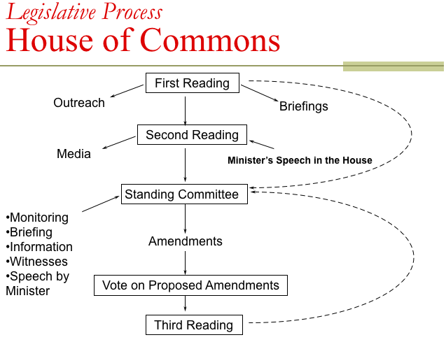

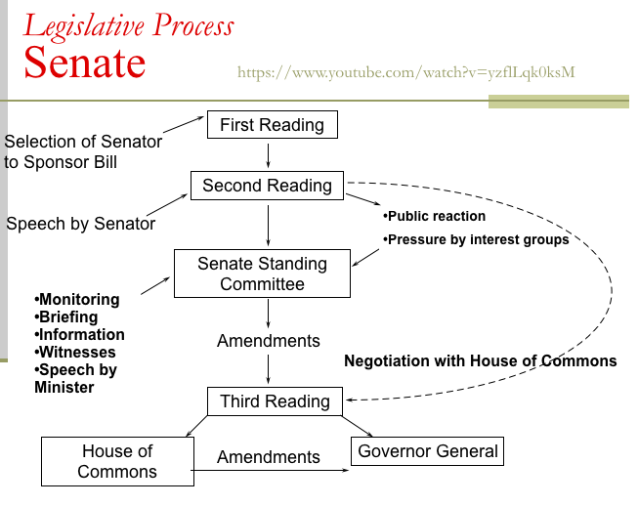

1927 marijuana became illegal

Priorities and Mandates

- Despite electoral mandate, governments often fail to keep their actual promises
- A number of reasons:
  - will for political survival and to stay in power - can cause politicians and governments to change priorities almost instantly to maintain voter support
  - lack of prior information, knowledge, and abilities necessary to actually make desired policy outcomes a reality
  - scarcity of resources and competing priorities
  - new demands that arise from sources both external and internal to the federal government
  - old priorities resurface to get re-packaged and pitched in a new form
  - Structural questions …
  - or ...

Juristat
OCT 30th will be day UofO will most likely go on strike

******MIDTERM QUESTIONS*******
- Always two questions on cohen relationship on criminology and politics and politics in crime
- How structure influences politics and policy
- Big gov’t departments in criminology: (1) Public safety and emergency preparedness (Crime Protection canada federal level). (2) Department of Justice
- Fillin the blanks or t/f:
  - Five agencies in Public safety and emergency preparedness
  - Rationale for structural change came out of : SARS, 9/11, Hurricane Katrina
  - Speech of the Throne
- The prime minister and the cabinet are the centre of the policy making process (EXAM QUESTION)
- Capitalism as an economic system produces crime.

Theories and Practice Framing Process, Place and Objectives

A good theory has to be testable and have the capability to be questioned.

Making Connections and Making Sense- Thinking theoretically

- misconceptions about theory:
  - We should not confuse a theory with its subject matter; we can develop a good theory about a very unpleasant subject
    - Need to be aware of the difference between a normative theory (about how things ought to be), from an empirical theory (about how things actually are)
    - There are many different types and categories of theory; to understand a theory, we need to understand what type it is
  - We should not treat theories as an end in themselves; they are simply a tool we use to help us understand an important problem
  - Although many theories appear verbose, it is important to carefully define the terms we use or create in describing a new theory about a given social problem
  - Theory construction is not a mechanical exercise only for those who love computers and data; it begins as a contemplation of some real problem, and being creative in trying to understand it

Criteria for Guiding and Evaluating Theory

- Validity
  - A theory must be an accurate representation of the reality it attempts to explain
  - not the same as verification, which is a test to ensure that the model has been synthesized exactly as intended
- Economy
  - A theory must be simpler than the phenomena being studied
  - Need to balance complexity and simplicity, and determine which variables must be included, and which can be omitted
- Testability
  - Must be able to measure the phenomena described by the theory, and test predictions of the theory
  - Can test using quantitative or qualitative methods
- Organization/Understanding
  - Good theory brings order to what would not be explicable, and helps us structure our knowledge
- Heuristic
  - Acts as a catalyst to guide further research; helps direct our research course and information uptake
- Causal explanation
  - Good theory answers the question “why?”; uncovers causal relationships that might have been overlooked
- Predictive
  - The best theories identify causal relationships and predict them into the future, and the predictions fit with empirical data
- Relevance/usefulness
  - Needs to address important problems, and provide insights and understanding that cannot be obtained otherwise
- Powerful
  - Offers a large number of nontrivial inferences – i.e. powerful theory explains a lot; generalizable to many different cases
- Reliability
  - Repeated tests yield similar results (i.e. replicable); successive re-examinations can reveal errors and bias in a theory
  - Social theories much harder to replicate than physical theories
- Objectivity
  - Debate exists about the role of values in shaping theory, and whether theory should aim to be objective
- Honest theory
  - Good theory should make clear the relationship between the values of the theoretician, and the concepts in the theory; a scholarly theory must aim to inform, not to prejudice

History of Policy Studies and Analysis

- Study of public policy/government has existed for a long time
  - E.g. Plato explored the nature of governance
- Nature of studies changes in mid-20th century
  - WWII
  - Lasswell’s (1951) ‘policy science’ (6 characteristics):
    - Interdisciplinary – social & natural sciences
    - Empirical – ‘critical’ empiricism
    - Megapolicy – big questions
    - Necessity of Theoretical complexity
    - Applied value
    - Normative/prescriptive – in the interests of prevention of ‘politicization’
  - policy studies failed to catch on in academia until late 1960s
- By late 1960s academic terrain was ripe for a scientific study of public policy:
  - Need to understand the effects of Great Society social programs of Lyndon Johnson in the US
  - “Increasing magnitude and intractability of challenges facing western industrialized societies” led decision-makers to seek help from social science research…
  - …but much traditional academic work was not very useful for applied policy research, because it lacked many of the key characteristics Lasswell had identified
- A significant growth period in policy research then erupted, leading to new models, methodologies and approaches for studying public policy
  - Limitations emerged
    - Failure of actual programs to work as predicted by policy analysts;
    - Backlash against central planning;
    - Research that was too ideological/descriptive, or too technical and not useful

Policy Theory Today

- Why still no unified approach to policy analysis and studies?
  - Nature of the problems
  - Geo-political, social and economic contexts
- Why no agreement?
  - the subject is too diverse, number of variables too many & relationships too complex for a single theory
    - Politicization
    - Evidence gathering
    - Limitations in time lines
    - Nature of the subject matter
  - lack of true multidisciplinary perspectives
    - Nature of academia
    - Ideology
    - interests

Theories of Policy Making: Constructing our Understanding
- All theories of policy-making are rooted in different values and analytical concerns
- They have different assumptions about
  - the major actors in the policy process
  - the nature of society and politics
  - the role of government-state relations
  - the interests served by policy outputs
    - Ideally they will help explain,and predict, behaviour
- Micro-level theories:
  - Focus mainly on making of individual policy decisions, and how best to achieve the goals of government action
  - So they focus on the ‘how’ of decision-making, but not the ‘why’ of what government priorities are selected
- Macro-level theories:
  - Focus on broader patterns of public policy as part of the relationship between state and society

Systems Theory Easton (1965) All macro theories are system theories

- Application to politics and policy-making of the development of ‘systems theory’, applied to many different fields around mid-20th century
  - Developed originally to help solve planning/resource allocation problems during the war
- Political system allocates values throughout society through interactions amongst all elements of the system: i.e. political system, external environment, etc.
  - Takes in inputs (demands, support) and produces outputs (policies, decisions, actions)
- Key insight is that external environment (social structure, economy, culture) undergoes changes and stresses, that are transmitted to and impact upon the political system
  - Goal is to describe these interactions between the political system and its external environment, in a general way – i.e. so we don’t need to reinvent an analysis to describe every particular interaction as unique
- Describe all the complex interactions, that flow across system boundaries, via a few key indicators:
  - Outputs (decisions and policies) from the political system act as inputs to influence the environment; within this system, internal processes act on these inputs to produce new outputs back to the political system, and so on…
- Can characterize the inputs (transactions and exchanges) to the political system as:
  - Demands: will arise in the environment (culture, society, economy) that the political system could be expected to address, by generating solutions
  - Support: conditions within the broad environment necessary to allow the outputs of the political system to work, or not
  - Internal influences and interactions within the political system also play a role in determining outputs
  - Examples of these inputs: urbanization; fluctuations in the business cycle; development of interest groups; rise in desire for material goods

We think crime is a rising problem because it is majorly politicized.
Rise in 1970s pertains to youth crime, first time we had large number of youth that had leisure not just going to work like everyone else.
Now a lot of that has been disputed.

Discrimination towards rationalized people
- First Nations people were not acknowledged as actual human beings till 1967
- African American’s are not more likely to be victims of police brutality once picked up; the chances of being picked up without reason are higher instead. However, police brutality happens almost equally to everyone who is picked up.
- Incarceration rates of black people have gone up steadily through the years
- Middle class people are more likely to commit acts of terrorism, yet this group is not heavily policed
- Define the political system as a distinct entity with boundaries, within the broader environment

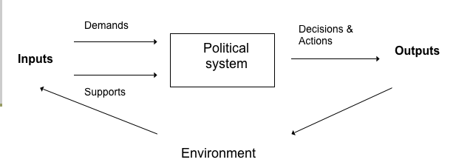

Policy Process as Rational Policy Stages-

Rational Model I

- Simple, idealized “process” model of regularized cycle of behaviour that policy actors need to work through or around
- There is not one single model of policy stages; this model of policy development as a process with stages has more, and more specific, stages than some others:
  - issue search or agenda setting
  - issue filtration
  - issue definition
  - forecasting
  - setting objectives and priorities
  - options analysis
  - policy implementation, monitoring and control
  - evaluation and review
  - policy maintenance, succession, or termination

Rational Model II

  - identification [articulation of a concern or issue]
  - definition [problem shaped or confined to practical limits]
  - alternative search [assess all possible ways to solve the problem for effectiveness and efficiency - including status quo]
  - choice [real resources must be committed or rejected]
  - implementation [form depends on problem - could be new legislation, regulation, order-in-council, expenditure, etc.]
  - evaluation [determine if objectives met; obtain feedback and make corrections if necessary]
- Bureaucrats have most influence on the policy process at the definition and alternative choice stages
  - ideas, facts, myth and rhetoric all in play as problem is “massaged”

Rational Comprehensive Model****

- This process produces ‘rational’ decisions (most efficient and effective means to achieve a particular end)
    - identifying the problem
    - ranking their objectives, values, goals
    - examining costs and benefits of alternate means to reach objective
    - comparing these different alternatives
    - selecting the most efficient path
    - implementing the decision
    - monitor for success, and change behaviour to correct for errors
- Two main influences:
- economically-rational decision-making:
  - Individuals or organizations make decisions to maximize their ‘utility’ (well-being) or solve a problem by
- belief in science, scientific method, and systematic planning:
  - embraces faith in the need to identify causality, establish “the facts”, and distinguish facts from values
  - includes faith in quantification, and scientific management

Limits of Rational Models

- public policy is almost never made “one policy field at a time”
- constant interaction of differing ideologies impacts on the functioning of the policy process
- some processes essential to government policy have a life of their own, which is not captured in the model
  - taxation: Dept. of Finance has a very secretive and independent culture around and control over tax policy
  - regulatory and expenditure processes also have their own internal dynamics
- problem definition reflects political demands, and may not capture the real range of alternatives (or demands for the same)
- “policies without resources” are common - approved by Cabinet, but not funded or otherwise resourced
- can lead to after the fact rationalization

Significance of Rational Model

- Other models of policy-making have all arisen, to some extent, as a reaction against the rational approach
- Criticism that real decisions and policies not made that way, and that it is not a good model to copy
  - Very few issues confronting government can be treated by this approach
  - Makes unreasonable demands for information and resources for analysis
  - Actually a normative model – prescribes how some people think decisions should be made
- But still has some value and influence
  - provides a general standard against which the policy process is measured and compared
  - influences view that governments must set and stick to long-term priorities, do “first things first”,
  - language of rationality still key to policy debate

Incrementalist Approach

- Core elements of “successive limited comparisons” approach:
  - Incremental: discrete, small, risk-averse steps emphasizing consensus
  - Starting point in policy making are the current policies and programs in place, NOT some ideal rational objective
  - *best predictor of future policy is recent past
  - restricted consideration of alternatives and consequences
  - small marginal adjustments to status quo
  - high value placed on consensus, and avoiding large errors
  - opposes how rational model does not consider people’s limited problem-solving capacity, and costliness of information and analysis
  - Offers many opportunities to redefine goals and adjust the means (programs, activities) and the ends (values, priorities) of policy-making
  - Lindbloom suggests key differences of incrementalist approach, compared to rational-comprehensive :
  - Selection of value goals and empirical analysis of the needed action are not independent of each other, but are fundamentally intertwined
  - Since means and ends are not distinct, means-end analysis (first select ends, then best means to get there) is often inappropriate or limited
  - A “good” policy is one that obtains agreement, not that analysts necessarily agree is the best means to an agreed objective
  - Analysis is drastically limited: important possible outcomes, alternative policies and affected values are neglected
  - Not a great reliance on or need for theory – i.e. making general propositions which can be applied to specific situations
  - Some criticisms of this approach:
    - “muddling through” is not how decisions should be made
    - Inherently conservative, tends to reinforce institutional inertia
    - unable to explain (apparent) quantum leaps and exceptional moments in Policy-making
    - in application, how does the policy analyst tell whether a change is fundamental versus incremental?
- Streams and Windows Model
  - Policy stream, political stream & windows of opportunity

New marijuana laws: incremental change or fundamental change
- If person over 18 sells weed to someone under 18, they get 14 years imprisonment

Criticism of incremental approach
- Internally conservative

MIDTERM
No short answer on ideology but a matching question
THEORY AND IDEOLOGY GO TOGETHER
Micro theories : rational models and incrementalist model

Pluralist Approach

- politics as peaceful, competitive struggle among interests
- many players whose positions must be accommodated through compromise
  - Different groups (e.g. political parties, interest groups) in society are divided by ideology, economic and cultural factors; all seeking to have their interests reflected in public policy
  - Tools are organizing, alliance-building, and political mobilization
- Core assumption that power is basically widely dispersed throughout society
  - implies that choice occurs by individuals and groups in a (more or less) open and competitive process
  - No one group ever dominates the policy process, because power shifts from coalition to coalition on different issues
  - value placed on constructive consensus and gradual change
  - state’s role is to ensure a democratic balance among competing interests is fostered and maintained, and to implement and enforce policies that reflect the wishes of the majority on each issue

Criticism of Pluralist Approach

  - Some groups never really have access to power, and influence over the policy process (e.g. the poor and working class)
      - Whereas the rich and the business class have much more resources, and smaller numbers which facilitate mobilization
  - Certain issues are structurally excluded from the nature of the official decision-making process (e.g. labour issues at the federal level)
  - ‘mobilization of bias’: existing values, beliefs, institutional processes operate systematically and consistently in the interests of elites to ensure certain issues never get on the policy agenda

Public Choice Theory

- The economic approach to politics
- Individuals involved in the policy process act as economically-rational utility maximizers, pursuing their self-interest in a world of scarce resources which are also desired by other competitors
  - views policy process as a series of interlocking games between different sectors and groups, where each player’s behaviour is best understood as maximizing their self-interest: e.g.
  - politicians select strategies to maximize votes
  - bureaucrats select strategies to maximize the budget money they control
  - voters seek to obtain maximum flow of benefits paid by others
  - http://www.truth-out.org/bill-talks-david-stockman-about-crony-capitalism/1327086518
- Key policy outputs of government are its fiscal choices:
  - Supply of government output (i.e. size of expenditures)
  - Composition of output or expenditures
  - Choice of revenue sources, instruments, rates
  - Variations in the above elements over time
- Public choice theorists study government using economic model of a monopolistic supplier of ‘public goods’ (i.e. regulations, public works, etc.)
  - Comes with associated negative characteristics of a monopoly supplier outlined in standard economics
  - Excessive production
  - Lack of responsiveness to price signals to change behaviour
  - Not much innovation, except to buy electoral support
- Differs from rational model, because there is no ‘public interest’, just many self-interests
  - unlike the theoretical “invisible hand” of the market, in politics no mechanism exists to ensure an optimal situation arises from this competition
  - reflects rise to dominance of the neo-conservative agenda, and growing influence of economists in public policy
  - studies politics using the mathematical models of economists
  - Key differences from pluralism:
  - Basic unit of politics is the individual, not the group; individuals join groups only if benefits outweigh costs
  - Some groups have more difficulty mobilizing support than others
  - Government is not a neutral arbiter, but a complex process of bargaining among bureaucrats and politicians seeking to maximize their interests

Neo-Marxist Analysis
- Group of approaches based on Marx’s analysis of capitalism and historical development
  - Reviewed core elements in last class on ideologies
- Neo-Marxist perspective on public policy:
  - The state serves the interests of the capitalist class:
    - Sets the conditions to foster capital accumulation
    - Forestalls class conflict by providing social harmony, which legitimizes capitalist society
Dominant ideology in our society also serves to diffuse class consciousness – e.g. beliefs in upward class mobility, importance of private property and the ‘free market’
- Most policies serve one of two functions:
  - Accumulation
(growth of capital held by capitalists) – i.e.:
  - Provision of industrial infrastructure
  - Subsidies for private sector firms
  - Fiscal policies aimed at creating a positive investment climate
  - Legitimation
(convincing the working class that this society works in their interests, to avoid class conflict) – i.e.:
  - Social welfare programs
  - Occupational health and safety
  - Environmental protection
  - Language and cultural policies
- Different varieties of neo-Marxist analysis suggest different means by which the state decides on particular policies:
  - Instrumentalist approach suggests the state serves the capitalist class because of strong links between the political and bureaucratic elites, and the business class (i.e. state is an instrument of the capitalist class)
  - Structuralist approach suggests the capitalist class is internally divided into factions, and the state must be relatively autonomous so it can serve the long-term interests of capitalism, rather than any particular faction
- Neo-Marxist approaches are not always clear on how the state makes particular policy choices or decisions at particular points in time

~MIDTERM OUTLINE~

Only until the end of deck #4

Pick 4 out of 12 short answer essay questions
Grammar doesn't matter as long as what your saying is comprehensible
Don’t use first person make argument and back it up explain your example laying out evidence
Point out weaknesses in your own argument
Don't tell your opinion.
Asked for opinion= formulate an educated argument
Organized and thought out
I don’t pick questions that overlap
Choose the stuff you feel most familiar with

Fill in blank= /15

t or f /10
Cohen obvious and significant fundamental aspects
Relationship of cabinet committees to government policy priorities
Acceptable forms of constitutional govt under westminster system
Main key statements of govt
Events that lead to public safety and emergency preparedness
Relationship between micro and macro theories ow they work together how they don't
Want to know m\basics of theories of policy making and assumptions about society and policy
Political ideologies associated with PCT

Matching questions entirely on structure
Know and can distinguish between all of the different structures of canadian policy making
Institutions of policy making would be PM Cabinet Treasury board… etc
Major factor and major determinate in policy how we measure well being, what we pay the most attention to when we think policy is not working. =GDP gross domestic product

MC

/75
Don’t need to know names except for key names.
Outline and discuss 6 of the outlined criteria
5 ways in which politics influences criminology(Cohen)

Centre of policy making in canada is?
Know what policy is
What stanley cohen was talking about in connection to criminology
Central agencies and the quasi agencies
theories> one of the model all other models are really reacting to, almost all macro theories are also
Public choice theory- where they think where they focus, fundamental unit where they see everything come out of

PCT and Neo- Marxist influenced by marxism ‘capitalism’

PCT is a lot more realistic
Marxism is on the left come from old french
Far right is fascism

