Exclusive Definitions and Topics
Chapter 1: Digital Logic Circuits Review
Digital Computer: Digital system that performs various computational tasks; Uses binary number system of 0 and 1.
Binary Digit: Bit; Information is represented in groups of bits
Gates:
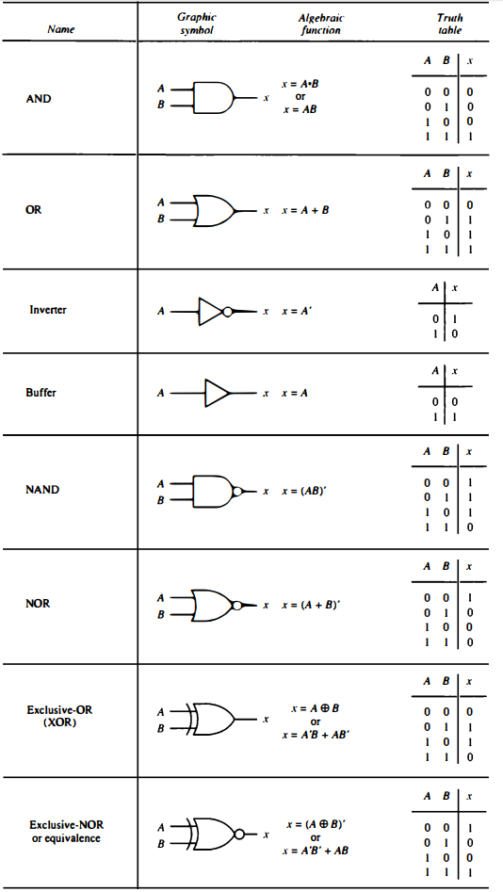
Boolean Algebra: Algebra that deals with binary variables and logic operations; Designated by letters such as A, B, x, and y
Boolean Function: Expressed algebraically with binary variables, the logic operation symbols, parentheses, and an equal sign; For a given value of the variables. The Boolean function can be either 1 or 0
The purpose of Boolean Algebra is to:
- Express in algebraic form a truth table relationship between binary variables
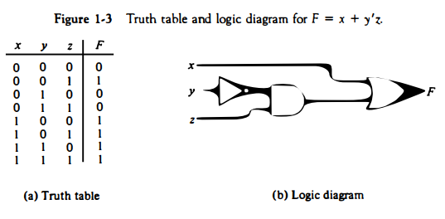
- Express in algebraic form the input-output relationship of logic diagrams
- Find simpler circuits for the same function
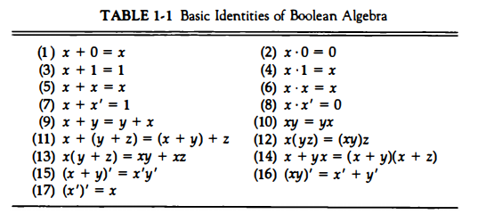
Complement of a Function: In a truth table, it is interchanging 1’s and 0’s in the values of F in the truth table; When using algebraic form, the complement of the function can be derived by means of DeMorgan’s theorem
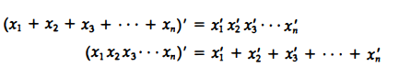
Karnaugh Map: A way to simplify a Boolean function
Minterms: The combination of the variables in a truth table
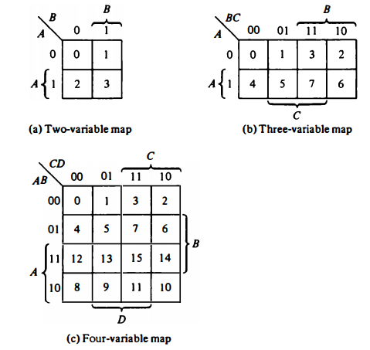
Product-of-Sums Simplification: sums are OR terms and the product denote the ANDing of these terms
Sum of Products Simplification: The product terms are AND terms and the sum denote the ORing of these terms
Don’t-Care Conditions: There are occasions where it does not matter if the function produces 0 or 1 for a given minterm; Marked with a X; Can be used to provide further simplification of an algebraic expression
Combinational Circuits: A connected arrangement of logic gates with a set of inputs and outputs; At any given time, the binary values of the outputs are a function of the binary combination of the inputs; Can be described by any truth table
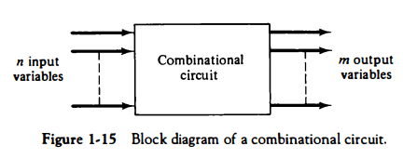
Half-Adder: A combinational circuit that performs the arithmetic addition of two bits
Full-Adder: A combinational circuit that performs the arithmetic addition of three bits (two significant bits and a previous carry); Made of two half adders
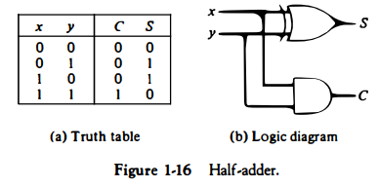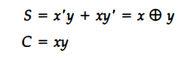
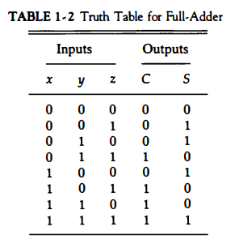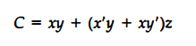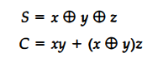
Flip-Flops: The storage elements employed in clocked sequential circuits
SR Flip-Flop: 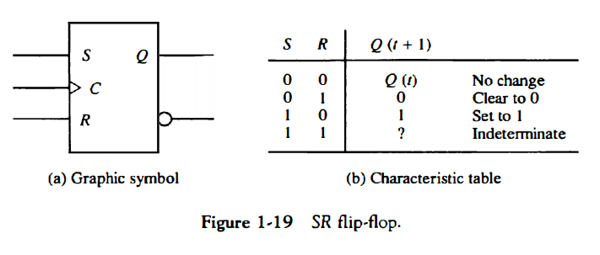
D Flip-Flop:
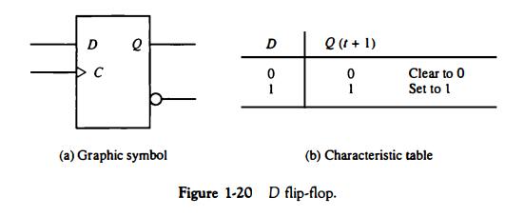
JK Flip-Flop:
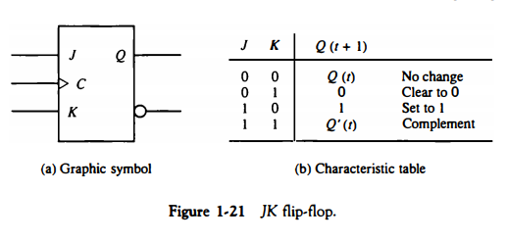
T Flip-Flop:
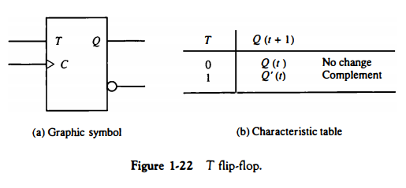
Excitation Tables: List of the required input combinations for a given change of state
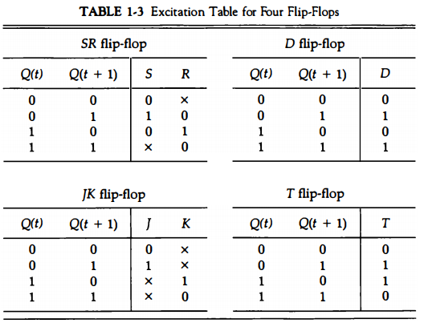
Sequential Circuits: Interconnection of flip-flops and gates
Flip-Flop Input Equations: The part of the combinational circuit that generates the inputs to flip-flops are described by a set of Boolean expressions 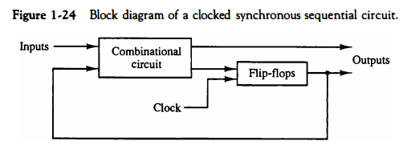
State Table: A table that consists of four sections: present state, input, next state, and output
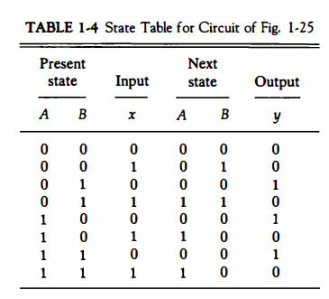
State Diagram: The information available in a state table that can be represented graphically in a state diagram
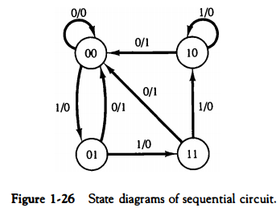
Chapter 2: Digital Components
Integrated Circuit: Small silicon semiconductor crystal, called a chip, containing the electronic components for the digital gates
Decoders: Combinational circuit that converts binary information from the n coded inputs to a maximum of 2^{n} unique outputs; The operation of the decoder can be clarified using the truth table
Enable Input: The decoder is enabled when E is equal to 1 and disabled when E is equal to 0

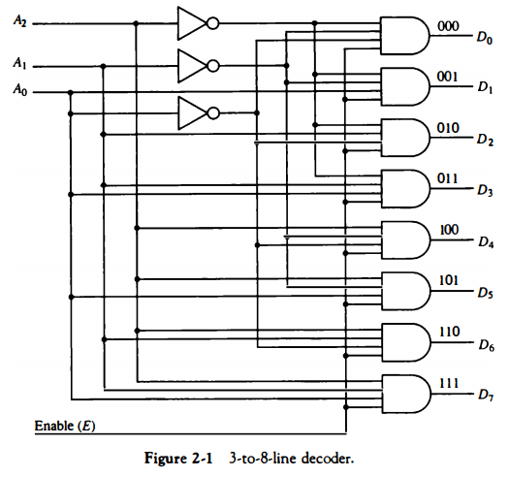
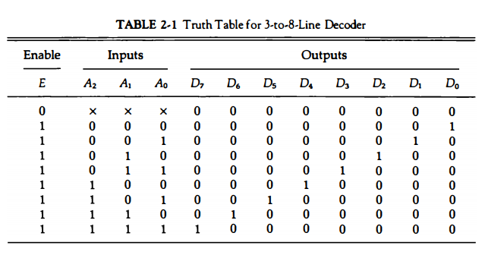
Encoders: Performs the inverse of a decoder
Multiplexer: A combinational circuit that receives binary information from one of 2^{n} input data lines and directs it to a single output line
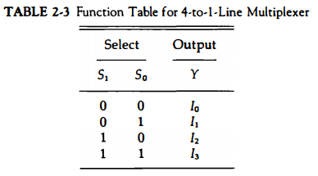

Registers: A group of flip-flops with each flip-flop capable of storing one bit of information; n-bit register = group of n flip-flops
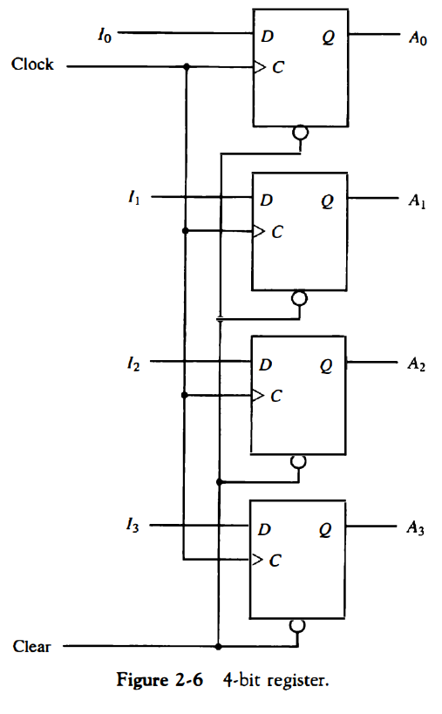
Parallel Load: With each clock pulse, the D input determines the next state of the output; For the output to be unchanged, it is necessary to make the D input equal to the present value of the output
Shift Registers: Shifting its binary information in one or both directions
Bidirectional; Shift register with Parallel Load: A register capable of shifting in both directions
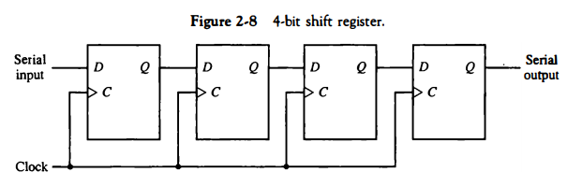
Most general shift registers have:
- An input for clock pulses to synchronize all operations
- A shift-right operation and a serial input line associated with the shift-right
- A shift-left operation and a serial input line associated with the shift-left
- A parallel load operation and n input lines associated with the parallel transfer
- N parallel output lines
- A control state that leaves the information in the register unchanged even though clock pulses are applied continuously

Binary Counters: A register that goes through a predetermined sequence of states upon the application of input pulses is called a counter; A counter that follows the binary number sequence is called a binary counter
A counter circuit will employ flip-flops with complementing capabilities: T flip flops and JK flip flops
Binary Counter with Parallel Load: When equal to 1, the clear input sets all the K inputs to 1, thus clearing all flip-flops with the next clock transition; The input load control when equal to 1, disables the count operation and causes a transfer of data from the four parallel inputs into the four flip-flops; There are two other operations
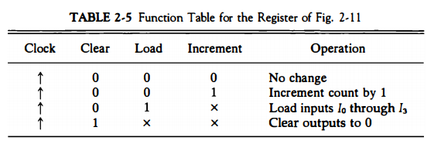
Memory Unit: A collection of storage cells together with associated circuits needed to transfer information in and out of storage
Words: Binary information in groups of bits stored in the memory; May represent a number, an instruction code, one or more alphanumeric characters, or any other binary-coded information
Byte: A group of eight bits; 16-bit word is two bytes
K = 2¹⁰; 64K = 2¹⁶
M = 2²⁰; 2M = 2²¹
G = 2³⁰; 4G = 2³²
Random Access Memory (RAM): The memory cells can be accessed for information transfer from any desired random location
Steps for Transferring a New Word to be Stored into Memory:
- Apply binary address of the desired word into the address lines
- Apply the data bits that must be stored in memory into the data input lines
- Activate the write input
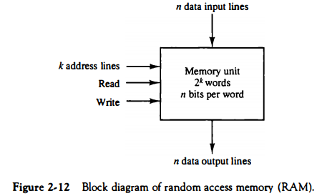
The steps that are taken to transfer a stored word out of memory:
- Apply the binary address of the desired word into the address lines
- Activate the read input
RAM Timing: The access time is defined for reading as the time delay from the moment when the address lines are made available to the time when the data becomes available at the output
Read-Only Memory (ROM): Memory unit that performs the read operation only; does not have write capability; Stored information is made permanent and cannot be altered
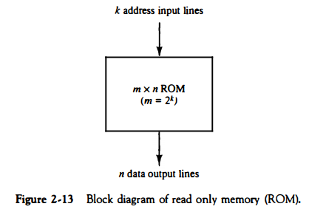
Mask Programming: Making the corresponding mask for the customer where the customer makes a truth table in which the ROM must satisfy
Programmable Read-Only Memory (PROM): For small quantities; When ordered, PROM units contain all the fuses intact giving all 1’s in the bits of the stored words; Allows users to program PROMS by themselves
Blown Fuse: Binary state 0
Intact Fuse: Binary state 1
The hardware procedure for programming ROMS or PROMs are irreversible and permanent
Chapter 3: Data Representation
Data Types: Can be one of the following:
- Numbers used in arithmetic computations
- Letters of the alphabet used in data processing
- Other discrete symbols used for specific purposes
Number Systems:
A number system of base, or radix: r (Eg. Decimal has a radix 10; Binary: r = 2)
To determine the quantity that the number represents, it is necessary to multiply each digit by an integer power of r and then form the sum of all weighted digits.
Conversion: Separating the number into its integer and fraction parts and converting each part separately
Complements: Used for simplifying the subtraction operation and for logical manipulation
Subtraction of Unsigned Numbers
- Add the minuend M to the r’s complement of the subtrahend N
- If M is greater than or equal to N, the sum will produce an end carry r^{n} which is discarded, and what is left is the result M-N
- If M is less than N, the sum does not produce an end carry and is equal to r^{n} – (N-M), which is the r’s complement of (N-M). To obtain the right answer in familiar form, take the r’s complement of the sum and place a negative sign in front
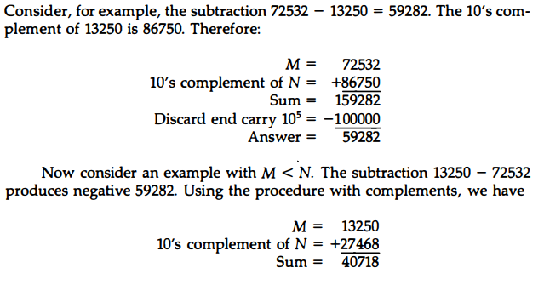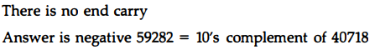
Overflow: When two numbers of n digits each are added and the sum occupies n+1 digits; The detection of an overflow after the addition of two binary numbers depend on whether the numbers are considered to be signed or unsigned
- When two unsigned numbers are added, an overflow is detected from the end carry out of the most significant position
- When two signed numbers are added, the leftmost bit always represents the sign and negative numbers are in 2’s complement form; the sign bit is treated as a part of the number and the end carry does not indicate an overflow
Floating-Point Representation: Two parts: the first part represents a signed, fixed-point number called the mantissa and the second part designates the position of the decimal (or binary) point and is called the exponent
Floating Point Format:
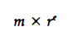
Gray Code: The reflected binary code that is converted into digital format by means of an analog-to-digital converter; Gray code changes one bit as it sequences from one number to the next
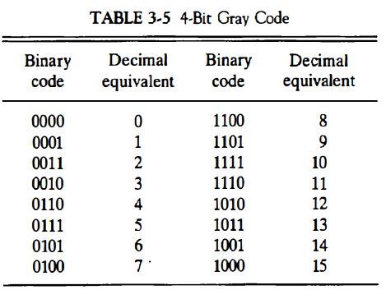
Grey Code Counter: A counter whose flip-flops go through a sequence of states; Remove ambiguity during the change from one state of the counter to the next because only one bit can change during the state transition
Error Detection Codes: A binary code that detects digital errors during transmission; Cannot be corrected but their presence is indicated
Parity Bit: An extra bit included with a binary message to make the total number of 1’s either off or even
Parity Generator: Generates a parity bit to be transmitted with the message to its destination
Parity Checker: Checks the proper parity adopted (odd or even); An error is detected if the checked parity does not conform to the adopted parity
Chapter 4: Register Transfer and Microoperations
Microoperations: Operations that are performed on the data stored in the registers; May replace the previous binary information of a register or another register
Three-State Buffers: A bus system constructed with three-state gates instead of multiplexers; Has normal input and control input; The control inputs to the buffers determine which of the four normal inputs will communicate with the bus line; Exhibits three states:
- Logic 1
- Logic 0
- High-Impedance state (open circuit)
Arithmetic Microoperations: Perform micro-operations such as additions and subtractions
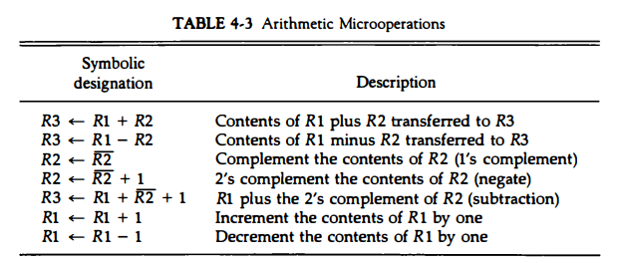
Binary Adder: At least two registers to hold the two numbers to be added and possibly a third adder to store the result
Arithmetic Circuit: A combination of arithmetic microoperations in one combinational circuit
4 full-adder circuits = 4-bit adder + 4 multiplexers


