Assignment #1
Linear Programming
Formulation and Graphical Method

Solution and Marking Scheme
10 points
Correctors: Student are required to provide and sign the Personal Ethics Agreement Concerning Telfer School Assignments; please note on their work if they do not.
Correctors: Each student must provide an individual original submission of completed Assignment #1. Please also note: Assignment #1 copies that are submitted jointly (i.e., by more than one author) will not be graded.
ADM2302 students are reminded that submitted assignments must be neat, readable, and well-organized. Assignment marks will be adjusted for sloppiness, poor grammar and spelling, as well as for technical errors. While working together is encouraged, plagiarism on assignments will not be accepted. Each student must provide an individual original submission of completed assignments. This assignment can be hand written. Solutions to all assignment problems are to include “managerial statements” that communicate the results of the analyses.

Correctors: DEDUCT 0.5 per problem if the “managerial statement” is missing.
1) Problem #9, p.85 Total Value: 2 points
Excel Solver solution:
 | X1 | X2 |  |  |  |  | Objective Function
Production | 60 | 0 | Total |  |  |  | Decision Variables
Margin | $50.00 | $30.00 | $3,000.00 |  |  |  | Constraints
 |  |  |  |  |  |  | Model coefficients
 | X1 | X2 | Usage | Maximum Resources
Time | 15 | 12 | 900 | ≤ | 900
Space | 8 | 16 | 480 | ≤ | 800
X1 | 1 |  | 60 | ≥ | 40
 |  |  | Non-negativity constraints:
 |  |  | x1 | ≥ | 0
 |  |  | x2 | ≥ | 0

- Graphical layout (Obj Fun in Yellow/Green below) Value: 1.5 point (+ shaded feasible region – not shown)
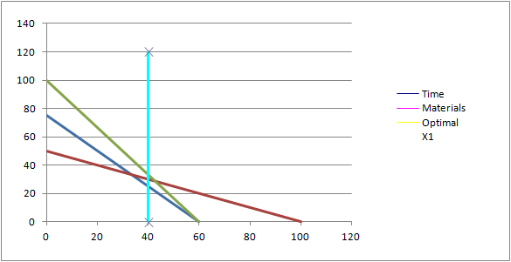
(b)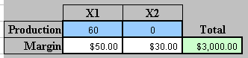

Managerial Statement: Value: 0.5 point
The optimal solution to the LP is:
- Decision variables are Product 1, x1=60 units and Product 2, x2=0 units
- Optimal (max) Objective Function is: z*=$3,000.00
2) Problem #10, p.85 (Note: Problems 9 and 10 are related) Total Value: 1 point
Excel Solver solution:
 | X1 | X2 |  |  |  |  | Objective Function
Production | 40 | 25 | Total |  |  |  | Decision Variables
Margin | $30.00 | $50.00 | $2,450.00 |  |  |  | Constraints
 |  |  |  |  |  |  | Model coefficients
 | X1 | X2 | Usage | Maximum Resources
Time | 15 | 12 | 900 | ≤ | 900
Space | 8 | 16 | 720 | ≤ | 800
X1 | 1 |  | 40 | ≥ | 40
 |  |  | Non-negativity constraints:
 |  |  | x1 | ≥ | 0
 |  |  | x2 | ≥ | 0
Graphical layout (Obj Fun in Yellow/Green below) Value: 0.75 point (+ shaded feasible region – not shown)

Managerial Statement: Value: 0.25 point
The optimal solution to the LP is:
- Decision variables are Product 1, x1=40 units and Product 2, x2=25 units
- Optimal (max) Objective Function is: z*=$2,450.00

3) Problem #31, p.88 Value: 3 points
- Accounting LP

Excel Solver Solution:
 | A | B |  |  |  |  | Objective Function
Production | 7.53 | 3.35 | Total |  |  |  | Decision Variables
Margin | $4.00 | $3.60 | $42.20 |  |  |  | Constraints
 |  |  |  |  |  |  | Model coefficients
 | X1 | X2 | Usage | Maximum resources |  |  | Slack
One | 11 | 5 | 100 | ≥ | 55 |  | -44.6
Two | 3 | 4 | 36 | ≤ | 36 |  | 0.0
Three | 4 | 9 | 0 | ≤ | 0 |  | 0.0
 |  |  | Non-negativity constraints:
 |  |  | x1 | ≥ | 0
 |  |  | x2 | ≥ | 0

- Graphical layout (Obj Fun in Yellow below) Value: 1.5 point (+ shaded feasible region – not shown below)

  - 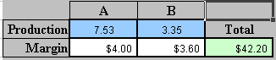

Managerial Statement: Value: 0.5 point
The optimal solution to the LP is:
- Decision variables are A (x1)=7.53 units and B (x2)=3.53 units
- Optimal (max) Objective Function is: z*=$42.20 (Revenue)

  - 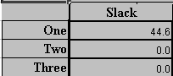

Managerial Statement: Value: 0.5 point
The Slack (<= constaints) and the Surplus (>= constraints) are as follows:

- >= Surplus: LHS-RHS = 100-55 = 45 units (non-binding)
- <= Slack: RHS-LHS = 36-36 = 0 units (Binding)
- <= Slack: RHS-LHS = 0-0 = 0 (Binding)

  - Managerial statement: Value: 0.5 point
There are zero (0) or no redundant constraints as they each provide a unique element to the definition of the feasible region solution space, i.e., no constraints can be removed without changing the feasible region.

4) Problem #52, p.91 Total Value: 3 points
LP Formulation: Value: 1 point

Let Xa denote the number of bags ordered from supplier A
Let Xb denote the number of bags ordered from supplier B

Minimize 6.50*Xa + 4.50* Xb (Total ordering cost, $)
Subject to
- Xa >= 250 bags
- Xb >= 250 bags
- (1-2%)*Xa + (1-5%)*Xb >= 1500 total non-defective bags
- Xa, Xb >= 0

Graphical method Value: 1 point
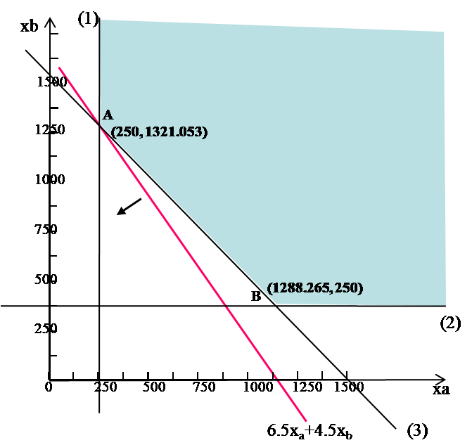

Managerial Statement: Value: 1 point

The optimal solution is at point A on graph.
- Decision variables are: Xa = 250 bags and Xb =1322 bags,
- Optimal Minimum ordering cost = $7,574.

5) Problem #53, p.91 (Note: Problems 52 and 53 "Carleton University Bookstore" are related; please also note that in the text for Problem 53, the reference there should be to "Problem 52" (not "53").) Total Value: 1 point
LP Formulation: Value: 0.5 point
Let Xa denote the number of bags ordered from supplier A
Let Xb denote the number of bags ordered from supplier B

Minimize number of bags cannot be sold:
0.02*Xa + 0.05* Xb (Total number of defective bags)
Subject to
- Xa >= 250 bags
- Xb >= 250 bags
- (1-2%)*Xa + (1-5%)*Xb >= 1500 total non-defective bags
- 6.50*Xa + 4.50*Xb <= 10000 limited budget $
- Xa, Xb >= 0

Graphical method Value: 0.25 point
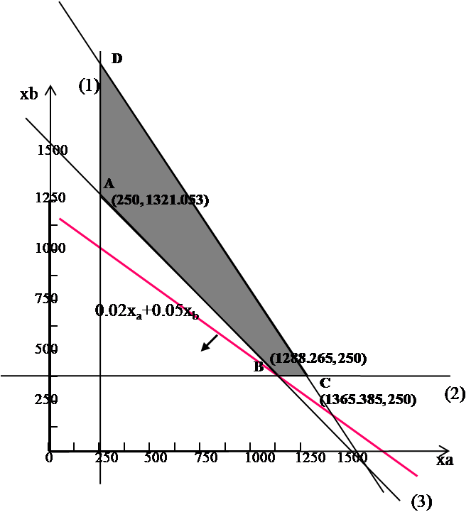
Managerial Statement: Value: 0.25 point

The feasible region in the figure above is ABCD. The optimal solution is at point B. Xa= 1289 bags and Xb=250 bags, and the minimum number of (defective) bags that cannot be sold are 38.28 bags.
Note that the percentage of defective bags: 38.28/ (1289+250) = 0.025 = 2.5% for Problem 53. For Problem #52, the number of defective bags = 0.02*250+0.05*1322 = 71.1 bags, the percentage of defective bags: 71.1/ (250+1322) = 0.045 =4.5%. Thus, the optimal solution of problem #53 provides lower percentage of defective bags.

