Life in a drop of Pond Water

Jonathan Kao
Student number: 22497473
Teacher name: Hediyeh Tahghighi

Introduction
Pond water houses a variety of plant and animal life where some are visible in our naked eye, whereas others are so small that a microscope is required to observe them. These microorganisms are single celled organisms that are mostly part of the Plantae, fungi, bacteria and Protista kingdoms. Microorganisms sometime may cluster together forming colonies which makes it visible to the naked eye. The ecosystem of the pond water consists of autotrophs (primary producers) and heterotrophs (consumers). Autotroph such as algae makes their own food by converting sunlight or chemical compounds into energy for food through a process called photosynthesis. Heterotrophs consume the autotrophs as a source for energy as they can’t make their own food resulting in primary, secondary consumer and so on. We were asked to examine a sample of collected pond water under the microscope with the aim of identifying the kinds of organism living in the sample, and estimating the number of living organisms in three samples we tested. This is observed with different magnification such as 40x, 100x and 400x.
Methods:
Equipment needed:
- microscope
- microscopic slide
- pond water
- pipette
- cover slip
- tissue paper
- methyl cellulose

Grab a microscopic slide and use a tissue to wipe of visible dust on the slide to avoid contamination. Use a pipette and place one drop of methyl cellulose in the centre of the slide. Afterward place one or two drops of pond water at the centre of the clean microscopic slide on top of the methyl cellulose. Hold the cover slip on the edge and drop one end of it on the slide at 45 degrees angle. Use a long cylinder object for the other end of the slip to rest on, allowing you to let go of the edge of the slip. Slowly lower the slip on top of the water to allow even spreading of the water sample in the centre of the slide which also prevents the formation of bubbles. If water starts leaking from the edge, grab a tissue and gently touch the edge allowing it to absorb the excess water. Place the slide on the microscope stage for observation. Magnification such as 40x, 100x and 400x can be used for clearer observations. Sketch the shape of the different organisms you observed and record the number of organism you see in all three samples.

Results
 | Low Power | Medium Power | High Power
Ocular Magnification (a) | 10x | 10x | 10x
Objective Magnification (b) | 4x | 10x | 40x
Total Magnification (a x b) | 40x | 100x | 400x
Diameter of field of View (mm) | 4.9 | 1.96 | 0.49
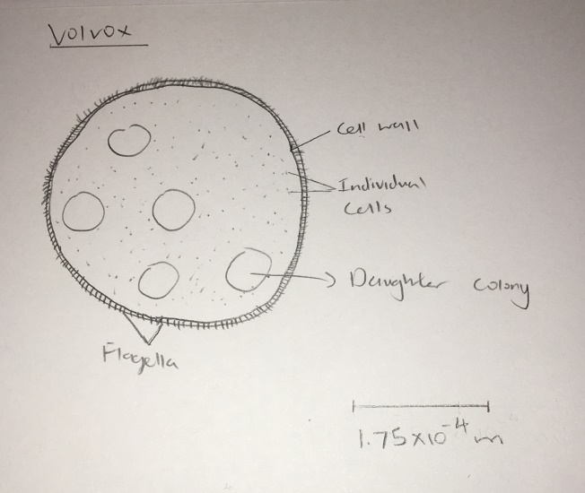
Under high power magnification, the specimen’s size took up about half the field of view with a diameter size of 0.49mm, we can say that the size of the specimen would be 0.49/2=0.245mm rounding it up to 0.25mm as 2 of the specimen can fit into the field of view.

Number | Species | FoV 1 | FoV 2 | FoV 3 | Total | Trophic level | Abundance %
1 | Green algae (no flagella) | 22 | 16 | 13 | 51 | autotrophs | 34.5
2 | Green algae (flagella) | 10 | 9 | 13 | 32 | autotrophs | 21.6
3 | Blue-Green algae | 1 | 3 | 0 | 4 | autotrophs | 2.70
4 | Flagellates | 1 | 0 | 0 | 1 | autotrophs | 0.676
5 | Diatoms | 2 | 2 | 6 | 10 | autotrophs | 6.76
6 | Filamentous green algae | 12 | 3 | 5 | 20 | autotrophs | 13.5
7 | Shelled Amoeba | 0 | 0 | 1 | 1 | Primary consumer | 0.676
8 | Ciliates Coleps | 1 | 0 | 0 | 1 | autotrophs | 0.676
9 | Ostracods | 1 | 0 | 1 | 2 | Secondary consumer | 1.35
10 | Water fleas | 0 | 1 | 1 | 2 | Primary consumer | 1.35
11 | Desmids | 11 | 4 | 4 | 19 | autotrophs | 12.8
12 | Ciliates Paramecium | 1 | 0 | 0 | 1 | Primary consumer | 0.676
13 | Gastrotricha | 1 | 0 | 0 | 1 | Primary consumer | 0.676
14 | Spirostomum | 1 | 1 | 1 | 3 | Primary consumer | 2.03
Total |  |  |  |  | 148 |  | 100

Discussion
Based on the results, we managed to observe a variety of microorganisms. Some were pretty common, others weren’t. There was also a trend where there was a higher population of autotrophs than heterotrophs. This is likely due to most autotrophs being able to make their own food through photosynthesis using the energy from the sun whereas heterotrophs cannot make their own food thus they must either eat or absorb it. The process of producing food using chemical energy stored in inorganic molecules is called Chemosynthesis
- The kingdom of Volvox, a colony of green algae, is the Plantae. It has chloroplasts that contain chlorophyll thus making it look bright green colour. It moves with fragella in groups of tiny green dots bounded by a clear membrane thus it has a cell wall which contains cellulose. The double membrane enclosed the chloroplasts of green algae.
- The trophic level of green algae is that they are primary producers. This is because they can produce their own food and are the ultimate food source for the marine, freshwater and terrestrial ecosystem as they are the basics of the food web, source of oxygen for other organisms.
- First bias is that a small sample sized could not possible determined the entire species of organisms in the pond since the bucket of pond water taken only represents a small part of the water column. Second bias is that methyl cellulose is used which slows down the movements of most organisms reducing the ability for us to spot moving species as smaller organism could hide behind other organisms. Thirdly, the microscope has a maximum field of view thus there is a limit to how many variety we can see, preventing us to view tinier organisms.
- I did not observe any bacteria due to the size of it being beyond our maximum field of view capacity. Clearly even with our maximum field of view, it was not enough for us to one able to observe the bacteria thus a more powerful microscope is needed.
- FOVnew = FOVcurrent × (MAGcurrent/MAGnew)
FOV(250X) = 0.3 × (400/250)
FOV(250X) = 0.3 × 1.6
FOV(250X) = 0.48mm=0.48 x 10^-3m
Diameter of Specimen= 50 x 10^-6m
The specimen can fit into the FOV: 0.48 x 10^-3/50 x 10^-6 = 9.6 times

Increasing the microscope’s magnification would decrease the FOV and thus increasing the apparent size of an object observed. This is because increasing the magnification would mean the object would spread over a larger region so our eyes can see, thus decrease our field of view.

Bibliography

Material Type: Web page
In-text: (MicroscopeMaster, 2018)
Your Bibliography: MicroscopeMaster. (2018). Pond Water Under the Microscope. [online] Available at: https://www.microscopemaster.com/pond-water-microscope.html [Accessed 23 Mar. 2018].

Material Type: Web page
In-text: (MicroscopeMaster, 2018)
Your Bibliography: MicroscopeMaster. (2018). Microorganisms - Taking a look at Pond Water organisms. [online] Available at: https://www.microscopemaster.com/microorganisms.html [Accessed 23 Mar. 2018].

Material Type: Web page
In-text: (Sciencenetlinks.com, 2018)
Your Bibliography: Sciencenetlinks.com. (2018). Pond 2: Life in a Drop of Pond Water - Science NetLinks. [online] Available at: http://sciencenetlinks.com/lessons/pond-2-life-in-a-drop-of-pond-water/ [Accessed 23 Mar. 2018].

Material Type: Web page
In-text: (prezi.com, 2018)
Your Bibliography: prezi.com. (2018). Organisms in Pond Water. [online] Available at: https://prezi.com/-h-v47tnvkqo/organisms-in-pond-water/ [Accessed 23 Mar. 2018].

