LIFESPAN DEVELOPMENT CH 01
Developmentalist→ study the human lifespan

Changing conceptions of childhood:
Pre-17th century: child mistreatment and abandonment, high child mortality and child labor; poverty. Not much emphasis on childhood being lovely and fun; it was more rough and labor-filled.
Idea of Christian religion- we are born into the world as a sin; you have to teach the children the right way. If you weren't disciplining them strictly, they would become spoiled brats and bad people. They didn’t get to really go to school, it was more working.

17 & 18 Century:
Scientific revolution, enlightenment, values taken away from religious thought and became more of a scientific light. Locke→ tabula rasa; clean-slate – you are not born sinful. You will become who you are based on your experiences. Rousseau→ innocence of childhood; you are not born into sin and will not become horrible people if you do not punish your children. When all children are forced to go to school, there are benefits: more educated, more technologically advanced, more freedom, less work, more around peers; their own cohort, learning new things, intellectually advanced.

Late 19 Century:
Kinder, more gentle view of children. Childhood is becoming more protected; it is seen as a dependent life stage. There is a universal education: mandatory primary school.

20 Century:
The term “adolescence” was coined by Stanley Hall and became a standard USA life stage with mandatory school attendance. There is a stage of “Strom and Stress” between childhood and adulthood. In the past, it would be childhood and then right away adulthood; there was no other stage in between. You now go to school at least until 16, you aren’t getting married at 13, you are extending the process. The bodies are physically becoming adults, but the frontal lobe is still developing, hence why teens don’t always make the best choices. Later came “emerging adulthood” for people between 18 to late 20s. This is a time for personal exploration. It is now less expected by society to be married at such a young age (~20); there is more of a demand for higher education.

Development is influenced by broad general influences:
- Cohort→ your birth group
- Socioeconomic status (SES)
- Culture & identity
- Gender

Baby Boomers→ born 1946-1964. They have two parent households and siblings. Typically; married, have kids, mom stays home to raise and care for family, father is breadwinner. They fought for civil rights, equality for the sexes.

Life expectancy was much lower before the 20th century. Now, we are medically advanced, infectious diseases reduced or eliminated, we just have present-day chronic diseases (Cancer, diabetes, heart disease). We have created new stages: “young-old” (60-70s) and “old-old” (80+). Females have seen to outlive men, however, now, they are becoming more equal. People tend to live longer in Japan. USA, Spain. Lower life expectancy – South Africa, Afghanistan.

Millennials Now:
They went from relating in the real world to residing in cyberspace. We now have online relationships; permanent change in how people relate to one another. This can cause a lack of interaction with humans; face to face; instead, it is more virtual. We have income inequalities. Women are having children later on in life, better pregnancies, less problems with pregnancy.
Other impacts:
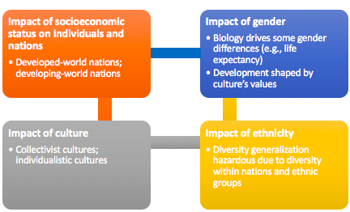

Socioeconomic Status:
Individual→ marker referring to status on the educational and income rungs.

Developed world→ high life expectancy, advanced technology, and widespread access to education and health care.
Developing world→ some may not have indoor plumbing, higher childhood mortality from “curable” diseases.

Culture & Ethnicity:
Collectivistic Culture→ social harmony, respect for elders and family group.
Individualistic Culture→ independence, competition, and personal success. They understand that people have their own thoughts and ideas at a younger age.

Gender:
Females have longer life expectancy; this is getting closer together in age. They are differences in play styles (biology or society). There are gender roles, income inequality. However, choosing your gender you wish makes you happier than being forced into a gender; it’s all about accepting who you are and living life as the gender you want to be.

Theory→ attempts to explain individual behavior. It allows for behavior prediction and presents ideas for interventions to improve behavior.

Behaviorism P.O.V:
Turning psychology into a science; to observe something, make some rigid testing, get measurements to compare and find a causal relationship between two variables. They believed we were born in a world in a blank slate – we learn everything as we grow by experiencing things and going through that. Learning changes you completely, whether good or bad. You become who you are based on what you’ve learned and what you have been exposed to.
- Nurture is all important
- Science of human behavior can be rigorous
- General laws of learning can explain all behavior
- Mental concepts no value for a science of psychology
- Practical value; applied to the real world as well (advertising, child rearing, etc.)
Child Rearing→ stern advice for parents. They should never hug, kiss, or let kids sit on their lap. One kiss on the forehead before bed. Shake hands, pat on head for a good job. You want to foster independence, if you show too much attention, they will just be dependent.

Operant conditioning:
Skinner. It is the law of learning that determines any voluntary response. You are reinforced (rewarded) for certain behaviors. Any behavior that is reinforced is likely to be repeated. Any behavior that is not reinforced is likely to be extinguished. However, if you want lasting effects – positive reinforcement will be better; the learning stays; you may not get the results right away, but it is the one that will last the longest. For example: punishing a child will stop them in the moment, but won’t necessarily in the long run. The problem with continuous positive reinforcement is the day you don’t get it, you are going to freak out or you will eventually get bored (desensitized). However, random positive reinforcement keeps you on your toes and keeps the thrill alive so you are more likely to continue doing what you are doing for that positive reinforcement.

Reinforcement VS Extinction→ successive approximation (small rewards when the pigeon is close). Behaviors will lead to reward that will be reinforced. Others will be extinguished. Whenever the pigeon pecked at something close to the button, it got a reward. Eventually, this stopped but the pigeon would get a reward when it pecks the button. Same thing is true with kids, you need to teach them and validate the smaller steps they’ve done so they learn to grow and to continue some actions.
Drawing on slide 27

Social Learning Theory:
We learn by watching what other people do.
Cognitive behaviorism→ learn by modeling (imitating) others. We model people who are nurturing or involved with us. We model those whom we perceive as being like us. Example: at about age 2, gender identification and gender-specific behaviors develop. Perceptions about reinforcers (rewards) determine behavior. Anything can be a reinforcer as long as the child views it as so.
Self-efficacy→ belief in personal competence. It is a sense that through our own efforts, we can be successful at a given task. A strong sense of self-efficacy is an important factor in a healthy child development. When you set yourself up in you can’t do it, it almost validates your fear; you need to change your views, challenge yourself. You need to have a belief in yourself and in your capabilities of what you can do. Encouraging the child, validating their abilities, listening to them and understanding. You have bumps in your life but that is normal; it is part of life. You need challenges, you need ups and downs.

Evolutionary Psychology:
Theorizing about the nature of human similarities. Look to nature, or inborn biological forces that have evolved to promote survival, to explain how we develop and behave.

Behavioral Genetics:
Research strategies devoted to examining the genetic contribution to the differences we see between human beings; the role that hereditary forces play in individual differences. Uses twin studies, adoption studies, and twin/ adoption studies to see environment vs genetics.
Heritability→ summarizes the extent to which a given behavior is shaped by genetics. It ranges from 1 (totally genetic) to 0 (no genetic contribution)

Attachment Theory:
By John Bowlby. He shared Freud’s psychoanalytic view; early life experiences with caregivers shape our personality. It determines whether people will become well-adjusted or emotionally impaired adults. Attachment response genetically programmed into our species to promote survival. Early attachments affect development.

Evocative forces→ inborn talents and temperamental tendencies naturally evoke certain responses from others. Bidirectional forces in relationships.
Active forces→ we actively select our environments based on our genetic tendencies.
Person – environment fit→ The extent to which the environment is tailored to biological tendencies and talents. Basic goal of developmental science is to foster the correct person-environment fit. The most crucial impact of the “nature” revolution is to allow intervention to change the environment in order to enhance one’s quality of life. Sometimes, the best person-environment fit is not feasible; example: music lessons are very expensive, so even if your child is very talented, you may not be able to afford the lessons.

Two principles:
- Our nature (genetic tendencies) shapes our nurture (life experiences)
- We need the right nurture (life experiences) to fully express our nature (genetic talents)

Freud:
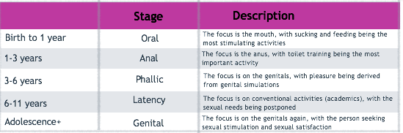
if you don’t get through a stage, you are left with a fixation.
Psychoanalytic theory→ analysis of psyche or inner life. “Mothering” during the first five years determines adult personality and mental health. Id = present at birth. Ego = emerges in the first five years. Superego = last to develop.
Age linked stages of sexuality. He focused on erogenous zones and defense mechanisms. Predecessor to attachment theory perspective.

Erik Erikson→ Father of lifespan development. He says it does not end in adolescence (as Freud believed). His theory is less sexual than psychoanalysis. He identified core developmental tasks, or psychosocial tasks, for each of the eight stages from infancy to old age. Each task is built upon the other.
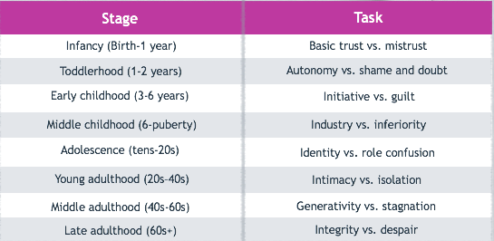

Piaget’s Cognitive-developmental theory→ qualitatively different stages exist in the way thinking develops (different age groups conceptualize the world in completely different ways). At every life stage human beings share a hunger to learn and to mentally grow. Schemas (cognitive structures), assimilation, accommodation, studies were focused on children. Example of schema: fluffy + white + four legs = kitty. Assimilation: kitty. Accommodation: white + furry + four legs…. But hops… = bunny.
Piaget’s cognitive development:
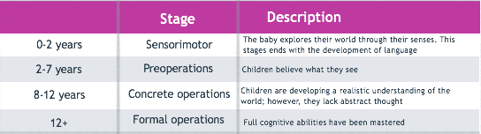

Interactive Models:
Ecological model→ highlighted multidirectional forces in human development. Total ecology, or life situation of the child, influences his/her development.
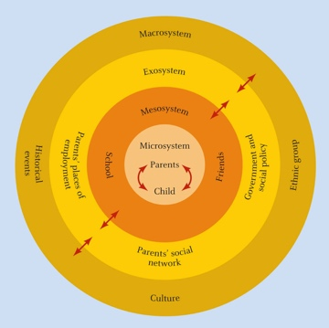
Developmental Systems approach→ stresses the need to use many different approaches in understanding human behavior. Emphasis on the need to look at the interaction of processes (genes, environment, family, society, culture).

Quantitative Research→ The typical research mode in developmental science using groups and statistical analyses to make general predictions about behavior
Qualitative Research→ Scientist not interested in numerical comparisons. Studying the life of a single person through observation and interviews, or observing a single individual in depth
Cross-sectional studies→ Observes or tests groups of different ages at the same period in time. More time effective, less expensive. Cannot address (dis)continuity because each age group involves different people
Longitudinal studies→ Observes or tests one group of individuals at each of several time periods. Expensive and a large time commitment. Allows examination of (dis)continuity because the same people were tested across time

LIFESPAN DEVELOPMENT CH 02
Females:
XX
They have a uterus - endometrium, cervix (neck of the uterus).
They have fallopian tubes.
They have ovaries – ova resides here, ova contains mother’s genetic material.
Drawing on slide 3
Males:
XY
They have testes (continually manufacture sperm) and a penis.
Drawing on slide 4

Fertilization Process:
Ovulation Occurs→ Ovum expelled from the ovary and is suctioned into the fallopian tube. Millions of sperm travel up the fallopian tube and to the ovum.
Fertilization→ One sperm penetrates the ovum. Nuclei (genetic material) of the male and female cells combine.

The Genetics of Fertilization:
DNA→ Holds blueprint of organism. It is made up of 2 strands.
Gene→ segment of DNA that is passed down from the parents.
Chromosomes→ genes are organized and packages in chromosomes. Humans have 23 pairs of chromosomes (one from each parent).

Prenatal Development:
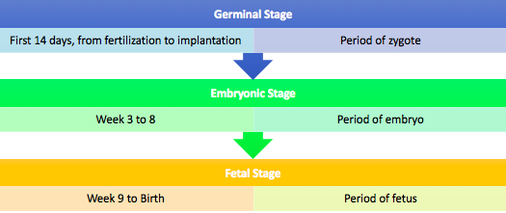

Germinal Stage→ the first two weeks. Not yet fully attached to the cell wall. Implantation= the process in which a blastocyst becomes embedded in the uterine wall. Corpus Luteum, Progesterone, HCG
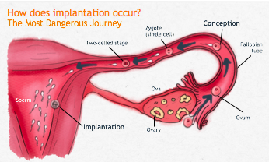

Embryonic Stage→ weeks 3-8. Fast paced; all major organs are constructed. By the third week, circulatory system forms and heart beats. 20-24 days - neural tube forms – differentiates into brain and spinal cord. By day 26 arm buds form. By day 37, leg buds appear; feet, elbows, wrists, and fingers begin to appear. By week 8, the embryo is 1.5 inches long. Internal organs are in place and the embryo begins to look human.

Proximodistal= growth from middle to outside
Cephalocaudal= growth from head (cephalo = top) to feet (caudal = bottom)
Mass to specific sequence= large structures appear before finer details. Large movements appear, before finer movements.
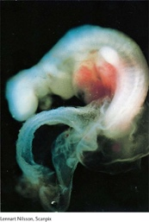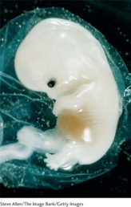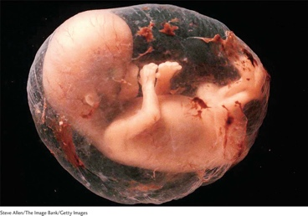

Fetal Stage→ week 9- birth. The baby grows dramatically. The body structures are refined (mass to specific). The building blocks of the brain are fully assembled. Neurons ascend to the top of the neural tube, reach their staging area, and begin to differentiate.

Gestation Period:
267-277 days. It is divided into three trimesters (about three months each). Each woman may vary in her experience (physical and emotional) of pregnancy.
- First Trimester→ Following implantation of blastocyst into uterus, flood of hormones may produce fainting, headaches, fatigue, tender breasts, and morning sickness. Progesterone; human. Chorionic gonadotropin (HCG). Miscarriages (spontaneous abortions) more prevalent at this time: roughly 1 in 10 pregnancies ends in miscarriage. Miscarriage rate increases to 1 in 5 for women in their late thirties.
- Second Trimester→ Physically may feel much better. By week 14, uterus grows (maternity clothes!). Quickening occurs (first indication of movement of the fetus). Feelings of attachment may begin. A strong sense of attachment during pregnancy predicts positive bonding after birth
- Third Trimester→ Physical Symptoms and Emotional States. Leg cramps, backaches, numbness in lower limbs, heartburn, insomnia. Irregular uterine contractions as baby sinks into the birth canal. Anxious anticipation may begin as the focus shifts to the birth

Partners:
Partners may also experience strong emotions. They may feel concerned about this life change. Negative forces that may contribute to distress during pregnancy can be economic concerns; low SES. Positive forces can be the presence of a loving partner may predict a happy pregnancy.

Threats to developing baby:
Teratogens= substances that may cross the placenta to harm developing embryo or fetus. They cause the most damage during the embryonic stage, they can cause brain damage, and are completely unpredictable. This can lead to birth defects= health problems at birth that can be caused from exposure to teratogens during prenatal development or from chromosomal and genetic abnormalities. Other teratogens: infectious diseases (Rubella, AIDS, Herpes), Medications (anti-psychotic drugs, antidepressants), Recreational drugs (cocaine, meth), Environmental toxins (Radiation, mercury), and vitamin deficiencies. However, the most common are:
ALCOHOL: excessive consumption contributes to chance of fetal alcohol syndrome.
NICOTINE: constricts blood vessels, increases the risk of smaller-than-normal healthy newborns, chances of preemie babies.
However, there are measurement issues; it is very difficult to measure these problems. Sometimes, mothers may not be honest and upfront with how much alcohol or nicotine they have had. There is also an impact of prenatal stress influence by many forces, such as: maternal personality and coping style, intensity/ quality/ and timing, stress can be from quitting alcohol or drugs (or other environmental factors). Pregnancy is stressful physically and psychologically; you need to have a good support system and good coping skills. For example: a study was conducted and found that risk of infant death soon after birth rose when the mother had a death in the family within 6 months of conception.

“Hunger Winter” → Findings suggest that heart disease rates were higher if a fetus was exposed to the Hunger winter. Hunger winter: limitation on food available. When a mother does not get enough food during pregnancy, there was high stress, low nutrients, but the child did survive. Babies eat from stored nutrients in the mom. Those who were born to mothers in starvation mode, they were born preterm or underweight. Those who were underweight, they put on a lot of weight. By not getting enough of the nutrients, it like they have a genetic predisposition and they gain a lot of weight afterwards.

Chromosomes problems→ we have 23 pairs, thus 46 in all. The embryo may miscarry if the developing baby is missing or has an extra chromosome. Examples: Down Syndrome (trisomy 21) = extra copy of chromosome 21.

Genetic disorders: single-gene disorders→ genes come in pairs (one on each chromosome) and determines specific traits. While most traits are dependent on many genes, single-gene disorders occur due to a flaw in a particular gene.

Three ways of inheritance:
- Dominant disorders (one or two D – you get it)
- Recessive disorders (you need both dd)
- Sex-linked single-gene disorders (carried on one of mom’s X chromosome)

Prenatal Tests:
You don’t need to take any of these ultrasounds, they are just there if you want.
- Ultrasound
- Chorionic villus sampling (CVS) → performed at 10-12 weeks. Does not detect neural tube defects. Chromosome abnormality.
- Amniocentesis→ detects neural tube defects. 15 weeks or later. Chromosomal or neural defects. It takes fluid from the amniotic sac to examine.

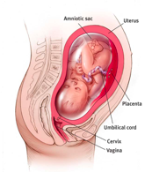
22 weeks – EARLIEST date for possibility of survival!

Fetus is positioned in the womb late in pregnancy.

Notice the placenta, amniotic sac, and umbilical cord.

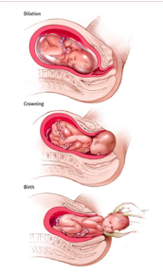
Stage 1: dilation and effacement
Stage 2: birth
Stage 3: expulsion of the placenta

Threats during birth:
- Baby in breech position (should be head down, legs first is breech)
- Cervix not fully dilated – less than 10cm dilation makes it very difficult to get the baby out
- Difficult position of the umbilical cord; can be wrapped around the neck

Birth Options:
- Natural Childbirth → Delivery without medication with the help of midwife or doula. Lamaze breathing (pain management). Bradley (natural, non-medicated childbirth). Making sure everyone is calm, relaxed, massages, etc. Sometimes, medical intervention is needed.
- C-Section→ Procedure common in some countries. Used if complications occur. There is an avoidance to do it. Longer recovery

Medical interventions:
- Episiotomy (if the baby’s head is crowning but can’t get through, they cut the skin to make it bigger)
- Epidural (the shot in the back)
- Electronic fetal monitor
- C-section (removes fetus manually by making incision into the adnominal wall and uterus. Used then complications occur).

Apgar Scale→ first test is immediately after birth. You rate from 0-2 for each category at 1 minute after birth and 5 minutes after birth. You rate on: color, muscle tone, respiration, heart rate, and reflex response. If you get a score over 7, the baby is healthy. Under 7, the baby must be monitored and may go to the NICU if needed.

Threats after birth:
- Low birth weight→ body weighs less than 5.5pounds. The baby may have arrived too early or did not grow in the womb.
- Very low birth weight→ body weighs less than 3.25pounds. Often the baby is premature and is rushed to the NICU.
Birth weight is highly correlated with infant mortality and intellect, delay in development.

