Needs Assessment

- A systematic inquiry about needs, attitudes, behaviours, and patterns of both participants and non-participants
- The first step of the programming process
- Often repeated and on-going
- Focus on programs and policy
- Limitations:
- Needs are infinite, often conflicting, and consensus is lacking/difficult to achieve
- Example of limitations
- Improve Health. But how? We can all agree that better health is a worthwhile goal. But we can see the issues becomes complex quickly.
- Infinite needs: Reduce smoking, increase fitness, reduce stress
- Conflicting needs: If I reduce smoking I might increase stress
- Consensus is difficult to achieve: The doctor might say that I need to quit smoking. My fitness trainer will insist that I need to dedicate more time and effort to the gym. My psychologist wants me to join a stress reduction focus group.

The Concept of Need

- Determining needs is difficult.
- Determining the standard, below which there is greater need is also difficult.
- The needs assessment is a tool to help reduce bias and identify different types of needs and also identify the level or standards related to the need.

Theoretical Understanding of Need

 | Ponsioen | - Society (community/organization/program) is responsible to meet the basic survival needs of its members.  - Required to identify a threshold, below which no one should fall.  - Needs exist when people fall below the established threshold.
 | Maslow | - Maslow proposed a hierarchical model  - Self-actualization  - Esteem  - Social  - Safety  - Survival  - Lower-level needs must be satisfied before higher level needs.

Key Questions of Needs Assessments

- Why are we doing one?
- What information do we want?
- How are we getting data?
- From where will we get data?
- When will we gather the data?
- From whom will we collect the data?
- Who will use the data?

Three Reasons for Needs Assessments
- Program management : manage duplication, address safety, help prioritize program plans, plan a variety of progreams, develop and meet individual goals
- Service orientation : constituent input, solicit new ideas, inclusion, meet real needs of people
- Desire for quality : profressional commitment, resource allocation, increase profits, accountability

Three Types of Data
(See following pics)

Two Sources of Data
- People as resources :
Comment cards : wide districution needed, must be visible to the public
Surveys : mail, telepone, in perso, electronic
Observations : who is and who is not participating
Open meetings : budgeting, resource allocation, capital improvements
Advisory boards or committees : comprised of community members
Direct assessment : ex therapeutic recreation
Focus groups and interviews : can be formal or informal
- Records as resources :
Registration information : who is and who is not participating
Activity analysis or program plans : can identify patterns in programming efforts
Statistics Canada
Social indicators : general health and wealth of community

Critical Components

We need to be concerned with the data we collect for our needs assessment. We want to be confident that the data is reliable and valid. However, these concepts are more appropriate to learn in a research methods course.

Reliability | Validity
- The degree of consistency that a needs assessment instrument or procedure demonstrates over time.  - Test-Retest, Alternative forms, Split halves and internal consistency | - The quality that allows the needs assessment instrument or procedure to discover what it is intended to discover.  - Content validity (expert evaluation), criterion-related validity (concurrent and predictive), construct validity (measure the theoretical phenomena)

Only collect data that

you need and that

you are definitely

going to use!

The Concept of Need

- In determining
that individuals or groups have a need, it is important to evaluate existing conditions against some societally established standards.
- If the community is at or above those standards, there is no need.
- If it is below those standards, there is need
- The difficulty comes in defining the standards. They are often vague, elusive, and changing.

Theoretical Understandings

- A society’s (or community’s) first responsibility is to meet the basic survival needs of its members, including biological, social, emotional, and spiritual needs.
- Social need exists when some groups do not have access to these necessary goods and/or services whereas others do.
- Until physiological survival needs are met, a person cannot be overly concerned with safety and security.
- Achievement of this second level of need then allows attention to higher levels--the need for love and self-actualization.

- Need
- A concept remains somewhat vague, often buried in phrases so global that it has little value for placing boundaries on the planning task.
- It is at times employed so narrowly that specific services are mandated and analysis is unnecessary.
- It is rarely operationalized. As more programs have to justify their activities they operationalize needs in a needs assessment.

Needs Assessment and the Planning Process

- Once problems have been identified and defined, they have to be translated into needs that are to be addressed through the planning process.
- As a concept, need is not only difficult to define but, once defined, difficult to measure.
Example 1 | - When we identify that a senior needs increased social contact we then need to measure this nebulous concept called “social contact”.  - Nebulous: (Of a concept or idea) unclear, vague, or ill-defined.
Example 2  (In an  American context) | - "The [U.S.] legislation defined a need as any identifiable condition that limits a person or individual or a family member in meeting his or her full potential." p. 52 This is a nebulous statement and can include anything from having mental illness, poverty, poor eye sight, learning disabilities, being overweight, etc... and we can create programs to address any of these issues.

- Understanding need requires that:
- understanding what we mean by the term need, with specific emphasis on the complexity of need as a
planning concept
- examining factors influencing need
- exploring categories of need
- general problems of reliability and validity of data used to determine need

Factors Influencing the Definition of Need
- Assumption that need itself is elastic and relative rather than static and absolute.
- Needs assessment assists the planner in estimating what the need is at that moment and what it may be at some time in the future if attitudes, expectations, conditions, and values do not change dramatically.
- Demand is likely to increase with increased service provision.
- A number of factors emerging from existing social, political, and economic considerations influence the phenomenon of elasticity.
- People (communities) do not always know that they have unmet needs.

 | The standard of living | These needs could be “wants” or “needs”.
 | Sociopolitical environment | You read examples of this in Notes from Canada Young Activists.
 | The availability of resources and technology | Or the lack of resources, technology or knowledge.

Perspectives on Need
- Four distinct approaches to measurement of need can be identified.

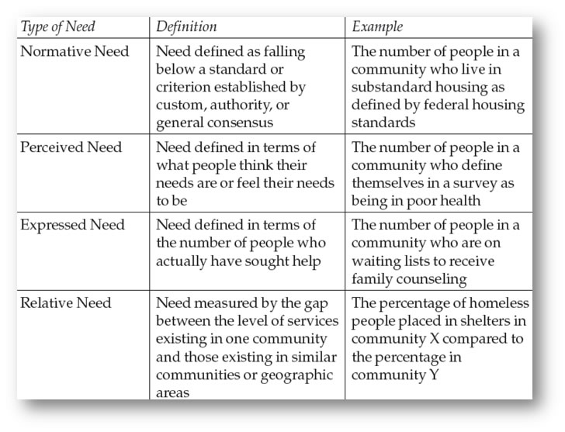
(see pic for more details)

Need Categories and the Planning Process

- The needs assessment process can feed a well-organized and pertinent flow of information into the overall management decision process. It can show what the actual demand on human service agencies is and what potential demand might be.
- It can provide useful information as long-term goals and capital budget programs are reviewed.
- It can provide a useful early warning system regarding potential changes in demand.
- Once key data sources are identified and data collection systems are organized, all four perspectives on need can be incorporated in a low-cost and efficient manner. Don't be fooled, this is complex and difficult to accomplish.

Who Is in Need

- The concept of “at-risk” populations is fundamental to any discussion of needs assessment.
- Once again there are different opinions. People do not need to be classified as “at-risk” to benefit from a program. For example, someone in the community determines there is a need for a book club and offers a free book club meet-up. There is value in the program, it meets a variety of needs and it is beyond the concept of “at-risk”.
- Needs assessment consists of establishing standards of need and devising some methodology of counting the number of people in a given community who fall below the standard and therefore are in need. Think broadly, for example, using Maslow’s hierarchy can you create programs for people who want to achieve self-actualization?

Two Major Problems

- Major problems in conducting a needs assessment:
  - current methods are useful only for deriving estimates.
  - decision makers often prefer greater precision.
  - data availability
- Program planners must accept these limitations and use existing data sources creatively.
- Although the data are imperfect, they can still be used to generate targets.
- This is about using data, such as Statistics Canada. The data is always a few years old, but it is the best large and free database we have access to.
- If you design and implement your own needs assessment & collect the data in a well designed needs assessment your results can be very precise (reliable and valid).
- Statistic Canada: Click on the link and explore some data like :
- Physical activity and sedentary behaviour of Canadian children aged 3 to 5
- Organized sports participation among children
- Explore the vast data sets we can access

There are three perspectives on need in a needs assessment; perceived need, expressed need and relative need.
- Perceived needs are defined by what people think about their needs, each standard changes with each respondent.
- Expressed needs are defined by the number of people who have sought help and focuses on circumstances where feelings are translated into action. A major weakness of expressed needs assumes that all people with needs seek help.
- Relative needs are concerned with equity and must consider differences in population and social pathology.^{[7]}

