MECH 361 notes

Lecture 5,September 20, 2016

Chapter 1:

What pressure is higher for a bubble, internal or external?
- Internal pressure, because it balances external forces and surface tension

Force balance applied to half droplet:
- P_{internal} = P_{outer} + 2σ/R

Detergents decrease surface tension in a washing machine so it could breakthrough cloth.

Surface tension and non homogenous (imp)

Lecture 6, September 22, 2016

Chapter 2: differential analysis

Slide 10 discussion problem

2 compressible because volumetric deformation
0 there’s no change in volumetric deformation

Prove compressibility? Apply Dilation = 0, incompressible

Viscosity is the reason for micro-level rotation. (Rotational flows= viscous flows)

Irrotational flows is vice versa

Does this flow has friction? Prove all components of vorticity are equal to zero. If one component isn’t equal to zero, there is friction

Vorticity must be related to vortex. Causes confusion with rotation. It is rotation and friction. Friction occurs when solid interfaces with fluid.

Air in an ideal situation, if a bulk of air isn’t interacting( no atmospheric phenomenon, no contact with solid surfaces) it has no viscosity, no rotation etc, act as a solid but very vulnerable.

September 27, 2016
P changes due to compressible flow

When does a stream function exist?

It exits only if there’s a 2 dimension and incompressible flow
Lines of constant stream function are streamlines, so fluid never crosses a streamline
The volumetric flowrate between 2 streamlines is equal to the difference between their values of the stream function
The direction of flow is determined by whether stream fn 2 >stream fn 1 or the opposite

September 29, 2016

You can’t sum stresses, just forces can be added/summed.

October 4, 2016

In navier stokes:
Friction or Diffusion is external to the fluid particle but internal to the entire fluid body

Pressure too is internal to the entire fluid body

Gravity is the only external force in Navier Stoke’s equation. May be in a form of pump or turbine.

CH 3: INVISCID FLOWS

October 6, 2016

At point of symmetry in velocity profile of circular pipe, shear stress is zero

CH 3 Incompressible inviscid flow

If gravity and friction are ignored in NS then we have Euler’s eq

October 11, 2016

There are no micro-rotations of particles in an inviscid flow because net forces equal zero

All irrotational flows are inviscid, but not all inviscid flows are irrotational.
Inviscid flow can’t stop a rotating flow, but irrotational flow doesn’t allow rotation.
BUT we consider inviscid are irrotational

A stream function exists for irrotational flows if the irrotational flow is incompressible and 2D as well. Satisfies laplace in this case

Bernoulli equation is valid between any two points provided they are on the same streamline for: inviscid flow

Bernoulli equation is valid between any two points on the same flow for: irrotational flow

A velocity potential exists for an irrotational flow, satisfies laplace when flow is incompressible

Why is V-theta 0 in a source/sink?
Because its velocity is radial inwards or outwards; so no rotation.

Irrotational vortex is called a free vortex

October 13, 2016

In a source/sink m is the intensity, equal to constant volumetric flowrate

In free vortex, ϕ/θ = K (=tao/2pi)

A scalar field ϕ associated with a vector field V through gradient V= grad ϕ, if V is a conservative force (meaning work from A to B doesn’t depend on path) then ϕ satisfies laplace (or simply when flow is incompressible)

Circulation is not equal to zero in a free vortex?
Because it has discontinuity

Circulation in potential flow frequently equal to zero if ϕ is continuous on contour and inside

October 18, 2016

If uniform flow was given in vertical direction, streamline function and velocity potential flip the variables. St.Fn = Uy becomes =Ux in vertical etc.

Streamlines can intersect at a stagnation point while preserving the continuity of the velocity field

CHAPTER 4

October 25, 2016

Ignore gravity for air when doing Navier-Stokes.

If horizontal stream flow, ignore gravity for very small width.

When could we consider a 2D flow 1D?
For a rectangular duct, no effect from vertical walls; no dependence on z

Pressure drop along a flow is constant and linear with a negative slope.

Highest shear stress in pipe line?
On the walls

Lowest shear stress?
Midpoint of the pipe

For 2 plate: Uav = $\frac{h^{2}}{3μ} (-\frac{dp}{dx})$ +ve or Uav = 2/3 Umax
FOR HORIZONTAL PLATES

For flows of thin liquid film
Uav = 2/3 Umax
Or $Uav= \frac{ρga_{0}sin⁡(α)}{3μ}$

For pipeline:
Uav= ½ Umax

Pressure gradient is -ve due to pressure drop, that is caused by a pump.

What powers a simple shear flow? Its an example of coette flow were the plates are very close to each other, thus velocity of the plate powers the simple shear flow

October 27, 2016

If the walls were rough, velocity profile stays the same; no slip conditions still apply.
Laminar flow is stable; thus rough walls cause vibrations. In the end, nothing happens to the velocity profile if the flow is Laminar.

Do these results (fixed parallel plates) apply to turbulent flow?
Velocity profile of a (edit: laminar) parabolic steady flow
Not applicable to Turbulent flow. Although NS are applicable to turbulent

Conditions for zero pressure gradient between 2 plates:
due to simple shear flow (linear) u(y) = ½ U(1+y/h)
Since the distance between the 2 plates is very small so pressure gradient is neglected

Pressure is uniform/constant in a thin falling film since pressure is equal to atmospheric pressure. Thus pressure GRADIENT is negligible when considering gage pressure.

Generally, if dz (width into plane) is large, we consider no change in z direction whatsoever

Why is max velocity at the air-liquid interface?
Since there is no shear stress at that point. Friction of air is negligible in this case, but not in supersonic speeds.
No shear (du/dy=0) = max velocity.

November 1, 2016

CHAPTER 5
November 3, 2016

Velocity doesn’t change along z
Pressure change only along z; linearly

In a pipeline:
Vav= ½ Vmax

Increasing the diameter of the pipe in a pipeline for the same pressure drop has a more dramatic effect on flowrate than increasing the pressure drop.
Q=piD^4 dP/128muL

If theta is not small there will be pressure change in the radial direction for an inclined pipe flow

There’s no mixing in laminar flow, but in turbulent flow there is.

The velocity profile flattens in a turbulent flow because of mixing of momentum.

Fully developed turbulent flow-velocity isn’t given in info sheet

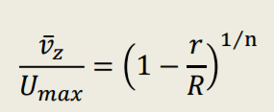

November 8, 2016

While velocity is parabolic, shear stress is linear.

For 2 fixed plates: Shear stress= y dP/dx (linear)
For circular pipe: shear stress= r/2 *dP/dz (linear) at r=R, shear for laminar or turbulent

If you have a flow in a pipeline which is laminar, it is laminar everywhere or turbulent everywhere. If it moves from laminar to turbulent, it is everywhere, due to velocity or distance is changed.

Velocity profile of turbulent flow is flat because of mixing of momentum.

Navier stokes equations apply to turbulent flows as well, but solution isn’t possible.

Are the Navier-Stokes equations for Newtonian Incompressible flows valid for Turbulent flows?
What are Reynolds stresses?
What is the mean velocity in turbulent flows? Mean velocity and fluctuations
Reynolds equations for turbulent Newtonian incompressible flows
What is the difference between viscous stresses and Reynolds stresses? Reynolds stresses aren’t related to viscous stresses
Stresses in fluid mechanics are the physical forces that result from fluid viscosity. TRUE
Are Reynolds stresses forces that result from fluid viscosity? FALSE
What is the laminar sublayer in fluid mechanics?

NOT PROVIDED IN FORMULA SHEET
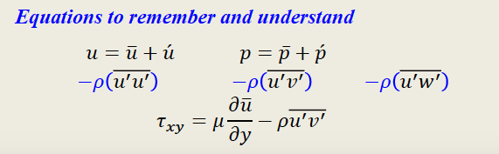

Roughness affects a turbulent flow by increasing its chaos scale

CHAPTER 6 EXTERNAL FLOWS

November 10, 2016

An inviscid flow can’t be laminar.

Laminar and turbulent are always related to viscosity.

A full turbulent layer also has a laminar sub-layer. (flat plate)

In a boundary layer over a plate the flow is laminar to a critical point where it turns into turbulent flow after the critical point

In a pipe or between plates the flow is laminar to a critical velocity when it turns into a turbulent flow, in the entire pipe.

November 15, 2016

Shear stress is called the skin friction

F=AKf’ ; Area and cons f’ keep changing when skydiving

Pressure (Patm) is equal all over a boundary layer in a case of a flat plate.

Pressure in a boundary layer of a curved surface is not uniform

In the main potential flow, Bernoulli can be applied

Viscous flow can’t be potential flow (around a sphere)

In a curved surface, energy increase, reaches max point then decreases

The wake is reduced significantly when turbulent boundary layer is applied instead of laminar. Reduces resistance as well.

Driving behind a truck as an example; energy of your movement is reduced.

Increasing roughness of soccer ball results in turbulent flow, thus less wake, resulting in further distance.

Turbulence in BL enhances the energy of particles by bringing momentum from outer layers

November 17, 2016

Separation happens because particles lose their energy; laminar

Turbulent flow, there is exchange of momentum in particles

The lift on any symmetrical body is ZERO.

For level flights and cruising altitudes, Lift=Weight

The entrance length is the length after which the flow is fully developed

Stall angle is the angle after which the aerofoil will lose lift

For Laminar flow flat plate BL $δ=C\sqrt{x}$ where C is a cons (used to determine BL thickness at corresponding position)
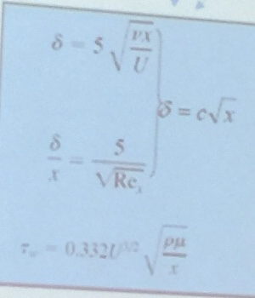
fps=1.47mph

November 22, 2016

In planes or race cars, we got to have a boundary layer. Use of vortex generators. It creates a swirling wake and brings energy from the main flow, placing it in the BL of the wing. The result for airplanes is a higher critical angle of attack, a lower stall speed, and gentler stall characteristics.

Flaps are a type of high-lift device used to increase the lift of an aircraft wing at a given airspeed. Flaps are usually mounted on the wing trailing edges of a fixed-wing aircraft. Flaps are used to lower the minimum speed at which the aircraft can be safely flown, and to increase the angle of descent for landing. Flaps also cause an increase in drag, so they are retracted when not needed.

Pressure is the normal stress perpendicular to surface

Shear stress is parallel to surface

Where we integrate pressure and shear stress, we get aerodynamic force or, (lift and drag forces)

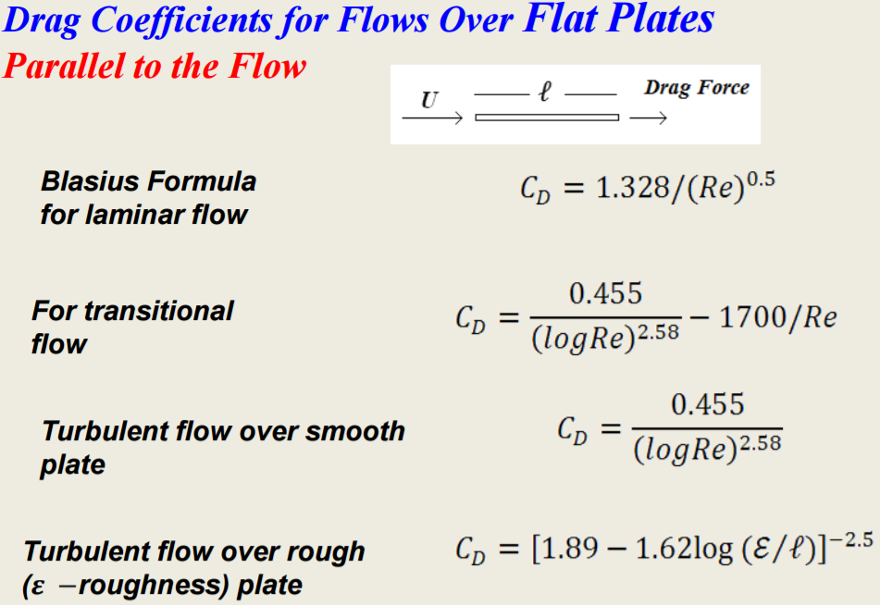 not provided formulae

Cd is decreasing with Re, but that doesn’t mean there is less drag for higher speeds because we also multiply by kinetic energy.

At moderate or intermediate Reynold number, the form drag (pressure) contributes more than skin(friction) drag

Pressure Drag: The drag force resulting from the distribution of pressure over the surface of the object (not including the contribution from frictional forces)

Golf ball from smooth to dimpled ball decreases form drag dramatically but increases skin drag. Will move to a further distance.

Cricket ball has asymmetric wake because of stitches around it.

Tapering will decrease wake, thus decreases wake equal to 10 times smaller sphere.

Tear drop structure to get rid of drag force (used in airplanes, subsonic panes etc)

Why do planes prefer to land against the wind and take of against the wind? Because of the magnus effect. Higher lift at lower plane speed, and air streams faster over the wing.

Trailing vortices: very high pressure below, and lower pressure above wing, thus vortices form. Results in a reduced effective angle of attack and lift.

Aspect ratio= span^2/Lift area
Higher Aspect ratio corresponds to more lift and less drag coefficients
Lower Aspect ratio corresponds to easier maneuvers

Compressible flows

November 24, 2016

Incompressible flows fail to explain phenomena at speeds that are appreciable compared to the speed of sound. Incompressible flows assume that the speed of sound is infinite.

Newtonian physics fails to explain phenomena at speeds that are appreciable compared to the speed of light. Newtonian physics assume that the speed of light is infinite.

Mass changes with any speed, but usually negligible with lower speeds, but grows exponentially when approaching light speed.

A little change in velocity, pressure, and density occurs when wave hits plate

Speed of sound C= (kRT)^0.5

November 29, 2016

Attaching shockwave is the reason for pointy tip of supersonic plane.

Shock wave is seen because air is humid and condensation occurs on the shock

Pressure doesn’t move in vacuum, but on particles.

Nozzle accelerate the flow?

December 1, 2016

In compressible flow dynamics, the speed of sound is a barrier between two different zones of laws of physics compressible subsonic and supersonic.

Speed of sound depends on temperature

Reference value for incompressible: Bernoulli
Reference value for subsonic: Stagnation parameters v=0
Reference value for supersonic: Critical parameters (M=1)

K is the heat capacity Cp/Cv= 1.4 for air

