Lesson 2 : Applying Time Value Concepts

Chapter 2

The Importance of Time Value of Money

Interest: is the rent charged for the use of money

Two ways to computing interest:

Simple interest: is the interest on a loan computed as a percentage of the loan amount or principal. The interest earned or paid is not reinvested. It’s calculated using the principal, the interest rate applied to the principal and the loans time to maturity,

I= P x r x t

Where,
I = interest earned
P = principal or present value
r = annual interest rate as a decimal or percent
t = time (in years)

Compound interest: refers to the process of earning interest on interest, eventually snowballing into a larger and larger base on which to earn interest

Annuity: refers to the payment of a series of equal cash flow payment at equal intervals of time.

FINANCIAL CALCULATOR

N: Number of periods
I/Y: Interest rate per period
PV: Present value
PMT: Payment per period
FV: Future value
CPT: Compute

Enter a value for four of the five TVM keys
Cash outflows: such as an investment amount, are entered as a negative number by pressing +/-
Cash inflows, such as investment amount are entered as a positive number
Specify the number of payment per year (P/Y) and the number of compounding periods per year (C/Y)

Future Value of a Single Dollar Amount

FORMULA TO DETERMINE FUTUR VALUE OF A SINGLE DOLLAR AMOUNT:

FV = PV (1 + i/n) ^nt

Where,
FV = future value
PV = Present value
i= annual interest rate
n = number of compounding periods per year
t= time

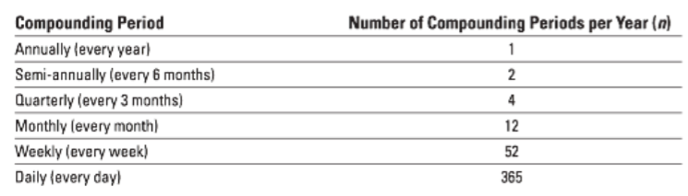

Future value interest factor (FVIF): a factor multiplied by today’s savings to determine how the savings will accumulate over time.

The higher the rate of return, the more your money will grow over a given time period.

FV = PV x FVIF I,n

Present Value of a Single Dollar Amount

You need to know:

- the amount of money to be received in the future
- the interest rate to be earned on your deposit
- the number of years the money will be invested
- the number of compounding periods

PV = FV / (1+ i/n)^nt

When interest rate compounds annually (n=1),
PV = FV / (1+i) ^t

Present value interest factor (PVIF): a factor multiplied by the future value to determine the present value of that amount. The PVIF is lower as the number of year increases. This means that less money is needed to achieve a specific future value when the money is invested for a greater number of years.

Future Value of an Annuity

Two main type of annuities:

Ordinary annuity: is a stream of equal payments that are received or paid at equal intervals in time at the end of a period

Annuity due: a series of equal cash flow payments that occur at the beginning of each period.

The difference: the payment occurs at the beginning instead of at the end of the period. For example, a monthly deposit of 50$ as new savings in a bank account at the end of every month is an ordinary annuity. If this deposit occurred at the beginning if the month, it would be an annuity due.

The best way to illustrate the future value of an ordinary annuity or an annuity due is through the use of timelines

USING A FORMULA TO DETERMINE FUTURE VALUE OF AN ANNUITY:

FV = PMT X [ (1-i) ^n – 1 / i]

Present Value of an Annuity

The present value of annuity can be obtained by discounting the individual cash flows of the annuity and totaling them

USING A FORMULA TO DETERMINE PRESENT VALUE OF AN ANNUITY

PV = PMT x [ 1- [ 1/(1+i)^n]/ i]

Interest Rate Conversion

A nominal interest rate is the stated, or quoted rate of interest.
- also know as the annual percentage rate (APR)

The effective interest rate is the actual rate of interest that you earn, or pay over a period of time.
- also know as the effective yield ( EY or EFF)
- allows for the comparison of two or more interest rated because it reflects the effect of compounding

EY = (1+i/n)^n – 1

- a nominal rate will always specify two quantities:
1) annulized rate
2) the compounding frequency

How to take advantage of compound interest
- Invest Early – the earlier one strts investing the better.
- Invest Often
- Hold as long as possible
- Consider interest rates
- Don’t forget compounding intervals

