DBMS objects:
- Tables
- Views - A view is simply the representation of a SQL statement that is stored in memory so that it can easily be re-used.
- Triggers
- Procedures
  - Function
- Should return a value
- Can be called from the SQL statement
- Can be used in expression directly
  - Stored procedure
- May or may not return a value
- Can’t call a SQL statement

DCL – Data Control Language
- deals with the transaction within the database
- COMMIT
- ROLLBACK

DML – Data Manipulation Language
- deals with the manipulation of data
- SELECT
- INSERT
- UPDATE
- DELETE

DDL – Data Definition Language
- used to define the database schema
- CREATE
- DROP
- ALTER
- TRUNCATE
- COMMENT
- RENAME

DATA DICTIONARY
- We use the data dictionary to analyze the metadata. Whenever there is an object being created, tables, indexes, views, if we want to manage these objects we need to query against the metadata, manage objects within the database system
- When is it updated? Every time we issue a DDL statement, create tables, indexes, views
- Why? For example, triggers are expensive – knowing what kinds of triggers are available within a particular schema is helpful

Data warehousing

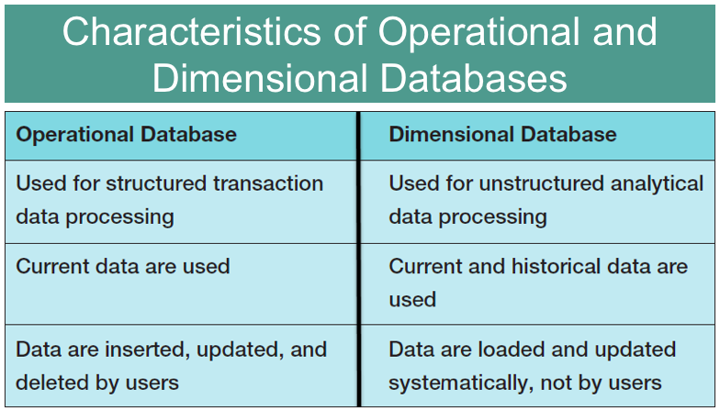

Star Schema
- Consists of a dimensional database that contain multiple tables that are classified as a dimensional tables or fact table

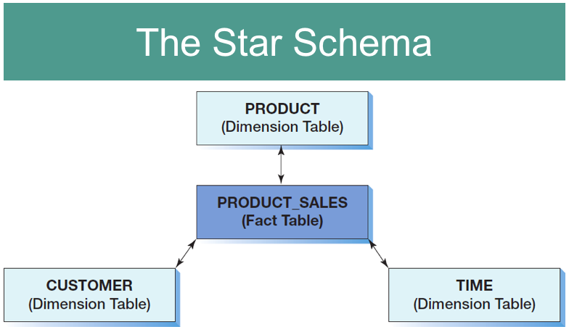

OLAP cube
- a presentation of a measure with associated dimensions.
- An OLAP cube can have any number of axes.
- The terms OLAP cube and OLAP report are synonymous
- Has measures and dimensions
  - Measure – data item of interest
  - Dimension – characteristics of a measure

Rollup
- Extension pr0cedures group subtotals from right to left and a grand total

Select customer_id, product_id, sum(quantity), total_quality, count (*)
From product, sales
Group by rollup (Customer_ID, Product_ID);
(or Group by cube(Customer_ID, Product_ID);

Pivot Operator
- Takes data in separate rows, aggregates it and converts into columns in its basic form

Big Data
- the current term for the enormous datasets

Business intelligence (BI)
- systems are information systems that assist managers and other professionals:
  - To analyze current and past activities.
  - To predict future events.
- Two broad categories:
  - Reporting
  - Data mining
- BI systems obtain data in three ways:
        - From the operational database
        - From extracts from the operational database
        - From data purchased from data vendors

ETL – Extract, Transfer and Load
- Process of collecting data from multiple sources and packaging it into a format that is going to be consumed by a business

Data mining applications
- are used to:
      - Perform what-if analysis
      - Make predictions
      - Facilitate decision making

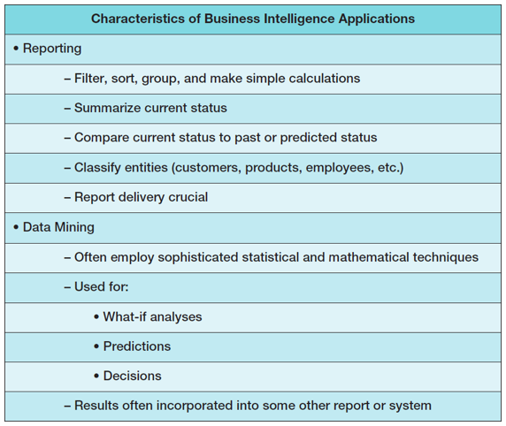

OLAP
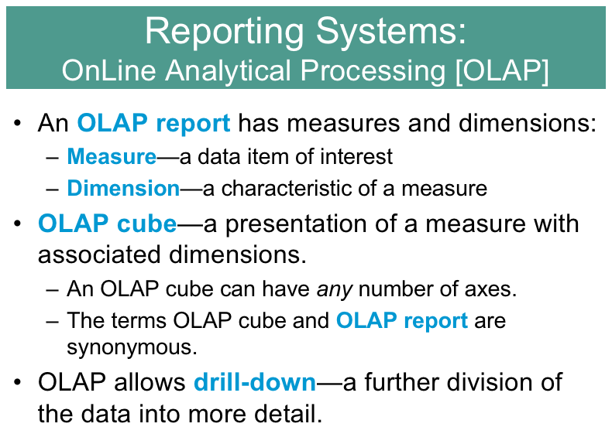

Create an OLAP report syntax

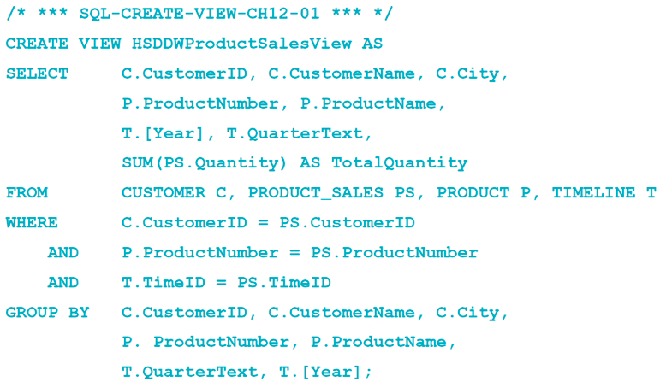

Normalization
- Process to avoid anomalies

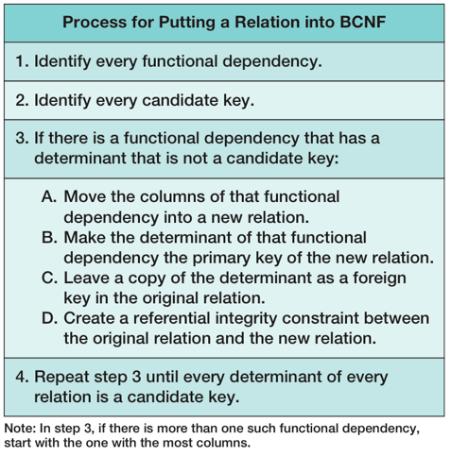

1st Normal Form
- no repeating groups
- all data values are atomic
- each field has a unique names
- has a primary key

2nd Normal form
- It is in the 1st normal form
- All non-key attributes are dependent on ALL PARTS of the primary key
- Each field has a unique name
- Has a Primary Key

3rd Normal form
- It is in the 2nd normal form
- All non-key attributes are NOT dependent on any other non-key attributes
- Each field has a unique name
- Has a primary key

BCNF
- It is in the 3rd Normal form
- A relation is in BCNF if every determinant is a candidate key

Data
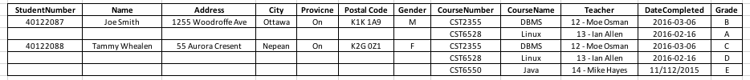

1st Normal form
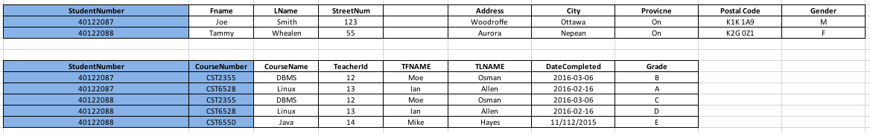

2nd Normal form
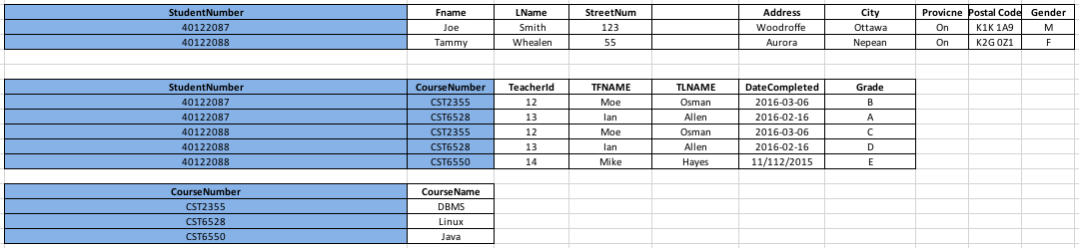

3rd Normal form
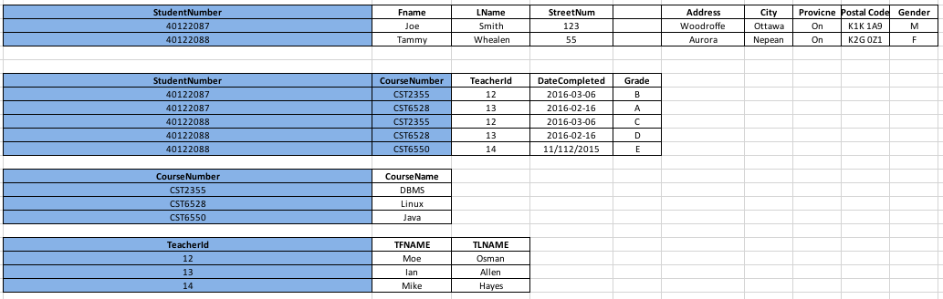

BCNF
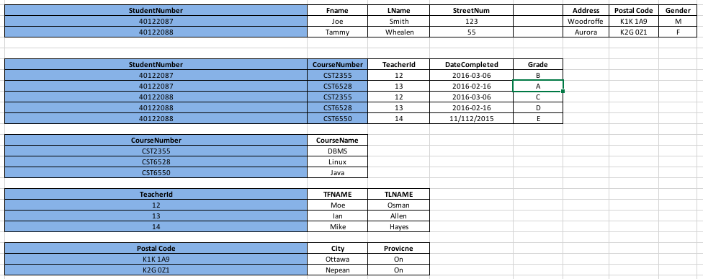

Anonymous block
- Has no name
- Does not get stored in the database
- Compiled every time
- Cannot be invoked by other applications
- Do not return values
- Cannot take parameters

Named block
- Named PL/SQL blocks
- Compiled only once
- Stored in the database
- Name and therefore, can be invoked by other applications
- If functions, must return values
- Can take parameters

A PL/SQL block has up to four different sections, only one of which is mandatory:

Header
Used only for named blocks. The header determines the way the named block or program must be called. Optional.
Declaration section
Identifies variables, cursors, and subblocks that are referenced in the execution and exception sections. Optional.
Execution section
Statements the PL/SQL runtime engine will execute at runtime. Mandatory.
Exception section
Handles exceptions to normal processing (warnings and error conditions). Optional.

How to declare variables:
var_name datatype | table_name.column_name%TYPE [:= expression]

v_salary instructor.salary%TYPE;
max_students NUMBER (2) := 0;

How to declare records (row)
record_name table_name%ROWTYPE;

Keywords for conditional statements
IF – IF
CASE – WHEN

Explicit Cursors
- Holds the result set of a query in a buffer and releases one row at a time

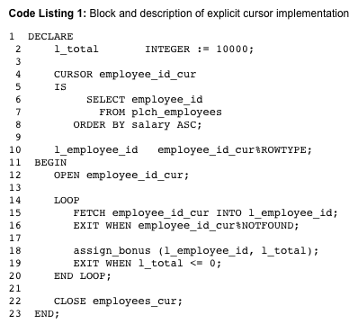

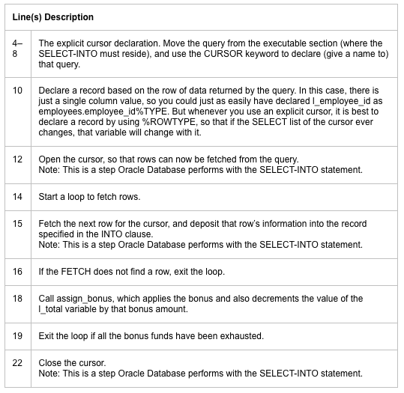

Steps:
DEFINE A CURSOR
student_cursor
DECLARE RECORD
student_record
OPEN CURSOR

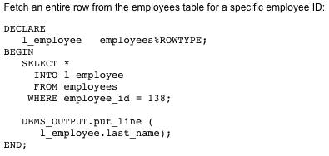

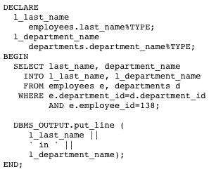

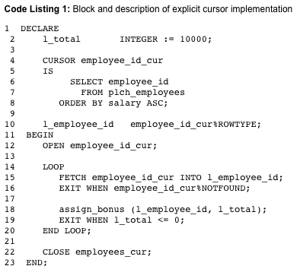

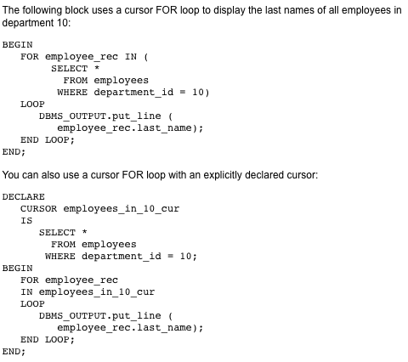

NON-CURSOR RELATED
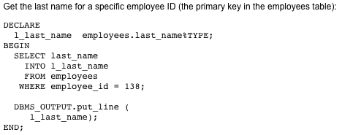

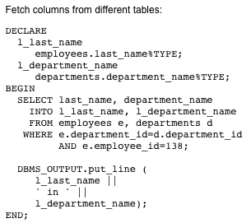
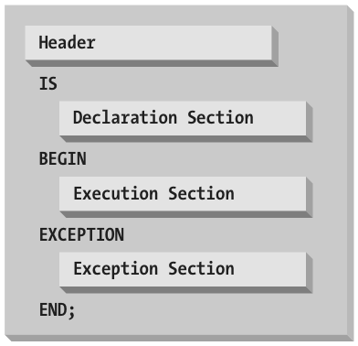

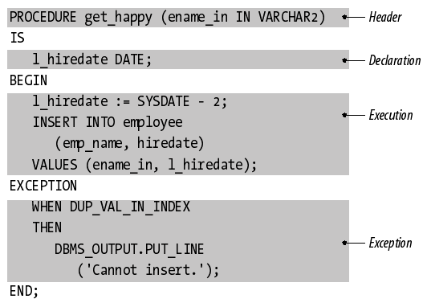

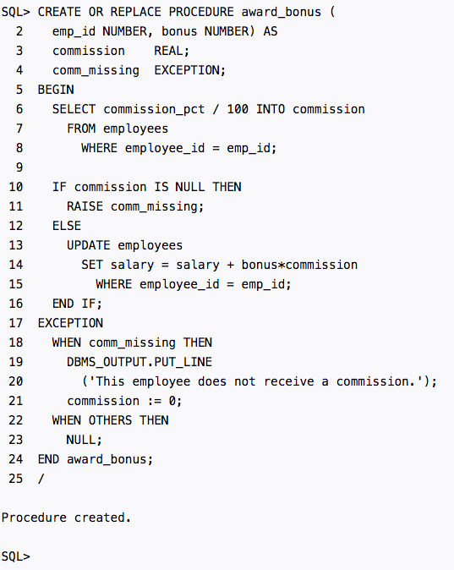

PL/SQL TRIGGER

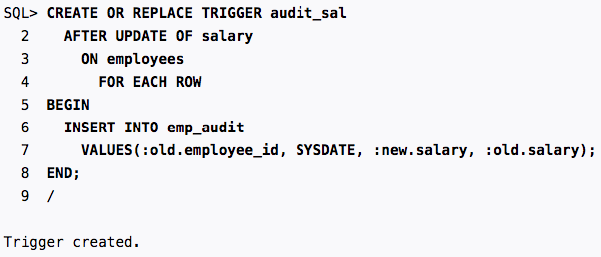

LOOP

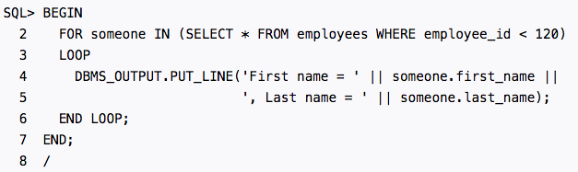

Trigger syntax

CREATE [OR REPLACE] TRIGGER schema.trigger-name
{BEFORE | AFTER} dml-event ON table-name
[FOR EACH ROW]
[DECLARE ...]
BEGIN
-- Your PL/SQL code goes here.
[EXCEPTION ...]
END;
/

PROCEDURE SYNTAX

CREATE [OR REPLACE] PROCEDURE procedure_name
[ (parameter [,parameter]) ]

IS
[declaration_section]

BEGIN
executable_section

[EXCEPTION
exception_section]

END [procedure_name];

