Stress and health
Relation between mind and body
- considered a physical illness. (could threaten well being).
Psychophysiological = psychosomatic (illness caused by psych factors)
Stimulus: caused by environmental factors that lead to physical response.
Life events: catastrophes, life changes, daily hassles.
Stress as Response: Dr. Hans Selye’s “General adaptation syndrome”
Stage 1: the alarm reaction
- primitive reflexes kick in from your nervous system (short of breath, tense muscle ect)
Stage2: Resistance
- subconsciously redefine continually stressed state as normal.
-leads to inefficient functioning
Stage 3: exhaustion
- fatigue, adrenal exhaustion and weakened immune system.
Horomonal brain signal – adrenal cortex – release of cortisol
Neural signal from brain – adrenal medualla – epinephrine and norepinephrine – raised blood pressure.
Responses:
Psychological – worry, loss of confidence, feeing upset
Bodily- rapid pulse, pounding heart, perspiration
Behavioural- accident proneness, increased/decreased eating or sleeping.
Coronary heart disease
- clogging of vessels that nourish the heart muscle
-leading cause of death in many developed countries
Lymphocytes
- 2 types of white blood cells
blymophocytes – form in the bone marrow and release antibodies that fight bacterial infections
tlymphocytes- form in the thymus and attack cancer cells, viruses and foreign substances.
the nervous system:
ans: fight/flight –acute
cns: perceived threat -chronic
Heart disease is the leading cause of death in US in 2000 –lifestyle related.
Stress is post often experienced from ages of 18-19 (40% have high stress)
Cognitive Appraisal and stress – or the individual perception of a stressful situation that affects the response to the situation,
Cerebral cortex perceives stressor
Sympathetic nervous system release stress hormones epinephrine and norepinephrine from adrenal glands.
Pituitary hormone in the bloodstream stimulates the outer pat of the adrenal gland to release the stress hormone cortisol.
Executive rat Experiment
Uncontrollable rat showed less increase in t-cells which kill harmful cells.
Pessimists are more likely to develop coronary disease (kubzansky)
Stress and Personality
type a: friedman and rosenman’s term for competitive, hard driven, impatient, verbally aggressive and anger prone people. Increased risk of heart disease.
type b: easygoing, relaxed people.
Personality cp 13
Personality- characteristic pattern of thinking, feeling and acting.
-psychoanalytic, humanistic, trait theories, cognitive.
Psychoanalytic Perspective:
based on FREUD – childhood sexuality and unconscious motivations influence personality.
- a school of thought united by a concern with dynamics or interaction forces lying deep within the mind.
Depth Hypothesis
The mind – Unconscious mental contents – preconscious contents (easily accessible)
- Dynamically unconscious contents (difficult to make accessible)
most of the mind is unconscious, only the ego is conscious.
Structural Hypothesis
ID – pleasure principle
Ego- reality principle
Superego- the conscience, morality principle
approach to therapy: free association, dream interpretation, analysis of resistance, projective tests.
Projective tests: personality test (Rorschach or TAT) provides stimuli designed to trigger projection of inner dynamics.
Thematic Appreception Test – people express their inner feelinfs and interests through stories they make up about ambiguous scenes,
Criticisms – lack of experimental support, cultural bias, dependence of inference, too pessimistic.
Neo-Fruedians
Alfred Adler – stress on childhood social tension.
Karen Horney- sought to balance freud’s masculine biases
Carl Jung – stressed the collective unconscious – concept of a shared, inherited reservoir of memory traces from our species’ history.
Humanistic Perspective
Human science not natural science
-phenomenological approach (see the world through the clients perceptions)
- more optimistic in nature.
- human potential/growth
Maslows Heirarchy of needs
Self actualization needs : need to live up to full potential
Esteem needs: self-esteem, achievement, competence; recognition and respect from others.
Belongingness and love needs: need to love and be loved; be accepted and avoid loneliness.
Safety needs: to feel the world is organized and predictable, need to feel secure and stable.
Physiological needs: hunger and thirst.
Carl Rogers – growth and fulfilment of individuals.
-many parents place conditions of worth on other; key to development of positive self-regard is unconditional positive regard from significant others.
Self-concept (present vs ideal)
answers to the question “whp am i”
anxiety happens when people lose pursuit of self-actualization
Contemporary Research – The Trait Perspective
Trait – pattern of behaviour. Disposition to feel and act, assessed by self-report and peer reports.
Personality is made up of multiple traits.
Allport and Odbert (1963) came up with 18 000 words representing traits.
- to condense the list of traits is through factor analysis, a statistical approach used to describe and relate personality traits.
Hans and Sybil Eysenck
Stable and unstable
Introverted and extraverted
Personality inventory
- questionnaire on which ppl respond to items designed to show a wide range of feelings/ behaves.
Empirically Derived Test : developed by testing a pool of items and then selecting those that discriminate between groups.
Minnesota Multiphasic Personality Inventory (mmpi)
Social Cognitive Perspective
Personal Control (vs helplessness) – controlling our environment instead of feeling helpless
External Locus of Control – perception that chance or other forces beyond your control determine your fate.
Internal Locus of Control- perception that you control your own fate.
Psychological Disorders ch.14
Abnormal behaviour
norm violation, personal discomfort, statistical rarity, maladaptive behaviour.
Categories:
Harmful to self or others
poor contact with reality
emotional reactions unsuitable to situation
Erratic behaviour
- deviant, distressful, dysfunctional.
Ancient societies thought of abnormal behaviour as being deviant and supernatural; treatment was exorcism or trephination (?)
The medical perspective –disorders are caused by abnormalities in brain and nervous system.
Psychodynamic Perspective – originate from intrapsychic conflict (id,ego)
Cognitive behavioural- learned maladaptive behaviour patterns and can be understood by looking at envrio factors.
Humanistic – arise when ppl perceive that they must earn positive regard of others.
Sociocultural – culturals play a main factor in mental disorder development
Explaining abnormal behaviour
medical model - symptom, disease, patient, treatment
Axis I - Clinical syndrome
  - Axis II - Personality disorders
  - Axis III - General medical disorders
  - Axis IV - Psychosocial/environmental problems
Axis V – Global assessment of fcning
psychogenic causes: anton franz Mesmer hypothesis
Bio-psycho-social perspective
-assumes bio, socio, psycho factors combine and interact to produced psycho disorders.
Bio- evolution, genes, brain structure.
Social- roles, expectations, normality and disorder.
psycho- stress, trauma, learned helplessness.
Theory and treatment
neurotic disorder – distressing but allows one to think rationally and function socially.
psychotic dis- loses contact with reality, irrational ideas and perceptions
generalized anxiety disorder – tense, apprehensive, autonomic nervous system arousal.
panic dis- episodes of intense dread – chest pain, choking frightened sensations
phobia – irrational fear of something
OCD- obsessions and compulsions PET scan of brain, high metabolic activity in frontal lobe with areas involved with directing attention.
Somatoform Disorders
- psych conflicts that take on somatic or physical form.
Mood disorders
-emotional extremes
depression – altering any one component of the chemistry- cognition- mood circuit can alter the others
1. Neg stressful states
2. Pess explanatory style
3. Hopeless depressed state.
4. Hamper the way the person acts
Rumination?
Mood dis
manic epi – hyperactive, wildly optimistic state
bipolar dis – brain energy rises and falls with emotional switches.
neurological perspective
genetics’ 3x more likely to be depressed if first degree relatives are. 10x more likely to be bipolar.
Dissociative Disorders – conscious awareness becomes separated from previous memories thoughts and feelings.
- Dissociative Identity disorder
- person exhibits two or more distinct and alternating personalities
- formerly called multiple personality disorder
Schizophrenia - sevre distortion of thought/language, perception, mood, and weird behavior.
delusions, hallucinations.
7 patterns of delusions – persecution, grandeur, hypochondriacal, sin/guilt, reference, control.
chronic and acute schizophrenia
- when it develops slowly recovery is doubtful. Negative symptoms
- when it rapidly develops recovery is better. Pos symptoms.
Personality disorders – inflexible and enduring patterns that impair social functioning.
odd/eccentric
dramatic/emotional
anxious/fearful
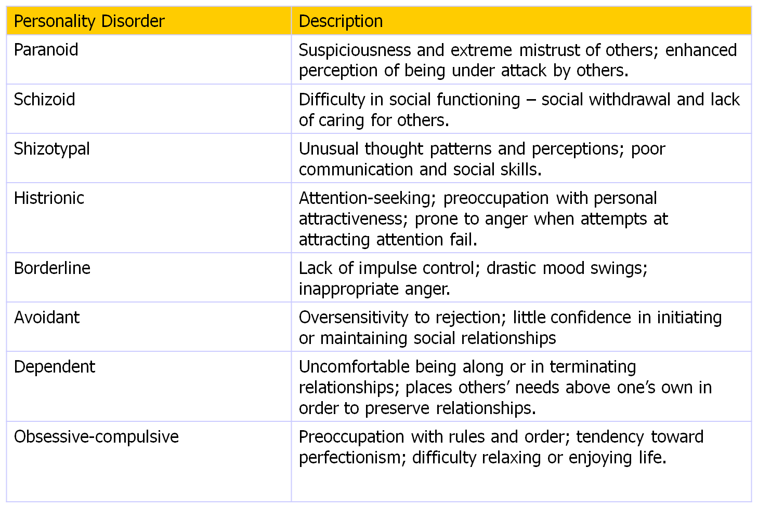
Antisocial personality disorder – ex kids before committing crime respond with lower levels of stress hormones tahtn others do at their age. Lower level of arousal. Pet scans of 41 murderers showed lower activity in frontal lobes. 11% less. 

