Final exam BIOL 266
You have isolated a mutant line of mammalian cell deficient in Emerin. This mutant live is expected to be impaired in:
  - export of 40s and 60 s ribosomal subunits from the nucleus
  - ribosome assembly in the nucleus
  - transcription of some genes in certain tissues
  - nuclear import of lamina
  - attachment of lamina to cytosolic filaments of the nuclear pore complex
  - attachment of lamina to the terminal ring of the nuclear basket

Some oπf the enzymes inserted into the outer mitochondrial membrane convert fatty acids into forms that are subsequently metabolized in the mitochondrial matrix. lack of these enzymes is expected to:
  - completely block the synthesis of ATP in mitochondria
  - completely abolish the formation of acetyl- CoA in mitochondria
  - Completely eliminate the flow of electrons through the mitochondrial electron transport chain
  - completely shut down the formation of CO2 in mitochondria
  - all of the above
  - none of the above

ATP synthase in the thylakoid membrane catalyzes the synthesis of ATP. This newly formed ATP is released to:
  - the inter membrane space between the inner and outer membrane of the chloroplast
  - the storm of the chloroplast
  - the thylakoid lumen
  - the space outside the chloroplast
  - all of the above
  - nonce of the above

Plant cells synthesize hemicelluloses and pectins in the golgi apparatus. Lack of the enzymes that catalyze the synthesis of these two compounds is expected to:
  - prevent the retrograde vesicular transport of proteins from the golgi to the ER
  - Abolish the vesicular transport of proteins from the golgi to the ER
  - Change the composition of the cell wall
  - impair the vesicular transport of proteins from the golgi to the plasma membrane
  - all of the above
  - nonce of the above

Lysosomes contain a proton ATPase. lack of this enzyme is expected to:
  - stimulate the ability of cells to digest small molecule taken up from the outside by endocytosis
  - promote autophagy
  - activate phagocytosis
  - increase pH in the lumen of the lysosome
  - decrease pH in the lumen of the lysosome
  - none of the above
The nucleolus is:
  - site of phospholipid synthesis
  - the most prominent membrane bound organelle in the nucleus
  - the site of protein synthesis
  - the assembly centre for chromatin
  - the assembly centre for ribosomes
  - the site of sphingolipid synthesis

In a typical mammalian cell, primary lysosomes digest:
  - age dor defective mitochondria
  - bacteria taken up from the outside the cell by phagocytosis
  - aged or defective peroxisomes
  - the debris of dead cells taken up from outside the cell by phagocytosis
  - all of the above
  - nonce of the above

You have isolated a mutant line of mammalian cell deficient in an essential component of clathrin. This mutant line is expected to be impaired in:
  - ribosome assembly
  - oxidative phosphorolation
  - biosynthesis of cholesterol
  - fatty acid oxidation
  - movement of K+ into the cell
  - biosynthesis

Conversion of fatty acids to carbohydrates occurs:
  - in mitochondria the root of cells of plant
  - in mitochondria of germinating plant seeds
  - in chloroplast of leaf cells of a plants
  - in peroxisomes of germinating plant seeds
  - in chloroplast of root cells of a plant
  - in peroxisomes of leaf cells of a plants

Objective lenses in light microscope
  - magnify the image that has been focused on the objective focal plane
  - focus the light from a bright source onto the specimen
  - Focus the image of the specimen on the objective focal plane
  - do not create a magnified image of the specimen onto the focal plane
  - project the magnified image of the specimen onto the plane of the human eye
  - none of the above

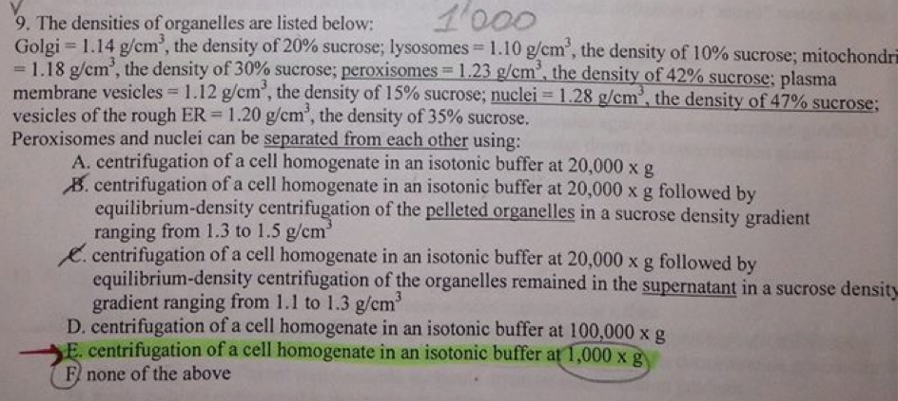
Membrane fluidity can be decreased by
  - decreasing the proportion of lipids with saturated hydrocarbon tails
  - decreasing the proportion of lipids with long hydrocarbon tails
  - increasing the extend of unsaturation of the hydrocarbon tails
  - decreasing the extent of unsaturation of the hydrocarbon tails
  - decreasing the length of the hydrocarbon tails
  - decreasing the amount of cholesterol

A transmembrane transporter for a small ion is likely to be made up of a protein with the following characteristics
  - an integral membrane protein that is anchored in the lipid bilayer by a covalently attached glycolipid
  - a transmembrane protein with five beta sheets; two of these beta sheets have only amino acids with hydrophilic side chains; the other three beta sheets have only amino acids with hydrophobic side chains
  - a transmembrane protein with five alpha helices; two of these alpha helices have only amino acids with only hydrophobic side chains; the other three alpha sheets has the hydrophilic amino acids chains on one side foe the helix and the hydrophobic amino acid chains on the opposite side of the helix
  - a transmembrane protein with four alpha helices; two of these four alpha helices have only amino acids with hydrophobic side chains; the other two alpha helices have only amino acids with hydrophilic side chains
  - a transmembrane protein with four beta sheets;each of the four beta sheets has only amino acids with hydrophobic side chains
  - a transmembrane protein with three alpha helices;two of these three alpha helices have only amino acids with hydrophobic side chains; the other alpha helix has only amino acids with hydrophilic side chains

Facilitated diffusion differs from active transport in that the facilitated diffusion of small water soluble molecules across membrane
  - moves all water soluble molecules only against their concentration gradient
  - does not require external source of energy
  - requires membrane transport proteins
  - couples the movement of one type of water soluble molecule against its concentration gradient to the movement of a different type of water soluble molecules down its concentration gradient
  - all of the above
  - nonce of the above

An ion channel is similar to an antiporter in that they both
  - move only a very limited number of water soluble molecules at a time
  - do not require the energy of ATP hydrolysis to move water soluble molecules across a membrane
  - couple the movement of one type of water soluble molecules against its concentration gradient to the movement of a different water-soluble molecule down its concentration gradient
  - move multiple water soluble molecules at a time
  - require the energy provided by ATP hydrolysis for the movement of water soluble molecules
  - nonce of the above

The inability of a cell to hydrolyze GTP is expected to:
  - impair glycosylation of proteins in the lumen of the ER
  - Eliminate the activity of Na+/K_ ATPase in the plasma membrane
  - abolish the TCA cycle in the mitochondria
  - promote protin import into the nucleus
  - impair the formation of disulfide bonds in the ER
  - abolish the flow of electrons through the mitochondrial electron transport chain

The signal recognition particle
  - keeps newly synthesized proteins carrying the ER sorting signal in an unfolded state
  - binds to translocons in the ER membrane
  - delivers proteins carrying the ER sorting signal to the ribosome that have been attached to the er membrane
  - delivers proteins carrying the ER sorting signal to translocons in the ER membrane after these proteins have been completely synthesized on free ribosomes in the cytosol
  - significantly decrease the rate of translation of protein carrying the ER sorting signals by free ribosomes in the cytosol
  - significantly decreases the rate of translation of proteins carrying the ER sorting signal by ribosomes attached to translocons in the ER membrane

A sliding force between polar microtubules is generated by:
  - the movement of dyneins along microtubules towards their - minus end
  - the movement of kinesins along microtubules towards their - minus end
  - the movement of myosin I along microtubules towards their + plus end
  - the movement of kinesins along microtubules towards their + plus end
  - the movement of myosin along microtubules towards their - minus end
  - the movement of dynes along microtubules towards their + plus ends
Dynamic instability of microtubules is due to:
  - the inability of alpha-tubulin to bind GTP
  - the inability of beta-tubulin to bind to GTP
  - the inability of beta-tubulin to hydrolyze GTO
  - the inability of beta tubular to hydrolyze GTP shortly after polymerization of tubular dimers
  - the ability of alpha-tubulin to bind GDP
  - the ability of beta tubular to activate the GTPase activity of alpha-tubulin

The nuclear envelope re-assemble around each set of daughter chromosomes during
  - anaphase
  - telophase
  - metaphase
  - prophase
  - prometahase
  - cytokinesis

By the end of interphase, microtubules extend outward from
  - the nucleus
  - a single centrosome
  - spindle poles
  - two centrosomes
  - centromeres
  - kinetochores

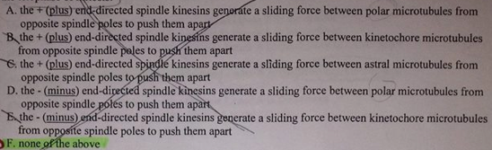
In the the telophase of mitosis

During cytokinesis, the cyclin B-activated M phase Cdk phosphorylates:
  - condensins
  - microtubule-associates proteins
  - lamins
  - proteins that stabilize the plus+ ends of the overlapping microtubules of the mitotic spindle
  - all of the above
  - none of the above

The second messenger phosphatidylinositol 3,4,5-triphosphate (PIP3) initiates a series of the signal transduction steps ultimately leading to activation of:
  - adenylate cyclase
  - the beta isoform of phospholipase C (PLC-beta)
  - the MAP kinase
  - the Ras protein
  - the Akt protein kinase
  - glycogen phosphorylase

Cofilin
  - increases the rate of dissociation of ADP-bound actin monomers from the +plus end of actin filaments
  - decreases the rate of dissociation of ADP-bound actin monomers from the +plus end of actin filaments
  - increases the rate of dissociation of ADP-bound actin monomers from the - minus end of actin filaments
  - decreases the rate of dissociation of ADP-bound actin monomers from the - minus end of actin filaments
  - increases the rate of dissociation of ADP-bound actin monomers from the - minus end of actin filaments
  - decreases the rate of dissociation of ADP-bound actin monomers from the - minus end of actin filaments

the receptor for the steroid hormone cortisol
  - activates transcription of cAMP-inducible genes only in the presence of cortisol
  - represses transcription of cortisol-regulated genes only in the absence of cortisol
  - is transported into the nucleus only after it binds cortisol
  - is located on the outer surface of the plasma membrane
  - is always located in the nucleus
  - is always located in the cytosol

The receptor for the steroid hormone thyroxine
  - forms a dimer only in the presence of thyroxine
  - is located ont he outer surface of the plasma membrane
  - is always located int he nucleolus
  - is always located in the cytosol
  - in the absence of thyroxine, acts as a repressor of transcription of thyroxine-inducible genes
  - in the presence of nitric oxide-inducible genes

the receptor for nitric oxide
  - is located ont he outer surface of the plasma membrane
  - is located on the inner surface of the plasma membrane
  - is always located in the nucleus
  - is always located int he cytosol
  - is transporter into the nucleus only after it binds nitric oxide
  - in the presence of nitric oxide, acts as an activator of transcription of nitric oxide inducible genes

The free Ca2+ unbound form of calmodulin (CaM) activates protein kinases that phosphorylate:
  - the myosin light chain
  - glycogen phosphorylase kinase
  - the CREB protein
  - cAMP phosphodiesterase
  - all of the above
  - none of the above

Glycogen synthase catalyzes the synthesis of glycogen from glucose monomers. This enzyme is inactivated by:
  - phosphorylation by regulatory subunit of protein kinase A in the cytosol
  - phosphorylation by regulatory subunit of protein kinase A in the nucleus
  - phosphorylation by a catalytic subunit of protein kinase A in the absence of cAMP in the cytosol
  - phosphorylation by a catalytic subunit of protein kinase A in the nucleus
  - phosphorylation by a tetramer of protein kinase A in the cytosol

The kinase activities of cyclin-dependant protein kinases (Cdks) change during the cell cycle as a result of:
  - the Cdks phosphorylating each other
  - the Cdks phosphorylatingcyclins
  - the concentration of Cdks changing throughout the cell cycle
  - the Cdks phosphorylating activating kinases
  - the Cdks phosphorylating activating phosphates
  - the concentration of cycles changing throughout the cell cycle

Protein kinase A is a tretramer consisting of two subunits and two C subunits. which of the following mechanism concerning protein kinase A activation is correct?
  - the enzyme is activated by the removal of cAMP from the R subunits
  - cyclic AMP activates the cAMP-regulated phosphatase, which in turn activates the protein kinases A
  - cyclic AMP activates the cAMP-regulated protein kinase, which in turn activates the protein kinases A
  - the binding of cAMP to the C subunit releases the R subunits which are then free to phosphorylate specific proteins
  - the binding of cAMp the R subunit releases the entire enzyme from the membrane resulting in its activation
  - none of the above

Prostaglandin-dependant regulation of adenylate cyclase activity relies on:
  - catalytic subunit of protein kinase A
  - heterotrimeric Gs, protein
  - regulatory subunit of protein kinase A
  - heterotrimeric Gi protein
  - Gs-protein-linked receptor
  - glycogen phosphorylase kinase

The major difference between Gs and go proteins lies in their ability to:
  - bind GTP
  - bind GDP
  - bind adenylate cyclase
  - regulate adenylate cyclase activity
  - regulate the activity of cAMP phosphodiesterase
  - hydrolyze GTP

Glycogen phosphorylase catalyses the breakdown of glycogen to glucose. This enzyme is activated:
  - by binding to a cytosolic domain of the B-adrenergic Gs-protein linked receptor
  - by phosphorylation by glycogen phosphorylase kinase in the absence of cAMP in the cytosol
  - by phosphorylation by a catalytic subunit of protein kinase A in the absence of cAMP in the cytosol
  - by phosphorylation by a catalytic subunit of protein kinase A in the presence of cAMP in the cytosol
  - by phosphorylation by glycogen phosphorylase kinase in the presence of cAMP in the cytosol

Following its activation, phospholipase C produced a water soluble second messenger and a lipid second messenger. The lipid product:
  - is inositol 1,4,5 triphosphate (IP3)
  - activates adenylate cyclase
  - is phosphatidylinositol 4,5-biphosphate (PIP2)
  - is phosphatidylinositol 3,4,5-triphosphate (PIP3)
  - activates protein kinase A
  - activates protein kinase C

Ras protein
  - activates the receptor tyrosine kinases
  - promotes the recruitment of the Grb2 protein from he cytosol to the plasma membrane
  - activates the guanine nucleotide-exchange activity of the Sos protein
  - is GTPase
  - activates adenylate cyclase only when the raw protein is present in its active,GTP-bound form
  - activates the beta isoform of phospholipase C (PLC-beta) only when the raw protein is present in its active GTP bound form

catalytic subunit of cAMO-activated kinase A phosphorylates and inactivates;
  - adenylate cyclase
  - phosphodiesterase
  - glycogen phosphorylase kinase
  - glycogen phosphorylase
  - cAMP-response element binding (CREB) protein
  - glycogen synthase

the Akt protein is recruited from the cytosol to the plasma membrane by:
  - DAG (diaglycerol)
  - the active form of Raf
  - PIP2
  - IP3
  - PIP3
  - the GTP-bound form of Ras

Rise in cytosolic Ca2+ initiates a series of signal transduction events ultimately leading to
  - inactivation of glycogen phosphorylase
  - muscle relaxation
  - activation of adenylate cyclase
  - inactivation of glycogen synthase
  - formation of DAG and IP3 from PIP2
  - formation of PIP3 from PIP2

Profilin
  - binds to the coffin bound + plus end of the actin filament and stimulates the exchange of ATP for ADP
  - binds to the coffin-bound - minus end of actin filaments and stimulates the exchange of ATP for ADP
  - binds to the cofilin-bound ATP actin monomer and stimulates the exchange of ATP for ADP
  - binds to the cofilin-bound ADP-actin monomers and stimulates the exchange of ADp for ATP
  - binds to the coffin bound Arp2/3 protein and stimulates the exchange of ATP for ADP
  - binds to the cofilin-buond nucleation site of actin filaments and stimulates the exchange of ATP for ADP

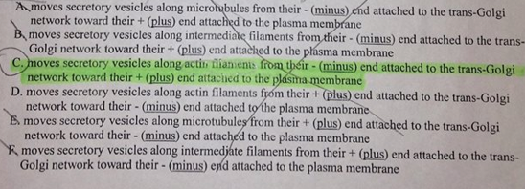
Myosin I

Intermediate filaments
  - are polymer that are constantly undergoing assembly and dissasembly
  - are involved in cell movement
  - are involved in the separation of chromosomes during mitosis
  - are required for the intracellular transport of membrane bounded vesicles and organelles
  - provide attachment sites for the chromatin in the nucleus
  - none of the above

Adrenaline-induced activation of adenylate cyclase depends on:
  - phospholipase C (PLC)
  - calmodulin (CaM)
  - receptor tyrosine kinase
  - Ras protein
  - MAP kinase
  - nonce of the above

In plant cell ribosomal proteins can be found in five different locations. name all of these locations. In which these ribosomal proteins are assembled into ribosomes that contain both 40S and 60S subunits? In which of these locations the completely assembled ribosomes are not attached to a membrane?

briefly describe five consecutive steps in the cycle of events regulating activity of the M phase Cdk

name two mechanism for generating the asymmetry of the plasma membrane lipid bilayer. which of these two ways for generating the uneven distribution of lipids within the bilayer does not depend on the plasma membrane proteins? Name two lipids whose uneven distribution within the bilayer is due to this protein-independent mechanism

recessive mutation in the CFTR gene cause a fatal disease. What is the name of this disease? what type of cells is affected by these mutations? what is the primary clinical manifestation of this disease and why? Where within the mutant cells carrying any of these mutations the protein product of the CFTR gene is located?

You have isolated a mutant line of mammalian cells deficient in the synthesis of the lipid called dolichol. Name the cellular process that is expected to be impaired in these mutant cells and briefly explain why.

name four protein kinases that are involved in the increase of intracellular concentration of glucose in response to a rise in the cytosolic Ca2+

name at least two protein kinases that regulate the level of cAMP in the cytosol. Name two protein that are phosphorylated by these kinases

name three guanine nucleotide-exchange factors and briefly describe their function in signal transduction

How do astral microtubules mediate the movement of daughter chromosomes toward opposite spindle poles during anaphase of mitosis?

briefly explain why the assembly of a microtubule occurs only if the concentration of GTP-bound tubular at its plus + en is high/

name two feature of coffin that are essential for the ability of this protein to promote the shortening of actin filament

briefly describe the six steps in signal transduction that lead to the activation of Raf kinase

name the organelle (or organelles) that has/have cytoskeletal protein filaments located inside of this/these organelle(s). what is the collective name of proteins that compose these cytoskeletal protein filaments located inside of the organelle(s)

whats is the functional difference between intermediate filaments and the two other known types of cytoskeletal protein filaments? what is the major difference in structure between intermediate filaments and the two other known types of cytoskeletal protein filaments

