Quiz 10 Name: ID Time: 25 min
Q1. (4 marks) The genetic frequencies of two separate populations are:

 | AA | Aa | aa
Population 1 | .36 | .48 | .16
Population 2 | .33 | .33 | .33
Population 3 | .55 | .10 | .35

Which of these populations are in Hardy-Weinberg equilibrium?
A) Population 1 is in Hardy-Weinberg equilibrium, but populations 2 and 3 are not.
B) Population 2 is in Hardy-Weinberg equilibrium, but populations 1 and 3 are not.
C) Population 3 is in Hardy-Weinberg equilibrium, but populations 1 and 2 are not.
D) Populations 1 and 2 are in Hardy-Weinberg equilibrium, but population 3 is not.
E) None of the populations are in Hardy-Weinberg equilibrium.
Q2. (4 marks) What is the probability that individual “A” in the pedigree below is homozygous by descent?

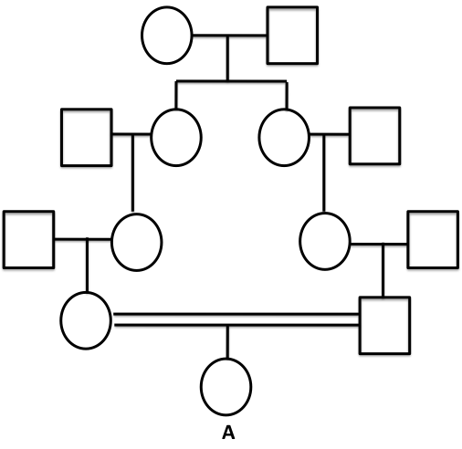

A) 1/8
B) 1/16
C) 1/32
D) 1/64
E) 1/256

Q3. (2 marks) Inbreeding in populations that are normally outbreeding leads to which of the following?
A) a higher rate of genetic drift
B) a higher rate of mutation
C) an increase in the frequency of heterozygotes
D) more individuals affected by rare diseases
E) a smaller population

Bonus Q1. (5 marks) What is the minimum number of tRNAs required to recognize the six codons specifying the amino acid leucine?

Because of wobble (Table 12.2), one tRNA can recognize
both UUA and UUG codons for leucine. However, it
takes two more tRNAs to recognize CUU, CUC, CUA,
and CUG. Therefore, a minimum of three tRNAs are
required to recognize the six codons for leucine.

Bonus Q2. (10 marks)
The following is a portion of a mature mRNA sequence:
3′-AUCGUCAUGCCG-5′
- During transcription, was the adenine at the left-hand side of the sequence the first or the last nucleotide added to the portion of mRNA shown? Explain how you know. 50 marks.
Last.

The synthesis of RNA from DNA by the enzyme RNA polymerase is called transcription. The RNA polymerase binds on a 3’-5’ template strand of DNA, and then it adds its first nucleotide to the 5’ of mRNA and last nucleotide to 3’ end of mRNA.

B) Write out the sequence of the DNA duplex that encodes this mRNA segment. Label the coding and template DNA strands. Indicate their 5’and 3’ ends. 100 marks.
Your mRNA is: 5’ GCCGUACUGCUA 3’

Therefore, the DNA duplex is:
5’ GCCGTACTGCTA 3’ Coding strand
3’ CGGCATGACGAT 5’ Template strand

- On your answer from B: Identify the direction in which the promoter region for this gene will be located. Use an arrow. What is the function of the promoter? 50 marks.

The arrow should point to the upstream of the gene (i.e. left-side of the DNA duplex). As the promoter is located at 25-30 bp upstream of transcription start site. This sequence is almost always located just upstream from the starting point for transcription (the 5' end of the DNA).

Q3. When a triplet of bases in the coding sequence of DNA is GCA, what is the anticodon for the tRNA that would be used in translation?
- CGU

Quiz 10 Name: ID Time: 25 min
Q1. (4 marks) Human albinism is an autosomal recessive trait. Suppose that you find a village in the Andes where one-fourth of the population is albino. If the population size is 1000 and the population is in Hardy-Weinberg equilibrium with respect to this trait, how many individuals are expected to be heterozygotes?
A) 50
B) 250
C) 300
D) 500
E) 750

Q2. (4 marks) What is the inbreeding coefficient for individual “B” in the following pedigree?
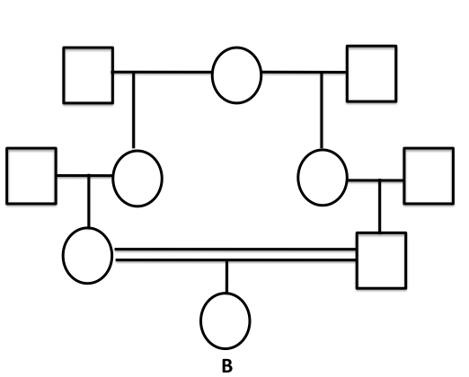
A) 1/8
B) 1/16
C) 1/32
D) 1/64
E) 1/256

Q3. (2 marks) Which of the following conditions results in the faster evolution of a population?
- mutation
- selection
- non-random mating
- natural disaster

Bonus Q1. (5 marks: 2 marks for a, 2 marks for b and 1 mark for c) (a)Why is the genetic code a triplet code instead of a singlet or doublet code? (b) How many different amino acids are specified by the genetic code? (c) How many different amino acid sequences are possible in a polypeptide 146 amino acids long?

(a) Singlet and doublet codes provide a maximum of 4 and (4)² or 16 codons, respectively. Thus, neither code would be able to specify all 20 amino acids.
(b) 20
(c) (20)^{146.}

Bonus Q2. (10 marks) Below is a schematic of gene Y, which encodes protein Y. The promoter region is indicated by the dotted box. Transcription begins immediately following the promoter.

i) The transcript first produced by this gene would be approximately how many nucleotides long?

The transcript first produced by this gene would be approximately 5000 nucleotides long. (3 marks)

ii) Two different transcripts are produced from this gene, one is approximately 2000 nucleotides long, the other is approximately 3000 nucleotides long. Explain how two different transcripts can be produced from this gene.

Alternative splicing could produce two different transcripts. One transcript could contain exons 1, 2 and 3, the other could contain only exons 1 and 3.
(3 marks)

iii) Assume each transcript produces a protein. Given your answer above and the diagram, what is the approximate size of the two proteins produced from this gene?
The transcript contain all three exons would encode a protein beginning at the ATG at position 200 and end at the stop codon. This is about 2600 nucleotides, which represents about 866 codons. SO the two proteins expected would be about 866 amino acids long and about 533 amino acids long.
(4 marks: 2 marks for 866 aa and 2 marks for 533 aa)

Quiz 10 Name: ID Time: 25 min
Q1. (4 marks) The genetic frequencies of two separate populations are:

 | AA | Aa | aa
Population 1 | .36 | .48 | .16
Population 2 | .33 | .33 | .33
Population 3 | .55 | .10 | .35

Which of these populations are in Hardy-Weinberg equilibrium?
A) Population 1 is in Hardy-Weinberg equilibrium, but populations 2 and 3 are not.
B) Population 2 is in Hardy-Weinberg equilibrium, but populations 1 and 3 are not.
C) Population 3 is in Hardy-Weinberg equilibrium, but populations 1 and 2 are not.
D) Populations 1 and 2 are in Hardy-Weinberg equilibrium, but population 3 is not.
E) None of the populations are in Hardy-Weinberg equilibrium.
Q2. (4 marks) What is the inbreeding coefficient for individual “B” in the following pedigree?

A) 1/8
B) 1/16
C) 1/32
D) 1/64
E) 1/256

Q3. (2 marks) Inbreeding in populations that are normally outbreeding leads to which of the following?
A) a higher rate of genetic drift
B) a higher rate of mutation
C) an increase in the frequency of heterozygotes
D) more individuals affected by rare diseases
E) a smaller population

Bonus Q1. (5 marks) What is the minimum number of tRNAs required to recognize the six codons specifying the amino acid leucine?

Because of wobble, one tRNA can recognizeboth UUA and UUG codons for leucine. However, it takes two more tRNAs to recognize CUU, CUC, CUA, and CUG. Therefore, a minimum of three tRNAs are required to recognize the six codons for leucine.

Bonus Q2. (10 marks) Below is a schematic of gene Y, which encodes protein Y. The promoter region is indicated by the dotted box. Transcription begins immediately following the promoter.

i) The transcript first produced by this gene would be approximately how many nucleotides long?
The transcript first produced by this gene would be approximately 5000 nucleotides long. (3 marks)

ii) Two different transcripts are produced from this gene, one is approximately 2000 nucleotides long, the other is approximately 3000 nucleotides long. Explain how two different transcripts can be produced from this gene.

Alternative splicing could produce two different transcripts. One transcript could contain exons 1, 2 and 3, the other could contain only exons 1 and 3.
(3 marks)

iii) Assume each transcript produces a protein. Given your answer above and the diagram, what is the approximate size of the two proteins produced from this gene?

The transcript contain all three exons would encode a protein beginning at the ATG at position 200 and end at the stop codon. This is about 2600 nucleotides, which represents about 866 codons. SO the two proteins expected would be about 866 amino acids long and about 533 amino acids long.
(4 marks: 2 marks for 866 aa and 2 marks for 533 aa)

