IBUS462
Week 9

Regional Economic Integration

- Regional Economic Integration

  - Agreements between countries in a geographic region
  - To reduce tariff and non-tariff barriers
  - To the free flow of goods, services, and factors of production between each other
  - Cannot happen between 2 less developed countries
  - Based on political will

Question: Do regional trade agreements promote free trade in the world?
- In theory, yes, but the world may be moving toward regional trade blocks that compete against each other

- Free Trade Area eliminates all barriers to the trade of goods and services among member countries

- European Free Trade Association (EFTA) - Norway, Iceland, Liechtenstein, and Switzerland
- North American Free Trade Agreement (NAFTA) - U.S., Canada, and Mexico

- A Customs Union

  - Eliminates trade barriers between member countries.
  - Adopts a common external trade policy
- Example: Andean community (Bolivia, Colombia, Ecuador, and Peru)

- A Common Market has

  - No barriers to trade between member countries,
  - Common external trade policy, and
  - Free movement of the factors of production
- Example: MERCOSUR (Brazil, Argentina, Paraguay, and Uruguay)

- An Economic Union has

  - Free flow of products and factors of production between members,
  - Common external trade policy,
  - Common currency, a harmonized tax rate, and a common monetary and fiscal policy
    - Example: European Union (EU)

- A Political union involves

  - Central political apparatus that coordinates the economic, social, and foreign policy of member states (Partial or Full)
    - the EU is headed toward at least partial political union
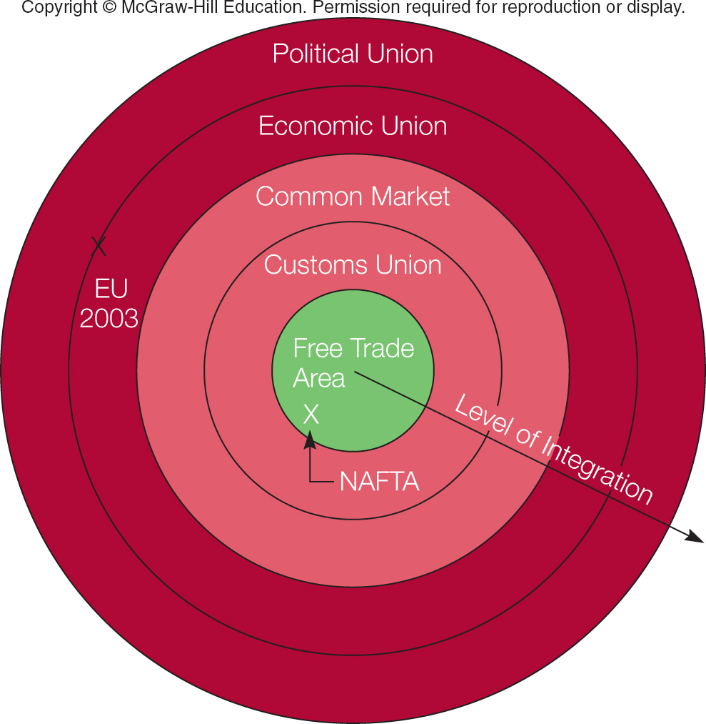

- Integrated Economies

- All countries gain from free trade and investment
- regional economic integration is an attempt to exploit the gains from free trade and investment

- Linking countries together, making them more dependent on each other
- Creates incentives for political cooperation and reduces the likelihood of violent conflict
- Gives countries greater political clout when dealing with other nations

- Limits Efforts at Integration

- Economic integration can be difficult because
  - while a nation as a whole may benefit from a regional free trade agreement, certain groups may lose
  - it implies a loss of national sovereignty
- Regional economic integration is only beneficial if the amount of trade it creates exceeds the amount it diverts
  - Trade creation occurs when low cost producers within the free trade area replace high cost domestic producers
  - Trade diversion occurs when higher cost suppliers within the free trade area replace lower cost external suppliers

- The Euro

- The Maastricht Treaty committed the EU to adopt a single currency
  - Created the second largest currency zone in the world after that of the U.S. dollar
  - Used by 17 of the 28 member states
  - Britain, Denmark, and Sweden opted out
- Since its establishment January 1, 1999, the euro has had a volatile trading history with the U.S. dollar

- Benefits of the euro
  - Savings from having to handle one currency, rather than many
  - It is easier to compare prices across Europe, so firms are forced to be more competitive
  - Gives a strong boost to the development of highly liquid pan-European capital market
  - Increases the range of investment options open both to individuals and institutions

- Costs of the euro
  - Loss of control over national monetary policy
  - EU is not an optimal currency area

- Should The EU Continue to Expand?

- Many countries have applied for EU membership
- Ten countries joined in 2004 expanding the EU to 25 states
- In 2007, Bulgaria and Romania joined bringing membership to 27 countries
- In 2013 Croatia entered the EU becoming the 28th member nation
- Turkey has been denied full membership because of concerns over human rights

- The Status of Economic Integration in the Americas

- There is a move toward greater regional economic integration in the Americas
- The biggest effort is the North American Free Trade Area (NAFTA)
- Other efforts include the Andean Community and Mercosur
- A hemisphere-wide Free Trade of the Americas is under discussion
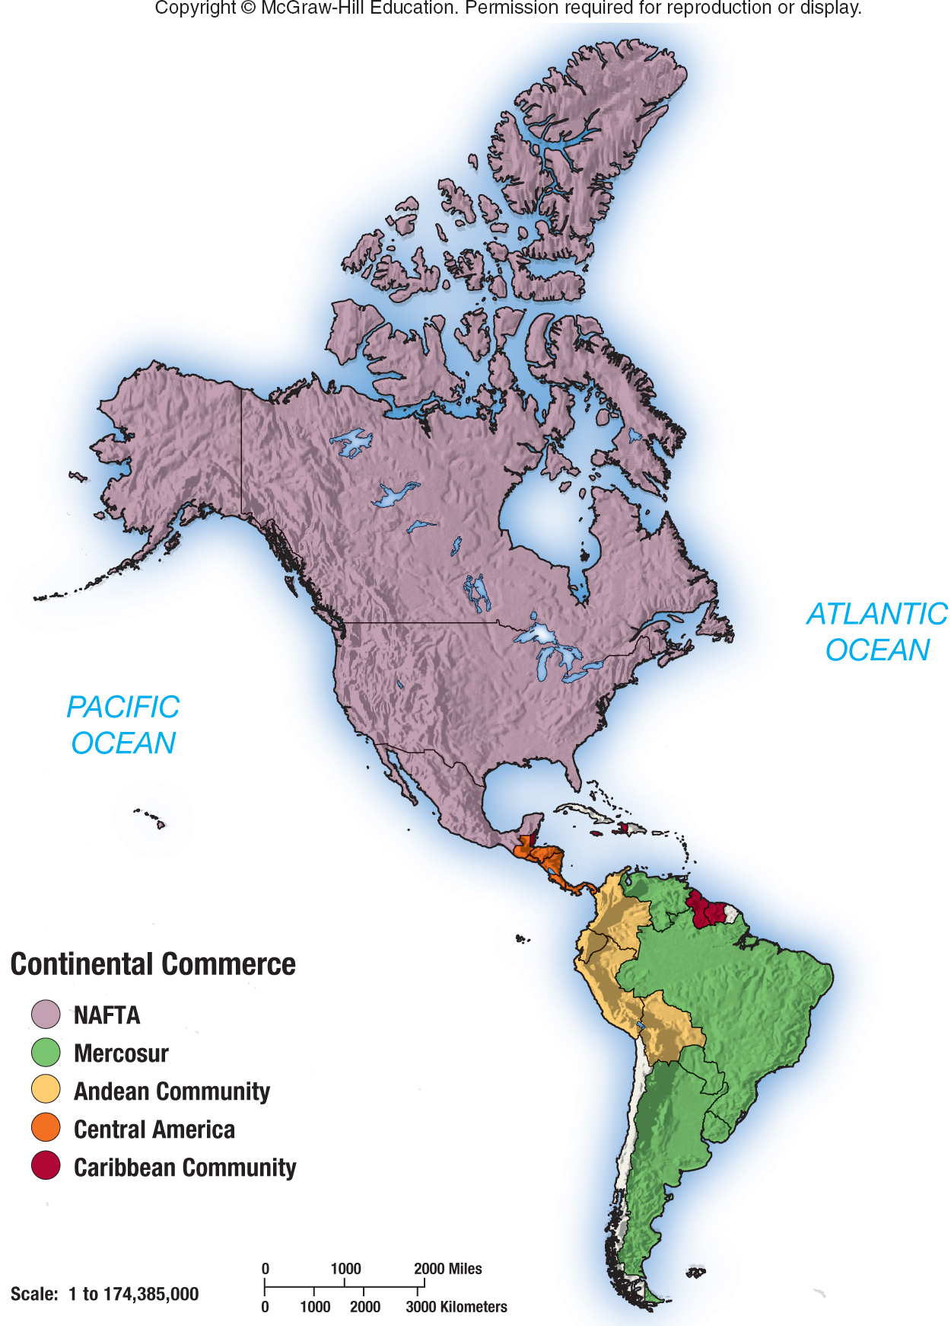

NAFTA includes the United States, Canada, and Mexico

  - Abolished tariffs on 99% of the goods traded between members
  - Removed barriers on the cross-border flow of services
  - Protects intellectual property rights
  - Removes most restrictions on FDI between members
  - Allows each country to apply its own environmental standards

Is NAFTA beneficial?

Supporters of NAFTA claimed that
- Mexico would benefit
  - From increased jobs as low cost production moves south and will see more rapid economic growth as a result
- U.S. and Canada would benefit from
  - Access to a large market
  - The lower prices for consumers from goods produced in Mexico
  - Low cost labor
  - Increased imports by Mexico

Critics of NAFTA claimed that
  - Jobs would be lost and wage levels would decline in the U.S. and Canada
  - Pollution would increase due to Mexico's laxer standards
  - Mexico would lose its sovereignty

Overall:
- Research indicates that NAFTA’s early impact was subtle, and both advocates and detractors may have been guilty of exaggeration
- NAFTA is credited with helping create increased political stability in Mexico
- Other Latin American countries would like to join NAFTA

- Mercosur

  - Originated in 1988 as a free trade pact between Brazil and Argentina
  - Was expanded in 1990 to include Paraguay and Uruguay and in 2005 with the addition of Venezuela
  - May be diverting trade rather than creating trade,
  - Initially made progress on reducing trade barriers between member states
  - More recently efforts have stalled

- Central American Trade Agreement and CARICOM

- There are two other trade pacts in the Americas
  - the Central American Trade Agreement – (CAFTA, 2005) - to lower trade barriers between the U.S. and members
  - CARICOM (1973) - to establish a customs union
- Neither pact has achieved its goals yet
- In 2006, six CARICOM members formed the Caribbean Single Market and Economy (CSME)
  - To lower trade barriers and harmonize macro-economic and monetary policy between members

- Economic Integration in Asia

- Various efforts at integration have been attempted in Asia, but most exist in name only
  - Association of Southeast Asian Nations (ASEAN)
  - Asia-Pacific Economic Cooperation (APEC)

