IBUS462
Week 5

Chapter 6: International Trade Theory

International trade allows a country:
- to specialize in the manufacture and export of products that it can produce efficiently
- import products that can be produced more efficiently in other countries even if they can be produced in the home country.

- An overview of Trade Theory

Free trade: When a Government does not attempt to influence:
- trade through either quotas or duties
- what its citizens can buy from another country or
- what they can produce and sell to another country.

- The Benefit of trade

The great strength of those theories is that they identify the specific benefits of international trade.

- The theories confirm our common sense notion; however, it goes beyond by showing it is beneficial for a country to engage in international trade even for products it is able to product itself.

The gain of buying from other nations arise because international trade allows a country to specialize in the manufacture of product or services that can be produced most efficiently.
Example US: jet craft vs. textile.

- The Patterns of International Trade

- Heckscher-Ohlin (HO) theory suggest interaction between resources and possibility of making a product. However, the product life-cycle theory of Raymond Vernon suggests a product can be finally exported back to the place it was invented.

- International trade allows a country
  - To specialize in the manufacture of products that it can produce efficiently and export
  - Import products that can be produced more efficiently in other countries

- The New Trade Theory by Paul Krugman: countries are specialized in the production and export of particular product not because of underlying differences in factor endowments, the world market can support only a limited number of firms in a particular industry (First movers & competitive advantage.)

- Government Roles in Trade
These theories agree on the benefit of international trade but lack agreement in their recommendations for government policy.
Limiting imports vs. Free hand of market vs. Limited intervention.

New trade theory and Porter’s theory of national competitive advantage justify limited and selective government intervention to support the development of certain export-oriented industries.
Smith, Ricardo, and Heckscher-Ohlin promote unrestricted free trade

- Mercantilism
The mercantilist philosophy: Government involvement in promoting exports and limiting imports
Mercantilism states that it is in a country’s best interest to maintain a trade surplus (import > export???) and advocates government intervention to achieve a surplus in the balance of trade.
- Accumulate gold and silver > essentially wealth, problem Hume.
- View at trade as “zero-sum game” – gain for one, results in a loss for another
Do we still find Mercantilism today? China?

- Theory of Absolute Advantage (Adam Smith)

Adam Smith (1776) in Wealth of Nations says that:
- A country has an absolute advantage in the production of a product when it is more efficient than any other country in producing it
- Countries should specialize in the production of goods for which they have an ABSOLUTE ADVANTAGE and then trade these goods for the goods produced by other countries
Example: England textile, France wine. OR Ghana vs. South Korea.

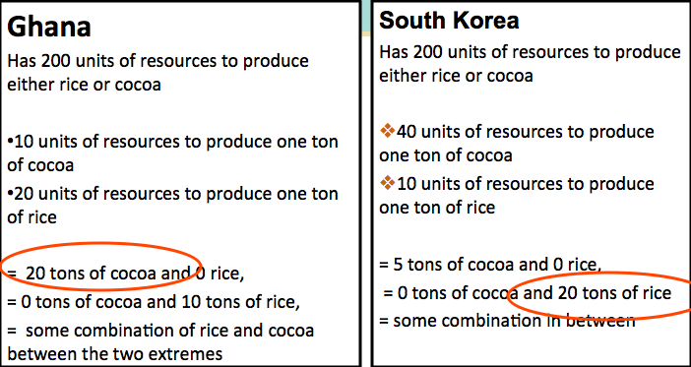

- Without trade
  - Ghana would produce 10 tons of cocoa and 5 tons of rice
  - South Korea would produce 10 tons of rice and 2.5 tons of cocoa

- With specialization and trade
  - Ghana would produce 20 tons of cocoa
  - South Korea would produce 20 tons of rice
  - Ghana could trade 6 tons of cocoa to South Korea for 6 tons of rice

- After trade
  - Ghana would have 14 tons of cocoa left, and 6 tons of rice
  - South Korea would have 14 tons of rice left and 6 tons of cocoa

- If each country specializes in the production of the good in which it has an absolute advantage and trades for the other, both countries gain.

- Comparative Advantage Theory (David Ricardo)

- What can happen when one country has an absolute advantage in the production of all goods?

- Countries should buy goods from other countries even if they can produce them efficiently themselves and benefit from the “combined production” or “specialization”

- COMPARATIVE ADVANTAGE: “Positive-sum game”

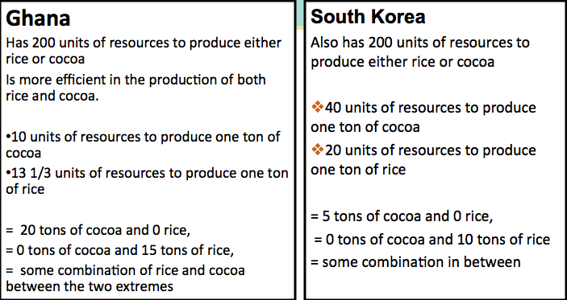
- With trade
  - Ghana could export 4 tons of cocoa to South Korea in exchange for 4 tons of rice
    - Ghana will still have 11 tons of cocoa, and 4 additional tons of rice
  - South Korea still has 6 tons of rice and 4 tons of cocoa
    - if each country specializes in the production of the good in which it has a comparative advantage and trades for the other, both countries gain
- Comparative advantage theory provides a strong rationale for encouraging free trade
- Unrestricted free trade is beneficial, but the gains may not be as great as the simple model of comparative advantage would suggest
- Immobile resources : loss of jobs, some loose, short term pain.
- Diminishing returns because not all are of the same quality & different goods use different proportions of resources.
- Dynamic effects & economic growth: free trade actually increases a country’s stock of resources as labour from other countries become available, then free trade also increases the efficiency of resources’ use (economies of scale, technology, competition, etc.)

- Opening a country to trade could increase
  - a country's stock of resources as increased supplies become available from abroad
  - the efficiency of resource utilization and so free up resources for other uses
  - economic growth

- Paul Samuelson - the dynamic gains from trade may not always be beneficial
  - Free trade may ultimately result in lower wages in the rich country
    - Offshore services jobs may have the effect of a mass inward migration into the United States, where wages would then fall
- But, protectionist measures could create a more harmful situation than free trade

- Heckscher-Ohlin Theory

Eli Heckscher (1919) & Bertil Ohlin(1933)

Comparative advantage arises from differences in national factor endowments
- Extent to which a country is endowed with availability of land, resources, labour and capital
the more abundant the endowments, the lower the cost
Countries will export those goods that benefit from locally abundant factor endowments and import goods that are limited due to scarce factor endowments.
Benefits of trade is based on differences in factor endowments as opposed to differences in productivity.

The Leontif Paradox
Wassily Leontief (1953) theorized that since the U.S. was relatively abundant in capital compared to other nations, the U.S. would be an exporter of capital intensive goods and an importer of labour-intensive goods.
- However, he found that U.S. exports were less capital intensive than U.S. imports.
- Since this result was at variance with the predictions of the theory, it became known as the Leontief Paradox

- Product Life Cycle Theory

Proposed by Raymond Vernon (mid-1960’s):
Suggested that as products mature both:
The location of sales (target market) and the optimal production location will change affecting the flow and direction of trade.
- The big and rich U.S. market - strong incentive to develop and sell new products in US.
- As demand grew in other developed countries, U.S. firms would begin to export
- Demand for the new product would grow in other advanced countries - local producers begin producing for their home markets
- U.S. firms might also set up production facilities in those advanced countries where demand was growing.
- As the market in the U.S. and other advanced nations matured, the product would become more standardized, and price the main competitive weapon.
- Producers based in advanced countries with labor costs lower than the US start to export to the US.
- If cost pressures became intense, developing countries would begin to acquire a production advantage over advanced countries

The United States switched from being an exporter of the product to an importer of the production moves to lower-cost countries.

But, the globalization and integration of the world economy has made this theory less valid today
- the theory is ethnocentric
- production today is dispersed globally
- products today are introduced in multiple markets simultaneously

- New Trade Theory

- The ability of firms to gain economies of scale can have important implications for international trade.

International Trade

Its impact on economies of scale, trade can increase the variety of goods available to consumers and decrease the average cost of those goods.

Without trade, nations might not be able to produce those products where economies of scale are important.
- With trade, markets are large enough to support the production necessary to achieve economies of scale
- Therefore, trade is mutually beneficial because it allows:
- The specialization of production
- The realization of scale economies
- The production of a greater variety of products at lower prices

Even when resource endowments do not differ!!

In those industries when output required to attain economies of scale, represents a significant proportion of total world demand, the global market may only be able to support a small number of enterprises.
  - First mover advantages - the economic and strategic advantages that accrue to early entrants into an industry
  - Economies of scale
  - First movers can gain a scale based cost advantage that later entrants find difficult to match

Implications

- Nations may benefit from trade even when they do not differ in resource endowments or technology
  - A country may dominate in the export of a good simply because it was lucky enough to have one or more firms among the first to produce that good
- The implication that governments should consider strategic trade policies that nurture and protect firms and industries where first mover advantages and economies of scale are important

- Porter’s Theory of national competitive advantage

Michael Porter tried to explain why a nation achieves international success in a particular industry and identified four attributes that promote or impede the creation of competitive advantage:
- Factor endowments - a nation’s position in factors of production necessary to compete in a given industry
- Can lead to competitive advantage
- can be either basic (natural resources, climate, location) or advanced (skilled labor, infrastructure, technological know-how)

- Demand conditions – the “home demand” for the product or service.
- influences the development of capabilities.
- Sophisticated and demanding customers pressure firms to be competitive.

- Relating and supporting industries - the presence or absence of supplier industries and related industries that are internationally competitive
- Can spill over and contribute to other industries
- Successful industries tend to be grouped in clusters in countries
Ex: Having world class manufacturers of semi-conductor processing equipment can lead to (and be a result of having) a competitive semi-conductor industry

- Firm strategy, structure, and rivalry - the conditions governing how companies are created, organized, and managed, and the nature of domestic rivalry.
- Different management ideologies affect the development of national competitive advantage
- Vigorous domestic rivalry creates pressures to innovate, to improve quality, to reduce costs, and to invest in upgrading advanced features
Determinants of National Competitive Advantage: Porter’s Diamond
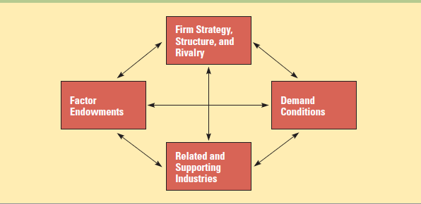

Government policy can:
- affect demand through product standards
- influence rivalry through regulation and antitrust laws
- impact the availability of highly educated workers
- Help develop advanced transportation infrastructure.
The four attributes, government policy, and chance work as a reinforcing system, complementing each other and in combination creating the conditions appropriate for competitive advantage.
However, Porter’s theory has not been sufficiently tested to know how well it holds up.

- Implications for managers:

- Location implications - a firm should disperse its various productive activities to those countries where they can be performed most efficiently
- Firms that do not, may be at a competitive disadvantage.
- First-mover implications - a first-mover advantage can help a firm dominate global trade in that product
- Policy implications - firms should work to encourage governmental policies that support free trade
- Firms should lobby the government to adopt policies that have a favorable impact on each component of the diamond

