IBUS462
Week 1

Chapter 1: Globalization

- What is globalization?

The world is moving away from self-contained national economies toward an interdependent, integrated global economic system

Globalization refers to the shift toward a more integrated and interdependent world economy. It has two major aspects:
- markets
- production

- Globalization of Markets

- Historically distinct and separate national markets are merging into one huge global marketplace.
  - Falling trade barriers make it easier to sell Internationally.
  - Consumers’ tastes and preferences are converging on some global norm
  - Firms promote the trend by offering the same basic products worldwide – standardized global products
  - The depth and scope of globalization is not the same for industrial and consumer goods

- The globalization of Production

- Refers to the Sourcing of goods and services from locations around the globe to take advantage of national differences in the cost and quality of different factors of production such as land, labor, and capital.
- Companies can :
  - Lower their overall cost structure
  - Improve the quality or functionality of their product offering

- Global Institutions

- Global institutions
  - Help manage, regulate, and police the global marketplace
  - Promote the establishment of multinational treaties to govern the global business system

- GATT and WTO : World Trade Organization / General Agreement on Tariffs and Trade (WTO’s predecessor)
  - Polices the world trading system
  - Makes sure that nation-states adhere to the rules laid down in trade treaties
  - Promotes lower barriers to trade and investment

- IMF: The International Monetary Fund (1944)
  - Maintains order in the international monetary system
  - Lender of last resort for countries in crisis
      - Argentina, Indonesia, Mexico, Russia, South Korea, Thailand, Turkey, Ireland, and Greece

- The World Bank (1944)
  - Promotes economic development via low interest loans for infrastructure projects.

- UN: The United Nations (1945)
  - Maintains international peace and security
  - Develops friendly relations among nations
  - Cooperates in solving international problems
  - Promoting respect for human rights
  - Center for harmonizing the actions of nations

- The G20
  - Forum through which major nations tried to launch a coordinated policy response to the 2008-2009 global financial crisis

- Drivers of Globalization

              - Declining trade and investment barriers

The decline in barriers to the free flow of goods, services, and capital that has occurred since the end of World War II.
  - Average tariffs have drastically dropped and are now at just 4%.
  - More favorable environment for Foreign direct investment (FDI) = occurs when a firm invests resources in business activities outside its home country.
    - global stock of FDI was $20.4 trillion in 2011
  - Facilitates global production
- Firms can view the world, rather than a single country, as their market
- Firms can base production in the optimal location for that activity…not necessarily next door…
- Economies of the world’s nation-states are becoming more inter-twined

              - The role of technological Investment

  - Microprocessors and telecommunications: Falling cost of phone and Web
  - Internet: information backbone of the global economy.
    - E-commerce has reduced constraint of location, scale, and time zone.
  - Transportation technology: jet craft, super freighter, containerization, etc

Technological change means:

Implication for the globalization of production:
  - Lower transportation costs: help to create global markets and allow firms to disperse production to economical, geographically separate locations
  - Low cost information processing and communication: firms can create and manage globally dispersed production

Implication for the Globalization to Markets include:
  - Low cost global communications networks: help to create an electronic global marketplace
  - Low-cost transportation: Help to create global market.
  - Global communication networks and global media: create a worldwide culture and a global consumer product market

- The changing Demographics of the Global Economy

There has been a drastic change in the demographics of the world economy in the last 30 years

Four Important Changes – Trends:
- The Changing World Output and World Trade Picture (US was dominant)
- The changing Foreign Direct Investment Picture (US was dominant)
- The changing Nature of the Multinational Enterprise (Us was dominant)
- The changing World Order (Communist “world” was off limits from western economy)

- The World Output and World Trade Picture

In 1960, the United States accounted for over 40% of world economic activity. By 2008, the United States accounted for just over 20% of world economic activity and a similar trend occurred in other developed countries.

- The foreign Direct Investment Picture

- The share of world output generated by
  - Developing countries: has been steadily increasing since the 1960s.
  - Developed countries: has been steadily decreasing
- The stock (total cumulative value of foreign investments) generated by rich industrial countries has been on a steady decline.
- There has been a sustained growth in cross-border flows of foreign direct investment.
  - Developing countries, especially China, have also become popular destinations for FDI

Percentage Share of Total FDI Stock 1980-2013

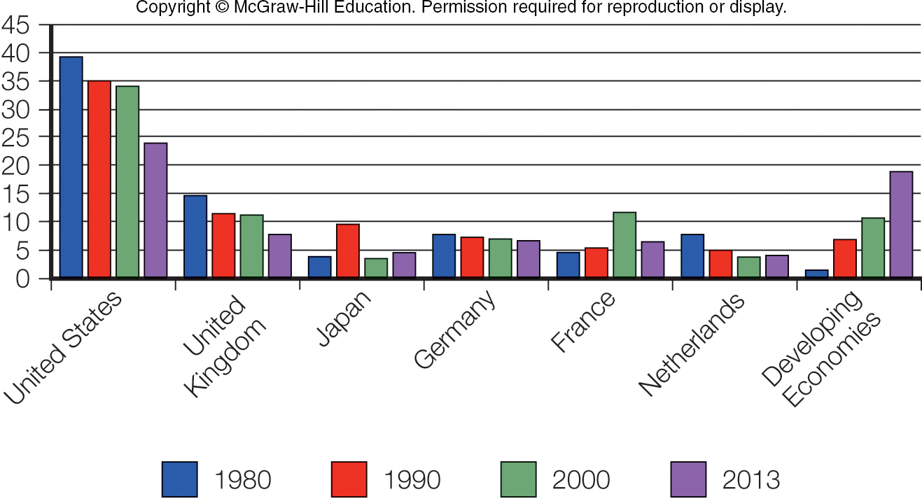

- The Nature of the Multinational Enterprise

A multinational enterprise (MNE) is any business that has productive activities in two or more countries.
Since the 1960s, there has been (1) a rise in non-U.S. multinationals, and (2) a growth of mini-multinationals
International business is different because:
- Countries are different; cultures are different; regulations are different
- The range of problems is more complex than those in a domestic business
- Firms have to find ways to work within the limits imposed by government intervention in the international trade and investment system
- International transactions involve different currencies

- How Does the Global Marketplace Affect Managers?

Managing an international business differs from managing a domestic business because
countries are different:
- The range of problems confronted in an international business is wider and the problems more complex than those in a domestic business
- Firms have to find ways to work within the limits imposed by government intervention in the international trade and investment system
- International transactions involve converting money into different currencies

Supporters | Protestors
Increased trade and cross-border investment mean lower prices for goods and services, greater economic growth, higher consumer income, and more jobs  Tougher environmental & labor standards associated with economic progress  Limited to what nation-states grant – need to get countries to agree to certain actions  The best way for poor nations to improve is to reduce trade barriers and implement economic policies based on free market economies and to receive debt forgiveness  Increased awareness of global issues on the part of MNE | Will cause job losses, environmental degradation, and the cultural imperialism of global media and MNEs  Firms avoid tougher labor & environ. laws by moving to locations where these regulations don’t apply  Interdependent nature of the global economy shifts economic power away from national government s towards supranational orgs. Like the WTO, EU or UN  Argue that the gap between rich and poor nations is only getting wider  MNE only get involved for their own personal gain

