LECTURE 2

ATP-ADP Cycle
- All life requires energy
  - The form of energy used almost exclusively is ATP
- This cycle is important as an organism requires energy to metabolize and function
- Nutrients can be taken from different forms
- Energy is contained in the covalent bonds between the phosphates of ATP
- There is a continual supply
- High energy in between the phosphate bond

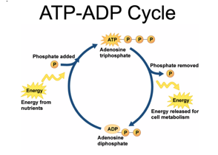

DNA
- Genes encode proteins, and proteins do the work in the cell
- The proteins determine the properties of the organism
- Nucleotide sequences determine the amino acid sequence of proteins, which then controls what the protein can actually do
- Nucleotide sequences from different organisms produce similar proteins
- Humans and chimpanzees have about 96% of the same genome
  - Only 4% has changed over time
- Human genome is about 3,000,000 base pairs long
- No two individuals within a species have the same genome information
  - Excluding twins
- Differences are present and they are important
  - Biological evolution can’t happen without genetic differences within a species

Natural Selection
- The theory of evolution is the cornerstone of modern scientific understanding of life
- Have genetic diversity within a population
  - The interaction between genetic diversity and change in the environment
- When you have genetic diversity and environmental influences it can lead to evolutionary change
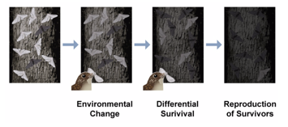

- Example is white coloured moths vs. black coloured moths during industrial revolution
  - White moths dominated when the trees were light because they were able to hide, but as the environment changed and the trees got darker, dark moths dominated and lived on to reproduce
  - Change in the environment
  - The whole population evolved
- Individuals within a population don’t evolve, a population as a whole evolves because of genetic diversity

Macro vs. Micro Evolution
- Evolution operates at two different scales in populations:
  - Microscale and macroscale
- Macro evolution:
  - Results in the evolution of two distinct species at the end
  - Takes places over a longer period of time
  - Example is the geographic isolation of squirrels
    - Two new species and environments of squirrels in the end
- Micro evolution is the change in allele frequencies that occur over time within a population
  - A change in the same species over time
  - This change is due to four different processes:
    - Mutation, selection (natural and artificial), gene flow, and genetic drift

Key Concepts of Evolution
- Concept of biological evolution originally proposed by Darwin
  - He was an important contributor to evolution
- Evolution is the core theme of Biology
- Individuals don’t evolve populations do
- Evolution requires genetic diversity in population and environmental conditions that promote fitness of certain individuals
  - Fitness means able to reproduce
- “Nothing in biology makes sense except in the light of evolution”

Module 2: Energy and Matter

Energy
- The capacity to do work
- Energy can take on many forms:
  - Electromagnetic radiation
    - What the sun is emitting, visible light and UV light
  - Chemical energy
    - Chemicals contain energy within bonds that makeup molecules, which make up matter
  - Kinetic energy
    - Energy of movement
- The Sun is the source of all energy on Earth
- Converting matter into energy and that energy is in the form of electromagnetic radiation
- One form of energy can be converted into another

Matter
- Occupies space and has mass
- All tangible substances are made of matter
- Matter is converted to energy by the Sun and the Sun releases the energy
  - Therefore, both matter and energy are connected

Electromagnetic Spectrum
- Grouped in terms of wavelengths of electromagnetic radiation that can be detected by the human eye
  - Visible light
- All being emitted by the Sun
- The far right and left side of spectrum is filtered out before they reach the Earth’s surface
- Shorter wavelengths have higher energy
- Longer wavelengths have lower energy
- The length of a wavelength is determined by the distance between the peaks
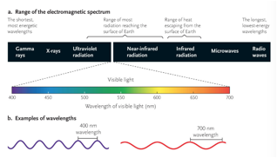

Light
- Light is electromagnetic radiation that humans can detect with their eyes
  - Also a wave of discrete particles called photons
  - Photons of light have different wavelengths and energy levels
  - Example is blue and red photons have different wavelengths and energy levels

Wavelength
- Distance between two successive peaks
- To be used, light energy must be absorbed by molecules called pigments

Light Interacts with Matter
- Interacts with the pigment molecules
- When light encounters matter three things can happen:
  - Light can be reflected when it encounters matter
  - Light can be transmitted when it encounters matter
  - Light can be absorbed when it encounters matter
- When light gets absorbed, energy is absorbed and can be used
  - Example is chloroplasts absorb light and use it to create energy
    - Photosynthesis

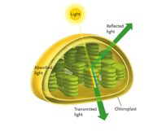

Pigment Structure
- Shared characteristics:
  - They all have a conjugated bond system
  - Systems of alternating double/single carbon bonds
  - They all can have different molecular shapes
  - They are not relative to other molecules
  - Electrons that make up the bonds are delocalized
    - Not restricted in their location
    - Are more spread out and are therefore more available to absorb photons of light
  - Pigments do not absorb the same photons/wavelengths of light

Absorption of Light by Chlorophyll
- Colour is the result of wavelengths of light that are not absorbed by a pigment
- The orbital that the electron is in defines the amount of energy that the electron has
  - Relative position of the nucleus
- The ground state is 0 and the most stable electrons exist here
  - There are higher energy states that electrons can exist at like 1 and 2
- If an electron interacts with a green photon of light, nothing will happen as it doesn’t absorb green light, but reflects it
  - Green light won’t change energy of electrons because chlorophyll doesn’t absorb absorb; it reflects
- If an electron interacts with a red photon of light, it will be promoted to the first energy level
- If an electron interacts with a blue photon of light, it will be promoted to the second energy level
- The amount of energy in a red wavelength of light matches the difference in length between the ground state and the first state
- In order for a photon of light to be absorbed by a pigment, the energy of the wavelength has to match the difference between the ground state and one of the energy states
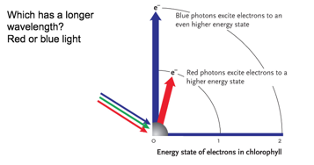

LECTURE 3 Light as a Source of Energy

Photosynthesis Sustains Almost All Life

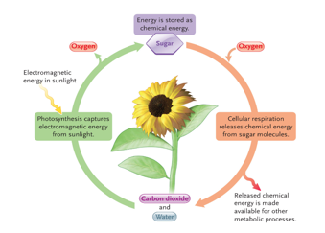

- Electromagnetic energy in sunlight is captured by chlorophyll
- Photosynthesis converts light energy into chemical energy (sugar)
- Sugar molecules contain some of the energy captured
- Oxygen extracts energy from sugar using cellular respiration and turns it into ATP
- From cellular respiration, carbon dioxide and water are released, which are the building blocks for photosynthesis
  - ATP is also produced

Producers
- Organisms that make organic molecules from carbon dioxide (CO2)
- Photosynthesis is a type of producer that uses light as the energy source
  - Plants capture light energy and transform it into chemical energy though photosynthesis
- Chemosynthesis is a type of producer that uses inorganic chemical reactions as the energy source
  - They are taking energy in the form of light and converting it to chemical energy

Photosynthesis Reaction

Carbon dioxide + water + energy = organic molecules + oxygen

Organic Molecules
- They are all mainly composed of hydrocarbon molecules
- Stored chemical energy in bonds
  - Electrons that makeup bonds
  - Some are higher energy bonds
- Chemical reactions rearrange bonds and therefore this causes bonds to release energy or need more energy
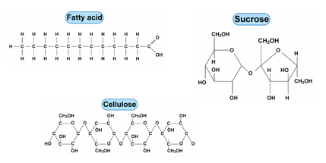

Consumers
- Eat to acquire organic molecules
- Use cellular respiration to extract energy from organic molecules; this process converts organic molecules back to carbon dioxide
  - Include animals, some protists and bacteria

Cellular Respiration Reaction
- Reverse of Photosynthesis reaction

Organic molecules + oxygen = carbon dioxide + water + energy

Decomposers
- Consumes waste and once-living organisms as their source of energy

Ecosystem

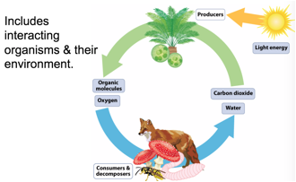
- Light energy is captured by producers and converted into organic molecules
- All organisms interact with each other
- Organisms are exchanging energy and matter
- Consumers can also be producers
  - A sea slug blurs the line between a consumer and a producer because their chloroplasts produce food for them
  - Sucks chloroplasts out of algae and incorporates them into skin cells
    - Green skin colour
  - Can maintain chloroplasts for months at a time and can photosynthesize at the same time
  - Since it photosynthesizes, it doesn’t need to eat algae

Clicker Question: Plants photosynthesize, and are therefore considered Producers. Do plants also perform cellular respiration (and therefore also fit the description of a Consumer?)
The answer is yes. Plants also perform cellular respiration in the mitochondria and need ATP to grow, divide, reproduce, etc.

LECTURE 4

Metabolism
- The sum of all chemical reactions occurring in every cell
- Chemical reactions are the rearrangement of bonds
  - Bonds breaking and forming
- Bonds breaking release energy and bonds forming need energy

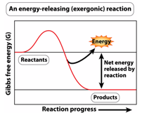

Exergonic Reactions
- Energy is lost and released as different forms of energy
- Most of the energy is released as heat energy, but some of it is captured and used for other purposes
- Bond is broken and energy contained within the bond is released
- Gibbs free energy
  - Energy released in molecules
- Reactants are being converted to products
- Reactants have more free energy than the products
- The difference in energy between the reactants and the products is net energy
  - Example is hydrolysis releases ATP; cellular respiration uses molecules from photosynthesis to release ATP

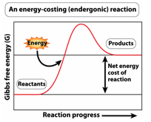

Endergonic Reactions
- Reactants have a lower amount of energy than products
- Molecules of reactants have more energy than reactants
- Energy was put into the reaction
  - Usually in a cell, the energy comes from the hydrolysis of ATP
- Usually coupled with exergonic reactions
  - Energy released from exergonic reactions drive endergonic reactions
- Cellular respiration is a multi step process and is therefore an exergonic reaction
  - Also photosynthesis

Light as a Source of Information

Photoreceptors
- A photoreceptor is a basic light-sensing system, found almost universally in all organisms
- Rhodopsin is the most common photoreceptor in nature
  - Highly conserved photoreceptor
  - Consists of a pigment molecule (retinal) bound to a membrane protein (opsin)
  - It is the basis of vision in animals and it is also used by many other organisms

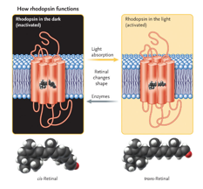

A Green Alga
- Uses light as a source of energy and for information
- Composed of one cell
  - Eukaryote, photosynthetic, and has a nucleus
- An eyespot is a light sensor
  - It is filled with rhodopsin using light as a source of information
- Chloroplast is the biggest part

Photomorphogenesis
- Phytochrome is a photoreceptor in plants
  - Sense light, triggers photomorphogenesis
- Phytochrome consists of a protein and a pigment called a bilin
  - It is critical for photomorphogenesis
- Photomorphogenesis means plant development in the light
  - Growing plants in the dark makes them white and skinny
    - No phytochrome as no light is sensed
- Photomorphogenesis cannot be initiated if the plant is in the dark

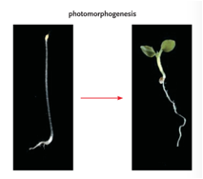

Using Light to Tell Time

Circadian Rhythms
- Telling time using light
  - The defining feature to a circadian rhythm is that its not a direct response to the presence or absence of light
    - Example is how something will continue to work when light is added/removed, but eventually it will stop
- The light/dark cycle has a set circadian rhythm
- Oscillate with a period of approximately 24 hours
- Controlled by an internal (endogenous) organism based clock
- Cell division happens during the night so it can be protected with no UV radiation
- Changes in the photo period will result in changes in the organism’s behavior
  - Days are getting shorter so organisms are responding to the change in that photo period
  - Squirrels collecting nuts, leaves changing colour
- Organisms cannot anticipate a photo period, but since days are getting shorter it leads them into changing

Module 6: Water

Properties of Water
- Polarity
- An excellent solvent
- Hydrophilic and hydrophobic

Water Molecule Are Polar
- A molecule with an uneven distribution of charge is polar
- Electronegative oxygen atom associates with electropositive hydrogen atoms of adjacent water molecules to form hydrogen bonds
  - Electrons are drawn more to the hydrogen atoms, which means the hydrogen has a partial negative charge
  - If the electrons were taken away from the hydrogen, then it would have a partial positive charge
- Hydrogen bonds are not covalent
  - These bonds are important in DNA and proteins
- Hydrogen bonds are not strong but there are a lot of them, so when you add them all up together they can be rather strong
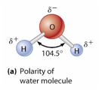

Water is an Excellent Solvent
- A solvent is a fluid in which another substance called a solute, can be dissolved
- Polar/charged molecules form hydrogen bonds or ionic bonds with water molecules
- Hydrophilic (“water loving”):
  - Sugars
  - DNA and RNA
  - Organic acids
  - Some of the amino acids
  - Water is the solvent in the cells of aqueous solutions
- Hydrophobic (water fearing):
  - Do not dissolve in water,
  - Lipids (hydrocarbons)
  - Some amino acids
    - Example is those in intermembrane proteins that associate with lipids

LECTURE 5

Water
- Polar substances dissolve readily in water
- Water interacts with atoms and separates them, causing them to dissolve

Hydrophobic Molecules
- No polar regions
  - Non-polar
  - No charge, not even a partial one
- Do not interact electrostatically with water
- Disrupt hydrogen-bonded structure of water
  - When you add oil to water, clumps appear on the water because oil is hydrophobic
- Tend to coalesce with each other in water
- Water molecules tend to exclude molecules that disrupt hydrogen bonding
- Hydrophobic interactions (type of non-covalent bonding) are a major driving force in folding of molecules (like proteins), assembly of cellular structures, and membrane organization

Hydrophilic Molecules
- Water is a good solvent for these molecules because it’s polar

Phospholipids are Amphipathic
- Membrane is made of phospholipids, preventing it from dissolving in water
- Amphipathic:
  - Has a hydrophobic and hydrophilic region
- Polar head is hydrophilic
- 2 non-polar hydrocarbon tails are hydrophobic

Phospholipid Bilayer
- Phospholipids form a phospholipid bilayer
- Hydrophilic interactions between the hydrophilic tails hold both phospholipid bilayers together
- Polar heads are associated with aqueous solutions
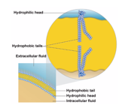

Phospholipids Form Bilayers in Solution
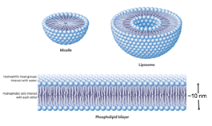
- Micelles and liposomes are spontaneously formed because phospholipids are amphipathic
  - There is a difference between a micelle and a liposome:
    - A micelle is constantly interacting with one another (a solid particle)
    - The liposome has a phospholipid bilayer and inside, they have an aqueous solution

Module 13: Cells

Cells Compose Organisms or Can Be Organisms
- Unicellular organisms consist of a single cell
- Multicellular organisms can have specialized cells for different functions, but cells have the same basic structure
- There are around 200 different types of cells in the human body
- Cells being unicellular or multicellular is not defined by it being eukaryotic or prokaryotic

Cell Theory
- All organisms are composed of one or more cells
- Cells are the basic structural and functional unit of life
- Cells come from other pre-existing cells

Why are cells so small?
- Large cells have less surface area per unit volume
  - Surface area to volume ratio is why they are so small
- Volume of cell determines the capacity of the cell and surface area determines how much capacity can be supported
  - Chemical processes require molecules that need to go into the cell, and then those processes produce waste that need to go out of the cell
- Large cells are less capable of transporting materials across the plasma membrane
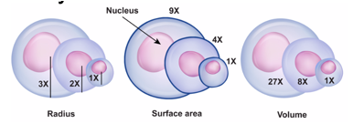

What are four ways that we can observe cells?
- Light microscopy
- Transmission electron microscopy
- Scanning electron microscopy
- Fluorescence microscopy

