MANA 202 MIDTERM

Chapter 1- Organisational behaviour and opportunity

Organisations have been described as “clockworks” in which human behaviour is logical and rational, but they often seem like “snake pits” to those who work them.

- The “Clockwork” metaphor reflects an orderly, idealised view of organisational behaviour devoid of conflict of dilemma because all the working parts (the people) are believed to mesh smoothly
- The “snake pit” metaphor conveys the daily conflicts, distress, and struggle in organisations. Each metaphor reflects reality from a different perspective- the organisation’s versus the individual’s point of view

This chapter discusses:
- An overview of human behaviour in organisations, its interdisciplinary origins, and behaviour in times of change
- Organisational context within which behaviour occurs
- Highlights the opportunities that exist in times of change and challenge for people at work
- Addresses the ways people learn about organisational behaviour and explains how the text’s pedagogical features relate to various learning styles
- Presents the plan for the book

Organisational behaviour: is the study of individual behaviour, group processes, and structural dimensions of organisations. Concerned with the psychosocial, interpersonal, and behavioural dynamics in organisations
- Organisational variables that affect human behaviour at work are also relevant and these include: jobs, the design of work, communication, performance appraisal, organisational design, and organisational structure.

Understanding human behaviour: (the vast majority of theories and models of human behaviour fall into 2 categories)

- The internal perspective: looks at the individual’s minds and is psychodynamically oriented and its proponents understand thoughts, feelings, past experiences, and needs of the individual and explains people’s actions and behaviour in terms of their history and personal value systems implies that people are best understood from the inside.
- External perspective: understands human behaviour in terms of external events, consequences, and environmental forces to which a person is subject.

EXAMPLE: The internal perspective might say Mary is an outstanding employee because she has a high need for achievement, whereas the external perspective might suggest that it is because she is well paid for her work.
Interdisciplinary influences:
- Psychology
- Sociology
- Engineering
- Anthropology
- Management
- Medicine

What do managers do?

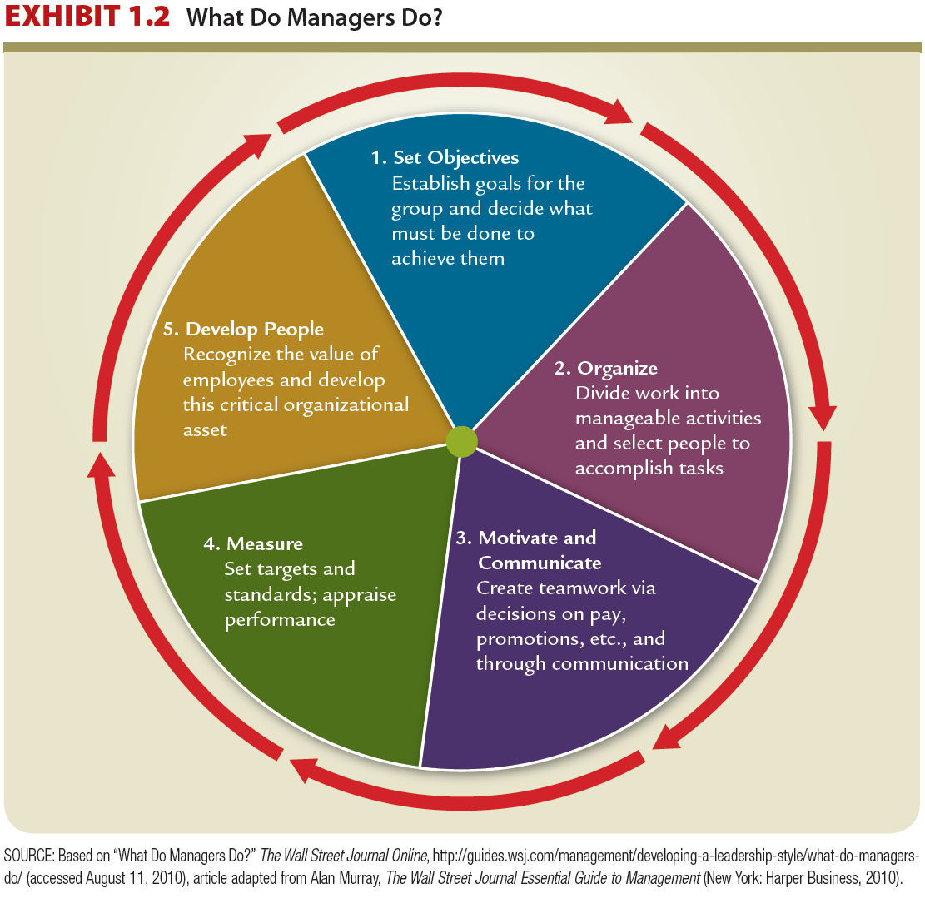

8 good behaviours for managers:
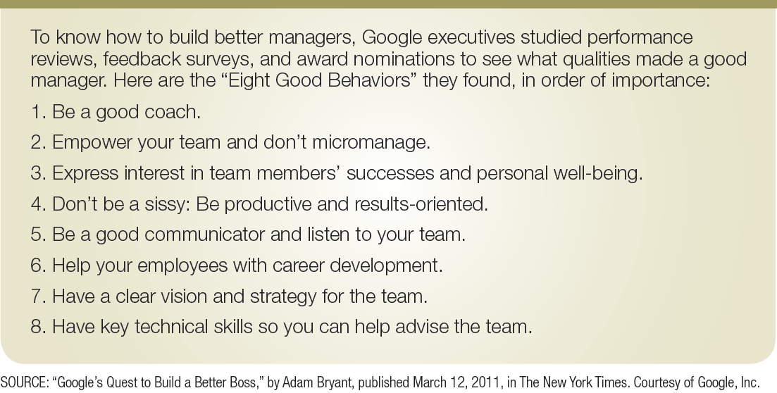
The rigour of organisational behaviour:

- OB Looks at Consistencies
  - What is common about behaviour, and helps predictability?
- OB Looks Beyond Common Sense
  - Systematic study, based on scientific evidence
    - Evidence-based management (EBM)
- OB Has Few Absolutes
  - Few, if any, simple and universal principles that explain OB
- OB Takes a Contingency Approach
  - Considers behaviour in context

Contingency Approach:

- Behaviour in organizations is a complex function of many interacting factors. For example:
  - Personal characteristics
  - organizational culture
  - organizational structure
  - group processes
  - external factors (job market, gov’t. restrictions)

An Integrative model:
- Three Levels of Analysis:
  - Individual
  - Group
  - Organization

OB Levels:

Critical managerial skills:

Technical | Skills necessary to accomplish specific tasks  within the organization
Interpersonal | Skills used to communicate with, understand,  and motivate individuals and groups
Conceptual | Skills used in abstract thinking
Diagnostic | Skills to understand cause-effect relationships  and to recognize optimal solutions to problems

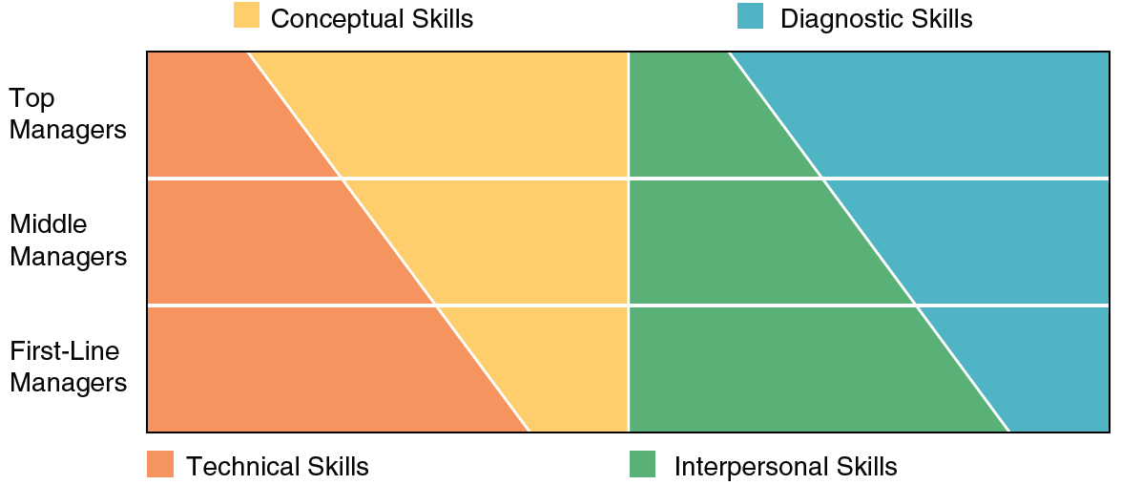

The Open System View:

The open systems framework derives from the models of ecosystems in biology, so that organizations are viewed as living organisms, interacting with their environment and requiring balance to survive. This notion fits well with the competing values framework discussed earlier in the chapter and outlined in Exhibit 1.2. In this framework effective managers focus both inside and outside their organization and also try to balance the need for stability with the need for adaptability.

The systems approach to organisations:

Formal Organization :
The official, legitimate, and most visible part of the system.
Informal Organization:
The unofficial and less visible part of the system.

Formal vs informal organisations:

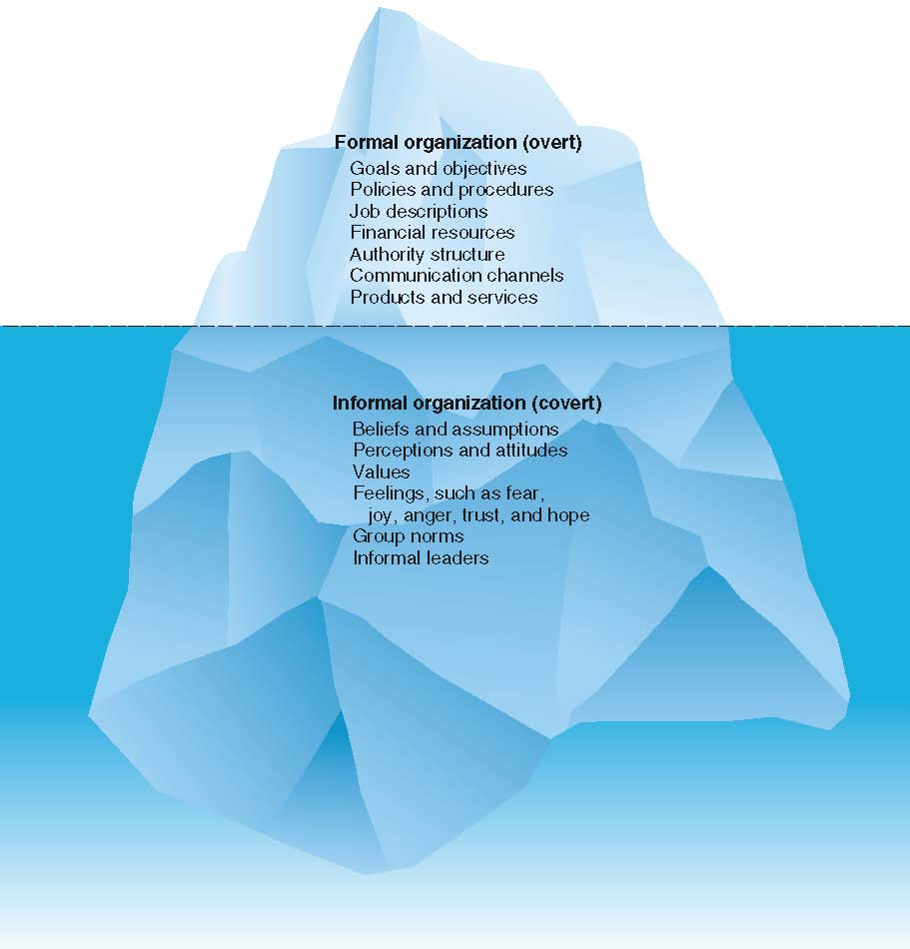

Hawthorne studies:
  - Worker productivity was measured at various levels of light illumination.
  - Researchers found that regardless of whether the light levels were raised or lowered, worker productivity increased.

Human Relations Implications Hawthorne effect- the effect of attention on performance
  - Behavior of managers and workers in the work setting is as important in explaining the level of performance as the technical aspects of the task

Some contemporary management concerns:
  - Diversity Organizational behaviour is concerned with issues that have to do with the management of a diverse workforce and how to benefit from the opportunities that a diverse workforce provides.
  - Globalization
  - Employee-Organization Relationships
  - Talent Management
  - Ethics-Corporate Social Responsibility (CSR)

Workforce diversity:
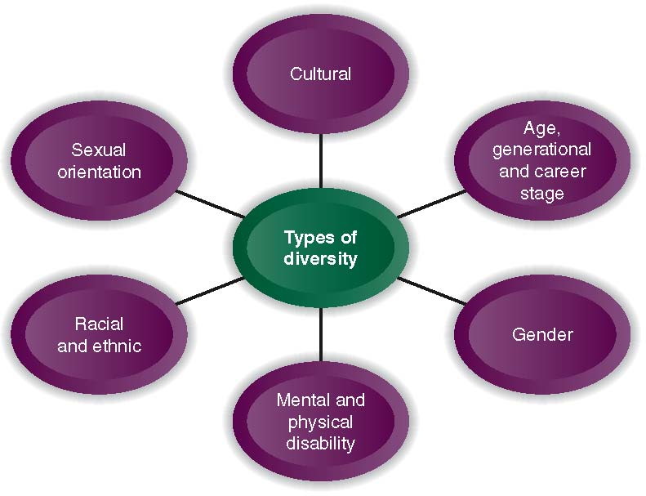

The challenges of global competition:

Increased global competition is driving radical change in North America resulting in:
  - Pressure on all categories of employees
  - Demand for increased productivity & value
  - Need to be customer focused
  - Create a focus on quality

Employee- organisation relationships:

- Downsizing, restructuring, re-engineering, and outsourcing
- Major structural changes in work arrangements (e.g., part-time, temporary, contract work).
- Changes in the workplace have changed the nature of employee-organization relationships.

Talent management: refers to an organization’s processes for attracting, developing, retaining, and utilizing people with the required skills to meet current and future business needs.

- Two most important management challenges:
  - Recruitment of high-quality people
  - Improving the appeal of the company culture and work environment

Ethics and Corporate social resposibility (CSR):

- CSR refers to an organization taking responsibility for the impact of its decisions and actions on its stakeholders.
- It extends beyond the interests of shareholders to the interests and needs of employees and the community in which it operates.

What motivates employees today?
- Camaraderie, peer motivation
- - Intrinsic desire to a good job
- - Feeling encouraged and recognized
- - Having a real impact - Growing professionally
- - Meeting client/customer needs
- - Money

Chapter 3: PERSONALITY, PERCEPTION, AND ATTRIBUTION

Exploring the concept of “individual differences” – individuals are unique in terms of their skills, abilities, personalities, perceptions, attitudes, emotions, and ethics. These differences are said to represent the essence of the “challenge” of management.

The basis for understanding individual differences stems from Lewin’s early contention that behaviour is a function of the person and the environment this idea has been developed by the “interactional psychology approach”

Interactional psychology approach: emphasises that in order to understand human behaviour we must know something about the person and the situation. These are the 4 basic propositions:

- Behaviour is a function of a continuous, multi- directional interaction between the person and the situation
- The person is active in this process and is both changed by situations and changes situation
- People vary in many characteristics, including cognitive, affective, motivational, and ability factors
- Two interpretations of situations are important: the objective situation and the person’s subjective view of the situation (situation consists of the environment the person operates in, including the organisation, work group, personal life situation, job characteristics, and other environmental influences)

Skills and abilities: many selection procedures include an assessment of specific job- related skills but few employers use intelligence tests (General Mental Ability; GMA) to screen employees, relying instead on education as an indication

PERSONALITY AND ORGANISATIONS:

Personality: Refers to a relatively stable set of characteristics that influences an individual’s behaviour// Influenced by both environment (family, cultural, educational influences) and heredity.

BIG FIVE-PERSONALITY MODEL: (Acronym = OCEAN)

Extraversion | The person is gregarious, assertive, sociable, talkative, enjoys social situations (as opposed to being reserved, timid, quiet, withdrawn, shy)
Agreeableness | Co-operative, warm, tolerant, trusting, altruistic (vs. cold, rude, disagreeable, antagonistic)
Conscientiousness | Hardworking, organised, dependable, responsible (vs. lazy, unreliable, careless, impulsive)
Emotional stability (opposite: neuroticism) | Calm, self-confident, collected, cool, even tempered (vs. depressed, anxious, insecure)
Openness to experience | Creative, curious, cultured, original, open-minded (vs. dull, unimaginative, practical with narrow interests)

Preliminary research proposes:

- Introverted and conscientious employees are less likely to be absent from work
- High agreeableness workers- tend to rate others more leniently on peer evaluations
- High conscientiousness- tend to be harsher when it comes to critique
- Extroverts tend to have higher salaries, receive more promotions, and be more satisfied with their careers
- For customer service individuals need to rate high in emotional stability, agreeableness, and openness for the best performances
- Managers with emotional stability and extraversion are top performers

PERSONALITY CHARACTERISTICS IN ORGANISATIONS:

There are characteristics with particularly strong influences on the individual in organisations: Core self- evaluation (CSE), Self Monitoring, and positive/negative affect.

Core self-evaluation (CSE) The positive-ness of a person’s self concept; it comprises locus of control, self- esteem, self- efficacy, and emotional stability. Research suggests that people with high CSE are more popular, make more money, have higher prestige jobs, and higher job satisfaction.

Locus of control Refers to an individual’s generalised belief about internal control (self-control) vs. external control (control by the situation or by others). People who believe they control what happens to them have an internal locus of control (personal actions, self- initiative, free will) whereas people who believe that circumstances or other people control their fate have an external locus of control (fate, luck, powerful others). Internals have higher job satisfaction and change their behaviour in such a way as to promote positive outcomes, whilst externals’ perceptions of their passive role means they are less likely to deal directly with problems or initiate constructive actions. // Internals also don’t react well to close supervision, whereas externals appreciate a more structured work setting and greater management support and prefer not to participate in decision making.

Self- efficacy an individual’s general belief that he or she is capable of meeting job demands in a wide variety of situations. // Employees with high general self- efficacy have more confidence in their job- related abilities and other person resources (energy, influence over others, personal resources) whilst people with low general self- efficacy often feel ineffective at work and may express doubts about performing a new task well.

Self- esteem is an individual’s general feeling of self-worth// Behavioural plasticity theory: those with low self-esteem are more susceptible to external and social influences.

Self- monitoring The extent to which people base their behaviour on cues from other people and situations and regulate how they appear in social settings// high self monitors pay attention to what is appropriate in particular situations and to the behaviour of other people, and they behave accordingly (socially adaptable) vs. low self-monitors who pay less attention to situational cues and act from internal states instead (act how they feel no matter what and are consistent throughout)

Positive/ Negative affect Positive affect refers to an individual’s tendency to accentuate the positive aspects of themselves, and the world in general // Negative affect refers to an individual’s tendency to accentuate the negative.

APPLICATION OF PERSONALITY THEORY IN ORGANISATIONS:

- An area that remains controversial is the use of personality tests in personnel selection. Generally, the validity is low for predicting performance, accounting for only 15% of the variation in performance. This may be partially due to the fact that most tests are self- reports but also lies in the fact that the profile of an “excellent” performer is influenced by an organisation’s culture, the work group, and the specific tasks assigned.
- It is simplistic to expect that there is a single set of characteristics defining the ideal applicant as different jobs have different demands.

EXAMPLE: Although conscientiousness generally predicts stronger performance, it has been shown to be a potential liability in jobs, requiring innovation and creativity and in jobs requiring expedient completion of many tasks (because individuals may be overly concerned with detail and not accomplish as much as needed)

Myers- Briggs Type Indicator instrument (MBTI) An instrument developed to measure Carl Jung’s theory of individual differences: To understand individual differences by analysing the combinations of preferences.

EXTRAVERSION | SENSING | THINKING | JUDGING
Outgoing | Practical | Analytical | Structured
Publicly expressive | Specific | Clarity | Time oriented
Interacting | Feet on the ground | Head | Decisive
Speaks, then thinks | Details | Justice | Makes lists/ uses them
Gregarious | Concrete | Rules | Organised

INTROVERSION | INTUITION | FEELING | PERCEIVING
Quiet | General | Subjective | Flexible
Reserved | Abstract | Harmony | Open ended
Concentrating | Head in the clouds | Heart | Exploring
Thinks, then speaks | Possibilities | Mercy | Makes lists/ loses them
Reflective | Theoretical | Circumstance | Spontaneous

How organisations use MBTI:
- To understand individual differences
- Identify learning and teaching styles for specific individuals
- Conflict management as they use it as a tool to help employees understand the different viewpoints of others in organisations.
- Managers value type theory for its simplicity and accuracy which in turn helps managers develop interpersonal skills
- Understand management styles
- They also use it for building teams to capitalise on individuals’ strengths and to help individual team members appreciate differences

However, it is important to note that the MBTI instrument can be misused to categorise and label workers and claiming results as a convenient excuse that a person simply cant work with someone, and avoiding responsibility for learning to work flexibly with others. TYPE is NOT an excuse for inappropriate behaviour.

PERCEPTION:
The processes through which people select, organise, and interpret information from their environment

Selection: A filtering process
Organisation and interpretation: a creative process

Social perception: The process of interpreting information about another person; virtually all management activities rely on social perception.
-- Perception is also culturally determined

Characteristics of a PERCEIVER:

- Past experiences lead the perceiver to develop expectations that affect current perceptions = PERCEPTUAL SET
- “Needs” unconsciously influence perceptions by causing us to perceive what we wish to perceive
- “Emotions”/ “Moods” such as anger, happiness, or fear, can influence our perceptions.
- “Familiarity” When we are familiar with someone, we have multiple observations on which to base out impression, however, it does not mean accuracy due to the fact that when we know someone well, we tend to screen out information that’s inconsistent with our beliefs about that person.
- “Attitude” E.g.: If one is interviewing candidates for an important position that usually requires negotiating contracts with supplies, most of whom are older, one may feel that young people are incapable hence affecting perceptions
- “Perceiver’s self- concept” An individual with a positive self-concept tends to notice positive attributes whilst the person with negative self- concept with opts to pick out negative traits. The better we understand ourselves, the more accurate our perception of others.
- “Cognitive structure” An individual’s pattern of thinking such as one’s incessant need to judge physical attributes, as opposed to central traits such as personality. Cognitive complexity allows a person to perceive multiple characteristics of another person rather than attending to just a few traits.

Perceptual Defence:
- The tendency for the perceptual system to defend the perceiver against unpleasant emotions
- People often “see what they want to see” and “hear what they want to hear” selective hearing/ seeing

Characteristics of the Target: The target involves interpretation and addition of meaning// also judged on demographics such as age, status, and appearance.
- “Physical appearance”: The perceiver will notice physical features such as height, weight, estimated age, gender and contrast it with the norm. Physical attractiveness is also a benefit as they are judged more positively.
- “Verbal communication” – we listen to the tops targets discuss, their voice tone, and their accent
- “Nonverbal communication” – eye contact, facial expressions, body movements, and posture are all deciphered to gain impression
- “Intentions” of the target are inferred by the perceiver, who observes the target’s behaviour

Characteristics of the situation:
- Perception occurs in some situational context, and this context can affect what is perceived
- “Social context” of the interaction is a major influence.

BARRIERS TO SOCIAL PERCEPTION:

- Discounting principle: The assumption that an individual’s behaviour is accounted for by the situation
- Selective perception: The process of selecting information that supports our individual viewpoints while discounting information that threatens Individuals tend to ignore information that threatens their viewpoints
- Stereotyping: A generalisation about a group of people in a social category there’s also a tendency to ignore variations among them; stereotypes helps us develop impressions of ambiguous targets and most of them are inaccurate, especially when we use them to develop perceptions of specific individuals. For instance: thinking an attractive person is “warm”, a female is less competent than a male, or a younger employee may be less able to a seasoned one.
- First- impression error: The tendency to form lasting opinions about an individual based on initial perceptions
- The recency effect: is the opposite of first impression as the tendency is to weigh recent events more than earlier events. // Many employees take advantage of the recency effect by increasing their effort right before their annual appraisal, guessing correctly that the supervisor is more likely to be influenced by this vivid recent performance that the errors made months ago
- Contrast effect: The tendency to diminish or enhance the measure of one target through comparison with another recently observed target
- Projection: overestimating the number of people who share our own beliefs, values, and behaviours.
- Self- fulfilling Prophecies: The situation in which our expectations about people affect our interaction with them in such a way that our expectations are fulfilled.
- Halo effect: The creation of an entire impression based on one attribute or trait

Stereotypes in business:

GENDER:

The glass ceiling for women as barriers to progress due to:
- The lack of role models in business - they possess traditional job stereotypes
- No track record - hiring through the “old boys” network
- Feeling isolated/ little peer support- little advice and “sponsorship”
- Concentrated in areas not leading to upper level positions – assigned less visible jobs
- “Invisible Women” syndrome- difficulty showing competence
- Use of “fit” criteria – “good qualifications but will she fit in?”

Genders pay Differentials

Canadian women, on average, earn less than men
These possible contributing factors are:
- More women work part- time
- Women are less likely to work in teams
- Women are clustered in low- wage industries

Reducing stereotypes:
The detrimental effects of gender stereotypes are reduced or removed when decision makers have good information about the qualifications and performance of particular women and an accurate picture of the job that they are applying for or seeking promotion into.

Attribution in organisations:

Attribution theory: A theory that explains how individuals pinpoint the causes of their own behaviour and that of others

We make:
DISPOSITIONAL attributions: person acts a certain way because of internal characteristics (personality, values, intelligence, desires, etc) or
SITUATIONAL attributes: person acts a certain way because of the situation or the environment

Attributional Biases:

Fundamental attribution error The tendency to make attributions to internal causes when focusing on someone else’s behaviour such as seeing someone fall, you are likely to blame THEIR clumsiness, but when the same thing happens to you, you attempt to look for something that tripped you or a puddle, an external attribution. This means that we tend to blame people for their problems, even when the situation is the actual culprit, and we may credit people for their successes even when they did nothing to truly deserve it.

Self- serving bias The tendency to attribute one’s own successes to internal causes and one’s failures to external causes.

Performance and Kelley’s Attribution Theory:

Harold Kelly’s theory aims to help explain the behaviour of other people and extended it by trying to identify antecedents of internal and external attributions. Kelley proposed that people make attributions based on info gathered in the form of 3 informational cues: (covariation principle)

- Consensus: An informational cue indicating the extent to which peers in the same situation behave in a similar fashion,
- Distinctiveness: An informational cue indicating the degree to which an individual behaves the same way in other situations,
- Consistency: An informational cue indicating the frequency of behaviour over time.

CHAPTER 4: ATTITUDES, EMOTIONS, AND ETHICS

Attitude: A psychological tendency expressed by evaluating an entity with some degree of favour or disfavour

THE ABC MODEL:

- Affect: The emotional component of an attitude. It refers to an individual’s feeling about something or someone. Affect is also measured by physiological indicators, such as blood pressure, which show emotional changes by measuring physiological arousal. E.G. “I don’t like my boss”
- Behavioural: An intention to behave in a certain way towards someone or something. Observed behaviour and verbal statements about intentions measure it. E.G.: “I want to transfer to another department”
- Cognitive (thought): reflects a person’s perceptions or beliefs. Attitude scales and verbal statements about beliefs measure them. E.G. “I believe my boss plays favourites at work”

Cognitive Dissonance A state of tension that is produced when an individual experiences conflict between attitudes and behaviour. The tension (dissonance) motivates individuals to change either their attitudes or behaviours to maintain consistency.

- Employees often find themselves in situations where their attitudes conflict with their behaviour
- Some employees find the conflicts between strongly held attitudes and required work behaviour so uncomfortable that they leave the organisation to escape dissonance
- A manager can sometimes use dissonance deliberately to change an employee’s attitude. Involving the employee in a task that contradicts the underlying attitude does this.

ATTITUDE FORMATION:

- 2 major influences on attitudes are direct experience and social learning.
- Research has shown that attitudes derived from direct experience are stronger, held more confidently, and more resistant to change than attitudes formed through indirect experience. These attitudes are powerful because of their availability; they are easily accessed and active in our cognitive process.
- Substantial social learning occurs through modelling in which individuals acquire attitudes by observing others such as children adopting certain attitudes when their parents reinforce or approve of it (culture, social norms)

ATTITUDES AND BEHAVIOUR:

- Attitude-behaviour correspondence depends on 5 components:
- Attitude specificity
- Attitude relevance
- Timing of measurement
- Personality factors
- Social constraints

JOB SATISFACTION:

- Job satisfaction is a pleasurable or positive emotional state resulting from the appraisal of one’s job or job experiences. It has been treated both as a general attitude and as satisfaction with specific dimensions of the job such as pay, the work itself, promotion opportunities, supervision, and co-workers.
- The 2 most extensively validated measures of job satisfaction are the job descriptive index (JDI) and the Minnesota Satisfaction questionnaire (MSQ)

DISCREPANCY THEORY: A theory that job satisfaction stems from the discrepancy between the job outcomes wanted and the outcomes that are perceived, to be obtained.

DISPOSITION: The dispositional view of job satisfaction is based on the idea that some people are predisposed by virtue of their personalities to be more or less satisfied with their job.

What does tend to make employees more satisfied?
- Studies have shown the importance of good relations with management and interesting work, co-worker support, good pay and security.
- Factors important for job satisfaction vary with the individual for example: more educated workers are more likely to emphasise the intrinsic job content (interesting job, meets your abilities, opportunity to use initiative, useful for society) and less educated workers are more likely to endorse extrinsic factors such as pay, good hours, and generous holidays.
- Satisfaction-performance link
- The key to influencing both satisfaction and performance through rewards is that the rewards are valued by employees and are tied directly to performance
- Job satisfaction connects to other important outcomes. Dissatisfied workers are more likely to skip work and quit their jobs, driving up the cost of turnover
- Dissatisfied workers also report more psychological and medical problems than do satisfied employees
- One factor that leads to dissatisfaction at work is a misfit between an individual’s values and the organisation’s values, which is called a lack of person-organisation fit

Consequences of Job satisfaction:
- Absence from work
- Turnover
- Mental & physical health
- Performance( not a strong predictor)
- Organizational citizenship behaviour
- Customer Satisfaction

Psychological contract Based on a mutual understanding between employee and employer about their reciprocal expectations

Sample attitude survey:

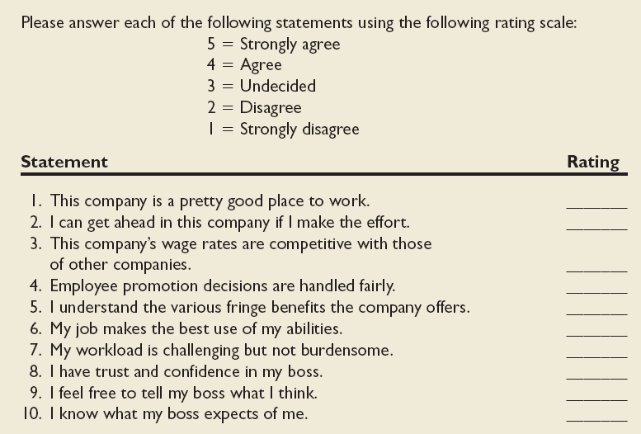
ORGANISATIONAL CITIZENSHIP VS. WORKPLACE DEVIANCE:

Job satisfaction encourages organisational citizenship behaviour- BEHAVIOUR THAT IS ABOVE AND BEYONG THE CALL OF DUTY.
Satisfied employees are more likely to help their co-workers, make positive comments about the company, and refrain from complaining when things go poorly
Going beyond the call of duty is especially important to organisations using teams. Employees depend on extra help from each other to get things accomplished.
Often employees may feel that citizenship behaviours are not recognised because they occur outside the confines of normal job responsibilities
- Individuals who identify strongly with the organisation are more likely to perform OCB’s
- High self-monitors who base their behaviours on cues from the situation, are also more likely to perform OCBs.
- OCB’s influence “bottom-line” effectiveness in the organisation and has been shown to relate to productivity, efficiency, reduced costs, customer satisfaction, and unit-level turnover.

In direct contrast to the desirability of OCB is the existence of workplace deviance. Workplace deviance refers to: ANY VOLUNTARY COUNTERPRODUCTIVE BEHAVIOUR THAT VIOLATES ORGANISATIONAL NORMS AND CAUSES SOME DEGREE OR HARM TO ORGANISATIONAL FUNCTIONING.

- Layoffs for instance, may inspire employees to develop negative attitudes, to feel anger and hostility toward the organisation, and to retaliate.

TYPES OF WORKPLACE DEVIANT BEHAVIOUR:

Production Deviance:
- Leaving early
- Taking excessive breaks
- Intentionally working slow
- Wasting resources

Property Deviance:
- Sabotaging equipment
- Accepting kickbacks
- Lying about hours worked
- Stealing from company

Political Deviance:
- Showing favouritism
- Gossiping about co-workers
- Blaming co-workers
- Competing non beneficially

Personal Aggression:
- Sexual harassment
- Verbal abuse
- Stealing from co-workers
- Endangering co-workers

ORGANISATIONAL COMMITMENT AND JOB SATISFACTION:

- Organisational commitment: The strength of an individual’s identification with an organisation
- Affective commitment: The type of organisational commitment that is based on an individual’s desire to remain in an organisation. Affective commitment encompasses loyalty and a deep concern for the organisation’s welfare and consist of 3 factors 1) A belief in the goals and values of the organisation, 2) A willingness to put forth effort on behalf of the organisation, and 3) A desire to remain a member of the organisation
- CONTINUANCE COMMITMENT: The type of organisational commitment that is based on the fact that an individual cannot afford to leave
- Normative commitment: The type of commitment that is based on an individual’s perceived obligation to remain with an organisation.
- All 3 types of commitment are related to lower turnover.
- Those that show “affective commitment” show higher attendance, better performance, higher OCB, and even less stress in their environments.

3 types of organisational commitment:

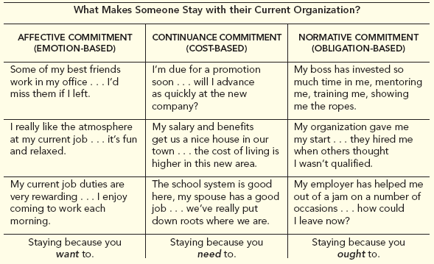

PERSUASION AND ATTITUDE CHANGE:

Through persuasion, one individual (the source) tries to change the attitude of another person (the target). Certain characteristics of the source, target, and message affect the persuasion process.
Source characteristics: EXPERTISE, WORTHINESS, AND ATTRACTIVENESS
Target characteristics: Individuals with low self-esteem are more likely to change their attitudes in response to persuasion than are individuals with high esteem
Message characteristics: Less threatening approaches are less likely to illicit negative reactions. The emotional tone of the message is also important as messages framed with the same emotion, as that felt by the receiver are more persuasive.

Cognitive routes to persuasion:
- THE CENTRAL ROUTE: involves direct cognitive processing of the message’s content. Individual’s think carefully about issues that are personally relevant. The listener may nod his or her head at strong arguments and shake their heads at weak ones. Logical and convincing arguments will change attitudes
- THE PERIPHERAL ROUTE: The individual is not motivated to pay much attention to the message’s content because they are distracted or perceives the message as personally irrelevant. Instead, the individual is persuaded by characteristics of the persuader, for instance through expertise, trustworthiness, and attractiveness. In addition, they may be persuaded through statistics.

EMOTIONS AT WORK:

- Emotions: Mental states include feelings, physiological changes, and the inclination to act
- Emotional labour: The need to manage emotions in order to perform one’s job effectively
- Emotional dissonance: conflict between what a person feels and what the person is expected to express// there is “surface acting” or “deep acting”
- EMOTIONAL INTELLIGENCE: A SET OF ABILITIES RELATED TO THE UNDERSTANDING AND MANAGEMENT OF EMOTIONS IN YOURSELF AND OTHERS
- Emotional intelligence is not fixed, however, and can be enhanced through training, feedback, and coaching.

EMOTIONAL INTELLIGENCE:
- SELF AWARENESS
- SELF- REGULATION
- MOTIVATION
- EMPATHY
- SOCIAL SKILL

Model of Emotional Intelligence:

(Highest to lowest)

- Relationship management- managing other people’s emotions
- Social awareness- perceiving and understanding the meaning of other’s emotions
- Self management- managing our own emotions
- Perceiving and understanding the meaning of your own emotions

Emotional contagion:
- The tendency for moods and emotions to spread between people or throughout a group
- Teams experiencing more positive affect tend to be more cooperative, helpful, and successful, all of which contributes to job satisfaction

Emotional regulation:
- The requirement for people to conform to certain “display rules” in their job behaviour in spite of their true mood or emotions

ETHICAL BEHAVIOUR:
Acting consistently with one’s personal values and the commonly held values of the organisation and society

Guidelines for Ethical decision-making:
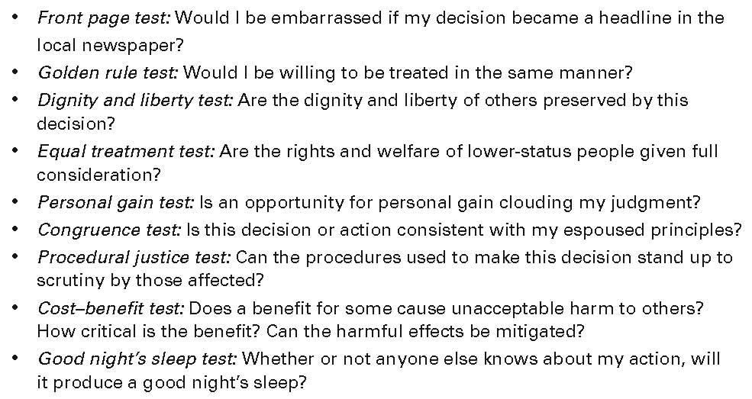

The need for Corporate Ethics programs:

- Organizations should develop an organizational ethics program by establishing, communicating, and monitoring uniform ethical values and legal requirements
- A strong ethics program includes:
  - Written code of conduct
  - Ethics officer to oversee the program
  - Care in the delegation of authority
  - Formal ethics training
  - Auditing, monitoring, enforcement, and revision of program standards

Corporate Codes of Ethics:

  - Trustworthiness
  - Respect
  - Responsibility
  - Fairness
  - Caring
  - Citizenship

CHAPTER 5: MOTIVATION AT WORK

Motivation: The energizing forces that influence the direction, intensity, and persistence of effort. Components: Arousal, direction, and maintenance

Theory X: A set of assumptions that workers are lazy and dislike responsibility
Theory Y: A set of assumptions that workers will like work and will seek responsibility

An employee has limited time and resources and choose how to use them. The most an employer can do is create the right circumstances to provide what the employee is looking for so both can meet their needs. However, the better the employer understand employee motivation, the more likely those “right” circumstances can be created.

Components of Motivation:

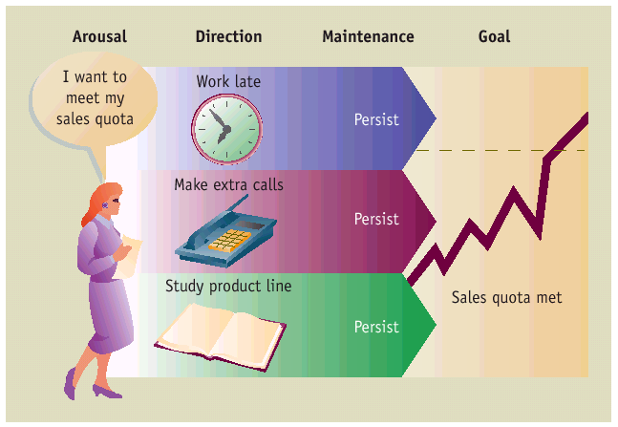

Motivational Theories:

- NEEDS THEORIES: Identify internal factors/ variables within the individual, typically deficiencies, that give rise to motivation// E.G. MASLOW, ERG, McCllenad, HERZBERG
- PROCESS THEORIES : Identify how internal factors interact with the environment to influence motivation// E.G. Adams’ equity theory, expectancy theory
- PSYCHOANALYSIS: Sigmund Freud’s method for delving into the unconscious mind to better understand a person’s motives or needs// suggests that a person’s organisational life was founded on the compulsion to work and the power of love

Maslow’s theory of needs:

Specifies that there are FIVE human needs and that these are arranged in such a way that lower, more basic needs must be satisfied before higher-level needs become activated

Our actions are directed to fulfil the lowest level of unmet need. However, a single action can meet more than one need; for example: a meet fulfils physiological needs but often social needs (eating a family member’s meal to avoid hurting feelings) and esteem needs (you cooked a gourmet meal).

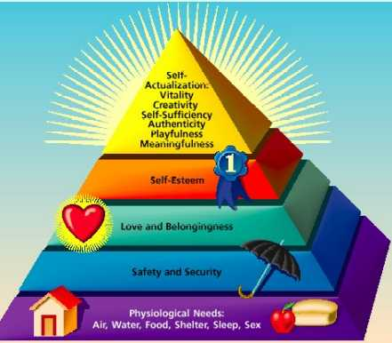

ESTEEM: The need to develop self- respect and to gain the approval of others
SELF ACTUALISATION: The need to discover who we are and to develop ourselves to the fullest potential

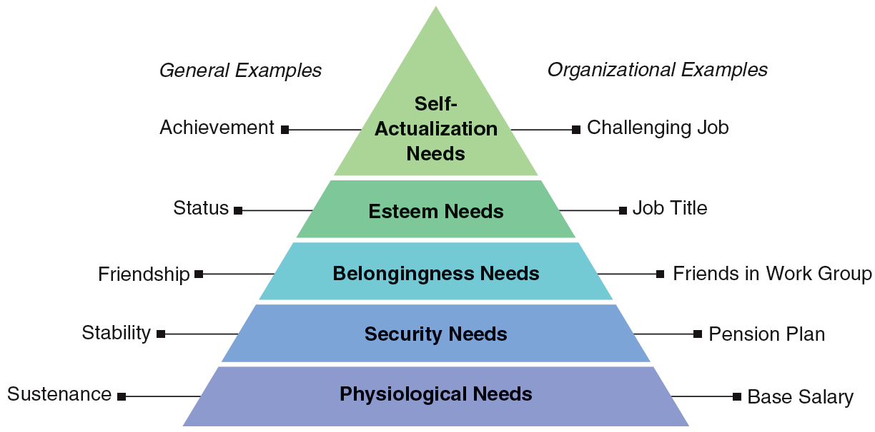

Maslow Basic Principles:

1. Lowest level unsatisfied need: greatest motivating potential.
2. Once needs at a particular level are satisfied, they are no longer motivating (deficit principle).
3. Needs exist in a strictly ordered hierarchy. A need at one level becomes activated only when needs at lower levels are satisfied (progression principle).

Alderfer’s ERG Theory:

He proposed the ERG theory of motivation, which grouped human needs into only 3 basic categories: EXISTENCE, RELATEDNESS AND GROWTH.

Alderfer classified Maslow’s physiological and physical safety needs in an EXISTENCE category
Interpersonal safety, love, interpersonal needs in a RELATEDNESS NEED category
Self-actualisation and self- esteem in GROWTH category

Assumptions:
More than one need may motivate a person at the same time
Frustration-regression –Frustration of a higher-level need can lead to efforts to satisfy a lower-level need

McClelland’s Need theory:

3 learned needs acquired through a person’s upbringing:
- Achievement
- Power
- Affiliation

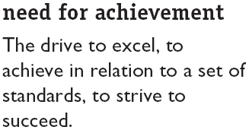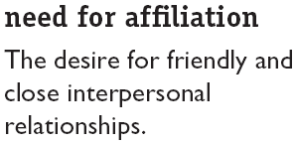

McClelland found that people with
A high need for achievement perform
Best. 3 characteristics: 1) They set
Goals that are moderately different,
Yet achievable, 2) they like to receive
Feedback on their progress, and 3) they
Do not like having external events or
Other people interfere with their progress.

-They are also persistent and motivated by INTRINSIC REINFORCEMENT

- - INTRINSIC MOTIVATION: Motivation that stems from the direct relationship between the worker and the task and is usually self-applied.
- Examples include:
  - Feelings of achievement, accomplishment, challenge, and competence derived from performing one’s job, and the sheer interest in the job itself.

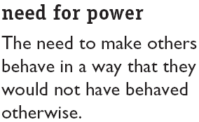
Theorist distinguished between “socialised power” which is constructive and is used for the benefit of many, whilst “personalised power” which is destructive and is used for personal gain. Managers need to have high socialised power to be effective.

nAch
nPow
nAff

Need for Autonomy:

This is the desire for independence and freedom from constraints. People with a high need for autonomy prefer to work alone and to control the pace of their work. They dislike bureaucratic rules, regulations, and procedures.

Extrinsic motivation:

IS MOTIVATION THAT STEMS FROM THE WORK ENVIRONMENT EXTERNAL TO THE TASK. IT IS USUALLY APPLIED BY OTHERS// Examples include: PAY, FRINGE BENEFITS, COMPANY POLICIES, AND VARIOUS FORMS OF SUPERVISION

HERZBERG’S TWO FACTOR THEORY:

MOTIVATION FACTORS: Work conditions related to satisfaction of the need for psychological growth

HYGIENE FACTORS: Work conditions related to dissatisfaction caused by discomfort or pain.

Hygiene factors avoid job dissatisfaction

- Company policy and
administration
- Supervision
- Interpersonal relations
- Working conditions
- Salary
- Status
- Security

- Achievement
- Achievement recognition
- Work itself
- Responsibility
- Advancement
- Growth
- Salary?
Motivation factors increase job satisfaction

Even in the absence of good hygiene factors, employees still are motivated to perform their jobs well if the motivation factors are present.

CONCLUSION: 1) Hygiene factors are important but not sufficient for motivation, 2) the presence of motivation factors is essential to enhancing employee motivation to excel at work.

PROCESS THEORIES:
Motivation theories that specify the details of HOW motivation occurs:
- Equity theory
- Expectancy theory

EQUITY THEORY:
- Individuals are motivated by a sense of fairness in rewards distribution
- This sense of fairness results from a social comparison with others, i.e., the referent(s)
- Equity theory says that motivation is a function of perceived fairness (equity) in a social exchange and that inequity (unfairness) is an important motivator// States that job satisfaction stems from a comparison of the inputs one invests in a job and the outcomes one receives in comparison to the inputs and outcomes of another person or group.

- INEQUITY: The situation in which a person perceives he or she is receiving less than he or she is giving, or is giving less than he is receiving.
- Pay inequity has been a thorny issue for women in some organisations and has led to the application of “equal pay for work of equal value” concepts in determining fairness in pay for female vs male dominated jobs.

 | PERSON | COMPARISON OTHER
(A) EQUITY | Outcomes  Inputs | = ‘’’
(B) NEGATIVE INEQUITY | Outcomes  Inputs | < ‘’’’
(C) POSITIVE INEQUITY | Outcomes  Inputs | > ‘’’’

Equity sensitive: an individual who prefers an equity ratio equal to that of his or her comparison other
Benevolent: an individual who is comfortable with an equity ratio less than that of his or her comparison other
Entitled: An individual who is comfortable with an equity ratio greater than that of his or her comparison other

Procedural Fairness:

Fairness in HOW THINGS ARE DONE

- Fairness that occurs when the process used to determine work outcomes is seen as reasonable.
- It is concerned with how outcomes are decided and allocated.

- Occurs when the employer:
  - Gives adequate reasons for his/her decisions
  - Follows consistent procedures
  - Uses accurate information and appears unbiased
  - Allows two-way communication during the allocation process
  - Welcomes appeals of the procedure or allocation

- Interactional justice Fairness in how people are treated// Are employees treated with politeness, dignity, and respect?

OCB –ORGANISATIONAL CITIZENSHIP BEHAVIOUR

CORRECTING INEQUITY FEELINGS:

Actions to correct inequity: Example:

Reduce our inputs | Less organizational citizenship
Increase our outcomes | Ask for pay increase
Increase other’s inputs | Ask coworker to work harder
Reduce other’s outputs | Ask boss to stop giving other preferred treatment
Change our perceptions | Start thinking that other’s perks aren’t really so valuable
Change comparison other | Compare self to someone closer to your situation
Leave the field | Quit job

EXPECTANCY THEORY: (Victor Vroom)

-A process theory that states that motivation is determined by the outcomes that people expect to occur as a result of their actions on the job.
- Focuses on personal perceptions of the performance process This cognitive process theory is founded on the basic notions that:

“PEOPLE DESIRE CERTAIN OUTCOMES OF BEHAVIOUR AND PERFORMANCE, WHICH MAY BE THOUGHT OF AS REWARDS OR CONSEQUENCES OF BEHAVIOUR, AND THAT THEY BELIEVE THERE ARE RELATIONSHIPS BETWEEN THE EFFORT THEY PUT FORTH, THE PERFORMANCE THEY ACHIEVE, AND THE OUTCOMES THEY RECEIVE”

The key constructs of the theory are:

- Valence of an outcome (The value or importance one places on a particular reward) How much do I value the outcomes?

- Expectancy Can I achieve desired level of performance?

- Instrumentality (The belief that performance is related to rewards) If I perform at that level, what will happen? What work outcomes will be achieved?

Strengthening the Link between Effort and Results (Help employees succeed):

- To enhance expectancy, managers can match people to jobs and tasks and provide training, resources, and support so employees will believe they can be successful
- Instrumentality is enhanced when a manager observes and responds to varying performance levels.
- Manager is to be sensitive to the valence of various rewards to individuals and do whatever possible to attach valued rewards to strong performances this means that they will have to be willing to treat people differently

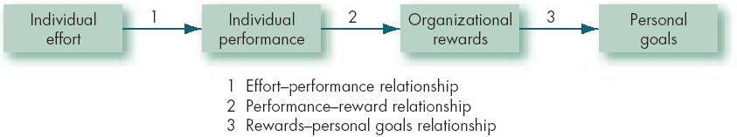

FACTORS THAT INFLUENCE AND EMPLOYEE’S EXPECTANCY PERCEPTIONS:

- Self-efficacy (self-confidence)
- Previous success at the task
- Help received from a supervisor and subordinates
- Information necessary to complete the task
- Good materials and equipment to do work with

CHAPTER 6: learning and performance management

Learning: is a change in behavior acquired through experience. Learning helps guide and direct motivated behavior// may begin with cognitive activity of developing knowledge about a subject, when then leads to a change in behavior

Classical conditioning:
Modifying behavior by pairing a conditioned stimulus with an unconditioned stimulus to elicit an unconditioned response// E.G. people working at a computer terminal may get lower back tension (unconditioned response) from poor posture (unconditioned stimulus). If they become aware of that tension only when the manager appears (conditioned stimulus) then they may develop a conditioned response (lower back tension) to the appearance of the manager

Operant conditioning:

Modifying behavior through the use of positive or negative consequences following specific behaviours

Reinforcement theory emerges from operant conditioning as they focus on the power of consequences to influence behaviour.

Timing of consequences is important (the closer an outcome is to the behaviour, the more impact is has); the consistency of reinforcement affects how fast something is learned and how quickly it is “unlearned” once reinforment stops.
Underlying premise is that people develop or strengthen behaviours that are followed by positive consequences and weaken or eliminate behaviours that are not.
Organisations use 4 basic strategies:
- Positive reinforcement
- Negative reinforcement (both of which serve to encourage more of the behaviour)
- Punishment
- Extinction (Both of which discourage the repetition of the behaviour)

Positive reinforcement: Attempting to strengthen desirable behaviour by bestowing positive consequences (like a bonus)

- Managers can use either continuous or intermittent schedules of positive reinforcement.
- When managers design organizational reward systems, they consider not only the type of reinforcement but also how often to provide it
- Research results indicate that ratio schedules of reinforcement that link reinforcement to specific responses are more effective than interval ones based on time passed
- Unsurprisingly this suggests pay for performance schemes will motivate greater effort than fixed salaries
- Research also suggests that variable, unpredictable schedules of reinforcement motivate a steadier high rate of response than fixed scedules
- Not knowing the likely outcome of the next move and knowing it could be important will trigger a more motivated employee than knowing exactly when and how one will be reinforced.

Negative reinforcement: Attempting to strengthen desirable behaviour by withholding negative consequences//E.G. A manager who promises an employee that, if she figures out how to resolve a tough debugging problem, he will take her place at the committee meeting this week, the one she dislikes attending so much.

NEGATIVE REINFORCEMENT:
- Present ‘unpleasant’ stimulus;
- Subject responds;
- Remove ‘unpleasant’ stimulus.
Result: subject will respond again
Again, success depends on reinforcement being contingent on behaviour

Punishment: Attempting to eliminate or weaken undesirable behaviour by bestowing negative consequences or withholding positive consequences // E.g. a professional athlete who is offensive (undesirable behaviour) will get removed from the playing field (negative consequence)

Extinction: Attempting to eliminate or weaken undesirable behaviour by attaching NO consequences to it// E.G. by complimenting a colleague for constructive comments (reinforcing desirable behaviour) whilst ignoring sarcastic comments (extinguishing undesirable behaviour)

Errors involving reinforcement:
- Managers sometimes make the following errors when trying to use reinforcement:
  - Confusing rewards with reinforcers Rewards fail to serve as reinforcers when they are not made contingent (subject to chance) on some specific desired behaviours.

  - Neglecting diversity in preferences for reinforcers Organizations often fail to appreciate individual differences in preferences for reinforcers.

  - Neglecting important sources of reinforcement Managers often neglect important sources of reinforcement such as those administered by co-workers or intrinsic to the job.

Two important sources of reinforcement that managers often ignore are:
--Performance feedback
--Social recognition

  - Management Reward Folly

Management Reward Follies- Rewarding the WRONG behaviour

- We hope for
- Teamwork and collaboration
- Innovative thinking & risk-taking
- Commitment to quality

- But we reward
- The best team members
- Proven methods, not making mistakes
- Shipping on schedule, even with defects

Individual and Team rewards

Individual rewards
- Incentive effect
- Sorting effect
- Undermine cooperative behavior and encourage dysfunctional competition

Team rewards
- Emphasize cooperation by eliminating competitiveness and elevating joint effort
- Emphasize sharing of information & knowledge
- Incentive and merit pay can be based on group performance rather than individual performance
- Gainsharing plans emphasise collective cost reduction by allowing workers to share in the gains achieved by reducing production costs
- Profit sharing encourages everyone to support each other as they all play a role in contributing to the organisation’s success and their pay offs.
- HOWEVER, group based plans also have their drawbacks such as individualistic cultures such as Canada prefer their pay to be based on individual performance.

Hybrid approach
- Use both individual and shared rewards

Effective punishment:
- Punish immediately.
- Make sure that punishment is truly aversive.
- Do not reward unwanted behaviour before or after punishment.
- Do not punish desirable behaviour.
- Provide positive reinforcement

REPRIMAND
- Identify the inappropriate behaviour
- Point out impact of problem on performance of others
- Identify causes
- Explore remedies
REDIRECT
- Describe the standards of expected behaviour
- Ask if individual will comply
- Be supportive
REWARD
- Clarify reward-performance link
- Reward improvements in performance

SOCIAL AND COGNITIVE THEORIES OF LEARNING:

BANDURA’S SOCIAL LEARNING THEORY:

Albert Bandura believes learning occurs when we observe other people and model their behaviour, since employees look to their supervisors for acceptable norms of behaviour, they are likely to pattern their own actions after the supervisor’s.

- A major component of this theory is TASK SPECIFIC SELF- EFFIACY an individual’s beliefs and expectancies about his or her ability to perform a specific task effectively.

There are 4 sources of task- specific self – efficacy:
- Prior experiences
- Behaviour models
- Persuasion from other people
- Assessment of current physical and emotional capabilities

- The process of imitating the behaviour of others:
  - Examining the behaviour of others
  - Seeing the consequences they experience
  - Thinking about what might happen if we act the same way
  - Imitating the behaviour if we expect favourable consequences

- Involves self-reinforcement.
- Attractive, credible, competent, high-status people are most likely to be imitated.

Bandura saw the power of social reinforcement, recognizing that financial and material rewards often occur following or in conjunction with the approval of others, whereas punishment often follow social disapproval. Thus, self-efficacy and social reinforcement influence behaviour and performance at work.

Mentoring can help poor performance

