Verification of Boyle’s Law

Simran Jaffer, Natasha Kerlovich
Completed on September 19th 2017
Due on September 26th 2017
CHM1311 Section 2
TA: Alex Steeves
Dr. Rashmi Venkateswaran
Introduction
Gases differ from liquids and solids in the way that their volume and shape is much more variable in comparison. Due to this property, gases are influenced by volume, temperature and pressure. The change in volume of a gas due to temperature is demonstrated in Charles’ Law, which essentially states that gases will expand when temperature increases and will contract when temperature decreases. (Silberberg, 2013). The relationship between the volume of a gas and the pressure it exerts on its container is demonstrated in Boyle’s Law. Essentially, Boyle’s Law states that as volume increases, the pressure the molecules in a gas exert on its container will decrease and vice versa. The theory behind this is that if the volume increases, the molecules will be further apart and thus will collide less often allowing for a decrease in pressure. This theory is said to hold true if all other factors are controlled for. In this case, the temperature must remain constant for the relationship between volume and pressure of a gas to be measured (Silberberg, 2013). This experiment attempts to verify Boyle’s Law which will be tested using a syringe and a Gas Pressure Sensor. The theory is that if the volume of air in the syringe is increased, then the pressure of the air inside the syringe will decrease proportionally. Inversely, if the volume of air in the syringe is decreased, then the pressure of the air inside the syringe will increase proportionally. If temperature is controlled for, then this experiment has the potential to verify Boyle’s Law.

Materials
LabQuest 2 | Vernier Gas Pressure Sensor | Plastic Syringe  (20 mL) | USB Key

Procedure
- The Gas Pressure Sensor was connected to the LabQuest 2.
- The LabQuest 2 was turned on.
- The option “New” from the “File menu” was selected.
- The plunger of a 20mL plastic syringe was moved, aligning the base of the cone-like end with the 10mL mark.
- The 20mL plastic syringe was attached to the Gas Pressure Sensor by placing it on and twisting it to the right to lock it into place on the sensor.
- LabQuest 2 data-collection mode was set up.
- “Mode” was selected on the meter screen.
- The mode was changed to “Events with Entry”.
- “Volume” was entered for the name and “mL” was entered for the units of the independent variable.
- “OK” was selected.
- The syringe plunger was held at the initial volume mark, 10mL.
- When the pressure reading was stable, “Keep” was tapped and the volume of the gas + 0.8 mL was entered. The reason 0.8 mL was added to the measurement is because there was 0.8 mL of additional space inside the pressure sensor. Therefore, for the initial trial where the syringe plunger was moved to the 10mL mark, the true volume was 10.8 mL and the data had to be recorded in this manner.
- The 10.8mL volume and the corresponding pressure was used as the control for this experiment. All other volume measurements and the corresponding pressure readings above and below the 10.8mL were compared to the control.
- “OK” was selected to proceed.
- The syringe plunger was moved to the next volume at the 9.0mL mark.
- The previous procedure was repeated for each volume measurement.
- Three (3) volume measurements above and below the initial 10.8mL volume were used for a total of 7 different volumes.
- For the final measurement, the plunger was not moved back to the original volume mark, but should have been. The two pressure readings corresponding to the two 10.8mL trials were therefore not compared, consequently one of the two was not chosen to be crossed out. This step was missed due to human error and will be further discussed in the analysis. When recreating this experiment, it is pertinent that this step is not ignored because it is important when analyzing the results.
- All steps were repeated to obtain 3 full sets of data.
- A USB was used to save information collected on the LabQuest 2 to later create graphs.

Observations
Qualitative Observations
During the lab, there was no colour change of the gas in the syringe; it remained a translucent gas. There was no odour produced and the syringe did not feel as though it changed temperature.
However, it was observed that when attempting to decrease the volume of the syringe, it became increasingly difficult to move the plunger. For example, when decreasing the volume from 10.8mL to 9.8mL in the syringe, it was not very difficult because the plunger moved relatively easily. When attempting to decrease the volume from 8.8mL to 7.8mL, it was extremely difficult to push the plunger down and to make it stay in place because it felt as if the plunger was resisting back at the force of the hand pushing it down. This qualitative observation will be further discussed in the analysis. demonstrates that as the volume in the syringe decreased, the pressure inside the syringe increased. Contrarily, when increasing the volume from 10.8mL to 11.8 mL, the plunger moved easily and there was no feeling of resistance pushing back at the hand pulling the plunger.

Data Tables and Graphs
Table 1: (Run 3) Relationship Between Volume of a Gas and Pressure
Volume (mL) | Pressure (kPa)
7.8 | 141.69
8.8 | 125.00
9.8 | 112.70
10.8 | 101.88
11.8 | 92.41
12.8 | 84.26
13.8 | 79.36

Table 2: (Run 4) Relationship Between Volume of a Gas and Pressure
Volume (mL) | Pressure (kPa)
7.8 | 141.88
8.8 | 125.52
9.8 | 114.20
10.8 | 101.76
11.8 | 93.40
12.8 | 85.56
13.8 | 76.60

Table 3: (Run 5) Relationship Between Volume of a Gas and Pressure
Volume (mL) | Pressure (kPa)
7.8 | 142.37
8.8 | 125.76
9.8 | 110.82
10.8 | 102.21
11.8 | 93.46
12.8 | 85.01
13.8 | 78.56

Table 4: (Average of Data in Tables 1-3) Relationship Between Volume of a Gas and Pressure
Volume (mL) | Pressure (kPa)
7.8 | 141.98
8.8 | 125.43
9.8 | 112.57
10.8 | 101.95
11.8 | 93.09
12.8 | 84.94
13.8 | 78.17

Graph 1 (Run 3): Relationship between Volume and Pressure of a Gas
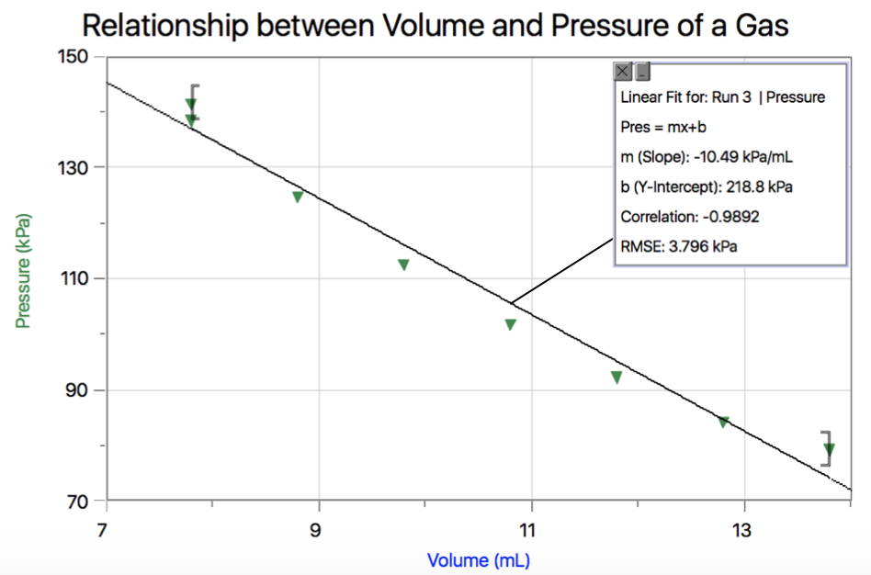

Graph 2 (Run 4): Relationship between Volume and Pressure of a Gas
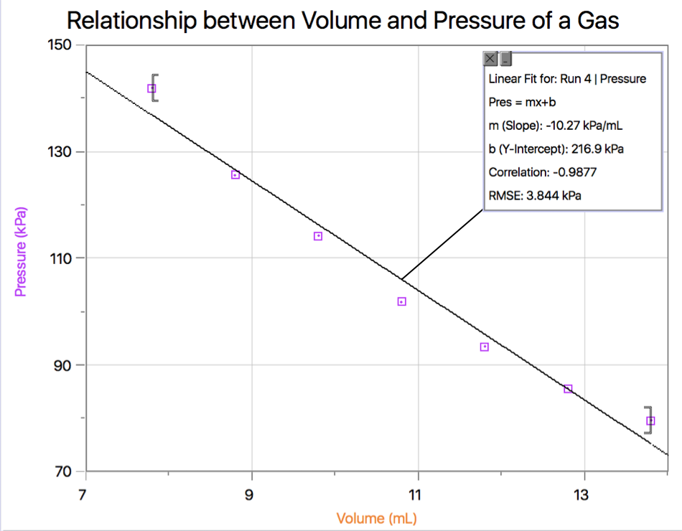

Graph 3 (Run 5): Relationship between Volume and Pressure of a Gas
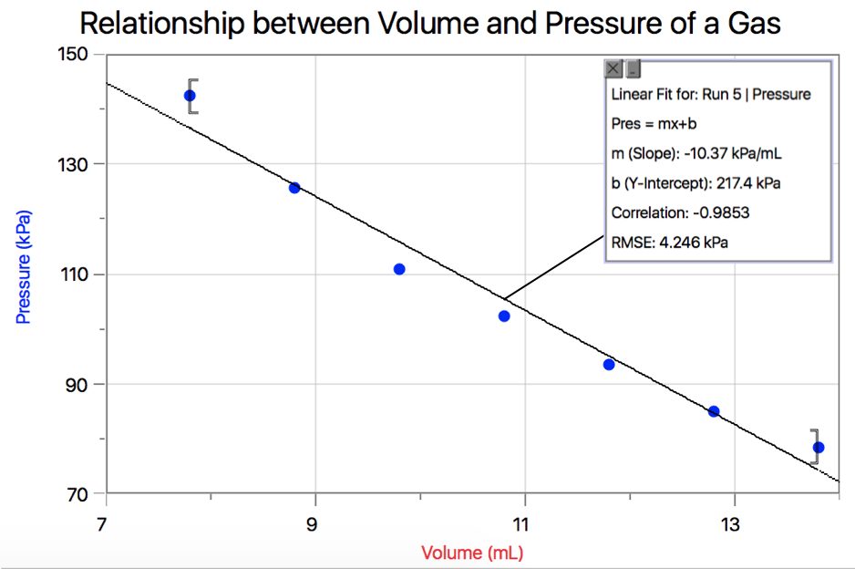

Data Analysis
The qualitative observation discussed in the observations section demonstrates that as the volume in the syringe decreased, the pressure inside the syringe increased. So, before analysing any quantitative values for this experiment, our tactile observations correspond to the theories explained in the introduction. Contrarily, when increasing the volume from 10.8mL to 11.8 mL, the plunger moved easily and there was no feeling of resistance pushing back at the hand pulling the plunger. Both observations correspond the Boyle’s Law that volume and pressure of a gas are inversely proportional.
Comparing the three trials, they are very precise because the pressure readings in each trial are very close to the corresponding pressures in all other trials. This confirms that our error is minimized.

To calculate Boyle’s Law constant, the equation $PV=k$ can be used (Silberberg, 2013).
Where;
P =Pressure (kPa)
V =Volume (mL)
k =Boyle’s Law Constant
The pressure and volume in this equation were used from Table 4: (Average of Data in Tables 1-3) Relationship Between Volume of a Gas and Pressure. In the following calculation, the volume used is 7.8mL for volume and 141.98 kPa/mL for pressure.

Using these givens, the previous equation can be used as follows to calculate Boyle’s law constant.
$$PV=k$$
$k= (141.98kPa)(7.8mL)$
$$k=1107.44 kPa∙mL$$
$k≃$1.1 x 10³ $kPa∙mL$

In this calculation, Boyle’s Law constant was found to be 1.1 x 10³ $kPa∙mL$. In a second and third calculation shown below the constants were also found to be approximately 1.1 x 10³ $kPa∙mL$. The calculation was done with 3 different corresponding volume and pressure measurements to take an average of all 3 k values and minimize the possibility of error.

$$k= (101.95kPa)(10.8mL)$$
$k≃$1.1 x 10³ $kPa∙mL$

$$k= (78.17kPa)(13.8mL)$$
$k≃$1.1 x 10³ $kPa∙mL$

Mathematically, the relationship between pressure and volume is multiplicatively inversely proportional. This means that as the volume of the gas increases, the pressure exerted decreases proportionally. This can be proven by observing the graphs. The line of best fit on each graph is linear and has a negative slope. The slope was calculated to be an average of -10.38 kPa/mL. Because this slope is negative, it demonstrates that as the volume increased (x-value) the pressure decreased (y-value). This shows that Boyle’s Law was not falsified during the experiment and our results are consistent with Boyle’s Law.

The reason as to why it was important to take the first and last measurement at the same volume, at the 10mL mark, is to test for error. After taking the initial pressure measurement at the 10mL mark, it is possible that gas could have escaped the syringe while taking the 6 other measurements. Therefore, it was important that we take the last measurement of the dependant variable, pressure, at the same volume used initially to see if, during the process, any gas escaped. If gas escaped during the process, then the initial pressure at 10mL would differ from the final pressure measured. This is further discussed in sources of error because this step was forgotten in this experiment.

Since Boyle’s Law evaluates the relationship between pressure and volume of a gas, all other variables must be controlled for. If temperature is not controlled for and is fluctuating during this experiment, it is impossible to properly analyse the relationship between volume and pressure of a gas. Therefore, temperature must remain constant during this experiment. In addition, it would be necessary to use the following equation that incorporates the temperature, the combined gas law, $\frac{P_{1}V_{1}}{T_{1}}$= $\frac{P_{2}V_{2}}{T_{2}}$.
To ensure the temperature stays constant, it is important to avoid touching the syringe too much with hands in order to avoid transferring body heat to the syringe and therefore the gas inside. In addition, the room temperature remained the same during the entire experiment because of the thermostat in the building.

Sources of Error
A possible source of error occurred when measuring the pressure of the gas when the volume in the syringe was 7.8mL. When doing this step, it was observed that it was difficult to keep the syringe in place due to the pressure inside the syringe pushing back on the syringe plunger. It was difficult to get the plunger to stay exactly at 7.8mL, so it was necessary to slightly hold the plunger in place, whereas when doing most if not all other measurements, the plunger would stay in place fairly easily. Because the volume measurement was not as accurate as others, the pressure reading for 7.8mL could have been affected.
Another possible source of error is the seal of the syringe. As discussed in the procedure, if syringe and the Gas Pressure Sensor were not tightly sealed, there is a chance that some gas in the syringe escaped or gas could have entered and thus would have created a difference in the measurement of the pressure. For example, when using a volume measurement lower than the initial 10.8mL, the pressure would have been higher inside the syringe than outside. If the seal was not tight then gas could have escaped.
Continuing the thought presented in the second source of error, forgetting to take a final pressure measurement at the initial volume of 10.8mL could have been a source of error. The reason for taking the pressure at a volume of 10.8mL twice was to assure that no gas escaped or entered during the experiment. If gas had escaped, it would have been apparent because the pressure would have decreased compared to the first trial at 10.8mL. This step was crucial however it was forgotten and now it is harder to test for error in our results.

Conclusion
The results from this experiment demonstrate that the relationship between the volume and pressure of a gas are inversely proportional. As the volume of a gas increases, the pressure decreases proportionally and vice versa, thus validating Boyle’s Law discussed in the introduction.

Raw Data Table: (Run 3-5) Relationship Between Volume of a Gas and Pressure
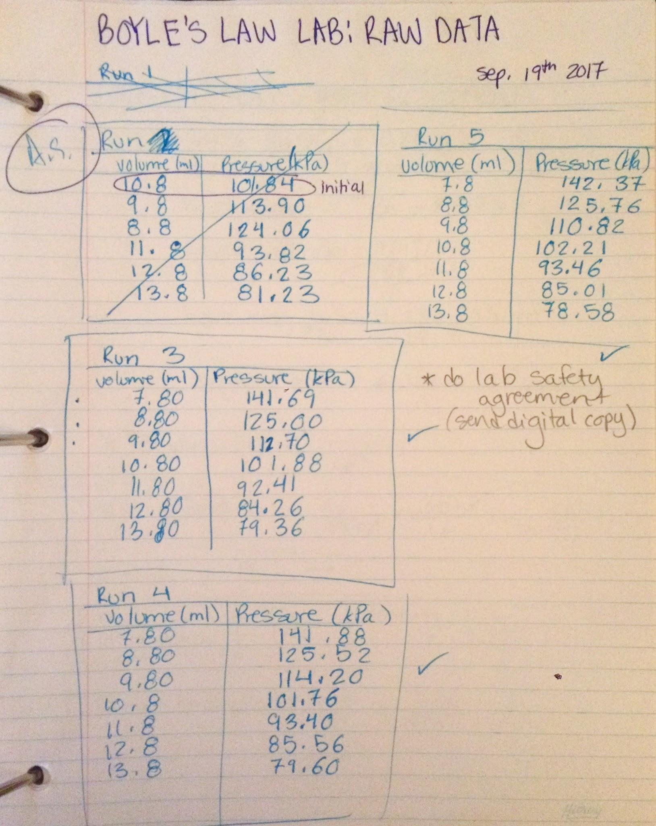

Lab Checklist
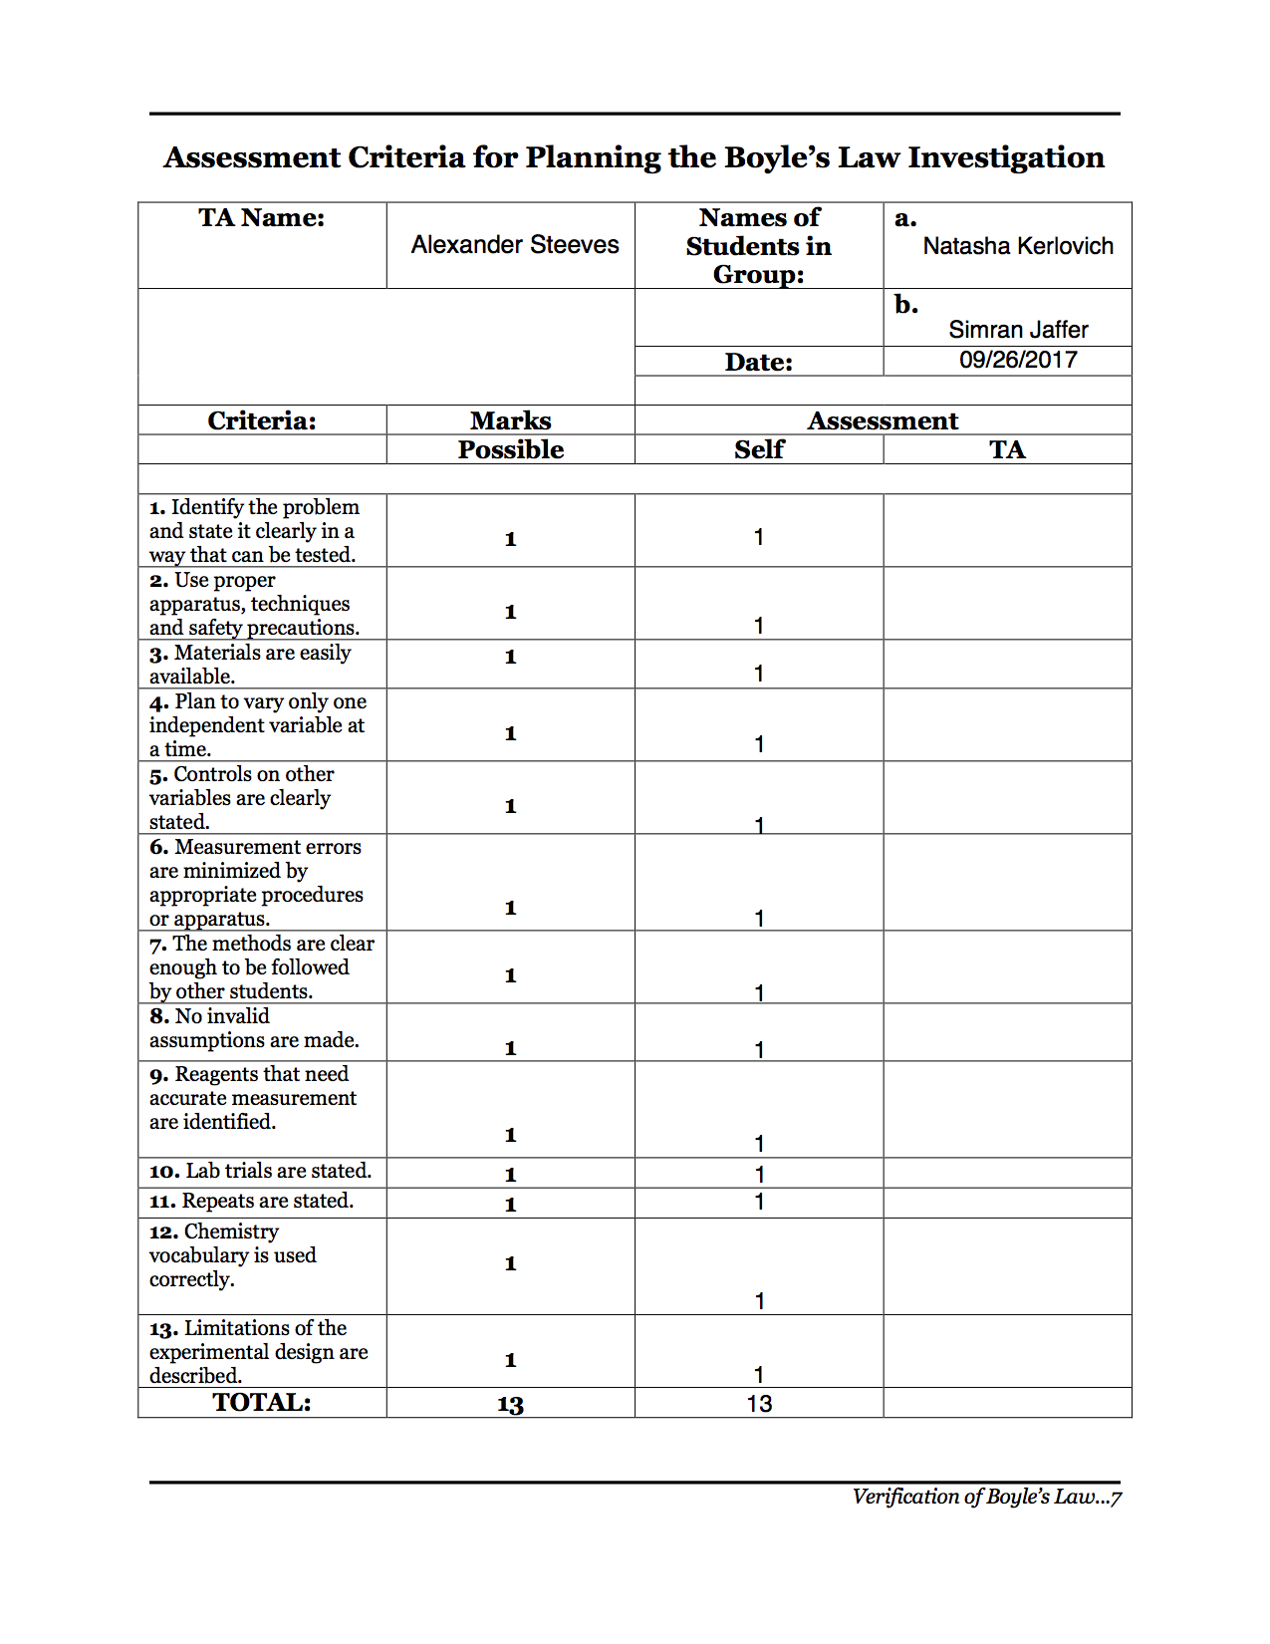
Verification of Boyle’s Law
Bibliography

Silberberg, M. (2013). Chemistry: The Molecular Nature of Matter and Change. Published in the United States of America: McGraw-Hill Ryerson Limited.

Hall, N. (2015, 05). Boyle’s Law. https://www.grc.nasa.gov/www/k-12/airplane/boyle.html

