Ch 2 – Personality and Learning
What is Personality?
- Relatively stable set of psychological characteristics – influences our interactions with others and the environment and how we feel, think, and behave
- Consists of dimensions and traits determined by genetic predisposition & learning history
- We have a variety of personality characteristics
Personality and OB
- Dispositional approach: Individuals possess stable traits/characteristics that influence attitude/behaviour
- Situational approach: Characteristics of the organizational setting influence one’s attitudes/behaviour
- Interactionist approach: Individual’s behaviour is a combination of dispositions and the situation
5 factor Model of Personality
- Each Big Five is related to job performance (conscientiousness is the biggest predictor)
- General dimensions that describe personality:
- Extraversion:
  - Outgoing vs shy
  - Important for jobs that require interpersonal interaction where social skills and ambition are important for success
- Emotional stability/Neuroticism
  - Emotional control
  - Low neuroticism – self-confident and high self-esteem
  - High neuroticism – self-doubt and depression
  - High emotional stability will result in more effective interactions with coworkers and customers
- Agreeableness:
  - Friendliness and approachableness
  - More agreeable = warm & considerate vs less agreeable = argumentative & uncooperative
  - Job performance that require interaction and involve helping & cooperating
- Conscientiousness:
  - Responsibility & achievement oriented
  - More conscientious = dependable/positive vs less conscientious = irresponsible/lazy
  - Results in strong performance in most jobs given hard working tendencies
- Openness to experience:
  - Flexibility & receptiveness
  - More open = creativity & innovation vs less open = status quo
  - Likely to excel in jobs that require creativity and learning

Locus of Control
- Whether one’s behaviour is controlled mainly by internal or external factors
- Internal: belief that opportunity to control their behaviour is within themselves
  - Self-initiative and free will
- External: belief that external forces determine their behaviour
  - Fate and luck
- Internals are more mindful and have a better outlook on life
- This is a general state of mind and not based on specific scenarios
What is Learning?
- Occurs when practice or experience leads to a relatively permanent change in behaviour potential
- Stems from an environment that provides feedback concerning consequences of behaviour
What do employees learn?
- Practical skills: job specific skills, knowledge, technical competence
- Intrapersonal skills: problem solving, critical thinking, risk taking
- Interpersonal skills: Interactive skills – communicating, teamwork, conflict resolution
- Cultural awareness: social norms, business operations, expectations, priorities
Social Cognitive Theory:
- Emphasizes the role of cognitive processes in learning and in regulating behaviour
- People learn by observing the behaviour of others
- Personal & environmental factors work together & interact to influence people’s behaviour
- Includes:
  - Observational learning: Observing and imitating the behaviours of others
  - Self-efficacy beliefs: Beliefs about one’s ability to successfully perform a task
  - Self-regulation: Use of one’s own learning principles to regulate one’s behaviour
Operant Learning Theory:
- The subject learns to operate in the environment to achieve certain consequences
- It is the connection between the behaviour and the consequence that is learned
- Used to increase the probability of desired behaviours and reduce undesirable ones
  - Reinforcement – reinforcer is a stimulus that follows some behaviour
Reinforcement: Positive vs Negative
- Positive reinforcers work by application to a situation
- Negative reinforcers work by removal from a situation
Organizational Errors Involving Reinforcement
- Confusing rewards with reinforcers
  - Rewards fail to serve as reinforcers when they are not contingent
- Neglecting diversity in preferences for reinforcers
  - Failure to appreciate individual differences in preferences for reinforcers
- Neglecting important sources of reinforcement
  - 2 sources often ignored: performance feedback & social recognition
Performance Feedback
- Provides quantitative or qualitative information on past performance
- Most effective when:
  - Conveyed positively and delivered immediately
  - Represented visually and specific to the target behaviour
Social Recognition
- Informal acknowledgement/praise from one individual/group to another
- When made contingent on behaviour it can be effective for performance improvement
Problems Using Punishment
- Does not demonstrate which behaviours should be removed or replaced – only indicates what is appropriate
- It is only a temporary suppressor that can provoke a strong emotional reaction
- Effective use:
  - Provide an alternative for the punished behaviour and limit emotions
  - Punishment should be immediate or reinstate the circumstance at an appropriate time
  - Do not inadvertently punish desirable behaviour
Ch 3 – Perception, Attribution & Diversity
What is Perception?
- Process of interpreting the messages of our senses to provide order & meaning to the environment
- Individuals base their actions on the interpretation of reality rather than reality itself
- Perception has 3 components: (each influences the perceiver’s impression)
  - A perceiver
  - A target that is being perceived
    - More ambiguous target = more interpretation
    - Less ambiguity does not make the perception more accurate
  - Some situational context in which the perception occurs
    - Can add information about the target
    - Perception can change with situation even if the perceiver and target remain the same
Bruner’s Model (Perceptual Process)
- With unfamiliar targets, perceiver is open to informational cues and makes a lot of perceptions
- Seek out cues to resolve ambiguity until target becomes clear/familiar and is then categorized
- The search for cues then becomes les open and more selective
- Search for cues that confirm the categorization of the target (cues become distorted/ignored)
Characteristics of the Perceptual Process
- Perception is selective:
  - Not all cues are used/emphasized
  - Perception is efficient but this can aid/hinder perceptual accuracy
- Perceptual constancy:
  - Tendency for target to be perceived in the same way over time and across situations
  - Ex: getting off on the wrong foot
- Perceptual consistency:
  - Select, ignore, distort cues so they fit together
  - Strive for consistency in our perception of people
Basic Biases in Person Perception
- Primacy effects
  - Early cues and first impressions
  - Lasting impact
  - Selectivity ad constancy
- Recency effects
  - Recent cues or last impressions
  - Last counts the most
- Reliance on central traits
  - Personal characteristics that intrigue perceiver
  - Powerful influencer
  - Physical appearance is important
- Implicit personality theories
  - Which personality characteristics go together
  - Inaccurate perception leads to misunderstanding
- Projection
  - Attribute own thoughts/feelings onto others
  - Can be efficient or misleading
- Stereotyping
  - Generalize and avoid variations
  - Distinguish category, make assumptions, generalize
  - Ambiguous targets, use of little information
  - Reinforced by selective perception
Attribution: Perceiving Causes and Motives
- Attribution: Process of assigning causes/motives to explain people’s behaviour
- Create a reason for why we perceive something
- Cause: Dispositional or Situational factors
- Dispositional:
  - Unique personality/characteristic is responsible for behaviour
  - Intelligence, greed, friendliness etc
- Situational:
  - External situation/environment is responsible
  - Bad weather, good luck, proper tools etc

- Attribution cues: external cues to make inferences – 3 questions:
  - Consistency: High consistency = dispositional
  - Consensus: Low consensus = dispositional
  - Distinctiveness: Low distinctiveness = dispositional
- Attribution in action: 3 cues are put together to form attributions
Biases in Attribution
- Fundamental attribution error
  - Overemphasize dispositional explanations instead of situational
  - Ignore social cues
  - Observed behaviour is distinctive to a particular situation
- Actor-observer effect
  - Actors and observers to view the cause differently
  - Actors say situational, observers say dispositional
- Self-serving bias
  - Attribute successes to yourself and failures to others
  - Reflect unique information about the actor
Ch 4 – Values, Attitudes, and Work Behaviour
What are Values and Attitudes?
- Values: Broad tendency to prefer certain states of affairs over others; what we consider good/bad
  - Motivational: signal how we should and should not behave
  - General: they do not predict behaviour in specific situations all the time
  - Generational: General values differ between generations (baby boomers vs millennials)
- Attitudes: Fairly stable evaluative tendency to respond consistently to some stimulus
  - Involve evaluations directed towards specific targets (more specific than values)
  - The demonstration of what is right/wrong (based on my belief, my attitude will differ)
  - Attitudes influence our behaviour (how we respond)
  - Attitude & behaviour is inconsistent – outside factors
- BELIEF + VALUE -> ATTITUDE -> BEHAVIOUR
What is Job Satisfaction?
- Job Satisfaction: Collection of attitudes that workers have about their jobs
  - Facet satisfaction: tendency for employee to be satisfied (or not) with facets of the job
    - Example of facets: Work itself, compensation, recognition, conditions, etc.
- Measure of Job Satisfaction: Job Descriptive Index (JDI)
  - Designed around 5 facets: People, Pay, Supervision, Promotions, Work Itself
- Differences in Job Satisfaction:
  - Discrepancy: Satisfaction is a function of the discrepancy in job outcome people want and what they perceive they obtain
  - Fairness: Affects what people want from the job and dealing with inevitable discrepancies of the organization
    - Distributive fairness
    - Procedural fairness
    - Interactional fairness
  - Equity Theory: Comparison between inputs one invests and outcomes one receives versus the inputs and outcomes of another person
    - Optimal satisfaction: Input = outcome
    - Equity -> My outcome/My input = Other outcome/Other input
    - Inequity is dissatisfying: short end of the stick
- Contributors to Job Satisfaction
  - Mentally challenging work
    - Work that test employees’ skills and abilities
    - Work is personally involving and important
    - Some people prefer mundane tasks
  - Adequate compensation
    - Pay and satisfaction are positively related
    - Some people will accept less hours or less pay and still be satisfied
  - Career opportunities
    - Promotions contribute to potential satisfaction
    - Cultural and personal differences in what is a fair promotion
  - People
    - The influence of others affects job satisfaction
    - Friendliness is a big contributor in low-level jobs
- Consequences of Job Satisfaction
  - Absence from work
    - Content of the work is best predictor for absenteeism
    - Less satisfied employees -> more likely to be absent
    - Relationship is not very strong
      - Absence is unavoidable at times
      - Organizations have attendance control
      - Tolerable level of absenteeism is unclear
  - Turnover
    - The rate at which employees resign from organization and are replaced
    - Relationship is imperfect
      - Outside factors affect turnover
      - Employees could be dissatisfied but “stick it out” for the long haul
  - Performance
    - High job satisfaction = high job performance
    - Relationship is complicated
      - Outside factors affect motivation and performance
      - Satisfaction is more likely to affect performance
  - Organizational citizenship behaviour
  - Customer satisfaction and profit
Ch 5 – Theories of Work Motivation
What is Motivation?
- Motivation: Extent to which persistent effort is directed toward a goal
  - Effort: Strength of the work-related behaviour (amount of effort on the job)
  - Persistence: Consistently applying effort on the job (consistent amount of effort)
  - Direction: The focus of the behaviour (where is the effort going?)
  - Goals: The objective of the behaviour (what am I working for?)
- Intrinsic Motivation: Direct relationship between worker and task
  - Usually self-applied
  - Ex: Feelings of achievement, accomplishment, challenge, etc.
  - Internal feeling: dependent on the person
  - Are they learned?
    - New experiences = new feelings of fulfillment (new motivators)
- Extrinsic Motivation: Comes from the work environment, external to the task
  - Usually applied by others
  - Ex: Pay, fringe benefits, company policies, etc.
  - Some motivators are both: there is a payoff but also a feeing of satisfaction
Motivation and Performance
- Performance: Extent to which an organizational member contributes to achieving objectives of the organization
  - Motivation contributes to performance but is not one-to-one
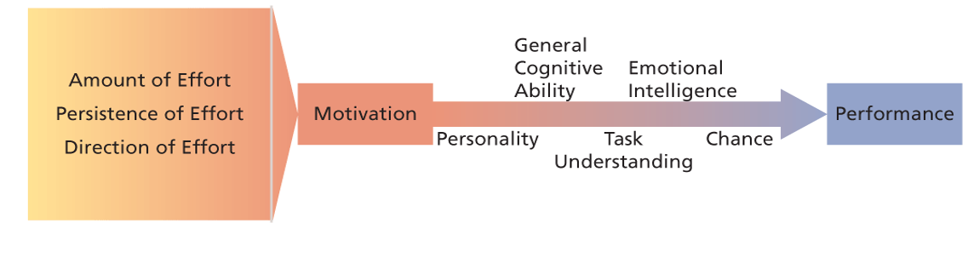
    - Other factors influence performance (personality, intelligence, etc.)
- General cognitive ability: Person’s basic information-processing capacities/cognitive resources
  - Overall capacity/efficiency to process info
  - Includes cognition (verbal, numerical, spatial) required to perform mental tasks
  - Predicts learning, training, career success & job performance (smarter=more successful)
- Emotional Intelligence: Ability to understand & manage own/other’s feelings and emotions
  - Perceive & express emotion
    - Accurately identify own emotions and those of others
    - Accurately identify emotions in peoples’ faces/non-verbal behaviour
    - Most basic level of EI -> needed to move to next steps

  - Assimilate emotion in thought
    - Use emotions/emotional experiences to guide/facilitate thinking and reasoning
    - Using emotions in functional ways (ex: making decisions)
  - Understand/Reason about emotions
  - Manage emotions in oneself & others
    - Ability to regulate, adjust, change own and others’ emotions to suit the context
    - Create emotional state in others/take advantage of current state
    - Highest level of EI -> requires the mastery of the previous levels
  - RESEARCH: EI predicts performance in areas such as job and academic performance
    - EI predicts job performance better than cognitive ability and Big Five personality variables
    - Most strongly related to job performance in jobs w/ high levels of emotional labour
    - More important for employees with low cognitive ability than those with high cognitive ability
Need Theories
- McClelland’s Theory of Needs: Non-hierarchical; conditions where certain needs result in patterns of motivation
- Different people have different needs but everyone has things that need to be satisfied
- McClelland predicts people will seek out/perform well in jobs that match their needs
- Behavioural consequences of 3 needs:
  - Achievement
    - Strong desire to perform challenging tasks well
    - High need for achievement:
      - Preference for situations where individual is accountable for outcome
      - Tendency to set moderately difficult goals (with calculated risk)
      - Desire for performance feedback
  - Affiliation
    - Strong desire to build good interpersonal relationships
    - Ability to learn social networking quickly (communicate well)
    - Avoid conflict and competition with others
      - Everyone has a certain level need for affiliation (high or low)
  - Power
    - Strong desire to influence others -> make an impact/impression
    - Seek out social settings where influence can be made
    - Perceived negatively but can be a good thing – determination & tenacity
- Maslow’s Hierarchy of Needs:
  - Look in textbook
Process Theories
- Specify the details of how motivation occurs
  - Expectancy theory
    - Motivation determined by outcomes expected as a result of actions
    - People are motivated to perform well in activities that they find attractive
    - Attractiveness depends on the extent of favourable outcomes
    - Victor Vroom’s basic components
      - Instrumentality
      - Valence
      - Expectancy
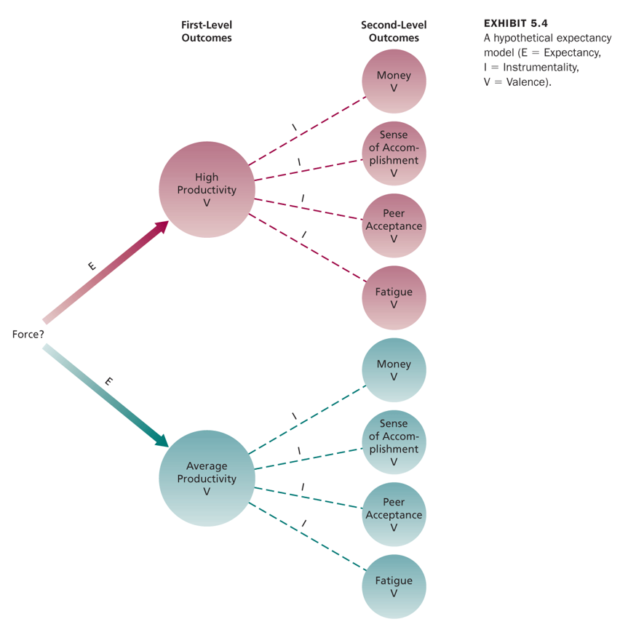

  - Equity theory
    - Explains job satisfaction through comparison of people’s inputs/outcomes
    - Equity=satisfaction, Inequity=dissatisfaction
    - Tactics for reducing inequity:
      - Perceptually distort one’s own or others’ inputs/outcomes
      - Choose another comparison person/group
      - Alter one’s inputs or outcomes
      - Leave the exchange relationship
  - Goal setting theory
    - Goal = object or aim of an action
    - Goals are motivational when they are:
      - Specific -> no ambiguity
      - Challenging -> attainable but not easy
      - Require commitment -> individual wants to achieve
      - Produce feedback -> Info is provided (accurate, specific, credible, timely)

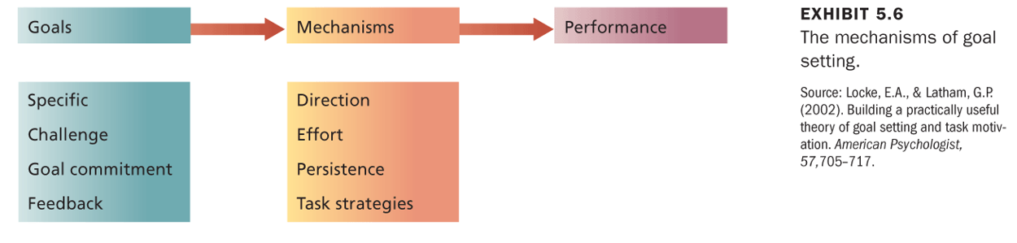
- Factors affecting goal commitment:
  - Participation
    - If a climate of distrust exists between employees/management
    - If it provides info that assists in fair/realistic goals
  - Rewards
    - Not a necessity – extrinsic motivator
    - Can add to the individual’s motivation
  - Management support
    - Supervisors should be supportive, especially during failure
    - Threat/punishment in response to failure is ineffective
      - Carrot method better than stick method
Ch 6 – Motivation in practice
- Money as a motivator: Usually underestimated
  - Can be effective – money and material possessions -> sign of success
  - Expectancy theory: Money is an effective motivator if it is clearly tied to performance
    - Financial incentives & pay-for-performance -> increase performance/lower turnover
    - Piece-work: Link that attaches your pay to the type of work that is done (commission)
Job Design
- Job Design as a motivator: Structure, content, configuration of person’s work tasks and roles
  - Attempt to capitalize on intrinsic motivation
  - Ensure the work given to employees is interesting/challenging for them
    - Intrinsic motivator -> job itself
- Traditional views: Industrial rev. – 1960s -> Job Simplification
  - Specialization was key to efficiency (assembly line work – narrow job scope)
- Scientific Management: Peak of job simplification – 1990s
  - Extreme division of labour and specialization
  - Standardization/regulation of work activities & rest pauses
  - No intrinsic motivation; no way to excel -> jobs are taxying
  - Helped achieve reasonable standard of living

Job Scope and Motivation
- Job Scope: Refers to the breadth and depth of a job
    - Breadth: Number of different activities performed on the job
    - Depth: Degree of discretion or control worker has over how tasks are performed
  - Jobs that have both are high-scope jobs
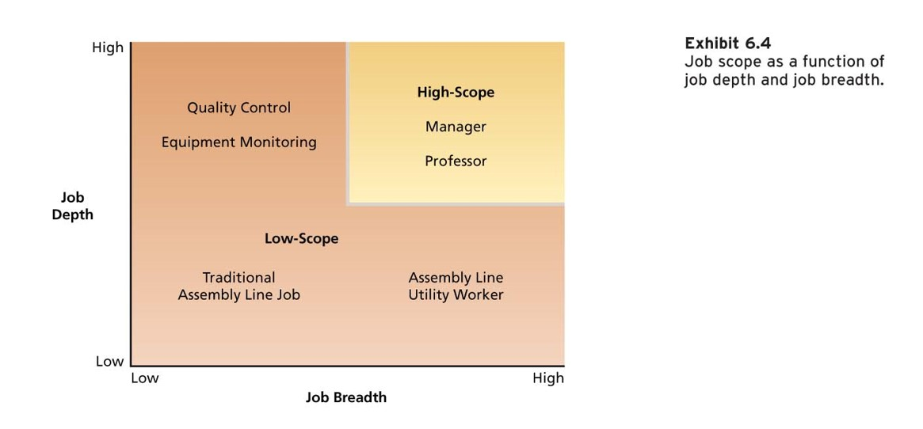

- Traditional views -> create low-scope jobs for specialization
  - High-scope provides more intrinsic motivation than low-scope
Increasing job scope
- Stretch Assignments: “stretch goals” Reward is tied to achievement & performance in assignments -> intrinsic motivation
  - Provide challenging opportunities to broaden employees’ skills
- Job Rotation: Employees get rotated to different tasks/jobs in an organization
  - Different functional arears/departments
  - Provides a variety of challenging assignments, develops new skills, prepares employees for future roles
    - Good for managers as well -> employees are interchangeable (freedom in scheduling)
Job Characteristics Model
- J.C. Model: Several ‘core’ job characteristics have certain psychological impact on workers
  - Psychological states induced by nature of job leading to certain outcomes
  - Moderators (factors) influence the extent of these relationships
  - 5 core job characteristics -> affect worker motivation:
    - Skill Variety: Perform variety of job activities using different skills/talents
      - Corresponds to job breadth
    - Task Identity: Degree that the job involves complete work - beginning to end
      - Ties into Job ambiguity
    - Task Significance: Impact that a job has on other people
    - Autonomy: Freedom to schedule own work activities and decide procedures
      - Corresponds to job depth
    - Job Feedback: Information about effectiveness of work performance
      - Ties into confusion
- Job Diagnostic Survey: JDS - Questionnaire to measure the core job characteristics
  - Individuals report amount of various core job characteristics in their jobs
  - Overall measure of motivating potential is calculated based on characteristics
    - Motivating potential score (MPS) is calculated using a formula
    - Skill Task Task
    - MPS = variety + identity + significance x Autonomy x Feedback
    - 3
  - Critical psychological states: Jobs higher up -> more intrinsic motivation
    - Experience meaningfulness of the work
      - Jobs high in skill variety, task significance, task identity -> meaningful
    - Experience responsibility for outcomes of the work
      - Jobs high in autonomy -> responsibility
    - Knowledge of actual results of the work activities
      - Jobs high in feedback -> knowledge of results
  - Outcomes: Critical psychological states lead to certain outcomes
    - High intrinsic motivation
    - High-quality productivity
    - Satisfaction with higher-order needs
    - General satisfaction with the job
    - Reduced absenteeism and turnover
  - Moderators: 3 moderators (contingency variables) may disrupt favorable outcomes
    - Job-relevant knowledge/skill of the worker
    - Growth need strength -> desire to achieve higher-order need satisfaction
    - Dissatisfaction with work context (ex. pay) -> individuals less responsive to challenging work
- Job Enrichment: Design of jobs to enhance intrinsic motivation, quality of working life, job involvement
  - Increases motivating potential of jobs via the core job characteristics
  - Combining tasks, establishing internal/external client relations, reducing supervision, etc
  - Forming Work Teams: When product/service is too large/complex for one person
    - Results in development of variety of skills & increases job identity
  - Potential Problems:
    - Poor diagnosis
    - Lack of desire or skill
    - Demand for rewards
    - Union resistance
    - Supervisory resistance
- Job Enlargement: Increasing job breadth -> more tasks at the same level
  - Workers get more boring, fragmented, routine tasks – mundane
Management by Objectives
- Management by Objectives: Elaborate, on-going program that facilitates goal establishment, goal accomplishment, and employee development
  - Objectives for organization -> designed by top management and spread downwards
    - Objectives translated into specific behavioural desires
    - Interaction between managers and workers is very important in MBO
      - Manager & employee meet to discuss employee objectives
      - Periodic meetings for employee monitoring
      - Appraisal meeting to determine if objectives have been met
      - MBO cycle is repeated

