APA 2134 Midterm Notes:
Lecture 1:
- Sports industry
  - Sport employs millions of people around the globe, is played or watched by the majority of the world’s population, and at the elite level, has moved from being an amateur pastime to a significant industry
  - Impacted by following industries
    - Health system
    - Transportation
    - Technology
    - Government
    - Education
    - Local business
- International Sport management
  - Big 4 sports
    - NBA
    - NHL
    - MLB
    - NFL
- Sport
  - Includes all forms of physical activity (competitive or non-competitive) exercise, fitness, leisure, recreation, dance, etc.
- Sport management
  - Field concerned with the coordination of limited human and material resources, relevant technologies, and situational contingencies for the efficient production and exchange of sport services
  - Areas
    - Management
    - Leadership
    - Human resources
    - Governance
    - Marketing
    - Organizational theory and behavior
    - Ethics
    - Risk management
- Sport manager
  - A person whose job entails planning, organizing, staffing, directing and controlling to be performed within the context of an organization whose primary or predominant product or service is sport and sport related
- Commercial sector
  - Involves services
  - Profit oriented
  - Provides a quality product
  - Focuses on service quality
  - Remain competitive
  - Remain affordable
  - Be unique
- Specialization
  - Individuals in an organization perform tasks that are narrow in scope
- Span of control
  - The number of people, units, and operations that a manager can control effectively and efficiently in a given time period
  - Type of work done
  - Competence of the person doing the job
  - Competence of the supervisor
  - Relationship between the supervisor and employees
  - Pressure for production
- Departmentation
  - Process of forming homogeneous groupings
  - Types
    - Process oriented/functional
    - Product/goal oriented
    - Matrix
- Unity of command
  - Each member of the organization should follow the orders of only one supervisor and be accountable only to that supervisor
- Bureaucracy
  - A form of organization superior to all others we know or can hope to afford in the near and middle future; the chances of doing away with it or changing it are probably nonexistent in the West in this century
  - Tenets of a bureaucracy
    - Division of labour
    - Hierarchical authority structure
    - System of abstract rules
    - Impersonality
    - Technical competence

Lecture 2:
- Good governance
  - Transparency
  - Accountability
  - Democracy
  - Responsibility
  - Equity
  - Diversity
- Roles of the board
  - Creating a strategic direction and vision
  - Forming suitable policies
  - Assess management performance
  - Report to stakeholders
  - Recruitment and retention of suitable CEO
  - Ensure compliance with legislation
  - Lobby for funding and sponsorship
- Women in sport governance
  - Underrepresentation of women in sport governance positions
  - Majority of sport boards < 20% female
  - Introduction of quotas for representation of women on sport governing boards
- Organizational theory
  - The study of organization’s and how they are best structured to maximize limited material and skilled resources in the pursuit of achieving particular goals while being managed in an efficient and effective manner
  - Theory
    - A proposition commonly thought to be correct as a way of explaining and or predicting phenomenon
  - Behaviour
    - Set of responses that is dependent on condition and/or context
    - Often influenced by a person’s environment, beliefs and attitudes towards an object
    - It is a manner of behaving or conducting one self
- Organizational Behaviour
  - The study of how individuals are influenced by and influence both group level communication and thinking as well as organizational goals
  - Applies behavioural science to management problems in an effort to help explain why people act the way that they do in organizational life
  - Try’s to maximize efficiency and effectiveness in organizational life
- Key management functions
  - Planning
    - Establishing goals, objectives and strategies
    - Analysis
      - Internal
        - The strengths and weaknesses of your organization
      - External
        - The opportunities and threats which surround your organization
    - Visioning
      - Helps direct decision making regarding where the organization wishes to be in the future
      - Mission/core purpose
        - Targeting
        - Common enemy
        - Role model
        - Transformation
      - Vision
        - Strategic
        - Measureable
        - Achievable
        - Realistic
        - Time sensitive
      - Philosophy (values, beliefs)
    - Action
      - Strategy
      - Tactics
    - Control
      - Benchmarks and indicators linked to goals/objectives
      - Indicators must be:
        - Specific
        - Pertinent
        - Objective
        - Representative
        - Transparent
        - Simple
  - Organizing
    - Selecting and grouping actions for accomplishing the organizations strategies, and designing appropriate structures for an effective and efficient organization
  - Leading
    - Process of influencing memebrs to achieve organizational goals
  - Evaluating
    - Measuring performance of individuals, units and the total organization and comparing to set standards in the planning process
- Organizational terms
  - Governance
    - Control of decision making
  - Jurisdiction
    - Official power exercised within a particular sphere of activity
  - Accountability
    - Obligation to give an explanation for actions
- Strategic management
  - Organizations relationship with the environment
  - Environmental analysis
    - SWOT

Lecture 3:
- Power of sport
  - Impact
    - Tourism
    - Local economic activity
    - Charity
  - Brings people together
    - Social
    - Entertainment
    - Drama
    - Escape
- Unique characteristics of sport
  - Aspects of sport are intangible
  - Sport is subjective
  - Sports are inconsistent and unpredictable
  - Sport is perishable
  - Sport involves emotions
- Sport marketing
  - Consists of all activities designed to meet the needs and wants of sport consumers through exchange processes
  - Product
    - Tangible good
    - Services
  - Price
    - A costs the leads to perceived value
  - Place
    - The ability to purchase and/or receive the product at a convenient and accessible location; ensuring distribution is set up to get the product to consumers
  - Promotion
    - Communication that will reach the target market
    - Types
      - Advertising
      - Personal selling
      - Sales promotion
      - Public relations/publicity
      - Sponsorship
- Types of sports products
  - Sporting goods
  - Sports information
- Major thrusts of sports marketing
  - Marketing through sports
  - Marketing of sports
- Developing a marketing plan
  - Identify the purpose
  - Analyze the sport product
  - Projecting the market climate
  - Positioning
  - Targeting consumers
  - Packaging
  - Pricing
  - Promoting
  - Placing
  - Promise of the plan
- Social Media
  - Categories
    - Blogs
    - Social networks
    - Content communities
    - Forums and bulletins
    - Content aggregators
- Theories
  - Uses and gratification theory
    - Social media can connect consumers with players, teams and others
    - Increases sport knowledge, vicarious achievement, social bonding
  - Social identity theory
    - Membership within a group
    - Increase self esteem
  - Para-social interaction
    - Celebrity worship
- Social media marketing
  - Word of mouth
    - Sharing of personal knowledge and experiences to other consumers
  - Relationship marketing
    - Empowers consumers, allows firms to gain better knowledge of customers

Lecture 4:
- Sport in Canada
  - Cultural influences
    - First nation
    - Immigration
  - History
    - Organized sport started in 1770
    - Lacrosse
  - First nation influence
    - Snow shoeing, tobogganing, lacrosse
    - Lacrosse is national summer sport of Canada
  - French influence
    - Running, wrestling, snow shoeing, canoeing
    - Enjoyed very masculine games
  - British influence
    - Hunting, licensing billiard tables, tavern life, curling, golf, horse racing
  - Spectator sports
    - Boxing
    - Horse racing
    - Ice-hockey
    - Baseball
  - Chronology
    - 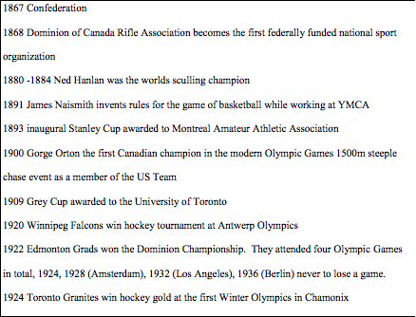
    - 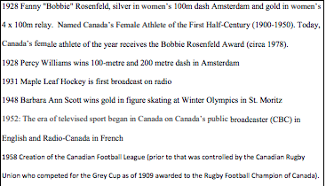
    - 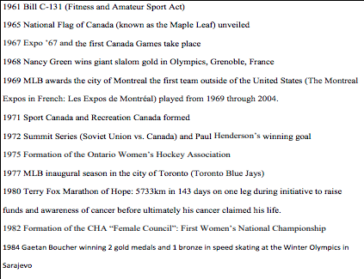
    - 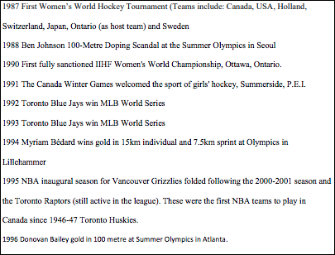
    - 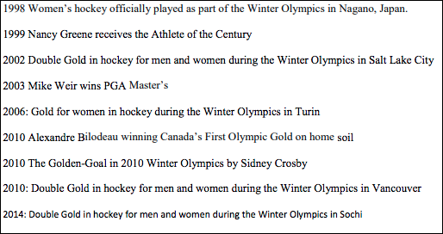
  - Major international hosting opportunities in Canada
    - 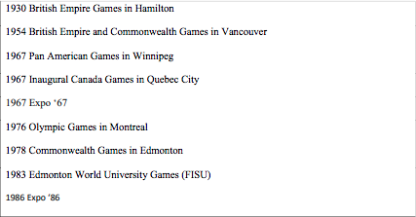
    - 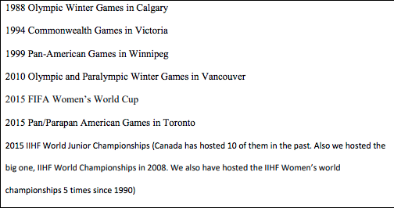
- Governance of sport in Canada
  - A complex network of sport organizations
  - Influenced by the federal government
  - National sport organizations
    - Supported by contributions from Sport Canada
    - Coordinate rules/regulations from Sport Canada
    - Sport funding accountability framework
  - Multi sport service organization
    - Supported by contributions from sport Canada
  - Provincial sport organizations
  - University sports
- Sport Canada
  - Federal governing body of sport policy and programming for amateur sport across the country overseeing most of the funding and programs
  - Funds various provincial and territorial sporting organizations through NSO’s and MSO’s
  - Public funds are aimed at achieving the ultimate goal of the organization; to help Canadians participate and excel in sport
  - Programs
    - Hosting program
      - To enhance the development of sport excellence and the international profile of sport organizations by assisting sport organizations to host the Canada Games and international sport events in Canada
    - Sport support program
      - Supports the development of athletes and coaches to focus on programs and services that have an impact on their development through the provision of funding to the NSO and MSO
      - Objectives
        - Increasing opportunities for underrepresented groups to participate in quality sport
        - To increase the capacity of the sport system to achieve world class results
        - To develop technical leadership and to advance Canadian interest, values and ethics in sport at home and abroad
    - Athlete assistance program
      - This program helps athletes pursue excellence through direct funding
      - Athletes are a part of a carding system whereby they are identified and financially supported if they are in the top 16 in the world in their sport, or they have been identified as having potential to reach that level of performance
- Sport policy
  - Bill C-131
    - The fitness and amateur sport act
    - A program under the ministry of health and welfare
    - Shift to promote the role of physical activity and sport as an important entity in the country
    - Provide funding annually to amateur sport and fitness related endeavors in efforts to assist athletes, fund and the professionalization of sport in the country vernally raise the bar
  - Important policy documents
    - Game plan
    - Best ever
    - Mills report
    - Canadian Sport Policy
    - LTAD
- Own the podium
  - Canada had not won gold on home soil in Montreal 1976 and Calgary 1988
  - Efforts to help a Canadian athlete achieve a gold medal through the provisional of additional monetary support avoiding further international embarrassment of not achieving gold on home soil
  - Record gold medal count in Vancouver 2010
  - Targets of OTP were not met in London 2012 or Sochi 2014
  - SFAF evaluates the participation and performance to help determine funding but OTP also is predicated on the evaluation of performance and thus, sport federations can be overly compensated for performance if high performance is achieved with access to SFAF
- Canadian Paralympic Committee
  - Paralympic games held in Toronto in 1976, lead to funding for developing sport opportunities for para-athletes
- The Canada games
  - One of the most important developmental initiatives for athletes and coaches
- AthletesCAN
  - MSO
  - Association of Canada’s national team athletes
  - Ensures an athlete centered sport system by developing athlete leaders who influence sport policy and, as role models, inspire a strong sport culture
- Sport matters group
  - A group of individuals and organizations who believe that a values based, ethical sport experience along with regular physical activity and the facilities within which to do these are integral to Canadian culture, the development of our people, communities and nation
  - Funded by contributions from the sector and foundations
  - Advocacy and Public policy
    - Promoting goals and issues of sport and physical activity outside the sector
    - Sport for development
    - Provide an opportunity for thought leaders from sport, physical activity and recreation to gather in order to look at the big picture

Lecture 5:
- Sport Canada
  - AAP
    - 28 million to 1900 athletes
  - SSP
    - 146 million to Canadian sport organizations
    - 62 million of 146 is based on recommendations by OTP
  - Hosting program
    - 20 million annually to assist in hosting world-class international sport events
- Growing and maintaining participation
  - Sport marketing
  - Consumer behavior
- Social factors
  - Attitudes
  - Values
  - Lifestyle
  - Family
- Key variables predicting involvement
  - Time
  - Money
- Demographics
  - Age
  - Race
  - Ethnicity
  - Location
- Population shifts away from hills
  - 50% of population lives in four major urban regions not near mountains
  - 90% of new immigrants live in a large metropolitan market and are uncomfortable leaving
- Economic factors
  - Consumer income
  - Inflation
    - Impact if salary increases don’t keep up with inflation
  - Recession
    - A period of economic activity characterized by negative growth
- Purchasing power
  - Income – cost of living = purchasing power
- Consumer behavior
  - The study of the thoughts and feelings people experience and the actions they perform during the exchange process
  - Involves understanding a persons attitudes and interactions
- Market segmentation
  - Identifies groups of consumers who are similar to one another in one or more ways and then devises strategies that appeal to one or more groups
- Sports consumer behavior
  - 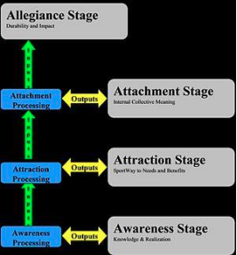
  - Cost of replacing one customer is six times more expensive than retaining an existing customer
  - Types
    - Affective
      - Attitudes
      - Feelings
      - Emotions
    - Behavioral
      - Actions
      - Hands on activities
    - Cognitive
      - The acquisition of information and knowledge about a sport
  - Create positive feelings about the sport and then encourage consumers to act behaviorally and cognitively
- Sports industry
  - Major elements
    - Sport consumers
      - Spectators
      - Participants
      - Corporate or business
    - Sport products
      - Events
      - Sporting goods
      - Sport information
    - Suppliers of the sport products
      - Ownership
      - Sponsors
      - Media
      - Agents
      - Equipment
      - Manufacturers

Lecture 6:
- Corporate social responsibility
  - Firms are part of a social institution that shape economic outcomes, and these firms must consider their social impact of business activity
  - Friedman
    - Social responsibility of a business is to make profits
    - People can choose what to do with their money
  - Factors
    - Natural
    - Social
    - Economic
    - Stakeholder
    - Voluntariness
  - Actions that appear to further some social good, beyond the interest of the firm and that go beyond what is required by law
  - Triple bottom line
    - People
    - Planet
    - Profit
  - Strategic CSR
    - Actions firms take with the expectation of a R.O.I
  - Altruistic CSR
    - CSR actions firms take with the understanding that R.O.I may not be forthcoming
  - Implementation
    - Setting objectives
    - Deciding whether to pursue objectives
    - Financing of these objectives
  - Carrol
    - Philanthropic
      - Contribute resources to the community
      - Improve quality of life
    - Ethical
      - Obligation to do what is right
      - Just and fair
      - Avoid harm
    - Legal
      - Law is society’s condition of right and wrong
      - Play by the rules
    - Economic
      - The foundation which all others rest
  - CSR in Sport
    - Sport is highly visible and customer oriented
    - Positioned to be leaders in CSR including the concept of environmental responsibility
  - Olympics
    - Olympics have a social responsibility to ensure that the organizing cities leave a positive legacy
    - Also identifies the environment as a component of Olympism since there is no future for sport development, if environmental values are not considered as the core of any intervention policies
  - Sustainability
    - Creation of long term positive changes in social, economic, and environment spheres, based on effective use of resource potential for today and tomorrow
  - FIFA
    - Sustainability has been a focus of CSR efforts
  - Environmental CSR
    - Environment is framed as a resource that should be protected
    - ECSR initiatives would be implemented if ROI were foreseeable
    - Customer demand for ECSR is low
    - Reluctance to communicate
      - Fatigue
      - Skepticism
    - Customer decisions are impacted by ECSR initiatives
    - Customers not willing to pay more for ECSR
  - Aboriginal youth in Canada
    - Fastest growing population of young people
    - Problems
      - Poverty
      - Standard of living
      - Education
  - Program and research overview
    - Quality assurance
      - Financial
      - Training
      - Human resources
    - Output monitoring
      - Participation
      - Community reach
      - Activity quality
    - Outcome monitoring
      - Indications of change
      - Life skills
      - Changes in attitudes
    - Result reporting
      - Intended vs. unintended
      - Improvement areas
    - Knowledge translation
  - Programming
    - Program delivery
      - Increase in volunteers needed
      - Clear communication of objectives
    - Monitoring
      - Consistent reporting
    - Evaluation
      - What defines success of this program is still unclear
    - Documentation
      - Must be simple reporting procedures
      - Should be written and oral to increase reach
    - Community ownership needs fostering
      - Information sharing
      - Identifying volunteers and mentors
  - Challenges towards sustainability
    - Financial resources
    - Human capacity
    - Communication
    - Reporting
    - Identifying community champions
  - UNICEF and common wealth games
    - Ambitions
      - Raise significant funds
      - Lead the way
      - Deliver impactful and effective programs
      - Protect and promote children’s rights
  - UNICEF and CGF
    - Incorporating child rights
    - Creating a legacy
    - Building on the impact
    - Child rights and major sporting events
    - Youth games and CGA development programs
    - Fundraising and athlete engagement
  - UNICEF and gold coast
    - The power to convene
    - The power of the brand
    - The power of legacy

Lecture 7:
- Human Resource Management
  - Evolution of employee and rights
  - Management of people
  - Recruitment
  - Socialization
  - Training
- Scientific management
  - The process of job analysis
    - Resulted in job design
  - Created scientific selection process
    - Workers who pass certain test/qualifications
- Human relations movement
  - Emerged in the 1920’s and fully embraced in the 1940’s
  - Examined jobs from perspective of workers
  - Focused on social authority, work group behavior, non-authoritative supervision
- Rise of unions
  - The depression (1930’s)
    - Wanted protection of worker rights
    - Government established
      - Minimum wage act
      - Unemployment insurance
  - 1960-80
    - Human rights, wages, working conditions, health and safety, and benefits
      - HRM emerged as key concept in 70’s
- Modern era of HRM
  - Legal
    - Rights
    - Safety
    - Equity
  - Planning
    - Labour relations
  - Job analysis
  - Recruitment
  - Selection
  - Training and developing
  - Performance appraisal
  - Compensation
    - Benefits
    - CBA
  - Health and safety
  - Job design
- HRM and OB
  - Employee motivation
  - Employee satisfaction
  - Employee commitment
- Job design
  - Job
    - Simplification
    - Rotation
    - Enlargement
    - Enrichment
    - Feedback
  - Task
    - Attributes
    - Variety
    - Variability
    - Autonomy
    - Identity
      - Whole or partial task
    - Significance
- Job rotation
  - Moving from one job to another
    - Minimizes repetitive strain injury
    - Multi-skills the workforce
    - Potentially reduces job boredom
- Job enlargement
  - Adding tasks to an existing job
- Job enrichment
  - Given more responsibility for scheduling, coordinating, and planning one own work
  - Clustering task into natural groups
    - Stitching highly interdependent tasks into one job
  - Establishing client relationships
    - Directly responsible for specific clients
    - Communicate directly with those clients
- Job characteristics model
  - 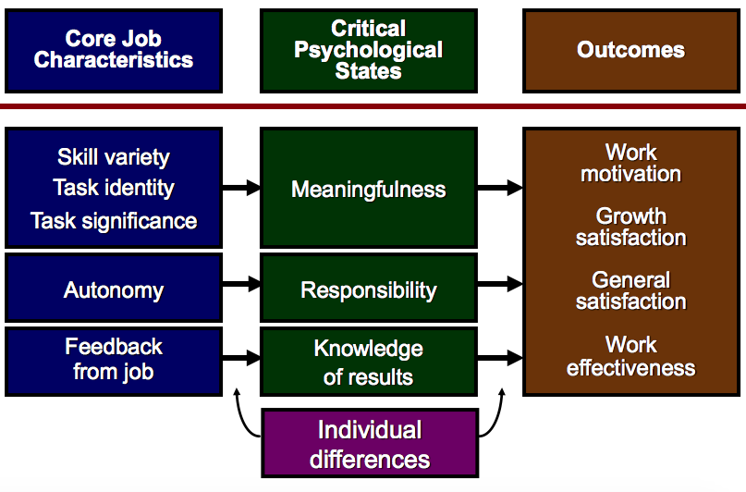
- Staffing
  - Focus on jobs
    - Staffing needs assessment
    - Job analysis
    - Job description
  - Focus on people
    - Recruiting
    - Hiring
    - Training
    - Person-job fit
    - Person-organizational fit
- Job analysis
  - Job description
  - Position title
  - Qualifications
  - Responsibilities
  - Supervision received
  - Supervision exercised
- Recruiting and hiring
  - To provide the sport organization with a pool of candidates
  - Internal and external strategies
  - Temporary vs. enduring organizations
  - Velocity of hiring and training
- Internal
  - Advantages
    - Promotions provide incentives for people to work harder
    - People know the jobs and organization
    - Faster
    - Cheaper
    - Can improve employee morale
  - Disadvantages
    - Stagnation
    - In-breeding
    - Limited scope
    - Infighting
- External
  - Advantages
    - New perspectives
    - Cheaper
    - Avoids politics
    - Avoids gender/minority bias
  - Disadvantages
    - Takes more time
    - May have to retrain
    - Unknown quantity
    - Costs more money
- Hiring and training
  - Orientation
  - Socializing
    - On boarding
    - Personal contract
    - Person organization fit
    - Stages
      - Anticipatory socialization
        - Psychological contract
      - Encounter socialization
        - Breaking in as a member
        - On boarding, orientation
      - Role management
        - Person organization fit
  - Training
  - Development
- Evaluations
  - Job specific task performance
    - Communication
    - Supervision and leadership
    - Management and administration
  - Non job specific task performance
    - Effort
    - Personal discipline
    - Facilitation of peer and team performance
- Performance appraisal
  - Formal assessment of how well employees are performing their jobs
  - Necessary for validating selection
  - Evaluating training program
  - Measures
    - Objective measures
    - Sales figures
    - Performance tests
    - Rating scales
    - Subjective methods
- Performance based rewards
  - Organizational
    - Profit sharing
    - Share ownership
    - Share options
    - Balanced scorecard
  - Team rewards
    - Bonuses
    - Gainsharing
  - Individual rewards
    - Bonuses
    - Commissions
    - Piece rate
- Reward effectiveness
  - Link rewards to performance
  - Ensure rewards are relevant to person
  - Ensure rewards are valued
  - Unintended consequences of rewards
- MARS Model
  - 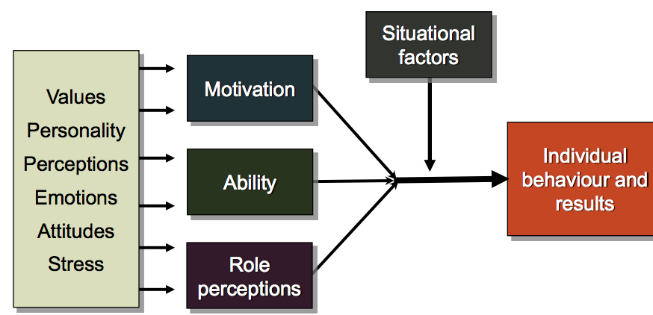
  - Motivation
    - Internal forces that affect a persons voluntary choice of behavior
      - Direction
      - Intensity
      - Persistence
  - Ability
    - Natural aptitudes and learned capabilities required to successfully complete a task
    - Competencies
      - Personal characteristics that lead to superior performance
    - Job matching
      - Selecting
      - Developing
      - Redesigning
  - Role perceptions
    - Beliefs about what behavior is required to achieve the desired results
  - Situational factors
    - Environmental conditions beyond the individuals short-term control that constrain or facilitate behavior
- Job satisfaction
  - Attitude people have about their job
  - Job performance affects satisfaction only when rewarded
  - Effect on performance strongest in complex jobs because of greater employee influence on performance
- Trends in workplace
  - Age
  - Gender
  - Diversity
  - Underemployment
  - Increasing jobs prior to career job
- Challenges in the workplace
  - Diversity
  - Inclusion
  - Wellness
  - Opportunity
  - Appropriate/professional behavior
- Changing workplaces
  - Employment standards act
  - Labour relations act
  - Millennial workforce
  - Centralization to decentralized models of work
- Managing diversity
  - Internal
    - Visible human characteristics throughout ones life
  - External
    - Decisions one makes in everyday life
Lecture 8:
- Leadership
  - The process of influencing the activities of an individual or group in efforts to achieve a goal in a given situation
  - Motivate and influence others toward goal achievement
- Bad leader types
  - Incompetent
  - Rigid
  - Intemperate
  - Callous
  - Corrupt
  - Insular
  - Evil
- Leadership process
  - An organizational process of the internal work environment
  - Leader behavior leads to outcomes
- Leading vs. Managing
  - Leading
    - Establish direction
      - Vision
    - Align people
    - Communicate
    - Motivate and inspire
    - Create
    - Innovate
    - Collaborate
  - Managing
    - Plan the budget
    - Organize and staff
    - Control and problem solve
    - Produce order
    - Policies, procedures, monitoring
- Leadership perspectives
  - Trait approach
    - Great man theory
    - Individual attributes
      - Physical characteristics
      - Intelligence
      - Skills
      - Social background
  - Behavioral
    - Process/task oriented behavior
    - Relationship/people-oriented behaviour
  - Situational
    - A leaders style must change to suit the situation
    - Leader effectiveness depends on match between leader behavior and follower maturity
  - Transformational
    - Transformational vs. transactional
    - Transformational vs. charismatic
    - Leader motivates, inspires follower to go above and beyond expectations; charismatic; visionary
    - Helping followers to meet higher order needs
    - Shifting/transforming values, goals and beliefs
    - Focus on innovation, change, motivation and inspiration
    - Bass 1985
      - Idealized influence
        - Promotes beliefs
        - Vision
      - Inspirational leadership
        - Communicates high expectations and confidence in followers abilities
      - Intellectual stimulation
        - Encourages problem awareness, innovative solutions
      - Individualized consideration
        - Promotes personal relationship, individual development
      - Attributed charisma
        - Generates respect and trust
    - Best in a stable organizational environment, when leader and members are satisfied
  - Transactional
    - An exchange for lower order needs
      - Security
      - Affiliation
      - Recognition
    - Focuses on consistency and control
    - Bass 1985
      - Leader exchanges rewards or punishments in return for follower effort and performance
      - Contingent reward
        - Rewards performance
      - Management by exception
        - Intervenes when something goes wrong
        - MBE active
          - Monitors performance for mistakes
        - MBE passive
          - Waits for mistakes to occur
  - Charismatic
    - Perceived as extraordinary
    - Build dependent and reliant followers
    - Loose touch with reality sometimes
    - Entrepreneurs, polarized and extreme reactions
    - Charisma
      - Refers to perceptions of members that the leader possesses some extraordinary gifts and talents
    - Process of influencing major change in attitudes and assumptions of org members, and building commitment for the organization’s mission or objectives
    - Characteristics
      - Vision and articulation
      - Personal risk
      - Environmental sensitivity
      - Sensitivity to follower needs
      - Unconventional behaviour
  - Implicit leadership
- Organizational culture
  - Tells people what is acceptable behavior
    - Standards
    - Rules
    - Norms
  - Helps people understand what is most important objectives and goals for organization
  - Key functions
    - Control system
    - Social glue
    - Sense making
  - Creation of organizational culture
    - Leaders ideas and vision
    - History
    - Norm formation around critical incidents
    - Primary embedding mechanisms
      - Leaders actions and reactions
      - Role modeling and coaching
      - Criteria for rewards and status
      - Criteria for recruitment, selection, promotion, retirement
    - Reinforcement mechanisms
      - Organizations design and structure
      - Organizational systems and procedures
      - Design of physical space
      - Stories, legends, myths and symbols
      - Formal statements of organizational philosophy and creeds
  - Artifacts
    - Organizational stories and legends
      - Serve as powerful social prescriptions of the way things should be done
      - Provides human realism to corporate expectations, performance standards
      - Produces emotions in listeners
    - Rituals and ceremonies
      - Rituals
        - Programmed routines of daily organizational life that dramatize the organizations culture
      - Ceremonies
        - Planned displays of organizational culture, conducted specifically for the benefit of an audience
    - Organizational language
      - Verbal symbols of cultural values
      - Highlights values held by organizational subcultures
    - Physical structures and symbols
      - May suggest the company’s emphasis on teamwork, environmental friendliness, flexibility, and any other set of values
  - Strategies for strengthening organizational culture
    - Attracting, selecting and socializing employees
    - Actions of founders and leaders
    - Introducing culturally consistent rewards
    - Aligning artifacts

Lecture 9:
- Sponsorship challenges/issues
  - Amount of clutter
  - Amount of money needed to activate
  - Deliver value
  - Sponsorship fatigue
  - Ambush marketing
- Sponsorship
  - Amount of sponsorship dollars invested in sport has led sport organization to have a vested interest in maintaining and expanding their brand
- Ambush marketing
  - The efforts of an organization to associate itself directly with an event in an effort to reap the same benefits as an official sponsor
  - Creates confusion in the consumers minds
    - Gaining benefits of association without being an official sponsor
    - Weakening the impact of a competitor being the exclusive sponsor of an event
  - Impacts
    - Audience
      - Target group cannot differentiate between official sponsors and ambushers
    - Official sponsors
      - Weakening impact of sports sponsorship
      - Potential withdrawal from their sponsorship
    - Event organizers
      - Depreciation of their sports event
      - Lowering revenues from sponsorship
    - Media
      - Insecurity of organizers transferred to media as coverage serves as a means of distinguishing from media competition
    - Sports market
      - Insecurity in the sports market
  - Resolving ambush marketing
    - Addressing clutter
    - Integrated public relations strategy
    - Value added programs
    - Meaningful sponsor recognition
    - Sponsor leveraging/activation
    - Increase level of marketing expertise of sport marketers
  - Legal
    - Regulations created explicitly in response to request of IOC and other major sport events to ensure the protection of official sponsor through legislation

Lecture 10:
- Sport marketing
  - Activities that provide organizations with access to properties where people have unbridled passion for their team, their sport, their favorite players, their favorite coaches, etc.
  - Marketing through sports
  - Marketing of sports
  - Sponsorship
    - A promotional approach in which an organization or individual offers resources and/or services to support a sport organization’s event program, or product offering
    - Is important
    - Works
    - Transfers images
    - Relies on activation
    - Involves exclusivity
    - Must be evaluated properly
- Unique characteristics of sport
  - Intangible good
  - Subjective
  - Unpredictable and inconsistent
  - Perishable
  - Emotion laden
- Executional elements
  - Preliminary
    - Sound knowledge of total operations of organization
    - Promotion and organization must compliment each other
    - Understand audience and demographics of promotion’s targeted consumers
  - Timing
    - Not well researched by all promoters
    - Mistake can harm otherwise good promotional idea
    - Consider
      - Day of the week
      - Time of event
      - Other obstacles to smooth operation of promotion
  - Ideas
    - Use of brainstorming
    - Promising ideas should be assessed against organizations objectives
    - Secure opinions from sources outside your group
    - Develop mock situations
  - Follow up
    - Ensure all elements of promotion fit together
    - Have proper lead times
    - Execute assignments within specified period of time
    - Idea checked against budget and requirements
    - Get resources at minimal cost
    - Negotiate contra deals
    - Itemized list
      - Responsibilities
      - Contingency plans
  - Day of promotion
    - Every element must be rechecked
    - Mutually beneficial solutions would characterize sound planning
    - Whatever is offered during the promotion must be delivered
- Promotional mix
  - Advertising
  - Publicity
  - Personal sales
  - Sales promotions
  - Public relations
  - Sponsorship
    - Cash
    - In-kind
  - Online personal selling
  - Social media
- AIDA model
  - Make consumers aware (Attention)
  - Generate interest (Interest)
  - Create desire (Desire)
  - Ultimately lead to action (Action)
- Sponsorship
  - Key elements
    - Sponsor
      - Cash investment
      - Product investment
      - Service investment
      - Image transfer
      - Activation
      - Evaluation
    - Sponsee
      - Revenue generator
      - Budget reducers
      - Marketing platform
      - Activation
      - Exclusivity
      - Evaluation
- Activation
  - Definitional issues
    - Activation
    - Leveraging
    - Servicing
  - Key elements
    - Standard activities
      - Commercials
      - Advertising
    - Value added
      - Creative efforts that seek to maximize the effect of the sponsorship
- Exclusivity
  - Reduced clutter
  - Increased sales
  - Positive associations between brand and sponsors
  - Better recognition of official sponsors versus non-sponsors
  - Increased knowledge of sponsor contributions
- Sponsorship recall
  - Key factors
    - Sponsor relatedness
    - Sponsor prominence
    - Corporate exposure of the brand to individuals at the events
    - Individual exposure to sponsors due to the individual involvement or identification with the sport and team
- Sponsorship objectives
  - Heightened visibility
  - Shaping consumer attitudes
  - Communicate commitment to a lifestyle
  - Business to business relationships
  - Differentiation tactic
  - Entertain clients
  - Swag
  - Showcase product attributes
  - Drive sales
- How companies decide what to sponsor
  - Image compatibility
  - Audience composition
  - Ability to incent retailers
  - Ability to leverage
  - Media
  - Exclusivity
  - Product showcase
  - Ability to impact consumer sales
  - Efficiency
  - Measurability
  - Continuity
  - Ease of administration
  - Rights and benefits
- Evaluating sponsorships
  - Measuring participation
  - Photographic record
  - Media monitoring
  - Measuring awareness
  - Market share
- Why sponsors drop out
  - Decrease in market value of product
  - Not achieving objectives
  - Change in corporate direction
  - Increased costs and/or budget cutbacks
  - Conflict organizer
  - Poor event execution by organizer
  - Timing and scheduling conflicts
- Ambush marketing
  - Main objective is to create confusion in the consumers minds therefore:
    - Gaining the benefits of association without being an official sponsor
    - Weakening the impact of a competitor being the exclusive sponsor of an event
  - Strategies
    - Sponsoring media coverage
    - Sponsoring subcategories
    - Sponsoring related team/athlete
  - Fighting
    - Sponsor recognition program
    - Lobby governments for legislation
    - Work with sponsors to develop activation strategies
    - Review sponsorship and broadcast structures
    - Reduce clutter
    - Brand integration
  - Olympic and Paralympic marks act
    - Created explicitly in response to request of IOC that host cities ensure the protection of official sponsors through legislation
    - Provides protection over and above the Trademarks Act which protects intellectual property
    - Remedies
      - Immediate injuctions
      - Recovery of damages or profits
      - Publication of a corrective ad
      - Destruction, exportation, or other disposition of any packages, labels and/or materials that have contravened regulations

Lecture 11:
- Sport events and tourism
  - Can take people temporarily outside of their home environment to participate in or watch physical activities
  - Travel to a destination to experience sport
- Risk management
  - Fields
    - Financial
    - Management
    - Health and safety hazards
    - Environmental
    - Reputational
- Great event management
  - Planning
  - Implementation
    - Coordinating
    - Staging
  - Wrap-up
    - Evaluation
- Delhi Commonwealth games
  - Issues
    - Bridge collapse
    - Roof collapse
    - Dengue fever outbreak
    - Unfit accommodations
    - Terrorism threats
    - Security an issue
    - Citizens displaced
    - Corruption
  - Athlete experience questionnaire
    - Factors
      - Athlete village
      - Sporting venues
      - Security
      - Communication
      - Overall satisfaction
      - Food services
      - Travel
      - Ceremonies
      - Medical
    - Top 5 problem areas
      - Housekeeping
      - Laundry
      - Contacting people in village
      - Wireless connection
      - Bedrooms
- Legacy
  - Bidding concept for sport events
  - CWG
    - Infrastructure
    - Cultural
    - Social
    - Sporting
    - Educational
    - Knowledge and skills

DGD 2:
- Strategic management
  - Elements
    - Performance
      - Achieving goals and objectives
    - Resources
      - Tangible
      - Intangible
      - Resource based view of firm
    - Environment
      - Economic
      - Political
      - Sociocultural
      - Legal
      - Demographic
      - Ecological
      - Technology
      - Competition
  - Levels
    - Corporate level
      - Strategies followed by an organization as a whole
    - Business level
      - How to compete within a particular industry
    - Functional level
      - Strategy for a particular business unit
  - Direction
    - Mission statement
      - Captures essence of an organizations goals
    - Vision statement
      - Helps organization look to the future
    - Organizational objectives
      - Specific
      - Measurable
      - Attainable
      - Realistic
      - Time oriented
    - Performance measures
      - Monitoring
      - Evaluation
      - Effectiveness
        - The extent to which goals can be attained
      - Efficiency
        - The cost/benefit ratio incurred in the pursuit of those goals
  - Organizational effectiveness
    - Goal attainment approach
      - How well an organization attains its goals
    - Systems resource approach
      - The ability of an organization to use its position to obtain valued resources
    - Internal process approach
      - The ability of an organization to create or transform inputs into outputs
    - Strategic constituencies
      - How effective an organization is at meeting constituency needs

DGD 3:
- New media
  - Emergence of digital, computerized or networked information and communication technologies
  - Characteristics
    - Geographic distance
    - Speed of communication
    - Interactivity
    - Interconnection and overlap of communication
  - Four functions of social media
    - Maintenance of organizational identity
    - Opportunity to build relationships
    - Ability to control issues management
    - Opportunity to promote corporate social responsibility

DGD 4:
- Sport for development
  - Using sport as a tool for development and peace

DGD 5:
- Canadian sport policy
  - Objectives
    - Introduction to sport
    - Recreational sport
    - Competitive sport
    - High performance sport
    - Sport for development
  - Implementation
    - Designed as a roadmap with direction and desired outcomes
  - Values
    - Fun
    - Safety
    - Excellence
    - Commitment
    - Personal development
    - Inclusion and accessibility
    - Respect, fair play and ethical behavior
- Canada Sport for life LTAD 2.0
  - Factors
    - Physical literacy
    - Specialization
    - Developmental age
    - Sensitive periods
    - Mental, cognitive, and emotional development
    - Periodization
    - Competition
    - Excellence takes time
    - System alignment and integration
    - Continuous improvement
  - Stages
    - Active start
    - Fundamentals
    - Learn to train
    - Train to train
    - Train to compete
    - Train to win
    - Active for life

DGD 8:
- Sport events
  - Consider the impact of sport events on stakeholders
  - Regional
  - National
  - International
  - Typology
    - Special events
      - Planned
    - Minor sports events
      - Local/community level with relatively low attendance or media coverage
    - Festivals
      - Community based
    - Major sports events
      - High attendance
      - Media attention
    - Hallmark events
      - Recurring
      - Tied to a place
    - Large scale events
      - One off or recurring
    - Mega sports events
      - One off
  - Critical event management functions
    - Finance/budgeting
      - Develops a plan of revenues and expenses over a particular period of time
    - Risk management
      - The process by which an organization identifies and manages its risk and liabilities that arise from its activities
    - Tournament/event operations
      - Venue plan and layout
      - Equipment and facility needs
      - Schedule of activities
      - Food and beverage
      - Transportation
      - Athlete housing
      - Security
      - Crowd control
      - Sponsorship and media needs
    - Registration
      - How many athletes/coaches will be attending
      - A way to communicate with those at the event
    - Human resource management
      - Pulsating organization
        - One that expands and contracts its size and staff
      - Induction
        - The process by which an organization welcomes new employees to the company and prepares them for their new role
        - Reduces employee anxiety
        - Increase retention
        - Improves productivity and dependability
        - Steps
          - Organization vision, goals, values, and expectations are discussed
          - Establish relationships and team training
          - Providing a manual
          - Evaluation of the process
    - Event marketing/sponsorship
      - Sponsorship
      - Advertising
      - Public relations
      - Hospitality
      - Ticket sales
      - Broadcasting
      - Online
      - Licensing and merchandising
      - Fundraising

DGD 9:
- Leadership
  - The process of influencing the activities of an individual or group in efforts to achieve a goal in a given situation
  - Perspectives
    - Trait approach
    - Behavioral
    - Situational
    - Transformational
      - Inspire their followers to contribute to a greater cause by increasing awareness and commitment to a shared objective
      - Transaction is based on give and take
    - Implicit leadership
- Youth leadership
  - Individuals who think for themselves, communicate their thoughts and feelings to others, and help others understand and act on their own beliefs; they influence others in an ethically and socially responsible way
  - Stages
    - Beginning to self identify as a leader
    - Expansion and enhancement of leadership skills
    - Mastery of leadership abilities
- Sports leadership coaching
  - Training and instruction
    - To improve performance level of athletes
  - Democratic behavior
    - Participation of athletes in decision making
  - Autocratic behavior
    - Coach keeps apart from athletes and stresses his authority
  - Social support
    - How the coach satisfies the interpersonal needs of the athletes
  - Positive feedback
- Crucial to maintaining motivational level of athletes

DGD 10:
- Sponsorship
  - Investment in an activity in return for access to the exploitable commercial potential associated with that activity
- Sponsorship vs. advertising
  - Sponsorship persuades consumers indirectly
    - Aligns with the characteristics and features of the sport event
    - Considered more involved and vested in the team or sport event
    - Often achieves more diverse objectives
  - Advertising speaks directly to the consumer and uses emotion
    - Perceived to lack strong association with team or event
- Brand
  - A name, term, sign, symbol, or design which is intended to identify the good or services of one seller or group of sellers and to differentiate them from those competitors
  - Brand awareness
    - Likelihood a brand name is recalled
    - Starting point in the development of brand equity
  - Brand image
    - Cumulative effect of brand associations
    - Brand associations
      - Anything in the consumers mind linked to the brand
        - Unique
        - Favorable
        - Strong
  - Brand recall
    - The consumers ability to retrieve the memory of a brand when presented with a related cue
  - Brand recognition
    - The consumer’s ability to acknowledge previous exposure to a brand when they are presented with a brand as a cue

