Lecture 2 – Sep 26th

The Constitution protects the people against the government, not the dealings between people
Meaning only the government can infringe a person’s Charter of rights and freedoms
- E.g., The university does not have to abide by the Charter. If teachers wear shocking t-shirts to school, they may be evicted
- The employer does not have to respect the freedom of speech when it is not appropriate

Contract
It is an exchange, a bargain, has legal enforceability
- We assume that contracts are fair. Because we assume that you voluntarily choose to be in the agreement (parties are responsible to negotiate terms in their own favors)
No one is better to determine fairness than the involving parties

Why use public money to resolve private issues?
The purpose of contract law
It is about the economy, to promote trade and commerce
- The economy will be set back if it is not for the courts to enforce contracts
- By enforcing contracts, government can get a robust economy
NOTE: Contract law is the foundation of the economic system (free market – freedom to enter into contracts under a capitalist system)

Assumptions made in contract law
- The law assumes that people are rationally self-interested. They will not enter into contracts if they do not benefit from it
- You don’t receive gifts. Have to prove it
- The terms of contracts voluntarily entered are fair
- Exceptions: fairness does not matter unless it does, sometimes it does (when good faith v. bad faith is taken into consideration)
NOTE: CRTC will get involve if Rogers’s terms (e.g.,) is being too much (not because of contract law, BUT government steps in to help)
- But government involvement is not always for the better (imagine minimum wage et.c)

Contract Essentials (5)
These elements are very well established
Come entirely from precedents
These elements are also the starting points for all the problems in contract law
Used to determine whether there was a contract

Consensus (TB version is agreement)
- Combination of an offer and the acceptance of that offer
  - No offer, no acceptance no consensus no contract
- Needs to understand the difference between an offer and an invitation to treat
  - Price list in barbershops = invitations to treat
  - Customers = the ones with an offer
Also
  - Advertisement = mere invitations to treat. It can only be a contract when it is VERY clear, outline the legal obligations following the performance of it (not usually the case)
  - Price tags in grocery stores = invitation to treat
Offer and acceptance in the retail settings only happen at the cashier
- Needs to be communicated
- Effective when received and understood
  - An offer and an acceptance MUST relate. What we need is an offer and the acceptance of THAT offer, or else it will not be a contract

When does an offer lapse
- It is rejected – cannot accepted an offer after it is rejected
- It expires
  - What if there is no time limit? After a reasonable period of time under the law, offer can expire
  - Reasonable = appropriate, ordinary, etc.
- There is a counter-offer
  - A counter-offer kills the original offer
  - A counter-offer = a rejection + a new offer
Thus, is not a contract
What you lose with a counter-offer is the ORIGINAL offer
- It is revoked
  - You have until anytime prior to acceptance to revoke your offer
NOTE: If no consideration is given, then the promise is not enforceable (no legal consequences when for example you promise to open the offer until Wed night but revoke the offer on Tuesday no legal consequences because it is merely a promise)
- But the situation changes if a deposit is given and taken for the promise, it is the consideration going both ways and thus it is a contract
Think option contracts
- One of the party dies or becomes incompetent (OFFER)
  - Note that death of a party in a contract does not do anything, contract is till there

Acceptance
- Acceptance must be communicated
- Acceptance is effective when received and understood
If the person making an offer require you to specify your acceptance in a certain way then you have to do it. Otherwise, it must be reasonable
- Silence does not count as a form of communication, unless it is previously agreed that it is (gym membership renewal!! Or subscription model, they do not need to obtain acceptance from you at the end of every situations)
Post box acceptance rule – EXCEPTION
- When acceptance may be made by mail, the acceptance is effective when mailed, not when received.
  - Only applies to acceptances and MAILS

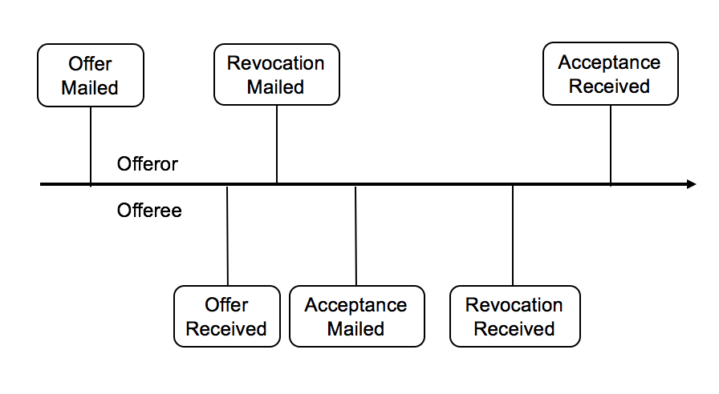
There is a contract when the acceptance is mailed! (in the prev. case)
What happens when the acceptance is lost/delayed? Offeror is responsible for the lost of this because they have the choice to specify means of communication

Acceptance
- Acceptance must be unqualified and complete
  - MUST be an acceptance of the entire offer
  - Buy for a fair price not a contract What is fair? Who is determine?
  - Buy for a price negotiated later not a contract Agreement to agree
  - If you provide a mechanism to determine the price it IS a contract

The test for whether there has been offer and acceptances is objective, not subjective.
- It doesn’t matter what we actually think (we = involving parties), it matters what a reasonable person would think
  - Because it is difficult to determine what a person actually thought
  - NO predictability to depend on what a person actually thought (no precedents)
  - Memories will become convenient at times
This is why the law relies on objectivity

Consideration
Something of value that is exchanged between the parties
We do not inquire the fairness of the consideration, only that there is consideration
Consideration does not include
- No consideration
- Past consideration
  - Not the consideration to support the promise but the consideration that is offered after the work has been done. Thus NO legal weight
- Illegal consideration
  - If you are already legally obligated to do it, promising to do is not anything of value
- Something that must be done
  - Variation of existing contracts (due to surging prices)
The law is actually unsettled for the last point (sth must be done), depends on the provinces
  - New Brunswick enforceable
  - Ontario non-enforceable

Exceptions
- Contracts under seal (idea dated back to history for all the efforts put into it)
  - Gratuitous promises are not contracts
  - If they name a building after my name that is different
  - But with a red seal it is enforceable. Formality can make a big difference
- Part payment of a debt
  - Statutory exception
  - Under common law rules, the government want people to compromise their debts, settle and move on
    - Even though they lack consideration, it is enforceable
    - E.g., Pay $7,500 instead of $10,000
- Promissory estoppel (difficult one)
  - E.g., Suppose I’m a landlord and you’re a tenant. Lease: building needs a new roof, landlord gives you 3 months to replace the roof (after landlord sends the notice). Or else the landlord kicks you out. After a month, landlord and tenant negotiate to buy the house instead. After another month, tenant is afraid that he is kicked out, landlord promises that it’s okay, she will not apply that rule. However, offer does not go through, tenant is kick out? NO, under promissory estoppel
    - Existing legal relationship
    - Express promise not to enforce
    - Detrimental reliance – (you (tenant) have to change your behaviour contingent on my promises)
Can apply promissory estoppel. However, can only be used as a shield and not sword. You cannot sue for for promissory estoppel.

Intention
Parties must intend to create a legally binding relationship
- Thus, not applicable between family members (domestic relationship)
Burden of proof is on the party who wants to prove that they ARE legally bound
The test is again objective. The test is not whether she DID actually intend to be legally bound, but depends on a reasonable person to decide for her intensions
- The law will presume intention in a business environment (as opposed to domestic relationships)
Burden of proof is on the party who wants to prove that they are NOT legally bound

Contractual terms
- Express terms – you can see them
- Implied terms – not written into the contracts
  - To make contracts work (it is obvious)
  - To reflect a pattern between the parties or industry norms or the statue tells them to (Sales Goods – refer to TB)
    - E.g., parties located in Canada, goods for sale within Canada implied that paid in CAD
    - However, if businesses have been done based on USD in the past (business norms) implied that future contracts will be dealt with in USD
Parol evidence rule – too thin, non-existent

Conditions precedent – has to be settled before it is legally bound
Conditions subsequent – more to do with termination of contract
Tell the difference between the two!!

Liability limitations
An attempt to limit liability by means of a contract
- Must be known when the contract is entered into
- Must be clear and unambiguous
NOTE: They are sometimes enforceable. Example of fairness comes into play.
- Because sometimes people sign waivers when they do not even know what they are signing
Government try to protect consumers against big firms by raising the bar and make it difficult to be enforceable, requiring limits set on liability must be
  - Known to the party, easy to understand, must appear obvious that people HAVE to understand
  - Clear and unambiguous
Example: the case in the textbook (drunk driving, rental car)
That is why they ask you for multiple signatures throughout the contract

- Liquidated damages clauses are enforceable reasonable estimate for compensation
- Penalties are not punishment cannot be agreed on non-enforceable

