Marketing
Ch. 1: Overview of Marketing
Marketing: set of business practices designed to plan for and present an organization’s products or services in ways that build effective customer relationships
Core Aspects of Marketing:
- Occurs in many settings
- Helps create value
- About satisfying customer needs [necessities] and wants [how to fulfill that need]
- Entails an exchange [not necessarily money for a good/service, can be information for convenience]
- Requires product [creating value through goods, services, and ideas], price [anything buyer gives up in exchange for the product: time, money, energy], place [activities that get the product to the customer in a timely fashion; SCM examines activities], and promotion [communication activities of marketing; used to inform, persuade, and remind potential buyers; used to influence their opinions or elicit a response] (marketing mix) decisions
- Can be performed by both individuals and organizations [B2B, B2C, C2C]
4 Orientations of Marketing:
- Product Orientation: ignores customer’s needs and focuses only on efficiently building a quality product (1900-1920)
- Sales Orientation: focuses on promoting sales of whatever a company makes/supplies, through marketing and sales calls (1920-1950)
- Market Orientation: focuses on discovering and meeting the needs/desire of its customers through its product mix
- Value-Based Orientation: focuses on the triple bottom line (people [consumer needs and wants], profits [long-term profitability relationships], planet [social and environmental responsibility])
  - Firms can become more value driven by:
    - Sharing information
    - Balancing customer’s benefits and costs
    - Building relationships with customers
    - Using technology to connect with customers
Marketing is important both within and outside an organization because it:
- Expands global presence [goods available to consumers around the globe, must understand consumer needs and wants from segment-segment, region-region]
- Is pervasive across channel members [each step in the supply chain involves marketing, all members ultimately focus on creating value for their customer and the end user consumer]
- Enriches society
- Can be entrepreneurial [important to both large firms and small ventures (especially new ventures)]
Ch. 2: Developing Marketing Strategies and a Marketing Plan
Marketing Strategy: identifies a firm’s target market(s), a related marketing mix (4 P’s), and the bases upon which the firm plans to build a sustainable competitive advantage
Develop customer value through:
- Customer excellence [retain loyal customers, provide excellence customer service]
- Operational excellence [strong supplier relationships, efficient operations, excellent SCM]
- Locational excellence [location, location, location]
- Product excellence [high perceived value + effective branding & positioning]
Developing a Marketing Plan:
- Define the business mission & objectives
- Conduct a situation analysis (SWOT [strengths, weaknesses, opportunities, threats])
- Identify and evaluate opportunities by using STP (segmentation, targeting, positioning)
- Implement marketing mix and allocate resources
- Evaluate performance using marketing metrics
Growth Strategies:
- Current market, current product/service: Market Penetration (having a sale)
- New market, current product/service: Market Development (new market segments [domestic, international] not currently being serviced)
- Current market, new product/service: Product Development (same market, new product; ex. McRib at McDonald’s)
- New market, new product/service: Diversification
Ch. 3: Analyzing the Marketing Environment
Microenvironmental Factors:
- Company Capabilities: core competency, knowledge, facilities, patents, technology, people, etc. applied to target markets, products, etc.
- Competition: identify and analyze direct and indirect competitors, know strengths & weaknesses, Competitive Intelligence (CI) used to collect and synthesize info; market relative to competition
- Corporate Partners: alliances with suppliers, corporate partners, etc. from manufacturers to retailers; greatly affects quality of final product and ability for business to operate
Macroenvironmental Factors:
- Culture: country culture vs. regional subcultures determine consumer values and decisions
- Demographics: characteristics of populations and segments impact consumer markets [gender, ethnicity, age]
- Social/Natural: income, education; purchasing power is tied to income which is linked to education; impact product/service has on society must be considered (ex. Environmentally harmful products should be reconsidered)
- Technology: skills and knowledge applied to the production, technology and materials needed for production must be considered; has resulted in new products, new forms of communication, and new retail channels (Ex. Social and mobile marketing: Foursquare)
- Economic: foreign currency fluctuations, inflation, and interest rates affect a firm’s ability to market goods and services; poor economic environment can inhibit production and consumer decision-making
- Political/Legal: Competition Act, Consumer Packaging and Labelling Act, Food and Drugs Act, NAFTA (all affect a firm’s ability to market)
Social & Natural Trends:
- Greener consumers: customers appreciate efforts of companies to supply environmentally friendly merchandise
- Privacy concerns: customers worry about loss of privacy, identity theft, etc. with increasing technology that is used to create value, about finding middle ground
- Time-poor society: consumers are on more of a strict time budget, products becoming more accessible
Ch. 4: Consumer Behaviour
Consumer Buying Process:
- Need recognition [functional needs, psychological needs]
- Information search [internal/external search for information]
  - Factors affecting search process:
    - Perceived benefits v. perceived costs
    - Internal locus of control [some control over outcomes; more search activities] v. external locus of control [fate, external factors control outcomes; why bother?]
    - Actual v. perceived risk [performance risk, financial risk, social risk, physiological risk, psychological risk]
- Alternative evaluation [evaluate criteria, determinant attributes, decision heuristics (price, product presentation, brand)]
- Purchase decision [increase conversion rate by reducing real/virtual abandoned carts (make it easy), having merchandise in stock (plenty on hand), reducing wait time (open more checkouts)]
- Postpurchase [potential outcomes: customer satisfaction, postpurchase dissonance (undesirable consumer behavior such as neg. word of mouth, internet posts, can be very damaging), customer loyalty]
Factors Influencing Consumer Buying Decisions:
- Psychological Factors
  - Motives [can be physiological, safety, love, esteem, self-actualization]
  - Attitudes [feelings towards object/idea, learned & long-lasting but can change abruptly, affective v. behavioural components]
  - Perceptions [negative perception towards something (tattoos) may inhibit a purchase]
  - Learning [affects attitudes and perceptions through social experiences]
  - Lifestyle [more apt to make purchases that fit into a perceived lifestyle]
- Social Factors
  - Family [decision-makers, influencers]
  - Reference groups [family, friends, co-workers, famous people provide info, rewards, self-image]
  - Culture [group can be school, country, religion; greatly influences behavior; marketers must understand differences among countries]
- Situational Factors
  - Purchase situation [external influence on buying behavior representing the circumstances (environment, emotional state, time pressure) experienced when faced with a purchase decision]
  - Shopping situation [external influence on buying behavior representing the way a store lays out items (candy bars near checkout)]
  - Temporal state [state of mind at any particular time can alter preconceived notions of what we’re going to purchase]
Involvement and Consumer Buying Decisions:
- High involvement purchases such as buying a car result in greater attention and deeper processing that develops strong attitudes and purchase intentions
- Low involvement purchases such as buying lunch result in less attention and peripheral processing that generate weak attitudes and increased use of cues
- Extended problem solving [expensive, infrequent purchases]
- Limited problem solving [impulse buying, habitual decision making]
Ch. 5: B2B Marketing
B2B Marketing: buying and selling goods or services to be used in the production of other goods and services, for consumption by the buying firm or for resale by wholesalers and retailers
B2B Markets:
- Manufacturers [buy raw materials, components, or parts to manufacture their own goods]
- Resellers [intermediary between manufacturer and retailer]
- Institutions [businesses sell to institutions such as schools, museums & religious organizations]
- Government [governments spend $240B annually in B2B markets, contracts posted on the Business Access Canada website]
Challenges of Reaching B2B Clients:
- Identify decision makers in organization who authorize/influence purchases
- Understand the buying process of each potential client
- Identify factors influencing buying process of potential clients
Differences Between B2B & B2C Markets:
- Market characteristics: demand for business products is derived, fewer customers, more geographically concentrated, larger orders
- Product characteristics: products are technical, based on specifications, mainly raw & semi-finished goods, emphasis on delivery time, technical assistance, after-sale service
- Buying process characteristics: decisions are more complex, competitive bidding, negotiated pricing, complex financial arrangements, more formalized buying process, buying criteria and objective specified, multiple participants in purchase decisions, reciprocal arrangements common, close long-term relationships, online buying common
- Marketing mix characteristics: direct selling & physical distribution essential, more technical advertising, promotions emphasize personal selling, negotiated, inelastic, prices affected by trade/quantity discounts
B2B Buying Process:
- Need recognition [generated internally or externally; recognized through suppliers, salespeople, competitors]
- Product specification [suppliers use to develop proposals; done collaboratively with suppliers]
- Request for proposal (RFB) process [document that solicits proposal, often made through a bidding process, by a company interested in acquiring a service/good from a potential supplier]
- Proposal analysis and supplier selection [often several vendors negotiating against each other, considerations other than price play a role in final selection]
- Order specification (purchase) [firms place order, details are specified, terms are detailed including payment]
- Vendor performance assessment using metrics [key issues including customer service, issue resolution, delivery, and quality are graded based on performance and importance]
Buying Centre: all members of an organization involved in the buying process, including the initiator, influencer, decider, buyer, user, and gatekeeper
Buying culture is influenced by the organizational culture (autocratic, democratic, consultative, or consensus)
Buying situations:
- New buy: first time purchase, high involvement, buying centre uses all 6 steps in buying process
- Straight rebuy: buying additional units that have been previously purchased, most B2B purchases are straight rebuys
- Modified rebuy: purchasing a similar product but changing specs, current vendors have advantage over new vendors
Ch. 6: Segmentation, Targeting, and Positioning
Segmentation-Targeting-Position Process:
- Establish strategy/objectives [consistent with mission statement, derived from mission & current state]
- Segmentation bases
  - geographic (continental, national, regional, provincial)
  - demographic (age, gender, income, education, occupation, race)
  - psychographic (lifestyle [VALS], personality, social class)
  - behavioural (benefits sought, occasion, usage, loyalty)
- Evaluate segment attractiveness
  - identifiability [who’s in the market, are the segments unique, does each segment require a unique marketing mix]
  - reachability [do consumers: know the product exists, understand what it can do, recognize how to buy]
  - responsiveness [customers must: react positively to firm’s offering, move towards the product/service, accept the firm’s value proposition]
  - substantiality and profitability (size matters, small insignificant segment won’t be profitable, growth potential equally important)
    - Segment size x adoption percentage x purchase behavior x profit margin % - fixed costs
- Select target market
  - Mass/Undifferentiated: ignores market segmentation; appeals to whole market with one strategy
  - Differentiated: appeals to at least 2 market segments/target groups
  - Concentrated: appeals to one defined market segment [Rolex, luxury]
  - Micromarketing (1 to 1): targets a small segment of consumers with specific needs for a product
- Identify and develop position strategy
  - Value: Some consumers value price, while some value quality; relationship of price to quality varies consumer to consumer
  - Product attributes: an association is made with the product based on an attribute, product feature, or a consumer feature
  - Benefits & symbolism: product enhances self-image, ego identification, belongingness, meaningfulness, affective fulfillment
  - Competition: position against a specific competitor or product classification
  - Market leadership: expand market, guard market share, remain leaders in expansion of market share
Positioning by Using Perceptual Mapping:
- Determine consumers’ perceptions & evaluations in relation to competitors
- Identify the market’s ideal points and size
- Identify competitors’ positions
- Determine consumer preferences
- Select position
Repositioning: changing the image of a product to target a newer or wider market (Ex. Whirlpool washers’ new design)
VALS Framework (related to psychological segmentation)
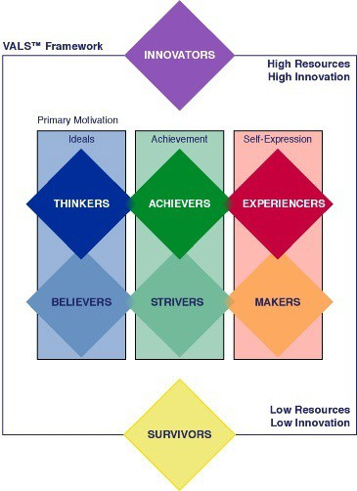

Ch. 7: Marketing Research
Why do we do marketing research?
- Deeper understanding of the market
- Keep track of competitors
- Gauge interest on product
- Influence decision-making
Marketing Research: set of techniques for systematically collecting, recording, analyzing and interpreting data that can aid decision makers involved in marketing goods, services, or ideas
Marketing Research Process:
- Define Research Problem and Objectives [What information is needed to answer the research question? How should that info be obtained?]
- Design Research Plan: Type of data (primary [data collected to address specific research needs; focus groups, surveys, interviews], secondary [data collected prior to start of focal project; internal or external, or both) Research method: (qualitative, quantitative, or both)
- Collect Data: recruit qualified researchers, prepare instruments (questions), detailed description of the process, technologies? Approvals?
- Analyze Data and Develop Insights: Converting data into information to explain, predict, and evaluate a particular situation (Data cleaning, data screening: basic techniques [averages, std. deviation, frequencies], advanced techniques [regression analysis, variance analysis], data analysis (rigorous)
- Present Action Plan: Prepare results (exec. Summary, body, conclusion, appendices) Present data (short & concise, interesting & appropriate to audience, no technical jargon, recommendations)
Secondary Data:
- Can be free/inexpensive to obtain
- External sources: government publications (census data), trade journals, guides and indexes, articles, etc.
  - Can be purchased from specialized research firms
  - Downside: may not be specific/timely to solve research needs
  - Scanner data: quantitative research that uses data obtained from scanner readings of UPC codes at checkout counters
  - Panel data: group of consumers responding to survey or sales receipts
- Internal sources: invoices, customer lists, etc.
  - Use data mining techniques to decipher large amounts of data
  - Downside: may not be the data you need or the right data
Primary Data Collection Techniques:
- Qualitative Research
  - Observation, Focus groups, In-depth interviews, Social media
  - ***needs to be reliable, valid, and done with a random sample
  - Generates insights about people, relationships, feelings, perceptions, etc.
  - Fuzzy needs, ill-defined sources, open-ended collection form
- Quantitative Research
  - Experiments, Scanner, Survey, Panel
  - ***information confirms/denies early insights, tests prediction/hypothesis
  - Verifies insights and aids in selecting course of action
  - Clear needs, well-defined sources, structured collection form
Ethical Issues with Emerging Technology & the Ethics of Using Customer Info:
- Deceptive Practices: not telling customers info is being collected, misrepresenting research results by changing database numbers
- Invasion of Privacy: companies have access to endless info on consumer, consumers don’t know the extent to which companies intrude on their lives
- Breaches of Confidentiality: companies share information of consumers without permission, instead making them “opt-out” of participation in such practices
- Objectivity: marketing research should be used to only produce unbiased, factual information
Ch. 8: Developing New Products
Product: anything that is of value to a consumer and can be offered through a marketing exchange (goods, services, places (hotels), people, or communities)
Firms create new products because:
- They provide value to firms and customers
- They need to innovate to stay in business, or be left marketing current products to current customers or moving to another market with similar customers
- Customers needs change
- It can make an existing product more interesting (Ex. Dyson vacuum)
- Markets saturate and the value of the firm declines the longer one product is in the market
- It allows firms to create a portfolio of products, which diversifies the firms risk
- Trendy industries (fashion, books, software) sales rely on innovative, new products
- They become pioneers by establishing a new market and can command greater market share over time (sometimes followers jump pioneers because they don’t need to market the category)
Diffusion of Innovation/Adoption of Innovation: process by which the use of an innovation spreads through a market group over time and over various categories of adopters (bell curve)
Categories of adopters:
- Innovators: imperfect product; enjoy risks; highly knowledgeable; not price sensitive (2.5%)
- Early Adopters: improved product; less risky; opinion leaders; not price sensitive (13.5%)
- Early Majority: perfect product + deal; not as risky; adopt before average person; price sensitive (34%)
- Late Majority: perfect product + greater deal; avoid risks; last group to enter market; price sensitive (34%)
- Laggards: perfect product + exceptional deal; no risks; may never enter market; tradition-bound; extremely price sensitive (16%)
Factors affecting diffusion:
- Relative Advantage: product is perceivably better than substitutes (quick diffusion)
- Compatibility: product aligns with cultural values (Ex. “getting a coffee”)
- Observability: products benefits and uses are easily communicable
- Complexity/Triability: product is less complex and easy to try
How firms develop new products:
- Idea generation: R&D (pioneers), licensing, brainstorming, customer input (lead users), competitors’ products (reverse engineering; copycat products)
- Concept testing: concept is presented to potential buyers (purchase decision, frequency, value, demographics, etc.)
- Product development: prototype (first physical form of a product), alpha testing (confirms product’s performance, done by R&D), beta testing (tests performance with customers on functionality, performance, problems/issues; can be done virtually)
- Market testing: Premarket tests (customers exposed to product, surveyed, and firm makes decision on product) or test marketing (product is launched, real consumer behaviour is observed, more expensive than premarket tests)
- Product launch: promotion (integrated marketing strategy), place (adequate inventory for shipment and presence in stores), price, timing
- Evaluation of results: satisfaction of technical requirements, customer acceptance, satisfaction of financial requirements
Product Life Cycle (PLC): stages that products go through in the market; bell shaped (introduction, growth, maturity, decline)
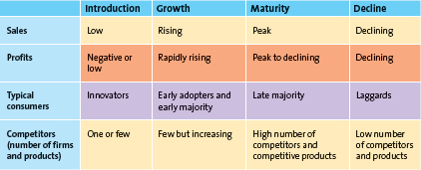
- Extend PLC by developing new uses, modifying product, increasing frequency, increasing users, finding users, repositioning, and tweaking the marketing strategy.
- PLC curves vary by type of product (high-learning product, low-learning product, fashion, fads)
- Managers don’t know precise PLC shape, no way to know what stage product is in (may believe product is declining when it could just be increased competition or a poor marketing strategy)
- Product life cycle characteristics*** (on phone)
Ch. 9 Product, Branding, and Packaging Decisions:
Components of a product:
- Core Customer Value: basic problem-solving benefits that customers seek
- Associated Service: non-physical attributes of a product; warranties, financing, product support, after-sale service, etc.
- Actual Product: brand name, features/design, packaging, quantity
Types of products:
- Specialty: g/s that customers sow a strong preference; considerable effort in search for best supplier(s)
- Shopping: g/s such as furniture, apparel, appliances, travel; consumers exert a fair amount of effort comparing alternatives
- Convenience: g/s that consumers don’t spend effort on evaluating alternatives prior to purchase; beverages, bread, etc.
- Unsought: g/s consumers don’t think of buying/unaware of; require a lot of marketing effort and various forms of promotion
Product mix/product line decisions:
- Product Mix: complete set of all products offered by a firm.
- Product lines: Groups of associated items, such as those that consumers use together or think of as part of a group of similar products
- Product Category: An assortment of items that a customer sees as reasonable substitutes for one another
- Product Mix Breadth: number of product lines, or variety, offered by the firm
- Product Line Depth: number of products within a product line
- Stock Keeping Units (SKUs): Individual items within each product category; the smallest unit available for inventory control
- Brand: The name, term, design, symbol, or any other features that identify one seller’s g/s as distinct from those of other sellers
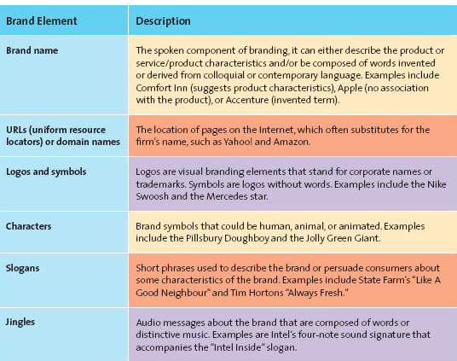

The value of branding is:
  - Brands facilitate purchasing
  - Brands establish loyalty
  - Brands protect from competition
  - Brands reduce marketing costs
  - Brands are assets
  - Brands impact market value
Brand Equity: the set of assets/liabilities linked to a brand that add/subtract from the g/s’s value; including:
- Brand awareness (familiarity through ads, personal selling, sponsorships/event marketing, publicity and public relations)
- Perceived value (relationship between the g/s benefits and costs; good marketing raises quality perceptions and thus, perceived value)
- Brand associations (mental links consumers make between a brand and its attributes; slogan, logo, etc.)

Branding strategies:
- Brand ownership:
  - National (manufacturer) brands (Coke)
  - Private label (store) brands (PC Cola)
  - Generic brands (Duck Tape, Aspirin; brand name is synonymous with product)
- Brand naming: descriptive, suggestive of benefits, qualities of product; easy to pronounce, recognize; translatable; trademarked and legally protected
  - Corporate (Gap)
  - Individual (Loblaws)
  - Corporate product line (Kellogg’s)
- Brand extension: well established name, high perceived value, lower marketing costs, synergy among products, boosts sales
  - FedEx Office, FedEx Ground, etc.
- Brand dilution: brand and extension don’t mesh; no brand association between two; brands must be distanced if necessary
  - Bengay > Bengay Aspirin
  - BIC pens, razors > Bic underwear
  - FritoLay chips > FritoLay lemonade
- Cobranding: two brands together on the same package/promotion
  - Dunkin Donuts/Baskin Robbins, KFC/Taco Bell
- Licensing: one brand allows another brand to utilize their name in their products to increase sales
  - David Lacoste licensed his likeness, clothes still sold today
  - ConAgra licensed Harley Davidson’s likeness to introduce the company into the beef jerky category
- Packaging/Labelling: physical elements of a brand’s product that can create value through customer excitement
Ch. 10: Services – The Intangible Product
Unique characteristics affecting services:
- Intangibility: can’t be touched, tasted like a product; hard to market/promote; requires cues
- Inseparability: service and consumption are inseparable; market by getting customers involved in the service because customers can’t try service before purchase and can’t be returned
- Inconsistency: quality may vary because it’s provided by humans; inferior service can’t be recalled; can be reduced through training; take advantage by offering customized services
- Inventory: time is perishable, can’t be stored for future consumption; must align with supply/demand curve, excess demand means turning customers away, excess supply means high expenses
The GAPS model:
- Knowledge Gap: difference between customers’ expectations and firms’ perception of those expectations
  - Understand customer expectations and service quality based on knowledge and experience, type of service, and type of situation (Lord Elgin v. Motel 6)
  - Customers have a zone of tolerance: the area between expectations and the minimum level of acceptable service
- Standards Gap: difference between the firm’s perceptions of customer’s expectations and the service standards it sets
  - High standards set by achieving service goals through training and committing to service quality
- Delivery Gap: difference between the firm’s service standards and the actual service it provides
  - Delivering on service quality done through the empowerment of employees, providing support and incentives, and using technology to facilitate a wider array of services
- Communication Gap: difference between actual service provided and the service the firm’s promotions promise
  - Manage expectations by promising only what you can deliver
When service is poor, service recovery is done by:
- Listening to the customer
- Resolving problems quickly
- Providing a fair solution (distributive, procedural justice)
Ch. 11: Pricing Concepts and Strategies
Pricing:
- Is a major component of firm revenue
- Influences purchase decision
- Signals value
- Signals quality
- Signals a firm’s competitive position
- Establishes value creation in the marketing mix
5 Cs of pricing:
- Company Objectives: profit orientation (maximize profits, target return pricing, target profit pricing), sales orientation, competitor orientation, customer orientation
- Customers: understanding customer’s reactions to different prices; consumers want value (think supply & demand)
- Costs: variable costs, fixed costs, total cost (think break-even analysis)
- Competition: monopoly, oligopoly, monopolistic competition, pure competition
- Channel Members: manufacturers, wholesalers, retailers can have different perspective on pricing; manufacturers must protect against grey market transactions
***The internet and economic factors also influence pricing***

Pricing strategies:
- Cost-Based: pricing based on costs calculated on a per unit basis; assumes costs don’t vary for different levels of production
- Competitor-Based: pricing based on how the firm wants consumers to interpret its products relative to competitor offerings (premium pricing)
- Value-Based: pricing based on the overall value of the product and consumer perceptions (improvement value method, cost of ownership method)
- Price Skimming: setting price high for innovators and lowering it to capture rest of segment
- Market Penetration Pricing: setting price low to build sales, market share, and profits quickly
Psychological factors affecting VBP strategies:
- Reference pricing: price buyers compare the selling price to, facilitating evaluation
- EDLP: pricing between regular prices and sale prices all the time, reduces search times
- High low pricing: prices are temporarily reduced to encourage purchases
- Odd prices: buyers may not round up, suggests good deal or low quality
- Price-quality relationship: consumers assume more expensive products are better quality
Pricing tactics:
- Price lining: establish price floor and ceiling for a line of similar products and set price points in between for differences in quality
- Price bundling: pricing of more than one product for a single, lower price; encourages sale of slow moving items, stock up, trial of new brand
- Leader pricing: enticing consumers with a popular item that’s priced to sell and hoping they will pick up other things while shopping
Pricing reductions:
- Coupons & rebates
- Markdowns
- Quantity discounts
Legal & ethical aspects of pricing:
- Deceptive or illegal price advertising
- Predatory pricing
- Price discrimination
- Price fixing (horizontal v. vertical)
Ch. 12: Distribution Channels
Distribution Channel: set of institutions that transfer ownership of and move goods from the point of production to the point of consumption
SCM: set of approaches firms employ to integrate their supplier, manufacturers, warehouses, stores, and transportation intermediaries into a seamless value chain in which merchandise is produced/distributed in the right quantities, at the right location, and at the right time
Logistics Management: integration of two activities for planning, implementing and controlling the flow of raw materials, in-process inventory and finished goods from the point of origin to the point of consumption
Supply Chain
Suppliers and supplier networks
Distribution Channels
Wholesalers and retailers
Suppliers
Producers
Consumers
Logistics Management
Flow of materials and information

Types of channels:
- Direct distribution: manufacturer > consumer
- Indirect distribution: manufactuer > retailer > consumer
  - Push strategy: manufacturer promotes to channel members, whom will bring product to end consumers
  - Pull strategy: manufacturer promotes to consumers, who will demand product and convince retailers to carry it
- Multichannel distribution: manufacturer > catalogues, retailers, wholesalers > consumer
Channels add value through:
Transactional Function
Buying | Purchase goods for resale to other intermediaries or consumers.
Risk Taking | Ownership of inventory that can become outdated.
Promotion | Promote products to attract consumers.
Selling | Transact with potential customers
Logistical Function
Physical Distribution | Transport goods to point of purchase
Storing | Maintain inventory and protect goods
Facilitating Function
Gather Information | Share competitive intelligence about customers or other channel members.
Financing | Extend credit and other financial services to consumers

Distribution Intensity: number of channel members to use at each level of the supply chain
- Intensive: get products into as many outlets as possible
- Exclusive: granting exclusive rights to sell to one or few retailers; can be geographic
- Selective: granting exclusive rights to few retailers in a territory
Conflict can arise in a supply chain, but can be avoided using vertical marketing systems, where members act as a unified system. The 3 types are:
- Administered: dominant channel member controls the channel relationship
- Contractual: independent firms join together contractually to obtain economies of scale, coordination, and conflict reduction (franchising)
- Corporate: parent company has complete control and can dictate objectives of the supply chain
SCM and DCM adds value by streamlining distribution (minimizing transactions) through order-to-delivery process simplification and inventory reduction.
Information flows form customer to stores, to and from distribution centers, to and from wholesalers, to and from manufacturers, and onto the supplier of raw materials. Purchase information is stored in a data warehouse.
You can manage supply chains through strategic relationships, which require mutual trust, open communication, common goals, and credible commitments.
Logistics management involves making merchandise flow through:
- Inbound transportation (coordinating deliveries through a dispatcher)
- Receiving and checking (arrival receipts, product undamaged and receival confirmation, RFID tag)
- Storing and cross-checking (traditional distribution centers, cross-docking distribution centers, or a combination of the two)
- Getting merchandise floor ready (ticketing, marking, placing garments on hangers)
- Shipping merchandise to stores (routing and scheduling computer systems considering rate of sales, road conditions, and transportation operating constraints)
- JIT systems (delivers less merchandise more frequently, reduces lead time, increases product availability, and lowers inventory investment)
Ch. 13: Retailing and Multichannel Marketing
Retailing: business activities that add value to g/s sold to consumers; includes products/services bought at stores, through catalogues, over the Internet
Companies choose retail partners based on their channel structure, channel member characteristics, and customer expectations.
Types of retailers:
- Food retailers
  - Conventional supermarkets
  - Big box retailers
  - Convenience stores
- General merchandise retailers
  - Discount stores
  - Specialty stores
  - Category specialists
  - Department stores
  - Drugstores
  - Off price retailers
  - Extreme value retailer
  - Services retailer
Create a retail strategy through the 4 Ps of marketing:
- Product: providing the right mix of g/s that satisfy the target market; in retail: large shipments, small quantities sold, high inventory, develop private labels
- Price: defines value of the g/s and general price range defines a store’s image; aligns with profit goals, consumer’s willingness to pay, and the other elements of the retail mix
- Promotion: traditional advertising plus e-marketing; once in store: displays and signs to simulate purchase of featured products (end caps); cooperative advertising; customer service
- Place: convenience of location is driver to success
Retail stores allow browsing, touching and feeling, personal service, cash and credit, social interactions, instant gratification, and reduced risk. Organizations opt for multichannel retailing, which provides:
- Broader selection
- Personalization
- Insights into consumer behavior
- Increased customer satisfaction and loyalty
- Expanded market presence
Multichannel options and the benefits of each:
Stores | Kiosks | Catalogues | Internet
- Browsing  - Touching and feeling products (Using all 5 senses)  - Personal service (Sales associates)  - Cash and credit payment  - Entertainment and social interaction  - Instant gratification  - Risk reduction | - Broader selection  - Access to items online that are out of stock in stores  - Access to wish lists and gift registries  - Access to loyalty program information | - Convenience (Info is easily accessible for a long period of time)  - Information (How the products can be used)  - Safety (Being able to look at merchandise from the safety of your own home) | - Broader Selection (Vast number of alternatives & broad array of retailers)  - More information to evaluate merchandise  - Personalization  - Personalized customer service (Live online chats)  - Personalized offering (Interactive web page)

Effective multichannel marketing utilizes:
- Role of brands (overcomes inability to touch and feel product)
- Technology (provides look-and-see info that’s easily communicable over the Internet)
and
- Expands market presence
- Increases share of wallet
- Provides insight into consumer behaviour

Ch. 14: Integrated Marketing Communications
Integrated Marketing Communications (IMC): promotional dimension of the 4 Ps; uses communication methods such as:
- General advertising: most visible, creates awareness and generates interest
- Personal selling: salespeople (face-to-face), more expensive, add significant value
- Sales promotion: aimed at consumers or channel members, achieves short term and long term objectives
- Public relations: free media attention, PR becoming more important as skepticism of marketing increases
- Direct marketing: targeted, motivates an action, measurable, provides info (personal selling, direct mail, kiosks, catalogues)
- Digital media: websites, blogs, social media
3 parts of an IMC strategy:
- Consumer/target market
- Channel through which the message is communicated
- Evaluation of the results of the communication
Sender (firm) > Transmitter (advertising agency) > Communication channel (media, Internet) > Receiver (consumer) > Feedback loop (consumers need a medium to offer feedback)
Steps in planning an IMC campaign:
- Identify target audience (conduct research to set tone of advertising and select media)
- Set objectives (push or pull strategy; evaluate nature of market, product, and stage in PLC)
- Determine budget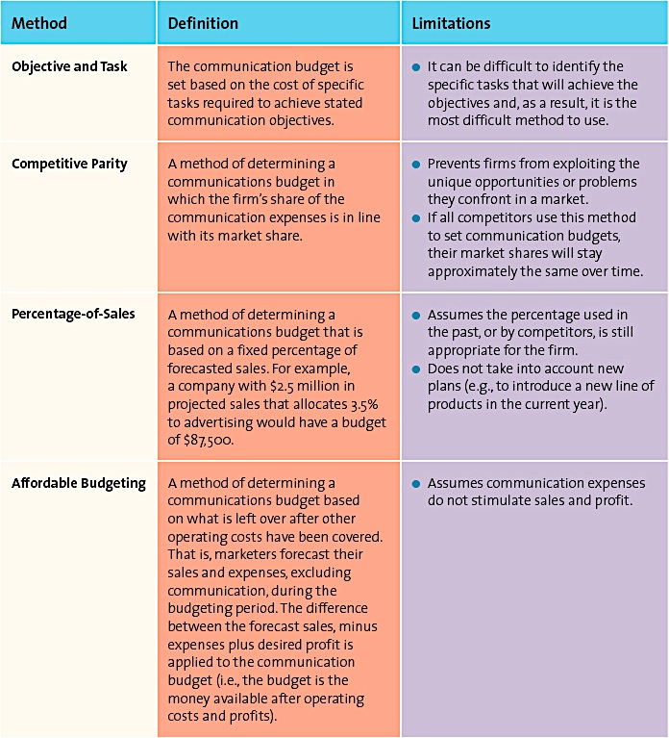
- Convey message (unique selling proposition; differentiate product by communicating unique attributes; utilize theme/slogan; rational or emotional appeal)
- Evaluate and select media (media planning, media mix, media buy; determine advertising schedule: continuous, fighting, pulsing)
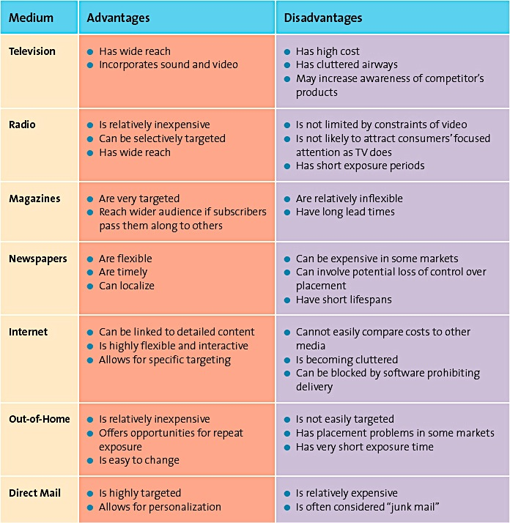
- Create communication (type of medium determines execution style; creativity affects execution; creativity can’t overshadow message; execution style matches objectives)
- Assess impact (pretesting, tracking, post-testing; results measured through frequency, reach, and GRP [frequency x reach])
Ch. 15: Advertising, Sales Promotions, and Personal Selling
Advertise using the AIDA model:
- Attention: customers need to recognize/recall a brand name; awareness through aided recall, top-of-mind interest
- Interest: after customer is aware, they must be persuaded and want to further investigate product/service
- Desire: after investigation, customer must go from liking it to wanting it based on product’s attributes and message
- Action: actual purchase action
*It generally takes several exposures to an ad before an action is taken, this is the lagged effect.
3 goals of advertising:
- Inform (early in PLC)
- Persuade (growth and early maturity stage of PLC, or in later stage to reposition)
- Remind (after market acceptance, top-of-the-mind awareness)
*Can be product focused, institutionally focused, a PSA, or socially focused.
There are regulatory agencies that enforce laws & informal restrictions on advertisements that protect consumers from deceptive advertising, loophole is through puffery.
Sales promotions can be targeted at consumer or channel members through either push or pull strategies. Consumer strategies include:
- Coupons
- Deals
- Premiums
- Contests
- Sweepstakes
- Samples
- Loyalty programs
- POP displays
- Rebates
- Product placement
Some channel member strategies include:
- Discounts and allowances
- Cooperative advertising
- Sales force training
Evaluate sales promotions using:
- Realized margin from promotion
- Cost of additional inventory required for expected increase in sales
- Potential increase in sales
- Long-term impact
- Potential loss from switches to promoted item from more profitable items
- Additional sales by customers attracted to store from promotion
Personal selling involves face-to-face selling, video conferencing, telephoning, and use of the Internet. It adds value to IMC strategies because:
- Salespeople can customize the message for a specific buyer
- It creates strong supply chain relationships
- It increases customer loyalty through relationship selling
- It gathers research input from customers
- It assists in CRM
Steps in the personal selling process:
- Generate and qualify leads (done through networking events, the Internet, trade shows, telemarketing, cold calling, and using current customers)
- Preapproach (set goals for what’s to be accomplished)
- Sales presentations and overcoming objections (person-to-person interaction; ask questions and listen carefully to gain insight on customer’s needs; anticipate objections and have a prepared response)
- Closing the sale (getting the order, not giving up after the first ‘no’)
- Follow-up (determines future buying behavior; service quality based on: reliability, responsiveness, assurance, empathy, and tangibles)
Ch. 16: Global Marketing
Global markets are assessed through a PEST analysis:
- Political/Legal: tariffs, quotas, boycotts, exchange control, trade agreements, trade sanctions
- Economic: general economic environment, market size/population growth rate, real income, PPP, HDI
- Sociocultural analysis: power distance, uncertainty avoidance, individualism, masculinity, time orientation
- Technology & Infrastructure: transportation, distribution channels, communication, commerce
The greatest change is the growth of four countries known as the BRIC countries; Brazil, Russia, India, and China.
Global market entry strategies, going from least control and risk to highest:
- Exporting: limited return, requires request from host country, less employment for host country, direct or indirect
- Franchising: less costly than opening own units, limited control over operations, reduced profits, potential for franchisee to break away after realizing methods for success
- Strategic Alliance: collaborative relationship between 2 international companies
- Joint Venture: provides greater understanding of foreign market, many problems arise from differences in profit location, objectives, beneficiary, culture; contract manufacturing or management contracting
- Direct Investment: high level of investment and exposure to risks including loss of investment, complete control over foreign operation
Global STP is more complicated than domestic STP because of:
- Cultural nuances
- Subcultures
- View of product and consumer role
- Different positioning
- Adaptation
- Single positioning strategy
Product/service strategies include:
- Selling the same g/s in both home and host country
- Selling a similar g/s to host country with minor adaptations
- Sell totally new g/s in host country
Pricing strategies take tariffs, quotas, anti-dumping policies, economic conditions, and competitive factors into consideration
Distribution strategies are complex; involving intermediaries, exporters, importers, and different transportation systems; increase cost and final selling price
Communication strategies involve adapting the marketing strategy to consider varying literacy levels, media availability, language differences, cultural/religious differences
Ethical issues involved in global marketing include:
- Environmental concerns (different regulations in different countries)
- Global labour issues (working conditions, wages, child labour)
- Impact on host country’s culture (cultural imperialism)

