List Data Structure Interface
Next
Next
Next
Next
Data
Data
Data
Data
Head
Rear
Node
Node

import java.util.Iterator;
public interface ListADT<T> extends Iterable<T>
// Removes and returns the first element from this list
public T removeFirst ();
// Removes and returns the last element from this list.
public T removeLast ();
// Removes and returns the specified element from this list
public T remove (T element);
// Returns a reference to the first element in this list
public T first ();
// Returns a reference to the last element in this list
public T last
// Returns true if this list contains the specified target element.
public boolean contains (T target);
public T find(T element);
// Returns true if this list contains no elements
public boolean isEmpty();
// Returns the number of elements in this list
Singly Linked List
public int size();
// Returns an iterator for the elements in this list
public Iterator<T> iterator();
public String toString(); // Returns a string representation of this list.
Indexed List ADT
public interface IndexedListADT<T> extends ListADT<T>
// Inserts the specified element at the specified index
public void add (int index, T element);
// Sets the element at the specified index
public void set (int index, T element);
// Adds the specified element to the rear of this list
public void add (T element);
// Returns a reference to the element at the specified index
public T get (int index);
// Returns the index of the specified element
public int indexOf (T element);
// Returns and returns the element at the specified index
public T remove (int index);
Linked List
import java.util.*;
public class LinkedList<T> implements ListADT<T>, Iterable<T> {
protected int count;
protected LinearNode<T> head, tail;
public LinkedList() {
count = 0;
head = tail = null;
public T removeFirst() throws RuntimeException {
if (isEmpty())
throw new RuntimeException ("List");
LinearNode<T> result = head;
head = head.getNext();
if (head == null)
tail = null;
count--;
return result.getElement();
public T removeLast() throws RuntimeException {
if (isEmpty())
throw new RuntimeException ("List");
LinearNode<T> previous = null;
LinearNode<T> current = head;
while (current.getNext() != null)
previous = current;
current = current.getNext();
LinearNode<T> result = tail;
tail = previous;
if (tail == null)
head = null;
else
tail.setNext(null);
count--;
return result.getElement();
public T remove (T targetElement) throws RuntimeException {
if (isEmpty())
throw new RuntimeException ("List");
boolean found = false;
LinearNode<T> previous = null;
LinearNode<T> current = head;
while (current != null && !found)
if (targetElement.equals (current.getElement()))
found = true;
else {
previous = current;
current = current.getNext();
if (!found)
throw new RuntimeException ("List");
if (size() == 1)
head = tail = null;
else if (current.equals (head))
head = current.getNext();
else if (current.equals (tail)) {
tail = previous;
tail.setNext(null);
else
previous.setNext(current.getNext());
count--;
return current.getElement();
public boolean contains (T targetElement) throws RuntimeException {
if (isEmpty())
throw new RuntimeException ("List");
boolean found = false;
Object result;
LinearNode<T> current = head;
while (current != null && !found)
if (targetElement.equals (current.getElement()))
found = true;
else
current = current.getNext();
return found;
public boolean isEmpty() {
return (count == 0);
public int size() {
return count;
public String toString() {
LinearNode<T> current = head;
String result = "";
while (current != null) {
result = result + (current.getElement()).toString() + "\n";
current = current.getNext();
return result;
public Iterator<T> iterator() {
return new LinkedIterator<T>(head, count);
public T first() {
return head.getElement();
public T last() {
return tail.getElement();
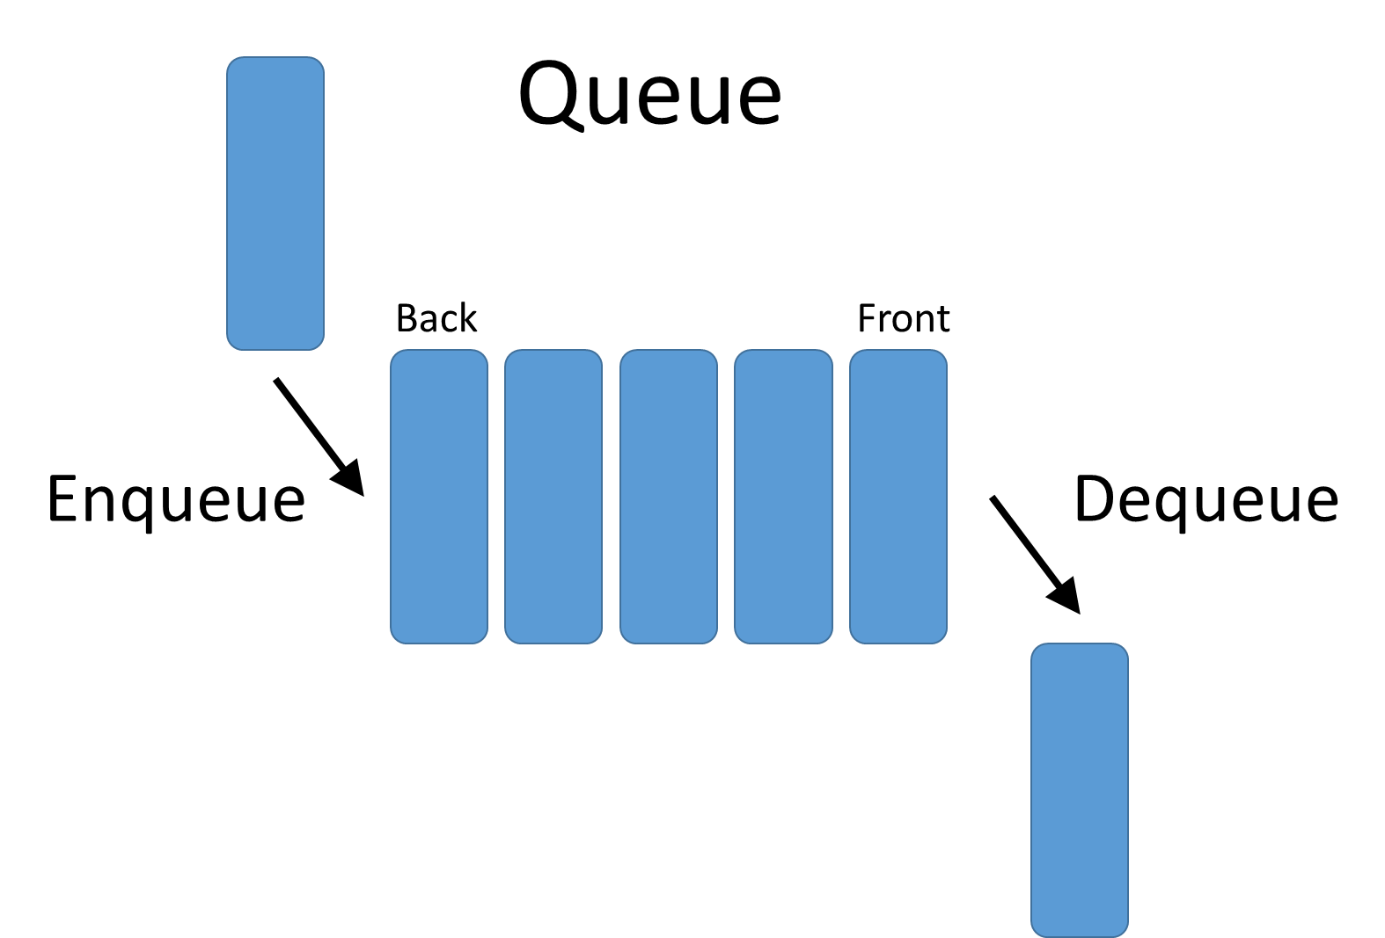
Queue ADT
public interface QueueADT<T>
// Adds one element to the rear of this queue.
public void enqueue (T element);
// Removes and returns front element.
public T dequeue();
// Returns without removing front element.
public T first();
// Returns true if this queue contains no elements.
public boolean isEmpty();
// Returns the number of elements in this queue.
public int size();
// Returns a string representation of this queue.
public String toString();
Unrdered List ADT
public interface UnorderedListADT<T> extends ListADT<T>
// Adds the specified element to the front of this list.
public void addToFront (T element);
// Adds the specified element to the rear of this list.
public void addToRear (T element);
// Adds the specified element after the specified target.
public void addAfter (T element, T target);
Binary Search Tree List
import java.util.Iterator;
public class BinarySearchTreeList<T> extends LinkedBinarySearchTree<T>
implements ListADT<T>, OrderedListADT<T>, Iterable<T>
public BinarySearchTreeList()
super();
public void add (T element)
addElement(element);
public T removeFirst () // Removes and returns first
return removeMin();
public T removeLast () // Removes and returns last
return removeMax();
public T remove (T element) // Removes and returns specified element
return removeElement(element);
public T first () // Returns first
return findMin();
public T last () // Returns last
return findMax();
public Iterator<T> iterator() // Returns iterator
return iteratorInOrder();
Linked Stack
public class LinkedStack<T> implements StackADT<T>
private int count; // Indicates number of elements stored
private LinearNode<T> top; // Pointer to top of stack
public LinkedStack() // Creates an empty stack.
count = 0;
top = null;
public LinkedIterator<T> iterator()
return new LinkedIterator<T>(top, count);
public void push(T element) // Adds the specified element to the top.
LinearNode<T> temp = new LinearNode<T>(element);
temp.setNext(top);
top = temp;
count++;
// Removes the element at the top of this stack and returns a reference to it.
public T pop() // Throws an EmptyCollectionException if the stack is empty.
if (isEmpty())
throw new EmptyCollectionException("Stack");
T result = top.getElement();
top = top.getNext();
count--;
return result;
// Returns a reference to the element at the top. Not removed. Throws an
public T peek() // EmptyCollectionException if the stack is empty.
if (isEmpty())
throw new EmptyCollectionException("Stack");
return top.getElement();
public boolean isEmpty() // Returns true if stack is empty and false otherwise.
return top == null;
public int size() // Returns the number of elements in this stack.
return count;
public String toString() // Returns a string representation of this stack.
LinearNode<T> current = top;
if (isEmpty())
throw new EmptyCollectionException("Stack");
String result = current.getElement().toString();
while (current.getNext() != null)
current = current.getNext();
result += current.getElement().toString();
return result;
Doubly Linked List (Node)
public class DoublyLinkedList<E>
private DoublyLinkedList<E> next;
private DoublyLinkedList<E> previous;
private E element;
public DoublyLinkedList()
next = null;
previous = null;
element = null;
public DoublyLinkedList (E elem)
next = null;
previous = null;
element = elem;
public DoublyLinkedList<E> getNext()
return next;
public DoublyLinkedList<E> getPrevious()
return previous;
public void setNext (DoublyLinkedList<E> node)
next = node;
public void setPrevious (DoublyLinkedList<E> node)
previous = node;
public E getElement()
return element;
public void setElement (E elem)
element = elem;
Stack ADT
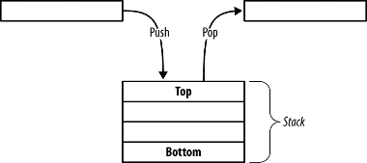
public interface StackADT<T>
// Adds one element to top.
public void push (T element)
// Removes and returns top.
public T pop();
// Returns without removing top.
public T peek();
// Returns true if theres no elements.
public boolean isEmpty();
// Returns the number of elements.
public int size();
Ordered List ADT
public interface OrderedListADT<T> extends ListADT<T>
// Adds the specified element to this list at the proper location
public void add (T element);
Linked Binary Search Tree
import java.util.Iterator;
public class LinkedBinaryTree<T> implements BinaryTreeADT<T>
protected int count;
protected BinaryTreeNode<T> root;
public LinkedBinaryTree()
count = 0;
root = null
public LinkedBinaryTree(T element)
count = 1;
root = new
BinaryTreeNode<T>(element);
public LinkedBinaryTree(T element, LinkedBinaryTree<T> leftSubtree, LinkedBinaryTree<T> rightSubtree)
root = new BinaryTreeNode<T>(element);
count = 1;
if (leftSubtree != null)
count = count + leftSubtree.size();
root.setLeft(leftSubtree.root);
else
root.setLeft(null);
if (rightSubtree != null)
count = count + rightSubtree.size();
root.setRight(rightSubtree.root);
else
root.setRight(null);
public T getRoot() throws EmptyCollectionException
if (!isEmpty())
return root.getElement();
throw new EmptyCollectionException("Tree is empty");
public boolean isEmpty()
return count == 0;
public int size()
return count
public boolean contains(T targetElement)
T temp;
boolean found = false;
try
temp = find(targetElement);
found = true;
catch (Exception ElementNotFoundException)
found = false;
return found
public T find(T targetElement) throws ElementNotFoundException
BinaryTreeNode<T> current = findAgain(targetElement, root);
if (current == null)
throw new ElementNotFoundException("binary tree");
return (current.getElement());
private BinaryTreeNode<T> findAgain(T targetElement, BinaryTreeNode<T> next)
if (next == null)
return null;
if (next.getElement().equals(targetElement))
return next;
BinaryTreeNode<T> temp = findAgain(targetElement, next.getLeft());
if (temp == null)
temp = findAgain(targetElement, next.getRight());
return temp
public String toString()
ArrayUnorderedList<T> templist = new ArrayUnorderedList<T>();
preorder(root, templist);
return templist.toString();
public Iterator<T> iteratorInOrder()
ArrayUnorderedList<T> tempList = new ArrayUnorderedList<T>();
inorder(root, tempList);
return tempList.iterator();
protected void inorder(BinaryTreeNode<T> node, ArrayUnorderedList<T> tempList)
if (node != null)
inorder(node.getLeft(), tempList);
tempList.addToRear(node.getElement());
inorder(node.getRight(), tempList);
public Iterator<T> iteratorPreOrder()
ArrayUnorderedList<T> templist = new ArrayUnorderedList<T>();
preorder(root, templist);
return templist.iterator();
protected void preorder(BinaryTreeNode<T> node, ArrayUnorderedList<T> tempList)
if (node != null)
tempList.addToRear(node.getElement());
preorder(node.getLeft(), tempList);
preorder(node.getRight(), tempList);
public Iterator<T> iteratorPostOrder()
ArrayUnorderedList<T> templist = new ArrayUnorderedList<T>();
postorder(root, templist);
return templist.iterator();
protected void postorder(BinaryTreeNode<T> node, ArrayUnorderedList<T> tempList)
if (node != null)
postorder(node.getLeft(), tempList);
postorder(node.getRight(), tempList);
tempList.addToRear(node.getElement());
public Iterator<T> iteratorLevelOrder()
ArrayUnorderedList<T> nodes = new ArrayUnorderedList<T>();
ArrayUnorderedList<T> templist = new ArrayUnorderedList<T>();
BinaryTreeNode<T> current;
nodes.addToRear(root.getElement());
while (!nodes.isEmpty())
current = (BinaryTreeNode<T>) nodes.removeFirst();
if (current != null)
templist.addToRear(current.getElement());
nodes.addToRear(current.getLeft().getElement());
nodes.addToRear(current.getRight().getElement());
else
templist.addToRear(null);
return templist.iterator();
Binary Tree Node
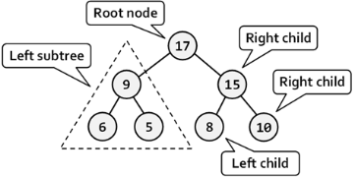
public class BinaryTreeNode<T>
protected T element;
protected BinaryTreeNode<T> left, right;
BinaryTreeNode (T obj)
element = obj;
left = null;
right = null;
public int numChildren()
int children = 0;
if (left != null)
children = 1 + left.numChildren();
if (right != null)
children = children + 1 + right.numChildren();
return children;

Binary Search Tree ADT
public interface BinarySearchTreeADT<T> extends BinaryTreeADT<T>
// Adds the specified element to the proper location in this tree.
public void addElement (T element);
// Removes and returns the specified element from this tree.
public T removeElement (T targetElement);
// Removes all occurences of the specified element from this tree.
public void removeAllOccurrences (T targetElement);
// Removes and returns smallest.
public T removeMin();
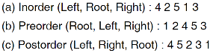
// Removes and returns largest.
public T removeMax();
// Returns reference to smallest.
public T findMin();
// Returns reference to largest.
public T findMax();
Linked Queue
public class LinkedQueue<T> implements QueueADT<T>
private int count;
private LinearNode<T> front, rear;
// Creates an empty queue
public LinkedQueue()
count = 0;
front = rear = null;
// Adds the specified element to the rear of the queue.
public void enqueue (T element)
LinearNode<T> node = new LinearNode<T>(element);
if (isEmpty())
front = node;
else
rear.setNext (node);
rear = node;
count++;
// Removes the element at front. Returns a reference to it. Throws an EmptyCollectionException if the queue is empty.
public T dequeue() throws EmptyCollectionException
if (isEmpty())
throw new EmptyCollectionException ("queue");
T result = front.getElement();
front = front.getNext();
count--;
if (isEmpty())
rear = null;
return result;
// Returns a reference to the element at front. Front not removed. Throws an
EmptyCollectionException if the queue is empty.
public T first() throws EmptyCollectionException
if (isEmpty())
throw new EmptyCollectionException ("queue");
return front.getElement();
// Returns true if this queue is empty and false otherwise.
public boolean isEmpty()
return (count == 0);
// Returns the number of elements currently in this queue.
public int size()
return count;
// Returns a string representation of this queue.
public String toString()
String result = "";
LinearNode<T> current = front;
while (current != null)
result = result + (current.getElement()).toString() + "\n";
current = current.getNext();
return result;
Circular Array Queue
public class CircularArrayQueue<T> implements QueueADT<T>
private final int DEFAULT_CAPACITY = 100;
private int front, rear, count;
private T[] queue;
public CircularArrayQueue()
front = rear = count = 0;
queue = (T[]) (new Object[DEFAULT_CAPACITY]);
public CircularArrayQueue(int initialCapacity)
front = rear = count = 0;
queue = ((T[]) (new Object[initialCapacity]));
public void enqueue(T element) // Add to rear
if (size() == queue.length)
expandCapacity();
queue[rear] = element;
rear = (rear + 1) % queue.length;
count++;
public T dequeue() throws EmptyCollectionException //Take from front
if (isEmpty())
throw new EmptyCollectionException("queue");
T result = queue[front];
queue[front] = null;
front = (front + 1) % queue.length;
count--;
return result;
public T first() throws EmptyCollectionException // Return front
if (isEmpty())
throw new EmptyCollectionException("queue");
return queue[front];
public boolean isEmpty()
return front == rear;
public int size()
return count;
public String toString()
if (isEmpty()) return “[]”; // Also shows traversing
String result = "";
if (front < rear)
for (int i = (front) % queue.length; i != rear; i = (i + 1) % queue.length)
result = result + queue[i].toString() + "\n";
else if (front > rear)
for (int i = (rear) % queue.length; i != front; i = (i + 1) % queue.length)
result = result + queue[i].toString() + "\n";
return result;
public void expandCapacity()
T[] larger = (T[]) (new Object[queue.length * 2]);
for (int scan = 0; scan < count; scan++)
larger[scan] = queue[front];
front = (front + 1) % queue.length;
front = 0;
rear = count;
queue = larger;
Big O Notation (Time Complexity)
• 1 unit time for arithmetical (+, -, *, /) and logical operations (<, >, ==, !=)
• 1 unit time for variable assignment and return
• Ex. return a + b; → T(sum) = 2 (Constant or O(1))
• Analyze time complexity for:
• Very large input (Low order variables obsolete)
• Worst case scenario (Pick time complexity of worst scenario)

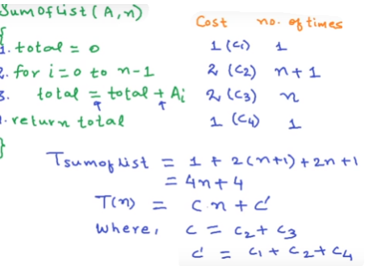
Data Structure Time Complexity
Data Structure | Access | Search | Insertion | Deletion
Array | O(1) | O(n) | O(n) | O(n)
Stack | O(n) | O(n) | O(1) | O(1)
Queue | O(n) | O(n) | O(1) | O(1)
SL-List | O(n) | O(n) | O(1) | O(1)
DL-List | O(n) | O(n) | O(1) | O(1)
BSTree | O(n) | O(n) | O(n) | O(n)
Array Sorting Algorithms
Algorithm | Time Complexity | Image
QuickSort | A: O(n log n)  W: O(n²) | 
Insertion Sort  (Stacks)(LinkedLists) | A: O(n²)  W: O(n²) | 
Selection Sort | A: O(n²)  W: O(n²)
• O($n^{2}$): Number of time innermost statement is executed.
• O($n$): Number of times inner statement is executed.
• O($logn$): If the loop variables is divided / multiplied by a constant amount.
• for (i = 1; i <= n; i *= c)
• for (i = n; i > 0; i /= c)
Insertion Sort of Stack: In → Array A storing n elements Out → Sorted array
insertionSort (A,n)
sorted = empty stack
temp = empty stack
for i = 0 to n-1 do {
while (sorted is not empty) and (sorted.peek() < A[i]) do
temp.push (sorted.pop())
sorted.push (A[i])
while temp is not empty do
sorted.push (temp.pop()) }
for i = 0 to n-1 do
A[i] = sorted.pop()
Insertion Sort of Array: In → A with n values Out → {A in increasing order}
insertionSort (A,n)
for i = 1 to n-1 do {
temp = A[i]
j = i – 1
while (j >= 0) and (A[j] > temp) do {
A[j+1] = A[j]
j = j – 1 }
A[j+1] = temp }
Selection Sort Array: In → A with n values Out → { A in increasing order}
selectionSort (A,n)
for i = 0 to n-2 do {
smallest = i
for j = i + 1 to n – 1 do {
if A[j] < A[smallest] then
smallest = j }
temp = A[smallest]
A[smallest] = A[i]
A[i] = temp }
Quick Sort of Array: In → A with n values Out → {A in increasing order}
quicksort(A,n)
If n > 1 then {
smaller, equal, larger = new arrays of size n
n_{S} = n_{E} = n_{L} = 0
pivot = A[0]
for i = 0 to n-1 do { // Partition the values
if A[i] = pivot then equal[n_{E}++] = A[i]
else if A[i] > pivot then larger[n_{L}++] = A[i]
else smaller[n_{S}++] = A[i] }
quicksort(smaller,n_{S}) // Sort smaller
quicksort(larger,n_{L}) //Sort larger
i = 0
for j = 0 to n_{S} do A[i++] = smaller[j]
for j = 0 to n_{E} do A[i++] = equal[j]
for j = 0 to n_{L} do A[i++] = larger[j] }

Binary Search Tree Comparisons: $\frac{nx}{m}$ Where ↓
• $n$ = number in level • $x$= level (root = 0) • $m$ = number in tree
• Can’t build Binary Tree given only pre and postorder (If not full)

