By Jessica T. Earl
300014123

Partners:
Zijie

CHM1311 Section B10

Acid Base Titrations

Professor:
Dr. Rashmi Venkateswaren

Demonstrators:
Ying Sun

Experiment date: November 9th 2017

Friday November 16th, 2017

Department of Chemistry

University of Ottawa

Introduction:

The objective of this experiment is to determine the concentrations of unknown acids using a standardized base (NaOH) that was standardized by a strong acid (HCl).

There are two simple theories that define acids and bases: there is the Arrhenius theory and the Bronsted-Lowry theory. The Arrhenius theory states that an acid is a species that dissociates in water and produces H⁺/H₃O⁺ ions, while a base is a species that dissociates in water and produces OH⁻ ions (“The Editors of Encyclopædia Britannica”, 2016). The Bronsted-Lowry theory states that all acids are species that must contain hydrogen and must be able to donate a proton, whereas a base is a species that has a lone pair of electrons enabling the species to accept a proton (“Bronsted-Lowry Acid Base Theory”, 2017).

Acids and bases can be classified as either strong or weak based on their capacity to dissociate. In solution, strong acids and bases will completely ionize whereas weak acids and bases only partially ionize. The weaker the acid or base, the less the species ionizes (Dunee. 2012).

For the experiment, there will be three types of acids: monoprotic, diprotic and triprotic. The definition of a monoprotic acid is an acid that can only donate one proton per dissociated molecule. A diprotic acid is an acid that can donate two protons per dissociated molecule and a triprotic acid is an acid that can donate three protons per dissociated molecule

Titration is a method that can be used to determine the unknown concentration of a solution with a known volume by adding drops of a titrant with a known concentration until the solutions reach an equivalence point. The unknown concentration of the solution can be calculated using the formula C₁V₁ = C₂V₂, where C₁ is the concentration of the titrant, V₁ is the volume of the titrant, C₂ is the concentration of the second solution and V₂ is the volume of the second solution. One can observe when the solution reaches a point of equivalence by the use of a colour indicator such as, for the purpose of this experiment, phenolphthalein (“Titration”, 2016). The solution with the unknown concentration that will be titrated through this experiment will be an unknown acid as well as a juice with a different unknown acid present inside of it. For this experiment, the titrant with a known concentration is a base, standardized NaOH.

To identify the endpoint of this experiment, phenolphthalein, a colour indicator for alkaline solutions, will be used. Phenolphthalein commences to change colour to pink at a pH of 8.5—rather close to the point of equivalence which is at a pH of 7—and can become a pink to red colour when the pH reaches 9 (“The Editors of Encyclopædia Britannica”, 2016). It is important to use phenolphthalein for the experiment as once the solution yields a pinkish hue one can be certain that the point of neutralization and equivalence—at a pH of 7—has been reached and recorded, thus indicating the end of the experiment 9 (“Titration of a Strong Acid with a Strong Base.”, 2017).

A key step for this experiment will be to standardize the solution of NaOH using the standard acid, which is HCl. The standard acid’s concentration is predetermined and will enable for the calculation of the exact concentration of the NaOH solution through the equation C_{NaOH}V_{NaOH}= C_{HCl}V_{HCl} where “C” is the concentration in mol/L and “V” is the volume in L.

Observations:

Table 1: Observations when diluting NaOH.
 | Volume (L)
NaOH (6mol/L) | 0.005
H₂O | 0.250

Table 2: Observations when standardizing NaOH with HCl.
 | Volume (L)
Volume of the standardized acid | 0.010
Amount of NaOH used after ending titration | 0.0153
Amount NaOH used when titration solution changes colour | 0.0118

Table 3: Observations when titrating unknown acid with NaOH.
 | Volume (L)
Volume of the unknown acid | 0.010
Amount of NaOH used after ending titration | 0.009
Amount NaOH used when titration solution changes colour | 0.004

Table 4: Observations when titrating juice with NaOH.
 | Volume (L)
Volume of the juice | 0.010
Amount of NaOH used after ending titration | 0.0121
Amount NaOH used when titration solution changes colour | 0.009

Figure 1: Trial 1 data demonstrating the pH and First Derivative of the pH for the standardization of NaOH by a strong acid.

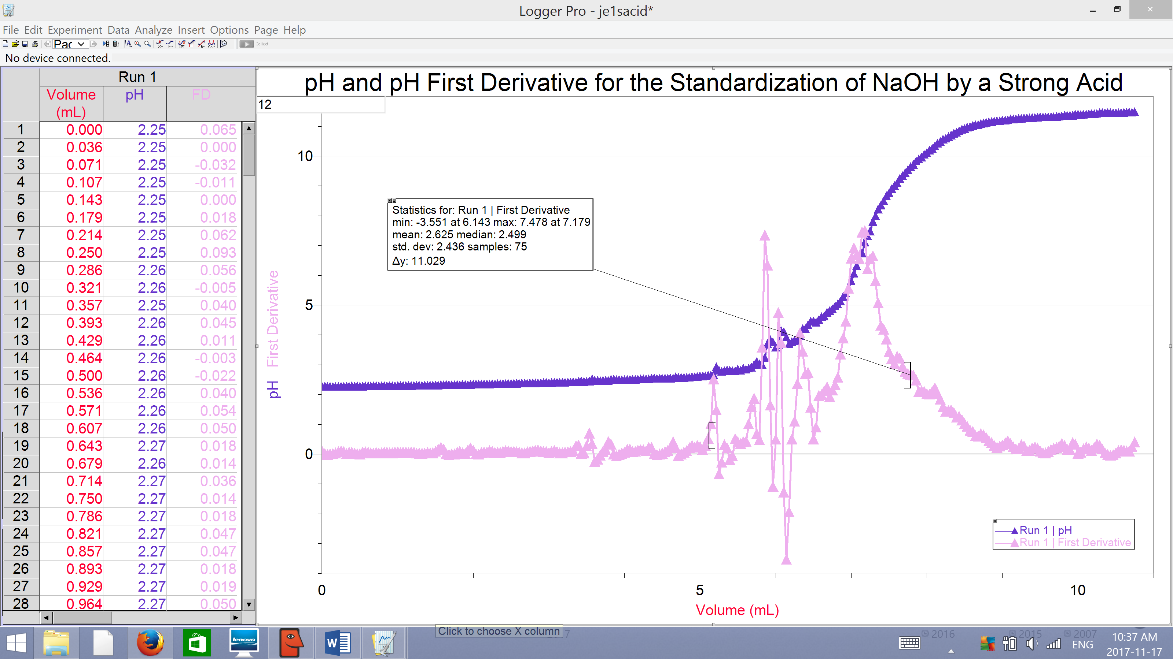Figure 2: Trial 1 data demonstrating the pH and First Derivative of the pH for the titration of an unknown acid by NaOH.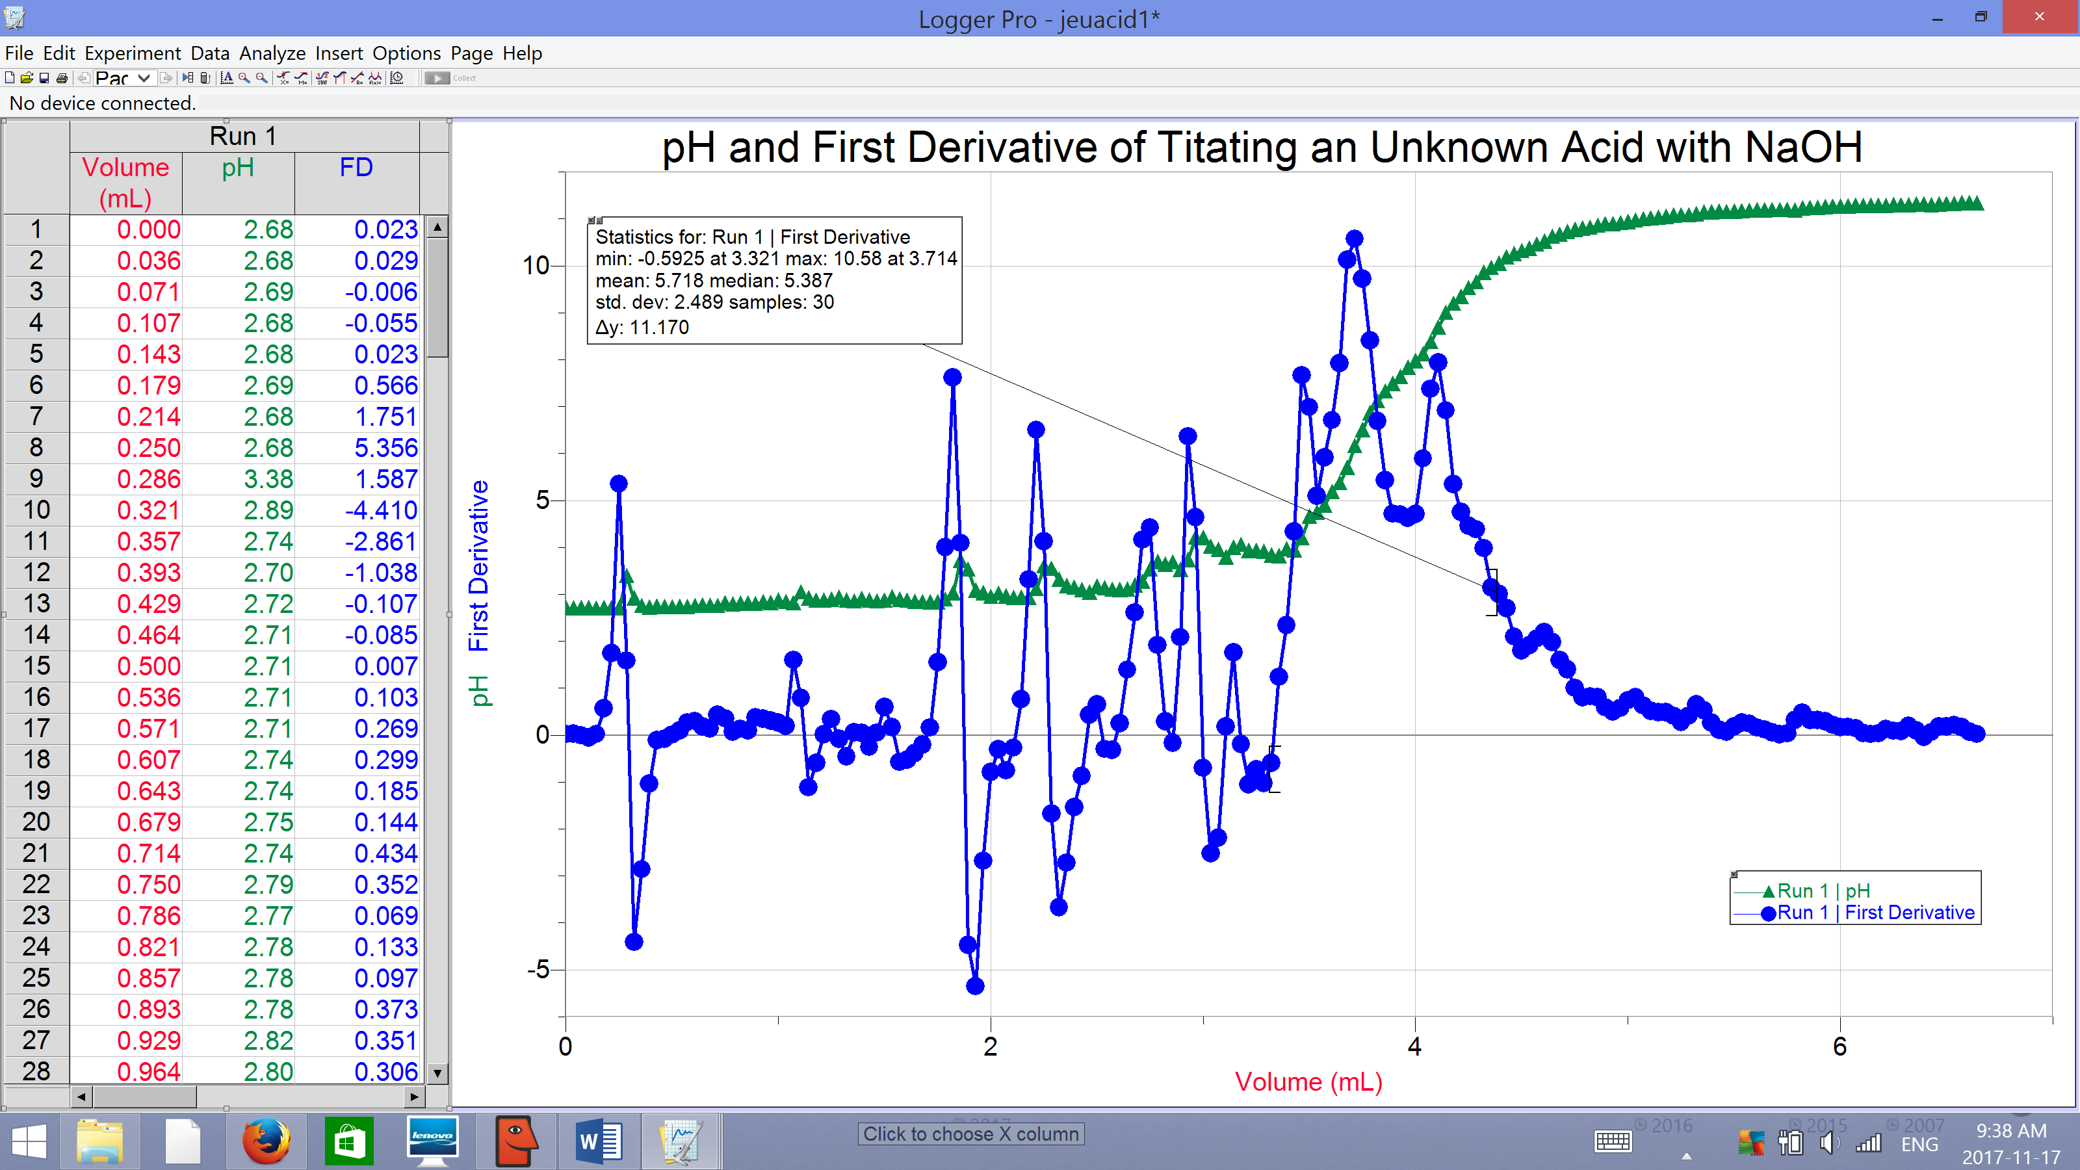

Figure 3: Trial 1 data demonstrating the pH and pH First Derivative of the pH for the titration of juice #2 by NaOH.
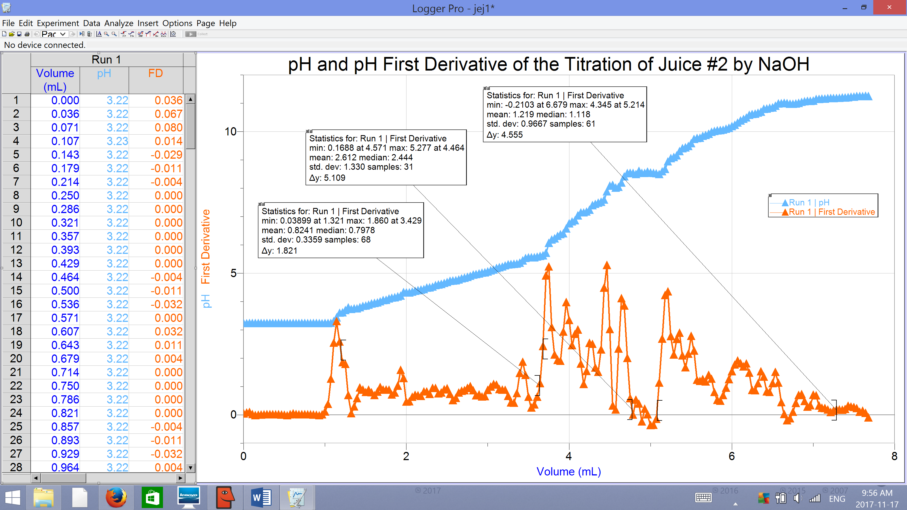

Figure 4: Trial 2 data demonstrating the pH and First Derivative of the pH for the standardization of NaOH by a strong acid.
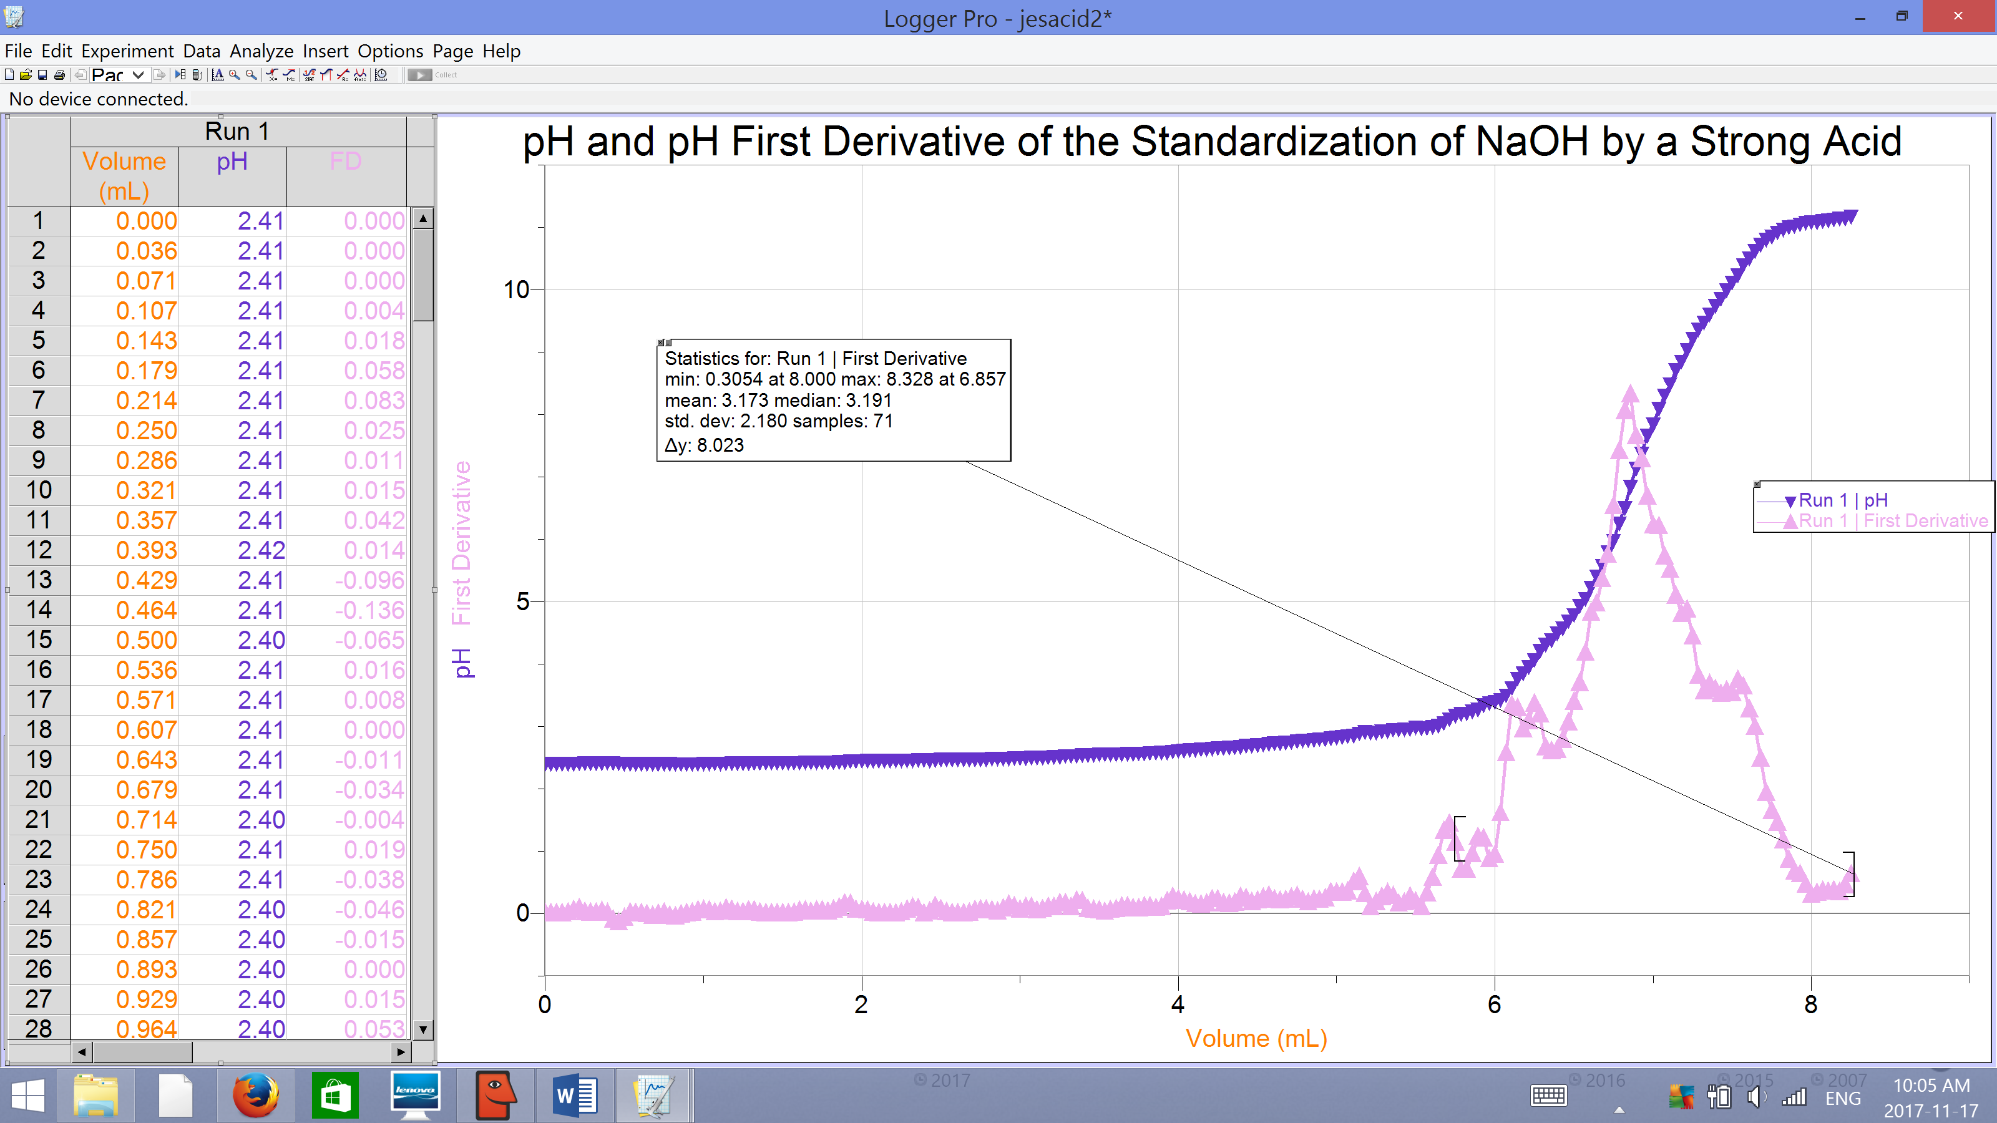

Calculations:

- To calculate the concentration of NaOH one must use the equation C₁V₁=C₂V₂ where “C” represents concentration (mol/L), “V” represents volume (L), the subscript 1 represents NaOH and the subscript 2 represents the final solution. To demonstrate:
C₁V₁ = C₂V₂
(6 mol/L)(0.005L) = C₂ (0.255L)
C₂ = 0.11765 mol/L
- The equation that represents the standardization of NaOH using the strong acid (HCl) is demonstrated as :
NaOH (aq) + HCL (aq) NaCl (aq) + H₂O (l)

As the stoichiometric coefficient ratio between NaOH and HCl is 1:1, to calculate the concentration of NaOH one must use the equation:
C_{NaOH} = (V_{HCl}·C_{HCl})/ V_{NaOH}
Referencing the data from LabQuest 2, at the point of equilibrium, the volume of the base (NaOH) for trial 1 is 7.179 ml. Thus, one would calculate the concentration of NaOH in trial 1 using the following method:
C_{NaOH} = (V_{HCl}·C_{HCl})/ V_{NaOH}
C_{NaOH} = ((0.010 L) (0.1 mol/L)) / (0.007179 L)
C_{NaOH} = 0.1393 mol/L
For trial 2, one would repeat the following calculation using the volume of the base at the point of equilibrium specific to this trial, which is 6.857 ml.
C_{NaOH} = (V_{HCl}·C_{HCl})/ V_{NaOH}
C_{NaOH} = ((0.010 L) (0.1 mol/L)) / (0.006857 L)
C_{NaOH} = 0.1458 mol/L
The average for the concentrations of NaOH for both trials can be calculated using the summation of both calculated concentrations divided by 2. For example:
Average C_{NaOH} = (C_{NaOH} from trial 1 + C_{NaOH} from trial 2) / 2
Average C_{NaOH} = (0.1393 mol/L + 0.1458 mol/L) / 2
Average C_{NaOH} = 0.1426 mol/L

Thus far, for the standardization of NaOH by strong acid (HCl), the following data has been recorded and calculated:
Table 5:
 | C_{HCl} (mol/L) | V_{HCl} (L) | V_{NaOH} (L) | C_{NaOH} (mol/L)
Trial 1 | 0.1 | 0.010 | 0.007179 | 0.1393
Trial 2 | 0.1 | 0.010 | 0.006857 | 0.1458
Average | - | - | - | 0.1426

- To calculate the concentration of the unknown diprotic acid (H₂A), one must consider the following equation:

H₂A (aq) + 2NaOH (aq) Na₂A (aq) + 2H₂O (l)

The stoichiometric ratio of the coefficients of the unknown acid to base is 1: 2, therefore to calculate the concentration of the unknown acid H₂A we use the following equation:
V_{NaOH}·C_{NaOH} = 2·V_{H2A}·C_{H2A}
C_{H2A} = (V_{NaOH}·C_{NaOH}) / (2·V_{H2A})
To demonstrate, the calculation for the concentration of the unknown acid in trial 1 is calculated below using recorded value for the volume of unknown acid used, 0.010 L, the calculated average value of the concentration of NaOH as well as the volume of NaOH at equilibrium, 3.714 ml, calculated by LabQuest2:

C_{H2A} = (V_{NaOH}·C_{NaOH}) / (2·V_{H2A})
C_{H2A} = ((0.003714 L)(0.1426 mol/ L))/(2· 0.010 L)
C_{H2A} = 0.0265 mol/L

Thus far, for the titration of H₂A by NaOH, the following data has been recorded and calculated:
Table 6:
 | V_{NaOH} (L) | C_{NaOH} (mol/L) | V_{H2A} (L) | C_{H2A} (mol/L)
Trial 1 | 0.003714 | 0.1426 | 0.010 | 0.0265

- As the juice contains citric acid (H₃C₆H₅O₇), to calculate the concentration of the acid in the juice, one must consider the following equation:
H₃C₆H₅O₇ (aq) + 3 NaOH (aq) Na₃C₆H₅0₇ (aq) + 3 H₂O (l)
Since the stoichiometric ratio of the coefficient of acid and base is 1:3, to calculate the concentration of acid, one must use the following equation:
V_{NaOH}·C_{NaOH} = 3·V_{H3C6H5O7}·C _{H3C6H5O7}
C _{H3C6H5O7} = (V_{NaOH}·C_{NaOH})/ (3·V_{H3C6H5O7})
To demonstrate, below is the calculation for the concentration of the acid in the juice for trial 1 using the volume of the base that is calculated by Labquest2 at the second point of equivalence, 4.464ml, the average concentration of the base and the volume of the juice:
C _{H3C6H5O7} = (V_{NaOH}·C_{NaOH})/ (3·V_{H3C6H5O7})
C _{H3C6H5O7} = ((0.00464 L · 0.1426 mol/L)/ (3·0.010 L)
C _{H3C6H5O7} = 0.0221 mol/L
- To calculate the mass percentage of the acid, one must use the density of the juice and calculated concentration of the acid in the juice. The mass percent of the acid in the juice is calculated using the following equation:
Mass Percent of Acid in Juice = (C _{H3C6H5O7} mol/L) (MM _{H3C6H5O7} g/mol) x100
(density_{juice}, g/ml)x1000

To demonstrate, below is the calculation for the mass percent of acid in the juice:

Mass Percent of Acid in Juice=((0.0221 mol/L·192.14 g/mol)/((0.9993 g/ml)·1000))x100
Mass Percent of Acid in Juice= 0.4249%

Discussion:

For this experiment, titration of strong acids and base methods were used to determine the concentrations of unknown acids, including the acid that was present in the juice #2. It was necessary to note the volume of the concentrated NaOH used at the very beginning of the experiment as the volume of the NaOH was used to calculate the concentration of the pre-standardized dilute base through the equation C₁V₁ = C₂V₂ where “C” represents concentration (mol/L), “V” represents volume (L), the subscript 1 represents NaOH and the subscript 2 represents the final solution. The concentration of the pre-standardized dilute base was calculated so that one could compare it with the standardized concentration of base that was later calculated. Once the standardized concentration of base was calculated, one could use the standardized concentration of base to calculate the concentration of unknown acids using the equation C_{acid}V_{acid} = C_{base}V_{base}. The pre-standardized concentration of the base is 0.11765 mol/L and the average standardized concentration of the base is calculated to be 0.1426 mol/L. Errors such as inaccuracies from the design of the experiment can affect the concentrations obtained and can account for the discrepancies between trials 1 and 2 for the values of the volumes of the NaOH at the point of equivalency during standardization. An error to explain this would be a failure in the design of the stirrer plate as the magnetic stirrer demonstrated very inconsistent (slower) speeds which would have affected how well the base mixed into the solution and thus would have enabled more volume of the base to enter the solution and stay near the top of the solution affecting the total pH reading of the solution and delaying the solution to change colour indicating the endpoint. Do to this error, the total volume of base required for the solution to reach a point of equivalence may have been met well before the phenolphthalein indicated an endpoint, thus increasing the volume of NaOH recorded and consequentially increasing the concentration of the acids as the error is carried out through calculation. Some other errors can include reaction times to stop the dripping of NaOH into the acids once the indicator indicates that the endpoint has been reached by changing to pink. Slow reaction time to stop the addition of NaOH will increase the recorded volume of base used until the point of equivalence to a point that ishigher than it actually is, which will increase the concentrations of the acids through calculations. There might have been error as well in the calibration of the drop counter as the value recorded in the 10ml graduated cylinder could only be measured to one decimal place. Logger pro’s accuracy for volume, in the case of the experiment 9ml, equating a certain number of drops, in the case of the experiment 165 drops, may have been inaccurate. If the volume of base was lower than the amount of drops, this would have carried through in the calculations and decreased the calculated concentration of unknown acid which would explain why the volumes of base at the equivalence point recorded by logger pro were lower than the ones recorded through observation. To improve the experiment, one could use equipment with more precise readings, and possibly also manually stir the solution improve the distribution of base throughout. More trials can also be performed to determine the most precise and accurate set of data, which would yield a more precise and accurate concentration of unknown acids and juice acids.

The volumes at the equivalence point determined by Logger Pro /LabQuest2 are comparably smaller to the values that were observed. To explain this one can look at trial 1 for the standardization of NaOH by a strong acid. While the Logger Pro determined that the point of equivalence for the standardization of NaOH was when 0.007179 L of base was mixed into solution, the amount of NaOH used that was recorded by the method of observation was 0.0118L. Though the two values of relatively close, the difference would have affected the concentration of the standardized NaOH making it 0.0847 as opposed to 0.1393. As a result, had we used the observed value of the volume of NaOH at equivalence point as opposed to the one determined by Logger Pro, the average standardized concentration of NaOH would increase. As the standardized concentration of NaOH is used to calculate the unknown concentrations of all the acids using the equation C_{acid}V_{acid} = C_{base}V_{base}, an increase in the average standardized concentration of NaOH would also increase the calculated concentrations of all unknown acids.

To calculate the Mass Percent of the juice, a key thing to remember is that the density of the juice is given in g/cm³. As 1ml =1cm³, the density units can then be converted to g/ml. However, as the concentration of the acid is in mol/L, the density units must be converted to g/L so that the L from the unit of density and the unit of the concentration of acid cancels out. To convert the density units of the juice to g/L one must multiply the density by 1000 as there are 1000ml in 1 L.

The titration of juice #2 in this experiment is a titration of a weak acid, citric acid, with a strong base, NaOH. Citric acid, H₃C₆H₅O₇ is a polyprotic acid which has three ionizable acidic hydrogen atoms and three pKa values (3.14, 4.75, and 6.40) (Cash, David. 2015). Citric acid reacts with NaOH and produces different species according to the following reactions:
H₃C₆H₅O₇ (aq) + OH⁻ (aq) H₂C₆H₅O₇⁻ (aq) + H₂O (l)
H₂C₆H₅O₇⁻ (aq) + OH⁻ (aq) HC₆H₅O₇²⁻ (aq) + H₂O (l)
HC₆H₅O₇²⁻ (aq) + OH⁻ (aq) C₆H₅O₇³⁻ (aq) + H₂O (l)
Therefore:
- At 0 ml of add base: there is 100% of H₃C₆H₅O₇ and there is 0% of H₂C₆H₅O₇⁻ and of other species. This is because there is no NaOH in the solution, thus there is no neutralization reaction.

- At midway to the first equivalent point: there are two species in the solution H₃ C₆H₅O₇ and H₂C₆H₅O₇⁻ . At this point there is approximately 50% of H₃C₆H₅O₇ and 50% H₂C₆H₅O₇⁻ or the ratio of H₃C₆H₅O₇ to H₂C₆H₅O₇⁻ is 1:1. This is because at this point, the amount of base added is enough to convert only 50% of H₃C₆H₅O₇ to H₂C₆H₅O₇⁻ according to the following reaction:
H₃C₆H₅O₇ (aq) + OH⁻ (aq) H₂C₆H₅O₇⁻ (aq) + H₂O(l)
At this point pH=pKa₁

- At the first equivalent point: there is 100% of H₂C₆H₅O₇⁻ and 0% of H₃C₆H₅O₇. This is because at this point there were enough of base (OH⁻) added to convert all of H₃C₆H₅O₇ in the solution to H₂C₆H₅O₇⁻ according to the following reaction:
H₃C₆H₅O₇ (aq) + OH⁻ (aq) H₂C₆H₅O₇⁻ (aq) + H₂O (l)

- At midway to the second equivalent point
there are two species in the solution H₂C₆H₅O₇⁻ and HC₆H₅O₇²⁻. At this point there is 50% of H₂C₆H₅O₇⁻ and 50% of HC₆H₅O₇²⁻ or the ratio of H₂C₆H₅O₇⁻ to HC₆H₅O₇²⁻ is 1:1. This is because at this point, the amount of base added is enough to convert only 50% of H₂C₆H₅O₇⁻ to HC₆H₅O₇²⁻ according to the following reaction:
H₂C₆H₅O₇⁻ (aq) + OH⁻ (aq) HC₆H₅O₇²⁻ (aq) + H₂O (l)
At this point pH=pKa₂

- At the second equivalent point: there is 100% of HC₆H₅O₇²⁻ and 0% of H₂C₆H₅O₇⁻ . This is because at this point there were enough of base (OH⁻) added to convert all of H₂C₆H₅O₇⁻ in the solution to HC₆H₅O₇²⁻ according to the following reaction:
H₂C₆H₅O₇⁻ (aq) + OH⁻ (aq) HC₆H₅O₇²⁻ (aq) + H₂O (l)

- At midway to the third equivalent point: there are two species in the solution, HC₆H₅O₇²⁻ and C₆H₅O₇³⁻ . At this point there is 50% of HC₆H₅O₇²⁻ and 50% of C₆H₅O₇³⁻ in the solution or the ratio of HC₆H₅O₇²⁻ to C₆H₅O₇³⁻ is 1:1. This is because at this point, the amount of base added is enough to convert only 50% of HC₆H₅O₇²⁻ to C₆H₅O₇³⁻ according to the following reaction:
HC₆H₅O₇²⁻ (aq) + OH⁻ (aq) C₆H₅O₇³⁻ (aq) + H₂O(l)
At this point pH=pKa₃

- At the third equivalent point: there is 100% of C₆H₅O₇³⁻ and 0% of HC₆H₅O₇²⁻ . This is because at this point there are enough of base (OH⁻) added to convert all of HC₆H₅O₇²⁻ in the solution to C₆H₅O₇³⁻ according to the following reaction:
HC₆H₅O₇²⁻(aq) + OH⁻ (aq) C₆H₅O₇³⁻ (aq) + H₂O (l)

Conclusion:

The objective of this experiment was to determine the concentrations of unknown acids using a standardized base through titration methods. The base equation that was used to determine all the concentrations of the acids was C_{base}V_{base} = b/a · C_{acid} · V_{acid} where “C” is the concentration in mol/L and “V” is the volume in L, “b” is the coefficient of the base in the equation and “a” is the coefficient of the acid. This equation allowed for the determination of polyprotic acids. The results show that the concentration of the unknown acid is 0.0265 mol/L, the concentration of the juice is 0.0221 mol/L and the mass percent of acid in the juice is 0.4249%. The differences between the point of equivalence recorded through observation in the experiment and between the recorded values on logger pro is evidence that experimental error occurred throughout the experiment. Some of these errors can include reaction times to stop the dripping of NaOH into the acids once the indicator indicates that the endpoint has been reached by changing colour. A slow reaction time to stop the addition of base will make the volume of base used until the point of equivalence higher than it actually is, which will increase the concentrations of the acids. There might have been error as well in the calibration of the drop counter as the value recorded in the 10ml graduated cylinder could only be measured to one decimal place. Thus, logger pro’s accuracy for volume, in the case of the experiment 9ml, equating a certain number of drops, in the case of the experiment 165 drops, may have been inaccurate. If the volume of base was lower than the amount of drops, this would have carried through in the calculations and decreased the calculated concentration of unknown acid which would explain why the volumes of base at the equivalence point recorded by logger pro were lower than the ones recorded through observation. To improve the experiment, one could use equipment with more precise readings. More trials can also be performed to determine the most precise and accurate set of data, which would yield a more precise and accurate concentration of unknown acids and juice acids. To explain why there are differences between the concentration values of NaOH in trials 1 and 2, one can look at the failure in the design of the stirrer plate as the magnetic stirrer slows down throughout the experiment, which would have affected how well the base mixes into the solution and thus would enable more volume of the base to enter the solution and reside on the top of the solution, affecting the total pH reading of the solution and delaying the indication of the endpoint by phenolphthalein and would consequentially increase the concentration of the acids as the error is carried out through calculation. To improve this aspect of the experiment, one could manually stir the solution along with the stirrer plate.

Work Cited

“Acid Base Titration End Point Detection.” Titrations.info, Chem Buddy, 6 Apr. 2012,
www.titrations.info/acid-base-titration-end-point-detection.

Barnum, Dennis W.; Predicting Acid-Base Titration Curves without Calculations. Journal of
Chemical Education 1999, 76 (7), 938.

Cash, David. “Acid-Base Titrations with Citric Acid.” Chem13 News, University of Waterloo, 8
Dec. 2015, uwaterloo.ca/chem13news/acid-base-titrations-citric-acid-part-1.

Dunee. “Difference Between Strong and Weak Acids and Bases.” Difference Between,
Difference Between, 23 Apr. 2012, www.differencebetween.com/difference-between-strong-and-vs-weak-acids-and-bases/.

Petrucci, et al. General Chemistry: Principles & Modern Applications. 9th ed. Upper Saddle
River, New Jersey: Pearson/Prentice Hall, 2007.

The Editors of Encyclopædia Britannica. “Arrhenius Theory.” Encyclopædia Britannica,
Encyclopædia Britannica, Inc., 12 June 2016, www.britannica.com/science/Arrhenius-theory.

The Editors of Encyclopædia Britannica. “Phenolphthalein.” Encyclopædia Britannica,
Encyclopædia Britannica, Inc., 19 Apr. 2016, www.britannica.com/science/phenolphthalein.

“Titration.” Chemistry LibreTexts, MindTouch, 12 July 2016,
chem.libretexts.org/Demonstrations_and_Experiments/Lab_Techniques/Titration.

“Titration of a Strong Acid with a Strong Base.” Khan Academy, Khan Academy, 2017,
www.khanacademy.org/science/chemistry/acid-base-equilibrium/titrations/v/titration-of-a-strong-acid-with-a-strong-base.



