ENV1101 Final Exam Study Guide
- Environmentalism: what it is, basic principles
- Water: groundwater, properties, threats, watershed
- Ag: Green revolution, soil, degradation
- Population: impacts
- Energy: energy production, types, dams
- Atmosphere: ozone, GHGs, precipitation
Numbers and percentages only for WATER lecture
- First paragraph of each chapter

Ecology
- Beliefs, theories, and projects that consider humankind as a component of a broader ecosystem and wish to maintain the system’s balance in an evolutionary perspective.
- Environmentalism in theory
Environmentalism
- A movement to preserve the health of Earth and its ecosystems
- Refers to all forms of collective behaviour that aim to correct destructive forms of relationship between human action and its natural environment
- Ecology in practice
Principles:
1. Ethical ecological stewardship
2. Respect for other species
3. Wilderness as spiritual haven

Nature Deficit Disorder
- Refers to the phrase coined by Richard Louv in his book Last Child in the Woods that human beings are spending less time outdoors resulting in a wide range of behavioral problems.
1700’ s-1800:
- Associated with the frontier ethic characterized by efforts to tame and conquer the wilderness. Environmental laws of this period were intended to promote the extraction of the continents abundant natural resources.
1800’s: Preservationism
- Was aimed to regulate resource use and mitigate some of the environmental problems associated with Western expansion. Policies were influences by the emergence of the conservation and preservation ethics.
- Conservation movement
  - Pollution affecting human health
  - Manage resources for future (e.g. Clifford Sifton)
- Preserve wilderness for public use
- E.g. Henry David Thoreau; Mary Hunter Austin, John Muir
1960s: Oriented toward public action, influencing policy, confronting industry
Rachel Caron: Fought against DDT, declining birds
Recent:
- Ecofeminism: women and nature have historically been dominated by men
- environmental scepticism : Overstatement of environmental issues
- Anti-environmentalism: Change is inevitable, humans exaggerated sense of importance

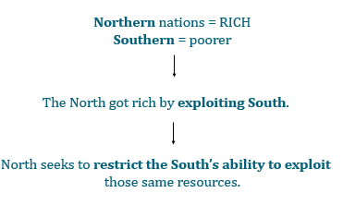
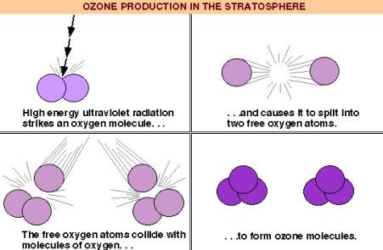

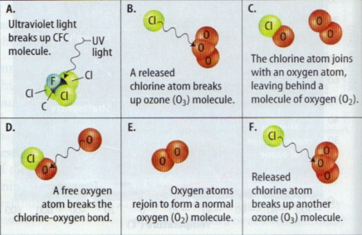
Greenhouse Effect
The sun radiates energy onto the planet. Plants, water, etc. absorb some of the energy, and the rest is reflected back into the atmosphere. Naturally existing gases in the atmosphere prevent some of the reflected energy from leaving and thus warm the earth. The use of fossil fuels has increased the level of these gases in the atmosphere and thus fueled the greenhouse effect.
Air Pollution & Global Climate Change
IPCC: Intergovernmental Panel on Climate Change

Carbon + Temperature = Climate Change Clues
- When the carbon dioxide concentration goes down, temperature goes down. A small part of the correspondence is due to the relationship between temperature and the solubility of carbon dioxide in the surface ocean, but the majority of the correspondence is consistent with a feedback between carbon dioxide and climate.

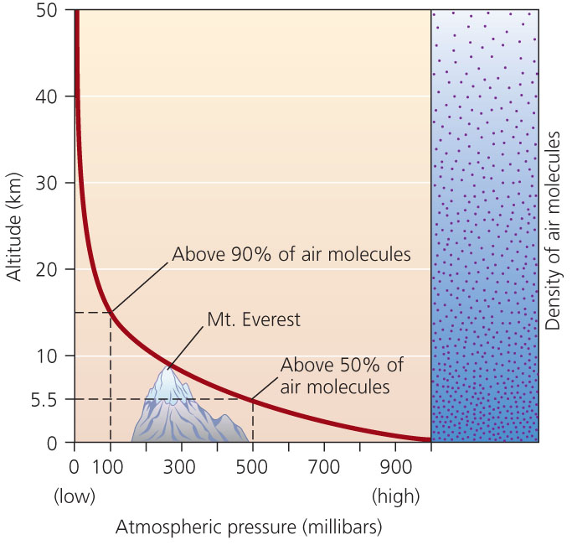
Atmospheric Properties:
  - Atmospheric pressure
  - Relative humidity
  - Temperature
The atmosphere drives weather & climate
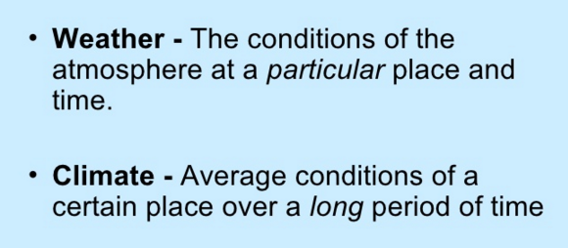
Air masses interact to produce weather
Front
- Boundary between air masses with different temp and moisture
Large scale circulation systems produce global climate patterns
Latitude & angle of sun rays : [56°] Fort Severn, ON (tundra) vs Glasglow Scotland (habitable)
- Tilt of sun during seasons
- Milankovich Cycles: Influence amount of solar radiation earth receives
  - Earth’s orbit is not perfectly round
    - Cycle = 100,000 years
  - Earth’s angle of tilt varies
    - Cycle = 40,000 years
  - Earth wobbles
    - Cycle = 26,000 years
Elevation & altitude
Topography : Mountain range, coastal region
Effects of Geogrpahy : “Lake effect”, coastal regions, tornado alley
Greenhouse gases/Climate change over time (Forcing agents) : Rising temp
Additional
- Albedo
  - Fraction of solar energy reflected from the Earth back into space
  - Have had a cooling effect that has counteracted about half of the warming caused by the build-up of greenhouse gases
- Volcanic Activity

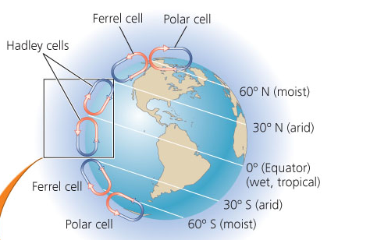
ENSO El Niño Southern Oscillation
Anthropogenic (human induced) Climate Change
- Increasing greenhouse gas levels, thus increasing greenhouse effect
- Resulting conditions
  - Warmer days & nights
  - Fewer colder days
  - More droughts, extreme storms
  - Rising sea levels
Vulnerability = potential for harm or loss
- To sea level rise:
  - Exposure & sensitivity similar to Holland and Bangladesh
  - Different adaptive capacities in vulnerable regions
Climategate
- Emails between scientists trying to hide parts of data/misrepresent data
Responding to Climate Change
  - Adaptation
    - Adjust and reduce vulnerability
    - E.g. Forest Change Canada
  - Intervention
    - Large scale technological modifications
    - Cloud seeding, pumping liquid CO₂ into rocks and deep ocean
  - Mitigation
    - Reduce greenhouse gases
UN Framework Convention on Climate Change
- Keep track of greenhouse gas emissions
- Prevent dangerous accumulation of greenhouse gases
- Assist vulnerable countries in adapting to the impacts of climate change
- Meet each year to discuss how to implement the convention (called COPs)
Kyoto Protocol
- 1997 at COP-3
- Greenhouse Gases
- Industrialized nations have mandatory targets
- “Annex I countries” collectively agreed to reduce their emissions to 5% below 1990 levels by the period 2008-2012
- Canada Target: 94% of 1990 emissions
- Developing countries have no mandatory targets
- No fossil fuel substitutes of equal caliber
- Measureable changes in CO₂
- Poor compliance
- Emissions RISING globally
Montreal Protocol
- Reduce the production/consumption of ozone depleting substances in order to reduce their abundance in the atmosphere
- 1987, signatory nations (197)
- ALL nations mandatory targets, industrialized nations required to act 1st
- Cut CFC production in HALF
- Countries can plead for exceptions
- Available CFC substitutes
- Measureable changes in ozone layer
- High level of compliance
- Emissions FALLING globally
Water Resources & Pollution
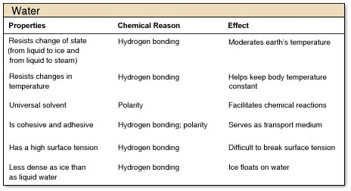
Water Availability around the World
97.5% Salt water
1.7% Polar ice caps & glaciers
2.5% Fresh water
0.77% ACCESSIBLE Fresh water
Human Stresses on Water
- Overuse
- Pollution
- Climate Change
Water SOURCES
- Groundwater
  - 98% of all liquid freshwater
  - Recharges through percolation SLOWLY
  - Overdrawing = Global problem
    - Falling water tables → Depleted resources
    - Saltwater intrusion
    - Diminishing surface waters &wetland ecosystems
    - Land subsidence (ground caving in)
- Surface water
  - Harnessed through damns, diversions, channelization

Dams: Benefits vs Drawbacks
PROS | CONS
- Water storage  - Flood Control  - Irrigation  - Increased/improved farmland & navigation | - Ecological disruption  - Fragmentation of rivers, species displacement, vegetation destruction  - Seepage & evaporation  - Erosion downstream by sediment-starved waters  - Failure of dam = Massive flood

Three Gorges Dams: Benefits vs Drawbacks
PROS | CONS
- Power  - Flood Control  - Navigation | - Methane  - Ecosystem  - Heritage  - People

Desalinization: The removal of salt from seawater
Distilling: Hastens evaporation and condenses the vapor
Reverse Osmosis: Forces water through membranes to filter out salts
Best way to save water: minimize inefficiencies
Best way to manage water more sustainably: Drinking & wastewater RATES
- Reduce consumption/demand in: agriculture, municipal use, industry
  - Appropriate water pricing / reduce subsidies
  - Privatization
  - International aid
Water Poverty Index: Canada ranks 2nd best of 147 countries
- Resources
- Access
- Capacity
- Use
- Environment
      - Strong correlation between water poverty and INCOME poverty
Water Pollution
- Excess nutrients
- Pathogens & waterborne diseases
- Toxic chemicals
- Suspended matter
- Thermal pollution
Drinking Water Contaminated by Excreted Drugs
- Most treatment plants do NOT filter out pharmaceuticals.
- There are NO national drinking water STANDARDS for pharmaceuticals
Perfluoroalkylated Substances (PFAs)
- Used in industrial & consumer products
  - Adhesives, cosmetics, cleaning products and firefighting foams
  - Some spread on Canadian farmland
Point vs Non-point Sources
Non-point = Diffused =Land runoff
- Caused by rainfall or snowmelt moving over and through the ground
Point = Single spot source = Industrial and sewage treatment plants

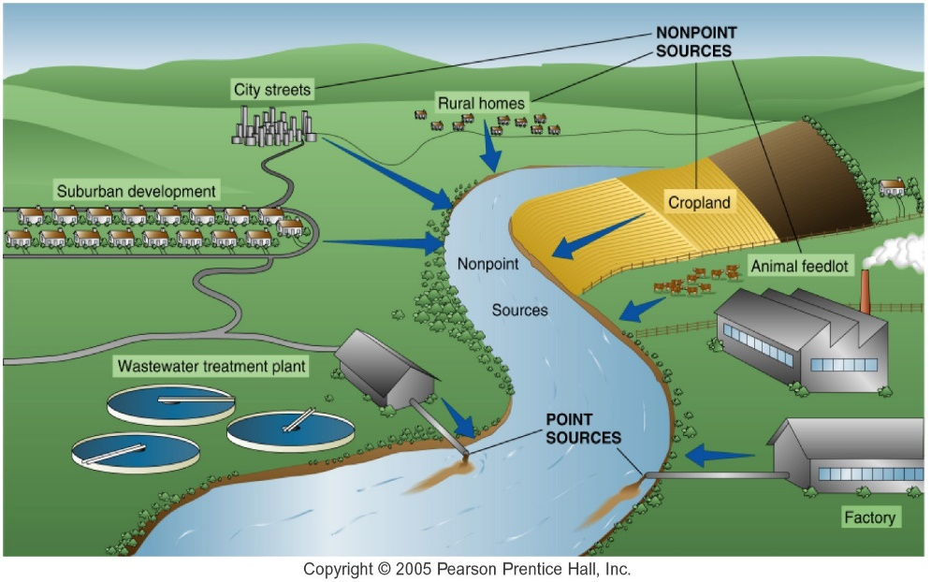
Unsanitary water
- Increased disease
- More toxins in environment

India + Water
- More people have cell phones than toilets
- Open defection
- Large portion of the population is poor
  - More vulnerable
  - Unable to adapt toilet/social norms = hindrance
  - Loss of productive time
    - Sick = unable to work
    - Children not in school so they can retrieve water
Evolution of Sewage Capture & Treatment
- No capture
  - Wastewater collects in low-lying areas
- Storm drains and collection sewers built
- Interception trunk & treatment center built
Abortion Politics
- Decision context characterized by either lack of values consensus or HIGH uncertainty
Tornado Politics
- Decision context characterized by either values consensus and LOW uncertainty
New York Watershed Controversy
- EPA orders NYC to construct a water filtration system
- City petitions the EPA and proposes to control water quality upstream rather than pay for expensive filtration system

Upstream (rural) = Rights-based ethics
Downstream (urban) = Utilitarian
Result:
- MYC Memorandum of Agreement – MOA
- NYC agreed to provide economic development funds to the watershed towns in exchange for accepting the regulations, and eminent domain rights were transferred from state to local watershed communities
- The LAP institutional protections under the MOA benefitting the watershed towns could be seen as extremely forward-looking and generous, but the expanding LAP nevertheless has motivated a backlash
- Lesson #1:
Ethical traditions were at the core of the conflict
- Lesson #2:
Policy ultimately addressed these ethical dimensions
Soil & Food
Most common species of banana consumed globally: Cavendish
Green Revolution
- 1940-1960s, still continues today
- Technology transfer to developing nations
- Higher yield varieties (HYVs) introduced
- Development of new crops, pest resistance
Food Security
- Exists when all people, at all times, have physical and economic access to sufficient safe and nutritious food that meets their dietary needs and food preferences for an active and healthy life
- Dimensions
  - Availability
  - Access
  - Utilization
  - Stability
- Threats
  - Soil degradation
  - Changing diets
  - Food to energy
  - Climate Change
  - Technology (GMOs)
Soil Degradation
Soil = Mixture (system) of organic material, inorganic material, and living organisms
Maintenance of soil = Cornerstone of civilization

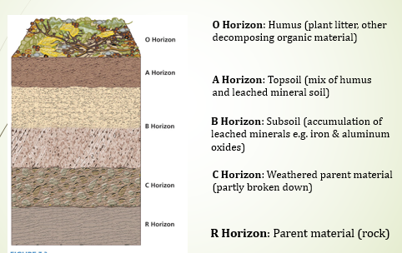
SMALLEST | Clay | Microscopic
MEDIUM | Silt | 0.002-0.02 mm
LARGEST | Sand | 0.02-2 mm

- Fertile Soil
- Availability of nutrients, minerals (P, also K, Ca)
- Ability to hold water
- Aeration
- pH near neutral (i.e. neither especially acid nor alkaline)
- Minimal amount of salt
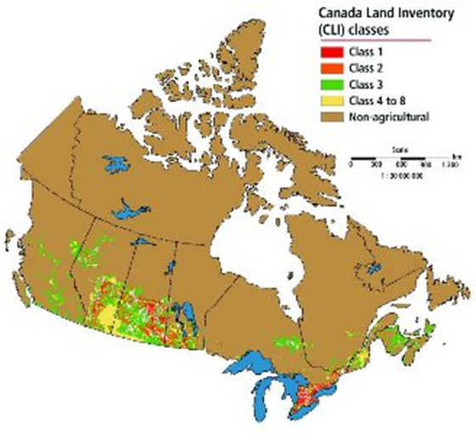

Red = Class 1 = BEST Soil
Golden horseshoe, GTA

Milorganite
- Milwaukee recycled sewage into fertilizer
Largest Contributors to Soil Degradation
- Overgrazing
- Deforestation
- Cropland agriculture
- Other overexploitation
- Industrialization
Deforestation: Removal of vegetative cover for construction
Over-cultivation
- Dust Bowl, Kansas 1930s
Over grazing
Over irrigation
Erosion
- Loss of soil fertility
  - Solution: Fertilizers
    - Problem: Eutrophication
Desertification
- Water holding capacity diminished
- Dryland
  - Cover 1/3 of Earth’s land area
  - Defined by rainfall not temperature
  - 19% of land surface threatened
^^^ These 2 threaten global food production
Changing Diets
- Demand for meat increasing
- Eating beef and pork require massive amounts of resources (specifically water)
Food to Energy
- Production of biofuels
Climate Change
- 80% of greenhouse gas emissions from food come from livestock
Tech: Genetic Modification
- GMOs allow for biofuel production
- 90% of CAD wheat is planted with normal seed
- 90% of USA soy GMO
- UN Convention on Biological Diversity
  - Recommendation: NOT to approve Terminator Technology
4 countries produce 99% of GMO Crops
- USA (68)
- Argentina (22)
- Canada
- China

