Psy1102 Midterm 2
Personality Lecture

Personality – an individual’s characteristic pattern of thinking, feeling and acting.

Freud – psychodynamic theories: personality with a focus on the unconscious and childhood experiences.
- He was a psychiatrist and a physician who specialized in nervous disorders.
  - He realized these disorders had no organic cause.
- He was a determinist – nothing happens by accident, everything has a cause.
- When you watch someone, you are making observations and inferences.
- Freud’s approach was to follow the person’s utterances back to their point of origin.
  - He named his technique psychoanalysis.
- Freud saw the unconscious as a reservoir of mostly unacceptable thoughts, feelings or theories.
  - He used the unconscious to create the iceberg analogy.

Iceberg analogy:
- Conscious process: the part we are aware of.
- The larger part of our self takes place in the preconscious or unconscious (repressed thoughts) domains.
- There are three parts to the iceberg theory.
- The Id – animalistic part. It is how one wants to behave.
- The Superego – the conscious. It is how one should behave.
- The Ego – the mediator between the id and the superego. It is how one behaves.
Example: In relation to sex, the id wants to satisfy the sex drive and the superego wants to adhere to morals.

Psychosexual stages

Stage Name
Age
Pleasure Area

Oral | 0-18 months | Pleasure focuses on the mouth.
Anal | 18-36 months | Pleasure centres on bowel and bladder control.
Phallic (for girls it is the Electra complex – however it was a male dominated society)* | 3-6 years | Pleasure zone is the genitals. Also touches on the idea that you’re jealous of your same-sex parent.
Latency | 6 to puberty | Dormant sexual feelings.
Genital | Puberty on | Maturation of sexual interests.
*Side note about women in society:
- Hysteria is derived from the Greek word for uterus.
- Women had no way to get off because sex wasn’t foreplay focuses and masturbation was heavily frowned upon.
- It is thought that many women with hysteria just weren’t satisfied sexually.

Neo-Freudians

Alfred Adler
- Believed sex wasn’t the driving thought, but that it was power.
- Coined the term inferiority complex.
Karen Horny
- Believed it was childhood anxiety that drove our need for love and security.
- Also confirmed that “penis envy doesn’t exist”
Carl Jung
- Agreed with the unconscious, however, extended it to include a collective unconscious, that is shared between the human race.

Projective Tests
- Show us one thing and have to interpret it.
- Hershaw test – ink blot

Humanistic theories
- Personality with a focus for healthy personal growth.
- From the 1960’s – focused on healthy people and not on patients.

Abraham Maslow
- The hierarchy of needs – you need to satisfy the lower needs before the top.
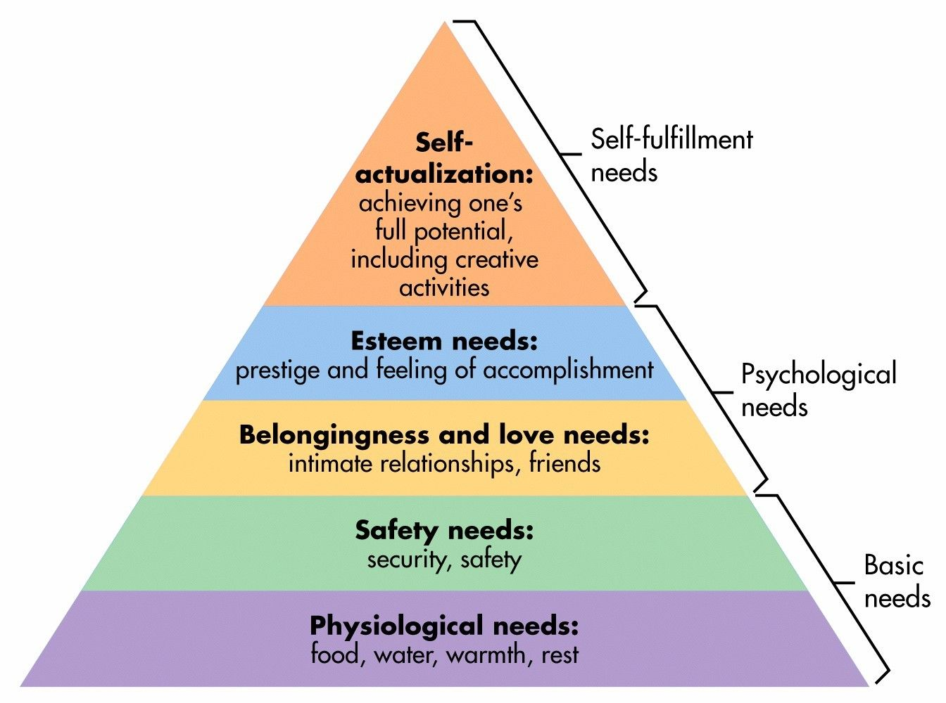

Carl Rogers
- We are fundamentally good and are primed to strive for self-actualization.
- 3 important qualities
- Genuineness – growth happens when we are open about our feelings, share information about themselves and drop their façade (social mask).
- Acceptance – unconditional positive regard.
- Empathy – active sharing of the feeling of another person.
- The assessment of personality is a constant challenge
  - Carl asked people to describe their ideal self and their actual self.
  - On the contrary to this idea, another view is that any standardized assessment of personality is depersonalising.

Trait Perspective

- Looks at a person as a group of traits that together make a person.
  - This was developed by Gordon Allport.
- The primary approach to personality types is the Myers Briggs Test
  - This is based on Carl Jung’s book who posited on an introvert, extrovert axis
  - Myers and Briggs created four types of dichotomies, which created 16 types.
    - Extrovert (E) – (I) Introvert
    - Sensing (S) – (N) Intuition
    - Thinking (T) – (F) Feeling
    - Judging (J) – (P) Perceiving
  - Feedback is given to the person after the test
Factor Analysis
- Factor Analysis is a tool that looks for clusters of attributes – between a trait and a top down approach.
  - The Eysencks believed these attributes grouped into meaningful clusters.
  - The factors seem to be genetically influenced.
- Traits are assessed by personality inventories
  - These are questionnaires to assess several traits.
- The oldest one is MMPI, which has 10 scales.
- They are backed by research but are objectively scored.
- The Eysencks two factors have been expanded to be the big five (CANOE).
  - Conscientiousness
  - Agreeableness
  - Neuroticism (emotional stability vs. instability)
  - Openness
  - Extraversion
- They cross cultures and geography.

Social Cognitive Perspective

- Started by Albert Bandura in 1980’s
- It acknowledges the existence of traits but emphasizes their interaction with situational effects.
- The behaviourist perspective posits that we are simply a black box that processes a stimulus and emits a response.
  - The social cognitive perspective says that we are not pawns to be moved by the environmental stimuli.
- Although our environment influences us, we also help create this environment.
- Our personalities shape how we interpret and react to events.
- Our personalities help create situations to which we react.
- A part of the social cognitive perspective is personal and locus of control
  - Locus of control is where control is located, whether internal of external
  - Having an internal locus of control is associated with achieving more, having better heath, and feeling less depressed.

Psychological Disorders

- At what point does a behaviour become not normal/more serious?
- How should we define, understand and classify psychological diorders.
  - This includes not labeling the disease to the person.
- Classifying psychological disorders is used with the Diagnostic and Statistical Manual of Mental Disorders. They use DNS-5.
  - In these the diagnostic labels get updated.

Anxiety Disorders

Generalized Anxiety Disorder:
- A person in a unexplained continuous tenseness, is apprehensive and in a state of autonomic nervous system arousal.
- Women are twice as likely to have it.
- Becomes fairly rare past the age of 50.

Panic Disorder
- 1 in 75 people have it.
- An anxiety disorder marked by unpredictable, minute long episodes of intense dread in which a person experiences terror and accompanying chest pain, chocking, and other frightening sensations, followed by worry about a future attack.

Phobias
- A persistent, irrational fear and avoidance of a specific object, activity or situation.

Depressive and Bipolar Disorders

Major Depressive Disorders
- Found across many cultures.
- More common for women.
- Can end with or without therapy.
- Persistent state of hopelessness or lethargy
  - Must Have 5/9 symptoms for 2 or more weeks.
    - Depressed mood
    - Reduced interest in activities
    - Challenges regulating appetite and weight
    - Challenges regulating sleep
    - Lethargy
    - Feeling listless
    - Problems concentrating
    - Thinking of death and suicide.

Persistent Depressive Disorder
- Mildly depressed mood, usually for 2 years or more
  - Experiences mildly depressed feelings
- 2 of the following symptoms
  - Difficulty in decision making
  - Feeling hopeless
  - Poor self-esteem
  - Reduced energy levels
  - Problems regulating sleep
  - Problems regulating appetite

Bipolar Disorder
- A disorder where a person alternates between the hopelessness and lethargy of depression and te over excited state of manic.
- Although episodes of depression end, instead of returning to a neutral mood, the become manic.
- Is it real?
  - Between 1994-2003, the amount of Americans diagnosed rose from 20,000 to 800,000, about 2/3 of them being boys.
  - It is twice as common in the U.S. than in other countries
  - The DSM-5 uses disruptive mood disorder for kids and adolescents.

Schizophrenia
- About 1% of the world has schizophrenia.
- A patient with positive symptoms
- They may experience hallucinations, may talk in a disordered manner, and could exhibit negative emotions.
  - This would be a patient with negative symptoms.
- Symptoms
  - Disturbed perceptions
  - One definition of hallucination is “sensory experience without sensory stimulation”
    - Can occur in vision, hearing, taste, and smell.
    - Most in schizophrenia are auditory
  - Disordered thinking and speech
  - Fragmented
  - Diminished and inappropriate emotions.
- Mostly, arrives in young people maturing into adulthood, males.
- Can appear quickly and gradually.
- Scans of people with schizophrenia have abnormal brain activity.

Dissociative Disorders
- A disorder of consciousness.
- Person is dissociated by a stressful situation.
- Getting up too quickly is dissociation.
- “Out of body”

Dissociative Identity Disorder
- Characterized by a massive dissociation of consciousness.
- A person exhibits two or more distinct personalities.
- Used to be called Multiple Personality Disorder
- Psychoanalysis’ see DID as a defense against anxiety.
  - Alternatively DID is a way to deal with PTSD especially related to childhood abuse, however we can’t predict DID.

Personality Disorders
- Antisocial personality disorder is the most troubling and researched personality disorder.
- Lack of conscious.
- Used to be labelled as psychopaths and sociopaths.

Eating Disorders

Anxiety Nervosa
- Most common among adolescents and 90% of cases are female.
- Typically begins dieting to lose weight but progresses until underweight.
- They may see themselves as overweight.
- As we need food to stay alive, many people enter a binge purge cycle.

Bulimia Nervosa
- Enters binge purge cycle but without a feeling of depression.

Binge Eating Disorder
- Binge with no purge.
- They may become overweight.

Contributing factors could be a mother who focuses on her weight or family link to an eating disorder. Culture could also be a factor.

