The following LP formulation specfies the model to maximize total profit:
Calculations & Explanations
The data are derived from 2017 Fall Mid-term. In a LP question, We only deal with:
a. Objective Function Coefficients
b. RHS value of a constraint
Part One: RHS and Shadow Price
1. Non-binding Constraint (resource-based):
Meaning: excess resources
(“I don’t mind if you continue to add more non-electric modules. I only need 3940 to maximize my profit.”)
Slack = excess resources = allowable decrease = Constraint RHS – Final optimized value
Shadow price = 0
Allowable increase = 1E+30
2. Binding Constraint: (resource-based)
Meaning: scarce resources
(“I need all of them to get this amount of profit. Do not accept any change outside my range of feasibility.”)
Final value = Constraint RHS value

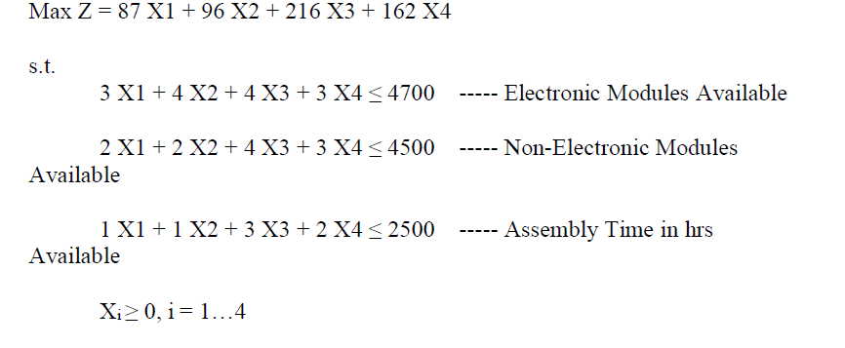
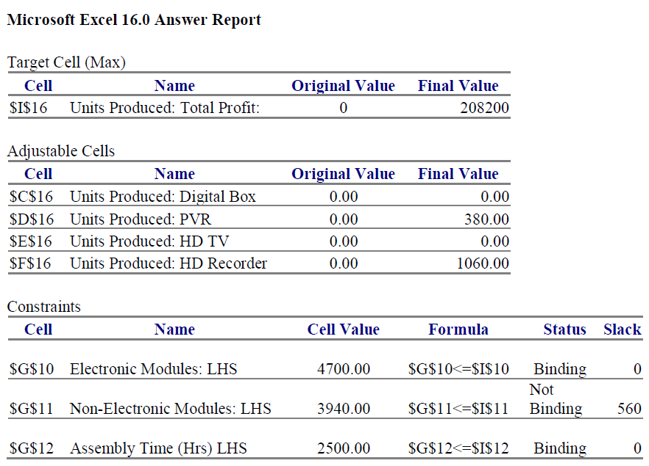
Sensitivity Report:
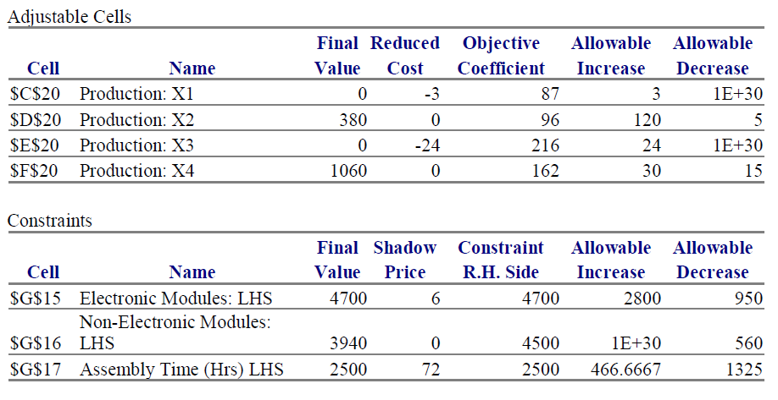
Part Two (Objective Function Coefficients, maximizing profit problem)
Reduced cost: from accounting prospective, it is the contribution margin that a business will lose if it does not engage in another specific, related activity to reverse the loss
With this in mind, we have two cases: a product has a negative or positive CM
a. Positive CM: The product is profitable reduced cost = 0 (it does not need improve its profitability)
b. Negative CM: The management will not choose to produce (original value = final value = 0)
Reduced cost = how much the product needs to improve before any production
a.k.a Reduced cost = allowable increase, Allowable decrease = 1E+30 (meaning no matter how much we further make it less profitable, the management team still will not produce)
(In a minimizing cost case, it will be reduced cost = allowable decrease)

-

