Solution


PERSONAL FINANCE - FINA200
Fall 2016, Section EC
Case 2 - due Thursday, April 6, 2017 11:59pm
Covering Chapters 7, 10, 13-15
(excluding Chapters 8, 9,11,12)
___________________________________________________________
Student Name: Student ID: ___________________________________________________________
PLEASE NOTE
- THIS IS AN INDIVIDUAL ASSIGNMENT AND MUST BE COMPLETED BY YOU ALONE.
- DO NOT FORGET TO WRITE YOUR NAME AND STUDENT ID ABOVE BEFORE SUBMITTING.
- YOUR SOLUTION MAY BE SUBMITTED IN ENGLISH OR FRENCH.
- ACCEPTABLE SUBMISSION FORMATS INCLUDE WORD or PDF. EXCEL IS NOT ACCEPTED.
- ALL RESPONSES MUST BE WRITTEN IN THE SPACES PROVIDED; THE SPACES EXPAND IF YOU NEED MORE ROOM FOR YOUR RESPONSE.
- OUTSIDE RESEARCH WILL LIKELY BE REQUIRED; PLEASE QUOTE ALL SOURCES AND DO NOT COPY AND PASTE.
- ALL RESPONSES WITH CALCULATIONS MUST BE DONE TO TWO DECIMAL PLACES.

Save your work and submit/upload the Case as: Last name First name Student ID Case 2 (example: MillerJane35439984Case2)
For Teaching Assistant’s only:
 | Student mark
Question 1 | /2.5
Question 2 | /2
Question 3 | /1
Question 4 | /1
Question 5 | /.5
Question 6 | /3
Total | /10
Please show all calculations for full marks and cite your outside sources – use templates when provided
(your eConcordia Personal Finance online textbook does not need to be referenced as a source).

Mini-Case A:
Bruno and Mary are nervous as they are meeting with their banker on Friday to obtain a pre-approved mortgage. The initial call with the banker was intimidating as the bank asked them to prepare a number of items for the meeting. Bruno and Mary reached out to you, their friend, to help them prepare for the meeting to ensure that all goes smoothly with regards to the purchase of their first home.

Bruno and Mary’s information:
- Bruno’s annual gross salary (no other sources of income): $70,000
- Mary’s annual gross salary (no other sources of income): $75,000
- Bruno and Mary split everything 50:50
Information on their dream home that they are looking to purchase:
- Home’s market value $250,000
- Down payment: $35,000 (cash in their joint savings account)
- Monthly property taxes on the home: $200
- Bruno’s monthly student loan: $65
- Mary’s monthly student loan: $10
- Monthly heating costs: $250
- Monthly car payments: $225

Question 1: (2.5 marks)
In order to be prepared for the meeting with the bank, you help Bruno and Mary with a number of key areas:

- Provide Bruno and Mary with a list of what they should bring to the bank for their mortgage application (name 4 items). (.25 mark)
1) copies of tax returns, 2) residence history, 3) employment history, 4) information about bank and investment accounts, 5) listing of debts, 6) evidence of auto and 7) any real estate ownership (page 222)

- Calculate the current loan-to-value ratio. (.25 mark)
$215,000/$250,000 = 86% (page 210)

- Calculate how much ($) is missing on their down payment for a conventional mortgage. (.5 mark)
$250,000 x 20% = $50,000 is needed as a down payment for a conventional mortgage, therefore Bruno and Mary are missing $15,000 on their down payment i.e. ($50,000 - $35,000) (page 209)

- Over the phone, the bank explained to Bruno and Mary that it is a “seller’s market”. They did not understand this term so explain to them how a seller’s market could potentially impact their offer of $250,000 and the effect on their down payment. (.5 mark)
In times of high demand for housing, Bruno and Mary’s negotiating may be limited or minimized as the home that they are looking at may receive several offers. In fact, Bruno and Mary may have to increase the offer of $250,000 which means that they would have to increase their down payment. (page 215).

- Bruno and Mary are wondering if they should be considering monthly or accelerated weekly mortgage payments. Provide which one you would recommend and why. (.5 mark)
If Bruno and Mary can afford it, accelerated payments would be recommended. Choosing accelerated payments results in more payments, which in turn shortens the amortization period saving them on interest. (page 222).

- Bruno and Mary are excited about purchasing this home together but know that they are currently in a rocky relationship. Both know that if they broke up, that neither could afford the mortgage payments on their own and that they would need to sell the house. If they obtained a closed fixed-rate mortgage with a “prepayment penalty” what would this mean if they sold before the end of the mortgage term?
(.5 mark)
They would have to pay a prepayment penalty which is the higher of 1) three month’s interest or 2) the interest rate differential; it is a charge that could cost thousands of dollars to “get out of the mortgage” early (as it is a penalty charge that is imposed by the lender if Bruno and Mary pay the mortgage loan early). (page 219)

Question 2: (2 marks)
- Bruno has a Registered Retirement Savings Plan (RRSP) with a market value of $31,335 and Mary has a RRSP currently worth $35,244. If Bruno and Mary wish to have a conventional mortgage and based on the result that you calculated in 1c) above, what is the amount that each would need to withdraw from their respective RRSP’s under the Home Buyer’s Plan (HBP)? Remember, that they split everything evenly between the two of them.
(.5 mark)
The difference to ensure that they obtain a conventional mortgage requires them to cover $15,000 as follows:
Bruno must withdraw $7,500 from his RRSP under the HBP (.25 mark)
Mary must withdraw $7,500 from her RRSP under the HBP (.25 mark)

- Under the HBP, each person can borrow a maximum of $__25,000______ from their RRSP. (.25 mark)
- Based on 2a), Bruno and Mary are ___________________. Check the correct response (.25 mark)
within the limit to borrow from their respective RRSP and can participate in the HBP.
Or
 over the limit to borrow from their respective RRSP and therefore cannot participate in the HBP
- If in 2017, Bruno does not repay his RRSP under the Home Buyer’s Plan, explain to him what will happen. (.25 mark)
Nothing happens in 2017 regarding repayment as Bruno only withdrew the funds in 2017 from the HBP (i.e. he does not need to start repaying in 2017). The funds however must be repaid over a maximum of 15 years, starting the second year following the year in which they are withdrawn. Each year that a repayment is due but that Bruno does not pay, 1/15th of the amount borrowed will be included in his taxable income. (page 209).

For example, Bruno withdrawing in 2017 from his RRSP under the HBP requires a minimum annual repayment in 2019 (i.e. 1/15th)

- Calculate the amount that Bruno needs to repay each year into his RRSP under the Home Buyer’s Plan. (.25 mark)
1/15 x $7,500 = $500/year (page 209)

- Bruno and Mary do not understand what the big deal is between a conventional mortgage and a high-ratio mortgage (i.e. non-conventional mortgage). Explain to them the key reason on why they would want a conventional mortgage. (.25 mark)
On a high-ratio mortgage, Federal law requires that mortgage default loan insurance be purchased to protect the lender should the borrower default on the mortgage payments. These insurance premiums range from .60% to 3.35% on the total loan in addition to fees charged for the application. (page 209-210)
Overall, not borrowing under a conventional mortgage arrangement is very expensive for homeowners but sometimes the only way to purchase a home.
Just a little side note: Banks could decide to charge you mortgage default loan insurance even if you have more than 20% as a down payment if you have “red flags” such as bad credit rating, you’re self-employed, you have a spotty employment history, you carry a large debt load that’s close to the threshold etc. (which is why it is so great that you are taking this course and “know” the importance of having great credit scores

- Bruno and Mary’s Total Debt Service (TDS) ratio is 40%, calculate their monthly mortgage amount (principal and interest). (.25 mark)
Calculation for the Total Debt Service (TDS): (page 210)
=Monthly principal and interest + monthly property taxes + monthly heating costs + monthly debt
Monthly gross income

40% = χ +$200 +$250 + $300
($145,000/12)
χ = $4,083.33 monthly mortgage (principal and interest)

Mini-Case B:
Lenny is 65 years old and just retired after having worked 20 years for the same Montreal company. He has a few questions for you regarding his investments and his retirement income.
Lenny’s information:
- Lenny moved from Italy to Canada 20 years ago and has been living in Quebec since.
- Lenny’s wife passed away 18 years ago, they had been married for 40 years.
- Lenny has a daughter, Sylvie who is 30 years old.

Question 3: (1 mark - .25 each) (page 432-433)
- Lenny is entitled to Old Age Security (OAS) which is based on being a __resident_____of Canada.
- If the maximum (or full benefit) for Old Age Security (OAS) was $6,800/year, Lenny would be entitled to receive _20___/40 years. Based on this, calculate his estimated Old Age Security pension benefit: _$3,400/year___.
- Lenny would also be entitled to a Quebec Pension Plan (QPP) benefit. The amount of the pension that Lenny will receive will depend on ________________________________.
how much and for how long Lenny has contributed to the QPP and on the age that he wants the pension to start.

Question 4: (1 mark)
a) Using the template below, what is Lenny’s average cost per mutual fund share for the Bank of Montreal Canadian Equity Fund under the dollar cost averaging technique. (1 mark)

Year | Investment Amount | Number of shares | Price per Bank of Montreal Canadian Equity Fund share
2017 | $4,000 | 100 | $40 per share
2016 | $4,000 | 80 | $50 per share
2015 | $4,000 | 50 | $80 per share
Total | $12,000 | Total investment amount/Total number of shares  = $12,000 /230 shares
Average cost per Bank of Montreal Canadian Equity Fund share
= $52.17 per share (1 mark)

Question 5: (.5 marks)
a) Lenny would like to leave everything to his daughter Sylvie upon his death but Lenny does not have a Will. What is the term called when someone dies without a valid Will:_to die intestate (page 453).
(.25 mark)
b) Who “steps” in when you die without a Will? (.25 mark)
If you fail to prepare a Will, the province in which you legally reside steps in and controls the distribution of your estate without regard for your wishes. (page 453)

Mini-Case C:
Question 6: (3 marks) give extra .25 to all as marks add to 2.75
In order to respond to the questions below, see Table A (at the end of Case 2) for the mutual fund information on CIBC Dividend Growth fund. The information is from Morningstar - a great investment research site.
- What is the Management Expense Ratio (MER) for this fund? 2.03% (.25 mark)
- What is the reported fund’s return since its inception? 7.48% (.25 mark)
- Knowing what you have learned about MER, has the MER in 6a) been deducted in the reported fund’s performance returns in 6b)? (.25 mark)
Yes or No (circle the correct response) Yes
- What is the minimum investment amount needed to get into this fund? $500 (.25 mark)
- What type of fee is charged: No-load, Front-end load or a Back-end load? No-load (.25 mark)
- What is the Net Asset Value (NAV) per share to buy into this fund? $40.17/mutual fund share (as of March 10,, 2017) (.25 mark)
- Based on your response in 6f), if you had $5,000 to invest in this fund, how many mutual fund shares could you purchase? 124.47 mutual fund shares (as of March 10, 2017) (.25 mark)
- If you had $5,000 to invest in this fund, and if this fund had a front-end load of 2%, how many mutual fund shares could you purchase? 121.98 mutual fund shares (as of March 10, 2017) (.25 mark)
- What is the investment objective and strategy of this fund? To maximize income and potential capital growth by investing primarily in Canadian equity securities that produce dividend income. (.25 mark)
- What is the asset allocation percentage of this fund? ( .25 mark)
  - Cash 2.24%
  - Canadian Equity 92.91%
  - U.S. Equity 1.82%
  - International Equity 0%
  - Fixed Income 0%
  - Other 3.04%

- Name the top 10 equity holdings in this fund? ( .25 mark)
  - Toronto Dominion Bank
  - Royal Bank of Canada
  - Bank of Nova Scotia
  - Canadian National Railway
  - Canadian Imperial Bank of Commerce
  - Bank of Montreal
  - Enbridge Inc.
  - BCE Inc.
  - Suncor Energy Inc.
  - Manulife Financial Corporation

TABLE A

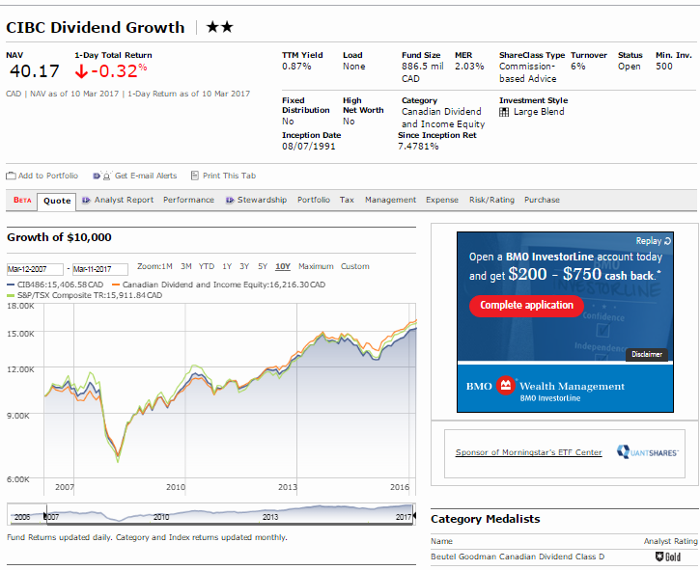

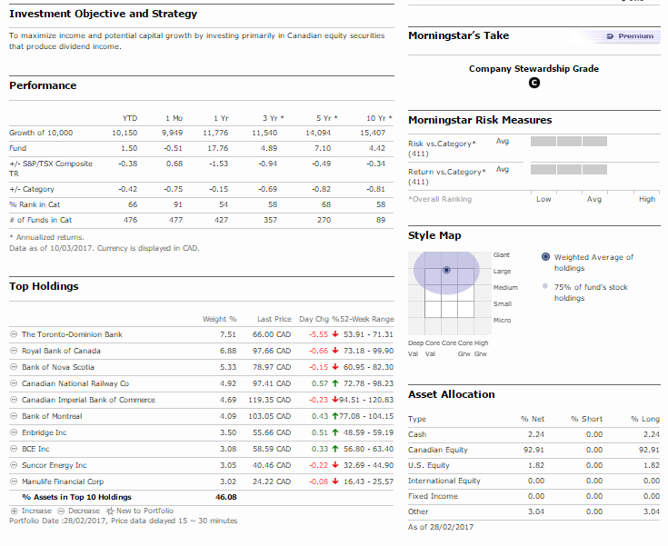

http://quote.morningstar.ca/quicktakes/fund/

The End
Good luck!

