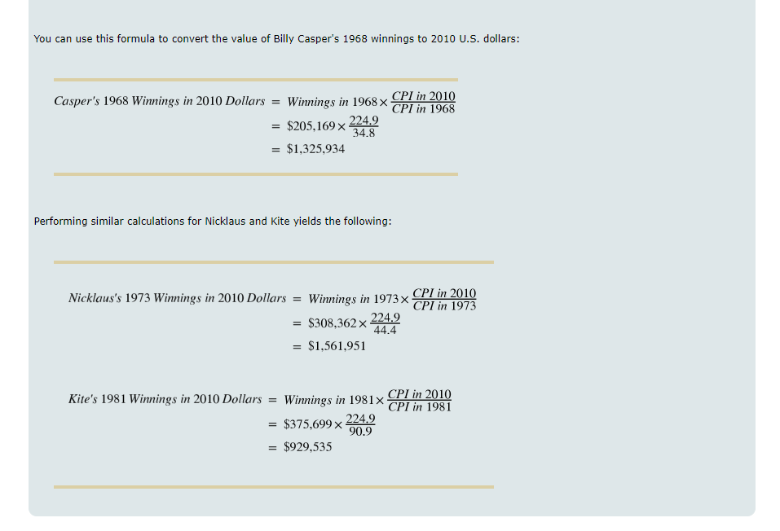
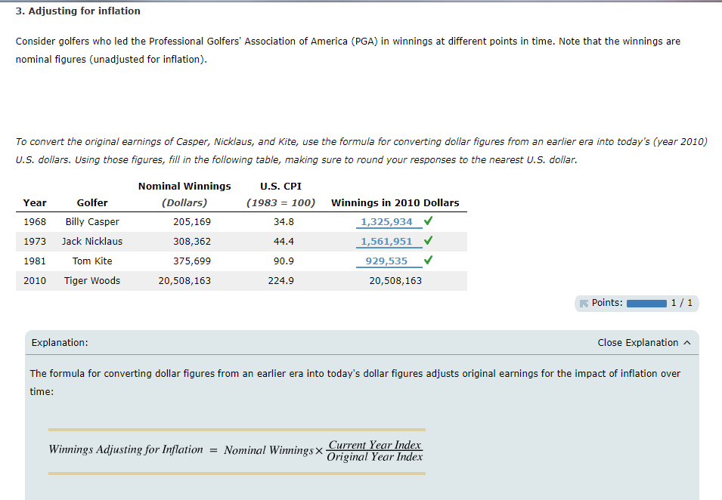
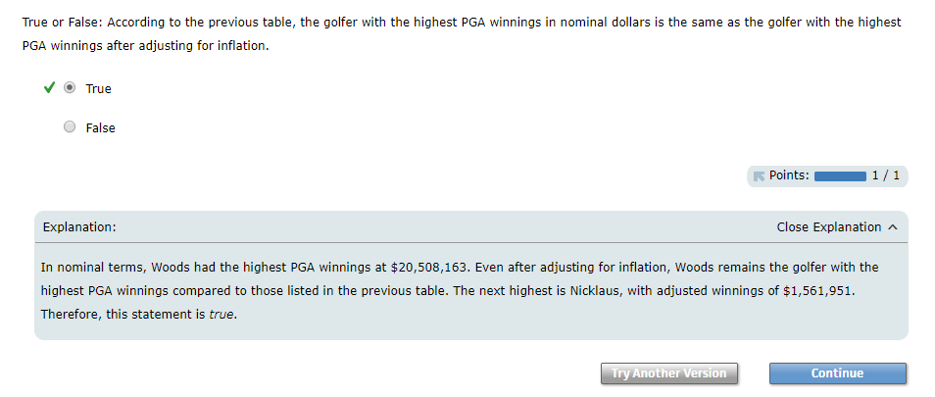
Consider golfers who led the Professional Golfers' Association of America (PGA) in winnings at different points in time. Note that the winnings are nominal figures (unadjusted for inflation).
To convert the original earnings of Casper, Nicklaus, and Kite, use the formula for converting dollar figures from an earlier era into today's (year 2010) U.S. dollars. Using those figures, fill in the following table, making sure to round your responses to the nearest U.S. dollar.
Year | Golfer | Nominal Winnings | U.S. CPI | Winnings in 2010 Dollars
Year | Golfer | (Dollars) | (1983 = 100) | Winnings in 2010 Dollars
1968 | Billy Casper | 205,169 | 34.8 | 1,325,934
1973 | Jack Nicklaus | 308,362 | 44.4 | 1,561,951
1981 | Tom Kite | 375,699 | 90.9 | 929,535
2010 | Tiger Woods | 20,508,163 | 224.9 | 20,508,163
Points:
1 / 1
Close Explanation
Explanation:
The formula for converting dollar figures from an earlier era into today's dollar figures adjusts original earnings for the impact of inflation over time:
You can use this formula to convert the value of Billy Casper's 1968 winnings to 2010 U.S. dollars:
Performing similar calculations for Nicklaus and Kite yields the following:
True or False: According to the previous table, the golfer with the highest PGA winnings in nominal dollars is the same as the golfer with the highest PGA winnings after adjusting for inflation.
True
False
Points:
1 / 1
Close Explanation
Explanation:
In nominal terms, Woods had the highest PGA winnings at $20,508,163. Even after adjusting for inflation, Woods remains the golfer with the highest PGA winnings compared to those listed in the previous table. The next highest is Nicklaus, with adjusted winnings of $1,561,951. Therefore, this statement is true.

