Chapter 2 Information Systems: Concepts and Management
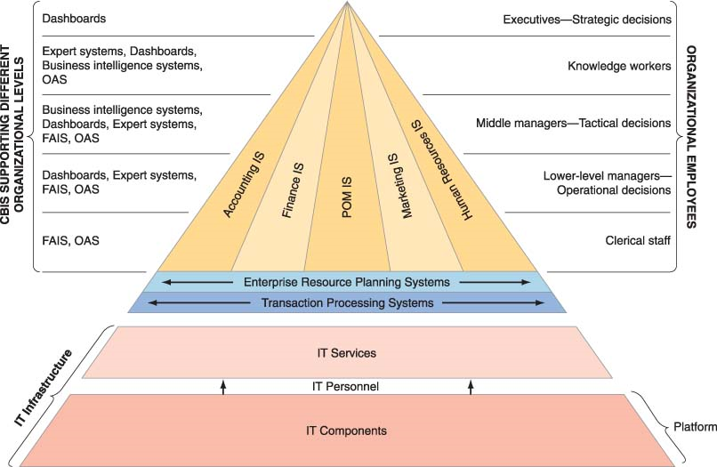
2.1 Types of Information Systems
Information System: it collects, processes, stores, analyzes, and disseminates information for a specific purpose. There’s a different types of IS’s that is used for different purposes in an organization.
Computer-based Information Systems: information system that uses computer technology to perform some or all of its intended tasks (most IS’s are computerized).
CBIS has few basic components:
1) Hardware: device such as a processor, monitor, keyboard and printer – they accept data and information, process them, and display them
2) Software: program or collection of programs that enables the hardware to process data.
3) Database: collection of related files or tables containing data
4) Network: connecting system (wireline or wireless) that permits different computers to share resources
5) Procedures: set of instructions about how to combine the above components in order to process information and generate desires output
6) People: individuals who use the hardware and software, interface with it, and use its output
Major capabilities of information systems:
- Perform high-speed, high volume, numerical computations
- Provide fast, accurate communication and collaboration within and among organizations
- Store huge amounts of information in an easy-access, yet small, space
- Allow quick and inexpensive access to vast amounts of information, worldwide
- Interpret vast amounts of data quickly and efficiently
- Increase the effectiveness and efficiency of people working in groups in one place or several
- Automate both semi-automatic business processes and manual tasks
Application programs: computer based program designed to support a specific task or business process. Each functional area within a business organization uses dozens of application programs. The collection of application programs in a single department is referred to as a departmental information system. Example is HRIS is human resource management area.
Functional area information systems (FAIS): IS designed to summarize data and prepare reports for a functional area such as accounting or finance. Helps in decision making.
Enterprise resource planning (ERP) systems: IS designed to correct a lack of communication among the functional area information systems. As some of the FAIS’s were developed to be standalone and did not communicate effectively, ERP system resolves this problem by tightly integrating the FAIS via a common database – increases organizational productivity.
Transaction Processing System (TPS): supports the monitoring, collection, storage, and processing of data from the organization’s basic business transactions. This generates data and sends it to other part of the organization. Example would be when cashier swipes an item across the bar code reader (one transaction). TPS supports core operations and is critical for success in the organization.
Nearly all ERP systems are TPS, but TPS are not all ERP systems.
Inter-organizational information systems (IOSs): information systems that connect two or more organizations. This supports many inter-organizational operations such as supply chain management and customer relationship management.
Supply chain: the flow of materials, information, money, services from suppliers of raw material through factories and warehouses to the end customers (All the processes Dell goes through when a laptop is ordered).
Electronic commerce systems: another type of IOSs that enable organizations to conduct transactions, called business-to-business (B2B) electronic commerce, and customers to conduct transactions with businesses, called business-to-consumer (B2C) electronic commerce.
Support for Organizational Employees
Information systems also support particular employees within the organization.
Clerical Workers: support managers at all level of the organization
Lower-level managers: handle day to day operations, making routine decisions (assigning tasks to employees)
Middle managers: make tactical decisions, short term planning, organizing and control
Executives: Long term planning, make decisions that can change the way the business is
Knowledge workers: professional employees (financial/marketing analysts) who are expert in a particular subject area. They create info and knowledge which they integrate into the business and act as advisors to middle managers and executives (Uses decision support system, ES, BI)
Type of IS | Function | Example | Supports who?
Functional area IS | Supports the activities within a specific functional area | A system for processing payroll | Middle/Lower-level managers to make decisions
Transaction processing system | Processes transaction data from business events | A Wal-Mart checkout point of sale terminal | Supports core operations and process/analyze data for ERP to work
Enterprise resource planning system | Integrates all functional areas of the organization | Oracle, SAP | Supports organization as a whole, and increases productivity with increased communication
Office automation system | Supports daily work activities of individuals and groups (develop documents, schedule resources, communicate) | Microsoft Word | Clerical staff, lower/middle managers, knowledge workers
Management information systems | Produces reports summarized from transaction data, usually in one functional area | A report on total sales for each customer | Helps managers to make decisions
Decision support system | Provides access to data and analysis tool (financial analysis for if they should buy a new equipment | A “what-if” analysis of changes in budget | Knowledge workers
Expert system | Duplicate work of human expertise to make decisions | A credit card approval analysis | Knowledge workers
Executive dashboard | Presents structured, summarized information in forms of reports about aspects of business | A report showing the status of sales by product | Executives, Managers
Supply chain management system | Manages flow of products, services, information among organizations (raw material to delivered to customer) | The Wal-Mart retail link system, connecting suppliers to Wal-Mart | Supports organization as a whole
Electronic Commerce System | Enables transactions among organizations and between organizations and customers, B2B & B2C | www.dell.com | Supports organization as a whole
Business intelligence systems | Provide computer-based support for complex, non-routine decisions | Used with a data warehouse allowing users to perform their own data analysis | Middle managers and knowledge workers

2.1 Competitive Advantage and Strategic Information Systems
Competitive advantage: An organization outperforming its competitors in some measure as cost, quality or speed. Helps a company control a market and generate larger than average profit
- Using IT is a good source to gain competitive advantage – low cost, excellent customer service, superior supply chain management. Firms must understand Porters competitive forces model, value chain model and value system (all components). Also review Strategies for competitive advantage below.
Strategic information systems (SISs): provide a competitive advantage by helping an organization implement its strategic goals and increase its performance and productivity. Any IS helping organization gain a competitive advantage or reduce a competitive disadvantage is a SISs
Porters Competitive Forces Model
- Best-known framework for analyzing competitiveness
- Used to understand competitiveness surrounding an organization and gain competitive edge
- Overall impact of the web has increased competition
- There’s 5 major forces that could endanger or enhance a company’s position in a given industry
- The threat of the entry of new competitors: The threat of new competitors is High when it’s easy to enter the market and Low when significant barriers entry exists. Entry barrier is a product or service feature that customers have learned to expect from organization in a certain industry. Web is increasing the threat of new competitors (it’s easy to set up a website, competitors can compete from anywhere far and a lot of them are successful). Threat is also high in industries that perform an intermediary role (linking between buyers and sellers like stock brokers/travel agents) and industries where the primary product or service is digital (music).
- The bargaining power of suppliers: Supplier power is high when buyers have few choices about who they can buy from and low when buyers have many choices. Monopoly companies such as Microsoft can set their prices really high as there isn’t many competitors. The internet helps both suppliers and buyers. Buyers can find alternate suppliers of what they want and suppliers can use the internet to integrate their supply chain
- The bargaining power of customers: Buyer power is high when buyers have many choices about who they can buy from, and low when buyers have few choices. The web increases buyer power by allowing them to access information about products and suppliers (compare prices). They can find alternate suppliers.
- The threat of substitute products or services: The threat is high when there are a lot of substitutes for a product and low when there are few. New technologies create substitute products very rapidly (Internet music instead of CDs, cell-phones, ethanol/gasoline)
- Rivalry among existing firms in the industry: The threat from rivalry is high when there is intense competition among many firms in an industry and is low when competition is among fewer firms and is not as intense
- The internet also makes proprietary systems – it’s difficult for a firm to keep secrets. Websites show their products and menus. Competitors will try to match in order to remain competitive. As a result, there are fewer differences among competitors.
- Competition is also being affected by the extremely low variable cost of digital products. Cost of producing one more additional unit is zero, and selling over the web is cheaper
- Most successful firms have internet-based systems where they have created their own online divisions (it’s easier and cheaper to sell over the internet because physical distribution in a store is more expensive).
Porters Value Chain Model
- Porters competitive forces model is useful for identifying general strategies while value chain model is used to identify specific activities where they can be use competitive strategies to achieve the greatest impact. Also helps gain competitive advantage for a firm.
- Porters Value Chain Model divides the activities conducted in any organization in to:
- Primary activities: business activities that relate to the production and distribution of the firm’s products and services, thus creating value for which customers are willing to pay. Includes purchasing materials, processing materials into products, and delivering products to customers. As it goes through each activity, it adds value to the product.There are 5 primary activities (Making of a Dell laptop):
- Inbound logistics (inputs): incoming materials are processed (in receiving, storage)
- Operations: turning raw material into products (manufactured and tested)
- Outbound logistics: prepared for delivery (packaging, storing, shipping)
- Marketing and sales: sell products to customers, create demand for the product
- After-sales services: warranty services, upgrade notification, customer satisfaction
- Support activities: adds competitive advantage by supporting primary activities making sure it’s done well (maintaining time, cost, quality). Consists of:
- The firm’s infrastructure (accounting, finance, management)
- Human resource management
- Product and technology development (R&D)
- Procurement
Value System: Includes producers, suppliers, distributors and buyers, all with their value chains. Value chain is simply part of the larger system (value system). When firms create products, these products pass through the value chains of distributors all the way to the customers. All part of these chains are included in the value system. To gain competitive advantage, firms must understand every components of the value system.
Strategies for Competitive Advantage
- Cost leadership strategy: produce products or services at the lowest cost in the industry. An example would be Wal-Mart’s automated inventory replenishment system, enabling them to reduce inventory storage requirements.
- Differentiation strategy: offer different products, services or product features.
- Innovation strategy: introduce new products and services, add new features to existing products and services, or develop new ways to product them. Example would be RIM producing PDA with a keyboard
- Operational effectiveness strategy: improve the manner in which internal business processes are done so that a firm can perform similar activities better than its rivals. They can increase their quality, productivity, and employee/customer satisfaction.
- Customer-orientation strategy: concentrate on making customers happy. Customer relationship management having one-to-one relationship with each customer.
Disadvantages of information systems: Information systems are very expensive to implement, and it might be hard to integrate with the existing system.
2.3 Why is Information Systems so important to us?
Information systems have numerous impacts on organizations and on society as a whole.
- IT makes managers more productive, and increases number of employees who can report to a single manager
- It decreases the number of managers (fewer staff/line managers) and experts required in an organization when IT system is implemented
- IT changes the way managers do their work. Reduces time for decision making process, helps complete tasks efficiently and effectively. Managers can spend more time on planning activities (search engines and intranets makes life easier as they can gather information much more quickly)
- Improves quality of life - people can now work from anywhere (home/vacation) using the computers and internet
- IT provides opportunities for people with disabilities (ex. Voice recognition capabilities)
- Improvements in healthcare – new and better drugs, doing surgery faster and more accurate (using robots)
- Concern 1: As computers gain in intelligence and capabilities, the competitive advantage of replacing people with machines is increasingly rapidly. This could lead to higher unemployment issues.
- Concern 2: Because IT has made globalization possible, outsourcing and offshoring is another concern for some employees working in organizations.
- Concern 3: School-age children using computers too much could be a lack of social contact for them causing damage to social, moral, and cognitive development
- Concern 4: Working at a desk for too long for an organizational employee could cause job stress (lowering productivity), and develop other health problems – eyesight, cancer (radiation from video display terminals), repetitive strain injuries (backaches, fingers), carpal tunnel syndrome (pain in wrists/hands from RSI)
2.4 Managing Information Resources
Information Resources: is a general term that includes all of the hardware, software (information systems and applications), data, and networks in an organization
There are two computing resources in an organization:
1) Information systems department (ISD): main function is to use IT to solve end users’ business problems. It is responsible for corporate-level and shared resources. ISD must also work closely with external organizations such as vendors, business partners, consultants etc. (by CIO)
2) End-user computing: responsible for departmental resources
Now, the responsibility for managing information resources is divided between ISD and the end users. It is important that ISD and the end users work closely together and cooperate regardless of who is doing what.
New Major Information system functions include:
- Designing specific strategic systems
- Use of internet, electronic commerce, intranets, extranets into the business
- Educating non-IS managers about IT
- Supporting end-user computing
- Partnering with the executives
- Managing outsourcing
- Create business alliance with vendors and IS departments in other organizations

