Identifying Unknown Acid A and B by Calculating Their Equilibrium Constant Values Using Titration and a pH Meter.
Partners: Jennifer Onwuemeodo & Alyssa Ollivier
Lab performed: Monday May 8th, 2017
Lab due: Tuesday May 16th, 2017
Alyssa Ollivier
Results
Table 1: Measuring the Viscosity of Glycerol, Ethanol, and 1,2-ethanediol
Trial # | Glycerol | Ethanol | 1,2-ethanediol
1 | 31.63 | 1.06 | 1.56
2 | 40.51 | 1.03 | 1.59
3 | 31.36 | 1.00 | 1.66
Average | 34.5 | 1.03 | 1.60

Table 2: Boiling points of Glycerol, Ethanol,1,2-ethanediol and PTFE
Compounds | Glycerol | Ethanol | 1,2-ethanediol | PTFE
Boiling point (°c) | 290 | 89 | 197 | 644

Table 3: Qualitative Observations of Water on Cellulose and PTFE
Fig.1: Cellulose Fig.2: PTFE
-Stayed as a drop
- Did not soak into PTFE
- Sat on surface of PTFE
- Water and PTFE did repel each other
- Soaked in easily
- Expanded into the cellulose paper
- Did not stay as a drop
- Water and cellulose did not repel each other

Table 4: Qualitative Observations of the maleability of copper metal and copper (II) sulfate pentahydrate
Copperwire:
-Stays together when hit with a hammer
-Not as brittle as Copper Sulfate Pentahydrate
-Instead of crumbling it flattens
- Malleable
Copper Sulfate:
-Crushes into smaller pieces when hit with a hammer
-Very brittle
-Not Malleable
-Crystal
Results Summary:
The results from the first experiment showed that glycerol was the most viscous of the three compounds the next the viscous was 1,2-ethanediol and lastly was ethanol. Glycerol was measured to have a time for the nail to fully drop of 34.5 seconds compared to ethanol which had a time of 1.03 seconds this means that ethanol’s nail dropped about 33.5 times faster than glycerol’s showing that ethanol is less viscous. The next experiment was done to show the malleability of two different copper based compounds. Both copper metal and copper sulfate were hit with a hammer and very different results were shown in each case. For copper metal when hit with a hammer it started to flatten. When copper sulfate was hit with a hammer instead of flattening it crushed under the impact. The Third experiment was to research the boiling points of four different compounds. It was found that Polytetrafluoroethylene (PTFE) had the highest boiling point, next came glycerol, then 1,2-ethanediol, and lastly was ethanol. The boiling point of PTFE was 7.8 times higher than that of ethanol. The last experiment that was conducted was to see the absorption of water on cellulose and PTFE. It was observed that the water soaked into the cellulose while the water on the PTFE stayed as a singe drop. It seamed the 0% of the water absorbed into PTFE while most of the water spread through the cellulose.
Discussion: PART A
An intramolecular bind is any force that holds together atoms that make up a molecule or compound. This force includes ionic and covalent bonds which are a lot stronger that an intermolecular bond. An intermolecular bond is the force of attraction or repulsion which acts between neighboring particles (atoms, molecules or ions) these forces are weak compared to intramolecular forces.
Glycerol:
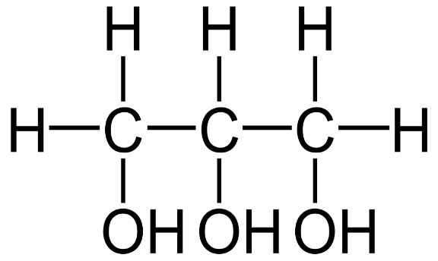
The first sample to analyse is glycerol which is a poly alcohol that contains multiple hydroxyl groups. Glycerol is covalent and polar and can have hydrogen bonds since there s and H and O is very electronegative. It has 100 e which will make the forces stronger due to London forces. This molecule since being polar also has dipole dipole forces which is the attraction of oppositely charges of polar molecules, the strength of this force depends on the polarity of the molecule. Glycerol also has covalent bonds between the carbons because it is an organic compound.
Ethanol:
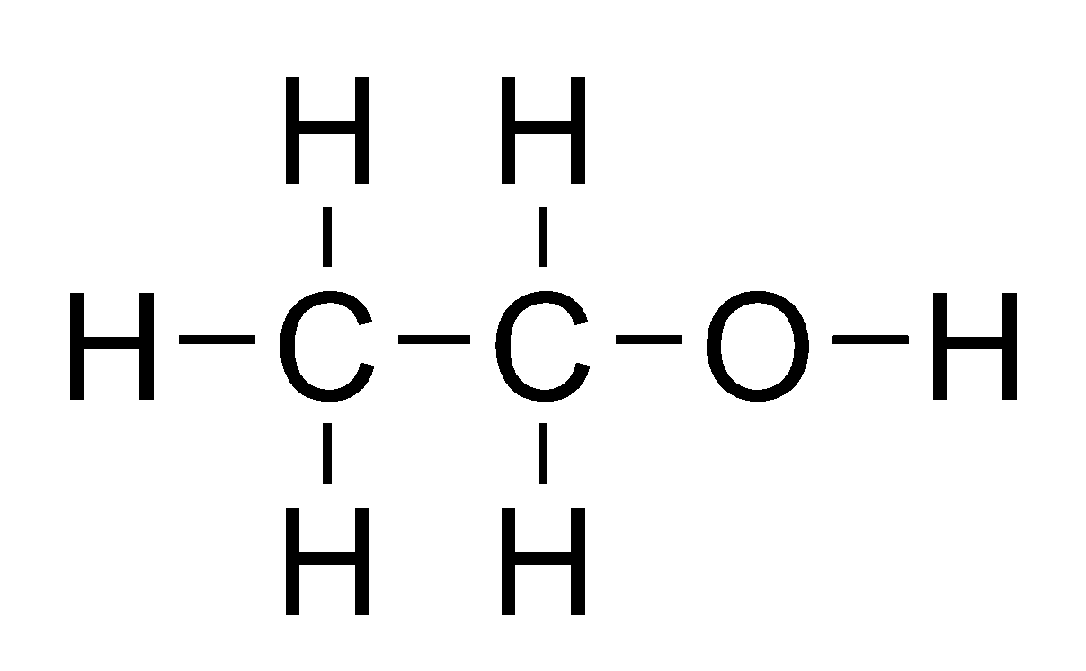
Ethanol is another alcohol that contains one hydroxyl group. Ethanol is composed of 52 electrons which helps to hold the molecule together. Ethanol is also able to H-bond because it has a hydrogen and oxygen with lone electron pairs. Ethanol is a very polar molecule due to it’s hydroxyl group and the high electronegativity of oxygen.
1,2-ethanediol:
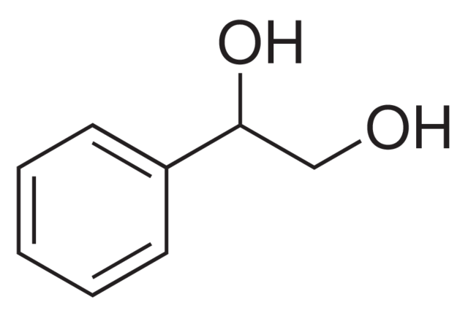
1,2-ethanediol due to the presence of the O-H there is a strong hydrogen bonding which is usually the strongest intermolecular interaction.
Copper Metal:
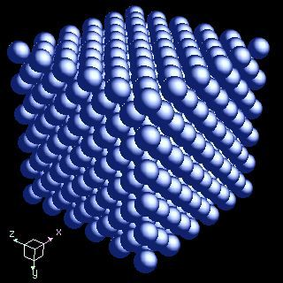
Copper metal is formed from metallic bonds. It has a relatively low London forces due to only having 58 electrons. Since it is formed from a single element it is nonpolar there for it does not have high dipole dipole forces and it is not able to hydrogen bond.

Copper (II) Sulfate pentahydrate:
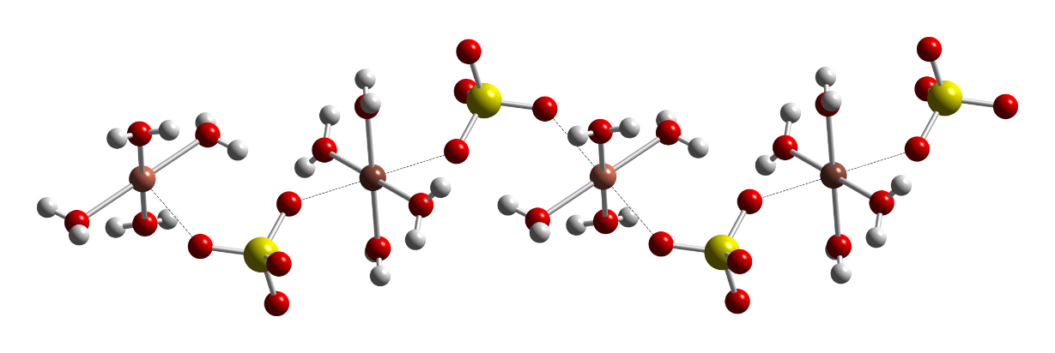
CuSO₄·5H₂O is the chemical formula for Copper (II) Sulfate pentahydrate. It forms crystal like bonds. The sulfur and the sulfate ions would form ionic bonds which would make and overall crystal ionic shape.
PTFE:
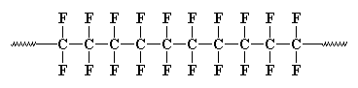
PTFE is an organic molecule that has a long carbon chain. This molecule has a high London force due to the string of carbons. This large molecule is non-polar because all of the dipole forces cancel each other out. There fore it would have a very low dipole dipole force. PTFE would also not be able to Hydrogen bond due it not having a hydrogen to bond with.
Cellulose:
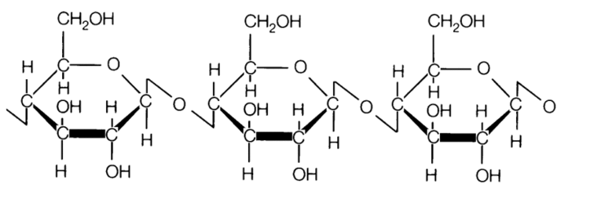
Cellulose is an organic compound with a high London force keeping the molecule together. Cellulose has the ability to hydrogen bond because it has lone pairs and hydrogens. Cellulose is also a polar molecule due to the attraction of the OH groups.
Water:
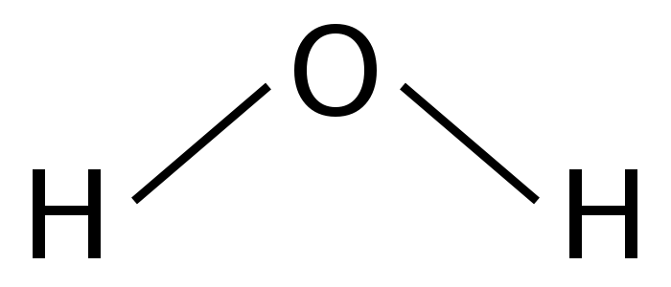
Water has covalent bands which are a lot stronger than ionic. This makes the molecule over all has strong intramolecular forces. Water also has stronger forces due to its ability to hydrogen bonds. The water molecule is a polar molecule.
Part B:
Viscosity is the measurement of how well a substance flows. The stronger the IF’s the more viscous a substance will be since the forces will resist the movement. In the first physical property experiment was observing the viscosity of glycerol,1,2-ethanediol and ethanol.it was observed that the most viscous was glycerol. This makes sense because it is the most polar molecule therefore more dipole dipole forces. It also has very strong London forces and can make hydrogen bonds. While ethanol seemed to be the least viscous because the nail feel the quickest and did not resist the flow very much.

34.5 s 1.60 s 1.03 s

glycerol 1,2-ethanediol ethanol
In the second experiment a hammer was used to test the malleability of two different copper based compounds. Copper metals since the bonds were not as rigidly organized they were able to roll over each other while retaining the structure. In order to understand this malleability is he a physical property to be molded, bent and pressed with force and not shatter. When a lot of stress is put on a malleable metal it can rearrange and will permanently stay in its new position. It was shown that the copper metal was more malleable that the copper (II) sulfate pentahydrate because of the bonds and that fact that the Copper(II) sulfate is crystal ionic. In a crystal ionic substance at the right amount of pressure that crystal will shatter.
In the third experiment the boiling point of glycerol, ethanol,1,2-ethanediol, and PTFE was researched. Boiling point directly reflects the strength of the bond and that is what makes one compound have a higher boiling point if they have stronger bonds. So, in the case of this lab we found that PTFE had the highest boiling point of 644 °c this makes cense because PTFE had a long chain of covalently bonded carbons which have a strong bonding force.
Lastly in the fourth experiment the absorption of water onto cellulose and PTFE was observed. The water fully absorbed into the cellulose because the cellulose was polar. (Refer to Fig.1) This mutual attraction is based on the polarity of both substances. On the other hand, the PTFE did not attract any of the water in result the water just sat on the surface. This is because PTFE is not polar and it repelled the polarity of the water. (Refer to Fig.2)

