Basic concepts and definitions ECON

Economics: study of how society manages its scarce resources
Scarcity: in relation to wants, existing resources are inadequate

Choice
Opportunity Cost: cost of something in terms of what is given up

Production: act of making goods/services
Consumptions: act of using goods and services
Products/commodities: goods and services

Resources: (imports, services, factors of production)
Land: Natural resources
Labour: Human resources
Capital: Created resources

Decision Makers
Household (Consumers): People living under a roof who are subject to joint financial decisions
-Make consistent decisions
-Maximize well-being
-Principal owners of resources

Firms (Producers): Units that employ resources to produce commodities
- Make consistent decisions
- Maximize profit
- Principal users of resources

Government: All officials or agencies under direct control of federal, provincial or municipal governments
- Make inconsistent decisions – changing governments, differing agendas
- Maximize?

Decisions are made at the margin
- economic agents compare marginal benefits to marginal costs

Market: area in which buyers and sellers negotiate the exchange of a commodity
- Product markets
- Resource (factor) markets

Circular Flow Diagram
Commodities
Commodities
Resource Services
Resource Services

Evolution of Market Economies
- Subsistence Economies: basically, hunter and gatherers
- Agricultural revolution/permanent settlement
  - Agricultural revolution: people started to grow/look at stuff ex crops
- Possibility of exchange induced by:
  - Introduction of money
  - Population increases
  - Transportation/communication improvement
- Expansion of markets encourages specialization
- Division of labour
- Differences between economies
  - Private vs public ownership
  - Market vs command system
    - Command system very inefficient may have shortages or surplus
  - People respond to incentives

Invisible Hand (Adam Smith)
- Market system tends to coordinate individual decisions
- Can produce more efficient results

Microeconomics: study of the behavior of individual agents and markets
Macroeconomics: focuses on broad, aggregates such as overall production, employment, prices

Key issues in Microeconomics
- Efficiency: society is getting the most it can from scarce resources
- Equity: distributing income fairly among members of society market system better at ensuring efficiency vs equity
- Market Failure: free functioning market fails to allocate resources efficiently
- Externality: impact of person’s actions on a bystander
- Market power: the ability of an economic agent to have a substantial influence on market prices

Economic Models
- Statements
  - Positive: testable statements
  - Normative: opinions, value judgements
- Theory \ Scientific
- Assumptions: used to focus theory \ Theory
- Hypothesis \
- Variables
  - Endogenous (induced, dependent): variables explained within a theory
  - Exogenous (autonomous, independent): outside factors
- Dangers
  - Unrealistic assumptions
  - Embedded value judgments

Graphs
- Positive vs negative correlation
- Direct vs Inverse relationship

Production Possibilities Frontier (PPF)

Definition: graph showing all combinations of output that the economy can produce given the available resources and technology

Assumptions
- Economy produces 2 goods
  - Consumer goods: For immediate consumption
  - Capital Goods: Permit production of other goods
- Fixed Goods
- Fixed Technology
- Efficiency: Economy is operating at full employment and achieving full production
  - Full Employment: Doesn’t mean 0% unemployment rate
  - Full Production: Situation where you can’t get something for nothing

Characteristics
- Downward sloping (insert graph)
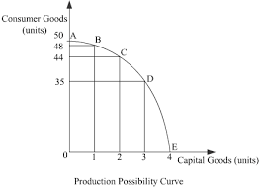
- Concave to the origin (bowed out)
  - Law of Increasing Costs: in order to get equal extra amounts of one goal, society must sacrifice ever increasing amounts of another good
- Points inside PPF represents (above-normal) unemployment and/or inefficiency
- Points outside PPF are unattainable

PPFs Illustrates
- Scarcity: unattainable combinations
- Choice: Different points on PPF
- Opportunity Cost: Downward slope

Changes in PPFs
- Technological change
  - Affecting both sectors equally
  - Affecting one sector more favourably Ex Consumer goods

- Resource base changes
  - Natural population increase/decrease
  - Immigration/emigration
  - Natural Resources discoveries/depletion

PPF Example
- Opportunity cost of moving c to d (1500-1100= 400)
Combination | Capital Goods | 10% Greater Production | Consumer Goods | 10% Greater Production
A | 0 | 0 | 2000 | 2200
B | 200 | 220 | 1800 | 1980
C | 400 | 440 | 1500 | 1650
D | 600 | 660 | 1100 | 1210
E | 800 | 880 | 600 | 660
F | 1000 | 1100 | 0 | 0

  - Opportunity cost per unit: C->D
  - 400 consumer goods/600-400 capital goods = 400/200 = 2 consumer goods/capital goods

  - Opportunity cost C->B
  - 400 – 200= 200 capital goods

  - Per unit Opportunity cost C->B
  - 200 capital goods/ 1800 – 1500= 300 consumer goods = 2 capital goods/3 consumer goods

  - Effect of population increase that allows 10% greater production of each good
  - (see above)

Interdependence and Gains from Trade Chapter 3

- Gains from Trade
  - Trade allows specialization and encourages efficiency
  - In smaller economies, allows development of economies of scale

- Absolute Advantage
  - Region holds AA over another in the productions of commodity X, if it requires a smaller amount of inputs to produce a unit of X
  - Example: hours needed to produce 1 unit of the following in Canada and Belgium

 | Wheat | Chocolate
Canada | 8 | 5
Belgium | 20 | 4

Canada has AA in wheat (8<20)
Belgium has AA in chocolate (4<5)
  - Case of reciprocal AA

- Gains from Illustration: suppose in the next 40 hr workweek, each country transfers a worker toward the good in which it has the AA

Production Changes | Wheat | Chocolate
Canada | +40/8= +5 | -40/5= -8
Belgium | -40/20= -2 | +40/4=+10
World | +3 | +2

Comparative Advantage
- Region has CA over another in the production of commodity X, if the opportunity cost of producing X is less
  - Example- hours needed to produce I unit of the following in Canada and Norway

 | Wheat | Fish
Canada | 8 | 16
Norway | 30 | 18

- Canada has AA in wheat (8<30), & fish (16<18)

c) Opportunity Costs

 | Wheat | Fish
Canada | 8/16 = .5 unit of fish | 16/8 = 2 units of wheat
Norway | 30/18 = 1.67 units of fish | 18/30 = .6 units of wheat

Canada has CA in wheat (.5<1.67); Norway has CA in fish (0.6<2)

d) Gains from trade illustration – each country transfers sufficient worker time to produce 1 more Unit of the good in which they have the CA

Production Changes table
 | Wheat | Fish
Canada | +1.0 | -.5
Norway | -.6 | +1.0
World | +.4 | +0.5

e) In general, countries should specialize on the basis of CA and export products in which they have CA and import goods for which they do not have CA

Terms of Trade (ToT)
- Quantity of imported goods per unit of exported goods
- If the ToT is between the opportunity costs of production for the 2 countries, both will benefit from trade

Demand and Supply (Ch. 4)

- Demand: the relationship between the price of a product and quantity that consumers are willing and able to purchase during some specified time period
- Demand Law: the lower the price of a commodity, the greater the quantity demanded, all other things equal
- Factors Affecting Demand
  - Endogenous factor: Own price (most important factor)
  - Exogenous factors
    - Price of related goods
    - Substitutes: items that can be used interchangeably
    - Complements: Items that are used together
  - Income
    - Normal Goods: as income increases demand increases ex Ferrari
    - Inferior Goods: As income increases, demand decreases ex Cheap items for a necessity, mac n cheese
  - Tastes and Preferences
  - Number of buyers
  - Consumer Expectations
    - Income: consumer confidence
    - Price: goes up, people buy more now

Demand Schedule: Table showing relationship between price and quantity demanded
 | Cents/lb | Lb demanded
1 individual | 20 | 100
1 year | 40 | 50
Apples | 60 | 38
 | 80 | 30

Demand Curve: Graph of the demand schedule

Change in Quantity Demanded (Qd): Caused by change in product price
- Increase in Qd
P2
P1

Changes in Demand: Occurs when, at each and every price level, a consumer is willing and able to buy more (less) of a good

Market Demand Curve: Horizontal summation of individual demand curves
P | Qd1 | Qd2 | Qd3 | Market Qd
20 | 3 | 4 | 5 | 12
15 | 5 | 6 | 8 | 20
10 | 10 | 10 | 11 | 31
5 | 15 | 12 | 15 | 42

Engel Curve: Shows relationship between income and quantity demanded (income on x, quantity demanded on y)
Normal Inferior x=quantity

Supply: the relationship between the price of a product and the quantity that firms are willing and able to produce/sell during some specific specified time period

Supply Law: for many commodities, the higher the price, the greater the quantity supplied, all other things equal

Factors Affecting Supply:
- Endogenous factor: Price
- Exogenous Factors: input costs, technology, taxes and subsidies, # of sellers, producer expectations

Supply Schedule: Table showing relationship between price and quantity supplied
Ex:
 | $/ barrel | Barrels Produced
1 Oil company | 10 | 100
1 day | 20 | 400
 | 30 | 650
 | 40 | 800
 | 50 | 900

Supply Curve: Graph of the supply schedule

Price of oil on y, Quantity of oil x, Supply=curve

Change in Quantity Supplied (Qs)
- Movement along supply caused by price change
  - Increase in Qs

Change in Supply: occurs when, at each and every price level, a producer is willing and able to sell more (less) of a good
- Increase in Supply (price of oil on y, quantity of oil on x)
Rightward shift: 2 -> 3
b) decrease in supply: 2-> 1 = leftward shift

Ex: what happens to oil supply when: (price of oil on y, quantity of oil on x)
- Cost of drilling wells increase Shift left: decrease in supply

- Drilling technology improves (price of oil on y, quantity of oil on x)
Shift right: increase in supply

- US Dramatically Increase shale oil production (price of oil on y, quantity of oil on x)

Market Supply Curve: Horizontal summation of individual supply curves (Qs1 + Qs2=MarketQs)
P | Qs1 | Qs2 | Market Qs
10 | 1 | 12 | 13
20 | 5 | 20 | 25
30 | 7 | 24 | 31
40 | 9 | 27 | 36
50 | 10 | 28 | 38

Market Equilibrium Chapter 5

Equilibrium (eqm): A situation in which the price has reached the level where quantity demanded (Qs) equals quantity supplied (Qs); occurs at intersection of supply, demand curves
(Equilibrium price on y, Equilibrium quantity)

Green: P1 horizontal, Qd vertical left, Qs vertical right

- Eqm Price (Pe): the price where Qd and Qs equalize
- Eqm Quantity (Qe): the Qd and the Qs at the eqm
- Excess Supply (ES or surplus): at any price above Pe,Qs> Qd
  - In order to sell surplus, producer will lower prices
  - Consumers see surplus, offer less for what they’re prepared to buy; price falls to Pe

Excess Demand (Ed or shortage)
- At any price below Pe, Qd>Qs P1 horizontal, Qs left vertical, Qd right vertical
Qd>Qs

- Consumers will try and outbid each other for existing supply
- Producers see people prepared to pay more, raise price and Qs
Comparative Statics: start from a position of equilibrium, introduce a change and compare the new equilibrium to the old equation
- Increase in demand: Start at Pe,Qe Green= new demand Blue= original
D->D2 = Ed at Pe, upward pressure on price, move along Sd2 to Pe2d Qe2, P up, Q up

Increase in supply or decrease in supply

What happens in the mustard market when:
- Price of hot dogs increases: price down, quantity down
- Mustard processing technology increases: price down, quantity goes up
- Hail wipes out half of the mustard crop: price up, quantity down
- Mustard producers put cheap, additive substances into product: price up, quantity up

Giffen Good: Apparent refutation of demand law; allegedly as prices rise, so does the demanded quantity (usually situation of rapidly changing tasks)

Double shifts: Change in either Pe or Qe will be ambiguous
Ex Alberta sulfur market: combination of large increases in natural gas supply (with by-product sulfur or sour gas) + increased popularity of sulfur substitutes in industrial applications
- Price definitely falls, but quantity change is indeterminate

Controlled Prices (Ch 6)
- Ceiling Price (CP): A legal maximum on the price at which a good can be sold
  - Designed to protect consumers
  - CPs above Pe are not binding (not effective)
  - CPs below Pe are binding (effective) Ex Cp2 Q2>Q1, Qexchanged = Qs
  - Possible allocative mechanism (not simple)
    - Rationing
    - Black Market (Prices rises to BMP)
    - Discrimination
  - Rent Control Example
    - Having quality deteriorates over time
    - New construction stops, government must take over industry or subsidize construction and landlords

- Floor Price (FP): A legal minimum or the price at which a good can be sold
  - Designed to protect producers
  - FPs below Pe are not binding (not effective)
  - FPs above Pe are binding (effective)
    - Ex FP2, Qs>Qd, Qexchanged = Qd
  - Government Typically buys up surplus
    - Sell at a discount abroad to get rid of surplus
    - World price less than domestic price
    - Give it away
    - Let it rot
  - Example: Minimum Wage (MW)
    - Income of workers without MW (We x Qe)
    - Income of workers with MW = (MW x Qs)

Elasticity (Ch.5)
- Elasticity (E): Ratio of the % change in one variable to the % change in another variable
- Measures
  - Point elasticity: measures elasticity at a particular point
    - Denote original point with 1, new point with 2
    - E= (change in z/change in z1 x 100)/ (change in y/change in y1 x 100) = change in z/change in y x y1/z1

 | Z | Y
Original (1) | 5 | 10
New (2) | 6 | 14
E= (6-5)/(14-10) x (10)/(5) = (+1)/(+4) x (10)/(5) = + 0.5

b) midpoint (arc): measures elasticity along a segment of a curve
E = (change in z/ z average) / (change in y / y average) = (change in z)/(change in y) x (y1 + y2)/(z1 +z2)
= (6-5)/(14-10) x (10+14)/(5+6) = 0.5 x (24/11) = +0.55

Own Price Elasticity of Demand (ed): measure of the responsiveness of quantity demanded to price change
- Measures
  - % change in q/ % change in P
    - Ex if a 10% increase in potato prices causes a 3% decrease in Qd, Ed for potatoes = (-3%)/(+10%)= -0.3
  - Point (change in q)/(change in p) x P1/Q1
    - Ed = (28-25)/(11-10) x (11)/(35) = -2.0
  - Midpoint (arc): (change in z)/(change in y) x (y1 + y2)/(z1 +z2)
    - Ed = (28-25)/(11-10) x (10+11)/(35+28) = -2.33
- Sign: negative due to demand law
  - Sometimes, negative sign is dropped
- Range/graphs 0 to o-infinity
  - Ed=0
    - Perfectly inelastic demand (price on y, quantity on x)
    - Vertical D
  - Ed between 0 & -1 (price on y, quantity on x)
    - |% change in Q| < |% change in P|
    - inelastic D
    - relatively steep D
  - Ed= =1 (price on y, quantity on x)
    - |% change in Q| = |% change in P|
    - unit elastic
  - Ed between -1 & - infinity (price on y, quantity on x)
    - |% change in Q| > |% change in P|
    - elastic D
    - relatively flat D
  - Ed= -infinity (price on y, quantity on x)
    - Perfectly elastic
    - Horizontal D

- Determinates
  - Necessity
  - Narrowness of commodity definition
  - Time frame
  - Substitutability

- Numerical Estimates
Automobiles | -2.1 inelastic
Gasolines | -0.3 elastic
Public Transport | -0.2 elastic
Cereals | -0.2 inelastic
Sugar | -0.3 inelastic
Veal | -2.5 elastic

- Ed & Revenue
  - Revenue (R) = Price x Quantity
  - Straight line demand curve

- Income Elasticity of Demand (Ei)
- Measure of responsiveness of quantity demanded to (I) changes

Measures
- General (% change in quantity)/(% change in income)
- Midpoint arc (change in quantity/change in income) x (I1 +I2)/(Q1+Q2)

Signs
- Normal goods: positive
  - (0 < Ei < 1): income elastic or necessity good
  - (Ei > 1): income elastic or luxury good
- Inferior goods: negative

Determinants
- Necessity
- Quality

Numerical estimates
- Durable goods (ex cars, furniture) 1.8, need an income surge
- Food 0.2 low income elasticity
- Gasoline 1.1 marginally luxurious
- Turnips -0.3 elastic, inferior
- Wine 1.8 elastic

- Cross Price Elasticity of Demand (Eab)
- Measure of the responsiveness of quantity demanded of one good (a) to price changes in another good (b)
  - Measures
    - General (% change in quantity a)/(% change in price b)
    - Midpoint (change in quantity a/ change in price in b) x (Pb1 + Pb2)/ (Qa1 + Qa2)
  - Signs
    - Substitutes: positive
    - Complements: negative

Price, Elasticity of Supply
- Measure of the responsiveness of quantity supplied to price changes
      - Measures:
  - General: % change in quantity/ % change in price
  - Midpoint (change in quantity a/ change in price in b) x (Pb1 + Pb2)/ (Qa1 + Qa2)
- B) Sign – zero or positive (by supply law)
- C) Range/graphs: 0 to infinity
  - Es = 0 (price on y, quantity on x)
    - Perfectly inelastic
    - Vertical S

  - Es 0<x<1 (price on y, quantity on x)
    - |% change in quantity | < | % change of price|
    - inelastic supply
    - relatively steep S

  - Es = 1 unit elastic, |% change in quantity| = |% change in price| (price on y, quantity on x)

  - Es between 1 and infinity |% change in quantity| > |% change in price| (price on y, quantity on x)
    - Elastic S
    - Relatively flat S

  - Es = infinity (price on y, quantity on x)
    - Perfectly elastic S
    - Horizontal S

- D) Determinants
  - Time frame
  - Ease of switching production

Tax Incidence and the Efficiency of Markets (Ch 6-8)

- Tax Incidence: the manner in which the burden of a tax is shared among participants in a market
  - Impact of excise (sales) tax
    - Start with supply, demand and equilibrium price/quantity
      - In practice, most taxes paid to government by the sellers
      - Suppose tax is $T / unit; supply curve shifts up by T$ to S prime
      - New equilibrium at Pe prime and Qe prime
      - Pe prime = price consumers pay
      - Pth = price producer takes home after tax is turned into the government
  - Given supply, more inelastic the demand curve, greater the burden on consumers
  - Given demand, the more inelastic the supply curve, the greater the burden on producers
  - In general, the less flexible part bears the greater burden of a tax
- Consumers’ Surplus (CS): the difference between what a consumer is willing to pay and the amount the consumer actually pays
  - Implicit savings to customers
- Producers’ Surplus (PS): The difference in what a producer takes home and the price it is willing to supply at
  - Explicit profit for producer
- Total Surplus (TS) : benefits to society
  - In a free market, TS=CS + PS (No distortion in market)
- Efficiency: An allocation of resources that maximizes TS in society
- Dead Weight Loss (DL): The loss of efficiency (in TS) that results from a market distortion
- Taxes and Dead Weight Example

Subsidy Example
EU placing massive subsidy on sugar production

MIDTERM
- Ch 1-8
  - 60 Multiple choice

Firms – Concepts and Assumptions (Chapter 13)

- Firms: units within which production takes place
  - Proprietorship: single owner & operator
    - Easy and inexpensive to set up
    - Complete control
    - Income subject to one level of taxation (ambiguous)
    - Unlimited liability (if you do a job for someone and something goes wrong, they can sue you for everything)
    - Difficult to raise money
    - Most numerous in economy
  - Partnership: multiple owners
    - More money sources/specialization advantages vs proprietorship
    - Unlimited or limited liability
    - Must be reorganized upon personnel change
  - Corporations: separate legal entity from individuals who own it
    - Ownership can be easily transferred ex publically traded corporations
    - Limited liability
    - Many potential sources of money
    - Income subject to two levels of taxation
    - Small shareholders have little say in running company
    - Create economic activity
- Financing
  - Debt-borrowed money
    - Bank loans
    - Bond issues – borrow money from public on long term basis
      - Only available to corporations
  - Equity: owner provided money
    - Initial inflow
    - Reinvested profits
    - Stock issues – only available to corporations
  - Order of Claim on company’s assets
    - Banks
    - Bondholders
    - Stockholders
- Costs
  - Explicit costs: input costs that require an outlay of money by the firm
    - Ex labour and new materials
  - Implicit costs: costs that do not require an outlay of money by the firm
    - Ex. Opportunity costs associated with money tied up in a business, compensation for risk, possible use of owner’s time
  - Opportunity Costs = explicit costs + implicit costs
  - Sunk Costs: costs that have been committed and cannot be recovered; irrelevant in terms of current and future decision making

Junk bonds: last resort for money

- Profits
- Profits = revenues minus costs
- Accounting profits = revenues minus explicit costs
- Economic profits = revenues minus (explicit & implicit costs)
  - Economic profits < accounting profits
- Normal profits – level of profits necessary to prevent owners from withdrawing resources from an industry
  - Zero economic profits
  - Positive accounting profits are necessary but not sufficient to guarantee normal profits

- Time Frames
- Very short run: all inputs and technology fixed
  - Perfectly inelastic supply
- Short Run: at least one input and technology fixed
- Long run: all inputs variable, technology fixed
- Very Long run: everything variable

Short Run Production Theory (Ch 14)

- Production Function: The relationship between the quantity of inputs used and the quantity of output used
- Definitions:
  - Total Product (TP): quantity of (Q) output produced = output
  - Average Product (AP): Total product by units of a variable input
    - Ex Fixed input = Capital (K)
    - Variable Input = Labour (L)
    - AP = TP/L
  - Marginal Product (MP): change in output that comes about when an additional unit of a variable input is explored
    - Formula: MP= (change in TP) / ( change in labour)
- Example and Graphs
Fixed Input Capital (K) | Variable Input Labour (L) | Output Total Product (TP) | Average Product (AP=TP/L) | Marginal Product (MP= change in TP/ change in labour)
1 | 0 | 0 | - | -
1 | 1 | 10 | 10/1= 10 | (10-0)/(1-0) = 10
1 | 2 | 22 | 22/2= 11 | (22-10)/(2-1)= 12
1 | 3 | 36 | 36/3= 12 | 14
1 | 4 | 48 | 48/4 = 12 | 12
1 | 5 | 56 | 56/5 = 11.2 | 8
1 | 6 | 60 | 60/6 = 10 | 4
1 | 7 | 56 | 56/7 = 8 | -4
1 | 8 | 50 | 50/8 = 6.3 | -6

Relationship Between Product Curves (goes with supply curve graph)
- Increasing marginal returns
  - Prior to 1, MP is rising specialization efficiencies
(MP = change in TP/ change in L) TP increases at increasing rate
- Diminishing Returns: As equal extra amounts of a variable input are applied to a fixed input, beyond same level output will increase of a decreasing rate
  - Between 1 & 3, MP is falling but positive
- Negative Returns
  - Beyond 3, MP is negative and TP is falling
- MP & AP
  - Prior to 2, MP > AP and AP is rising
  - At 2, MP cuts AP at AP’s maximum
  - Beyond 2, MP < AP and AP is falling

Costs
- Total Fixed Costs (TFC): Costs that do not vary with output
- Total Variable Costs (TVC): Costs that do vary with output
- Total Costs (TC): TFC + TVC
- Average Fixed Costs (AFC): TFC/Q
- Average Variable Costs (AVC): TVC/Q
- Average Total Costs (ATC): TC/Q
- Marginal Cost (MC): change in TC/ change in Q
  - Change in total cost that comes about when additional unit of output is produced

Example
- Price of capital (Pk) = $200/day
- Price of labour (Pl) = $100/day

L | TP (Q) | TFC | TVC | TC (TVC+TFC) | AFC  (TFC/Q) | AVC  (TVC/Q) | ATC  (TC/Q) | MC | MP
0 | 0 | 200 | 0 | 200 | ---- | ----- | ---- | ---- | ----
1 | 10 | 200 | 100 | 300 | 20 | 10 | 30 | 10 | 10
2 | 22 | 200 | 200 | 400 | 9.1 | 9.1 | 18.2 | 8.3 | 12
3 | 36 | 200 | 300 | 500 | 5.6 | 8.3 | 13.9 | 7.1 | 14
4 | 48 | 200 | 400 | 600 | 4.2 | 8.3 | 12.5 | 8.3 | 12
5 | 56 | 200 | 500 | 700 | 3.6 | 8.9 | 12.5 | 12.5 | 8
6 | 60 | 200 | 600 | 800 | 3.3 | 10 | 13.3 | 25 | 4
ATC could also be found be adding AFC+AVC

- Relationship Between Cost Curves
  - TFC is horizontal; AFC declines as output increases
    - At line 1, TFC = TVC, AFC=AVC
  - MC & TC and MC & MP
    - Prior to line 2, MC falls (increasing marginal returns)
    - MC = (change in total cost)/(change in quantity) = slope of Total Cost, TC flattens
    - Beyond line 2, MC rises (diminishing returns) & Total Cost steepens
    - TC and TVC always have the same slope at any level of quantity
  - MC & AVC
    - Prior to line 3, MC<AVC & AVC falls at line 3, MC cuts AVC at AVC’s minimum beyond line 3, MC>AVC & AVC rises
  - MC & ATC
    - Prior to line 4, MC<ATC & ATC falls
    - At line 4, MC cuts ATC at ATC’s minimum
    - Beyond line 4, MC>ATC & ATC rises
- Capacity: Level of output corresponding to minimum of short run ATC

Long Run Production Theory (Ch.13)
- Returns to Scale (RTS): long run relationship between the amount of output produced and the amount of inputs used
  - Constant returns to scale: A given % increase in the amount of inputs used or cost outlay results in an equal % increase in output
    - Let C=cost
(C/Q) = (2C/2Q)= (3C/3Q) = Average cost
    - Causes include
      - Replication of process
      - Perfect divisibility of inputs

  - Increasing RTS (Economies of scale): A given increase in cost outlay results in a greater % in increase in output
    - Causes include
      - Labour specialization
      - Large capital requirements
      - Advertising
      - Research and development
      - Buying in bulk
      - By-product utilization
  - Decreasing RTS (diseconomies of scale): A given % increase in cost outlay results in a smaller % increase in output
    - Causes
      - Management diseconomies
      - High transportation costs
- Long Run Average Cost (LRAC): Over a large range of output, a firm initially faces economies of scale but eventually experiences diseconomies of scale
  - Minimum Efficient Scale (MES): Level of output corresponding to the minimum point on an LRAC curve
    - Lowest possible per unit cost
  - Relationship between short run ATCs & LRAC: LRAC is an envelope curve enclosing all the short run ATCs
    - LRAC is less than equal to short run ATC
  - Shifts in LRAC
    - Change in technology = shift down
    - Change in input prices
- Basic Market Structures
  - Market structure: A set of characteristics of a market organization that are likely to a firm’s behaviour and performance
  - Spectrum
- Profit Maximization: All Structures
  - Profit (Tpi) = Total Revenue (TR) – Total Cost (TC)
  - Total Revenue (TR) = Price x Quantity
  - Average Revenue (AR) = (TR/Q) = (PQ/Q) = P
  - Marginal Revenue (MR) = (Change in TR)/(change in Q)
    - Additional revenue that comes about when 1 more unit of output is sold
  - Conditions: Assume price is fixed

1. Perfect Competition
Assumptions
- Very large # of very small firms
- Standardized Product
- Price Takers
- Freedom of entry and exit
- No non-price competition
- Demand
  - Market demand: Downward sloping demand curve
  - Firm demand: Horizontal market price
- Profit Maximization
  - Set MC=MR in order to find the profit maximizing level of output (Qpi)
  - Is firm making a profit or a loss?
    - Pi= TR – TC
    - TR= AR x Q
    - TC= ATC x Q
    - Final equation by plugging 2&3 into 1
      - AR x Q – ATC x Q= (AR-ATC) x Q
  - Economic Profits AR>ATC
  - Normal Profits AR=ATC
  - Economic Losses AR< ATC
  - Example:
Q | TC | ATC | MC | Adjusted Q
0 | 6 | -
1 | 19 | 19 | 13 | 0.5
2 | 28 | 14 | 9 | 1.5
3 | 33 | 11 | 5 | 2.5
4 | 40 | 10 | 7 | 3.5
5 | 53 | 10.6 | 13 | 4.5
6 | 78 | 13 | 25 | 5.5
7 | 119 | 12 | 91 | 6.5
Find Qpi and Pi if P=19, P=10 or P=6
P=19: Qpi=5 Pi=(Ar-ATC)x Q: (19-10.6) x 5 = +42
P=10, Qpi=4 Pi= (10-10) x 4= 0
P=6, Qpi=3 Pi= (6-11) x 4=-15
What if Q=0, Pi=-6

- Shutdown Point
  - Pi = (AR-ATC) x Q

ATC = AVC + AFC

Pi = (AR-AVC-AFC) x Q
Pi = (AR-AVC) x Q – AFC x Q
Pi= (AR-AVC) x Q – TFC
If Q=0, Pi = -TFC
  - AR>AVC
    - Lose less by producing pi, then by shutting down, therefore produce
  - AR<AVC
    - Lose less by shutting down, therefore shut down
- Supply Curve of the Firm
  - P1: shut down
  - P2: Produce Q2 and lose TFC
  - P3: Produce Q3 and lose money
  - P4: Produce Q4 and make money
    - As long as marginal cost is above average variable cost = firm supply
- Market (Industry) Supply Curve (S)
  - Horizontal summation of individual firm’s supply curve
- Long Run Equilibrium
  - AR>ATC signal for entry
    - Pe = AR = MR
    - As entry occurs, S shifts right until firms makes normal profit
  - AR < ATC signal for exit
    - As exit occurs, S shifts left until remaining firms make normal profits
  - Conditions
    - Normal Profits
    - Pe = AR= MR
    - Operating at capacity; operating at mES
  - Productive efficiency: Producing at lowest possible per unit cost
  - Allocative efficiency: Price of the last good produced = its MC

Monopoly (Ch. 15)
      - Monopoly: Market structure in which the output of an industry is controlled by a single seller or a group of producers making joint decisions
      - Characteristics
        - One firm (Pure monopoly)
        - Unique product
        - Price Setters
        - Barriers to entry
        - Goodwill
      - Barriers to Entry
        - Natural barriers
          - Economies of scale
          - Local monopolies (government not usually worried)
        - Created
          - Government imposed regulations/legal barriers
          - Absorbing/eliminating rivals
          - Control over necessary inputs
          - Unfair competition
      - Collusion – Cooperation between producers
        - Covert: formal secret agreement
          - Antitrust laws (US)/ Competition Act (Canada) created to counter market power and collusion
            - Antitrust action in 1910’s broke up Standard Oil: offspring included New Jersey (Exxon), New York (Mobil), California (Chevron), Shell, BP, Texaco, Gulf; known as the Seven Sisters
        - Overt: Formal open agreements Ex. Cartel
          - Organization of Petroleum Exporting Countries (OPEC)
          - Problems with cartels: preventing entry & cheating
        - Tacit: No formal agreement but firm follows same policies
          - Price leadership, trade associations
      - Measures of Market Power
        - Concentration Ratio (CR): % of sales/output of top ‘x’ firms
          - Generally, the larger the CR, the more market power in an industry
          - Can be misleading
Ex. Market share in %
 | 1 | 2 | 3 | 4 | 5 | CR
Industry A | 70 | 5 | 5 | 5 | 5 | 90
Industry B | 18 | 18 | 18 | 18 | 18 | 90

  - Herfindahl Index (HI): sum of squared market shares
Ex. HIA: 70^2 + 4x 5^2 = 5000
HIB: 5 x 18^2 = 1620

- Profit Maximization
  - Demand: Market demand
  - Marginal Revenue (MR)
    - With a straight-line demand curve, MR is twice as steep as AR & it’s Q intercept is ½ that of AR
    - Generally, MR is steeper and underneath AR
    - Sacrifice revenue if you want to sell more
  - Set MC=MR, go up to D to find P
  - P>MC no allocative efficiency

Definitions:

Ways to eliminate rivals
Horizontal Integration: Two companies doing the same thing merge together
Vertical Integration: Try to control as many production stages as possible

  - Profits and losses: compare AR & ATC
    - Economic Profits AR>ATC (Short run, no regulations, indeterminate amount of EP)
    - Normal Profits AR=ATC (Usually regulated)
    - Economic Losses AR<ATC
- Supply Curve: Non-existent
- Long Run Equilibrium: Non-existent
  - Because of barriers to entry
- Price Discrimination (PD): Occurs when a seller charges different prices for the exact same product or service that are not related to cost differences
  - Conditions: must be able to differentiate between sub-groups of customers
    - Must be able to prevent arbitrage (reselling a commodity)
  - Capture Consumer Surplus (CS)
    - Perfect PD: Charge each customer what they are willing to pay, increase revenue and leave CS=0
    - Usual PD: charge a fixed number of prices
    - Perfect PD and efficiency: Perfect PD more efficient then PD (more surplus)
- Regulated Monopoly: Natural monopolies with large economies of scale
  - Unregulated: set MR=MC, produce Qu, charge Pu, profit
  - Social Optimum: set P=MC, produce Qs, charge Ps, has a loss
  - Fair return: set P=ATC, produce Qf, charge Pf, normal profits (0)

Trade Policies
      - Gains for an exporting country
        - No trade equilibrium at Pnt & Qnt
        - CS= A+B+C, PS= F+G, TS= A+B+C+F+G
        - World price of commodity is Pw
        - Under free trade, consumers QD, producers QS, export Qs-Qd
        - CS=A, PS= B+C+E+F+G, TS= A+B+C+E+F+G, Gains = E
      - Gains for importing country
        - No trade CS= H, PS= J+M, TS= H+J+M
        - Free trade CS= H+J+K+L, PS= M, TS= H+J+K+L+M, Gains= K+L

Monopolistic Competition (Ch. 16)
- Assumptions
Perfect Competition | Monopolistic Competition | Monopoly
Very large # of very small firms | Large numbers of small firms | One Firm
Standardized Product | Differentiated Product | Unique Product
Price Takers | Price Setter (elastic D) | Price Setter (inelastic D)
Freedom of entry | Freedom of entry | Barriers of entry
No non-price competition | Non-price competition | Goodwill

- Firm’s Demand Curve
  - Distinct Firm D: Product Differentiation
  - MR positioned as in monopoly
- Profit Maximization
  - Firm sets MC=MR to get Qpi, goes up to demand curve to find P
  - Profits and Losses: compare AR and ATC (See monopoly graphs)
- Shutdown Point
  - Pi = (AR-AVC) = Q – TFC
  - Situations
- Option with Losses
  - Shutdown
  - Exit
  - Cut Costs (Move cost curves down)
  - Advertise
  - Improve Quality and/or Service
  - Price Discriminate
- Long Run Equilibrium
  - Economic Profits
    - Signal for Entry
  - Economic Losses: As firms exit, D shifts right for remaining firms until normal profits can be made
  - Conditions
    - Normal profits
- Illusion of Competition

Oligopoly (Ch.17)
- Characteristics
  - At least 2 firms, one or more of which is dominant
  - Standardized or differentiated product
  - Price setters
  - Strategic Behaviour
  - Barriers to entry
    - Absolute cost advantage
    - Brand proliferation
    - Advertising
    - Predatory Pricing
  - Lots of non-price competition
- Cooperation vs Competition
  - Motivations
    - Maximize share of industry profits
    - Maximize joint profits of industry
  - Tendency towards cooperation is greater, the:
    - Smaller the # of sellers
    - Higher the barriers to entry
    - Greater the dominance of a single firm
    - More standardized the product
    - Less non-price competition that exists

- Theories
  - Price Leadership
  - Quantity Leadership (Stackleberg)
    - Swing Producer
  - Simultaneous Quantity Setting (Cournet) – Firms make quantity decisions based on expectations of what other firms will produce; when expectations are fulfilled, have a Cournet equilibrium
  - Simultaneous Price Setting (Bertrand)
    - Cutthroat competition
  - Collusion- Effective monopoly
  - Usually end up somewhere between monopoly and perfect competition results

- Game Theory – Study of how people behave in strategic situations
2 players, 2 strategies, see if there is a predictable outcome
  - Prisoners’ Dilemma – 2 suspects (A&B) detained by police can either confess or deny crime

 |  | Jail | Time | In | Months
 |  |  |  | A | B
A confess, B denies |  |  |  | 0 | 6
A denies, B confess |  |  |  | 6 | 0
Both confess |  |  |  | 3 | 3
Both Deny |  |  |  | 1 | 1

  - Dominant Strategy – strategy that is best for a player regardless of the strategy of other players
    - If A believes that B will confess, A better off to confess (3<6)
    - If A thinks that B will deny, A better off to confess (0<1)
Therefore, A’s dominant strategy is to confess
    - Dominant strategy equilibrium (DSE) where both confess, spend 3 months in jail each
  - Nash Equilibrium – A situation where once the strategies of the other players are revealed, no one wishes to change their strategy
  - Pareto Equilibrium – A situation where no party can be made better off without making another party worse off
    - Pareto superior to DSE
    - DSE is not a Pareto equilibrium – Both better off denying crime (1 month in jail vs 3 months in jail)
    - Cooperation more likely if credible threat of retaliation exists
- Innovation and Oligopoly
  - Advantage over competitive firms – Barriers to entry and potential for long-term profits
  - Advantage over monopolists – competition of big rivals & potential for long term economic profits

Market Failure and Government Intervention (Ch. 10-11)
      - Market Failure: Occurs when free functioning market does not result in an efficient allocation of society’s resources
      - Private Cost - Best alternative use of resources available to the producer usually measured by market prices
      - Social Cost – Best alternative use of resources available to society; discrepancy between private and social valuations leads to market failure
      - Externalities – Costs or benefits of an activity that are incurred or received by bystanders
        - Can be negative or positive
        - Negative – external costs, social costs > private costs
Ex. Pollution, congestion
  - Positive - external benefits, private costs > social costs
Ex. Technology spillovers, immunization, public education
- Common Property Resources – Resources that are owned by as one, usable by anyone
  - Non-excludable (cannot prevent others from using them) & rival (one party’s use diminishes another party’s use)
Examples – Common grazing areas, Texas oilfields in the early 1900’s, fisheries
  - Without control of use, resource is overexploited and possibly ruined
  - Government must manage resources of established property right system
- Public Goods – Goods that cannot be provided to one person without being provided to others
  - Non-excludable and non-rival
Examples – lighthouse, security, defence
  - Free rider problem – People can receive the benefit of a good but can avoid paying for it
  - Generally underprovided by the private sector; firms will not find it worthwhile to produce the item but society could be better off if it were provided
  - Government can provide item and make situation more efficient
- Internalizing Externalities
  - Negative – pollution
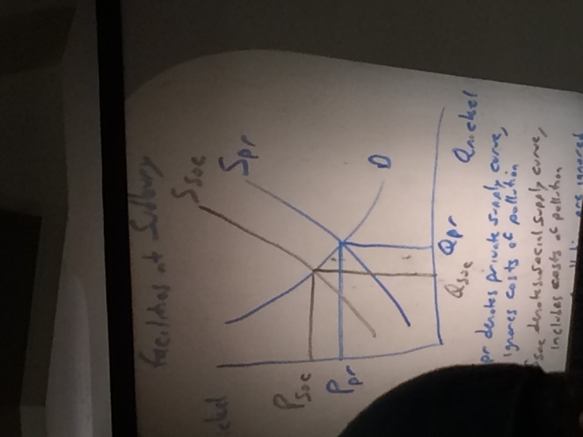
    - Ex. Ineo’s nickel production facilities at Sudbury
Spr denotes private supply curve, ignores costs of pollution
Ssec denotes social supply curve, includes costs of pollution
If costs of pollution are ignored, resourced are over allocated to nickel (Qpr>Qsec) & nickel price is artificially low (Ppr<Psec)

    - To internalize the cost of pollution, could:
  - Make Inco install and operate emission reduction equipment
  - Tax emissions
  - Create market for emissions

  - Positive – beekeeper next to an orchard
    - If benefits to orchard owner are ignored, resources are under allocated to honey (Qpr<Qsec) and honey price is artificially high (Ppr > Psec)
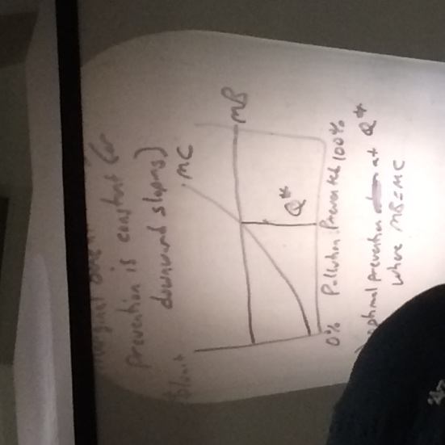
    - To internalize could have: direct payoff, subsidy,
- Optimal Intervention
  - Marginal cost (MC) of pollution prevention typically rises sharply
  - Marginal Benefit (MB) of pollution prevention is constant for downward sloping
  - Optimum prevention at Qstar, where MB=MC
  - Suppose enforcement costs are added (MC MC’); if profitable, Qstar=0

  - Changes overtime
Q*56=0
  - Society more concerned about pollution MB56 MB16
  - Technology has improved MC56MC16
  - Q*16>04
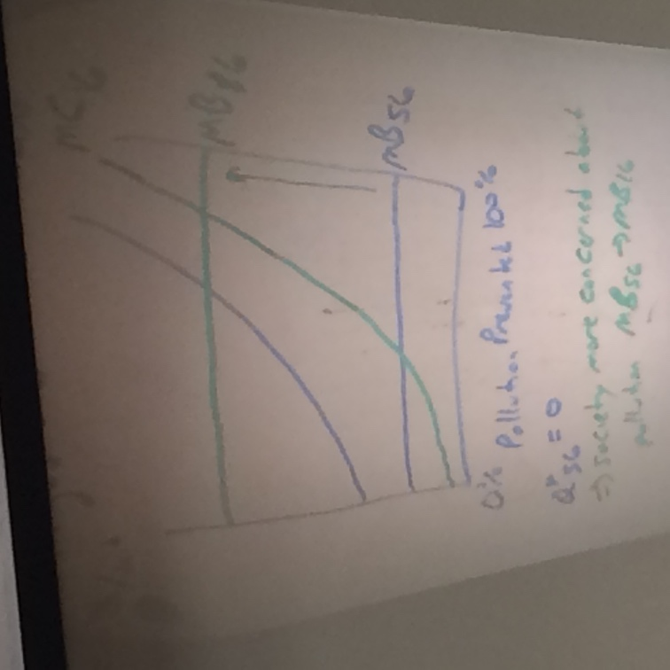
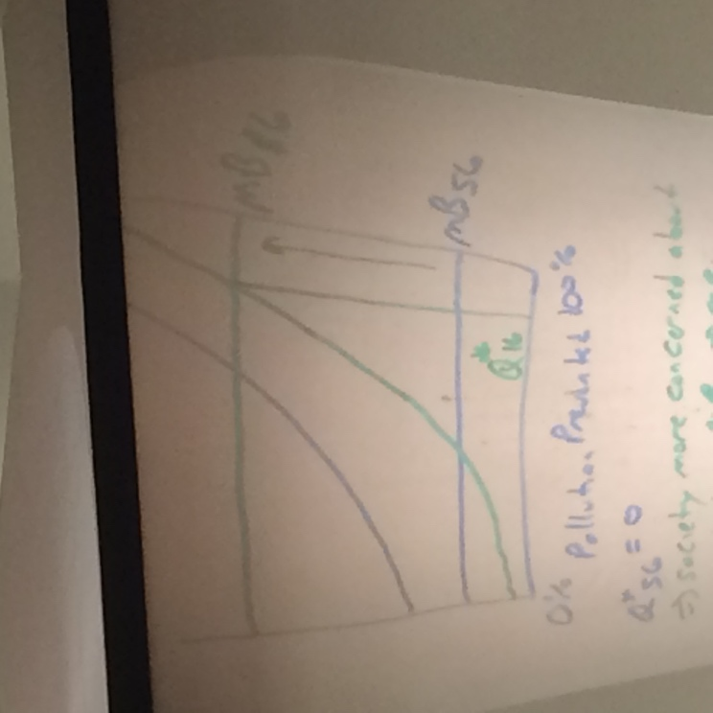

- Other Social Goals
  - Protect Individual from others
  - Protect Individuals from themselves

Reasonable income distribution (Ch.20)
    - Canadian Distribution
 | Market Distribution | After Tax Transfer Income
Poorest 5th | 2% | 5%
Richest 5th | 52% | 44%
  - Gini Coefficient: Measure to which incomes distribution deviates from perfectly equal distribution
  - 0 ; perfect equality ------------------ 1; perfect inequality
  - Canada’s GC ~ 0.3-0.4
    - Only more socialist European countries have a lower Gini coefficients than Canada
  - Poverty Line: Level of family income below which a family is considered ‘poor’ many subjective measures by all measures, ~10% of Canadians below poverty line

Factor Supply & Demand (Ch.18)
1) Derived Demand – the demand for any input depends on the existence of a demand for the goods & services it helps to produce
2) Marginal Product (MP) - change in the quantity of output that results from using one more unit of a variable factor
3) Value of Marginal Product (MP)
A) Definition – the additional revenue that results from using one more unit of a factor production
VMP = MP x MR
- under competitive model, MR=P
- VMP = MP x P
4) Factor Demands
A) assume firm is price taker in factor markets
- profit maximizing condition – firm will hire additional units of a variable factor up to the point where the marginal cost of the factor equals the value of marginal product
C) competitive market => Price of factor = MC of factor
D) labour market – wage (w) is the price of labour
=>set W=VMP *graph in phone*
=> demand for labour is VMP of labour

              - Shifts – output price
    - Technology labour augmenting vs labour saving

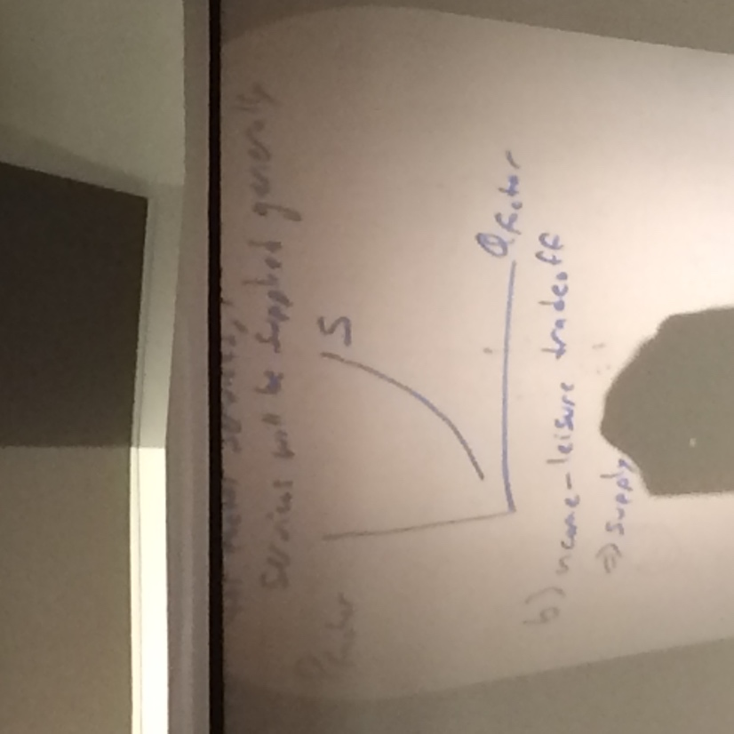

5. Supply of factors
a. If more is offered in return for factor services, more factor services will be supplied generally
b. income – leisure trade off
supply of labour generally upward sloping
At certain point, some may choose more leisure time over more income
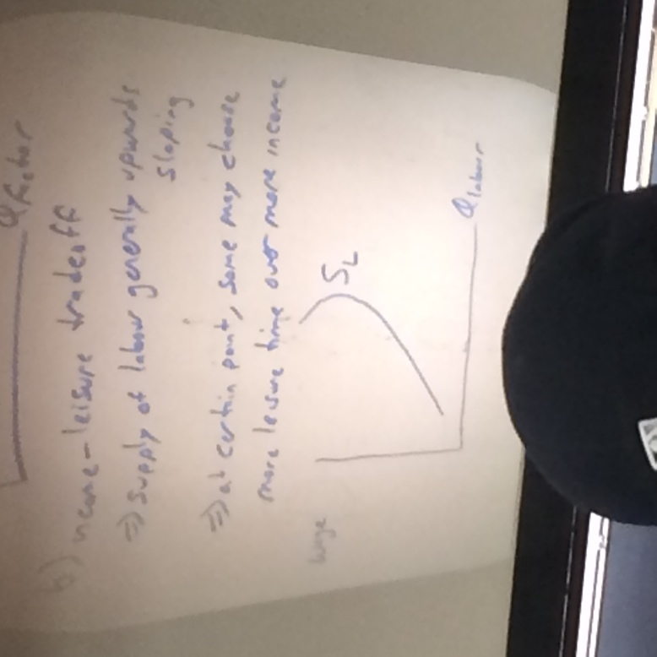
For majority of population only upward sloping portion applies
  - Changes – in taste/ changes in immigration

        - Intersection of Sc and Dc
        - Shifts
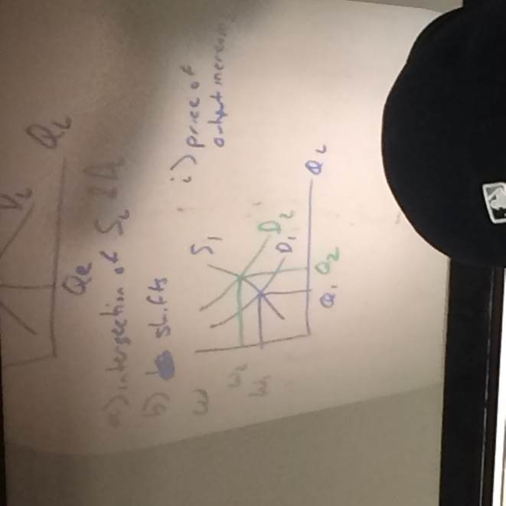
          - Price of output increases

          - More immigration

Earnings Variations (Ch.19)
  - Unpleasant, hard jobs vs easy, pleasant jobs
  - Human Capital
  - Ability, Effort, Chance
  - Above equilibrium wages due to unions, minimum wage
  - Below equilibrium wages due to monopsony
    - Monopsony – only a single buyer for a factor

Ch. 22
- Moral Hazard: the tendency of a person who is imperfectly monitored to engage in dishonest otherwise undesirable behaviour
  - Ex Insurance – put in deductible, Greek debt, big banks

Final Exam
- >80% from ch 10-11, 13-20, 22
  - Bound and copied
  - 100 questions

