Lab 6: Regioselective Nitration of Acetanilide

CHM 1321 Section

Demonstrators:

April 4, 2018
Department of Chemistry University of Ottawa

Intro
- Mechanism of ortho, para, meta isomers
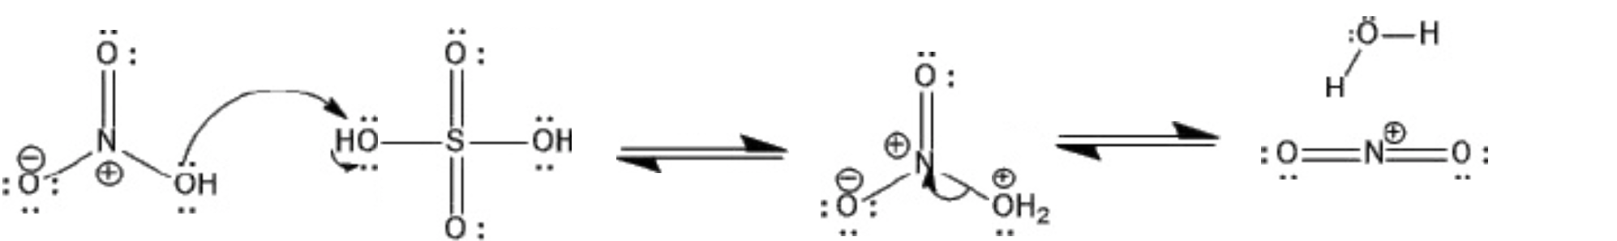
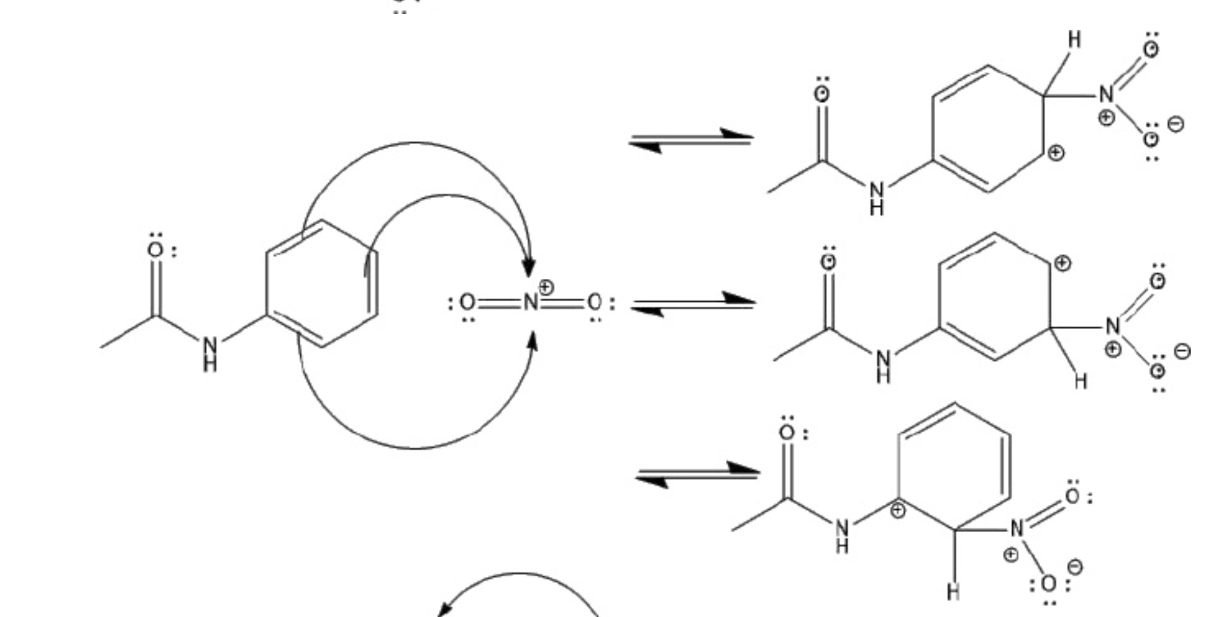
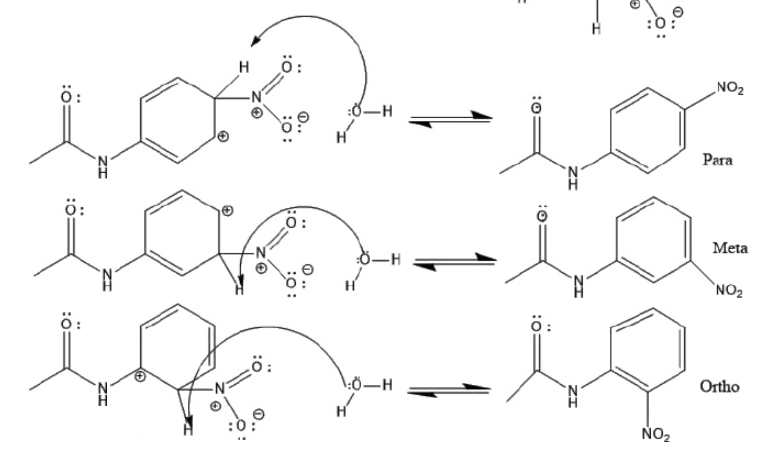

Procedure
-Refer to lab manual pages 53-54.
-Step 3, 5 mL of $H_{2}SO_{4}$ was used
-Step 5, 0.9 mL of nitric acid and 1.2 mL of sulfuric acid was used

Table of Reagents
Compound | Amount (g or mL) | Molecular Weight (g/mol) | Density (g/mL) | Moles (mol)
Acetanilide | 1 | 137.17 | 1.22 | 0.0073
Nitric Acid | 0.9 | 63.01 | 1.51 | 0.014
Sulfuric Acid | 1.2 | 98.08 | 1.84 | 0.012

Observations
- Acetanilide, white beige flakes
- Sulphuric Acid, clear liquid
- Addition of Acetanilide and Sulphuric Acid turned brown liquid, acetanilide did not fully dissolve
- solid obtained was a pale yellow colour, pliable in consistency

TLC
TLC 1: Acetanilide (in acetone) and solution in EtOAc:Hexanes 5:5 | TLC 2: Ortho and crude product in EtOAc:Hexanes 5:5
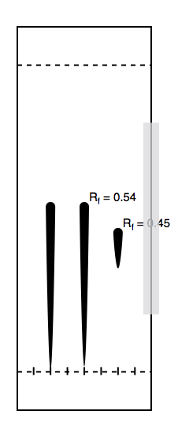  R C S | 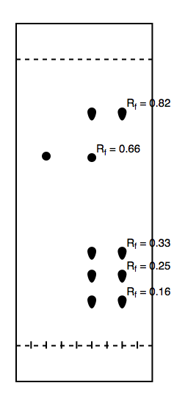  R C S
R: acetanilide in acetone  C: acetanilide and solution  S: solution | R: ortho  C: ortho and crude product  S: crude product

TLC 3: Meta and crude product in EtOAc:Hexanes 5:5 | TLC 4: para and crude product in EtOAc:Hexanes 5:5
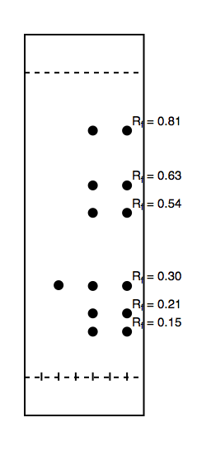 | 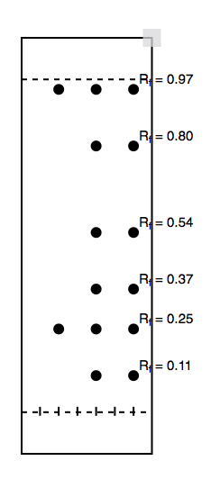  R C S
R: meta  C: meta and crude product  S: crude product | R: para  C: para and crude product  S: crude product

TLC 5: 2,4 dinitro and crude product in EtOAc:Hexanes 5:5  R C S | TLC 6: Crude product and purified product in EtOAc:Hexanes 5:5 | TLC 7: crystal product and mother liquid in EtOAc:Hexanes 5:5
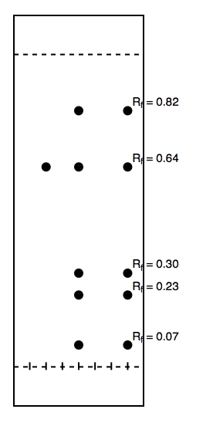  R C S | 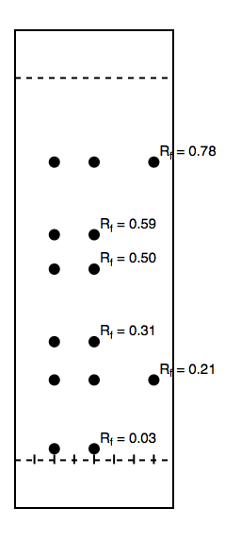  R C S | 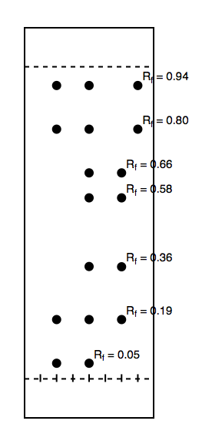  R C S
R: 2,4 dinitro  C: 2,4 dinitro and crude  S: crude product | R: purified product  C: purified and crude  S: crude product | R: purified product  C: purified and mother liquid  S: mother liquid

Table of Results:
Compound | Amount (g) | Molecular Weight (g/mol) | Density (g/mL) | Moles (mol)
Nitroacetanilide | 0.37g | 180.16 | 1.34 | 0.002

Calculations:
% yield = (mass collected/mass started with) x 100%
= (0.37g/1g) x 100%
=37%

Image J
-Absorbance of para = 23710.409
-Absorbance of dinitro = 28032.508
% Absorbance of para = (23710/23710+28032)x100% = 45.8%
% Absorbance of dinitro = (28032/28032+23710)x100% = 54.2%
Y= %absorbance 2,4-dinitro = 54.2%
Y=2.227x^2 – 1.6809x + 3.742
0=2.227x^2 – 1.689x -50.458
X= 4.39

%mole dinitro = 4.39%
%mole para = 95.61%

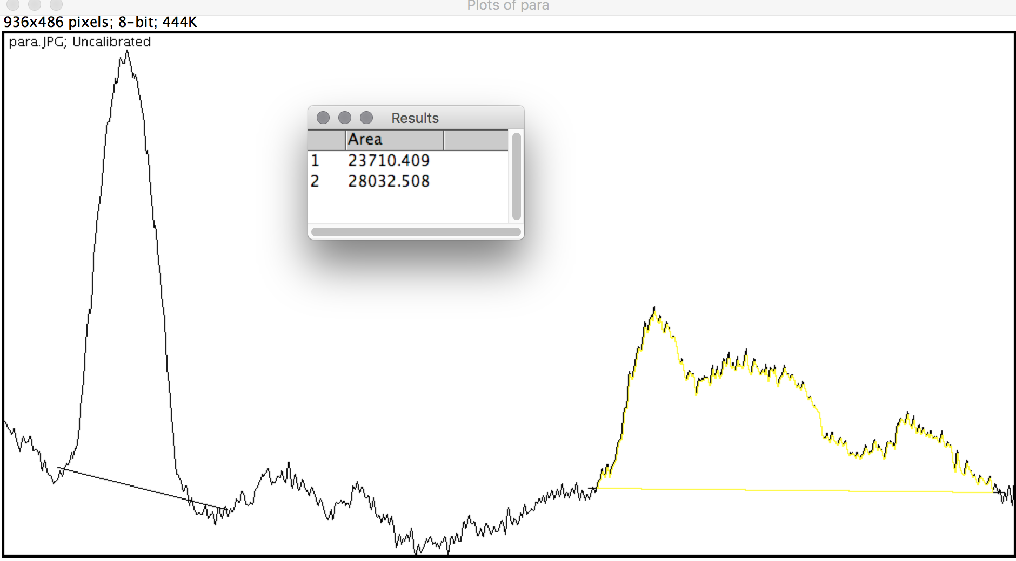

Discussion
- process was completed to show nitration of acetanilide using nitric and sulfuric acids
- the electrophile was a charged nitronium ion (from donation of proton from sulfuric acid)
-nitric acid acts as a base during this experiment as it is a weaker acid (will accept the proton)
- addition of nitronium ion occurred on the benzene ring, we then determined which isomer was most present
-TLC plates are used to distinguish between the three isomers of the products (ortho, para, meta)
- by comparing the TLC plates it is shown that the para isomer is the most favoured product as the reference and sample lanes show the most cohesion amongst the three isomers
- 2,4-dinitro was also tested on TLC, it was shown that it was not present in the crude product
- the para is the preferred isomer because of the two functional groups that are on opposite sides it diminishes the amount of steric hindrance produced making it more favourable.
- after testing of isomers the crude product was boiled in ethanol with the purpose of getting a purely para isomer product
- since ethanol is polar, when it is heated both isomers will dissolve, during recrystallization para will crystallize and any other contaminant isomers will be left in the mother liquid
- the crystal and liquid TLC shows that this did not happen perfectly and there might have been some contaminants somewhere
-the para isomer was found in both mother liquid and crystal product, so this shows the crystals themselves were at least pure as no other spots found in the liquid were present in the crystal
Sources of Errors
- Due to time restraints crystal product was not left to dry for a long enough time therefore not all water was removed
- Contaminant of para isomer in the mother liquid was found

Questions
- By examining the TLC plates, it is shown that the ortho isomers of the acetanilide is more polar. Ortho a polar isomer, is attracted to the also polar silica gel on the TLC plate causing it to move less up the plate. The para isomer is less polar and will therefore move higher up the plate.
- The addition of the second nitro group is slower than the first because of the difference in energy caused by the first addition of the nitro group. The addition moves the molecule to a lower energy level, making it less reactive. It takes longer because it needs to add onto a less reactive molecule.
- Para isomers are favoured instead of ortho isomers because the lack of dipole movement on the para isomer. The electronegative groups on the opposite side of the molecule create less steric interactions and allow more space for addition on the ring. Ortho however has the electronegative groups on the same side, meaning more steric interaction and less space for addition on the ring.
- a)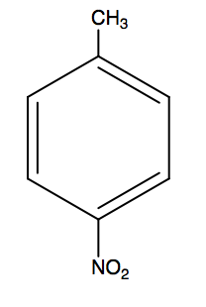b)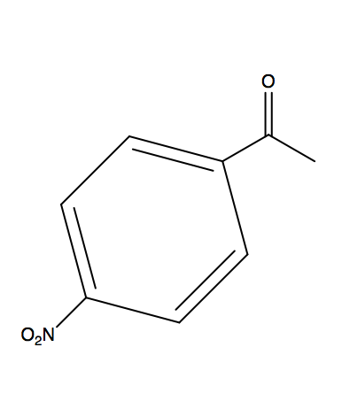 c)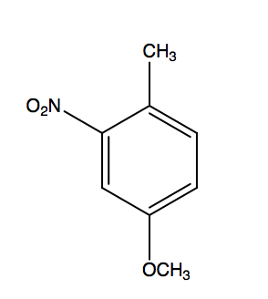
d)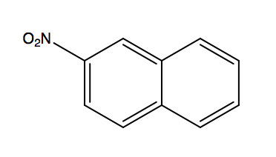

- When a carbon ring has one double bond, bromogenation will occur on both carbons. Within a benzene ring t is instead preferred to only bromogenate one carbon to return the molecule to aromacity. The double bon can then be reformed.

- Benzene + nitric acid + sulfuric acid nitrobenzene + ?
Benzene Nitric acid sulfuric acid nitrobenzene
Mass -780 g -750 mL -750 mL -1000 mL
Molar Mass -78 g/mol -16 g/mol -18 M -123 M
Moles – 10 mol -46.87 mol -41.66 mol -8.13 mol
- Benzene is limiting reagent as it has the least amount of moles
- Weight =(10 mol nitro) x(123g/mol nitro)
=1230 g
% yield = (actual/theoretical) x100%
= (1000/1230) x100%
= 81.3%
- Most probable side product is dinitrobenzene.
- The role of sulfuric acid is to activate the electrophile (nitric acid).
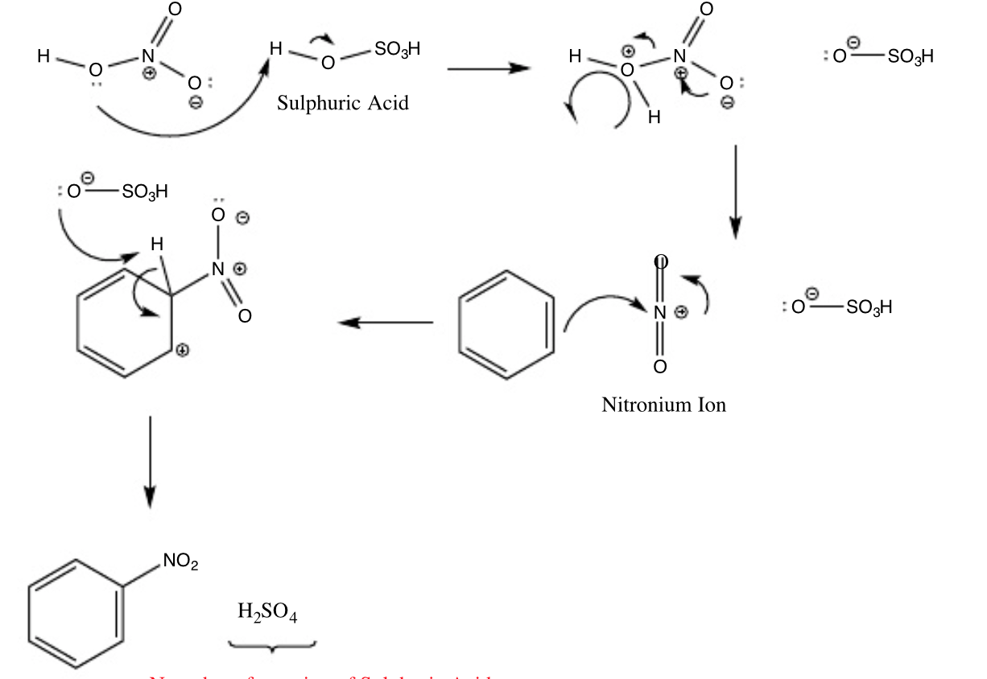
- Weight = (10 mol crystal) x (168.017 g/mol crystal)
= 1680.17 g

%Yield = (actual/ theoretical) x100%
= (250/1680.17)x100%
= 14.88%
- The preference of 1-nitrofuran is from the resonance structure. During its formation the positive charge is delocalized over 3 atoms (C3, C5 and O). The charge is not delocalized as evenly for 2-nitrofuran.

Signed Data


