How to download Windows Office product?

1. Login to MyConcordia (turn off adblock if you had it on)
2. Click on Software and Application
3. Click on Microsoft Imagine Premium (it will lead them to an external site)
4. Select the product you want (the website interface give many list of windows application the full version of it)
5. Add to cart
6. Click on Shopping Cart and Check Out

Please refer to the screen shot when finding the software
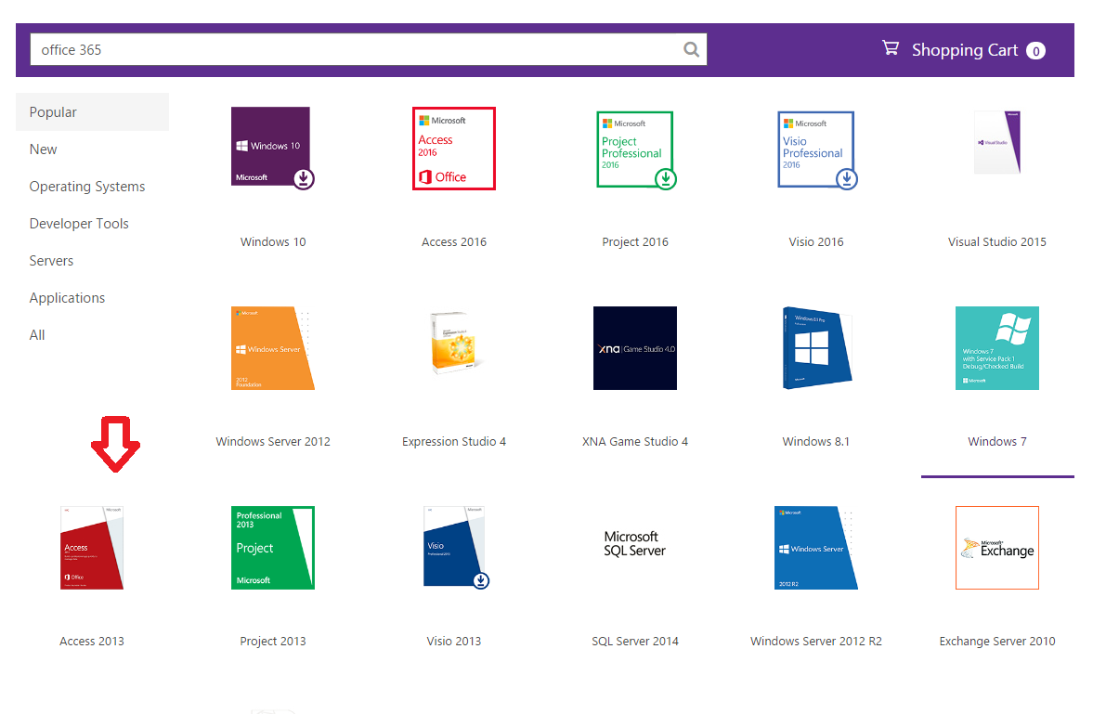

Once it's confirmed, you will receive a serial key (Under the "ITEMS TAB") to activate the windows application and you can download Access from the website. Below are the instructions to install Visio, it's downloaded on your computer:

How do I install my software?
To install your software once it has finished downloading:
- Navigate to the folder that you downloaded your software to.
- Double-click the installation package (usually an .exe or .zip file) that you downloaded.
- Follow the on-screen prompts to complete the installation.

What I can do if I don’t have access to Microsoft Imagine?
If you don’t have the access from your student portal, you can try OpenOffice, which is open source product. https://www.openoffice.org/

