LAB 6: SYNCHRONOUS COUNTERS

ITI 1100C - Digital Systems
Winter 2018 School of Electrical Engineering and Computer Science University of Ottawa

Course Coordinator: Dr. Ahmed Karmouch
Teaching Assistants: Heli
Jay
Mitchel
Jaafreh
Hala
Khaki

Group #23

Student Name and number: Georgio Karnabi 8166995
Student Name and number: Marco Borg | 300034912
Experiment Date: 27/03/2018
Submission Date: 03/04/2018

Objectives
- Design Synchronous Counters
- Simulate the functions of the various counters
- Display counter outputs as binary numbers on LED’s and test these counters.
Equipment & Components
- Quartus II 13.0 Service-Pack 1
- Altera DE2-115 circuit board
- Dell PC

Circuit Diagram
Part I – 4-bit Synchronous Counter
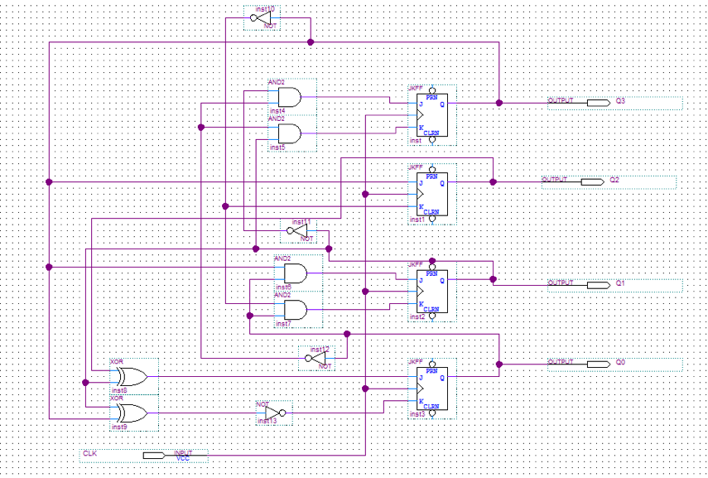
4-bit Synchronous Counter Logic Diagram

Experimental Data and Data Processing
Part I – 4-bit Synchronous Counter
4-bit synchronous counter

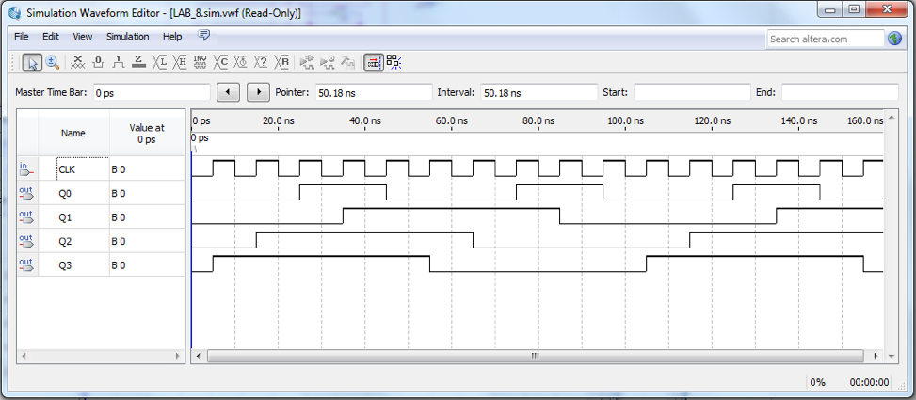
Waveform Simulation output for 4-bit Synchronous Counter

Table 1 : Experimental data observed from the circuit board (For output: 1 means the light flashed, 0 means the light did not flash):

Present State |  |  |  | Next State |  |  |  | Q3 Input |  | Q2 Input |  | Q1 Input |  | Q0 Input
Q3 | Q2 | Q1 | Q0 | Q3 | Q2 | Q1 | Q0 | J3 | K3 | J2 | K2 | J1 | K1 | J0 | K0
0 | 0 | 0 | 0
0 | 0 | 0 | 1
0 | 0 | 1 | 0
0 | 0 | 1 | 1
0 | 1 | 0 | 0
0 | 1 | 0 | 1
0 | 1 | 1 | 0
0 | 1 | 1 | 1
1 | 0 | 0 | 0
1 | 0 | 0 | 1
1 | 0 | 1 | 0
1 | 0 | 1 | 1
1 | 1 | 0 | 0
1 | 1 | 0 | 1
1 | 1 | 1 | 0
1 | 1 | 1 | 1

Comparison of Theoretical Data and Experimental Data
Part I – 4-bit Synchronous Counter
4-bit synchronous counter

Table 2 : Comparison of theoretical data and experimental data for the 4-bit synchronous counter

Discussion & Conclusions

In Lab 6 we worked with synchronous counters (4-bit synchronous counters especially). From this experiment, we can see how to build counters using JK flip-flops.

Synchronous counters use a clock signal so that when several flip-flops must change state, all of them occur at the same time. A binary counter is a simple counter which counts values up when an enable signal is present and will reset when the reset control signal is present.

JK flip-flops are used in synchronous counters because there are two inputs allowed. Moreover, the information to the J and K inputs is formed in parallel. In the parallel scheme, the number of inputs to each AND gate increases linearly with the number of stages.

In this experiment, we see how the counters are designed and how they work through simulation. In our case, the experimental data matches the theoretical data by comparing the state table, state diagram and the result of our simulation.

